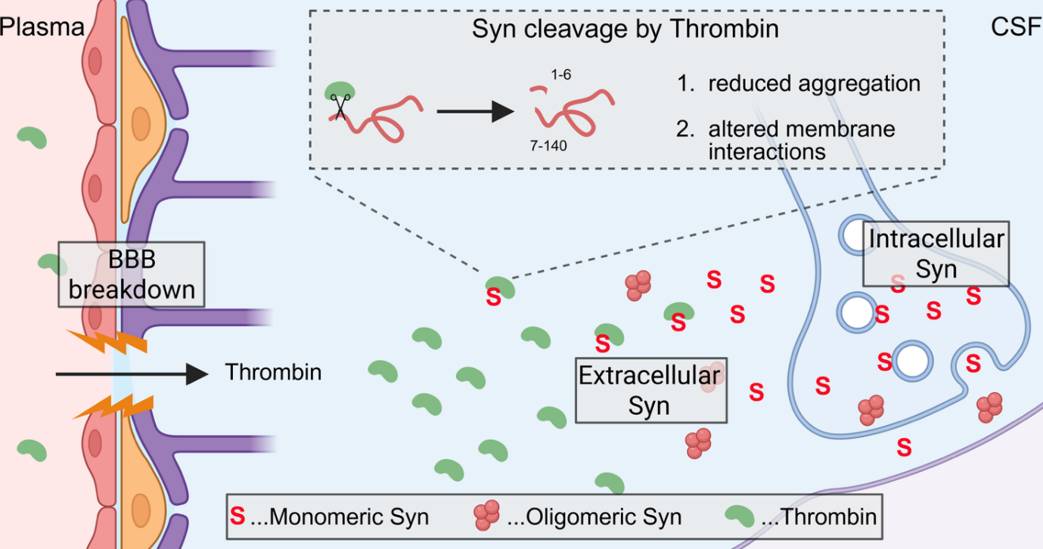
Scheme 1: Simplified graphical summary representing the possible interaction between Thb and extracellular Syn resulting in protein truncation. (created with Biorender)

