Linking thrombin to α-synuclein truncation reveals a molecular bridge between inflammation and Parkinson disease

Philipp Trolese^{1,2}, Benedetta Fongaro^{1,3}, Vittoria Scapin¹, Alice Sosic¹, Martina Scano⁴, Dorianna Sandonà⁴, Laura Acquasaliente¹, Patrizia Polverino de Laureto¹
¹Department of Pharmaceutical and Pharmacological Sciences, University of Padova, Italy
²Department of Neuroscience, Biomedicine and Movement Sciences, University of Verona, Italy
³Department of Agronomy Food Natural Resources Animals and Environment, University of Padova, Legnaro, Italy
⁴Department of Biomedical Sciences, University of Padova, Italy
*Corresponding author

Supplementary material

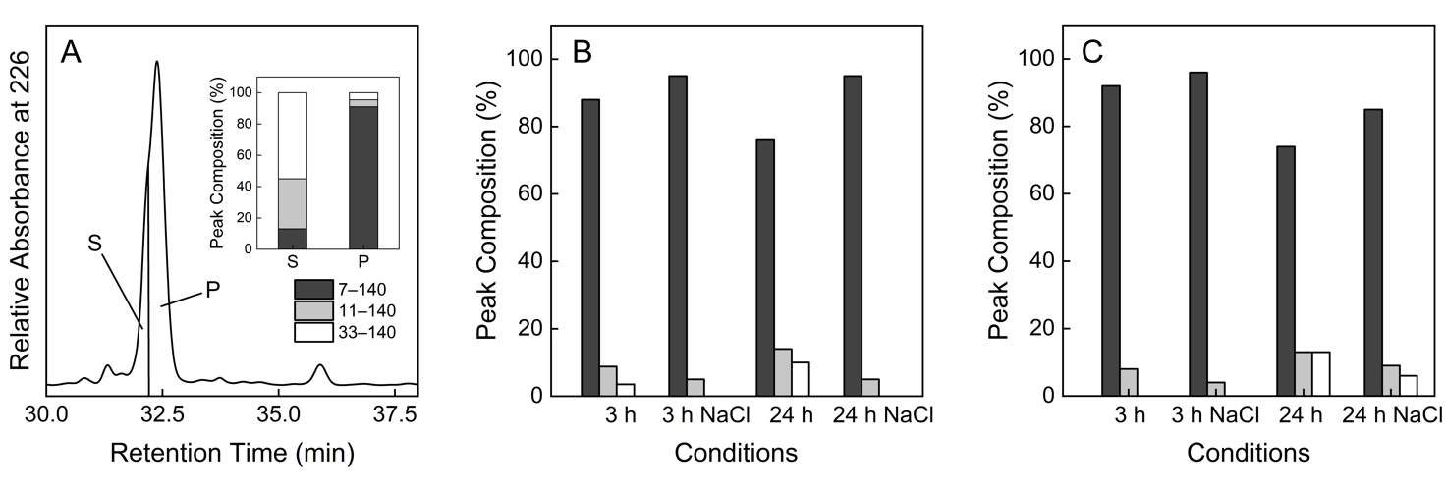

Fig. S1. Characterization of chromatographic fraction corresponding to 7–140 species. (A) Detail of the RP-HPLC peak at RT 32.5 min of the proteolysis mixture of Syn with Thb after 24 h without salt. S indicates the fraction corresponding to the shoulder, P the main fraction centred at 32.5 min, collected in correspondence of the peak top. The inset shows the composition of S and P analysed by MS. (B) Relative ratio between the species present in the peak eluting at 32.5 min of the proteolysis mixture of Syn with Thb at 3 h and 24 h in absence and presence of NaCl when collecting the whole peak. (C) Relative ratio between the species present in the peak eluting at 32.5 min of the proteolysis mixture of 7–140 Syn with Thb at 3 h and 24 h in the presence and absence of NaCl when collecting the whole peak. The ratios were determined by ESI-MS.

Table S1. Chemical characterization of species produced by proteolysis of Syn and 7–140 Syn by Thb.
RT (min) | MW  (Da) | Species | Peak Area
RT (min) | MW  (Da) | Species | 1:100 |  |  |  | 1:400
RT (min) | MW  (Da) | Species | 3 h | 3 h +  NaCl | 24 h | 24 h + NaCl | 3 h | 3 h +  NaCl | 24 h | 24 h + NaCl
29 | 3250 | 1–32 | 0.47 | NC | 0.58 | 0.39 | 0.42 | NC | 1.1 | 0.21
35.4 | 13708 13322 11227 | 7–140  11–140 33–140 | 74 | 18 | 97 | 56 | 55 | 10 | 101 | 37

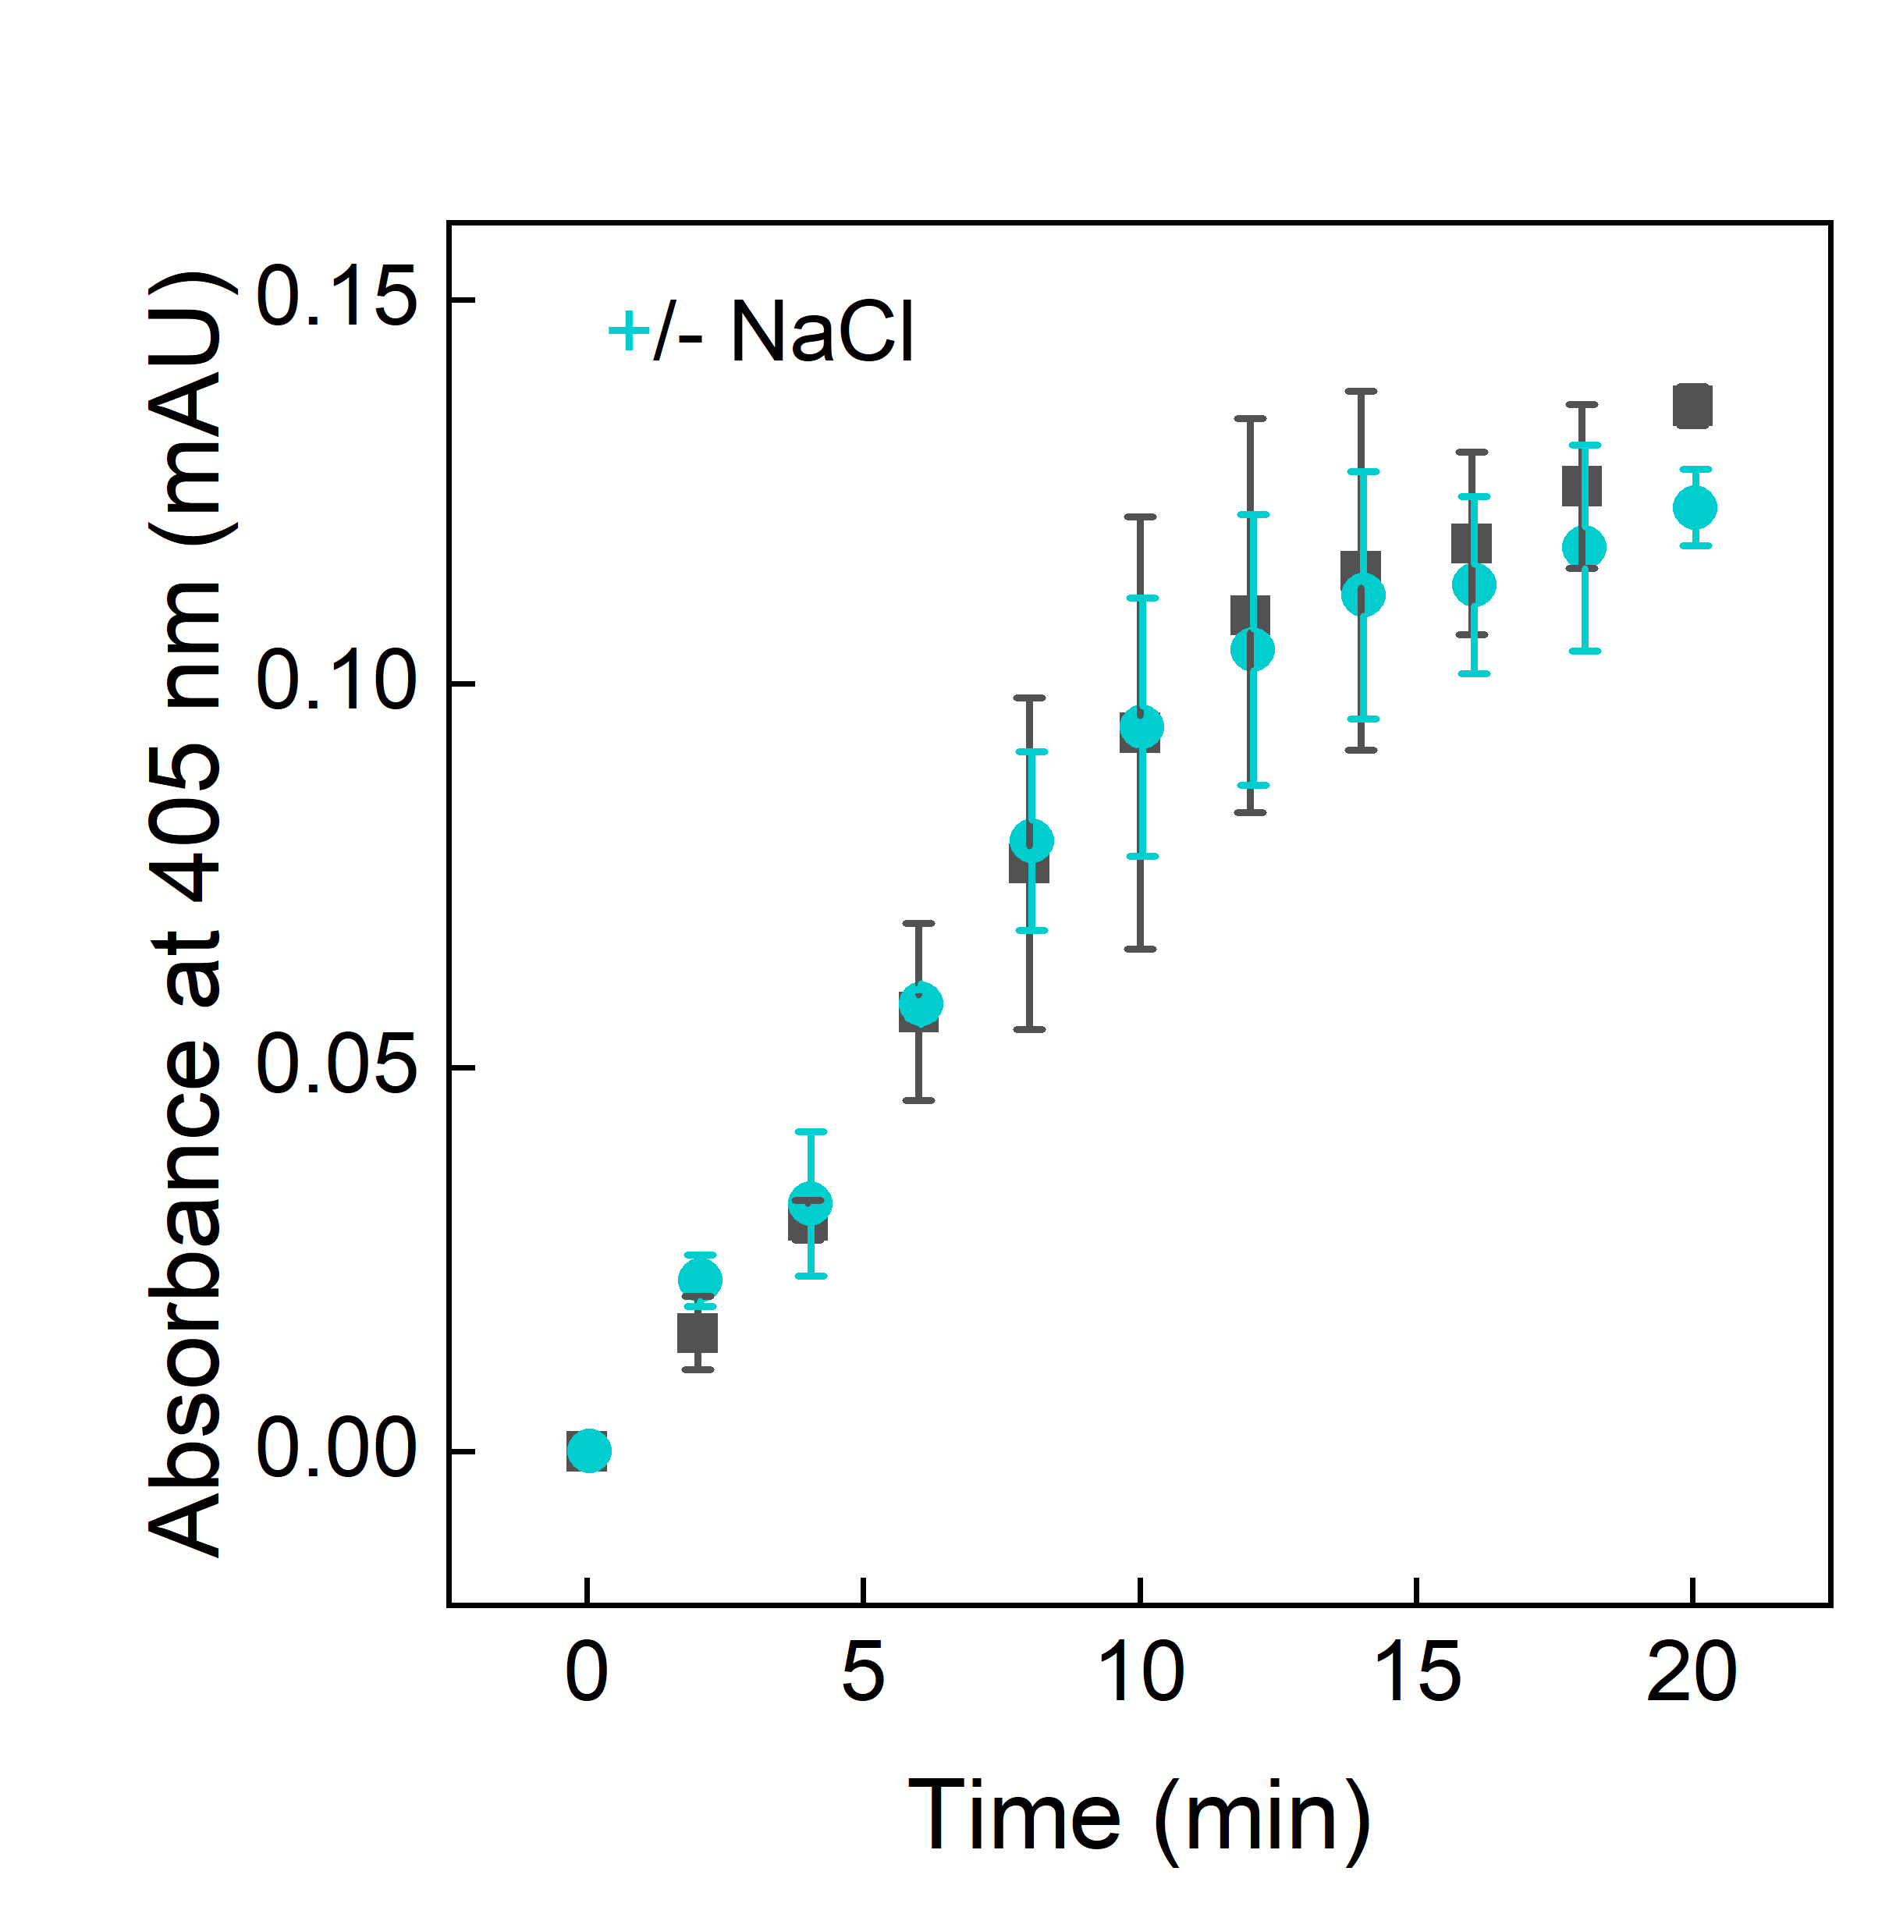

Fig. S2. Thb activity in the presence (ciano) and in the absence (black) of 150 mM NaCl. The release of pNA from (D)-Phe-Pip-Arg-pNA (S-2238) was monitored spectrophotometrically at 405 nm over time. The assay was conducted in 20 mM sodium phosphate, pH 7.4 at 37 °C, using an E/S 1:200000)

Table S2. Chemical characterization of the protein material found in the peak at 32.5 min RT of the chromatograms shown in Fig. 3D corresponding to the proteolysis of Syn by trypsin. The calculated masses were obtained from the amino acid sequence of Syn.

RP-HPLC RT (min) | Molecular Mass (Da) |  | Species
RP-HPLC RT (min) | Found | Calculated | Species
32.5 | 13 708.38 ± 0.60 | 13 708.20 | 7–140
32.5 | 13 322.40 ± 0.34 | 13 322.64 | 11–140
32.5 | 13 123.22 ± 0.12 | 13 123.28 | 13–140
32.5 | 12 039.13 ± 0.45 | 12 039.24 | 24–140
32.5 | 10 998.03 ± 0.20 | 10 998.07 | 35–140
32.5 | 10 064.92 ± 0.22 | 10 065.00 | 44–140
32.5 | 9 835.5 ± 0.30 | 9 835.72 | 46–140

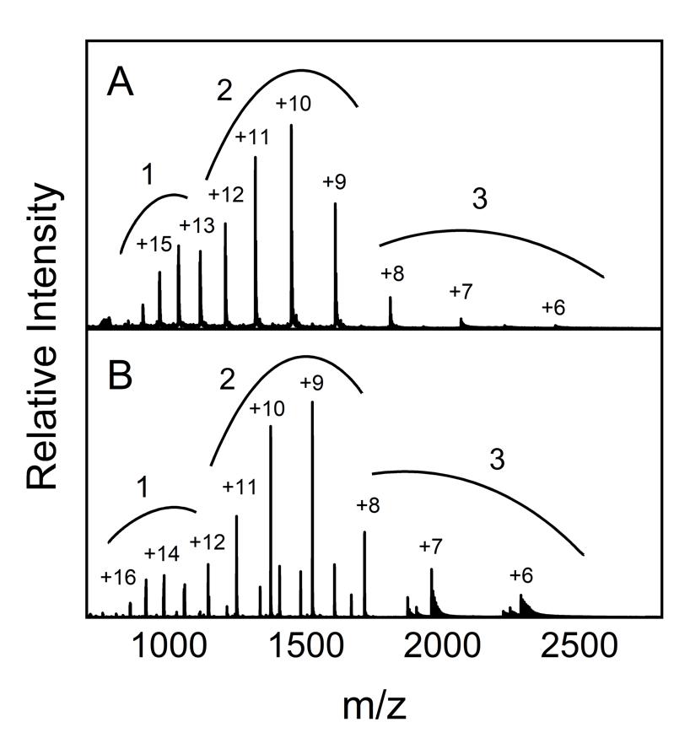
Fig. S3. ESI-MS spectra in native conditions of Syn (A) and 7–140 Syn (B).

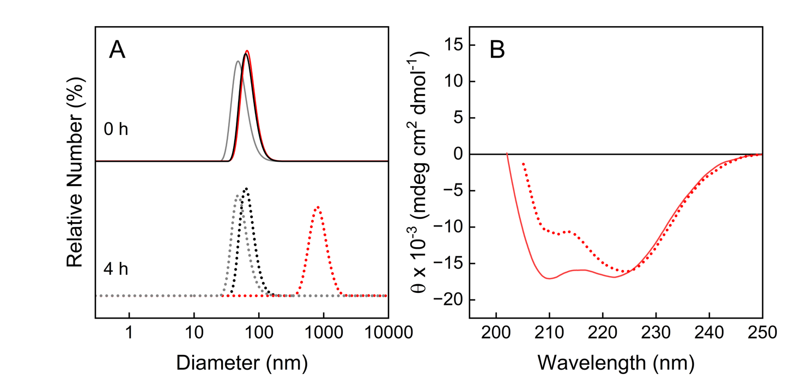

Fig. S4. Stability of SUV in the presence and in the absence of the protein species. (A) DLS of SUV before and after the mixing with the proteins at time 0 (continuous line) and after 4 h (dotted line) of incubation. Syn profiles are in red; 7–140 Syn profiles are in black, SUVs alone in grey. (B) Far-UV CD spectra of Syn in the presence of SUV (1:500 protein to phospholipid ratio) at time 0 (continuous line) and after 4 h (dotted line) of incubation.

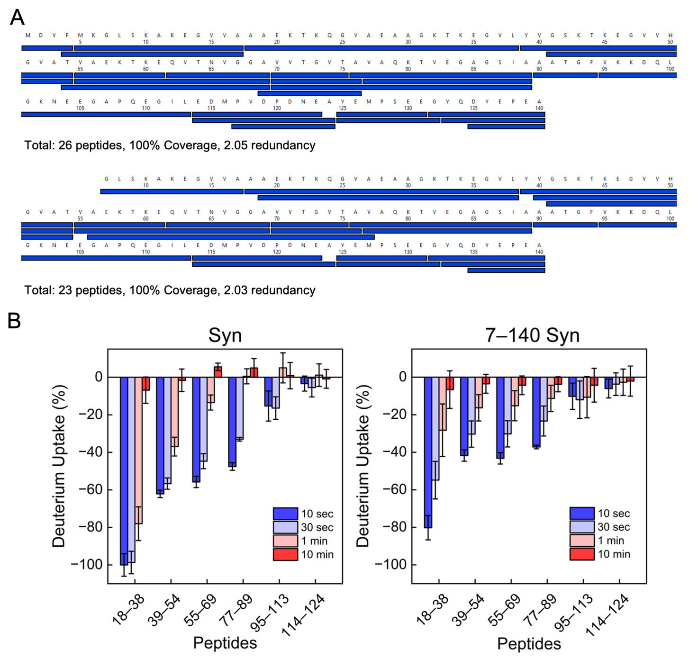
Fig. S5. (A) Sequence coverage and redundancy plots showing all peptides detected after in-column pepsin digestion of Syn (top) and 7–140 Syn (bottom). (B) Deuterium uptake of peptides with similar length covering the main portions of Syn (left) and 7–140 (right) sequence. Data were normalized by subtracting the uptake of the free protein from the uptake of the liposome bound protein; followed by dividing by the peptide with the most protection (peptide 18–38).

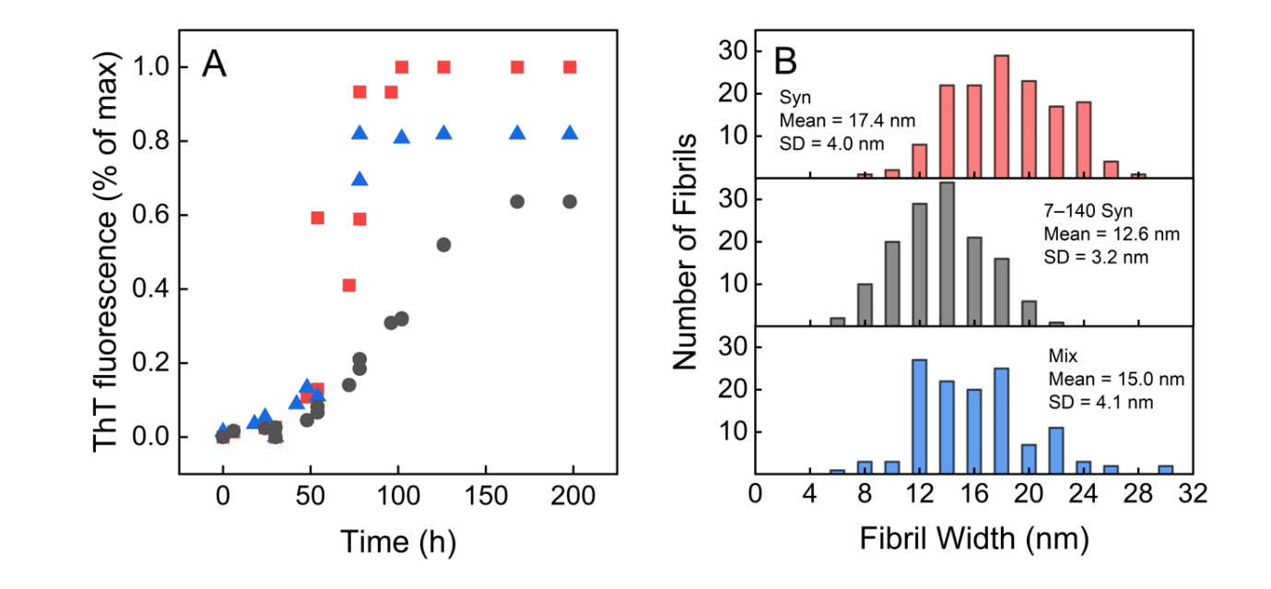
Fig. S6. (A) All raw ThT measurements performed for the aggregation mixtures of Syn (red), 7–140 Syn (black) and the 3:1 mixed sample (blue). (B) Histogram showing the distribution of the fibril width measurements obtained from TEM micrographs of Syn (red), 7–140 Syn (black) and the 3:1 mixed sample (blue) fibrils.

Table S2. Fitting parameters for the ThT curves obtained by AmyloFit.
Species | Model | MRE | k₊k_{n}  (conc^{-nc} time⁻²) | n_{c} | k₊k₋  (conc⁻¹time⁻²)
Syn | Fragmentation Dominated | 0.0053 | 5.52e+8 | 3.15 | 22.1
Mix | Fragmentation Dominated | 0.00137 | 9.79e+7 | 3.16 | 78.8
7–140 | Fragmentation Dominated | 0.000328 | 3.55+7 | 2.90 | 7.0

k₊k_{n}…product of elongation rate constant and primary nucleation rate constant
n_{c}…primary nucleus size
k₊k₋…product of elongation rate constant and fragmentation rate constant

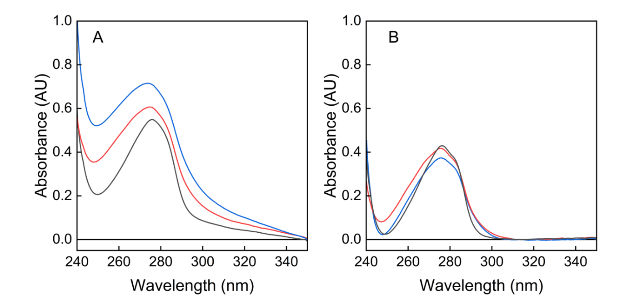

Fig. S7. (A) UV-vis absorption spectra of fibril pellets resuspended in 7 M Gnd–HCl, after correction for the intrinsic absorbance of Gnd–HCl of Syn (red), 7–140 Syn (black) and the 3:1 mixed sample (blue). (B) Baseline-corrected UV spectra of the same samples, showing removal of the scattering contribution arising from residual aggregates.

