Supporting Information
For
Superatomic Shell Closure Defines the Stability of Octacoordinate M[NH₃]₈ Complexes Across Phases
Jiarui Li,^{1,2} Yisen Yao,¹ Cen Li,³ Georg Schreckenbach,³ Pawel M. Kozlowski,^{2,4} Zhiming Wang,^{1,2} Yang Gao*^{1,2}
¹ Institute of Fundamental and Frontier Sciences, University of Electronic Science and Technology of China, Chengdu, Sichuan 611731, China
² Shimmer Center, Tianfu Jiangxi Laboratory, Chengdu 641419, China
³ Department of Chemistry, University of Manitoba, Winnipeg, Manitoba R3T 2N2, Canada
⁴ Department of Chemistry, University of Louisville, Louisville, Kentucky 40292, United States

Part 1 The structural parameters of gas-phase and solvated M[NH₃]₈ complexes. 2
Part 2 IR spectra of the M[NH₃]₈ complexes in the gas phase. 3
Part 3 Ground states of the gas-phase M[NH₃]₈ complexes. 5
Part 4 The SAMOs of the gas phase M[NH₃]₈ complexes and electron-spin density of the Eu[NH₃]₈ complex. 6
Part 5 Molecular orbital energy level diagram of the ligand NH₃ molecule. 10
Part 6 The supplementary validation of the 1S²1P⁶1D⁸2S² superatomic framework in related complexes. 11
Part 7 The charge, electron configurations and energy gaps of gas-phase and solvated M[NH₃]₈ complexes. 13
Part 8 Adiabatic ionization potential (AIP) of solvated M[NH₃]₈ complexes in different oxidation states. 15
Part 9 The solvated M[NH₃]_{m} complexes with different coordination numbers. 16
Part 10 The RDF diagrams of M²⁺[NH₃]₈ in the solution. 18
Part 11 The SAMOs of the solvated M²⁺[NH₃]₈ complexes. 19
Part 12 Side-by-side comparison of theoretical perspectives, representative systems, and applicability of different theory based on M[NH₃]₈ complexes. 21
Part 13 References 23

Part 1 The structural parameters of gas-phase and solvated M[NH₃]₈ complexes.
Table S1. Characteristic average distances and atomic, crystal and ionic radii. $d_{\overline{M-N(average )}}$ and $d_{\overline{N-H(average )}}$ represent the M-N’s characteristic average distances and N-H bond lengths of the five M[NH₃]₈ complexes and their divalent cations, respectively.
Systems | State | $d_{\overline{M-N(average )}}$ (Å) | $d_{\overline{N-H(average )}}$ (Å) | Atom radius (R, Å) | Crystal radius  (R_{cry}, Å) | Ionic radius (R_{ion}, Å)
Ca[NH₃]₈ | Singlet-gas | 2.585 | 1.021 | 1.74 | 1.26 | 1.12
Ca[NH₃]₈ | Singlet-sol | 2.591 | 1.020 | 1.74 | 1.26 | 1.12
Ca²⁺[NH₃]₈ | Singlet-sol | 2.589 | 1.015 | 1.74 | 1.26 | 1.12
Sr[NH₃]₈ | Singlet-gas | 2.732 | 1.020 | 1.91 | 1.40 | 1.26
Sr[NH₃]₈ | Singlet-sol | 2.742 | 1.020 | 1.91 | 1.40 | 1.26
Sr²⁺[NH₃]₈ | Singlet-sol | 2.755 | 1.015 | 1.91 | 1.40 | 1.26
Ba[NH₃]₈ | Singlet-gas | 2.934 | 1.019 | 1.98 | 1.56 | 1.42
Ba[NH₃]₈ | Singlet-sol | 3.068 | 1.019 | 1.98 | 1.56 | 1.42
Ba²⁺[NH₃]₈ | Singlet-sol | 3.052 | 1.015 | 1.98 | 1.56 | 1.42
Eu[NH₃]₈ | Octet-gas | 2.744 | 1.019 | 2.04 | 1.39 | 1.25
Eu[NH₃]₈ | Octet-sol | 2.790 | 1.019 | 2.04 | 1.39 | 1.25
Eu²⁺[NH₃]₈ | Octet-sol | 2.773 | 1.015 | 2.04 | 1.39 | 1.25
Yb[NH₃]₈ | Singlet-gas | 2.621 | 1.021 | 1.94 | 1.28 | 1.14
Yb[NH₃]₈ | Singlet-sol | 2.627 | 1.020 | 1.94 | 1.28 | 1.14
Yb²⁺[NH₃]₈ | Singlet-sol | 2.624 | 1.015 | 1.94 | 1.28 | 1.14

The ionic radii of Eu and Yb, being intermediate between Ca and Ba, allow for comparisons between lanthanide and non-f-electron alkaline earth systems. For the M[NH₃]₈ complexes, the slightly twisted square antiprismatic (TSAP) geometry is characterized by two key parameters: The M-N characteristic distance (d_{M-N}, Å) and torsion angle (ω, °). The d_{M-N} values follow the trend expected from ionic radii (Figure 1c): Ba (2.934 Å) > Eu (2.744 Å) > Sr (2.732 Å) > Yb (2.621 Å) > Ca (2.585 Å).^{1, 2}

Part 2 IR spectra of the M[NH₃]₈ complexes in the gas phase.
Figure S1. The IR spectra of the Ca[NH₃]₈ complexes in the gas phase were calculated and tested using different methods, and the spectra were corrected by frequency correction factors. The IR experimental spectrum of the Ca[NH₃]₈ complex (light grey) obtained previously.³
To ensure the reliability of the IR spectral calculations, this study systematically evaluated the performance of five representative functionals based on the characteristics of the coordination system: PBE-D3 (pure GGA),⁴ M06-2X-D3 (hybrid meta-GGA),⁵ B3LYP-D3 (hybrid GGA),⁶ wB97XD (long-range corrected with empirical dispersion),⁷ and TPSSh (hybrid meta-GGA)⁸. To account for systematic errors in theoretical calculations, all results were calibrated using the 6-311G** basis set combined with frequency correction factors reported in the literature. Notably, optimized structures from some methods exhibited shoulder peaks in the N-H stretching region, indicating significant structural distortion of the corresponding NH₃ ligands' N-H bonds. Among these methods, B3LYP-D3/6-311G** demonstrated the best computational accuracy, with predicted vibrational frequencies deviating from experimental values by less than 7 cm⁻¹, consistent with its parametric advantages in geometry optimization and frequency calculations.

Figure S2. The IR spectra of the M[NH₃]₈ complexes in the gas phase were calculated under M06-2X/def2TZVPP methods, with a frequency correction factor of 0.945, and the experimental IR spectrum of the Ca[NH₃]₈ complex (light grey) from the literature.³

As mentioned in the methods section, the M06-2X functional does not show significant advantages in frequency calculations, and under this method, the characteristic peaks in the N-H bond feature region exhibit a notable red shift compared to the peaks in Figure 1c of the manuscript, while Eu[NH₃]₈ and Ba[NH₃]₈ show more pronounced shoulder peaks, making them unsuitable for comparison, and thus not being used as the primary analysis mode.

Part 3 Ground states of the gas-phase M[NH₃]₈ complexes.
We first analyzed the ground state of M[NH₃]₈, where the first coordination layer is fully coordinated and saturated. The results reveal that the stability of these complexes is primarily governed by the central metal’s electron configuration. For alkaline earth metals (Ca, Sr, Ba), the ns² electrons hybridize with ligand orbitals to form a closed-shell configuration, resulting in singlet ground states. In contrast, lanthanide complexes exhibit more complex ground states: Eu[NH₃]₈ adopts an octet state (S=7/2) due to the localized nature of its half-filled 4f⁷ configuration, while Yb[NH₃]₈ exhibits a singlet ground state, with its fully filled 4f¹⁴ shell shielding the 6s² electron, akin to alkaline earth metal behavior. These differences highlight the influence of 4f/5d/6s orbital interactions in determining ground-state configurations, where localized 4f orbitals favor high-spin states.

Table S2. Relative energies of different electronic states of the M[NH₃]₈ complexes in the gas phase, and the valence electron configurations of metal atoms. The visual representation is shown in Figure 1e in the main text.
Systems | Ground State | Relative Energy (eV) | The valence electron  arrangement of metal atoms
Ca[NH₃]₈ | Singlet | 0.00 | [Ar] 4s²
Ca[NH₃]₈ | Triplet | 0.33 | [Ar] 4s²
Ca[NH₃]₈ | Quintet | 6.07 | [Ar] 4s²
Sr[NH₃]₈ | Singlet | 0.00 | [Kr] 5s²
Sr[NH₃]₈ | Triplet | 0.27 | [Kr] 5s²
 | Quintet | 7.09 | [Kr] 5s²
Ba[NH₃]₈ | Singlet | 0.00 | [Xe] 6s²
Ba[NH₃]₈ | Triplet | 0.22 | [Xe] 6s²
 | Quintet | 5.64 | [Xe] 6s²
Eu[NH₃]₈ | Quartet | 3.36 | [Xe] 4f⁷6s²
Eu[NH₃]₈ | Sextet | 0.53 | [Xe] 4f⁷6s²
Eu[NH₃]₈ | Octet | 0.00 | [Xe] 4f⁷6s²
Yb[NH₃]₈ | Singlet | 0.00 | [Xe] 4f¹⁴6s²
Yb[NH₃]₈ | Triplet | 0.34 | [Xe] 4f¹⁴6s²
Yb[NH₃]₈ | Quintet | 1.82 | [Xe] 4f¹⁴6s²

Part 4 The SAMOs of the gas phase M[NH₃]₈ complexes and electron-spin density of the Eu[NH₃]₈ complex.
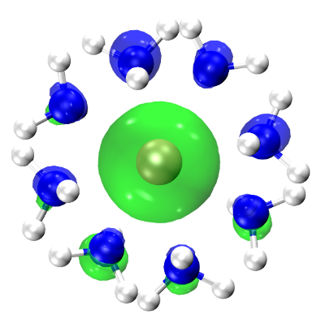
Figure S3. The electron-spin density isosurfaces of the Eu[NH₃]₈ complex. From the figure, it can be seen that the unpaired electrons of the Eu[NH₃]₈ complex are localized only near the metal atom.
Analysis of the electron spin density for the Eu[NH₃]₈ complex reveals that the spin is entirely localized on the Eu atom, as anticipated, arising from its 4f electrons. This result rationalizes the observed octet ground state.

Table S3. The SAMOs of the gas phase M[NH₃]₈ complexes. The orbital numbering (n) stands for the HOMO-n and their superatomic molecule orbitals (SAMOs) are marked. For Eu[NH₃]₈, both the spin-up (α) and spin-down (β) electrons orbitals are shown.
System  n | Ca[NH₃]₈ | Sr[NH₃]₈ | Ba[NH₃]₈ | Eu[NH₃]₈ α | Eu[NH₃]₈ β | Yb[NH₃]₈
LUMO | 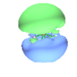 | 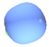 | 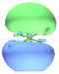 | 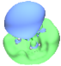 | 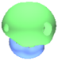 | 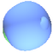
LUMO | 2P | 2P | 2P | 2P | 2P | 2P
0 |  |  | 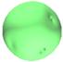 |  | 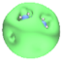 | 
0 | 2S | 2S | 2S | 2S | 2S | 2S
1 | 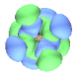 | 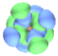 | 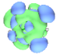 | 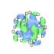 | 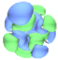 | 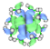
1 | 1D | 1D | 1D | 1F | 1D | 1F
2 | 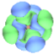 | 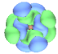 | 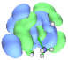 | 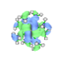 | 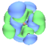 | 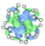
2 | 1D | 1D | 1D | 1F | 1D | 1F
3 | 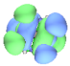 | 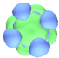 | 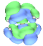 | 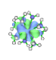 | 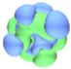 | 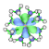
3 | 1D | 1P | 1P | 1F | 1P | 1F
4 | 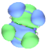 | 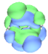 | 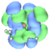 | 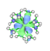 | 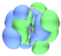 | 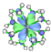
4 | 1D | 1P | 1D | 1F | 1P | 1F
5 | 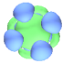 | 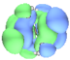 | 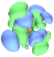 | 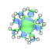 | 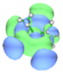 | 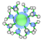
5 | 1P | 1P | 1D | 1F | 1P | 1F
6 | 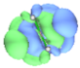 | 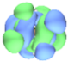 | 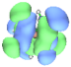 | 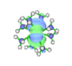 | 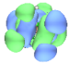 | 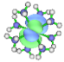
6 | 1P | 1D | 1P | 1F | 1D | 1F
7 | 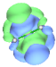 | 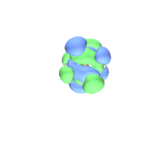 | 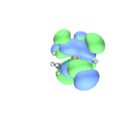 | 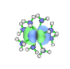 | 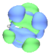 | 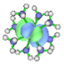
7 | 1P | 1D | 1P | 1F | 1D | 1F
System  n | Ca[NH₃]₈ | Sr[NH₃]₈ | Ba[NH₃]₈ | Eu[NH₃]₈ α | Eu[NH₃]₈ β | Yb[NH₃]₈
8 | 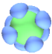 | 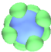 | 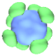 | 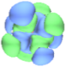 | 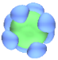 | 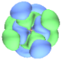
8 | 1S | 1S | 1S | 1D | 1S | 1D
9 | / |  |  | 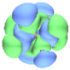 | / | 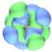
9 |  |  |  | 1D | / | 1D
10 |  |  |  | 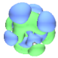 | / | 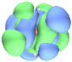
10 |  |  |  | 1P | / | 1D
11 |  |  |  | 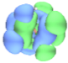 | / | 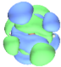
11 |  |  |  | 1P | / | 1D
12 |  |  |  | 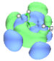 | / | 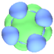
12 |  |  |  | 1P | / | 1P
13 |  |  |  | 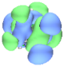 | / | 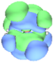
13 |  |  |  | 1D | / | 1P
14 |  |  |  | 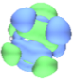 | / | 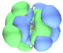
14 |  |  |  | 1D | / | 1P
15 |  |  |  | 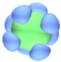 | / | 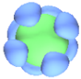
15 |  |  |  | 1S | / | 1S

Furthermore, the unconventional emergence of the 1S²1P⁶1D⁸2S² superatomic configuration in M[NH₃]₈ complexes, rather than the canonical 1S²1P⁶1D¹⁰, is jointly dictated by the pseudo-D_{4d} geometry and the alkaline earth metals nature of the core. Under D_{4d} symmetry, the five d-like orbitals split into three irreducible representations: A₁(d_{z}²) + E₂(d_{x}²_{–y}², d_{xy}) + E₃(d_{xz}, d_{yz}). The fourfold-degenerate E₂ + E₃ set thus forms an 8-electron 1D shell, while the remaining A₁(d_{z}²) component becomes symmetry-equivalent to the metal-centered s-type valence orbital, which also transforms as A₁.
Crucially, owing to the absence of inversion symmetry in D_{4d}, s–d mixing is no longer parity-forbidden. As a result, the A₁(d_{z}²) function strongly hybridizes with the metal center's A₁(s) orbital, forming a stable σ-type hybrid state. In terms of manifestation, this state is more appropriately classified under the S shell, but at the same time, it also belongs to the D-like shell. Consequently, the two-valence s-electrons of the alkali core preferentially occupy this 2S² orbital, leaving only 1D⁸ as the effective D-shell population. In summary, the formal closure is bypassed not by destabilization but by orbital reassignment: the nominal d_{z}² component is absorbed into the s-manifold, yielding a 1D⁸2S² closure as the true energetic minimum.

Part 5 Molecular orbital energy level diagram of the ligand NH₃ molecule.
Figure S4. Molecular orbital energy level diagram of the ligand NH₃ molecule. σ represents the σ bonding orbitals of the NH₃ molecule, LPE represents lone pairs electron, and NBMO represents antibonding molecular orbital.

Part 6 The supplementary validation of the 1S²1P⁶1D⁸2S² superatomic framework in related complexes.
Table S4. The occupied valence orbitals of the gas phase Zr[NH₃]₈ (pseudo D_{4d} symmetry), Ca[N₂]₈ (pseudo D_{4d} symmetry), Ca[CO]₈ (pseudo D_{4d} symmetry), Ca[N₂]₈ (O_{h} symmetry), Ca[CO]₈ (O_{h} symmetry) complexes. Only the occupied valence orbitals that are relevant for the M-NH₃ interactions are shown.
System  Orbital type | Zr[NH₃]₈  (pseudo D_{4d}) | Ca[N₂]₈  (pseudo D_{4d}) | Ca[N₂]₈  (O_{h}) | Ca[CO]₈  (pseudo D_{4d}) | Ca[CO]₈  (O_{h})
2S-like (s-orbital absolutely dominant) | 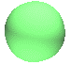 | / | / |  | /
class 1D-like (s- and d- hybrid orbitals, co-dominant) | 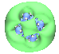 | 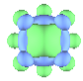 | 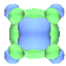 | 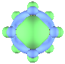 | 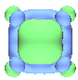
1D-like | 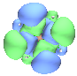 | 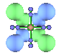 | 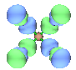 | 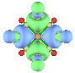 | 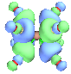
1D-like | 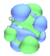 | 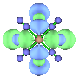 | 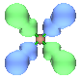 | 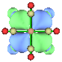 | 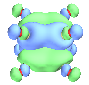
1D-like | 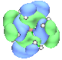 | 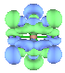 | 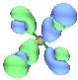 | 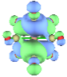 | 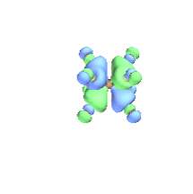
1D-like | 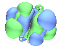 | 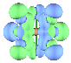 | 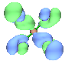 | 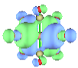 | 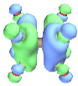
1P-like | 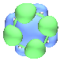 | 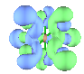 | 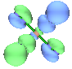 | 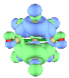 | 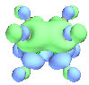
1P-like | 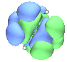 | 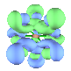 | 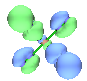 | 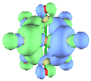 | 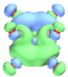
1P-like | 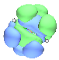 | 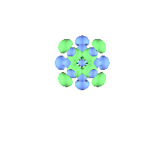 | 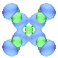 | 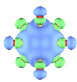 | 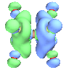
1S-like | 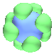 | 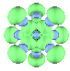 | 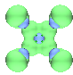 | 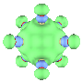 | 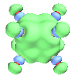

To further validate this theoretical framework, we investigated the Zr[NH₃]₈ complex, which also adopts the square antiprismatic (SAP, D_{4d}) geometry. Our calculations confirm that it exhibits the same characteristic: The A₁(d_{z}²) and A₁(s) orbitals undergo strong hybridization to form a stable σ-bonding state. This hybrid orbital, which we term a "class 1D-like orbital" in analogy to the 2S orbital in M[NH₃]₈, primarily exhibits S-orbital characteristics in its overall appearance, despite its mixed orbital. A key distinction for Zr[NH₃]₈, however, lies in the electronic structure of the Zr center (4d²5s²). The greater involvement of its d-orbitals in bonding results in the "class 1D-like orbital" possessing a higher d-orbital contribution compared to the alkaline earth analogues, though the hybrid orbital's dominant character remains S-type.
Subsequent calculations on Ca[N₂]₈ and Ca[CO]₈ complexes in both D_{4d} (SAP) and O_{h} symmetries reveal that these systems also adhere to the 18-electron rule. Notably, in these cases, the resulting electronic configurations exhibit more pronounced D-orbital characteristics. This series of findings strongly suggests that the 1S²1P⁶1D⁸2S² superatomic configuration is a general phenomenon arising from the interplay between the SAP geometry and the specific valence orbitals of the metal-ligand combination, rather than being exclusive to ammine complexes of alkaline earth metals.

Part 7 The charge, electron configurations and energy gaps of gas-phase and solvated M[NH₃]₈ complexes.
Table S5. Voronoi deformation density (VDD) atom populations and Hirshfeld atomic charges of M[NH₃]₈ in the gas phase, and the natural electronic configurations from NBO charge analysis.
Systems | Method | M | N (average) | Natural Electron Configuration
Ca[NH₃]₈ | VDD | 0.09 | -0.16 | Ca: 4s^{(1.81)}3d^{(0.44)}4p^{(0.45)}  N: 2s^{(1.47)}2p^{(4.58)}
Ca[NH₃]₈ | Hieshfeld | 0.14 | -0.20
Sr[NH₃]₈ | VDD | 0.08 | -0.16 | Sr: 5s^{(1.84)}4d^{(0.26)}5p^{(0.25)}  N: 2s^{(1.49)}2p^{(4.59)}
Sr[NH₃]₈ | Hieshfeld | 0.16 | -0.21
Ba[NH₃]₈ | VDD | 0.03 | -0.17 | Ba: 6s^{(1.82)}5d^{(0.25)}6p^{(0.16)}  N: 2s^{(1.50)}2p^{(4.60)}
Ba[NH₃]₈ | Hieshfeld | 0.16 | -0.23
Eu[NH₃]₈ | VDD | 0.05 | -0.16 | Eu: 6s^{(1.68)}4f^{(6.99)}5d^{(0.45)}6p^{(0.39)}  N: 2s^{(1.48)}2p^{(4.57)}
Eu[NH₃]₈ | Hieshfeld | 0.13 | -0.21
Yb[NH₃]₈ | VDD | 0.10 | -0.15 | Yb: 6s^{(1.82)}4f^{(13.99)}5d^{(0.53)}6p^{(0.42)}  N: 2s^{(1.47)}2p^{(4.58)}
Yb[NH₃]₈ | Hieshfeld | 0.15 | -0.20

Table S6. Voronoi deformation density (VDD) atom populations and Hirshfeld atomic charges of M²⁺[NH₃]₈ in solution, and the natural electronic configurations from NBO charge analysis.
Systems | Method | M | N (average) | Natural Electron Configuration
Ca²⁺[NH₃]₈ | VDD | 0.11 | -0.16 | Ca: 4S^{(0.20)}3d^{(0.44)}4p^{(0.46)}  N: 2S^{(1.45)}2p^{(4.57)}
Ca²⁺[NH₃]₈ | Hieshfeld | 0.31 | -0.18
Sr²⁺[NH₃]₈ | VDD | 0.12 | -0.16 | Sr: 5S^{(0.18)}4d^{(0.25)}5p^{(0.13)}  N: 2S^{(1.47)}2p^{(4.58)}
Sr²⁺[NH₃]₈ | Hieshfeld | 0.40 | -0.18
Ba²⁺[NH₃]₈ | VDD | 0.25 | -0.15 | Ba: 6S^{(0.11)}5d^{(0.16)}6p^{(0.52)}  N: 2S^{(1.49)}2p^{(4.60)}
Ba²⁺[NH₃]₈ | Hieshfeld | 0.64 | -0.19
Eu²⁺[NH₃]₈ | VDD | 0.10 | -0.16 | Eu: 6S^{(0.18)}4f^{(6.99)}5d^{(0.41)}6p^{(0.37)}  N: 2S^{(1.46)}2p^{(4.57)}
Eu²⁺[NH₃]₈ | Hieshfeld | 0.39 | -0.18
Yb²⁺[NH₃]₈ | VDD | 0.11 | -0.15 | Yb: 6S^{(0.20)}4f^{(13.99)}5d^{(0.52)}6p^{(0.43)}  N: 2S^{(1.44)}2p^{(4.57)}
Yb²⁺[NH₃]₈ | Hieshfeld | 0.32 | -0.17

Table S7. The energies of the lowest unoccupied molecular orbital (LUMO), the highest occupied molecular orbital (HOMO), and the frontier molecular orbital (HOMO-1) along with the corresponding energy gaps of M[NH₃]₈ in the gas phase.
Systems | LUMO (L) | HOMO (H) | HOMO-1 (H-1) | L–H gap | H–H-1 gap
Ca[NH₃]₈ | -0.58 | -2.61 | -9.89 | 2.03 | 7.28
Sr[NH₃]₈ | -0.65 | -2.59 | -10.06 | 1.94 | 7.47
Ba[NH₃]₈ | -0.75 | -2.54 | -10.02 | 1.79 | 7.48
Eu[NH₃]₈ (α) | -0.97 | -2.82 | -7.43 | 1.85 | 4.61
Eu[NH₃]₈ (β) | -0.96 | -2.79 | -10.09 | 1.83 | 7.30
Yb[NH₃]₈ | -0.63 | -2.63 | -6.90 | 2.00 | 4.27

Table S8. The energies of the lowest unoccupied molecular orbital (LUMO), the highest occupied molecular orbital (HOMO), and the frontier molecular orbital (HOMO-1) along with the corresponding energy gaps of M²⁺[NH₃]₈ in solution.
Systems | LUMO (L) | HOMO (H) | HOMO-1 (H-1) | L–H gap | H–H-1 gap
Ca²⁺[NH₃]₈ | 0.29 | -1.84 | -9.10 | 2.13 | 7.26
Sr²⁺[NH₃]₈ | 0.04 | -1.83 | -9.32 | 1.87 | 7.49
Ba²⁺[NH₃]₈ | 0.02 | -1.91 | -9.21 | 1.93 | 7.3
Eu[NH₃]₈ (α) | -0.11 | -2.05 | -6.79 | 1.94 | 4.74
Eu[NH₃]₈ (β) | -0.08 | -2.04 | -9.30 | 1.96 | 7.26
Yb²⁺[NH₃]₈ | 0.09 | -1.83 | -6.11 | 1.92 | 4.28

Part 8 Adiabatic ionization potential (AIP) of solvated M[NH₃]₈ complexes in different oxidation states.
Table S9. AIP for 2e⁻ and 3e⁻ oxidation and the total electron energy of the M[NH₃]₈, M²⁺[NH₃]₈, and M³⁺[NH₃]₈ complexes. Unit: eV.
Systems | E₀ (eV) | Systems | E_{(2e-)/(3e-)} (eV) | AIP = E_{(2e-)/(3e-)} – E₀ (eV)
Ca[NH₃]₈ | -30752.45 | Ca²⁺[NH₃]₈ | -30750.71 | 1.74
Ca[NH₃]₈ | -30752.45 | Ca³⁺[NH₃]₈ | -30744.26 | 8.19
Sr[NH₃]₈ | -13148.06 | Sr²⁺[NH₃]₈ | -13146.37 | 1.69
Sr[NH₃]₈ | -13148.06 | Sr³⁺[NH₃]₈ | -13139.92 | 8.14
Ba[NH₃]₈ | -13006.03 | Ba²⁺[NH₃]₈ | -13004.18 | 1.85
Ba[NH₃]₈ | -13006.03 | Ba³⁺[NH₃]₈ | / | /
Eu[NH₃]₈ | -31647.21 | Eu²⁺[NH₃]₈ | -31645.24 | 1.98
Eu[NH₃]₈ | -31647.21 | Eu³⁺[NH₃]₈ | -31641.25 | 5.96
Yb[NH₃]₈ | -43868.76 | Yb²⁺[NH₃]₈ | -43867.05 | 1.71
Yb[NH₃]₈ | -43868.76 | Yb³⁺[NH₃]₈ | -43864.76 | 4.00

All structures were fully optimized, and their energies were computed at the M06-2X/def2-TZVPP level of theory. The adiabatic ionization potentials were calculated as the energy difference between the optimized cationic species and the optimized neutral complex.
Here, E₀ represents the energy of the neutral species in its ground-state equilibrium geometry, and E_{(2e-)/(3e-)} represents the energy of the respective cation in its fully relaxed geometry after ionization. This adiabatic scheme accounts for the geometric reorganization energy following electron removal, providing a thermodynamically relevant measure of the ionization energy. All energies are reported in electron volts (eV).

Part 9 The solvated M[NH₃]_{m} complexes with different coordination numbers.
Table S10. The geometrical structure of solvated M[NH₃]_{m} complexes with different coordination numbers. m stands for coordination number (6-10).
System  m | Ca[NH₃]_{n} | Sr[NH₃]_{n} | Ba[NH₃]_{n} | Eu[NH₃]_{n} | Yb[NH₃]_{n}
6 | 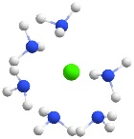 | 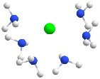 | 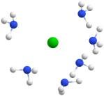 | 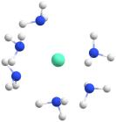 | 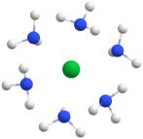
7 | 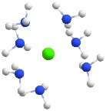 | 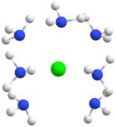 | / | 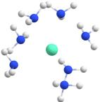 | 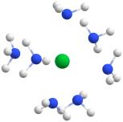
8 | 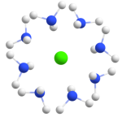 | 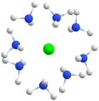 | 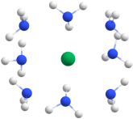 | 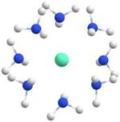 | 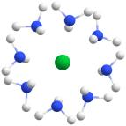
9 | 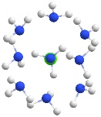 | 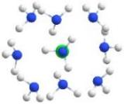 | 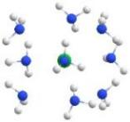 |  | 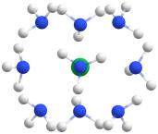
10 | 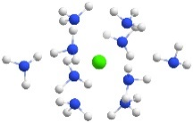 | 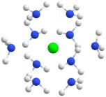 | 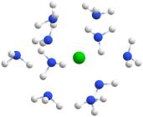 | 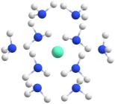 | 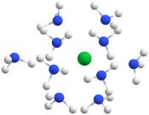

Table S11. The geometrical structure of solvated M²⁺[NH₃]_{m} complexes with different coordination numbers. m stands for coordination number (6-10).
System  m | Ca²⁺[NH₃]_{n} | Sr²⁺[NH₃]_{n} | Ba²⁺[NH₃]_{n} | Eu²⁺[NH₃]_{n} | Yb²⁺[NH₃]_{n}
6 | 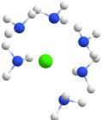 | 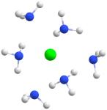 | 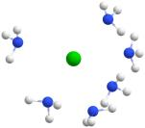 | 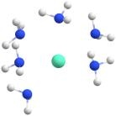 | 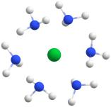
`7 | 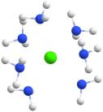 | 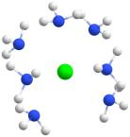 | 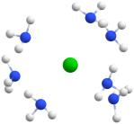 | 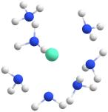 | 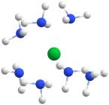
8 | 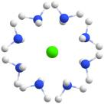 | 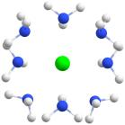 | 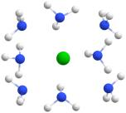 | 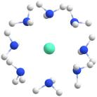 | 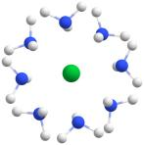
9 | 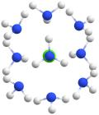 | 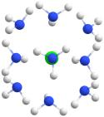 | 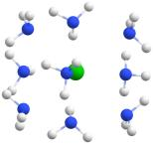 | 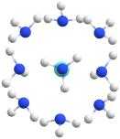 | 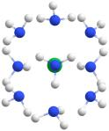
10 | 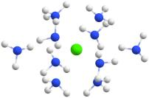 | 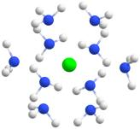 | 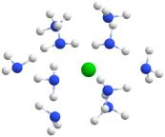 | / | 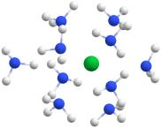

To determine the preferred coordination number under these conditions, we systematically explored the coordination landscapes for both neutral and divalent cationic complexes across a range of coordination number (m = 6–10). Based on a comprehensive analysis of the optimized geometries, we categorize the resulting structures into three distinct cases:
Under-coordination (m = 6–7): Structures in this regime are characterized by a clearly identifiable vacant space within the first coordination shell. The ligands do not fully occupy the spatial volume around the metal center, suggesting that the coordination sphere is incomplete and has a drive to incorporate additional ligands.
Optimal Coordination Window (m = 8–9): Structures with octa- or nona-coordination exhibit a uniform, near-symmetric distribution of ligands around the metal ion, resulting in a saturated first coordination shell. From a purely geometric perspective, it becomes challenging to discriminate between these two coordination numbers or to identify a definitive "most stable" structure based on geometry alone. Therefore, we preliminarily classify both as potentially stable configurations, warranting further energetic validation through potential energy surface (PES) scanning to elucidate the subtle stability landscape.
Over-coordination (m = 10): For the deca-coordinated species, the tenth ligand is distinctly displaced from the primary coordination shell. Its binding mode and position are indicative of a ligand residing in the second solvation sphere, confirming that the first shell's capacity has been exceeded. This classifies the structure as over-coordinated.

Part 10 The RDF diagrams of M²⁺[NH₃]₈ in the solution.
Figure S5. The RDF diagrams of M²⁺[NH₃]₈ in the liquid phase.

Part 11 The SAMOs of the solvated M²⁺[NH₃]₈ complexes.
Table S12. The SAMOs in solvated M²⁺[NH₃]₈ complexes. The orbital numbering (n) stands for the HOMO-n and their SAMOs are marked. For Eu[NH₃]₈, the spin-up (α) and spin-down (β) electrons orbitals are shown.
System  n | Ca²⁺[NH₃]₈ | Sr²⁺[NH₃]₈ | Ba²⁺[NH₃]₈ | Eu²⁺[NH₃]₈ α | Eu²⁺[NH₃]₈ β | Yb²⁺[NH₃]₈
LUMO | 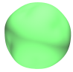 |  |  | 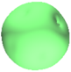 | 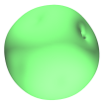 | 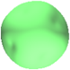
LUMO | 2S | 2S | 2S | 2S | 2S | 2S
0 | 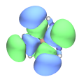 | 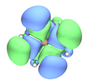 | 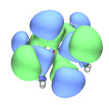 | 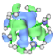 | 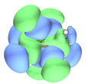 | 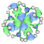
0 | 1D | 1D | 1D | 1F | 1D | 1F
1 | 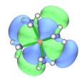 | 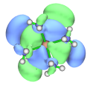 | 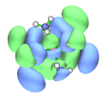 | 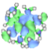 | 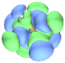 | 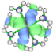
1 | 1D | 1D | 1D | 1F | 1D | 1F
2 | 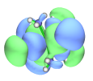 | 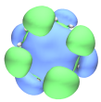 | 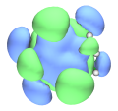 | 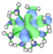 | 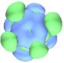 | 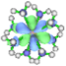
2 | 1D | 1P | 1P | 1F | 1D | 1F
3 | 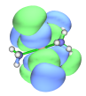 | 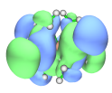 | 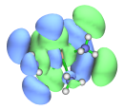 | 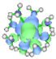 | 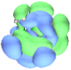 | 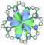
3 | 1D | 1D | 1P | 1F | 1D | 1F
4 | 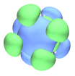 | 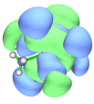 | 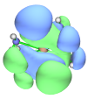 | 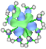 | 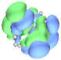 | 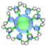
4 | 1P | 1D | 1P | 1F | 1D | 1F
5 | 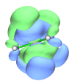 | 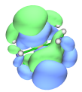 | 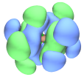 | 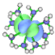 | 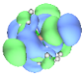 | 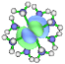
5 | 1P | 1P | 1D | 1F | 1P | 1F
6 | 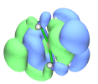 | 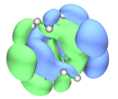 | 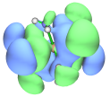 | 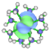 | 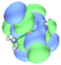 | 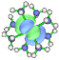
6 | 1P | 1P | 1D | 1F | 1P | 1F
System  n | Ca²⁺[NH₃]₈ | Sr²⁺[NH₃]₈ | Ba²⁺[NH₃]₈ | Eu²⁺[NH₃]₈ α | Eu²⁺[NH₃]₈ β | Yb²⁺[NH₃]₈
7 | 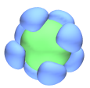 | 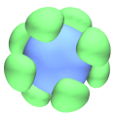 | 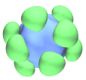 | 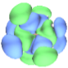 | 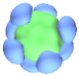 | 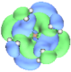
7 | 1S | 1S | 1S | 1D | 1P | 1D
8 | / |  |  | 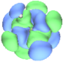 | / | 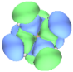
8 |  |  |  | 1D | / | 1D
9 |  |  |  | 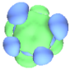 | / | 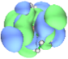
9 |  |  |  | 1P | / | 1D
10 |  |  |  | 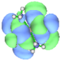 | / | 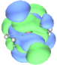
10 |  |  |  | 1D | / | 1D
11 |  |  |  | 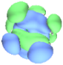 | / | 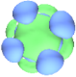
11 |  |  |  | 1P | / | 1P
12 |  |  |  | 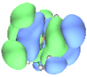 | / | 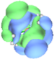
12 |  |  |  | 1P | / | 1P
13 |  |  |  | 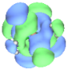 | / | 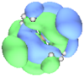
13 |  |  |  | 1D | / | 1P
14 |  |  |  | 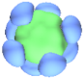 | / | 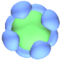
14 |  |  |  | 1S | / | 1S

Part 12 Side-by-side comparison of theoretical perspectives, representative systems, and applicability of different theory based on M[NH₃]₈ complexes.
The remarkable stability of M[NH₃]₈ complexes across gas, liquid, and solid phases raises fundamental questions regarding the adequacy of classical theories in coordination chemistry. LFT, while highly effective in describing d-orbital splitting in transition metal complexes, presumes a significant field-induced perturbation of d-orbital degeneracies—a condition largely absents in systems involving electropositive metals with filled or non-participating d- and f-shells. In our systems, the weak-field NH₃ ligands and the lack of crystal field-sensitive d electrons render LFT largely inapplicable. Molecular orbital theory (MOT), though more general in scope, struggles to account for the exceptional stability derived from shell-specific electron counts (e.g., 18-electron configuration) in the absence of classical bonding interactions. While MOT can reproduce the molecular orbital landscape, it offers limited physical intuition regarding phase-independent shell closure.
In contrast, the superatomic model provides a compelling framework to unify these observations. By conceptualizing the M[NH₃]₈ complexes as spherical quantum wells populated by delocalized metal-ligand hybrid orbitals (namely SAMOs), this model captures the essence of their electronic structure, namely, the occupation of discrete 1S, 1P, 1D, and 2S orbitals in a pseudo-atomic fashion. This approach not only rationalizes the observed 18-electron and 16-electron closed-shell configurations across various phases, but also explains the adaptive orbital rearrangement that preserves stability under solvation or crystallization. Notably, the persistence of SAMO-derived orbital patterns in the solid-state crystal lattice supports the view that these complexes function as “superatomic building blocks,” bridging molecular-scale coordination and bulk-phase robustness.

Table S13. Side-by-side comparison of theoretical perspectives, representative systems, and applicability of ligand field theory (LFT), molecular orbital theory (MOT), and superatomic model theory.

Feature  Dimension | Ligand Field Theory (LFT) | Molecular Orbital Theory (MOT) | Superatom model Theory
Fundamental Theory | The electrostatic and covalent electrons of the metal d orbital and the ligand electrons; Energy level splitting | Linear combination of atomic orbitals (LCAO); Construct local or whole-system molecular orbitals | The multi-center delocalized orbitals form atom-like orbital shells; Superatomic molecular orbital (SAMO)
Applicable Object | Transition metal complexes, especially partially filled d-orbital metallics (strong-field ligands) | Widely used for molecules, clusters | Metal clusters, superatomic clusters, non-d orbital dominated main group/lanthanide complex systems, etc.
Representative Systems | (Fe[CN]₆)³⁻, (Co[NH₃]₆)²⁺ | O₂, Benzene | (Al₁₃)⁻, Au₂₀, B₄₀, Ca[NH₃]₈, Sr[N₂]₈
Applicability to M[NH₃]₈ complexes | Not applicable, under the weak ligand field, there was no significant effect of d orbital involvement | It can describe some σ bonds, but it is difficult to explain the fully coordinated octa-coordination geometries and the stability resulting from specific electron counts. | Accurate characterization of 18-electron closed-shell (1S²1P⁶1D⁸2S²), revealing fundamental stabilization mechanisms across multiphases
Explanation of the Stability Sources | d orbital energy level filling makes it stable | Molecular orbital energy level energy gap and bonding-antibonding orbital energy gap | The "magic number" electronic closed-shell structure formed by the full occupancy of the shell
Phase Adaptability (Solid/Liquid/Gas) | It mainly describes the molecular state and is difficult to expand to the condensed state | Theoretically, it can be extended to condensed matter, but the physical correlation is weak | Suitable for three phases, it can explain the retention and stable intrinsic mechanism of SAMOs in solution and crystal
Physical Image | Energy level splitting diagram (a_{1g}/ e_{g}/ t_{1u}); Valence electron fill diagram | Molecular orbital energy level diagram; HOMO-LUMO orbital diagram | Orbital energy level diagram of shell (1S, 1P, 1D 1F…); SAMO diagram
Advantages and Disadvantages | Simple and intuitive, suitable for teaching; Only suitable for strong ligand field complexes | Universal, but it is difficult to explain the stability of collective behavior and magic number electronic rules | Higher-level requirements, applicable to new types of systems; The symmetry requirements are high, and the configuration of SAMO needs to be analyzed specifically

Part 13 References
1. Shannon RD. Revised effective ionic radii and systematic studies of interatomic distances in halides and chalcogenides. Acta Crystallogr, Sect A 32, 751-767 (1976).
2. McCarthy GJ. Divalent europium compounds in the systems Eu Mo O and Eu W O. Mater Res Bull 6, 31-39 (1971).
3. Albaqami MD, Ellis AM. Infrared spectroscopy of Ca(NH₃)_{n} complexes. Chem Phys Lett 706, 736-740 (2018).
4. Perdew JP, Burke K, Ernzerhof M. Generalized Gradient Approximation Made Simple. Phys Rev Lett 77, 3865-3868 (1996).
5. Zhao Y, Truhlar DG. The M06 suite of density functionals for main group thermochemistry, thermochemical kinetics, noncovalent interactions, excited states, and transition elements: two new functionals and systematic testing of four M06-class functionals and 12 other functionals. Theor Chem Acc 120, 215-241 (2008).
6. Tirado-Rives J, Jorgensen WL. Performance of B3LYP Density Functional Methods for a Large Set of Organic Molecules. J Chem Theory Comput 4, 297-306 (2008).
7. Chai JD, Head-Gordon M. Long-range corrected hybrid density functionals with damped atom-atom dispersion corrections. Phys Chem Chem Phys 10, 6615-6620 (2008).
8. Tao J, Perdew JP, Staroverov VN, et al. Climbing the Density Functional Ladder: Nonempirical Meta-Generalized Gradient Approximation Designed for Molecules and Solids. Phys Rev Lett 91, 146401 (2003).

