Supplementary
Table 5: Sensitivity analysis: CRRT Circuit Lifespan limited to 0-72 hours
Primary outcome | Integration | Separation | p-value
Intention-to-treat
Total circuit lifespan (h), | N=40 | N=40
Median (IQR) | 72 (45-72) | 70.5 (44.5-72) | 0.80
Total circuit lifespan* (h) | N=29 | N=31
Median (IQR) | 72 (43-72) | 72 (60-72) | 0.42
As-treated
Total circuit lifespan (h), | N=48 | N=32
Median (IQR) | 72 (48-72) | 70 (43.5-72) | 0.58
Total circuit lifespan* (h) | N=38 | N=22
Median (IQR) | 72 (47-72) | 72 (49-72) | 0.70
Sensitivity analysis: Circuit lifespans exceeding 72 hours were replaced with a maximum value of 72 hours to align with manufacturer recommendations.
*Patients who experienced death before the first circuit reached 72 hours, renal recovery leading to CRRT termination, or ECMO discontinuation were excluded.
h = hour

Table 6: Subgroup analysis of CRRT circuit lifespan in regional citrate anticoagulation use, ECMO types and centers
 | Subgroup | Median (IQR) |  | P-value
 | Subgroup | Integration | Separation | P-value
 | Subgroup by Citrate use
 | Citrate use (n=24) | n=13 | n=11
 | A) Total Circuit lifespan, h | 92 (72-120) | 69 (60-113) | 0.31
 | B) Circuit lifespan*, h | 120 (72-120) | 87.5 (68.5-115.5) | 0.23
 | Non-citrate use (n=56) | n=27 | n=29
 | A) Total circuit lifespan, h | 72 (30-82) | 72 (43-72) | 0.85
 | B) Circuit lifespan*, h | 58.2 (30-72) | 72 (45-72) | 0.50
 | Subgroup by center
 | CCIT (n=20) | n=9 | n=11
 | A) Total circuit lifespan, h | 61.3 (26-72) | 72 (44-72) | 0.75
 | B) Circuit lifespan*, h | 61.3 (26-72) | 72 (49-72) | 0.56
 | KCMH (n=60) | n=31 | n=29
 | A) Total circuit lifespan, h | 72 (47-103) | 68 (45-94) | 0.48
 | B) Circuit lifespan*, h | 72 (43-120) | 72 (60-99) | 0.81
Subgroup by ECMO type
VV ECMO (n=13) |  | n=8 | n=5
A) Total circuit lifespan, h |  | 72 (72-106) | 72 (68-98) | 0.61
B) Circuit lifespan*, h |  | 72 (72-106) | 70 (53-86) | 0.36
VA ECMO (n=67) |  | n=32 | n=35
A) Total circuit lifespan, h |  | 72 (37-97) | 69 (44-83) | 0.84
B) Circuit lifespan*, h |  | 61.3 (30-72) | 72(60-88) | 0.22
*Patients who experienced death before the first circuit reached 72 hours, renal recovery leading to CRRT termination, or ECMO discontinuation were excluded. Data was presented as median (IQR)
CCIT: Central Chest Institute of Thailand, h = hour, KCMH = King Chulalongkorn Memorial Hospital

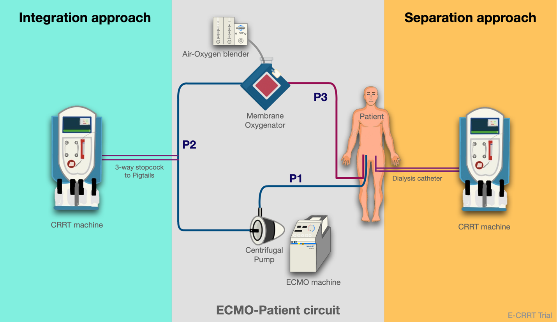
Figure 5: The circuit connection method, with the left side (in green) showing the circuit connected to P2 (integration technique), and the right side (in yellow) showing the circuit connected directly to the patient via a hemodialysis catheter (separation technique).

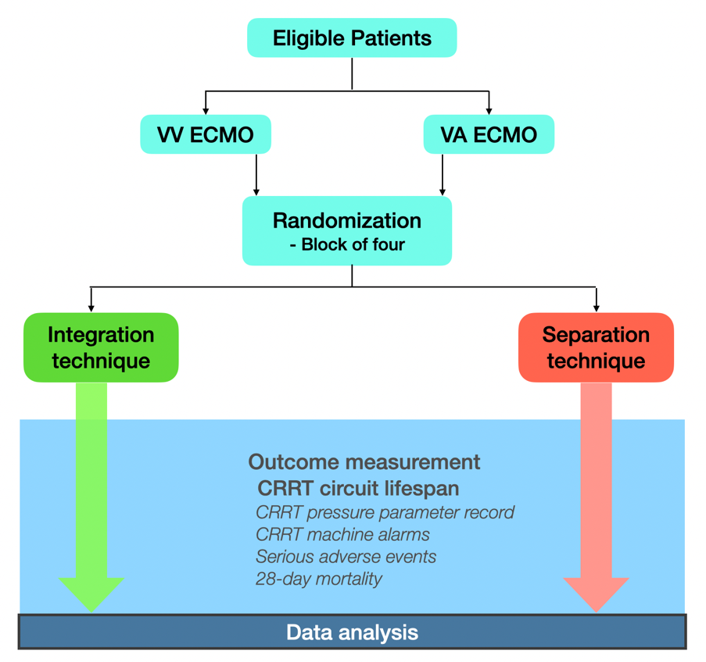
Figure 6: Flow chart of study protocol

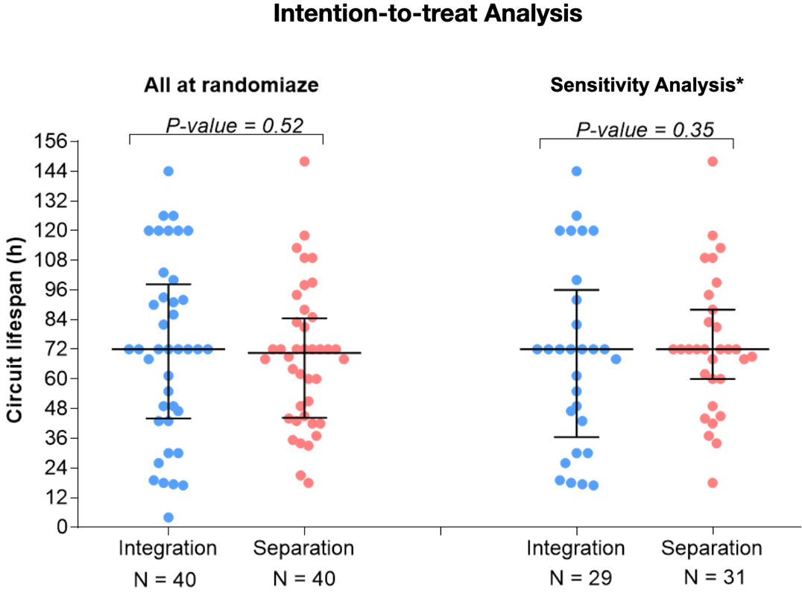
Figure 7: Scatter plot with median and interquartile range (IQR) illustrating circuit lifespan in the intention-to-treat analysis * *Patients who experienced death before the first circuit reached 72 hours, renal recovery leading to CRRT termination, or ECMO discontinuation were excluded.

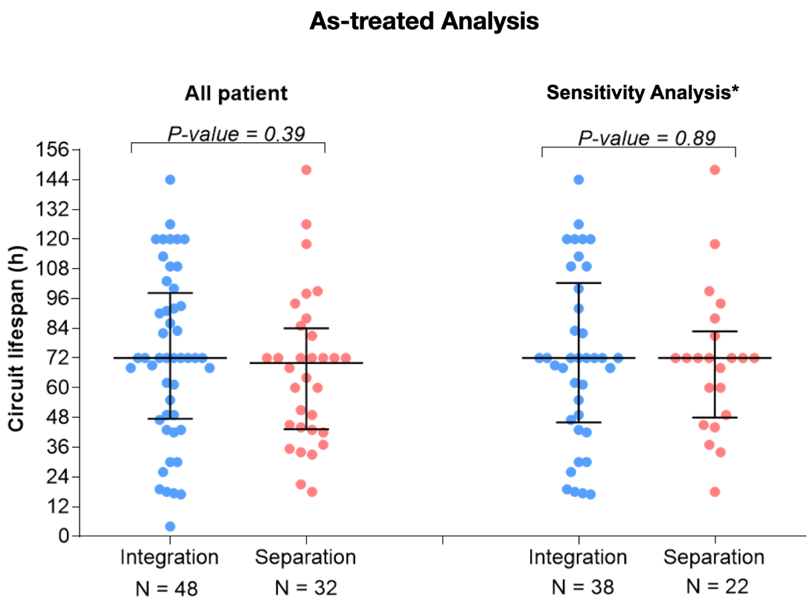
Figure 8. Scatter plot with median and interquartile range (IQR) illustrating circuit lifespan in the as-treated analysis.* *Patients who experienced death before the first circuit reached 72 hours, renal recovery leading to CRRT termination, or ECMO discontinuation were excluded.

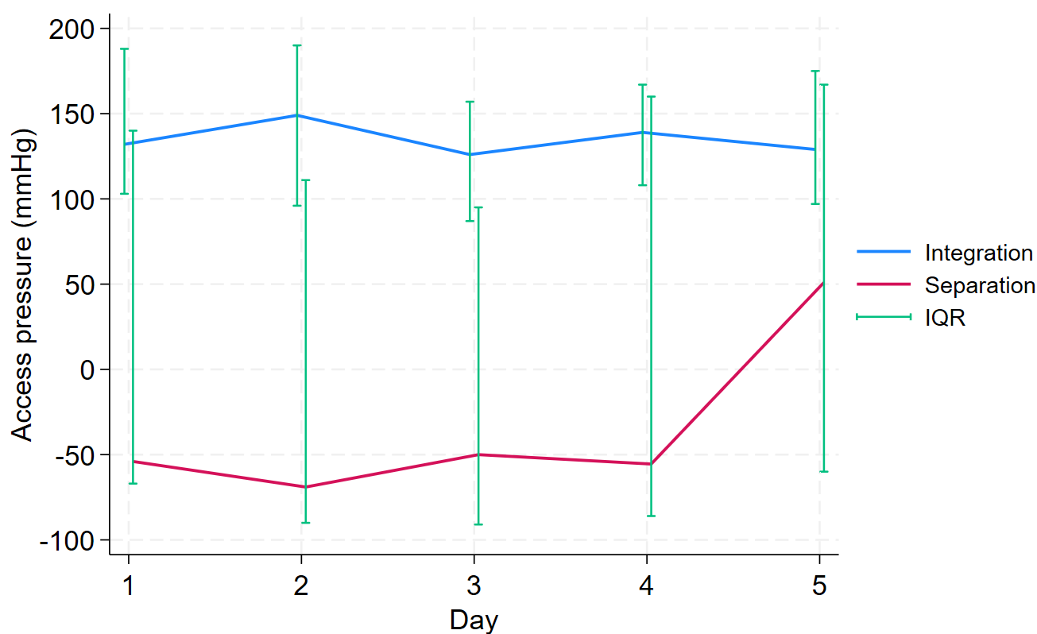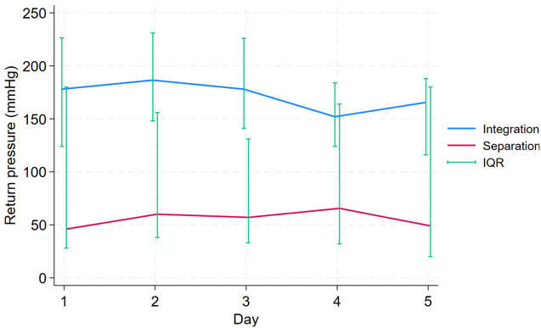

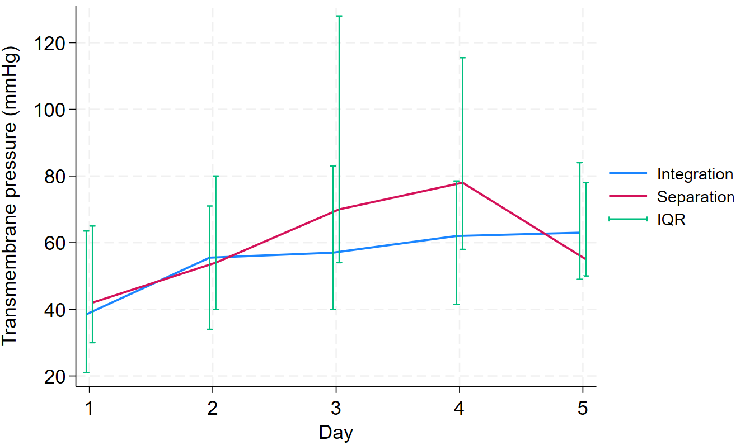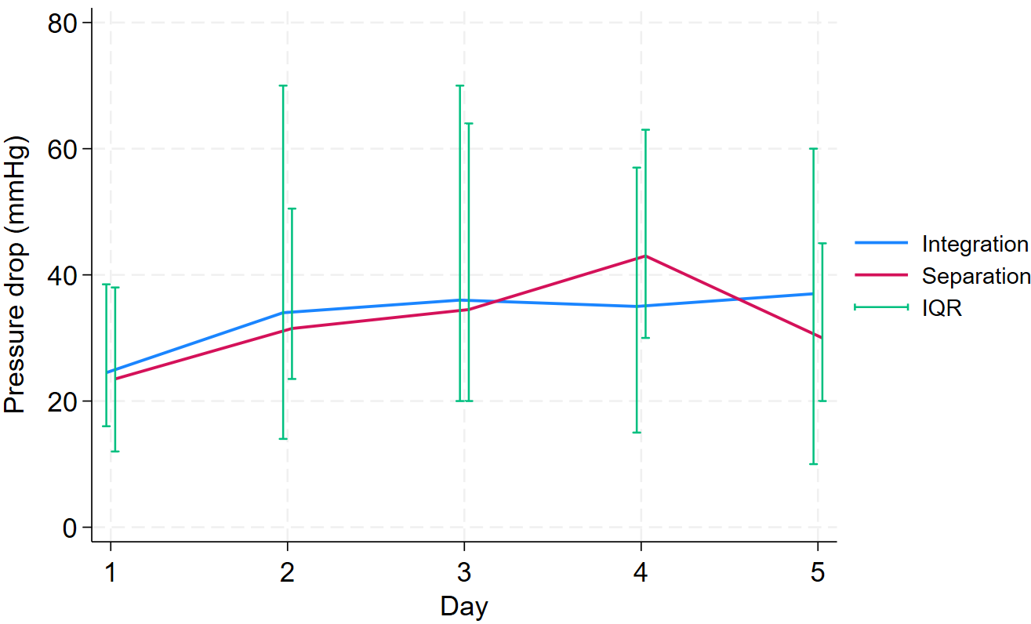

Figure 9. Daily median values and interquartile ranges (IQR) of access pressure, return pressure, transmembrane pressure, and pressure drop across the CRRT circuit in both the integration and the separation groups.

1. Holt AW, Bierer P, Bersten AD, Bury LK, Vedig AE. Continuous renal replacement therapy in critically ill patients: monitoring circuit function. Anaesth Intensive Care. 1996;24(4):423-9.

