Supplementary files
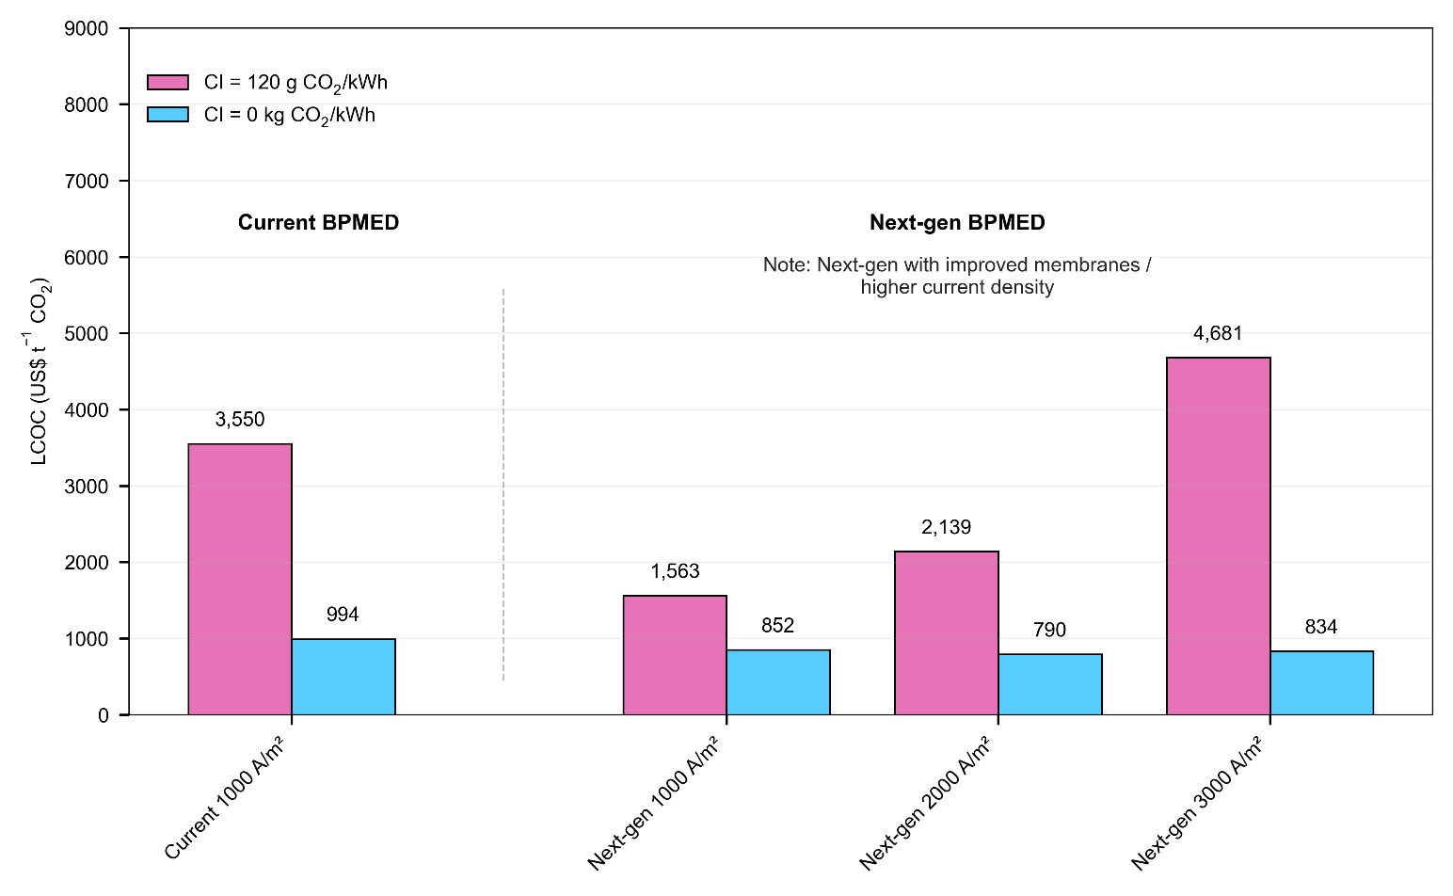

Supplementary Figure S1 | Impacts of Carbon Intensity (gCO₂ kWh⁻¹) and Current Density (Am⁻²) on LCOC for Current vs. Next-Generation BPMED Configurations
In Fig S1, electrochemical performance and electricity carbon intensity jointly exert a dominant influence on the near-term costs of tailings-based carbon mineralization. Under current BPMED configurations, reliance on carbon-intensive grids leads to high removal costs and limited net-negativity, whereas access to zero-carbon electricity reduces the levelized cost of carbon removal (LCOC) by more than 70%. These results highlight a critical temporal coupling: technological deployment must coincide with electricity decarbonization to ensure environmental integrity and cost competitiveness.
Next-generation BPMED membranes unlock further cost reductions by improving ion transport and reducing stack size, but only within an optimal performance window. Increasing current density enhances throughput but also elevates electrical losses, leading to significant cost escalation on fossil-dominated grids. When powered by clean electricity, however, advanced BPMED enables LCOC values below US$900 tCO₂⁻¹, a tenfold improvement relative to first-of-a-kind conditions. Coordinated investment in electrochemical innovation and low-carbon power systems is therefore essential to transform BPMED from a cost bottleneck into a key accelerator of scalable, permanent carbon removal.

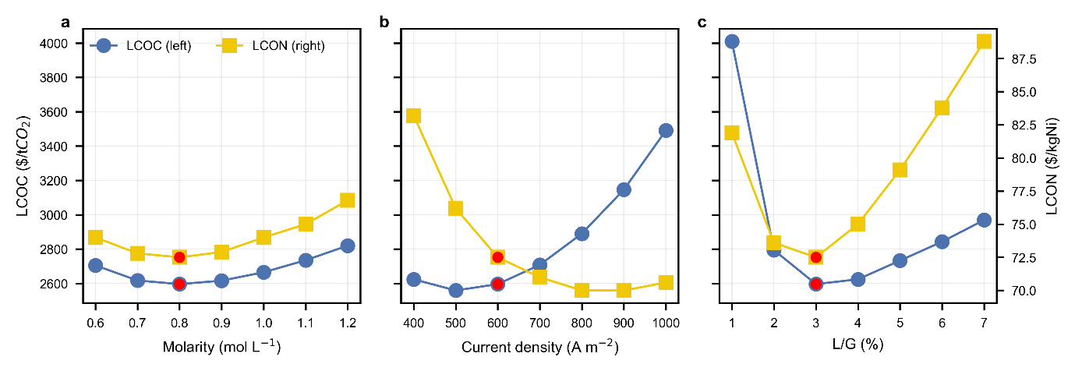Supplementary Figure S2 | Optimization of process design parameters: acid molarity in heap leaching, current density in BPMED, and liquid–gas ratio in the air contactor. Red markers indicate nominal base-case values.
Supplementary Figure S2 illustrates the joint techno-economic response of the system to variation in three key operational parameters: acid molarity (panel a), BPMED current density (panel b), and liquid-to-gas (L/G) ratio in the air contactor (panel c). In all cases, both the levelized cost of carbon removal (LCOC) and the levelized cost of nickel (LCON) display U-shaped trends, reflecting the competing physical and economic drivers embedded in the process design. Lower-than-optimal values constrain either dissolution kinetics, electrochemical throughput, or CO₂ uptake, resulting in insufficient Mg extraction and reduced nickel recovery efficiency. Conversely, aggressive operational intensification amplifies solvent regeneration and electrical losses, raising cost and emissions as the system departs from net-negative operation.
The techno-economic optima occur consistently in a narrow region around the selected base-case conditions (red markers): ~0.8 mol L⁻¹ acid molarity, ~600 A m⁻² current density, and 2–3% L/G ratio. These conditions balance extraction performance with manageable BPMED regeneration energy demand and CO₂ capture efficiency. Small deviations from these ranges lead to simultaneous increases in both LCOC and LCON, demonstrating the importance of coupled control rather than single-variable optimization. These results collectively reinforce the need for precise operating control, monitoring of solvent and energy balances, and adaptive process tuning to preserve cost-effective net-negative performance across deployment scales.

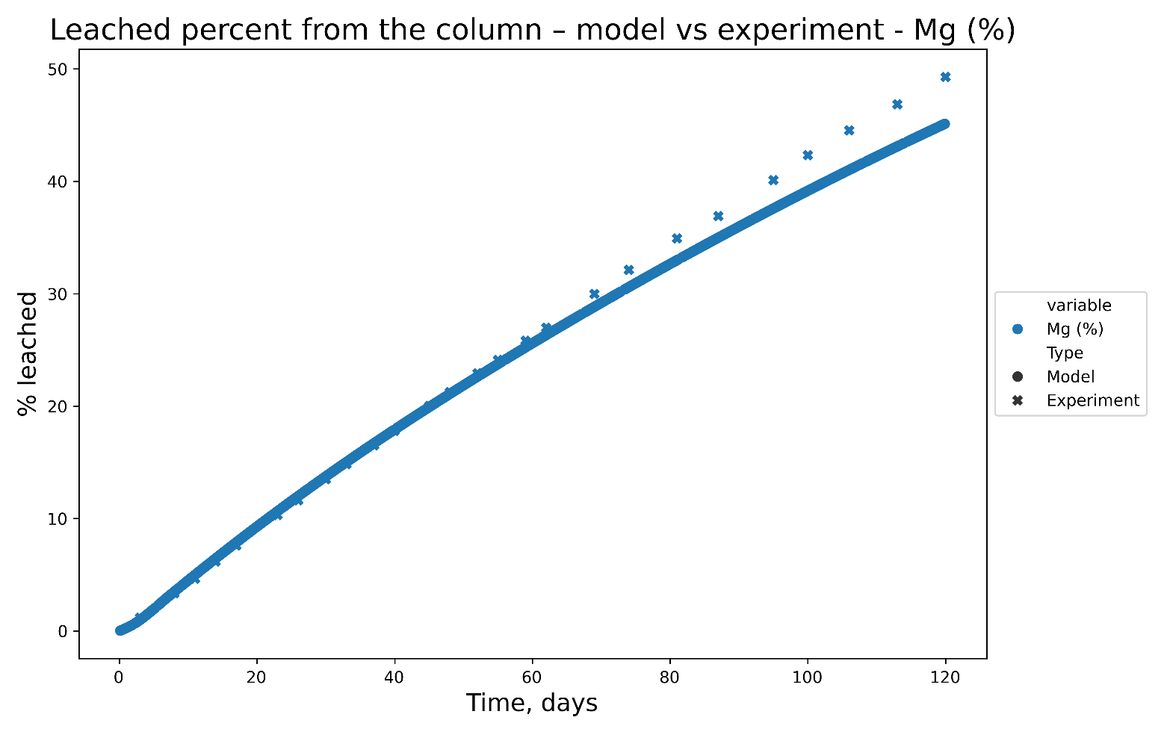

Supplementary Figure S3 | A comparison between Mg Leached, as a percentage of the initial rock, for both the model results (represented by circles) and experimental results (represented by crosses). The normalised root mean square error (when normalised to the mean) when comparing these two studies was 6.04 wt.%.
The initial rock composition of the experimental and modelled solutions differed by 1%, as the initial rock composition for the modelled solution was calculated from mineralogical model input (e.g. mineral proportions and mineral chemistry) while the total Mg from chemical analysis was used as initial rock composition in the original. More details describing the method and a comparison can be found in Supporting Information S1.

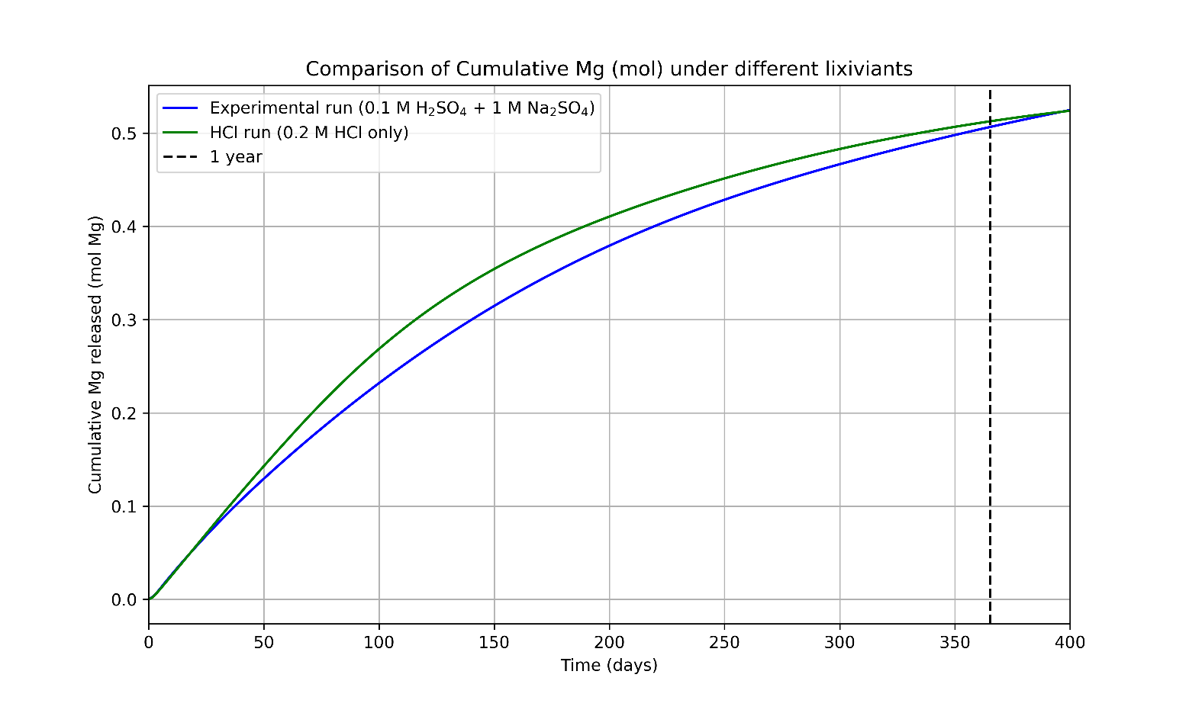

Supplementary Figure S4 | Graph comparing model simulations using 1 M H₂SO₄ + 1 M Na₂SO₄ (used in experiments and initial model simulations) with 0.2 M HCl (used for TEA analysis). After 365.25 days of leaching, the percentage difference between the two simulations, with the two lixiviants, is 1.4%.

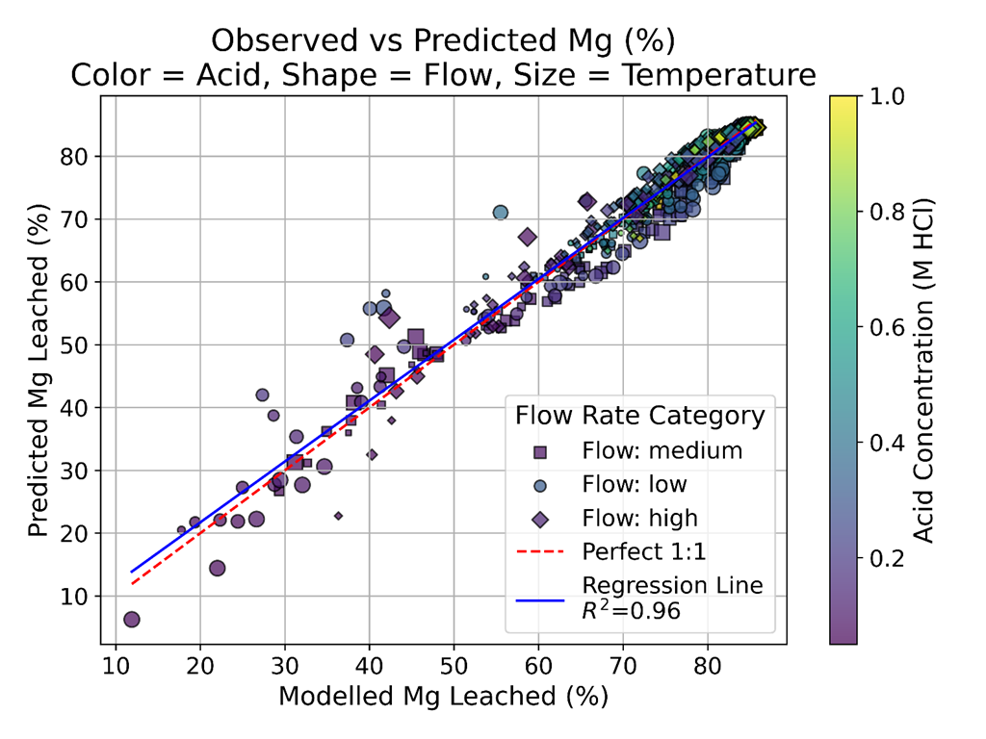

Supplementary Figure S5 | Comparison between the Modelled Mg leached (from reactive transport modelling) against Predicted Mg leached (from the surrogacy model) for each simulation ran using the reactive transport model described in Methods section and Supporting file S1. Fits are reasonable, with an r² of 0.96. Flow rate is grouped into low (1.09e⁻⁷ – 3.07e⁻⁷)), medium (3.07e⁻⁷ – 5.03e⁻⁷) and fast (5.03e⁻⁷ - 7.00e⁻⁷), to make the graph clearer.

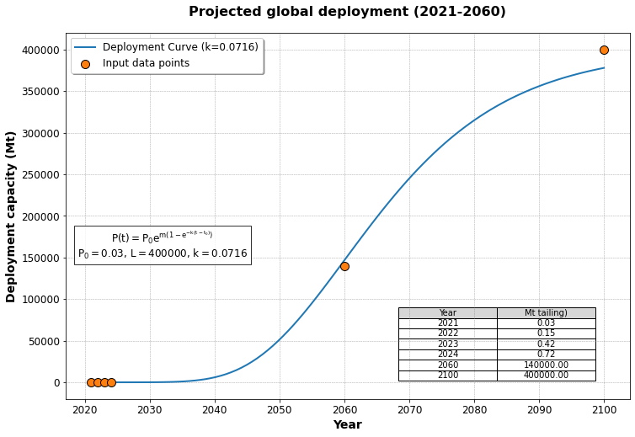

Supplementary Figure S6 | Projected global deployment capacity based on ex-situ mineralization project and fitted into Gompertz function (known data points are ex-situ mineralization purchase data from CDR.fyi accessed by December 2024)¹.
In the figure, $P_{0}$ represents the initial equivalent carbon mineralization capacity in 2021, based on an assumed carbonation ratio of 1 tonne CO₂ per 4 tonnes of tailings. The parameter $L=400 Gt (gigatonnes tailings)$ corresponds to the projected maximum cumulative carbon mineralization capacity by year 2100 - equivalent to the total tailings treatment potential - assuming an average of 1 Gt CO₂/year from 2025 to 2060, and 1.6 Gt CO₂/year from 2060 to 2100 ^{2–4}.

Supplementary Table S1 | Mass balance data of the integrated process as shown on Fig.1 in the main manuscript.
Line no. (Fig.1) | Description | Value in t d⁻¹
1 | Tailings treatment capacity | 100
2 | Ferrihydrite (solid) ${Fe}_{(1-y)}{Ni}_{y}{(OH)}_{3}$ | 18
3 | Aqueous iron (II) FeCl₂ | 1.2
4 | Ni production | 0.46
5 | Total leachate | 1598
6 | Mass of dilute acid solution for leaching | 2600
7 | Mass of concentrate base outlet | 2664
8 | Mass of output brine | 2479
9 | CM_solvent out _total | 4213
10 | NF_reject_out | 843
11 | NF_permeate_out | 3370
12 | IX_reject_out | 58
13 | IX_permeate_out | 5791
14 | RO_reject_out | 1158
15 | ROl_permeate_out | 4633
16 | Total_water_add | 1884
17 | Make-up water for acid tank | 2543
18 | Make-up water for base tank | 2610
19 | Pure_salt_add | 82
20 | Neutralization base solution | 437
21 | Mass of base solution for carbonation | 2174
22 | Excess base production | 63
23 | Air mass | 72475
24 | Total contactor solvent out | 2206
25 | Total leachate after neutralization | 2035
26 | Total Mass of precipitate | 28

Supplementary Table S2 | Complete input variables for cost estimation and sensitivity analysis
Base, low, and high values were applied in local and global sensitivity analyses. σ corresponds to the standard deviation of the input distribution used in Monte Carlo simulations (1,000 samples). Learning rates (LR) and equivalent starting capacities C_min are included for scale-up modelling.
Subsections | Item | unit | base | low | high | σ | LR |  | Equivalent starting capacity C_min (Mt tailings)
 |  |  |  |  |  |  | Capital cost | O&M cost*** | Current capacity | C_min
Heap leaching | Treatment capacity | t/day | 100 | 50 | 200 | 25 | 1%-5%^{5,6} | 1%-5% | 30 Mt tailings | 30
Heap leaching | temperature | ℃ | 20 | 10 | 30 | 3.3
Heap leaching | Excess acid ratio | % | 20 | 10 | 30 | 0.03
Heap leaching | Molarity of acid | mol/L | 0.8 | 0.4 | 1.5 | 0.18
Heap leaching | Nickel percent* | % | 1.5 | 0.5 | 2.5 | 0.3
Nickel recovery | Physical removal** | % | 80 | 60 | 95 | 6 | 18% | 2%-10% | 0.033 Mt tailings | 0.033
Nickel recovery | Nickel recovery | % | 80 | 60 | 95 | 6
BPMED | Current density | A/m² | 600 | 300 | 1000 | 117 | 15%⁷ | 2%-10% | $ 356 million market size | 3.7
Air contactor | L/G ratio | % | 3 | 1 | 5 | 1 | 5% – 10%⁶ | 0%-10% | 59ktone CO₂/yr | 0.2
Carbon mineralization | C/Mg ratio of | - | 0.8 | 0.4 | 1 | 0.1 | 10%-15%^{5,8–11} | 2%–10% | 200k tonne CO₂ | 0.8
Carbon mineralization | Carbonation rate | % | 50 | 30 | 80 | 0.08
Brine recycling | Salt rejection rate of nanofiltration | % | 15 | 5 | 25 | 3 | 1-5%¹² | 1%-5% | 34.8 billion tonnes brine treatment | 1148
MRV |  |  |  |  |  |  | 15% | 2%-10% |  | 0.8
Economics | Membrane price | $/m² | 700 | 200 | 1200 | 167
Economics | Electricity price | $/MWh | 60 | 20 | 90 | 12
Economics | Waste/sediment treatment fee | $/t | 0.5 | 0.1 | 1 | 0.2
Economics | Nickel price | $/kg | 20 | 5 | 50 | 8
Economics | CO₂ price | $/t | 720 | 285 | 1500 | 203
Economics | Base price (NaOH) | $/t | 100 | 50 | 300 | 42
Economics | Magnesium Carbonate Price | $/kg | 0.1 | 0.05 | 0.2 | 0.03
Economics | Make-up water price | $/m³ | 0.2 | 0.1 | 0.5 | 0.07
Economics | Discount rate | % | 5 | 2 | 5 | 0.01
Economics | MRV cost share | % | 7 | 1 | 13 | 0.02
Carbon | Carbon intensity of electricity | gCO₂/kWh | 120 | 0 | 500 | 83
Carbon | Carbon intensity of water | gCO₂/t | 500 | 100 | 1000 | 150
*Nickel mass percent in serpentine
** Physical removal percent of laterites from the reacted ore
*** Excludes fixed OPEX that is calculated as a percentage of CAPEX and decreases as CAPEX declines.
For global deployment projections, we apply optimized design variables, including tailings treatment capacity, excess acid ratio in heap leaching, acid molarity from bipolar membrane electrodialysis (BPMED), and the liquid-to-gas ratio of the air contactor. Region-specific parameters include temperature, electricity price, CO₂ price, electricity and water carbon intensities, nickel demand, location factor, installation factor and labor cost. Uncertainty is characterized through Monte Carlo simulations (1,000 samples per variable), covering feedstock and process performance (nickel content in serpentine, physical removal efficiency, nickel recovery, current density, C/Mg ratio, Mg reaction rate), techno-economic factors (membrane price, waste/sediment treatment fee, nickel price, NaOH price, magnesium carbonate price, make-up water price, nanofiltration salt rejection rate, discount rate), and monitoring, reporting, and verification (MRV) share.
Equivalent starting capacity C_min applied in the hybrid cost curve.
Heap leaching is well established process that ramp up to steady state production. Global Nickel laterite heap leaching has been demonstrated over the past 10–20 years on a large scale by almost all major mining companies and several juniors¹³.
The global Bipolar Membranes market is projected to be $ 356.2 million in 2024, with estimated NaOH production cost of $118-310 per ton NaOH^{14,15}, using theoretical solid-liquid ratio of 1mol serpentine (tailings): 6 mol HCl (then NaOH), with serpentine molecular weight of 287 g mol⁻¹, the equivalent tailings capacity for BPMED is 3.7 million tonnes tailings.
Nickel extraction through Fe(II)-catalysed recrystallization has been demonstrated at lab scale¹⁶ and its application with artificial laterites is still under the proof of concept at the time of writing (as part of the research project).
It is estimated that the CO₂ capture capacity by DAC is 59ktone CO₂ yr⁻¹ ¹⁷; based on the FOAK scald of 33kt tailings/8365 tonne CO₂ capture, the equivalent tailings capacity for DAC is 0.2million tonnes tailings.
Global mineralization capacity by the end of 2024 is 200k tonne CO₂ (based on mineralization purchased from CDR.fyi. Based on the FOAK scald of 33kt tailings/8365 tonne CO₂ capture, the equivalent tailings treatment capacity could be 0.8 million tonne tailings.
The worldwide brine desalination capacity is estimated to be 34.8 billion tone by 2019¹⁸; Based on the FOAK case with 1million tonne brine/33ktonne tailings, the equivalent tailings treatment capacity is 33*34.8*1000/1000 = 1148 million tonne tailings.
The equivalent tailing treatment capacity of MRV could be estimated close to the carbon mineralization capacity, which is around 0.8 million tonne tailings.

Supplementary Table S3 | Summary of mineralogy and formula used in the reactive transport model, as reported in Wang et al., (2025), and measured surface area, as reported in Turvey et al., (in prep). Methods stating how these data were collected are found in Supporting Information. The weighted pattern residual (Rpw) for the mineralogy fit to raw data was 6.3.
Mineralogy | wt.% | Formula
Serpentine | 53.5 | Mg_{2.9795}Ni_{0.0205}Si₂O₅(OH)₄
Forsterite | 18.4 | Mg₂SiO₄
Magnetite | 8.9 | Fe₃O₄
Dolomite | 1.1 | CaMg(CO₃)₂
Magnesite | 0.51 | MgCO₃
Amphibole | 6.2 | Ca_{1.7}Fe_{0.1}K_{0.14}Mg_{4.985}Na_{0.29}Si₈O₂₂(OH)
Brucite | 1.2 | Mg(OH)₂
Calcite | 0.3 | CaCO₃
Chlorite | 6.8 | Mg_{3.75}Fe²⁺_{1.25}Si₃Al₂O₁₀(OH)₈
Talc | 3.2 | Mg₃Si₄O₁₀(OH)₂
Surface Area | 8.67 m² g⁻¹

Supplementary Table S4 | Regional nickel production shares, ore-type proportions, and maximum tailing capacities. Values are adapted from ^{19,20}, percentages not rounded to 100% since regions with share <5% are excluded.
Region | Nickel production share (%) | Sulphide ore share (%) | Laterite ore share (%) | Maximum tailings capacity (Mt)
CAZ | 22.4 | 52 | 48 | 4,648
SA | 19.2 | 75 | 25 | 4,524
EA | 25.2 | 0 | 100 | 3,648
CSA | 14.2 | 3 | 97 | 2,104
RUS | 8.4 | 86 | 14 | 2,088
EUR | 4.8 | 50 | 50 | 812
Abbreviations: CAZ = Canada, Australia & New Zealand; SA = South Africa; EA = Emerging Asia (Indonesia, Philippines); CSA = Central and South America; RUS = Russia; EUR = Europe.

Supplementary Table S5 | Regional Nickel production (background information as supporting information)
Table S5. Nickel production prediction following IAM_SSP2EU-PkBudg500, Million tonne year ⁻¹
Year | CAZ | SA | EA | RUS | CSA | EUR
2024 | 1.0 | 1.0 | 0.5 | 0.5 | 0.3 | 0.2
2025 | 1.0 | 1.0 | 0.6 | 0.5 | 0.3 | 0.2
2026 | 1.0 | 1.1 | 0.6 | 0.5 | 0.3 | 0.2
2027 | 1.0 | 1.1 | 0.6 | 0.5 | 0.4 | 0.2
2028 | 1.1 | 1.1 | 0.6 | 0.5 | 0.4 | 0.2
2029 | 1.1 | 1.2 | 0.6 | 0.6 | 0.4 | 0.2
2030 | 1.2 | 1.2 | 0.7 | 0.6 | 0.4 | 0.2
2031 | 1.2 | 1.2 | 0.7 | 0.6 | 0.4 | 0.2
2032 | 1.2 | 1.3 | 0.7 | 0.6 | 0.4 | 0.2
2033 | 1.3 | 1.3 | 0.7 | 0.6 | 0.4 | 0.2
2034 | 1.3 | 1.4 | 0.7 | 0.7 | 0.4 | 0.2
2035 | 1.4 | 1.4 | 0.8 | 0.7 | 0.5 | 0.2
2036 | 1.4 | 1.5 | 0.8 | 0.7 | 0.5 | 0.3
2037 | 1.4 | 1.5 | 0.8 | 0.7 | 0.5 | 0.3
2038 | 1.5 | 1.6 | 0.9 | 0.7 | 0.5 | 0.3
2039 | 1.5 | 1.6 | 0.9 | 0.8 | 0.5 | 0.3
2040 | 1.6 | 1.7 | 0.9 | 0.8 | 0.5 | 0.3
2041 | 1.6 | 1.7 | 0.9 | 0.8 | 0.6 | 0.3
2042 | 1.7 | 1.8 | 1.0 | 0.8 | 0.6 | 0.3
2043 | 1.8 | 1.8 | 1.0 | 0.9 | 0.6 | 0.3
2044 | 1.8 | 1.9 | 1.0 | 0.9 | 0.6 | 0.3
2045 | 1.9 | 2.0 | 1.1 | 0.9 | 0.6 | 0.3
2046 | 1.9 | 2.0 | 1.1 | 1.0 | 0.7 | 0.4
2047 | 2.0 | 2.1 | 1.2 | 1.0 | 0.7 | 0.4
2048 | 2.1 | 2.2 | 1.2 | 1.0 | 0.7 | 0.4
2049 | 2.2 | 2.3 | 1.2 | 1.1 | 0.7 | 0.4
2050 | 2.2 | 2.3 | 1.3 | 1.1 | 0.8 | 0.4
2051 | 2.3 | 2.4 | 1.3 | 1.1 | 0.8 | 0.4
2052 | 2.4 | 2.5 | 1.4 | 1.2 | 0.8 | 0.4
2053 | 2.5 | 2.6 | 1.4 | 1.2 | 0.8 | 0.5
2054 | 2.5 | 2.7 | 1.5 | 1.3 | 0.9 | 0.5
2055 | 2.6 | 2.7 | 1.5 | 1.3 | 0.9 | 0.5
2056 | 2.7 | 2.8 | 1.6 | 1.3 | 0.9 | 0.5
2057 | 2.8 | 2.9 | 1.6 | 1.4 | 1.0 | 0.5
2058 | 2.9 | 3.0 | 1.7 | 1.4 | 1.0 | 0.5
2059 | 3.0 | 3.1 | 1.7 | 1.5 | 1.0 | 0.5
2060 | 3.1 | 3.2 | 1.8 | 1.5 | 1.0 | 0.6

Supplementary Table S6 | Carbon intensity of electricity of the selected regions (background information as supporting information)
Table S6. Carbon intensity of electricity prediction following IAM_SSP2EU-PkBudg500, gCO² kWh⁻¹
Year | CAZ | SA | EA | CSA | RUS | EUR
2024 | 99 | 282 | 245 | 75.9 | 210 | 105
2025 | 92 | 266 | 232 | 70.0 | 199 | 97
2026 | 84 | 250 | 220 | 64.5 | 189 | 89
2027 | 77 | 236 | 208 | 59.3 | 179 | 82
2028 | 71 | 222 | 197 | 54.4 | 170 | 75
2029 | 65 | 209 | 186 | 49.7 | 160 | 69
2030 | 59 | 196 | 176 | 45.4 | 152 | 63
2031 | 54 | 184 | 166 | 41.2 | 143 | 58
2032 | 49 | 173 | 157 | 37.3 | 135 | 53
2033 | 44 | 162 | 148 | 33.6 | 127 | 48
2034 | 40 | 151 | 139 | 30.1 | 120 | 43
2035 | 36 | 141 | 131 | 26.8 | 112 | 39
2036 | 32 | 132 | 123 | 23.7 | 105 | 35
2037 | 28 | 123 | 115 | 20.7 | 98 | 31
2038 | 25 | 114 | 108 | 18.0 | 92 | 28
2039 | 22 | 106 | 100 | 15.3 | 86 | 25
2040 | 19 | 98 | 94 | 12.9 | 80 | 22
2041 | 16 | 91 | 87 | 10.5 | 74 | 19
2042 | 13 | 84 | 81 | 8.3 | 68 | 16
2043 | 11 | 77 | 75 | 6.2 | 63 | 13
2044 | 9 | 70 | 69 | 4.2 | 58 | 11
2045 | 6 | 64 | 64 | 2.4 | 53 | 9
2046 | 4 | 58 | 59 | 0.6 | 48 | 7
2047 | 3 | 53 | 54 | -1.1 | 43 | 5
2048 | 1 | 47 | 49 | -2.6 | 39 | 3
2049 | -1 | 42 | 44 | -4.1 | 35 | 1
2050 | -2 | 37 | 40 | -5.5 | 31 | -1
2051 | -4 | 33 | 35 | -6.8 | 27 | -2
2052 | -5 | 28 | 31 | -8.1 | 23 | -3
2053 | -6 | 24 | 27 | -9.3 | 19 | -5
2054 | -8 | 20 | 24 | -10.4 | 16 | -6
2055 | -9 | 16 | 20 | -11.5 | 12 | -7
2056 | -10 | 13 | 17 | -12.4 | 9 | -8
2057 | -11 | 9 | 13 | -13.4 | 6 | -9
2058 | -12 | 6 | 10 | -14.3 | 3 | -10
2059 | -13 | 3 | 7 | -15.1 | 0 | -11
2060 | -13 | 0 | 4 | -15.9 | -3 | -12

Supplementary Table S7 | Carbon price of the selected regions
Table S7. CO₂ price prediction following IAM_SSP2EU-PkBudg500, $ t⁻¹CO₂
Year | CAZ | SA | EA | CSA | RUS | EUR
2024 | 138 | 16 | 61 | 83 | 87 | 143
2025 | 151 | 20 | 69 | 92 | 97 | 156
2026 | 166 | 26 | 78 | 102 | 107 | 170
2027 | 181 | 32 | 88 | 113 | 119 | 184
2028 | 197 | 40 | 99 | 125 | 132 | 199
2029 | 214 | 49 | 110 | 137 | 145 | 215
2030 | 232 | 59 | 123 | 150 | 159 | 231
2031 | 249 | 71 | 136 | 165 | 174 | 247
2032 | 268 | 84 | 151 | 179 | 190 | 265
2033 | 286 | 99 | 166 | 195 | 207 | 282
2034 | 305 | 115 | 182 | 211 | 224 | 300
2035 | 324 | 133 | 199 | 228 | 242 | 318
2036 | 343 | 152 | 217 | 246 | 261 | 336
2037 | 361 | 172 | 236 | 264 | 279 | 354
2038 | 380 | 193 | 255 | 282 | 298 | 372
2039 | 398 | 215 | 274 | 301 | 318 | 389
2040 | 415 | 238 | 294 | 320 | 337 | 406
2041 | 432 | 261 | 314 | 339 | 356 | 423
2042 | 449 | 285 | 334 | 358 | 375 | 440
2043 | 465 | 308 | 354 | 376 | 394 | 456
2044 | 480 | 331 | 373 | 395 | 413 | 471
2045 | 495 | 354 | 393 | 413 | 431 | 486
2046 | 509 | 377 | 412 | 431 | 448 | 500
2047 | 522 | 399 | 431 | 448 | 465 | 514
2048 | 534 | 420 | 449 | 465 | 481 | 526
2049 | 546 | 441 | 466 | 481 | 497 | 538
2050 | 556 | 460 | 483 | 497 | 512 | 550
2051 | 567 | 479 | 499 | 512 | 526 | 560
2052 | 576 | 497 | 514 | 526 | 539 | 570
2053 | 585 | 513 | 529 | 539 | 552 | 580
2054 | 593 | 529 | 542 | 551 | 564 | 588
2055 | 600 | 544 | 555 | 563 | 575 | 596
2056 | 607 | 558 | 567 | 574 | 585 | 604
2057 | 614 | 570 | 579 | 585 | 595 | 611
2058 | 620 | 582 | 589 | 594 | 604 | 617
2059 | 625 | 593 | 599 | 603 | 612 | 623
2060 | 630 | 604 | 608 | 612 | 619 | 628

Supplementary Table S8 | Electricity price of the selected regions
Table S8. Electricity price prediction following IAM_SSP2EU-PkBudg500, $ MWh⁻¹
year | CAZ | SA | EA | CSA | RUS | EUR
2024 | 48 | 29 | 43 | 24 | 32 | 53
2025 | 48 | 31 | 46 | 24 | 36 | 56
2026 | 47 | 33 | 47 | 26 | 37 | 55
2027 | 47 | 35 | 49 | 29 | 39 | 55
2028 | 46 | 37 | 50 | 31 | 41 | 55
2029 | 45 | 39 | 52 | 33 | 43 | 54
2030 | 44 | 42 | 53 | 35 | 45 | 54
2031 | 42 | 41 | 51 | 35 | 43 | 52
2032 | 40 | 41 | 49 | 35 | 42 | 50
2033 | 39 | 41 | 47 | 35 | 41 | 48
2034 | 37 | 40 | 45 | 35 | 39 | 46
2035 | 35 | 40 | 43 | 35 | 38 | 44
2036 | 34 | 39 | 41 | 33 | 37 | 44
2037 | 33 | 37 | 39 | 32 | 35 | 43
2038 | 33 | 36 | 37 | 31 | 34 | 42
2039 | 32 | 34 | 35 | 30 | 33 | 41
2040 | 31 | 32 | 33 | 29 | 31 | 40
2041 | 31 | 31 | 32 | 28 | 31 | 39
2042 | 30 | 30 | 31 | 27 | 30 | 39
2043 | 30 | 29 | 30 | 27 | 30 | 38
2044 | 29 | 28 | 29 | 26 | 29 | 38
2045 | 29 | 27 | 28 | 26 | 28 | 37
2046 | 28 | 27 | 28 | 26 | 28 | 37
2047 | 28 | 26 | 28 | 26 | 28 | 37
2048 | 28 | 26 | 28 | 26 | 28 | 37
2049 | 28 | 26 | 28 | 26 | 28 | 37
2050 | 28 | 26 | 28 | 26 | 28 | 37
2051 | 28 | 26 | 28 | 26 | 28 | 38
2052 | 28 | 26 | 29 | 27 | 28 | 38
2053 | 28 | 27 | 29 | 27 | 28 | 38
2054 | 27 | 27 | 30 | 27 | 28 | 39
2055 | 27 | 28 | 30 | 28 | 28 | 39
2056 | 27 | 28 | 30 | 28 | 28 | 39
2057 | 27 | 28 | 30 | 28 | 28 | 39
2058 | 27 | 29 | 30 | 28 | 28 | 39
2059 | 27 | 29 | 30 | 28 | 29 | 39
2060 | 26 | 29 | 31 | 28 | 29 | 39

Supplementary Table S9 | Electricity generation capacity of the selected regions
Table S9. Electricity generation capacity prediction following IAM_SSP2EU-PkBudg500, Ej year⁻¹
year | CAZ | SA | EA | CSA | RUS | EUR
2024 | 3.2 | 1.9 | 7.9 | 5.7 | 4.8 | 12.3
2025 | 3.2 | 1.9 | 8.3 | 5.8 | 4.8 | 12.4
2026 | 3.4 | 2.2 | 9.0 | 6.3 | 4.8 | 12.8
2027 | 3.5 | 2.4 | 9.7 | 6.8 | 4.9 | 13.2
2028 | 3.6 | 2.7 | 10.4 | 7.3 | 4.9 | 13.6
2029 | 3.8 | 3.0 | 11.1 | 7.8 | 5.0 | 14.0
2030 | 3.9 | 3.2 | 11.8 | 8.3 | 5.0 | 14.3
2031 | 4.0 | 3.6 | 12.6 | 8.9 | 5.1 | 14.8
2032 | 4.1 | 4.1 | 13.4 | 9.5 | 5.2 | 15.3
2033 | 4.2 | 4.5 | 14.3 | 10.1 | 5.3 | 15.7
2034 | 4.3 | 4.9 | 15.1 | 10.8 | 5.4 | 16.2
2035 | 4.5 | 5.3 | 16.0 | 11.4 | 5.6 | 16.6
2036 | 4.5 | 6.0 | 17.0 | 11.9 | 5.7 | 17.0
2037 | 4.6 | 6.7 | 17.9 | 12.5 | 5.9 | 17.4
2038 | 4.7 | 7.3 | 18.9 | 13.0 | 6.1 | 17.8
2039 | 4.8 | 8.0 | 19.9 | 13.6 | 6.2 | 18.2
2040 | 4.9 | 8.6 | 20.9 | 14.1 | 6.4 | 18.5
2041 | 4.9 | 9.6 | 22.2 | 14.5 | 6.6 | 18.9
2042 | 5.0 | 10.6 | 23.4 | 15.0 | 6.8 | 19.3
2043 | 5.0 | 11.6 | 24.6 | 15.4 | 7.1 | 19.6
2044 | 5.1 | 12.6 | 25.8 | 15.8 | 7.3 | 20.0
2045 | 5.2 | 13.5 | 27.1 | 16.3 | 7.5 | 20.4
2046 | 5.2 | 14.9 | 28.5 | 16.7 | 7.7 | 20.7
2047 | 5.2 | 16.3 | 29.9 | 17.1 | 7.9 | 21.1
2048 | 5.2 | 17.7 | 31.4 | 17.5 | 8.1 | 21.5
2049 | 5.3 | 19.1 | 32.8 | 17.9 | 8.3 | 21.9
2050 | 5.3 | 20.5 | 34.2 | 18.3 | 8.4 | 22.3
2051 | 5.3 | 22.4 | 35.9 | 18.7 | 8.6 | 22.6
2052 | 5.4 | 24.3 | 37.5 | 19.1 | 8.7 | 23.0
2053 | 5.4 | 26.2 | 39.1 | 19.5 | 8.9 | 23.4
2054 | 5.5 | 28.2 | 40.8 | 19.9 | 9.0 | 23.7
2055 | 5.5 | 30.1 | 42.4 | 20.2 | 9.2 | 24.1
2056 | 5.6 | 32.3 | 44.1 | 20.6 | 9.3 | 24.4
2057 | 5.6 | 34.5 | 45.8 | 21.0 | 9.4 | 24.7
2058 | 5.6 | 36.7 | 47.5 | 21.3 | 9.6 | 25.0
2059 | 5.7 | 38.9 | 49.2 | 21.7 | 9.7 | 25.3
2060 | 5.7 | 41.1 | 50.9 | 22.1 | 9.8 | 25.6

Supplementary Information | Reactive-transport model simulations (RTM) in PHREEQC, full model specification
The 1D-reactive transport model (RTM) used to derive a function for the Mg-leaching percent was programmed in PHREEQC (Parkhurst & Appelo, 2013). The RTM simulated the: (1) flow of acid (2) dissolution of an ultramafic mine tailing (UMT) and (3) precipitation of secondary phases over one year of reaction. Each simulation was subjected to a range of temperatures, acid concentrations and flow rates, as described in the methodology.
Time and space steps were optimised using the courant number, based on a given flow rate. Then, the ratio of rock:solution was calculated from the residence time of the solution in a given cell, and the acid density (to account forhigh concentration acids). During each time step, the program kinetically dissolved the mine tailings, and thermodynamically precipitated secondary phases if saturation was reached (phase dependent; between a saturation index of 0 and 0.5). The column was assumed to be at equilibrium with atmospheric CO₂ and O₂ conditions.
The dissolution of mineral phases within the UMT was simulated kinetically, with mineral dissolution rates programmed using a modified dissolution rate equation from Palandri & Kharaka (2004):
$$\frac{dm}{dt}=-SA∙\left[\begin{aligned}A_{acid}e^{\frac{-E_{acid}}{RT}}∙a_{H^{+}}^{n_{acid}}∙\left(1-SR\right) \\ +A_{neutral}e^{\frac{-E_{neutral}}{RT}}∙\left(1-SR\right) \\ +A_{base}{Ae}^{\frac{-E_{base}}{RT}}∙a_{H^{+}}^{n_{base}}∙\left(1-SR\right)\end{aligned}\right]$$
Where m is the number of moles of the mineral, t is time (in seconds, s), SA is the surface area of a mineral, A is the pre-exponential factor (the rate constant) of the acid, neutral and base dissolution mechanism, E is the activation energy of the acid, neutral and base dissolution mechanism, R is the gas constant for water (8.31, J mol⁻¹ K⁻¹), T is the temperature in Kelvin, K, a is the ion activity of hydrogen (H⁺), n is the reaction order for the acid, neutral and base dissolution mechanism, and SR is the saturation ratio.
The mineral kinetic constants were sourced from the Kinec_v3.dat database (Oelkers & Addassi (2025)). Saturation ratios were calculated internally through the model using thermodynamic data from LLNL.dat. Reversible dissolution/precipitation of Ferrihydrite, Schwermannite, Jarosite, and amorphous SiO₂ and Al(OH)₃ were simulated thermodynamically via chemical equilibria predictions, where a saturation index of 0 (0.5 for amorphous SiO₂ and Fe(OH)₃) initiated precipitation. Calcite precipitation was also simulated via equilibrium dynamics, however, dissolution from calcite in the host rock was simulated kinetically using data from the Kinec_v3.dat database (Oelkers & Addassi, 2025). All thermodynamic data required to simulate dissolution/precipitation were sourced from the LLNL.dat database (Parkhurst & Appelo, 2013), with the exception of amorphous SiO₂ and Al(OH)₃ which were sourced from PHREEQC.dat, and Schwertmannite and Calcite which were both sourced from the Thermoddem database (Blanc, 2017).
Rock mineralogy was determined from X-ray diffraction measurements. Carbonate concentrations were recalculated from coulometry data, and the mineralogy was renormalised to 100 wt.%. The mineralogy used in the model is reported in Supplementary Table S3.
The mineral chemistry of the minerals was optimised manually by combining whole-rock chemical assay data with the mineral stochiometric limits defined by the Handbook of Mineralogy (Anthony et al., 2002). Good fits between measured Mg wt.% (23.6 wt.%, from the rock assay) and calculated Mg wt.% (23.9 wt.%, from the mineral chemistry optimisation) were observed, with a difference of 1%.
Mineral surface area was attributed across the mineral phases as a function of the three parameters noted above, with the addition of the “mineral surface roughness factor”, as defined in McBride, in prep.
More detailed RTM coding files could be provided upon request.

References
1. CDRfyi. CDR.fyi_Leaderboards. https://www.cdr.fyi/leaderboards (2025).
2. Renforth, P. The negative emission potential of alkaline materials. Nat Commun 10, 1401 (2019).
3. IEAGHG. Mineral Carbonation using Mine Tailings – A Strategic Overview of Potential and Opportunities, 2022-10, July 2022. (2022).
4. Kelemen, P. B. et al. Engineered carbon mineralization in ultramafic rocks for CO2 removal from air: Review and new insights. Chemical Geology 550, 119628 (2020).
5. Faber, G. et al. Adapting Technology Learning Curves for Prospective Techno-Economic and Life Cycle Assessments of Emerging Carbon Capture and Utilization Pathways. Frontiers in Climate 4, (2022).
6. Roussanaly, S. et al. Towards Improved Guidelines for Cost Evaluation of Carbon Capture and Storage. None, 1779820 https://www.osti.gov/servlets/purl/1779820/ (2021) doi:10.2172/1779820.
7. Captura. Innovations and Cost Reductions in Direct Ocean Capture. https://capturacorp.com/wp-content/uploads/2024/08/DOC-innovations-and-cost-reductions.pdf (2024).
8. Breyer, C., Fasihi, M., Bajamundi, C. & Creutzig, F. Direct Air Capture of CO2: A Key Technology for Ambitious Climate Change Mitigation. Joule 3, 2053–2057 (2019).
9. McQueen, N. et al. A review of direct air capture (DAC): scaling up commercial technologies and innovating for the future. Prog. Energy 3, 032001 (2021).
10. Sievert, K., Schmidt, T. S. & Steffen, B. Considering technology characteristics to project future costs of direct air capture. Joule 8, 979–999 (2024).
11. Young, J. et al. The cost of direct air capture and storage can be reduced via strategic deployment but is unlikely to fall below stated cost targets. One Earth 6, 899–917 (2023).
12. Caldera, U. & Breyer, C. Learning Curve for Seawater Reverse Osmosis Desalination Plants: Capital Cost Trend of the Past, Present, and Future. Water Resources Research 53, 10523–10538 (2017).
13. Oxley, A., Smith, M. E. & Caceres, O. Why heap leach nickel laterites? Minerals Engineering 88, 53–60 (2016).
14. Valuates Reports. Bipolar Membranes Market, Report Size, Worth, Revenue, Growth, Industry Value, Share 2024. Valuates Reports https://reports.valuates.com/market-reports/QYRE-Auto-32U2344/global-bipolar-membranes (2024).
15. Virruso, G. et al. Multi-scale modelling of an electrodialysis with bipolar membranes pilot plant and economic evaluation of its potential. Desalination 583, 117724 (2024).
16. Frierdich, A. J., McBride, A., Tomkinson, S. & Southall, S. C. Nickel Cycling and Negative Feedback on Fe(II)-Catalyzed Recrystallization of Goethite. ACS Earth Space Chem. 3, 1932–1941 (2019).
17. Allied offsets. Tracking Global DAC Deployments. https://blog.alliedoffsets.com/tracking-global-dac-deployments (2024).
18. Jones, E., Qadir, M., van Vliet, M. T. H., Smakhtin, V. & Kang, S. The state of desalination and brine production: A global outlook. Science of The Total Environment 657, 1343–1356 (2019).
19. David, R. R. Strategic Materials and Energy Transition: Nickel. Energy Industry Review https://energyindustryreview.com/metals-mining/strategic-materials-and-energy-transition-nickel/ (2022).
20. Mudd, G. M. & Jowitt, S. M. The New Century for Nickel Resources, Reserves, and Mining: Reassessing the Sustainability of the Devil’s Metal. Economic Geology 117, 1961–1983 (2022).

