Supporting Information
A Universal Multi-source Fusion Acceleration Sensor for Vibration Monitoring in Irregular Space

Junbin Yu^{1,2}, Tie Li¹, Junfei Lin², Juanhong Zhao², Qin Li², Jian He², Jiliang Mu², Ting Zhang¹* and Xiujian Chou²*

¹i-Lab, Nano-X Vacuum Interconnected Workstation, Key Laboratory of Multifunction Nanomaterials and Smart Systems, Suzhou Institute of Nano-Tech and Nano-Bionics (SINANO), Chinese Academy of Sciences (CAS), Suzhou 215123, the People's Republic of China
²Science and Technology on Electronic Test and Measurement Laboratory, School of Instrument and Electronics, North University of China, Taiyuan 030051, the People's Republic of China
E-mail: tzhang2009@sinano.ac.cn, chouxiujian@nuc.edu.cn

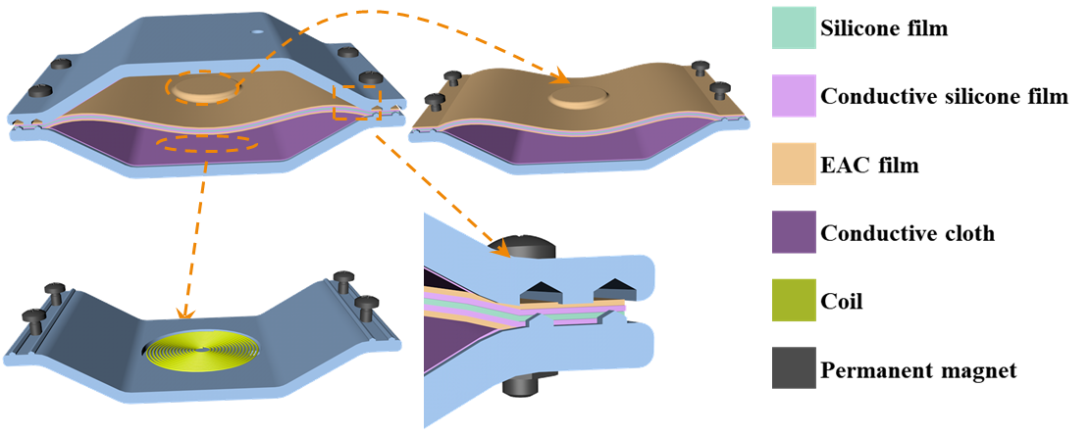
Figure S1. Detailed structural diagram of the MFSAS.

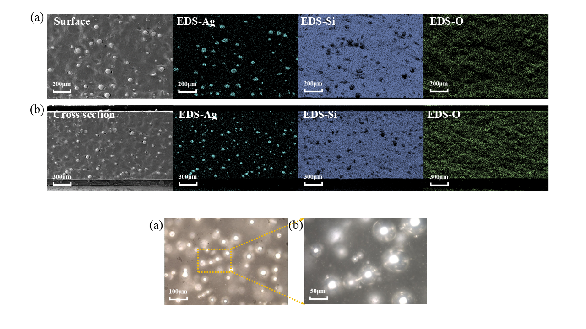
Figure S2. (a-b) Confocal microscopy images of the EAC film and its local enlarged views.

Figure S3. (a) Surface SEM image of the EAC film with low-content silver-coated glass microspheres and EDS maps of Ag and Si elements. (b) Cross-section surface images of the EAC film with low-content silver-coated glass microspheres and EDS maps of Ag and Si elements.

Figure S4. Thress kinds of sensors with different heights (the internal angles of the honeycomb structure are 140°, 150° and 160° respectively).

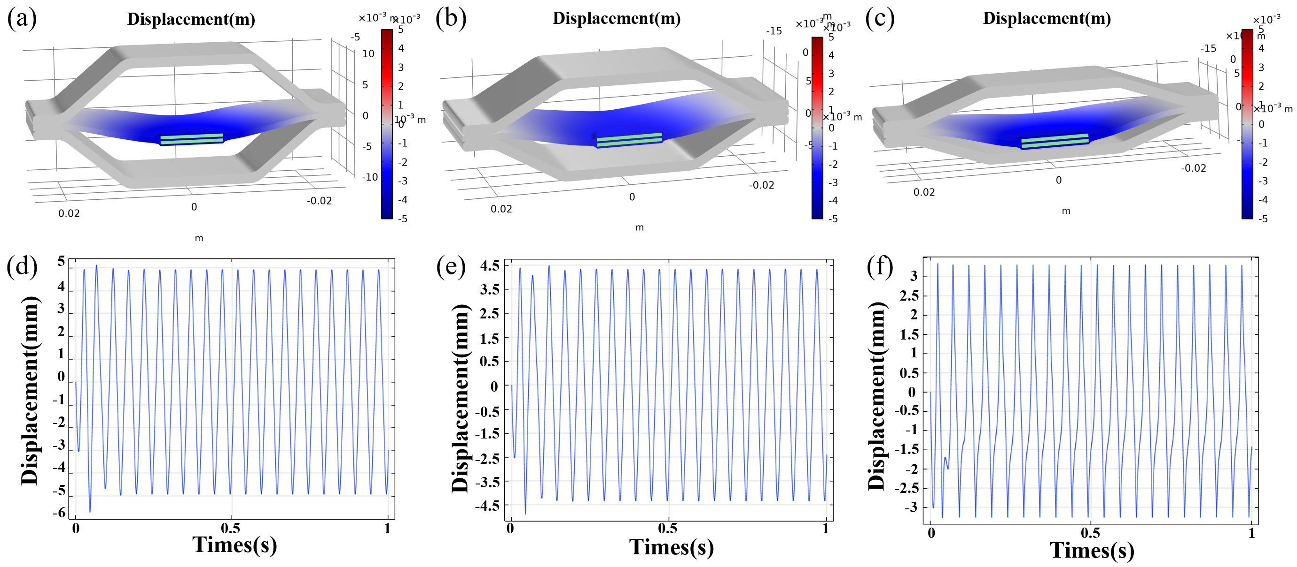
Figure S5. (a-c) Schematic diagrams of the three MFSAS structures operating under an acceleration of 60 m/s², and (d-e) the corresponding displacement simulations of the vibration capturing layer.

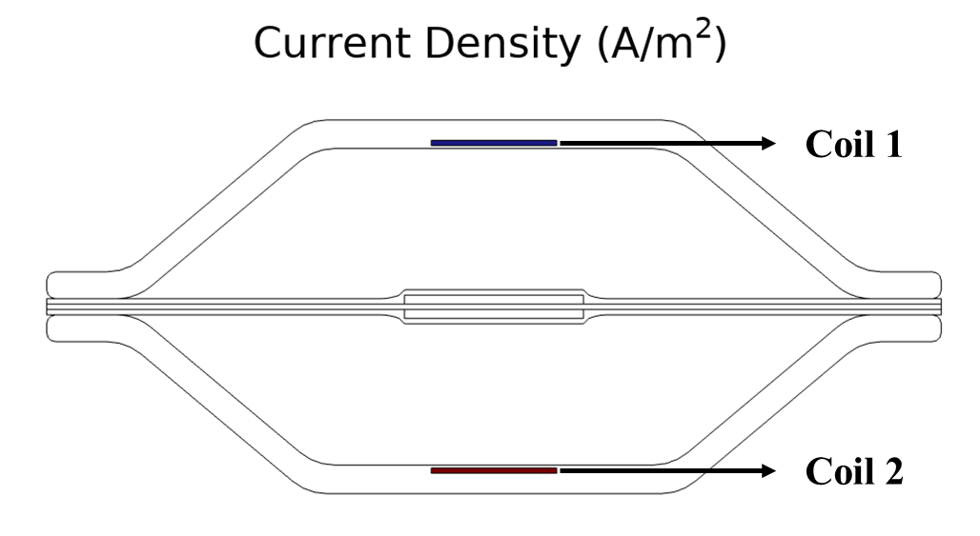
Figure S6. The positions of the two coils and the corresponding current density diagrams.
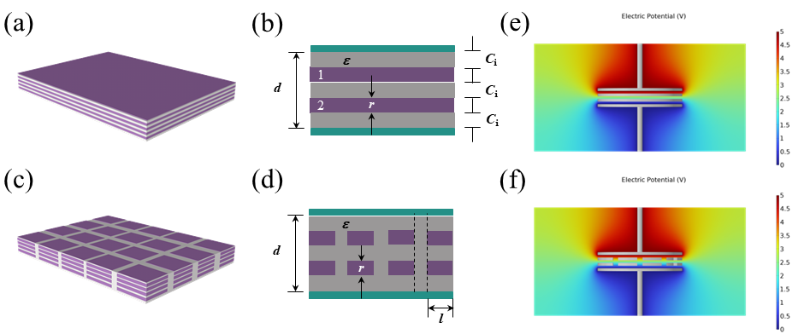
Figure S7. (a-d) Equivalent capacitance structures of doped silver-coated glass microspheres containing two layers and k layers. (e-f) Simulated capacitance results for the doped structures.

Figure S8. The schematic of the home-made vibration test system.

The detailed introduction of home-made test system.
This system can provide an external vibration excitation with different frequencies and accelerations for MFSAS. A MFSAS is fastened onto the vibration platform, the excitation signal is generated by the signal generator and then amplified by the power amplifier. The commercial acceleration sensor is also fastened onto the vibration platform to monitor the true vibration situation in real time. The electrical output signals generated by the MFSAS are measured by Keithley 2611b Digital Source Meter.

The detailed analysis formation process in three sensitivity/linearity variation regions of TM.
In low acceleration region, vibration capturing layer only have slightly vibration, and only electrostatic induction occurred by two triboelectric materials can generate little tribo-charges flow. In medium acceleration region, two triboelectric materials come into contact with each other, and more tribo-charges flow can be generated by coupling of contact electrification and electrostatic induction. In high acceleration region, the more contact between two triboelectric materials is occurred, and more tribo-charges flow and output voltage can be generated compared to the medium acceleration region. Hence, the amount of tribo-charges transfer can be divided into three processes with the vibration of vibration capturing layer, resulting the formation of three sensitivity/linearity variation regions.
The calculation method of RMSE and MAE in Figure 7e and f.
$$MAE=\frac{1}{n}\sum_{i=1}^{n}{\left|y_{i}-\hat{y_{i}}\right|}$$
$$RMSE=\sqrt{\frac{1}{n}\sum_{i=1}^{n}{{\left(y_{i}-\hat{y_{i}}\right)}^{2}}}$$
Where the $y_{i}$ represent actual value, $\hat{y_{i}}$ represent predicted value and n represent number of samples.

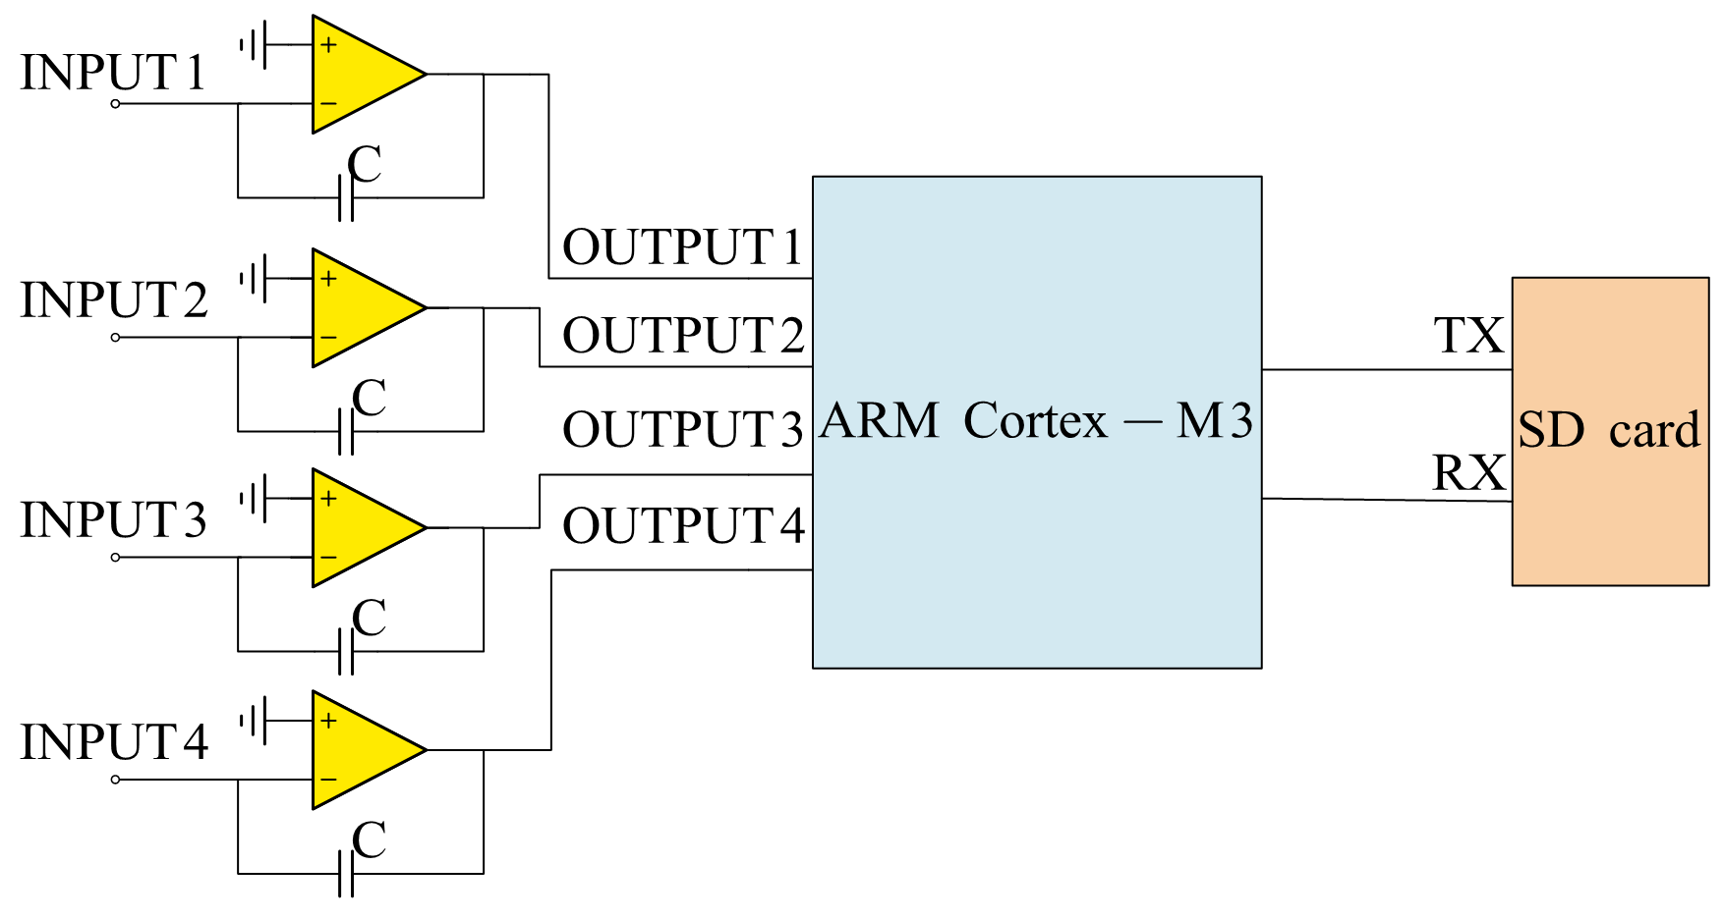
Figure S9. The schematic of developed circuit system.

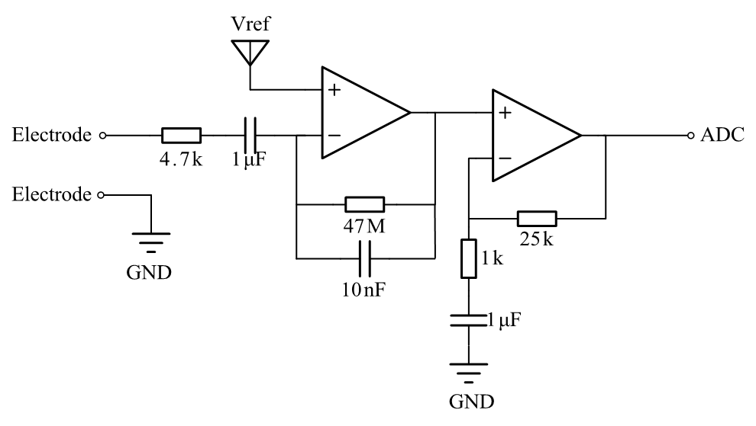
Figure S10. The schematic of charge-voltage conversion circuit.

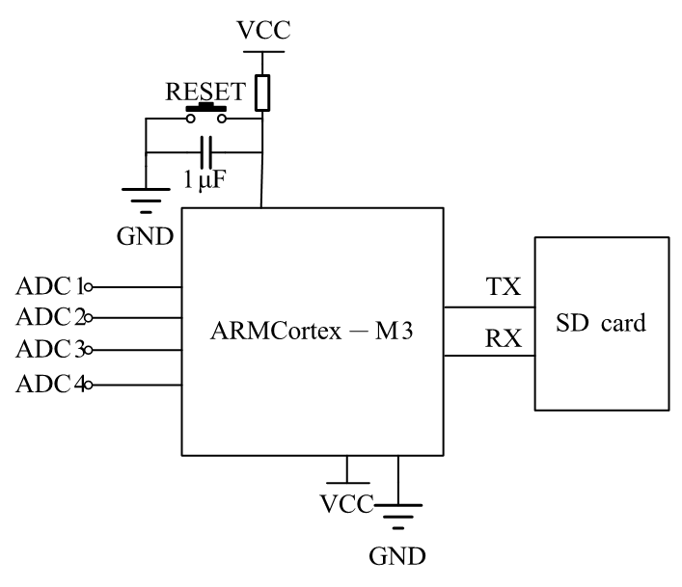
Figure S11. The schematic of main control circuit and storage circuit.
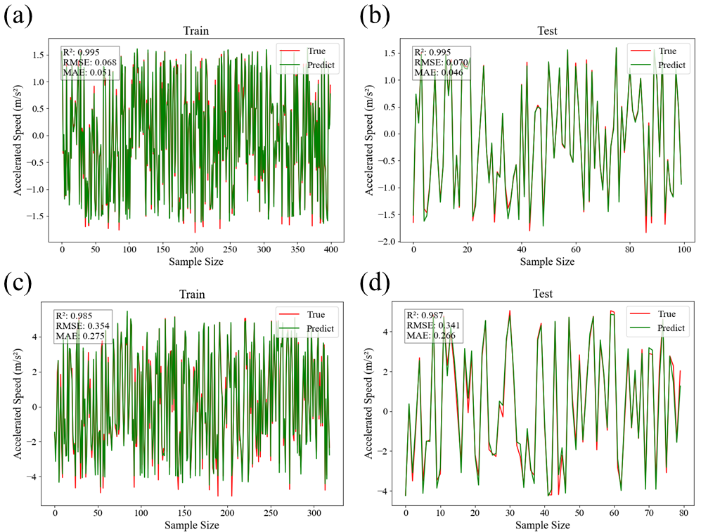
Figure S12. (a, b) Training result and testing result of the Figure 8c; (c, d) Training result and testing result of the Figure 8d.

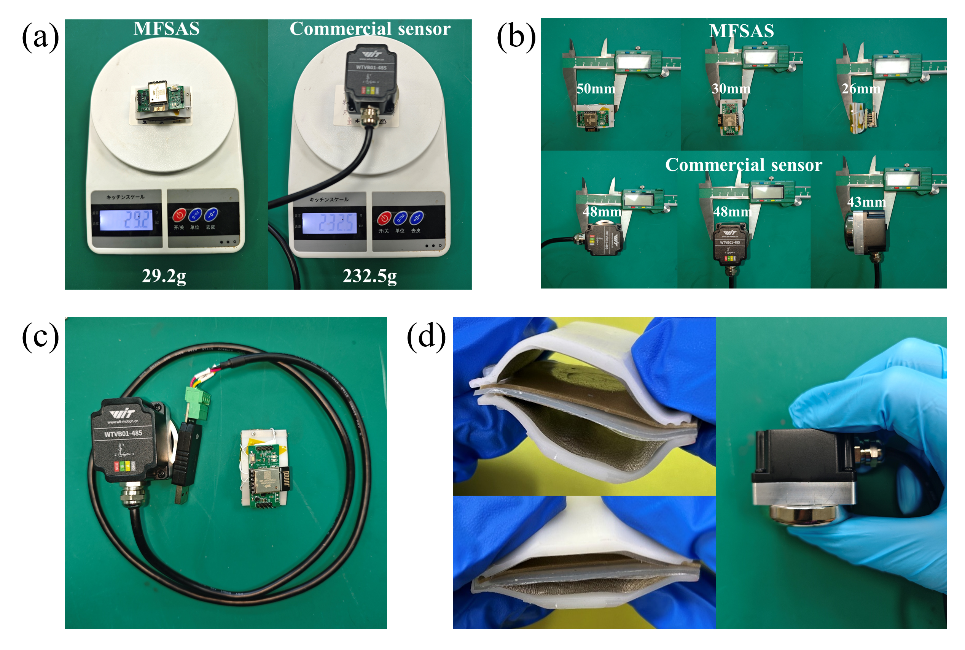
Figure S13. Comparison results between MFSAS and commercial sensors (wtvb01-485). (a) Weight comparison; (b) Size comparison; (c) Operating and data-transmission mode comparison; (d) Flexibility comparison.

