Theta burst stimulation of extrastriate body area for body image perception in anorexia nervosa: A Randomized Controlled Trial

Rebecca Boehme*^{1,2}, Reinoud Kaldewaij*^{1,2,3}, Morgan Frost-Karlsson¹, Andrew Wold⁴, Adam Enmalm^{1,2}, Isabel Khoure⁵, Jonna Tell⁵, Jessica Käll⁵, Mimmi Salerud⁵, Elin Rimhagen⁵, Charlotte Jackleus⁵, Sara Barsjö⁵, Magnus Thordstein⁴, Per A Gustafsson^{1,5}, Håkan Olausson^{1,4}, Maria Zetterqvist^{1,5}
¹ Center for Social and Affective Neuroscience, Department of Biomedical and Clinical Sciences, Linköping University, 58185 Linköping, Sweden
² Center for Medical Imaging and Visualization, Linköping University, 58185 Linköping, Sweden
³ Department of Experimental Psychology, Helmholtz Institute, Utrecht University, Heidelberglaan 1, 3584, CS, Utrecht, The Netherlands
⁴ Department of Clinical Neurophysiology, Linköping University Hospital, 58185 Linköping, Sweden
⁵ Department of Child and Adolescent Psychiatry, Linköping, Region Östergötland, 58185 Linköping, Sweden

Overview Content
Overview Content
Supplementary Methods
Participants
MRI data acquisition
MRI data preprocessing
Extrastriate body area and fusiform body area mask definition
Resting state analysis
Supplementary Results
Effect of body perception training and TMS on clinical outcome
Body shape Questionnaire (primary outcome)
Body Attitude Test
EDE-Q
Figure rating scale
BMI
EBA localizer task
Self-other-touch task
Resting state

Supplementary Methods

Participants
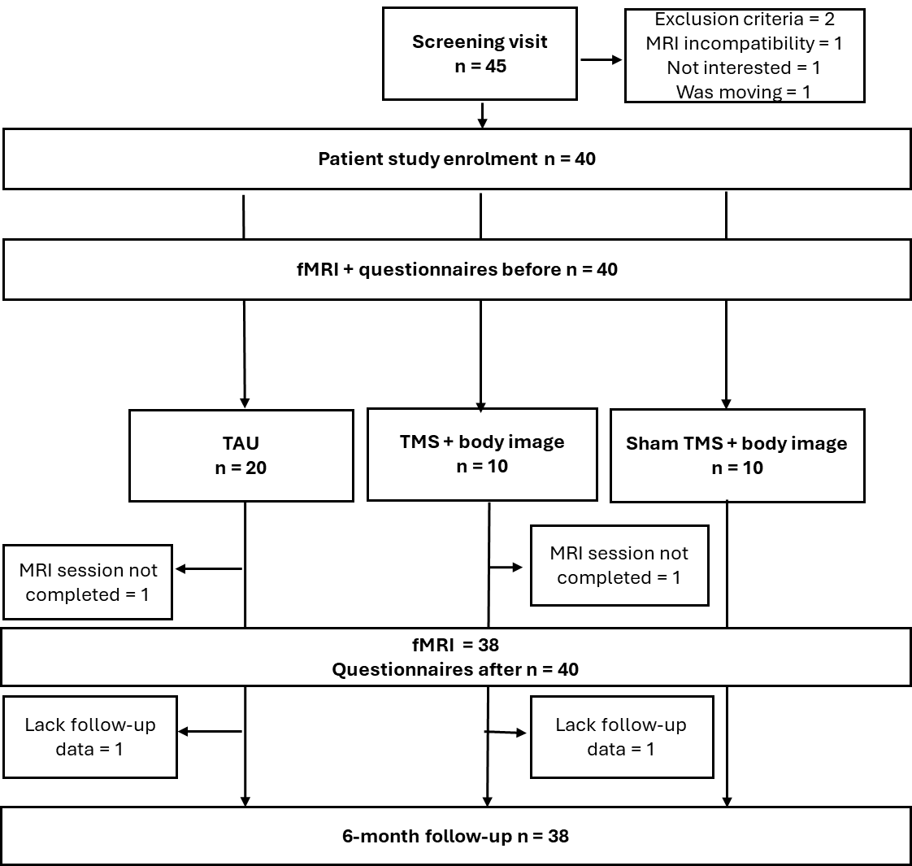
Additional criteria for the inclusion and exclusion of AN patients were as follows: Patients on 3-month stable medication could be included. Exclusion criteria were schizophrenia, psychosis, bipolar disorder, head injury, substance use, gestational age before 33 weeks, and epilepsy. Patients were informed about the study by clinical staff, and those interested were contacted by a research nurse not involved in the patient’s treatment. Patients had to be free of psychotropic medications or on stable (at least three months on the same dose) medication with antidepressants (SSRIs); on-demand use of anxiolytics, hypnotics, and treatment with central stimulants (if possible, paused on MRI investigation day and during iTMS treatment) were accepted. Further, inclusion depended on the judgement of the clinical physician if participation was in the best interest of the patient. Exclusion criteria: schizophrenia or psychotic disorder, bipolar disorder, and/or alcohol/drug dependence, ongoing treatment with antipsychotics or tricyclic antidepressants, previous severe head injury, seizures, birth before 33 weeks of gestation, hearing impairment, earlier epilepsy or seizure of other causes (other than fever cramps in childhood), claustrophobia, pregnancy, and cognitive disability. Due to covid19-related restrictions during different waves (March 2020, December 2020, September to December 2021), 7 participants were directly assigned to TAU in order to reduce their time of physical presence in the hospital.

Figure S1: Recruitment and attrition flow chart. (f)MRI: (functional) magnetic resonance imaging, TAU: treatment as usual, TMS: theta burst transcranial magnetic stimulation

MRI data acquisition
Before entering the MRI scanner, participants familiarized themselves with the tasks in a mock scanner (PST MR Simulator System, BlindSight GmbH, Germany), where they also trained to minimize head movements (MoTrak Head Motion Tracking System, Psychology Software Tools, PA, USA).
Functional neuroimaging data were acquired in a 3T scanner (Prisma, Siemens, Germany). A standard T1 structural scan for subsequent co-registration to functional scans was obtained (repetition time = 2300 ms; echo time = 2.36 ms; flip angle = 8º; field of view = 288 x 288 mm2; voxel resolution = 0.87 x 0.87 x 0.90 mm3), followed by functional scans during the tasks (repetition time: 1030 ms; echo time: 30 ms; slice thickness: 3 mm; matrix size: 64 × 64; field of view: 192 × 192 mm2; in-plane voxel resolution: 3 mm2; flip angle: 63°).

MRI data preprocessing
The following preprocessing steps were performed: Motion correction and realignment by registering to the mean EPI, coregistration of the anatomical image and mean EPI using normalized mutual information, segmentation of the T1 image using the unified segmentation approach, and spatial normalization of T1 and EPIs to the Montreal Neurological Institute T1 template (using forward deformations from the segmentation step, voxel size 2*2*2 mm3 for resampling, and 4th Degree B-Spline for interpolation). All functional images were spatially smoothed with an isotropic Gaussian kernel of 6-mm full width at half-maximum.

Extrastriate body area and fusiform body area mask definition
The bilateral extrastriate body area and right fusiform body area masks were defined as follows: For each of these regions, a search space was defined as a 18 mm sphere around the peak coordinates of the ‘body’ search term in the neurosynth database (www.neurosynth.org), which were masked by a standard grey matter mask (FMRIB Software Library). See figure 1A. For each participant individually, a mask was created within this space by drawing a 8-mm sphere around the peak voxel for the body vs. nature contrast.

Resting state analysis
Analyses of resting state fMRI data were performed using CONN release 22.v2407 (53) and SPM (54) release 12.7219. Functional and anatomical data were preprocessed using a modular preprocessing pipeline (1) including realignment with correction of susceptibility distortion interactions, slice timing correction, outlier detection, direct segmentation and MNI-space normalization, and smoothing (8 mm full width half maximum). In addition, functional data were denoised using a standard pipeline including the regression of potential confounding effects characterized by white matter timeseries, motion parameters and their first order derivatives outlier scans session effects and their first order derivatives and linear trends within each functional run, followed by bandpass frequency filtering of the BOLD timeseries between 0.008 Hz and 0.09 Hz. CompCor (2) noise components within white matter and CSF were estimated by computing the average BOLD signal as well as the largest principal components orthogonal to the BOLD average, motion parameters, and outlier scans within each subject's eroded segmentation masks.
At the subject level, seed-based connectivity maps and ROI-to-ROI connectivity matrices were estimated characterizing the patterns of functional connectivity with 14 ROIs. These ROIs were: the right EBA, left EBA, and right FBA; 7 salience network ROIs: anterior cingulate cortex, bilateral anterior insula, bilateral supramarginal gyrus, bilateral rostral prefrontal cortex; 4 default mode network ROIs: medial prefrontal cortex, bilateral lateral frontal pole, and posterior cingulate cortex (see supplement for more details).
At the individual level, functional connectivity strength was represented by Fisher-transformed bivariate correlation coefficients from a weighted general linear model, defined separately for each pair of seed and target areas (see main manuscript), modeling the association between their BOLD signal timeseries. Individual scans were weighted by a boxcar signal characterizing each individual task or experimental condition convolved with an SPM canonical hemodynamic response function and rectified.
Group-level analyses were performed using a General Linear Model (GLM). For each individual voxel, a separate GLM was estimated with first-level connectivity measures at this voxel as dependent variables and groups as independent variables. For each seed (right EBA, left EBA, right FBA, defined for each subject individually), 3 separate models were run, testing for (1) a group effect of patients (all treatment groups) vs. controls pre-treatment, (2) an interaction effect of treatment (BPT vs. TAU) and time (pre and post-treatment), (3) an interaction effect of TMS-treatment (TMS vs. sham) vs. treatment as usual) and time (pre and post-treatment).
Voxel-level hypotheses were evaluated using multivariate parametric statistics with random-effects across subjects and sample covariance estimation across multiple measurements. Inferences were performed at the level of individual clusters (groups of contiguous voxels). Cluster-level inferences were based on parametric statistics from Gaussian Random Field theory (3). Results were thresholded using a combination of a cluster-forming p < 0.001 voxel-level threshold, and a familywise corrected p-FDR < 0.05 cluster-size threshold. Connection-level hypotheses were evaluated using multivariate parametric statistics with random-effects across subjects and sample covariance estimation across multiple measurements. Inferences were performed at the level of individual clusters (groups of similar connections). Cluster-level inferences were based on parametric statistics within- and between- each pair of networks (Functional Network Connectivity (4)), with networks identified using a complete-linkage hierarchical clustering procedure based on ROI-to-ROI anatomical proximity and functional similarity metrics. Results were thresholded using a combination of a p < 0.05 connection-level threshold and a familywise corrected p-FDR < 0.05 cluster-level threshold.
Body Image Interventions
The body image interventions were developed by physiotherapists and psychologists with experience of treating eating disorders in psychiatric care. The content of the five sessions was presented in a structured manual with detailed instructions and information on the procedures for each session. Each intervention ended with questions from the therapist, encouraging reflections about body image based on participants’ experiences of the exercises, and potential discrepancies between perceived and actual body size. Each session took between 20-30 minutes to complete.
Psychoeducation
The psychoeducation contained information about the body, the anatomy and functions of the skeleton and muscles, and the stomach area, including internal organs, and the size and placing of the bowels and intestines. Participants were presented with a poster of a skeleton with muscles and given oral information. A rope was used to illustrate the intestines.
Drawing of estimated and actual body size
Participants drew the contours of their perceived body size on a large piece of paper with positions for head, shoulders, middle of body and arm length marked out. After that, the contour of their actual body size was drawn on the same paper, superimposed on the perceived body size, with the help of the therapist.
Estimating the size of different body parts using a piece of string
Participants were encouraged to estimate the size of their waist, overarms and thighs, one at a time, using a piece of string. The therapist then measured the actual size using a differently colored piece of string and the two pieces of string (perceived and actual size) were superimposed on each other forming two circles.
Estimating the size of different body parts using different sized hula hoop rings
Using eight hula hoop rings of different sizes, participants were instructed to choose the one they perceived would fit exactly round their body. Participants then tried fitting their body in the ring they had chosen. Based on this feedback experience and the discussion that followed, participants were encouraged to choose a new ring and try fitting that size over their body.
Adjusting the size of a computerized morph of their body
Participants were instructed to adjust a computerized body morph to the size they perceived their own body to be. The body morph was presented on a computer screen. The different versions were shown to the participants at the end of week 4.

Supplementary Results

Effect of body perception training and TMS on clinical outcome

Body shape Questionnaire (primary outcome)
Both the body perception training (BPT) and treatment-as-usual (TAU) group showed a decrease in BSQ-scores from pre- to post-treatment, F(1,38) = 14.22, p < .001. Descriptively, this was stronger for the BPT than for the TAU group, but this interaction effect (treatment x time) was not significant F(1,38) = 3.92, p = .055).
For both TMS-treatment groups (within the BPT group), BSQ-scores decreased from pre- to post-treatment, F(1,18) = 15.259, p = .001. No TMS effect was found for this first time-interval (pre- to post-treatment), F(1,18) = 2.17, p = .16.
Comparing all 3 treatment groups (TAU, BPT-TMS active, BPT-TMS sham) across all 3 timepoints, there was a significant effect of treatment type (treatment x time interaction): F(4,70) = 3.62, p = .010 (see main manuscript). Post-hoc tests (Holm-correction) indicated a significant decrease in BSQ scores in the active TMS group from pre- to post-treament (p = .018), and from pre-treament to 6-months follow-up (p = .019). In the TAU group, there was a significant decrease from pre-treatment to 6-months follow-up (p = .037).

Body Attitude Test
The BPT group showed a stronger decrease than the TAU on the BAT from pre- to post-treatment (time x group interaction: F(1,38) = 12.43, p = .001). For both TMS-treatment groups (within the BPT group), BAT-scores decreased from pre- to post-treatment, F(1,18) = 21.21, p < .001. No TMS effect was found for this first time-interval (pre- to post-treatment), F(1,18) = 2.53, p = .13. Comparing all 3 treatment groups (TAU, BPT-TMS active, BPT-TMS sham) across all 3 timepoints, there was a significant effect of treatment type (treatment x time interaction): F(4,70) = 4.12, p = .005. Post-hoc tests (Holm-correction) indicated a significant decrease in BAT scores in the active TMS group from pre- to post-treament (p = .001).

EDE-Q
Both the BPT group and TAU group showed a decrease in EDE-Q-scores from pre- to post-treatment, F(1,38) = 7.09, p = .011. There was no significant evidence for a stronger decrease in either treatment group (treatment x time: F(1,38) = .051, p = .82). For both TMS-treatment groups (within the BPT group) specifically, EDE-Q scores did not decrease significantly during this first time-interval (pre-to post-treatment), F(1,18) = 3.18, p = .091, and no TMS-effect was found, F(1,18) = 0.12, p = .73. Comparing all 3 treatment groups (TAU, BPT-TMS active, BPT-TMS sham) across all 3 timepoints, there was a significant overall decrease in EDE-Q across all groups, F(2,70) = 9.653, p < .001, but no effect of treatment on this decrease (treatment x time interaction: Time*Group F(4,70) = 0.22, p = .93).

Figure rating scale
There were 3 figure rating scales (FRS): Think, Feel and Ideal.
For FRS-think, the BPT group showed a stronger decrease than the TAU on the BAT from pre- to post-treatment (time x group interaction: F(1,37) = 6.01, p = .019). For both TMS-treatment groups (within the BPT group), FRS-think scores decreased from pre- to post-treatment, F(1,17) = 6.78, p = .019. No TMS effect was found for this first time-interval (pre- to post-treatment), F(1,17) = 6.78, p = .019. Comparing all 3 treatment groups (TAU, BPT-TMS active, BPT-TMS sham) across all 6 timepoints (pre-treatment, week 1,week 2, week 3, week 4/post-treatment, follow-up), there was a significant overall decrease in FRS-think across all groups, F(5,150) = 2.77, p = .020, but no effect of treatment on this decrease (F(10,150) = 1.71, p = .082).
For FRS-feel, both the BPT group and TAU group showed a decrease in scores from pre- to post-treatment, F(1,38) = 12.47, p = .001. There was no significant evidence for a stronger decrease in either treatment group (treatment x time: F(1,38) = 1.18, p = 0.28). For both TMS-treatment groups (within the BPT group), FRS-feel scores decreased from pre- to post-treatment, F(1,18) = 11.56, p = .003. No TMS effect was found for this first time-interval (pre- to post-treatment), F(1,18) = 1.28, p = 0.27. Comparing all 3 treatment groups (TAU, BPT-TMS active, BPT-TMS sham) across all 6 timepoints (pre-treatment, week 1,week 2, week 3, week 4/post-treatment, follow-up), there was a significant overall decrease in FRS-feel across all groups, F(5,155) = 3.81, p = .003, but no effect of treatment on this decrease (F(10,155) = 0.58, p = .83).
For FRS-ideal, both the BPT group and TAU group showed an increase in scores from pre- to post-treatment, F(1,36) = 9.97, p = .003. There was no significant evidence for a stronger decrease in either treatment group (treatment x time: F(1,38) = 0.35, p = .56). For both TMS-treatment groups (within the BPT group), FRS-ideal scores increased from pre- to post-treatment, F(1,18) = 1.17, p = 0.30. No TMS effect was found for this first time-interval (pre- to post-treatment), F(1,18) = 1.28, p = 0.27. Comparing all 3 treatment groups (TAU, BPT-TMS active, BPT-TMS sham) across all 6 timepoints (pre-treatment, week 1,week 2, week 3, week 4/post-treatment, follow-up), there was a significant overall decrease in FRS-ideal across all groups, F(5,150) = 6.63, p < .001, but no effect of treatment on this decrease (F(10,150) = 0.49, p = .90).

BMI
Neither the BPT group nor the TAU group showed an increase in BMI from pre- to post-treatment, F(1,35) = .40, p = .53. There was no significant evidence for a stronger increase in either treatment group (treatment x time: F(1,35) = .06, p = .80). For both TMS-treatment groups (within the BPT group) specifically, BMI did not increase significantly during this first time-interval (pre-to post-treatment), F(1,18) = 0.11, p = .75, and no TMS-effect was found, F(1,18) = 0.16, p = .70. Comparing all 3 treatment groups (TAU, BPT-TMS active, BPT-TMS sham) across all 3 timepoints, there was no significant overall increase in BMI across all groups, F(2,66) = 2.87, p = .064. However, this increase was significant when one outlier at the follow-up measurement was removed (p = .009). There was no effect of treatment on this increase (treatment x time interaction: Time*Group F(4,66) = 0.21, p = .93).

EBA localizer task
Masks (search space)

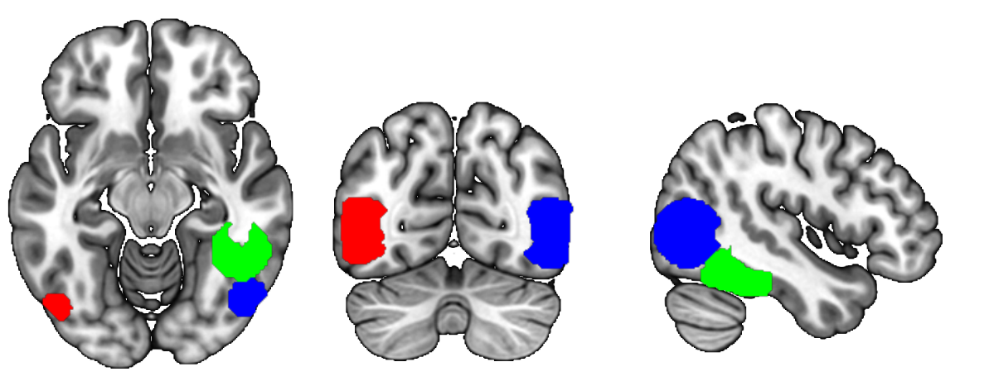
Z = -12
Y = -69
X = 45

Patients: Body vs. Nature
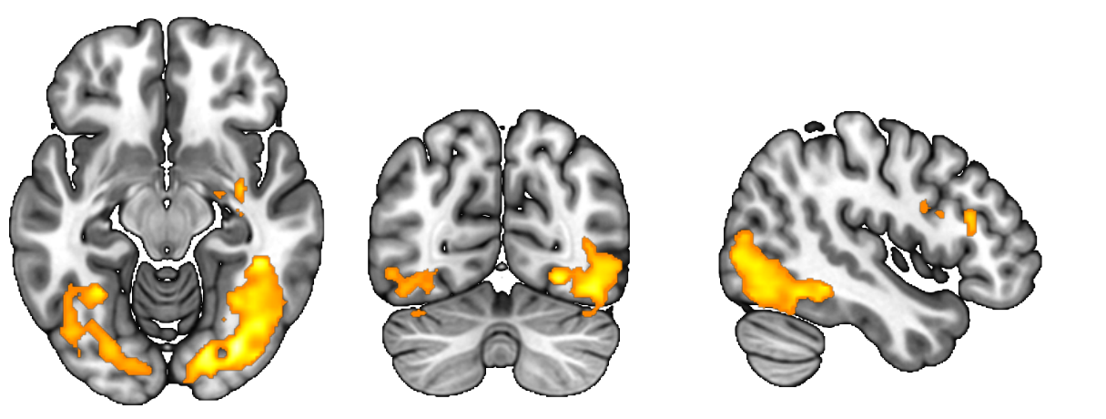
Controls: Body vs. Nature
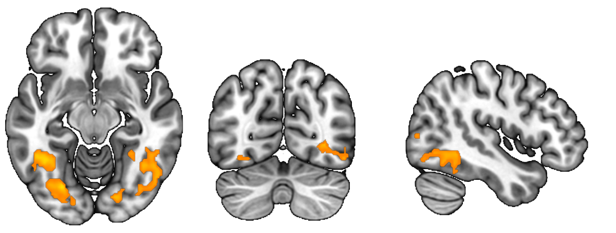
T
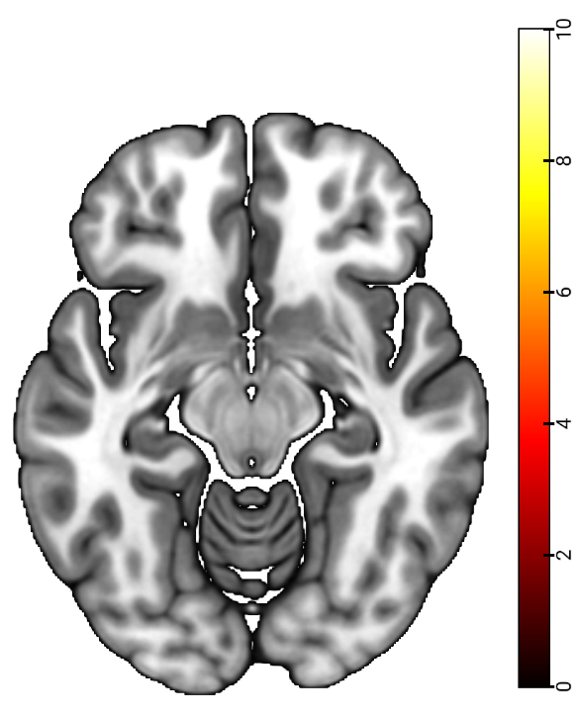
Figure S2. Activation for Body vs. Nature pictures. A Regions of interest: left extrastriate body area (red), right extrastriate body area (blue), right fusiform body area (green). B. Anorexia patients showed increased activation in the rFBA and bilateral EBA for body images compared to nature images. C. Healthy controls showed a similar pattern. All images in neurological orientation and thresholded at p < 0.05 (family-wise error corrected). T = t-value. X,Y,Z according to Montreal neurological institute coordinate system.
An exploratory ROI analysis on mean activation around individual peak activation within the bilateral EBA (i.e. mean beta estimates extracted from 8-mm spheres around the individual peak voxel within a predefined EBA mask) revealed no difference in activation between patients and controls at baseline. However, mean activation around individual peak activation within the right FBA was higher for the patients (p = .041)

Self-other-touch task
Pre-treatment, AN patients showed increased activation for other vs. self(corrected for movement) in the bilateral parietal operculum (S2), bilateral temporal poles, and insula, comparable to previous work with healthy controls (5, 6). Directly compared to the healthy control group, no differences were found at whole-brain corrected level. However, small-volume corrected (SVC) analyses showed increased activation for healthy controls for other vs. self(corrected for movement) touch in the right anterior cingulate cortex (ACC, pFWE = .010, MNI 8, 44, 4), right superior temporal gyrus (STG, pFWE = .029, MNI 68 -14 8) as well as the right fusiform gyrus (FG)/EBA (pFWE = .026, MNI 36, -70, -8) and right FBA (pFWE = .003, MNI 40 -40 -20). No differences were found for the left EBA and right insula (note that this analysis was restricted to right-sided volumes of interest, except for the left EBA). Note that the rFG/rEBA cluster overlaps with the EBA mask, but that its peak is in a different location than the rEBA cluster showing treatment effects over time (see main manuscript and figure S4)

TMS-sham TMS-active Treatment as usual
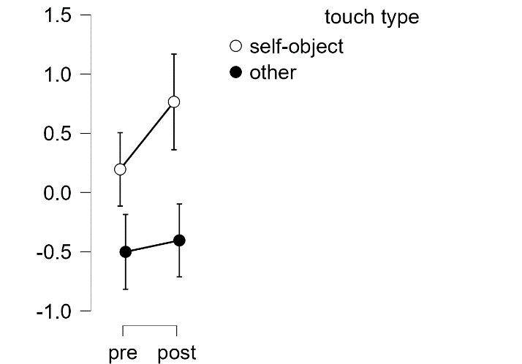
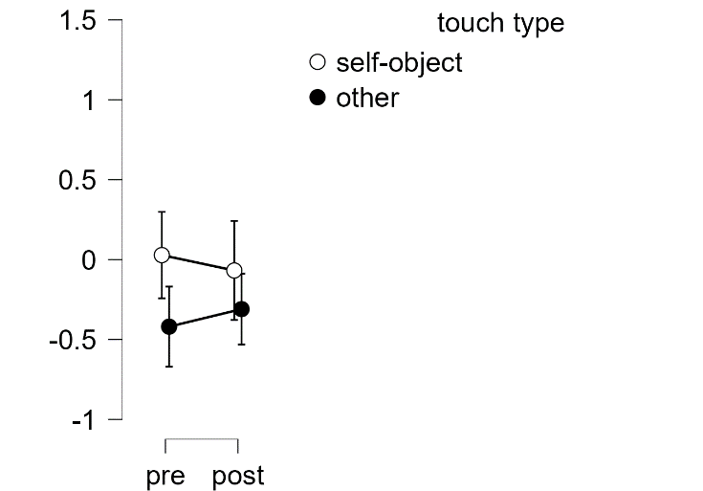
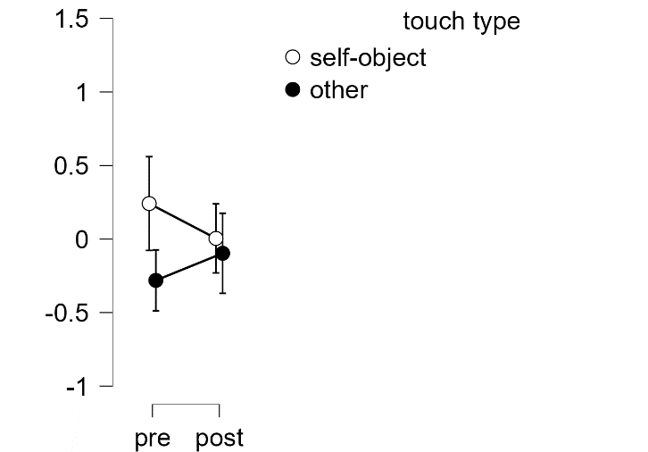

Pre-treatment
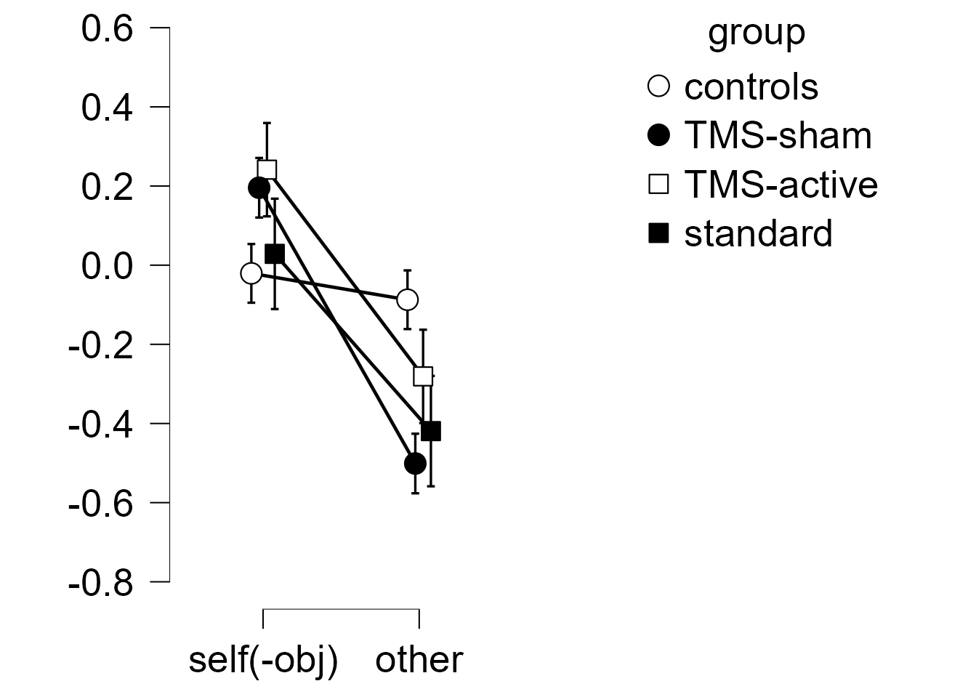
Figure S3 Right EBA cluster activation before and after treatment. Extracted from significant time(pre/post) x TMS-treatment cluster (see main manuscript)

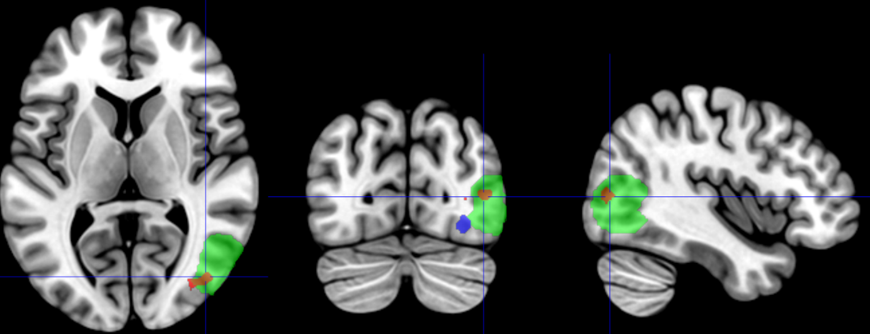
Right EBA mask
rEBA treatment effect
rFG/rEBA group effect at baseline
Figure S4. Specific location of rFG/rEBA group effect and rEBA treatment effect. rFG = righ fusiform gyrus, rEBA = right EBA.

Resting state
Seed-to-voxel analysis
There was no difference in right EBA connectivity during resting state between patients and controls before treatment. Left EBA showed increased connectivity to the right superior parietal lobule in anorexia patients compared to healthy controls. When comparing EBA connectivity between pre- and post-treatment sessions across all patients, we found a significant decrease in connectivity to prefrontal areas and the left cerebellum (see figure S5A for details). There was no interaction between time (pre- and post-treatment) and treatment group.
Compared to controls, AN patients showed stronger connectivity between the left EBA (defined for each participant individually based on the EBA localizer task) and the right superior parietal lobule (MNI 38 -52 54, cluster pFWE = .0026) pre-treatment. No pre-treatment differences between patients and controls were found for right EBA and right FBA connectivity. After treatment, connectivity between the right EBA and clusters in the bilateral frontal pole (left: -38 +62 +08 cluster pFWE = .0078; right: +38 +30 +22, cluster pFWE = .0098) and left cerebellum (-26 -70 -44, cluster pFWE < 0.001) decreased compared to before treatment. Similar decreases in connectivity were found between the left EBA and a similar cluster in the left cerebellum (-24 -72 -44, cluster pFWE = .0011), as well as the bilateral precentral gyrus/inferior frontal gyrus (left: -48 +08 +22, cluster pFWE = .0060 ;right: +50 +10 +24, cluster pFWE = .039).
ROI-to-ROI analysis
When comparing AN patients before treatment to healthy controls, several of the pre-selected regions including the right FBA, left EBA, and right EBA showed stronger connectivity to a cluster of salience network regions, including the anterior insula, ACC, SMG and rostral prefrontal cortex (Figure 5B ). There was no effect of time (pre- and post-treatment) or interaction between time and treatment group.

A
Anorexia patients > healthy controls
Left EBA seed

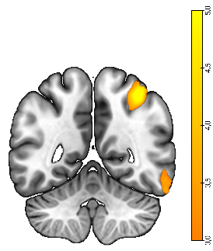
Anorexia patients:
pre- vs. post-treatment
Left EBA seed
Anorexia patients:
pre- vs. post-treatment
Right EBA seed

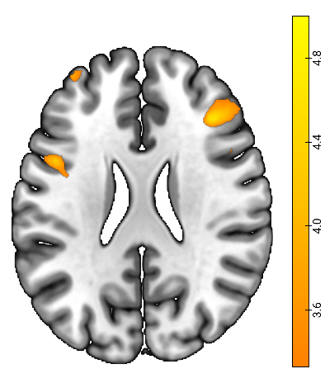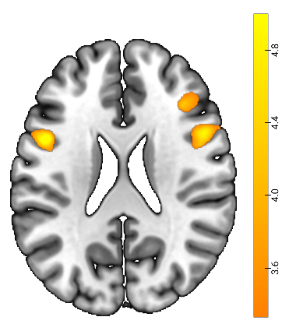
B

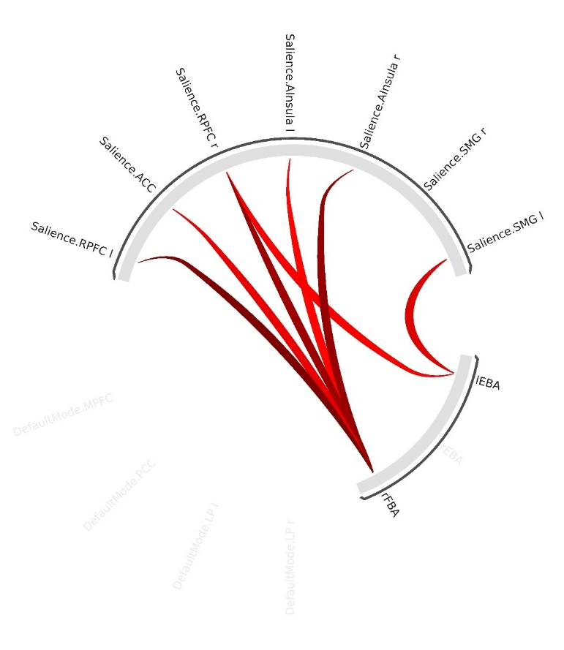
Figure S5 A. Clusters showing increased connectivity with the left EBA for anorexia patients compared to controls (top) and cluster showing decreased connectivity with the left and right EBA (bottom) after treatment in anorexia patients (across all treatment groups) B. Anorexia patients vs. controls, ROI-to-ROI analysis. A cluster containing the right FBA, right EBA and left EBA showed increased connectivity with the salience network in anorexia patients (pre-treatment) compared to healthy controls. RPFC = rostral prefrontal cortex, SMG = supra-marginal gyrus. Results are significant at the cluster level (i.e. connectivity between groups of ROIs). Red lines indicate the strongest ROI-ROI connections.

References
1. Nieto-Castanon A, Whitfield-Gabrieli S (2021): CONN functional connectivity toolbox (RRID: SCR_009550), Version 21. Series CONN functional connectivity toolbox (RRID: SCR_009550), Version. 21.
2. Behzadi Y, Restom K, Liau J, Liu TT (2007): A component based noise correction method (CompCor) for BOLD and perfusion based fMRI. Neuroimage. 37:90-101.
3. Worsley KJ, Marrett S, Neelin P, Vandal AC, Friston KJ, Evans AC (1996): A unified statistical approach for determining significant signals in images of cerebral activation. Human brain mapping. 4:58-73.
4. Jafri MJ, Pearlson GD, Stevens M, Calhoun VD (2008): A method for functional network connectivity among spatially independent resting-state components in schizophrenia. Neuroimage. 39:1666-1681.
5. Boehme R, Hauser S, Gerling GJ, Heilig M, Olausson H (2019): Distinction of self-produced touch and social touch at cortical and spinal cord levels. PNAS Proceedings of the National Academy of Sciences
6. Kaldewaij R, Salamone PC, Enmalm A, Östman L, Pietrzak M, Karlsson H, et al. (2024): Ketamine reduces the neural distinction between self-and other-produced affective touch: a randomized double-blind placebo-controlled study. Neuropsychopharmacology. 49:1767-1774.

