Supplementary Table S1. Summary of crystallographic information for PI3Kδ∙roginolisib.
PDB-ID | 9T07
Data collection and processing
X-ray source | PXI/X06SA (SLS¹)
Wavelength (Å) | 0.9999
Detector | PILATUS 6M
Temperature [K] | 100
Space group | P2₁2₁2₁
Unit cell parameters
a, b, c (Å) | 93.03, 113.39, 144.51
α, β, γ (°) | 90.0, 90.0, 90.0
Resolution (Å) | 2.75 (3.00-2.75)²
Unique reflections | 39,134 (8,981)²
R_{sym} (%)³ | 3.5 (44.4)²
R_{meas} (%)⁴ | 4.0 (49.3)²
Completeness (%) | 96.7 (97.9)²
Redundancy | 4.8 (4.9)²
Mean I/σ(I)⁵ | 24.06 (3.23)²
Refinement
Resolution range (Å) | 46.52 – 2.75
Reflections used in refinement  (work / free) | 39,134 / 746
Final R values for all reflections  (work⁶ / free⁷) (%) | 23.2 / 27.2
No. Atoms  Proteins  Ligand  Water | 8,749  37  28
RMSZ
Bonds (Å) | 0.66
Angles (°) | 1.06
Ramachandran parameters (%)⁸
Preferred regions | 94.4
Allowed regions | 4.9
Outliers | 0.7
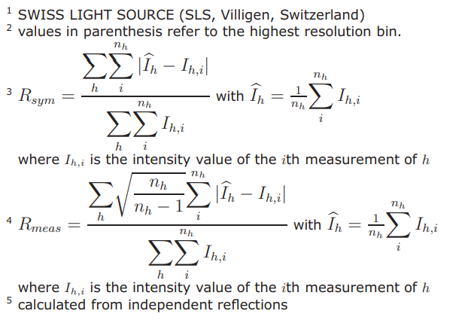
⁶R_{work} = (∑⎟(F_{obs} – F_{calc})⎥ / ∑⎟F_{obs}⎥)
⁷R_{free} = R_{work} based on ~1000 (at least 5%) of reflections excluded from refinement
⁸Calculated using COOT

Supplementary Table S2. Summary of crystallographic information for PI3Kδ∙IOA-288.
PDB-ID | 9T1P
Data collection and processing
X-ray source | PXI/X06SA (SLS¹)
Wavelength (Å) | 0.9999
Detector | PILATUS 6M
Temperature [K] | 100
Space group | P2₁2₁2₁
Unit cell parameters
a, b, c (Å) | 93.23, 113.34, 144.59
α, β, γ (°) | 90.0, 90.0, 90.0
Resolution (Å) | 2.97 (3.20-2.97)²
Unique reflections | 32,158 (5,053)²
R_{sym} (%)³ | 10.6 (43.5)²
R_{meas} (%)⁴ | 14.1 (65.4)²
Completeness (%) | 99.2 (98.1)²
Redundancy | 3.7 (3.8)²
Mean I/σ(I)⁵ | 6.6 (1.6)²
Refinement
Resolution range (Å) | 48.43 – 2.97
Reflections used in refinement  (work / free) | 32,142 / 871
Final R values for all reflections  (work⁶ / free⁷) (%) | 21.9 / 27.6
No. Atoms  Proteins  Ligand  Water | 8,743  38  49
RMSZ
Bonds (Å) | 0.63
Angles (°) | 1.05
Ramachandran parameters (%)⁸
Preferred regions | 93.7
Allowed regions | 4.9
Outliers | 1.4
⁶R_{work} = (∑⎟(F_{obs} – F_{calc})⎥ / ∑⎟F_{obs}⎥)
⁷R_{free} = R_{work} based on ~1000 (at least 5%) of reflections excluded from refinement
⁸Calculated using COOT

