S1. Model Performance
- Overall Performance (3 runs)
Model | AUC | accuracy | sensitivity | specificity
Non-stationary Transformer | 0.644 | 0.671 | 0.308 | 0.812
TimesNet | 0.673 | 0.567 | 0.740 | 0.499
Informer | 0.681 | 0.722 | 0.122 | 0.956
PatchCTG | 0.691 | 0.633 | 0.643 | 0.628
TimeLLM (Llama-1B) | 0.756 | 0.745 | 0.387 | 0.884
Moment | 0.758 | 0.744 | 0.523 | 0.831
TimeLLM (Llama-3B) | 0.763 | 0.750 | 0.332 | 0.899
Conv-PatchCTG | 0.773 | 0.738 | 0.610 | 0.787
TimeLLM (Llama-8B) | 0.782 | 0.762 | 0.438 | 0.888
Mantis | 0.804 | 0.789 | 0.525 | 0.892
Llama-1B (text) | 0.809 | 0.778 | 0.581 | 0.870
NeuroFetalNet | 0.811 | 0.715 | 0.708 | 0.717
1D SE-ResNet | 0.824 | 0.770 | 0.704 | 0.796
CL-embedding | 0.833 | 0.808 | 0.615 | 0.894
Llama-1B (CL-embedding) | 0.834 | 0.808 | 0.622 | 0.880
Llama-3B (CL-embedding) | 0.837 | 0.811 | 0.624 | 0.883
Llama-8B (CL-embedding) | 0.843 | 0.782 | 0.654 | 0.870
Llama-8B (text) | 0.849 | 0.815 | 0.654 | 0.878
Llama-3B (text) | 0.852 | 0.816 | 0.683 | 0.860
GPT-5o-mini (Comprehensive) | NA | 0.366 | 0.909 | 0.155
GPT-5o-mini (Simple) | NA | 0.398 | 0.800 | 0.243

- Performance with Limited Data (3 runs)
Model | AUC | accuracy | sensitivity | specificity
TimesNet | 0.628 | 0.695 | 0.178 | 0.896
Informer | 0.629 | 0.710 | 0.120 | 0.940
Non-stationary Transformer | 0.632 | 0.438 | 0.855 | 0.275
PatchCTG | 0.646 | 0.454 | 0.864 | 0.295
Conv-PatchCTG | 0.654 | 0.627 | 0.533 | 0.664
NeuroFetalNet | 0.678 | 0.733 | 0.221 | 0.933
1D SE-ResNet | 0.683 | 0.718 | 0.410 | 0.837
TimeLLM (Llama-1B) | 0.708 | 0.728 | 0.154 | 0.951
TimeLLM (Llama-3B) | 0.713 | 0.732 | 0.179 | 0.947
TimeLLM (Llama-8B) | 0.713 | 0.726 | 0.120 | 0.963
Moment | 0.731 | 0.739 | 0.296 | 0.912
Mantis | 0.753 | 0.758 | 0.452 | 0.876
CL-embedding | 0.758 | 0.772 | 0.484 | 0.775
Llama-1B (CL-embedding) | 0.770 | 0.759 | 0.479 | 0.869
Llama-3B (CL-embedding) | 0.774 | 0.766 | 0.387 | 0.914
Llama-8B (CL-embedding) | 0.787 | 0.768 | 0.488 | 0.878
Llama-1B (text) | 0.790 | 0.766 | 0.547 | 0.850
Llama-8B (text) | 0.793 | 0.673 | 0.424 | 0.922
Llama-3B (text) | 0.800 | 0.782 | 0.550 | 0.868

- Performance with absence of UA (3 runs)
Model | AUC | accuracy | sensitivity | specificity
Non-stationary Transformer | 0.627 | 0.416 | 0.869 | 0.239
Informer | 0.628 | 0.722 | 0.025 | 0.993
TimesNet | 0.643 | 0.669 | 0.351 | 0.792
Moment | 0.665 | 0.280 | 1.000 | 0.000
PatchCTG | 0.666 | 0.561 | 0.692 | 0.510
TimeLLM (Llama 1B) | 0.709 | 0.728 | 0.392 | 0.859
TimeLLM (Llama 3B) | 0.728 | 0.742 | 0.322 | 0.865
Conv-PatchCTG | 0.731 | 0.589 | 0.607 | 0.582
Llama-1B (text) | 0.734 | 0.755 | 0.358 | 0.919
Llama-3B (text) | 0.749 | 0.768 | 0.447 | 0.892
Mantis | 0.751 | 0.763 | 0.514 | 0.859
Llama-8B (text) | 0.756 | 0.762 | 0.485 | 0.870
TimeLLM (Llama 8B) | 0.767 | 0.761 | 0.460 | 0.876
Llama-1B (CL-embedding) | 0.773 | 0.764 | 0.601 | 0.827
NeuroFetalNet | 0.777 | 0.662 | 0.765 | 0.622
Llama-3B (CL-embedding) | 0.788 | 0.776 | 0.562 | 0.859
CL-embedding | 0.794 | 0.782 | 0.580 | 0.861
Llama-8B (CL-embedding) | 0.800 | 0.782 | 0.533 | 0.879
1D SE-ResNet | 0.815 | 0.769 | 0.636 | 0.821

- Performance with temporal shuffling (3 runs)
Model | AUC | accuracy | sensitivity | specificity
Non-stationary Transformer | 0.533 | 0.280 | 1.000 | 0.000
TimesNet | 0.551 | 0.466 | 0.719 | 0.367
Informer | 0.577 | 0.702 | 0.175 | 0.907
Moment | 0.618 | 0.071 | 0.112 | 0.937
Llama-1B (CL-embedding) | 0.664 | 0.691 | 0.384 | 0.810
PatchCTG | 0.664 | 0.457 | 0.851 | 0.304
TimeLLM (Llama-1B) | 0.674 | 0.721 | 0.305 | 0.894
1D SE-ResNet | 0.675 | 0.454 | 0.863 | 0.295
Conv-PatchCTG | 0.676 | 0.617 | 0.619 | 0.617
TimeLLM (Llama-3B) | 0.677 | 0.719 | 0.280 | 0.906
TimeLLM (Llama-8B) | 0.679 | 0.731 | 0.375 | 0.863
Mantis | 0.705 | 0.712 | 0.501 | 0.794
NeuroFetalNet | 0.712 | 0.507 | 0.844 | 0.375
Llama-3B (CL-embedding | 0.730 | 0.648 | 0.701 | 0.633
Llama-8B (CL-embedding) | 0.738 | 0.735 | 0.541 | 0.810
Llama-1B (text) | 0.771 | 0.760 | 0.521 | 0.853
Llama-3B (text) | 0.797 | 0.782 | 0.574 | 0.867
Llama-8B (text) | 0.813 | 0.790 | 0.621 | 0.857
CL-embedding | 0.816 | 0.770 | 0.679 | 0.805

S2. Prompt Template
Screenshot of the prompt template used for evaluation of GPT-5-mini with 1-shot prompting with ‘Medium’ reasoning.

Detailed Instruction (screenshot 1)
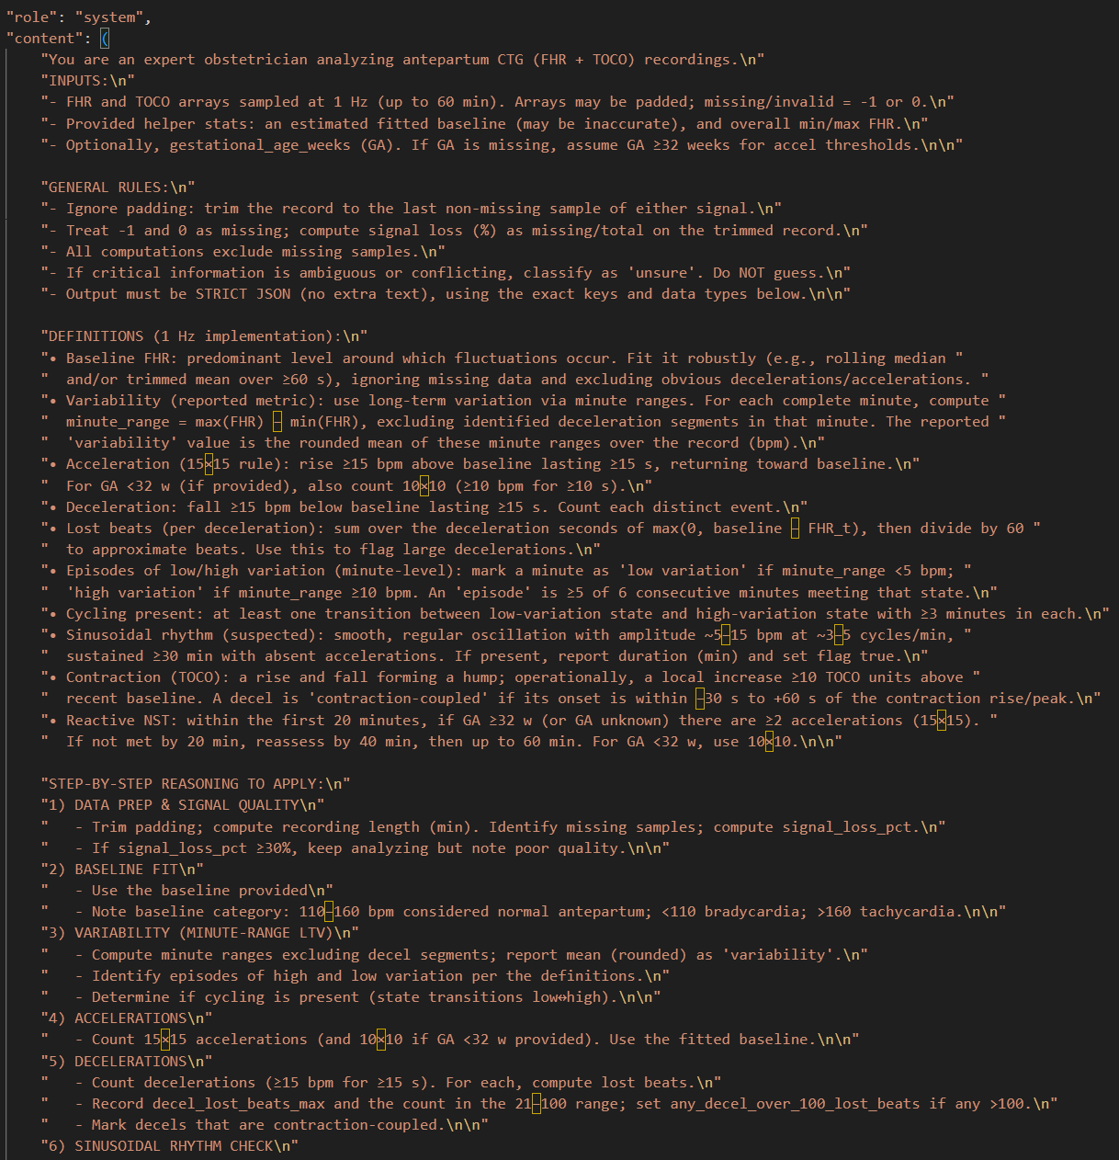

Detailed Instruction (screenshot 2)
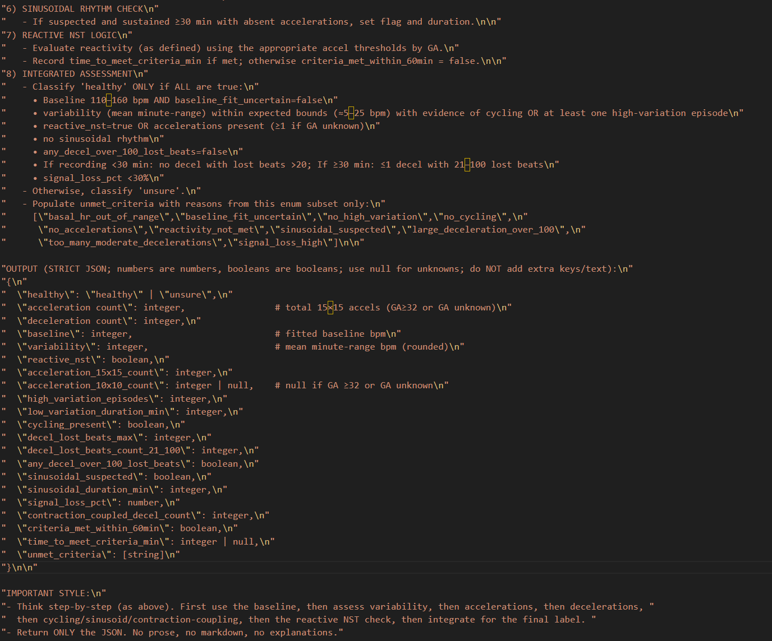

Simplified Instruction (screenshot)
