Supplementary Table S1.
Details of Streck plasma samples used in study. The ethnicity of subjects was unknown.
Disease state | Disease Stage | Age | Gender | Biobank
Healthy | N/A | 59 | M | BioIVT
Healthy | N/A | 48 | M | BioIVT
Healthy | N/A | 64 | F | BioIVT
Healthy | N/A | 55 | M | BioIVT
Healthy | N/A | 58 | M | BioIVT
Healthy | N/A | 54 | M | BioIVT
Healthy | N/A | 70 | M | BioIVT
Healthy | N/A | 49 | F | BioIVT
Healthy | N/A | 57 | F | BioIVT
Healthy | N/A | 59 | F | BioIVT
Healthy | N/A | 61 | M | BioIVT
Colitis | N/A | 35 | M | BioIVT
RA | N/A | 58 | F | BioIVT
Polyarthritis | N/A | 47 | F | BioIVT
Crohn’s Disease | N/A | 27 | F | BioIVT
Crohn’s Disease | N/A | 37 | F | BioIVT
Crohn’s Disease | N/A | 33 | F | BioIVT
Crohn’s Disease | N/A | 43 | F | BioIVT
Crohn’s Disease | N/A | 33 | F | BioIVT
Crohn’s Disease | N/A | 46 | F | BioIVT
Crohn’s Disease | N/A | 19 | M | BioIVT
Bile Duct Cancer | IV | 62 | M | Indivumed
Bile Duct Cancer | I | 53 | M | Indivumed
Bile Duct Cancer | III | 83 | F | Indivumed
Bile Duct Cancer | IV | 78 | F | Indivumed
Breast Cancer | III | 77 | F | Indivumed
Breast Cancer | IV | 60 | F | Indivumed
Breast Cancer | I | 43 | F | Indivumed
Breast Cancer | II | 68 | F | Indivumed
Breast Cancer | I | 49 | F | Indivumed
Breast Cancer | IV | 63 | F | Indivumed
Breast Cancer | IV | 55 | F | Indivumed
Breast Cancer | III | 78 | F | Indivumed
Breast Cancer | I | 45 | F | Indivumed
Breast Cancer | II | 51 | F | Indivumed
CRC | IV | 79 | F | Indivumed
CRC | IV | 77 | F | Indivumed
CRC | III | 82 | M | Indivumed
CRC | IV | 66 | F | Indivumed
CRC | IV | 80 | M | Indivumed
CRC | IV | 82 | M | Indivumed
CRC | II | 76 | M | Indivumed
CRC | I | 50 | M | Indivumed
CRC | II | 67 | F | Indivumed
CRC | II | 72 | F | Indivumed
Liver Cancer | I | 77 | F | Indivumed
Liver Cancer | II | 69 | M | Indivumed
Liver Cancer | IV | 56 | M | Indivumed
Liver Cancer | III | 63 | M | Indivumed
Liver Cancer | II | 81 | M | Indivumed
Lung Cancer | IV | 70 | M | Indivumed
Lung Cancer | II | 63 | F | Indivumed
Lung Cancer | IV | 62 | M | Indivumed
Lung Cancer | III | 63 | F | Indivumed
Lung Cancer | I | 82 | M | Indivumed
Lung Cancer | II | 65 | F | Indivumed
Lung Cancer | IV | 53 | F | Indivumed
Lung Cancer | IV | 75 | F | Indivumed
Lung Cancer | I | 58 | M | Indivumed
Lung Cancer | II | 69 | M | Indivumed
Prostate Cancer | II | 68 | M | Indivumed
Prostate Cancer | II | 74 | M | Indivumed
Prostate Cancer | IV | 80 | M | Indivumed
Prostate Cancer | I | 83 | M | Indivumed
Prostate Cancer | IV | 81 | M | Indivumed
Prostate Cancer | III | 71 | M | Indivumed
Prostate Cancer | I | 76 | M | Indivumed
Prostate Cancer | IV | 70 | M | Indivumed
Prostate Cancer | I | 78 | M | Indivumed
Prostate Cancer | III | 86 | M | Indivumed

Supplementary Table S2.
Details of Streck plasma samples used for determination of enrichment.
Disease state | Disease Stage | Age | Gender | Biobank
CRC | II | 59 | M | BioIVT
CRC | IV | 69 | M | BioIVT
CRC | IV | 60 | F | BioIVT
CRC | IV | 76 | F | BioIVT

Supplementary Figure 1. Graphical description of plasma CTCF ChIP-seq method
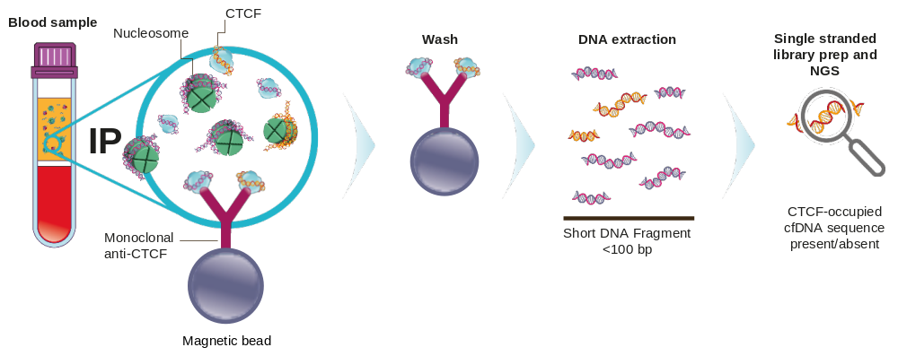

Supplementary Figure 2. The number of unique CTCF ChIP-seq peaks representing short 35-80 bp cfDNA fragments in plasma samples from 11 healthy subjects, 49 cancer patients and 10 patients with an inflammatory condition

