A longitudinal single-nucleus transcriptomic atlas of the bovine placenta reveals dynamic cellular hierarchies and regulatory networks during gestation

Guanghui Tan^{1, 2, 3}, Xiaoru Yan^{2, 4}, Xuesha Cao^{1, 2}, Ao Zhang^{1, 2}, Tao Shi^{1, 2}, Yaqi Zhou^{1, 2}, Xi Guo^{1, 5}, Haoping Wang⁶, Hengkuan Li^{1, 2}, Jiezhang Li⁷, Yingran Liu^{1, 2}, Xihong Wang^{1, 2}, Yu Jiang^{1, 2}*, and Yi Zheng¹*

Supplementary Figs
Fig. S1: H&E staining images of placental samples from different cow breeds on E60.
Fig. S2: Construction of a single-cell transcriptomic atlas of the bovine placenta throughout gestation.
Fig. S3: Activity of bovine trophoblast-stage-specific TF regulatory networks in other species.
Fig. S4: GSEA of transcriptomic dynamics during UNC differentiation in cows.
Fig. S5: RSS of stage-specific TFs.
Fig. S6: Top 30 predicted target genes of the stage-activated regulon in UNCs during E14-E30.
Fig. S7: Molecular characterization of bovine trophoblast differentiation.
Fig. S8: Comparative analysis of GL-relevant scores and gene constraint metrics across species.
Fig. S9: Functional enrichment analyses of stage-specific DEGs in placental macrophages.
Fig. S10: Genetic enrichment of RP-related pathways across cell types.
Fig. S11: Dynamic intercellular communication networks between macrophages and other RP-associated cell types throughout bovine gestation.

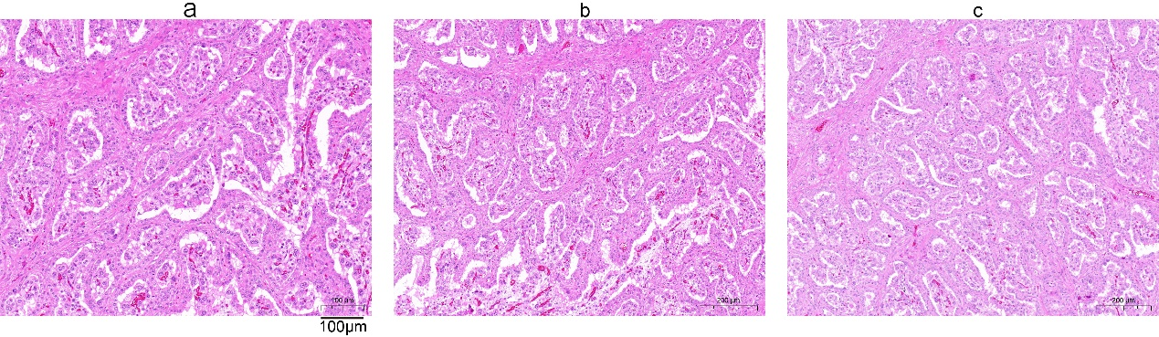
Fig. S1. H&E staining images of placental samples from different cow breeds on E60. a, Holstein (Bos taurus). b, Bos taurus × Bos indicus crossbred. c, Angus (Bos taurus). Scale bar = 200 μm.
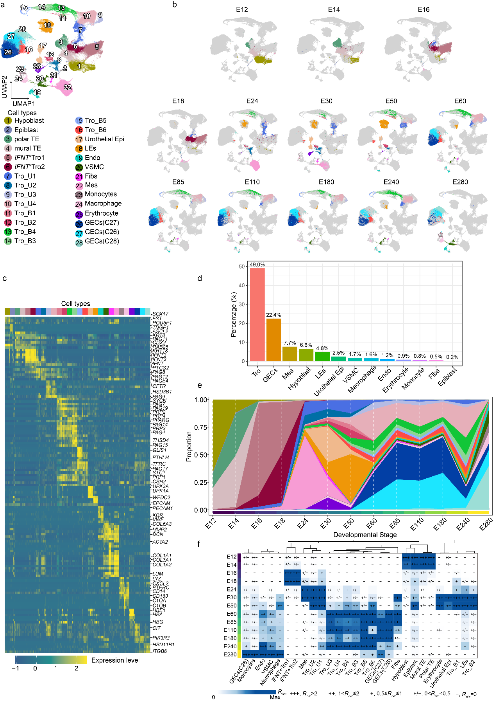
Fig. S2. Construction of a single-cell transcriptomic atlas of the bovine placenta throughout gestation. a, UMAP projection of all cells from all sampled stages, colored and annotated by cell type and subtype. Major cell types include: trophoblasts (Tro; containing subsets such as IFNT⁺ Tro, UNCs, and BNCs), epithelial cells (Urothelial Epi and glandular epithelial cells Les / GECs), vascular-related cells (Endo and VSMCs), mesenchymal cells (Fibs and Mes), immune cells (monocytes and macrophages), and erythrocytes (Ery). b, UMAP projection of each cell type across developmental stages (E12 to E280), showing the distribution of cell types at different time points. c, The heatmap displaying the expression of canonical markers for each cell cluster. Each row represents a representative marker, and each column represents an individual cell. A random subset of 600 cells per cell type was used for visualization. d, The bar plot showing the overall proportional composition of the major cell types. e, Changes in the relative abundance of each major cell type across developmental stages. f, Stage preference of each cluster estimated by SPI. R_{o/e} denotes the ratio of observed to expected cell counts.
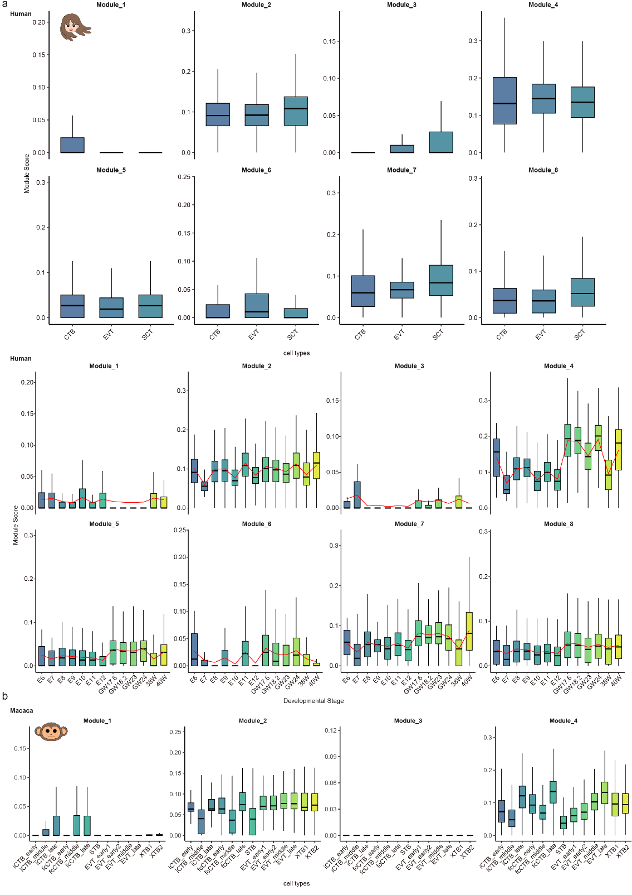
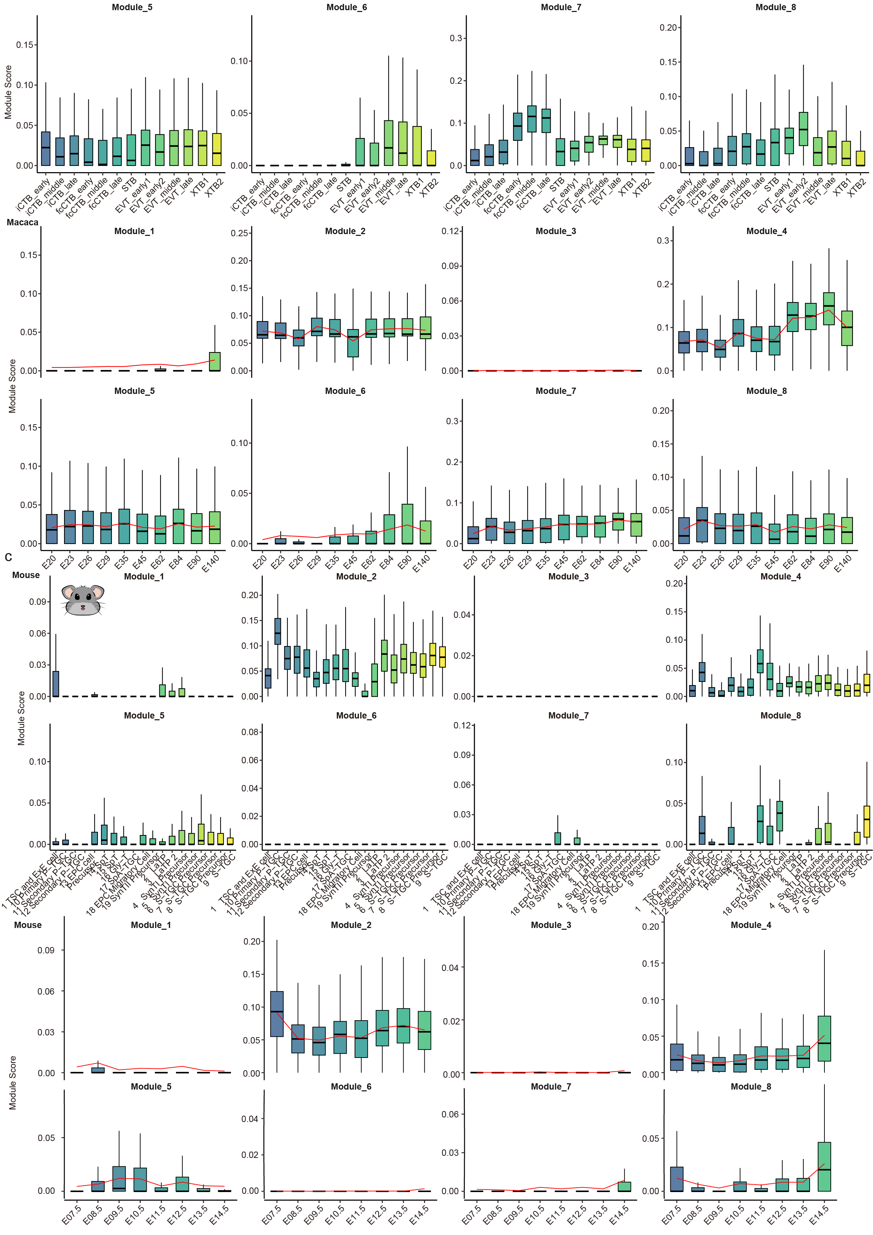
Fig. S3. Activity of bovine trophoblast-stage-specific TF regulatory networks in other species. a-c, Projection of the eight bovine trophoblast transcriptional regulatory networks onto trophoblast cells from (a) humans, (b) macacas, and (c) mice, revealing conserved and species-specific activities across developmental stages and subtypes.
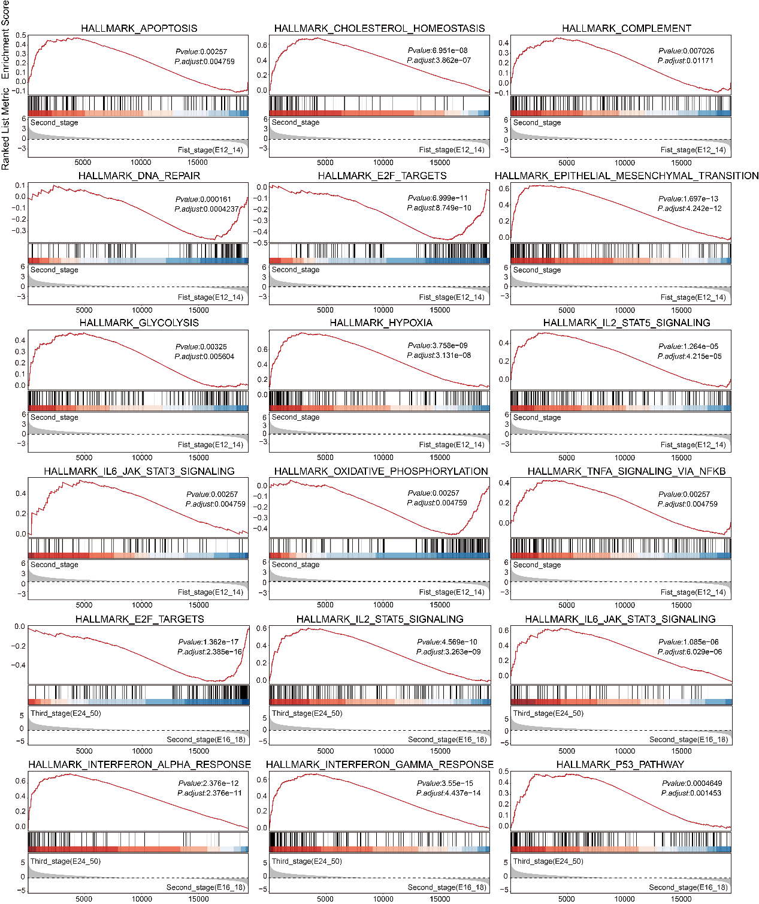
Fig. S4. GSEA of transcriptomic dynamics during UNC differentiation in cows. GSEA was performed using the MSigDB Hallmark gene sets. Only gene sets with more than ten one-to-one orthologous genes between humans and cows were retained. The analysis was conducted with the following parameters: nPermSimple = 10000, pvalueCutoff = 0.05, minGSSize = 20, maxGSSize = 1000, and pAdjustMethod = "BH".
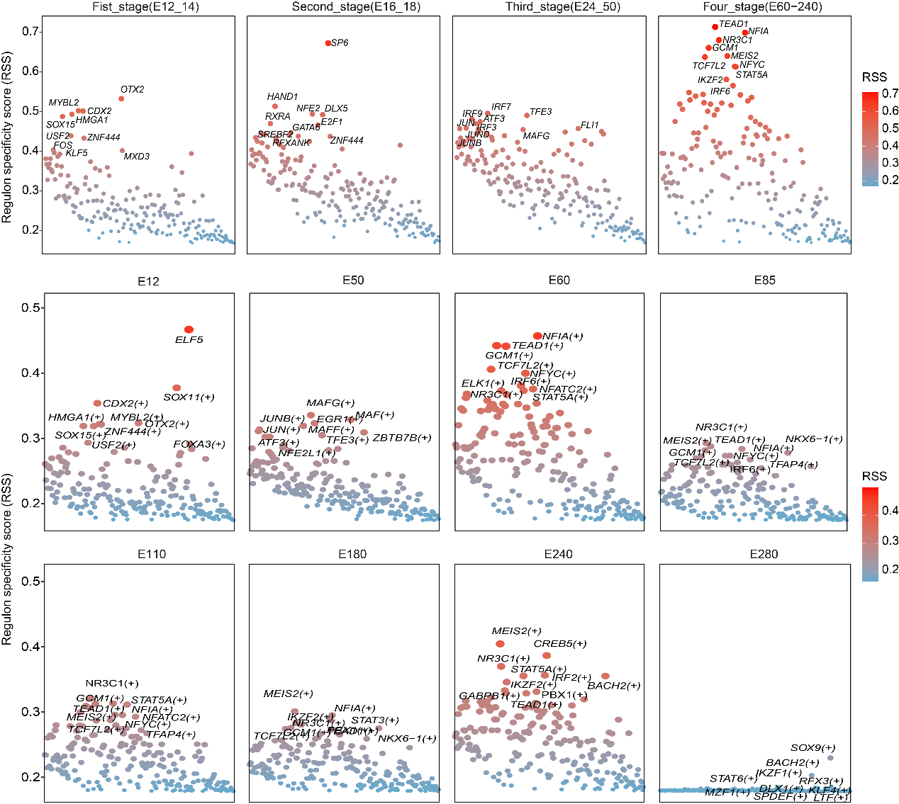
Fig. S5. RSS of stage-specific TFs.
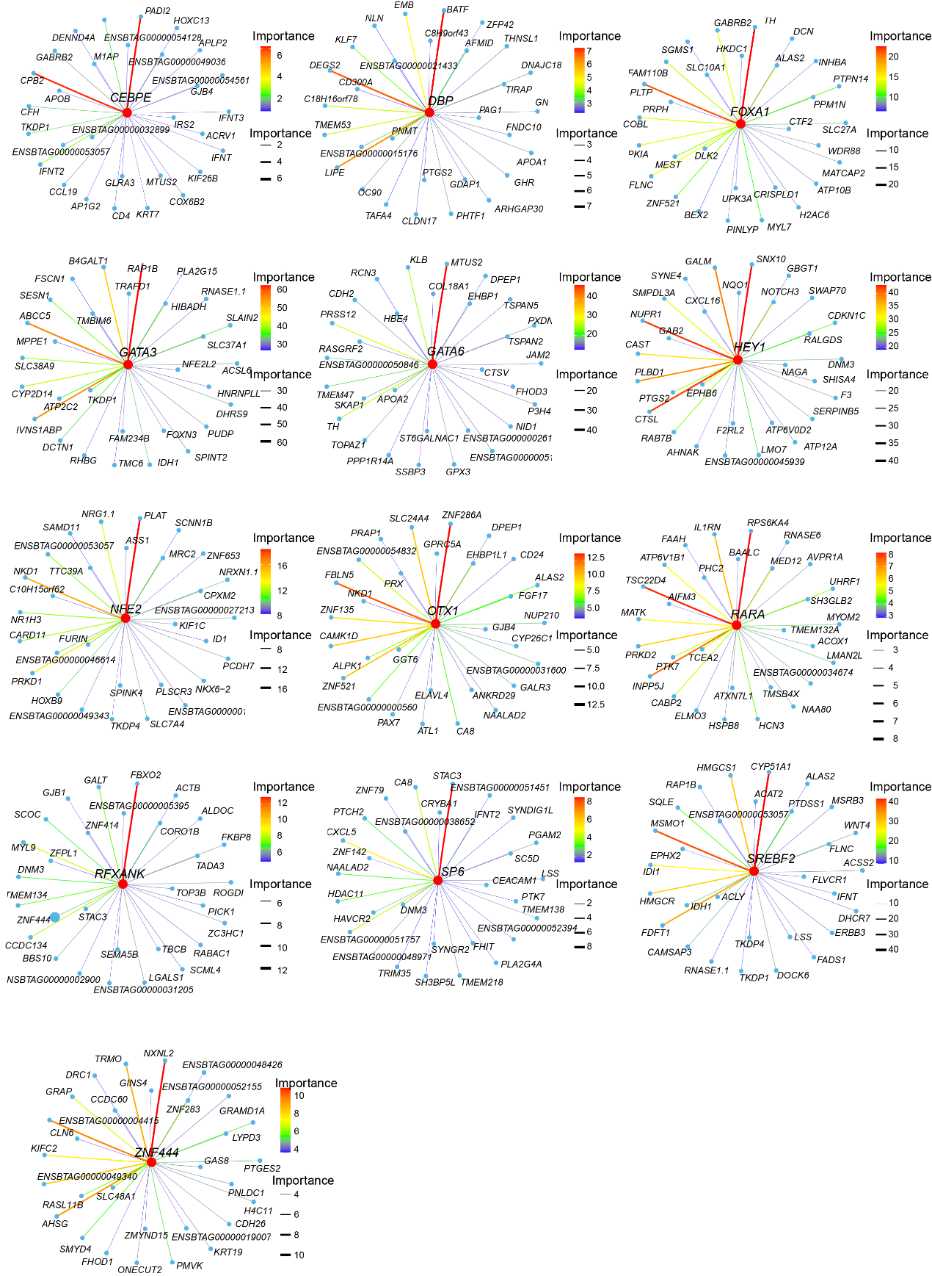
Fig. S6. Top 30 predicted target genes of the stage-activated regulon in UNCs during E14-E30.
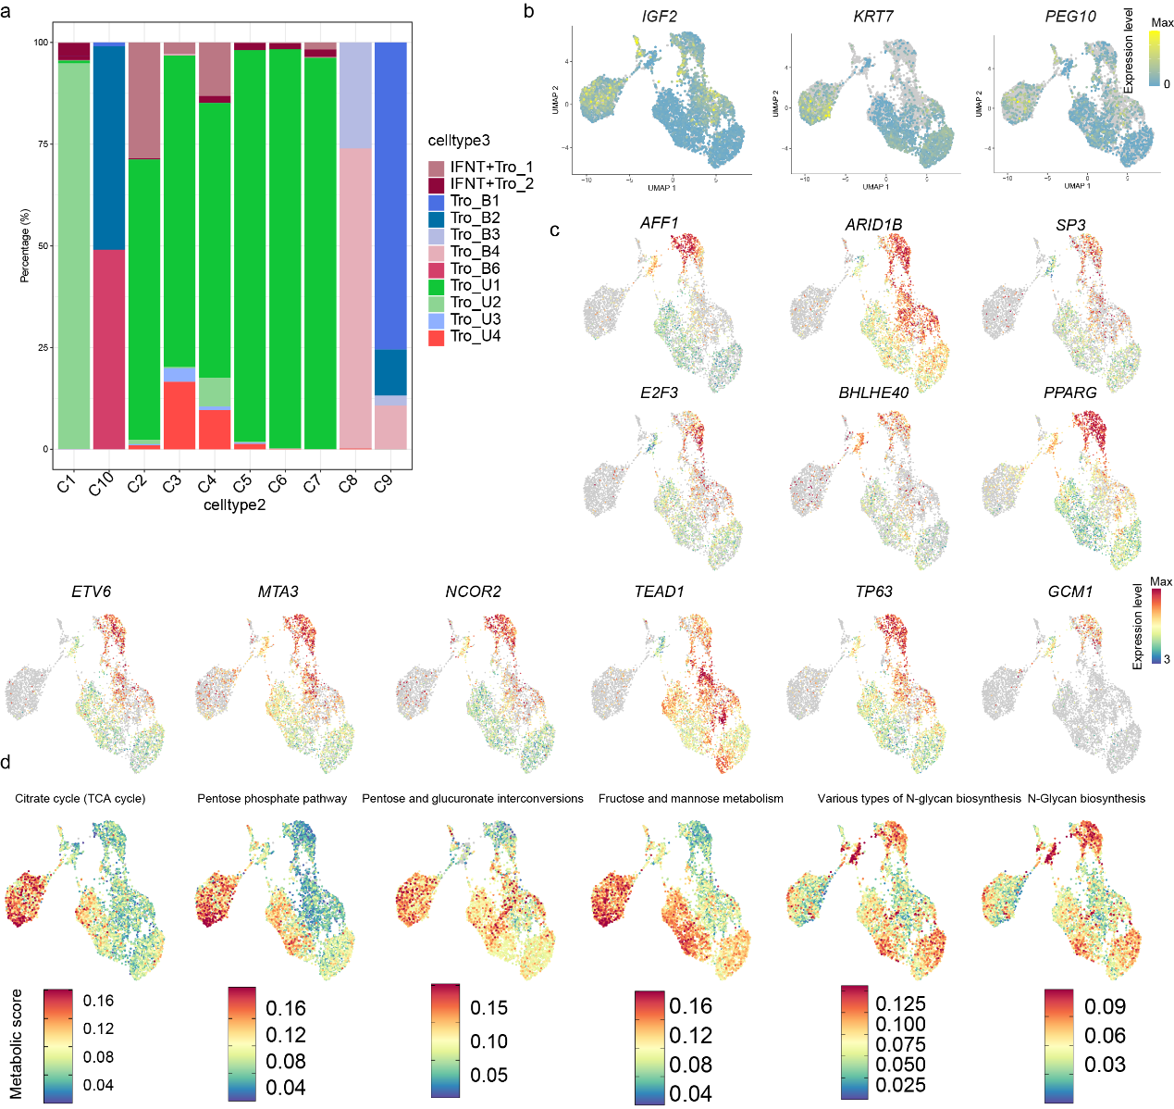
Fig. S7. Molecular characterization of bovine trophoblast differentiation. a, Proportion of E24 trophoblast cells (celltype2 annotation) within the integrated cell atlas (celltype3 annotation). b, Dynamic expression patterns of imprinted genes during trophoblast differentiation. c, Expression changes of key TFs during trophoblast differentiation. d, Metabolic pathway alterations during trophoblast differentiation.
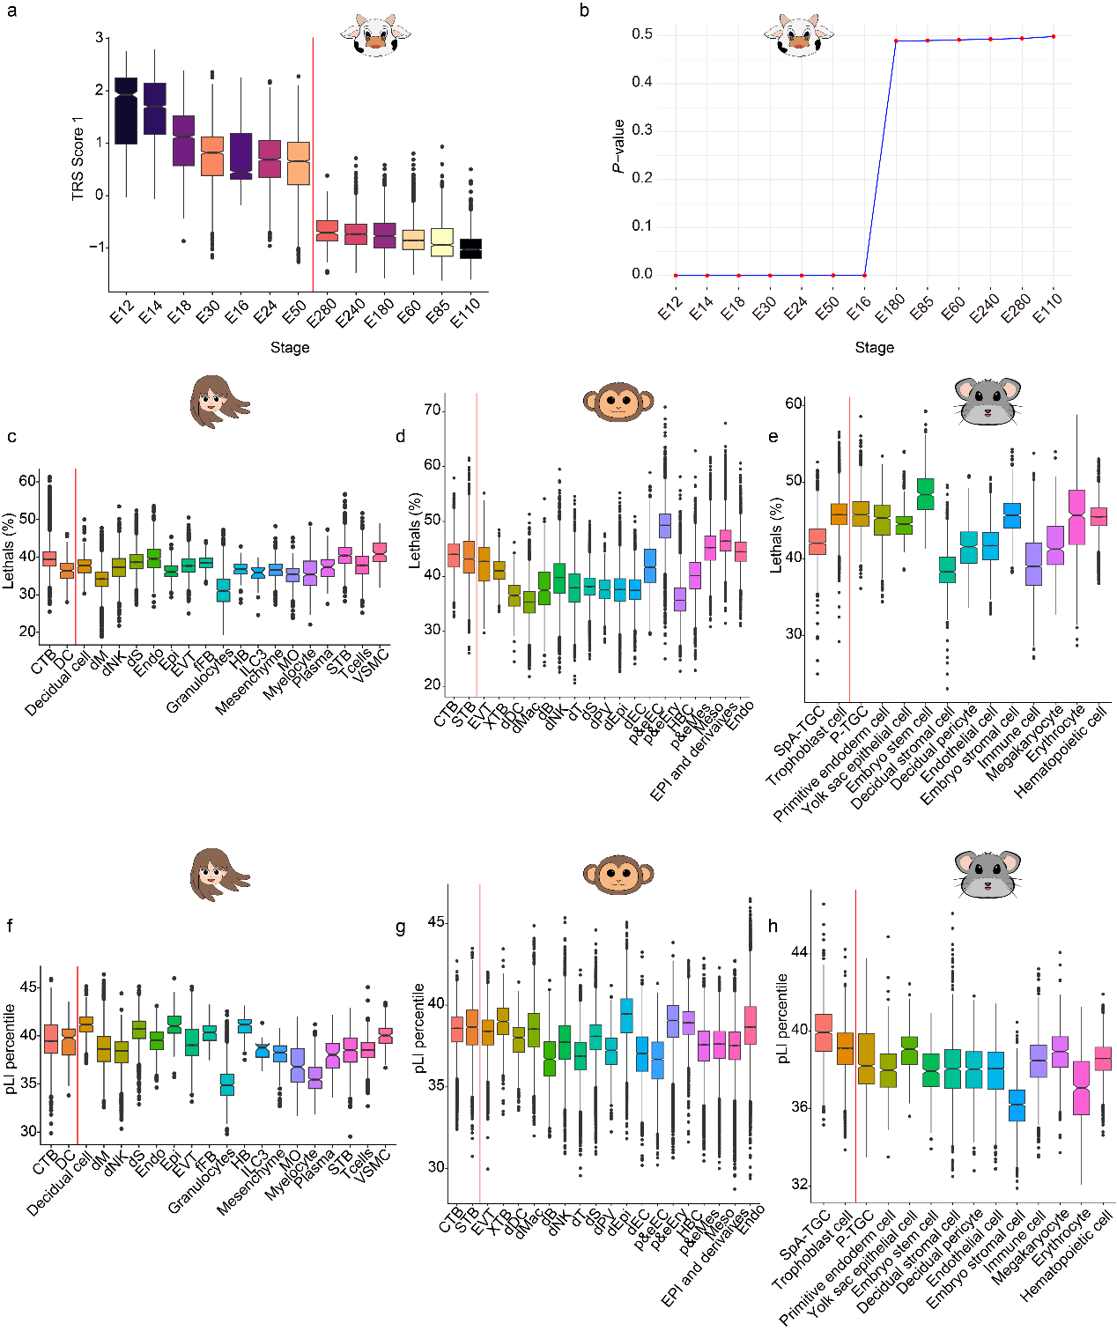
Fig. S8. Comparative analysis of GL-relevant scores and gene constraint metrics across species. a, The box plot showing the distribution of GL-relevant scores across different gestational stages in cows. b, The line plot depicting the statistical significance of GL-relevant scores across bovine gestational stages, expressed as −log₁₀(P‑value). The black dashed line indicates the significance threshold (P < 0.05), and red vertical lines distinguish statistically significant stages from non‑significant stages. c-e, Mean pLI scores of genes expressed in placental cell types from (c) humans, (d) macacas, and (e) mice. The pLI score reflects tolerance to loss‑of‑function mutations, with lower values indicating lower tolerance. f-h, Proportions of expressed genes that led to lethal phenotypes when knocked out in mice (based on 4,742 neutrally ascertained knockouts) in (f) humans, (g) macacas, and (h) mice.
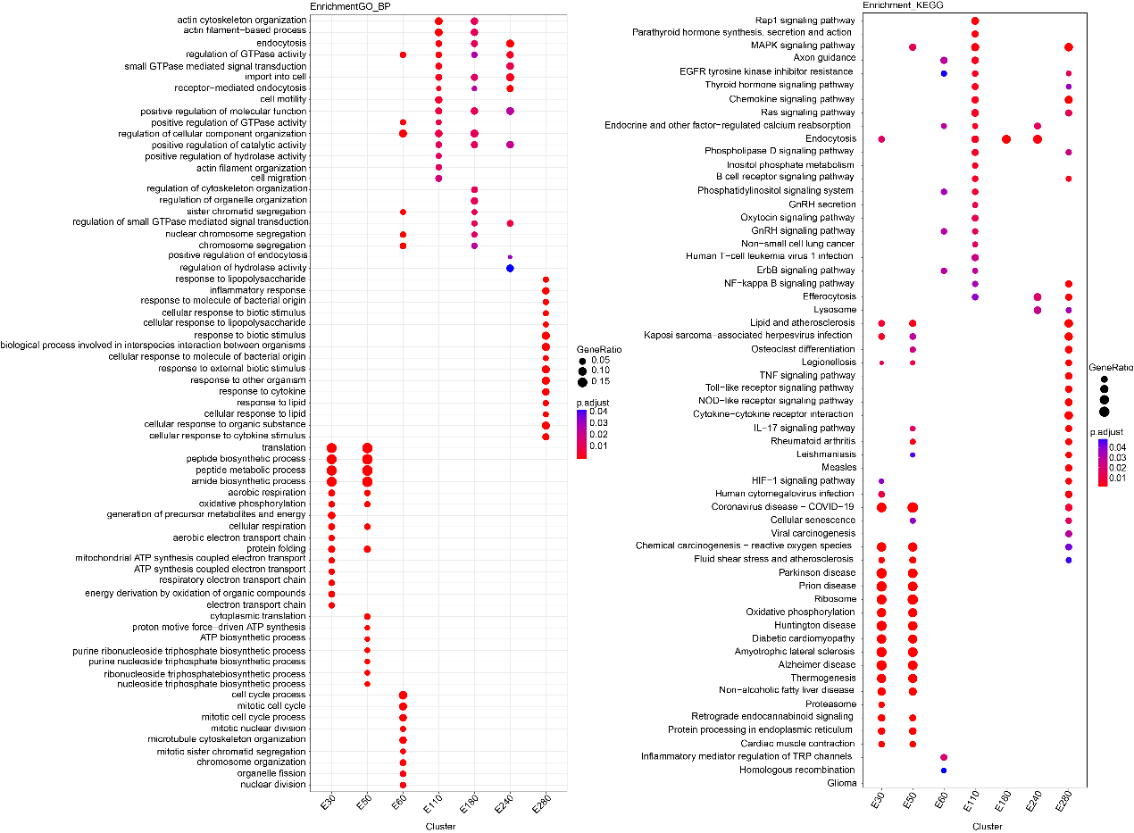
Fig. S9. Functional enrichment analyses of stage-specific DEGs in placental macrophages. Left: the GO-BP analysis; right: the KEGG analysis.
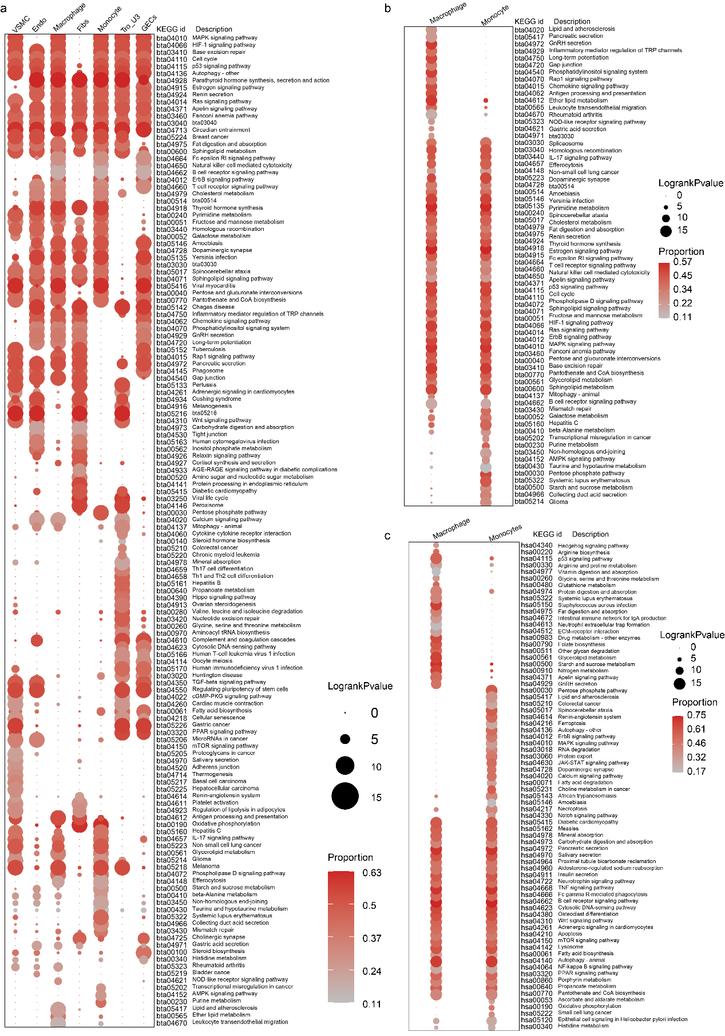
Fig. S10. Genetic enrichment of RP-related pathways across cell types. a, The dot plot displaying the top RP-associated pathways identified in seven major cell types (top 30 pathways per cell type). Dot size represents the −log₁₀(adjusted P-value) for each pathway, and color intensity indicates the proportion of cells influenced by the genetic component of a given pathway (the pathway-level coefficient β > 0) within each cell type. b and c, Top RP-associated pathways (top 50 per cell type) in bovine (b) and human (c) placental macrophages and monocytes.
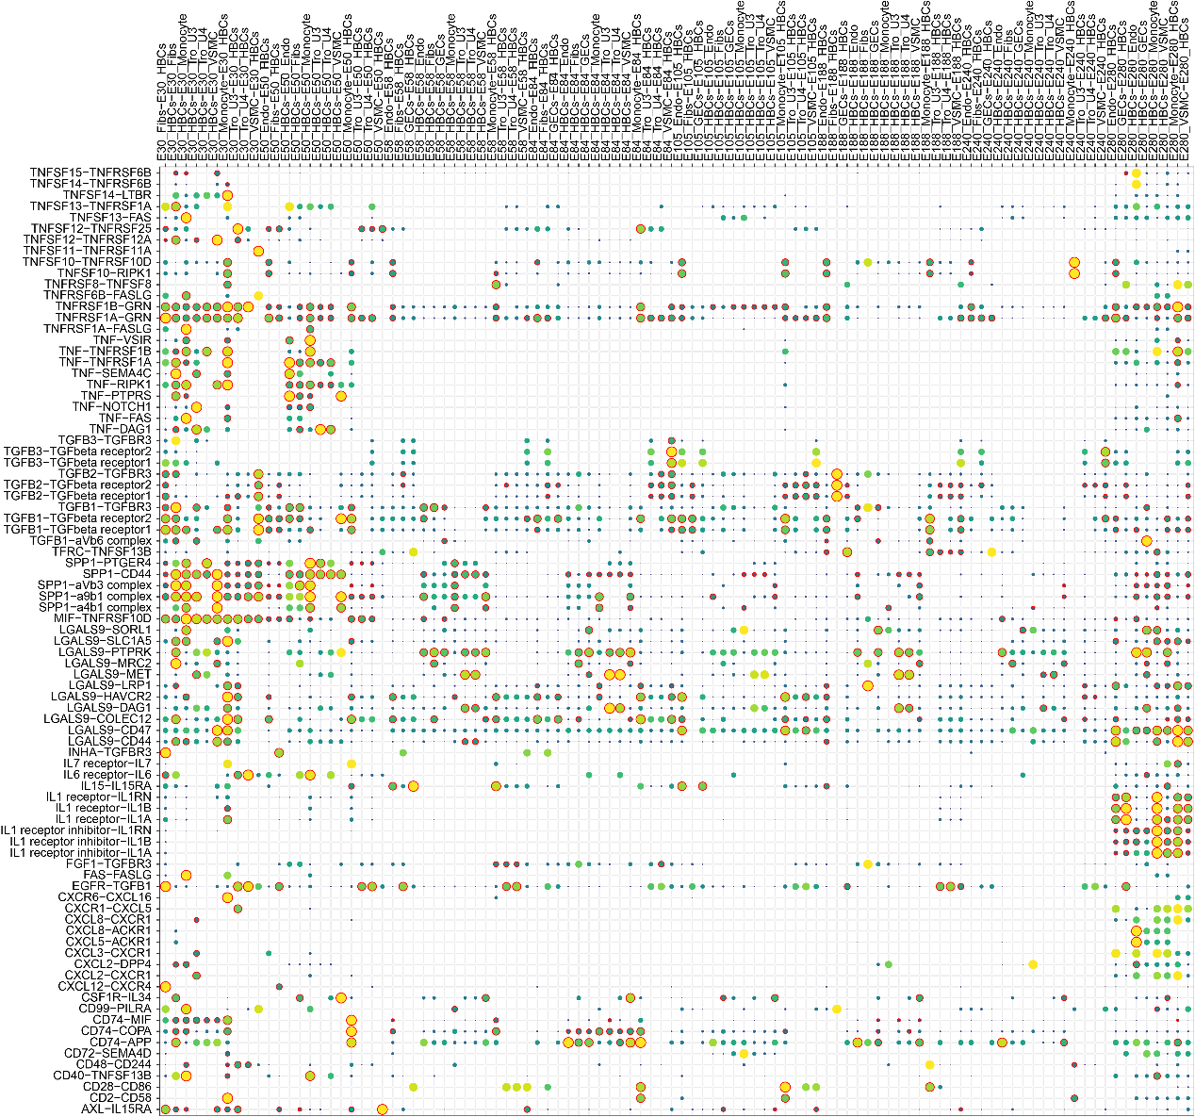
Fig. S11. Dynamic intercellular communication networks between macrophages and other RP-associated cell types throughout bovine gestation.

