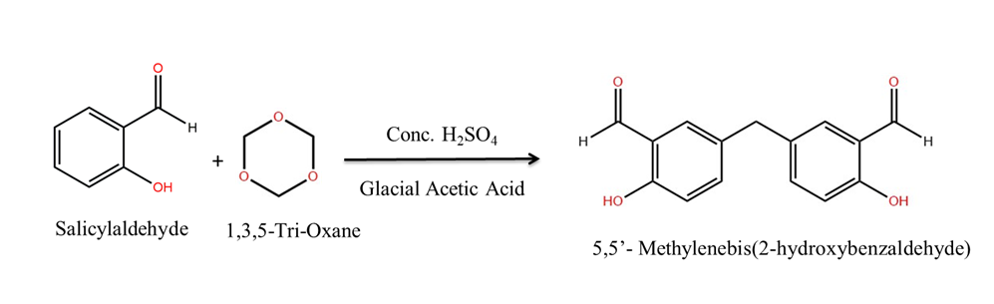
Scheme 1synthesis of 5,5’-methylenebis(2-hydroxybenzaldehyde)

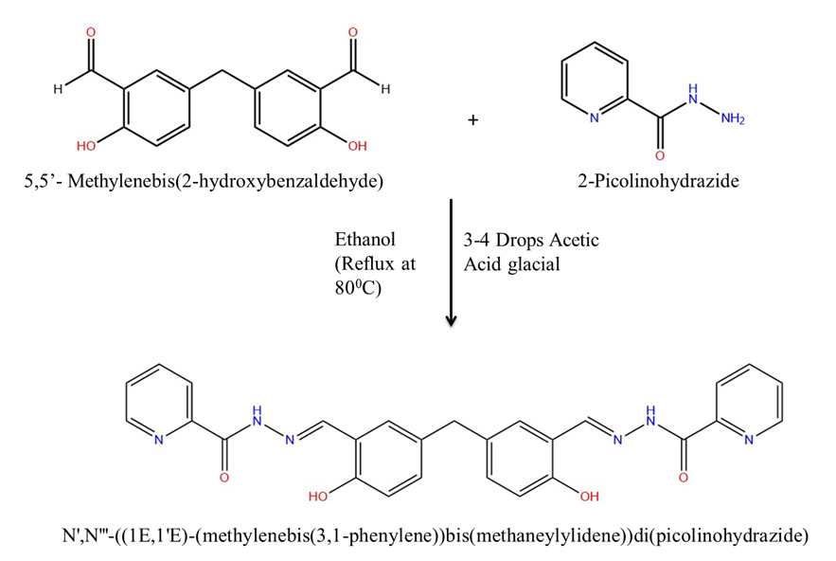

Scheme 2 synthesis of N’,N”-(1E,1E’)-(Methylenebis(6-hydroxy-3,1-phenylene)bis(methaneylydene)di(picolinohydrazide

