Additional information
Extended data
Supplementary information
Supplementary Note 1: Description of Anaerotruncus strain LDE-1
Supplementary Note 2: Description of Lachnospiraceae sp. strain LDE-2
Supplementary Note 3: Materials and methods for bacterial strain analysis
Supplementary Table 1-18
Statistical source data
Image source data

Extended Data Figures
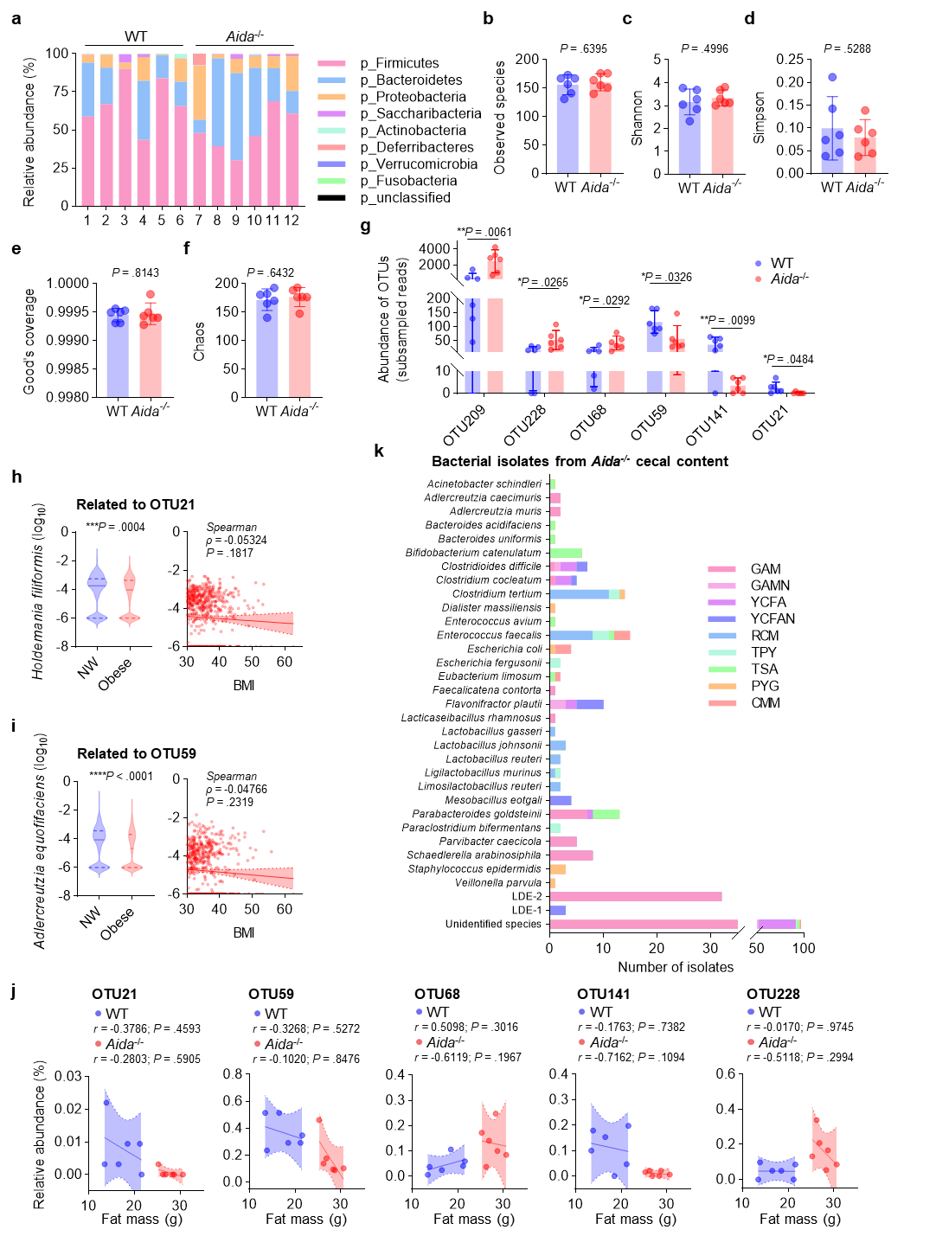
Extended Data Fig. 1: Gut microbiota diversity and strain characterisation in Aida^{-/-} mice.
a, Cecal microbiota composition at the phylum level in WT and Aida^{-/-} mice fed a high-fat diet (HFD). Data are presented as stacked bars, n = 6 mice per group.
b-f, Alpha-diversity metrics of cecal microbiota in wild-type (WT) and Aida^{-/-} mice. Observed species (b), Shannon (c), Simpson (d), Good’s coverage (e), and Chaos (f) indices. Data derived from 16S rRNA gene sequencing. Individual mice (n = 6 per group) are shown with mean ± 95% confidence intervals (CI). Differences assessed by two-tailed unpaired Student’s t-test.
g, Relative abundance of six OTUs significantly altered in Aida^{-/-} mice. Data are individual values (n = 6 per group) with mean ± 95% CI (multiple two-tailed unpaired Student’s t-test).
h,i, Relative abundances of Aida-related bacterial taxa and correlations with body mass index (BMI). Faecal metagenomic data from 355 normal-weight (BMI 18.5–24.9) and 631 obese (BMI > 30) individuals were analysed. Violin plots (left panels) depict the relative abundances of Holdemania filiformis (phylogenetically related to OTU21; h), and Adlercreutzia equolifaciens (phylogenetically related to OTU59; i). Medians (solid lines) and interquartile ranges (dashed lines) are shown. Significance was assessed using two-tailed unpaired Mann-Whitney test. Correlation analyses (right graphs) show Spearman’s rank correlation between BMI and taxon abundances in obese individuals. Correlation coefficients (ρ) and P values are annotated.
j, Pearson correlation analysis between fat mass (%) and relative abundance of OTU21, OTU59, OTU68, OTU141 and OTU228. Shaded regions indicate 95% confidence intervals (CI). Correlation coefficients (r) and P values are annotated.
k, The number of isolates from the cecal content of Aida^{-/-} mice. Gifu anaerobic medium (GAM), GAM + 0.1% taurocholate (GAMN), yeast casitone fatty acids broth (YCFA), yeast casitone fatty acids broth + 0.1% taurocholate (YCFAN), modified chopped meat medium (CMM), TSA medium with 5% defibrinated sheep blood (TSA), rumen bacteria medium (TPY), modified reinforced clostridial medium (RCM) and modified PYG medium (PYG). Thresholds with ≥ 98.7% identity to reference strains as the same species. **P < 0.01, *P < 0.05.

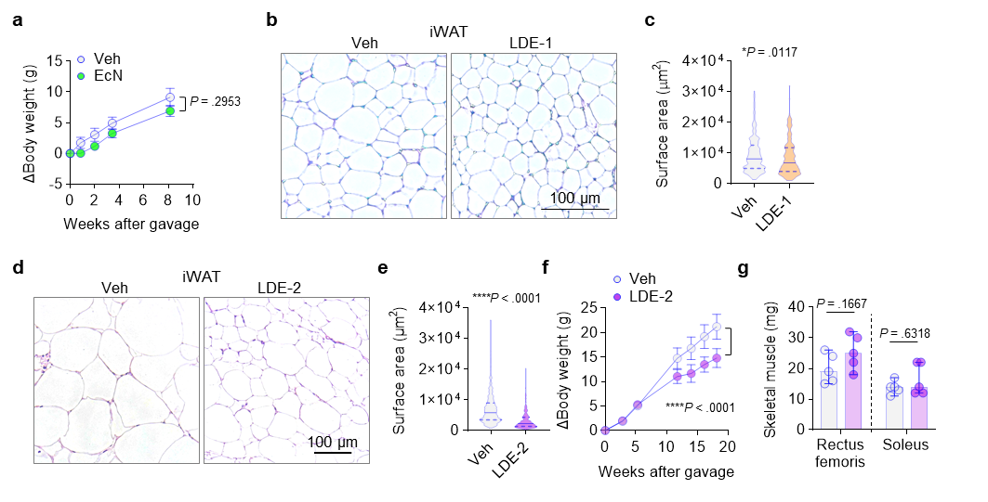
Extended Data Fig. 2: Metabolic and musculoskeletal effects of bacterial supplementation in mice.
a, Body weight trajectories of mice gavaged with Escherichia coli Nissle 1917 (EcN) or PBS control. Slopes were analysed by simple linear regression. Data are mean ± SEM, n = 5-6 mice per group.
b-e, Adipocyte morphology in inguinal white adipose tissue (iWAT). Representative H&E-stained sections from LDE-1- (b) and LDE-2-treated (d) mice. Adipocyte cross-sectional areas in LDE-1 (c; n = 7 mice) and LDE-2 (e; n = 5 mice) groups compared to vehicle controls. Violin plots show median (solid line) and quartiles (dashed lines). Two-tailed unpaired Mann-Whitney test.
f, Long-term body weight changes in mice after LDE-2 or PBS gavage. Slopes analysed by simple linear regression. Data are mean ± SEM; n = 5-6 mice.
g, Rectus femoris and soleus muscle mass 12 weeks post-treatment. Data are individual values (n = 5 mice per group) with mean ± 95% CI. Two-way ANOVA followed by Holm-Šídák’s test. ****P < 0.0001, *P < 0.05.
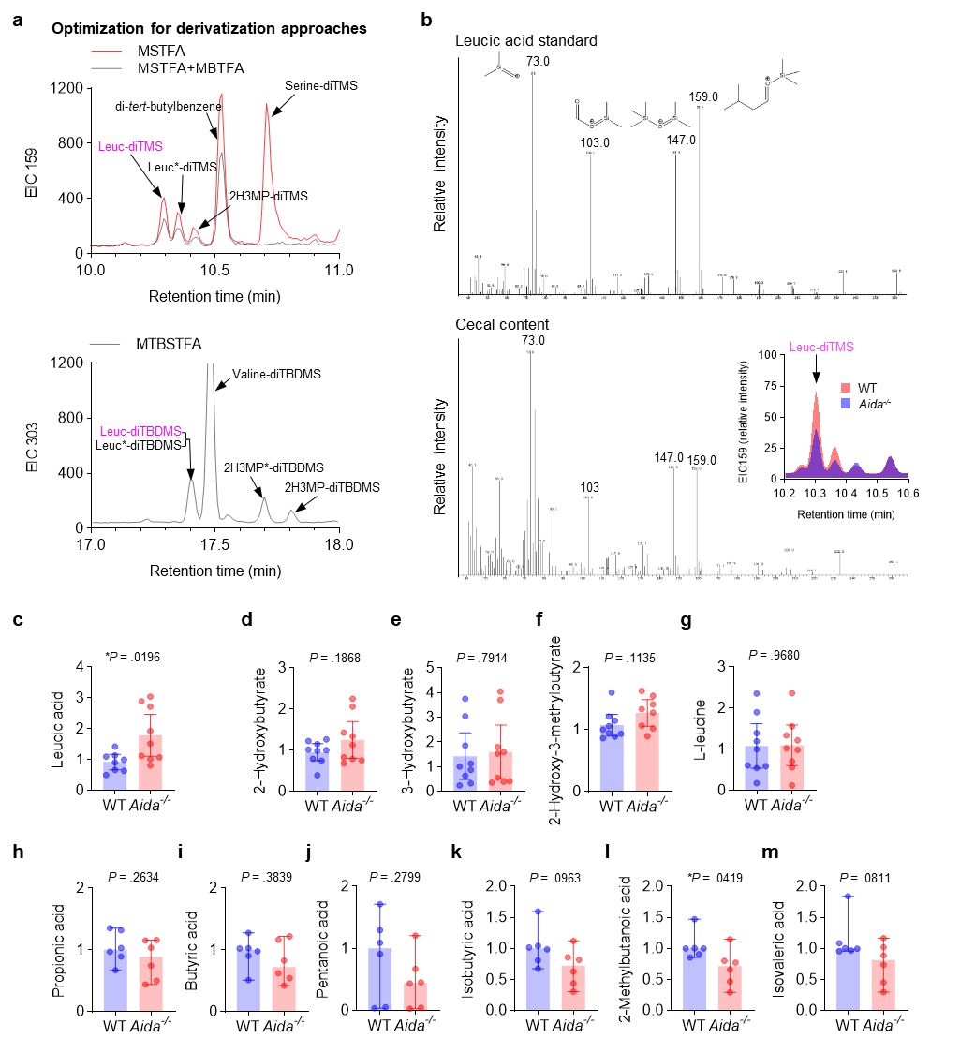
Extended Data Fig. 3: GC-MS quantification of leucic acid in cecal contents.
a, Optimisation of derivatisation approaches for quantification of leucic acid in cecal content. Representative GC-MS chromatograms of cecal content samples from NCD-fed mice administered 50 mM leucic acid for 3 days. Upper panel: comparison of trimethylsilyl (TMS) vs. sequential TMS-trifluoroacetyl (TFA) derivatisation. Lower panel: tert-butyldimethylsilyl (TBDMS) derivatisation. TMS derivatisation achieved a higher signal-to-noise ratio and baseline separation of leucic acid (leuc; 10.30 min) from an uncharacterised structural isomer (Leuc*; 10.35 min) not observed in the leucic acid standard. In contrast, TBDMS derivatisation resulted in co-elution of leuc and leuc* (17.45 min). 2H3MP: 2-hydroxy-3-methylpentanoate.
b, Validation of leucic acid abundance in WT and Aida^{-/-} mice. Cecal contents from HFD-fed mice were analysed by TMS-GC-MS. Leucic acid was identified via retention time alignment with a pure standard and diagnostic fragmentation. Upper, mass spectrum and fragmentation pattern of leucic acid standard. Characteristic ions (m/z 73, 103, 147 and 159) confirm identity. Lower, Selected Ion Monitoring (SIM) chromatograms for quantification of leucic acid (retention time: 10.3 min). Relative abundance was calculated from integrated peak areas.
c-f, Hydroxylated short-chain fatty acids (SCFAs) in cecal contents of WT and Aida^{-/-} mice fed HFD. Leucic acid (c), 2-hydroxybutyrate (d), 3-hydroxybutyrate (e) and 2-hydroxy-3-methylbutyrate (f) levels. Data represent individual mice (n = 8-9 mice per group) with mean ± 95% CI. Two-tailed unpaired Student’s t-test with Welch’s correction.
g-m, L-leucine and Non-hydroxylated SCFAs in cecal contents of WT and Aida^{-/-} mice. L-leucine (g), propionic (h), butyric acid (i), pentanoic acid (j), isobutyric acid (k), 2-methylbutanoic acid (l), and isovaleric acid (m) levels. Data are individual values (n = 6 mice per group) with median ± 95% CI. Two-tailed unpaired Student’s t-test. *P < 0.05.

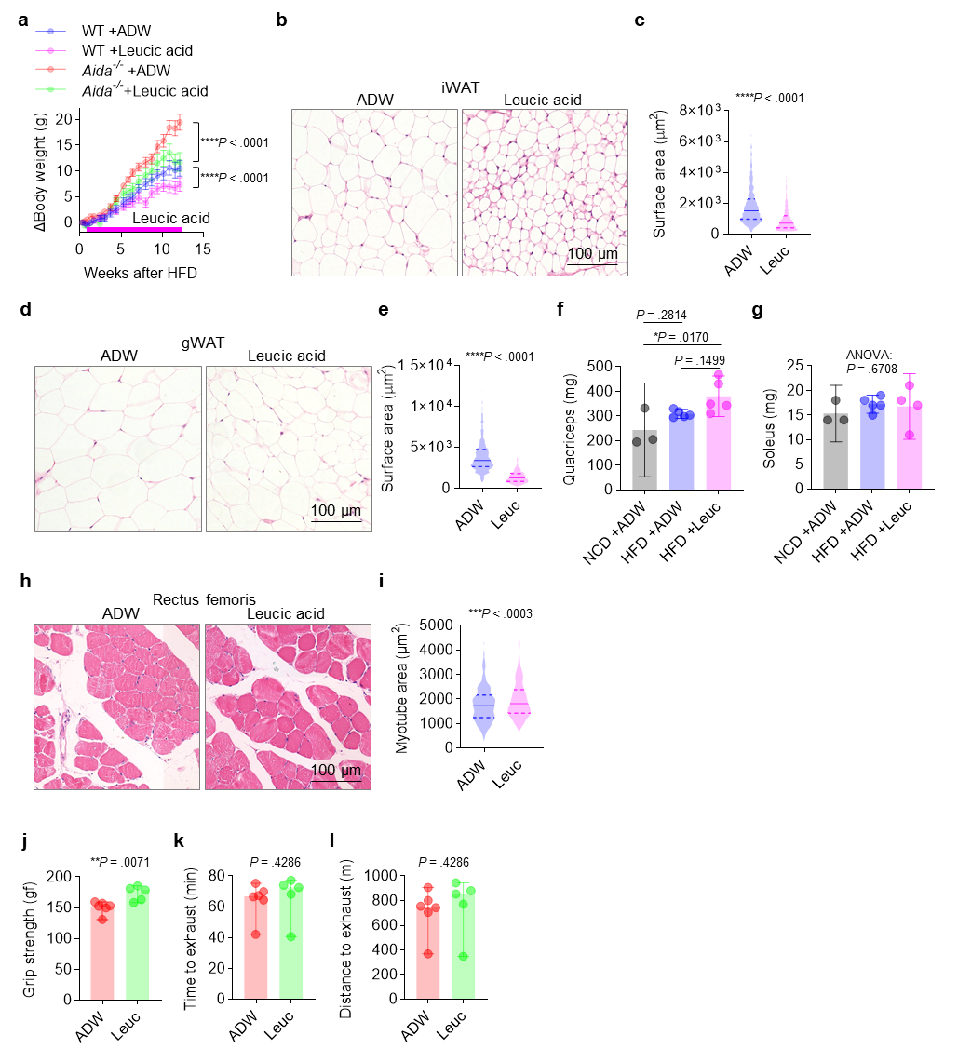
Extended Data Fig. 4: Assessment of safety parameters and related metabolic measures in leucic acid-treated mice.
a, Body weight trajectories of HFD-fed WT and Aida^{-/-} mice administered 50 mM leucic acid or acidified distilled water (ADW, pH-matched control) in drinking water. Slopes were analysed by simple linear regression analysis. Data are mean ± SEM, n = 6 mice per group.
b-e, Adipocyte morphology in iWAT (b, c) and gWAT (d, e). b,d, Representative hematoxylin and eosin (H&E)-stained sections. c,e, Violin plots of adipocyte cross-sectional areas quantified from 3 images per mouse (n = 6 mice per group). Median (solid line) and quartiles (dashed lines) are shown. Two-tailed unpaired Mann-Whitney test.
f,g, Quadriceps (f) and soleus (g) muscle mass. Data are individual values (n = 3-5 mice per group) with mean ± 95% CI. One-way ANOVA followed by Tukey’s test.
h,i, Skeletal muscle histology. h, Representative H&E-stained rectus femoris sections. i, Myofiber cross-sectional areas were quantified from 5 mice per group. Two-tailed unpaired Mann-Whitney test.
j-l, Functional metabolic assessments of Aida^{-/-} mice. j, Forelimb grip strength. k, Time to exhaustion. l, Treadmill exhaustion distance. Data are individual values (n = 5-6 mice per group) with mean ± 95% CI (j) or median ± 95% CI (k, l). Significance was assessed by unpaired two-tailed Student’s t-test (j) or unpaired two-tailed Mann-Whitney test (k, l).

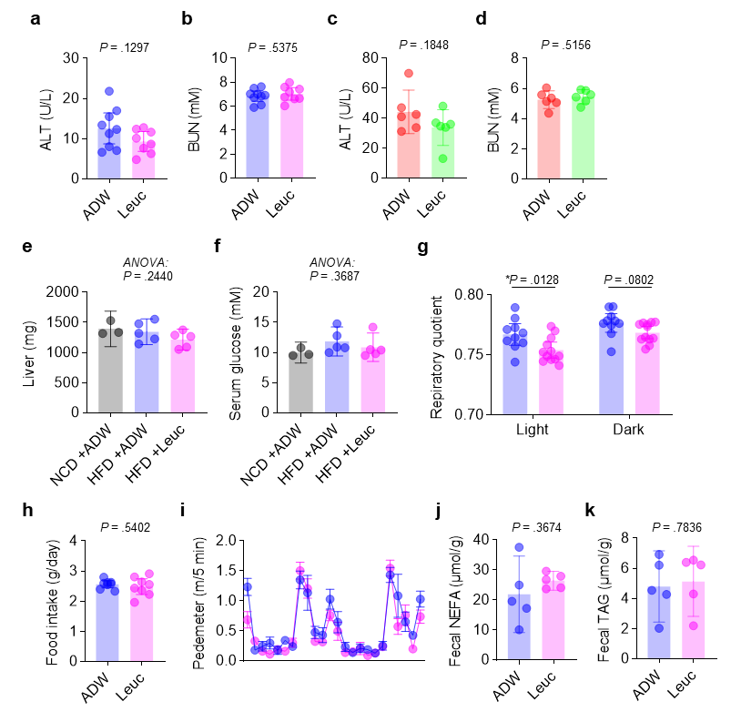
Extended Data Fig. 5: Leucic acid does not cause toxicity or change in HFD-fed mice.
a,b, Serum ALT (a) and BUN (b) levels in WT mice. Data represent individual mice (n = 8-9 per group) with mean ± 95% CI. Unpaired two-tailed Student’s t-test.
c,d, Serum ALT (c) and BUN (d) levels in Aida^{-/-} mice. Data represent individual mice (n = 6 per group) with mean ± 95% CI. Unpaired two-tailed Student’s t-test.
e,f, Liver mass (e) and blood glucose levels (f) in NCD- or HFD-fed mice treated with leucic acid or acidified water (ADW). Data represent individual values with mean ± 95% CI; n = 3 mice (NCD group), n = 5 mice (HFD groups). Statistical significance was determined by ordinary one-way ANOVA.
g, Respiratory quotient (RQ) in HFD-fed mice treated with leucic acid or ADW. RQ was measured over two consecutive days (n = 5-6 mice per group). Data are presented as individual values with mean ± 95% CI. Two-way ANOVA followed by Holm-Šídák’s test.
h, Daily food intake in HFD-fed mice treated with leucic acid or ADW. Food intake was measured weekly per cage (2 cages per group, each housing 5-6 mice). Individual mouse values were calculated by dividing cage-level intake by the number of mice per cage. Data represent estimated individual mouse values with mean ± 95% CI. Statistical significance was determined by two-tailed unpaired Student’s t-test.
i, Locomotor activity in HFD-fed mice treated with leucic acid or ADW. Activity was monitored continuously over two consecutive days using pedmeters (n = 5-6 mice per group). Data are mean ± SEM of pedmeters counts per 5 min interval.
j,k, Faecal lipid excretion in leucic acid-treated mice. Non-esterified fatty acids (NEFA) and triglyceride (TAG) levels in faeces from WT mice administered leucic acid or ADW as a control. Data represent individual biological replicates (n = 5 mice per group) with mean ± 95% CI. Statistical significance was assessed by two-tailed unpaired Student’s t-test. **P < 0.01, *P < 0.05.

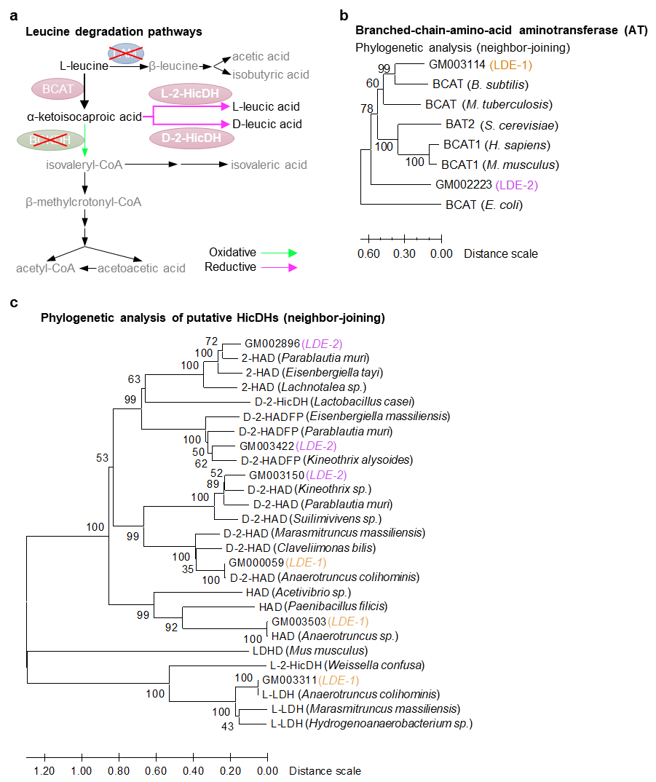Extended Data Fig. 6: Genomic analysis of leucic acid biosynthesis in LDE-1 and LDE-2.
a, Schematic diagram of leucine degradation pathways in bacteria, highlighting L-2-HicDH- or D-2-HicDH-mediated conversion of α-ketoisocaproic acid to L- or D-leucic acid, respectively.
b, Phylogenetic tree of putative branched-chain amino acid aminotransferase (AT) homologs inferred by the neighbour-joining method (500 bootstrap replicates).
c, Phylogenetic tree of putative HicDHs homologs inferred by the neighbour-joining method (500 bootstrap replicates).

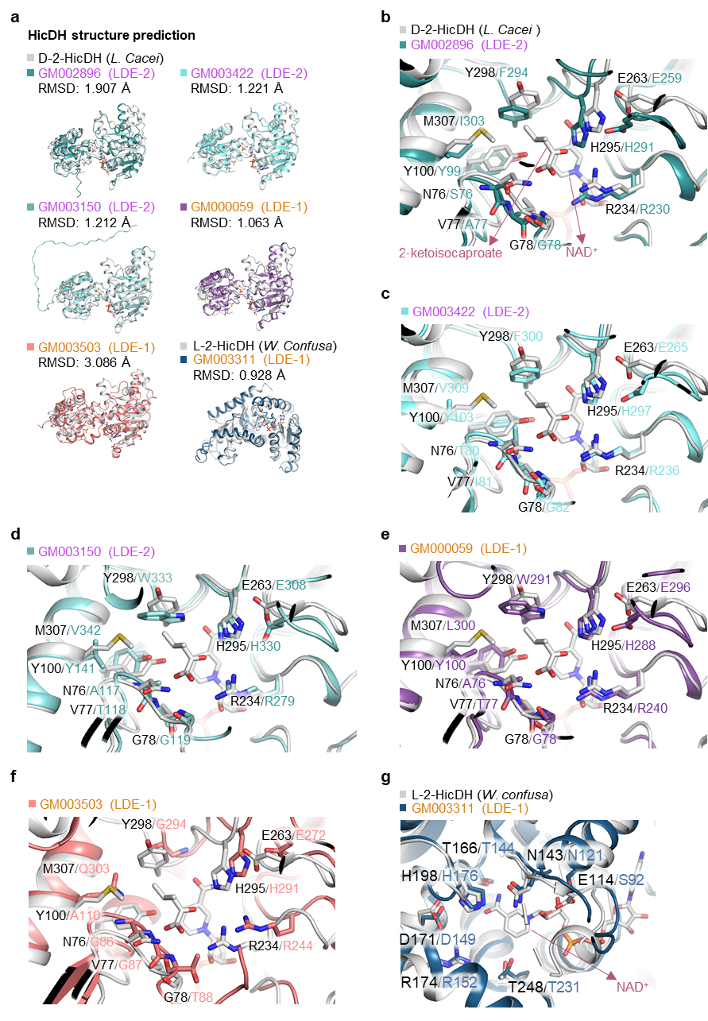
Extended Data Fig. 7: Structural characterisation of HicDH homologs.
a, Structural predictions of HicDH homologs. The structure of DHD2 from Lactobacillus casei (LcDHD2, PDB ID: 1DXY, colored in grey) was aligned with AlphaFold2 predicted structures of LDE-2_GM003150, LDE-1_GM003503, LDE-1_GM000059, LDE-2_GM002896, and LDE-2_GM003422, respectively. The structure of LHD2 (PDB ID: 1LDN, colour in grey) was aligned with AlphaFold2 predicted structure of LDE-1_GM003311.
b-g, Substrate-binding pocket analysis of putative HicDH homologues with 2-oxoisocaproate and NAD⁺. Alignment of key residues in putative HicDH homologs LDE-2-GM002896 (b), LDE-2-GM003422 (c), LDE-2-GM003150 (d), LDE-1-GM000059 (e), and LDE-1-GM003503 (f) vs. the D-2-HicDH from Lactobacillus casei, and LDE-1-GM003311 (g) vs. the L-HicDH from Weissella confusa.

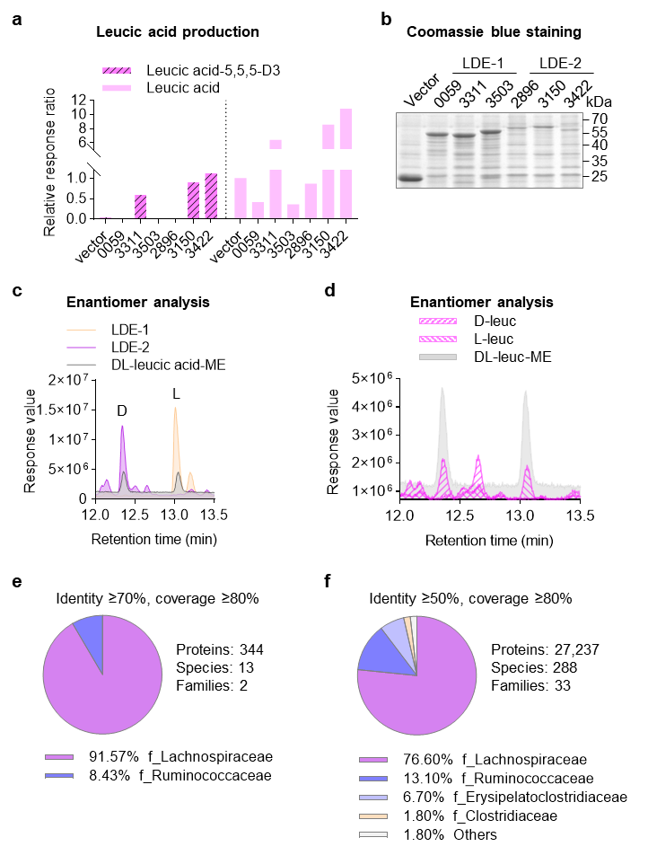
Extended Data Fig. 8: Functional characterisation and gut microbiome distribution of HicDHs from LDE-1 and LDE-2.
a, HicDH-dependent leucic acid production. Isotope tracing using L-leucine-²H₃ in E. coli BL21(DE3) expressing LDE-1/LDE-2 HicDHs. Total and ²H-labelled leucic acid were quantified by LC-MS.
b, Coomassie Brilliant Blue-stained SDS-PAGE of lysates from E. coli BL21 expressing predicted HicDHs. Cells were transformed with pGEX-4T-1 vectors encoding HicDH homologs, induced with IPTG, and lysed. Lysates were resolved by SDS-PAGE.
c, Enantiomeric resolution of bacterially derived leucic acid. Chiral GC-TQ-MS analysis of methyl ester derivatives identifies D-leucic acid (retention time: 12.3 min) as the dominant enantiomer (> 98%) in LDE-2 and L-leucic acid (retention time: 13.0 min) as the dominant enantiomer (> 98%) in LDE-1 cultures. DL-leucic acid methyl ester (DL-ME) standard shown for reference.
d, Gas chromatography (GC) validation of enantiomeric resolution for leucic acid. Representative GC chromatograms of D-, L-leucic acid methyl ester, and racemic DL-leucic acid methyl ester (reference standard). Racemic DL-leucic acid (two peaks) was used to resolve enantiomers, with pure D- and L-leucic acid methyl esters serving as standards to assign peak identities (D-enantiomer at 12.3 min; L-enantiomer at 13.0 min). Derivatised leucic acid methyl esters were separated on a CP-Chirasil-Dex CB column.
e,f, Family-level abundance of putative bacterial HicDH homologs identified by BLASTP alignment of the Unified Human Gastrointestinal Protein (UHGP) catalogue against three functionally validated reference sequences (LDE-1-GM003311, LDE-2-GM003422 and LDE-2-GM003150). Homologs were filtered by ≥80% query coverage and sequence similarity thresholds of (a) ≥70% (high-confidence) or (b) ≥50% (moderate-confidence). Pie charts depict the proportional representation of bacterial families harbouring putative HicDH enzymes. The total number of identified proteins, species, and families for each confidence category is annotated.

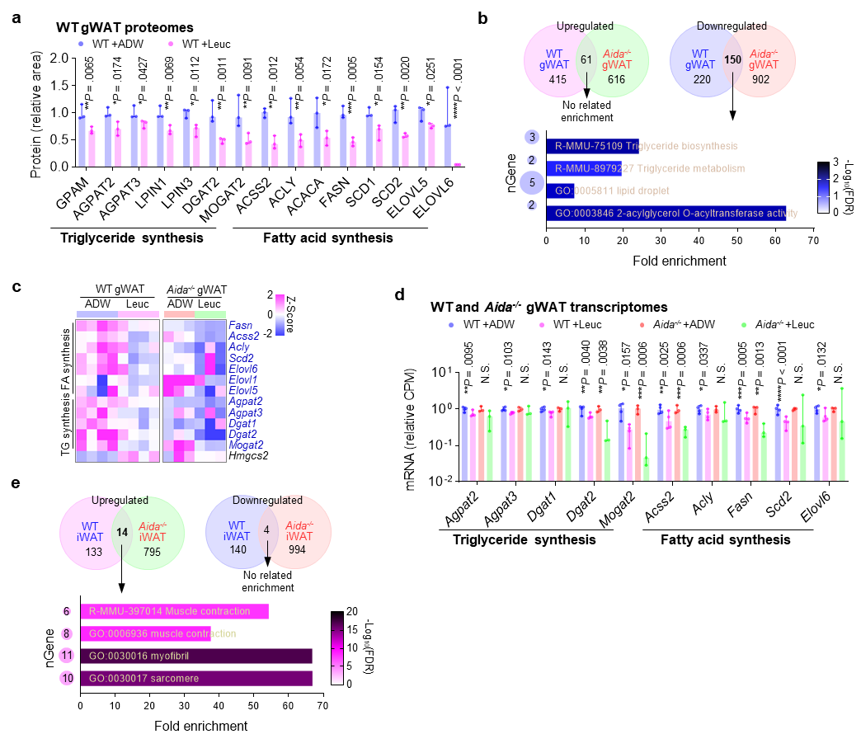
Extended Data Fig. 9: Leucic acid drives divergent regulation of lipid metabolism genes across adipose depots.
a, Proteomic quantification of triglyceride and fatty acid synthesis proteins in WT gWAT (Leuc vs. ADW; limma-voom).
b, Leucic acid-induced transcriptomic changes in gWAT. Upper: Venn diagram of differentially expressed genes (DEGs; |log₂(fold change)| > 0.5, P < 0.05) in WT (n = 4 mice) and Aida^{-/-} mice (n = 3 mice). Lower: enrichment analysis (ShinyGO) of downregulated pathways.
c, Heatmap of mRNA abundance for lipid synthesis enzymes in gWAT of WT (n = 4 per group) and Aida^{-/-} (n = 3 per group) mice after 2- or 4-week treatment.
d, mRNA abundance of lipid synthesis enzymes in WT and Aida^{-/-} gWAT (limma-voom).
e, Leucic acid-induced transcriptomic changes in iWAT. Upper: Venn diagram of DEGs (thresholds as in b) in WT and Aida^{-/-} iWAT (n = 3 mice per group). Lower: enrichment analysis (ShinyGO) of upregulated pathways. ****P < 0.0001, ***P < 0.001, **P < 0.01, *P < 0.05.
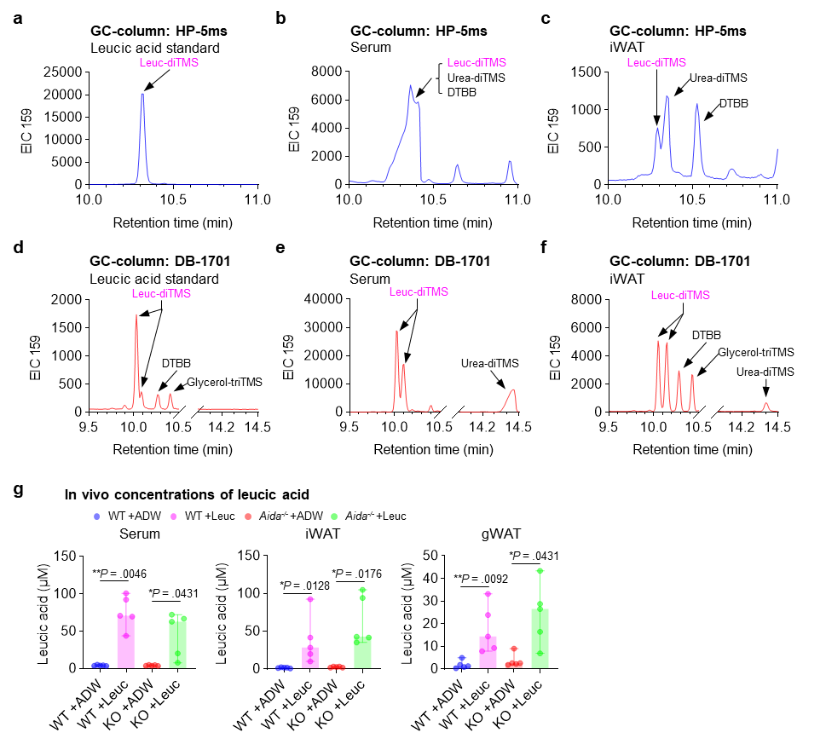
Extended Data Fig. 10: Improved GC-MS quantification of leucic acid and in vivo levels in HFD-fed mice.
a-f, Comparison of GC column performance for leucic acid detection via extracted ion chromatograms (EIC) for m/z 159 ± 0.5. Chromatograms show the TMS-derivatised leucic acid standard, serum and iWAT extracts from NCD-fed mice administered 50 mM leucic acid in drinking water for 3 days. Comparison of a conventional non-polar column (HP-5ms) (a-c) and low/mid-polar column (DB-1071) (d-f) reveals co-elution of TMS derivatives of leucic acid, urea, and the derivatisation agent 1,4-di-tert-butylbenzene (DTBB) on the HP-5ms column as merged peaks in serum (10.2-10.5 min) and iWAT (10.2-10.4 min). Baseline separation of leucic acid (10.0-10.2 min) was achieved using the DB-1071 column.
g, Concentration of leucic acid in HFD-fed mice. Mice were treated with 50 mM leucic acid or ADW for 6 weeks after 3 weeks of HFD. Leucic acid concentrations in serum, iWAT and gWAT were quantified by GC-MS. Data represent individual values with median ± 95% CI; n = 5 mice per group. Statistical significance was determined by Kruskal-Wallis test followed by Dunn’s test. **P < 0.01, *P < 0.05.

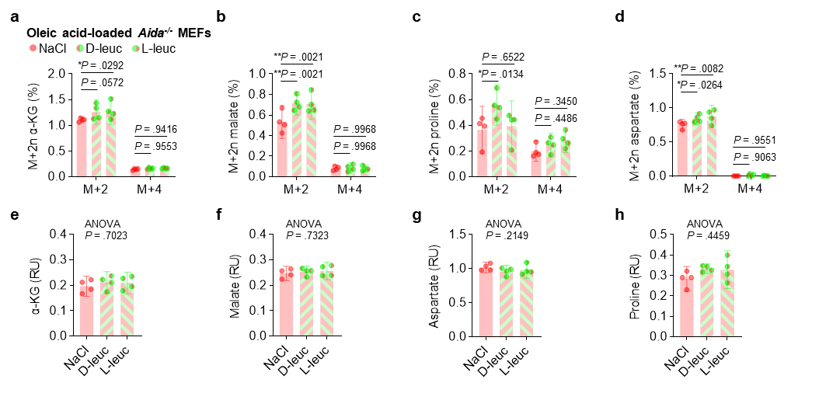
Extended Data Fig. 11: Leucic acid enantiomers differentially regulate fatty acid catabolism.
a-d, Isotopic enrichment in oleate-loaded MEFs. Cells pre-treated with 50 μM D- or L-leucic acid or NaCl for 24 h, then 250 μM [U-¹³C]oleic acid for 1 h. Aida^{-/-} MEFs. The ratio of M+2n species of α-ketoglutarate (α-KG) (a), malate (b), proline (c) and aspartate (d) (n = 4 biological replicates). Data are individual values with mean ± 95% CI, two-way ANOVA followed by Dunnett’s test.
e-h, Total abundance of α-KG (e), malate (f), proline (g) and aspartate (h) in oleate-loaded MEFs. Data are individual plates of cells (n = 4 per group) with mean ± 95% CI, one-way ANOVA. **P < 0.01, *P < 0.05.

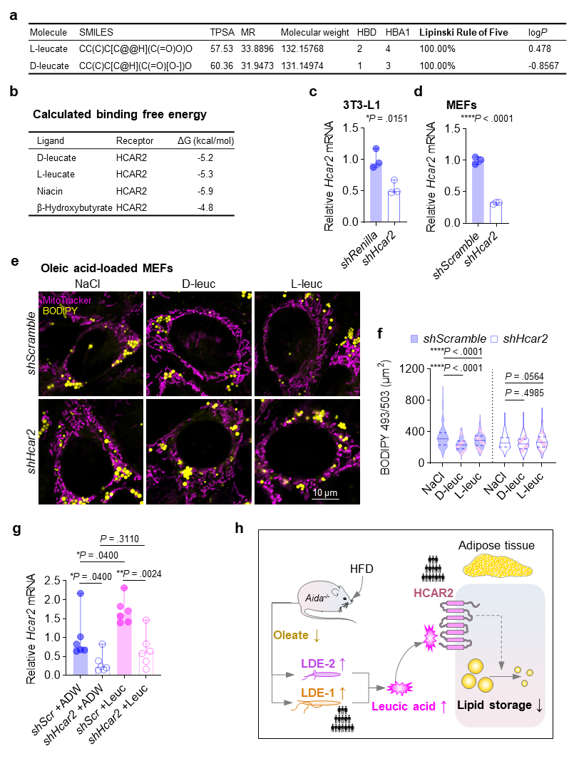
Extended Data Fig. 12: Hcar2-dependent reduction in lipid accumulation in MEFs.
a, Compliance of leucic acid to Lipinski’s rule of five. SMILES: simplified molecular input line entry system; TPSA: topological polar surface area; MR: molar refractivity; HBD: hydrogen bond donors; HBA: hydrogen bond acceptors; logP: lipophilicity-water partition coefficient.
b, Approximate binding free energies for different metabolites to HCAR2.
c,d, Knockdown efficiencies of Hcar2. Cells were infected with lentivirus carrying shRNA against Hcar2 or control shRNA. Relative mRNA levels of Hcar2 to Gapdh in 3T3-L1 cells (c) and MEFs (d). Data are experimental replicates (n = 3) with median ± 95% CI. Two-tailed unpaired Mann-Whitney test.
e,f, Hcar2 knockdown ablates leucic acid effects in MEFs. (e) Representative images: BODIPY (lipids, yellow), MitoTracker (mitochondria, magenta). Scale bar: 10 μm. (f) Quantification of lipid content. Data are presented as individual cells (n = 208-311 per group) with median ± 95% CI. Two-way ANOVA followed by Holm-Šídák's test.
g, Efficiency of AAV-mediated Hcar2 in vivo knockdown. Data are presented as individual fat depots (n = 6 per group) with median ± 95% CI. Two-way ANOVA followed by Holm-Šídák's test.
h, Host-microbe-metabolite axis mediating metabolic homeostasis. AIDA deficiency enhances intestinal lipid absorption, reducing luminal oleate levels and relieving growth suppression of novel obligate anaerobes LDE-1 and LDE-2. These strains biosynthesise leucic acid via HicDH enzymes. As a water-soluble hydroxy acid, leucic acid engages the plasma membrane receptor HCAR2, triggering the suppression of lipid storage in adipose tissues. The enrichment of leucic acid-producing strains represents a compensatory adaptation to host metabolic dysfunction, establishing a feedback loop that mitigates obesity. Human microbiota (abundance of OTU68 represented by LDE-1) and genetic (HCAR2 GWAS) associations underscore the translational relevance of this pathway. ****P < 0.0001, **P < 0.01, *P < 0.05.

Supplementary Note 1: Description of Anaerotruncus strain LDE-1.
Strain LDE-1 is a Gram-positive, strictly anaerobic rod that grows on modified Gifu anaerobic medium (mGAM), GAM, BHI, and Columbia blood agar plates, but only weakly on PYG, TSA, and LB agar. Under transmission electron microscopy, the cells appear rod-shaped, measuring 0.5 μm in width and 3.7-6.9 μm in length, possess flagella, and exhibit a dense cell wall (Note S1a). Strain LDE-1 selectively grows in modified yeast casitone fatty acids broth supplemented with taurocholate (YCFAN). The strain shows selective growth in modified yeast casitone fatty acids broth supplemented with taurocholate (YCFAN). After two days of incubation at 37 °C under an N₂/CO₂/H₂ (85:5:10, v:v) atmosphere, colonies on mGAM agar are circular, convex, creamy white, and exhibit entire translucent margins. Growth occurs at temperatures between 25 and 40 °C (optimum 37 °C) and pH values from 6.0 to 10.0 (optimum pH 7.0–7.5). Using the API 50 CHL system (BioMérieux), strain LDE-1 utilises L-arabinose, D-xylose, L-xylose, D-glucose, inulin, glycogen, D-tagatose, and potassium 5-ketogluconate, and weakly metabolises L-rhamnose, dulcitol, and aesculin. Acid production from glucose, maltose, xylose, and mannose was confirmed with the API 20A system. Using the API Rapid ID 32A kit, positive reactions were observed for indole production and alkaline phosphatase activity.

The genome of strain LDE-1 was sequenced to an average coverage of 277× (Note S1b). It comprises 3,674,259 bp with a G+C content of 53.64 mol%, encodes 3,975 predicted protein-coding genes, and contains one copy of the 16S rRNA gene (1,521 bp). Functional annotation was performed using BLAST searches against the GO (Note S1c) and KEGG (Note S1d) databases. Phylogenetic analysis based on the 16S rRNA gene sequence placed strain LDE-1 within the genus Anaerotruncus, with the closest relatives being Anaerotruncus colihominis (99.17% similarity), A. massiliensis (96.41%), A. rubiinfantis (94.82%) and Youxingia wuxianensis (93.16%). In the phylogenetic tree, strain LDE-1 formed a stable cluster with A. colihominis (Note S1e). Genome-based taxonomic classification using the Genome Taxonomy Database (GTDB) with 120 marker genes, along with average nucleotide identity (ANI) analysis, confirmed that strain LDE-1 belongs to the species A. colihominis with an identity of 99.03% (Table S17 and Note S1f). Therefore, strain LDE-1 represents a novel strain of the species Anaerotruncus colihominis.
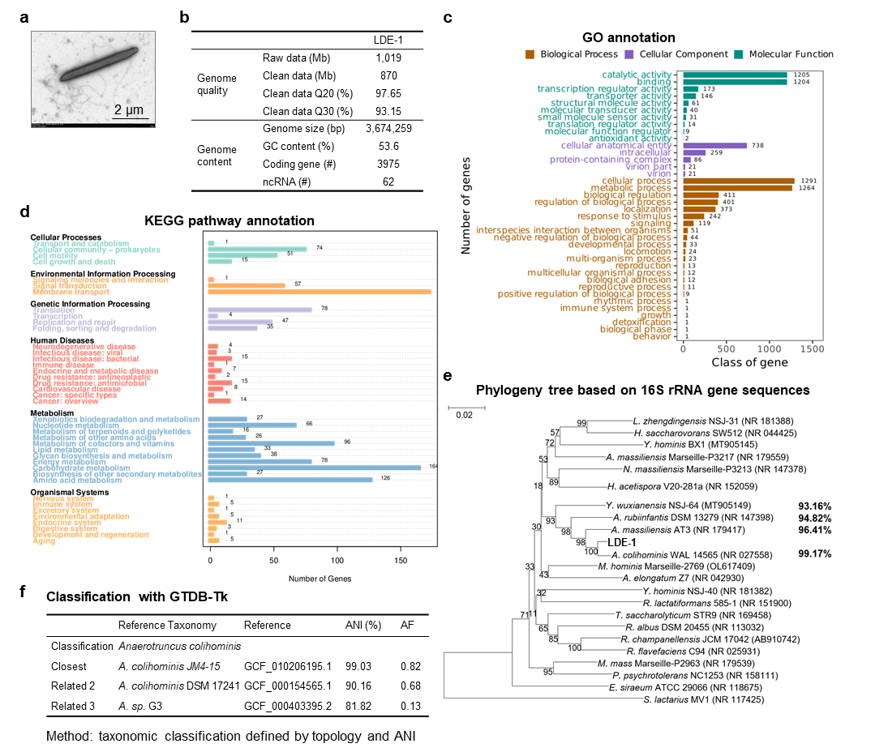
Supplementary Note Fig. 1: Characterisation and genomic analysis of strain LDE-1
a, Transmission electron micrograph of strain LDE-1 following negative staining. (B) Genome assembly metrics of strain LDE-1, including scaffold and contig characteristics. c,d, Functional annotation of the genome based on Gene Ontology (GO) and KEGG pathway analyses. e, Neighbour-joining phylogenetic tree based on 16S rRNA gene sequences, constructed using MEGA7. Bootstrap values (1000 replicates) are indicated at branch nodes. The scale bar represents evolutionary distance. Closest related type strains are shown with percentage sequence similarity. f, Taxonomic classification of strain LDE-1 using GTDB-Tk.

Supplementary Note 2: Description of Lachnospiraceae sp. strain LDE-2.
Strain LDE-2 is a strictly anaerobic, Gram-positive rod-shaped bacterium, measuring 0.2-0.5 μm in width and 3.0-6.1 μm in length, and possesses flagella (Note S2A). After 5 days of incubation on mGAM agar at 37 °C under an N₂/CO₂/H₂ (85:5:10, v:v) atmosphere, colonies reach 3-5 mm in diameter, appear round and light yellow, with irregular margins, a rough surface, and are non-hemolytic. Growth occurs at 37 °C and within pH 6.5-8.0 (optimum pH 7.2). No growth is observed on BHI, PYG, LB, or TSA media. According to the API 50 CHL test, the strain utilises maltose, melibiose, sucrose, trehalose, raffinose, and D-pinitol as carbon sources; moderately metabolises galactose, glucose, and fructose; and weakly metabolises D-arabinose, L-arabinose, α-methyl-D-glucoside, and D-tagatose. Using the API 20A system, acid production from sucrose, glucose, galactose, and mannose was detected. The API Rapid ID 32A system yielded positive reactions for α-galactosidase and α-glucosidase.

The complete genome of strain LDE-2 consists of a circular chromosome of 4,120,988 bp with a G+C content of 44.8%. Sequencing reached 367× coverage (Note S2B), and the assembly produced 74 scaffolds (> 500 bp) and 79 contigs (> 500 bp), with an N50 of 147,214 bp. The genome contains 4,425 protein-coding genes, totalling 3,708,483 bp, and one incomplete 16S rRNA gene sequence (1,305 bp). Functional annotation was performed via BLAST against the GO (Note S2C) and KEGG (Note S2D) databases. Based on 16S rRNA gene sequence similarity, the closest related species is Acetatifactor muris (91.78%) within the family Lachnospiraceae. Phylogenetic analysis placed strain LDE-2 within the Lachnospiraceae family, adjacent to genera such as Acetatifactor, Eisenbergiella, Enterocloster, Kineothrix, and Marvinbryantia. In the phylogenetic tree, strain LDE-2 formed a distinct branch (Note S2E), and the low 16S rRNA gene sequence similarity to other known taxa in Lachnospiraceae, suggested that strain LDE-2 represented a novel species, and possibly a new genus, within the family Lachnospiraceae suggests that it may represent a novel species, and possibly a new genus, within this family. Further study is required to clarify its taxonomic status.
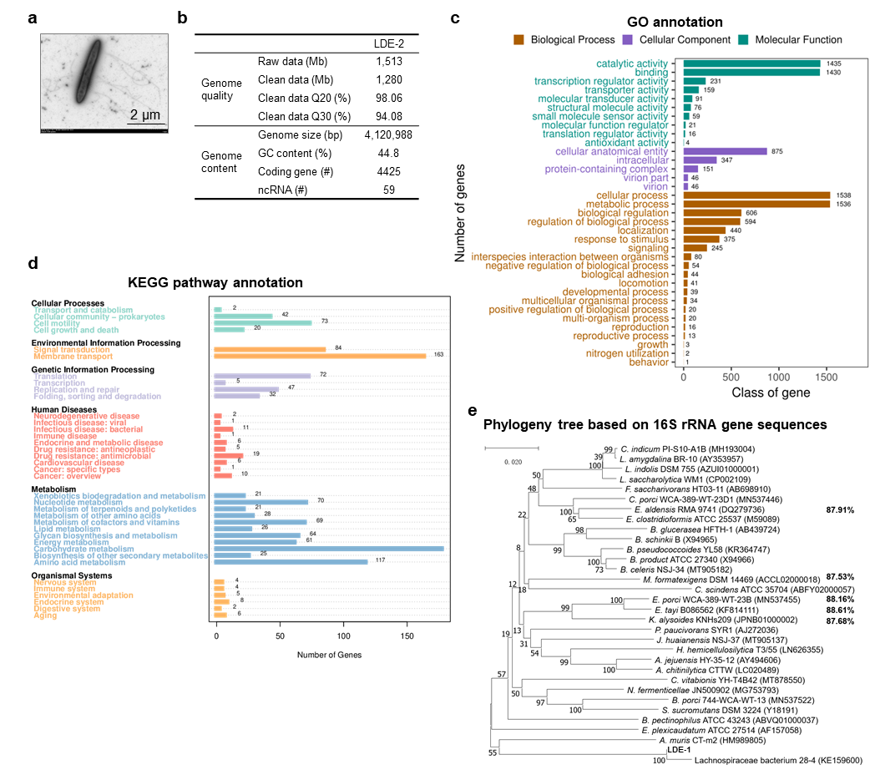
Supplementary Note Fig. 2: Characterisation and genomic analysis of strain LDE-2.
a, Transmission electron micrograph of strain LDE-2 following negative staining. b, Genome assembly metrics of strain LDE-2, including scaffold and contig characteristics. c,d, Functional annotation of the genome based on Gene Ontology (GO) and KEGG pathway analyses. e, Neighbour-joining phylogenetic tree based on 16S rRNA gene sequences, constructed using MEGA7. Bootstrap values (1000 replicates) are indicated at branch nodes. The scale bar represents evolutionary distance. Closest related type strains are shown with percentage sequence similarity.
Supplementary Note 3: Materials and methods for bacterial strain analysis.
Cell motility and morphology were observed using a transmission electron microscope (HT-7800, Hitachi, Tokyo, Japan). Cells in the exponential growth phase were collected from GAM agar for imaging. The temperature range for growth was assessed on GAM agar at 25, 28, 30, 33, 37, and 40 °C to determine the optimal growth temperature. The pH tolerance was evaluated in GAM liquid medium (HB8515, Hope Bio, Qingdao, China) across pH 5.5 to 10.0 (in increments of 0.5 pH units).

Physiological biochemical characteristics and enzyme activities were tested using the API 20A (20300, bioMérieux, Shanghai, China) and API 32A (32300, bioMérieux) systems, while carbon source utilisation profiles were determined with the API 50 CHL kit (50300, bioMérieux), following the manufacturer’s instructions. All API assays were performed in duplicate.

