Supplementary Information for
A unified Symmetry Framework for Spin–Ferroelectric Coupling in Altermagnetic Multiferroics

Wei Sun¹, Wenxuan Wang²*, Changhong Yang, Shifeng Huang¹*, Zhenxiang Cheng³*

1 Shandong Provincial Key Laboratory of Preparation and Measurement of Building Materials, University of Jinan, Jinan, 250022, China

2 School of Material Science and Engineering, University of Jinan, Jinan, 250022, Shandong, China

3 Institute for Superconducting & Electronic Materials, Faculty of Engineering and Information Sciences, University of Wollongong, Innovation Campus, Squires Way, North Wollongong, NSW 2500, Australia

* Corresponding Author

Part 1. The electronic and magnetic properties of MnPS₃ monolayer.

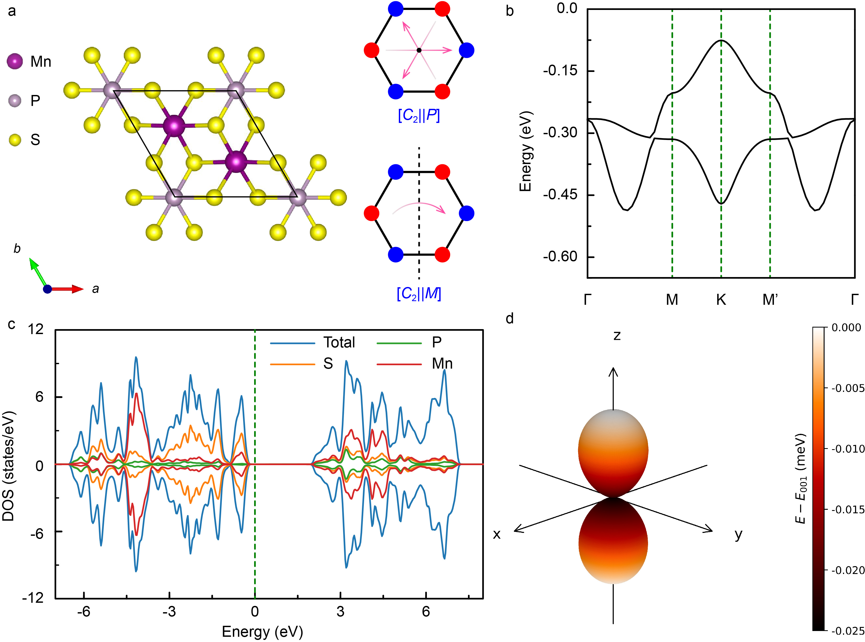
Fig. S1. (a) The top view of the monolayer MnPS₃ structure with a lattice constant of 6.046 Å, exhibiting [C₂||P] and [C₂||M] symmetries. Among these, the [C₂||P] symmetry-protected system exhibits (b) a spin-degenerate antiferromagnetic band structure. (c) represents the density of states of monolayer MnPS₃. (d) displays the magnetic anisotropy energy, indicating easy-plane anisotropy.

Part 2. Differential charge distribution of MnPS₃ bilayer.
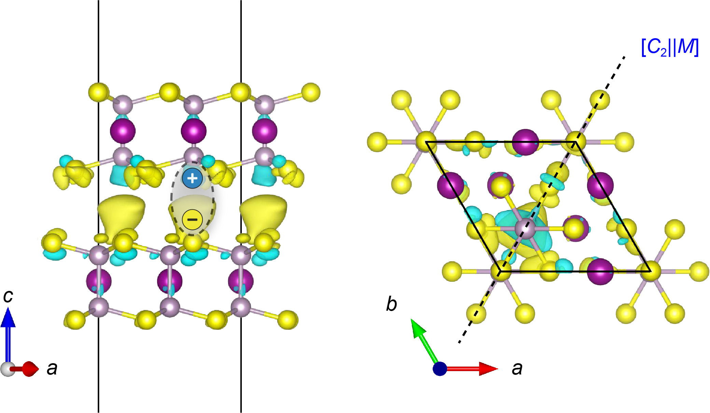
Fig. S2. Differential charge distribution of MnPS₃ bilayer at τ_{o} = (a/3, b/3). The side view clearly shows electron accumulation at the interfacial S atoms and depletion around the P atoms, establishing a vertical out-of-plane dipole moment. In the in-plane direction, mirror symmetry M enforces a symmetric distribution on both sides, thereby aligning the polarization direction with the mirror plane.

Part 3. The electronic structure of MnPS₃ bilayer.

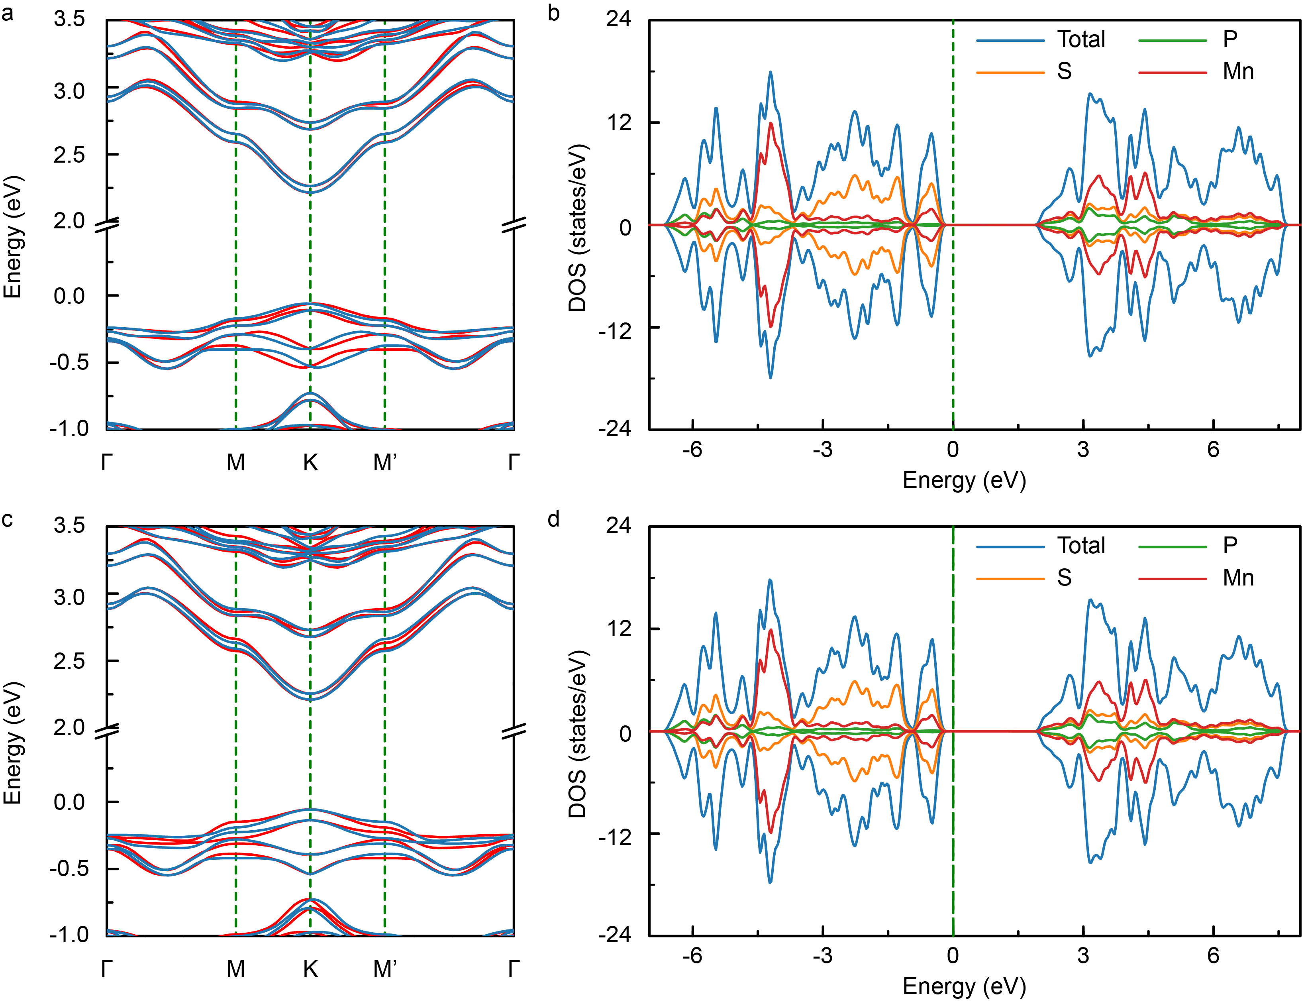
Fig. S3. Panels (a) and (b) respectively correspond to the band structure and density of states (DOS) for the MnPS₃ bilayer with L₁ magnetic ordering; panels (c) and (d) show the counterparts for the L₂ magnetic ordering. The observed similarity in electronic structures between the two orders is indicative of weak interlayer coupling.

Part 4. Band switching during the ferroelectric transition along path 3.

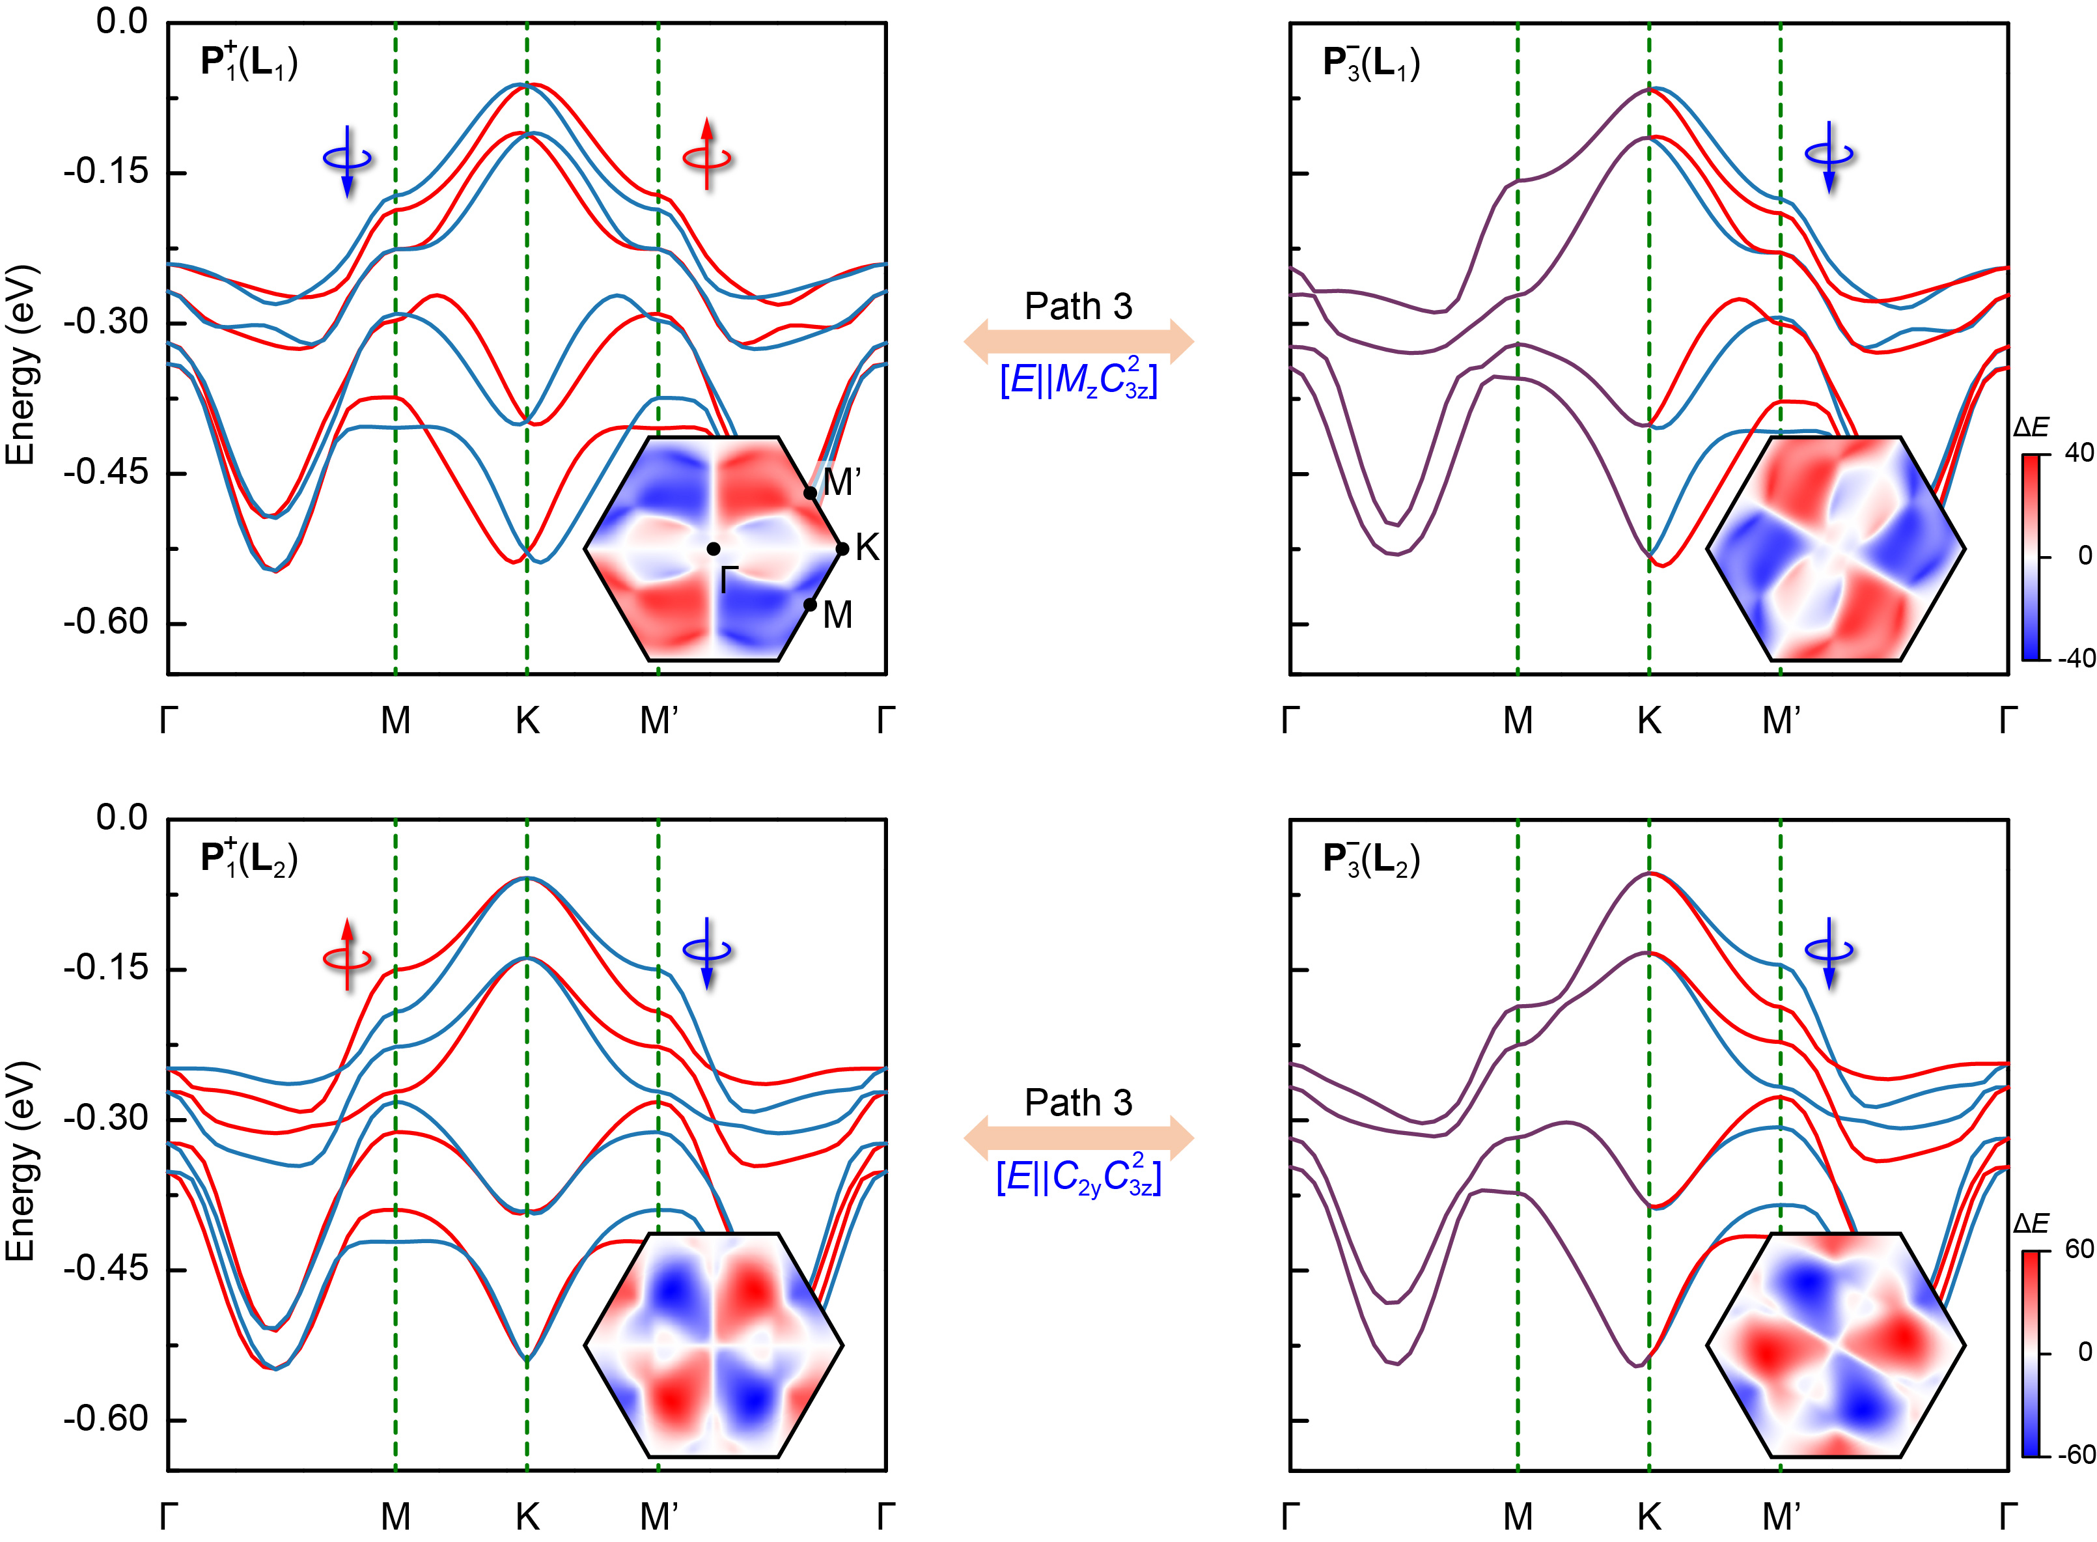
Fig. S4. Band switching during the ferroelectric transition along Path 3 for the L₁ and L₂ magnetic orderings. Similar to Path 2, this process involves an additional $C_{3z}^{2}∉ G$ symmetry operation, it induces a Type III — non-symmetric mapping, geometrically rotating the momentum-space spin texture by 2π/3.

Part 5. Influence of ferroelectric switching along path 3 on the spin-resolved charge conductivity.

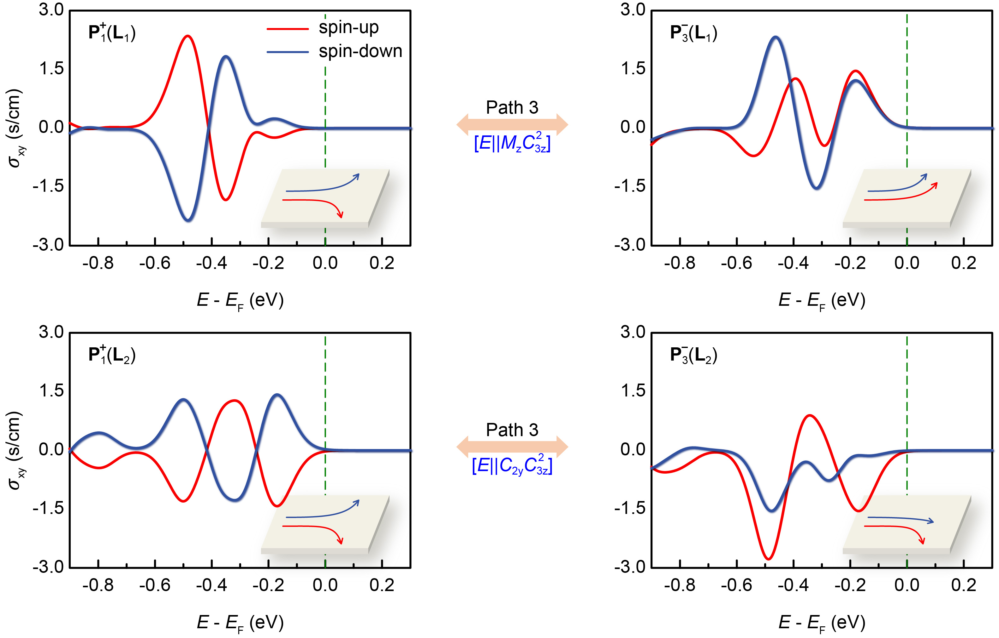
Fig. S5. Switching of the spin-resolved charge conductivity during the ferroelectric transition along Path 3 for the L₁ and L₂ magnetic orderings. The additional $C_{3z}^{2}∉ G$ symmetry rotates the orientation of the mirror plane. When an electric field is applied along the x-direction, which is no longer parallel to the rotated mirror plane, the spin-up and spin-down channels consequently lose their correlation in generating transverse Hall currents along the y-direction, resulting in a distinct asymmetric electrical response.

