Supplementary materials for：
Christiangramia qingdaonensis sp. nov., a novel polysaccharide-degrading Bacteroidota bacterium, isolated from intertidal sediment
Zhao-Tong Chen, Bing Yu, Yu-Shan Li, Zhi-Wei Zhu, Xi-Ying Zhang*, Yi Li*
College of Life Sciences, Shanxi Agricultural University, Taigu 030801, PR China
State Key Laboratory of Microbial Technology, Marine Biotechnology Research Center, Shandong University, Qingdao 266237, PR China

Running title: Christiangramia qingdaonensis sp. nov.
Subject category: New taxa of Bacteroidota
*Correspondence:
Yi Li
College of Life Sciences, Shanxi Agricultural University, Taigu 030801, China;
Tel: 86-354-6286908; Fax: 86-354-6286908; E-mail: liyi@sxau.edu.cn
Xi-Ying Zhang
State Key Laboratory of Microbial Technology, Marine Biotechnology Research Center, Shandong University, Qingdao 266237, PR China
E-mail: zhangxiying@sdu.edu.cn

The GenBank accession numbers for the 16S rRNA gene sequence and the genome sequence of strain ASW11-125^{T} are PV134465 and NZ_JBLWIM000000000, respectively.

Fig. S1 Neighbor-joining phylogenetic tree based on the 16S rRNA gene sequences, showing the phylogenetic positions of strain ASW11-125^{T} (in bold) and the phylogenetically related species. Bootstrap values (> 50%) based on 1000 replicates are shown at nodes. Filled circles indicate branches that were also recovered in maximum-likelihood tree and the minimum-evolution tree. Bar, 0.01 substitutions per nucleotide position

Fig. S2 Minimum-evolution phylogenetic tree based on 16S rRNA gene sequences showing the phylogenetic positions of strain ASW11-125^{T} (in bold) and the phylogenetically related species. Bootstrap values (> 50%) based on 1000 replicates are shown at nodes. Filled circles indicate branches that were also recovered in maximum- likelihood tree and neighbor-joining tree. Bar, 0.01 substitutions per nucleotide position

Fig. S3 Neighbor-joining phylogenetic trees based on 1542 OCs sequences showing relationships between strain ASW11-125^{T} (in bold) and the phylogenetically related species. Filled circles indicate branches that were also recovered in maximum-likelihood tree and minimum-evolution tree. Bar, 0.05 substitutions per amino acid position

Fig. S4 Minimum-evolution phylogenetic trees based on 1542 OCs sequences showing relationships between strain ASW11-125^{T} (in bold) and the phylogenetically related species. Filled circles indicate branches that were also recovered in neighbor-joining tree and maximum-likelihood tree. Bar, 0.05 the number of changes over the whole sequence

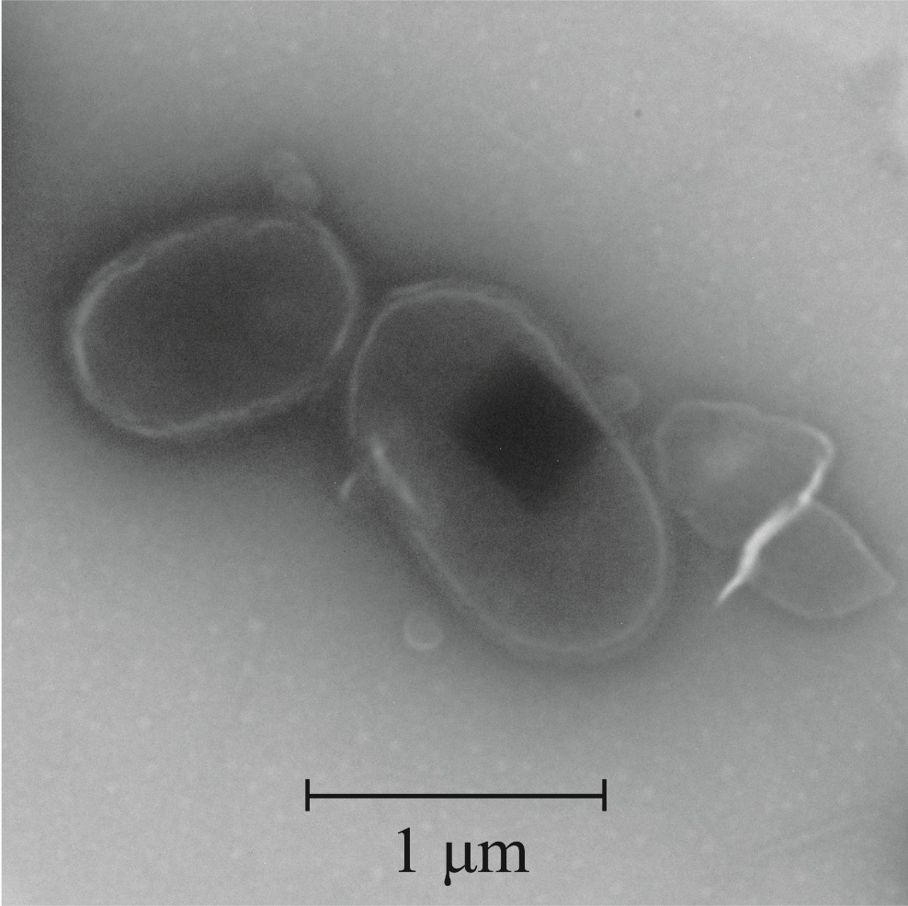
Fig. S5 Transmission electron microscopy image of novel isolate strain ASW11-125^{T} cultured in MA at 28 ℃ for 48 h

Fig. S6 Two-dimensional TLC plate images of lipids of C. qingdaonensis ASW11-125^{T} (a–c), C. portivictoriae MCCC 1A00585^{T} (d–f), C. aquimixticola KCTC 42706^{T} (g–i) and C. marina KCTC 12366^{T} (j–l), which were respectively stained with molybdatophosphoric acid (a, d, g and j), phosphorusmolybdenum Blue (b, e, h and k), and ninhydrin (c, f, i and l). PE, Phosphatidylethanolamine; AL, Aminolipid; L1, unknown lipid; L2, unknown lipid; L3, unknown lipid

Table S1 16S rDNA, average nucleotide identity (ANI) and digital DNA-DNA hybridization (dDDH) values for strain ASW11-125^{T} and other Christiangramia species
NO | Strains | 16S rDNA | ANI | dDDH
1 | Christiangramia portivictoriae DSM 23547^{T} (NZ_AUHF00000000) | 98.8 | 85.2 | 28.7
2 | Christiangramia aquimixticola KCTC 42706^{T} (NZ_JBLVTL000000000) | 98.8 | 74.6 | 18.6
3 | Christiangramia marina KCTC 12366^{T} (NZ_JBLVTK000000000) | 98.6 | 91.5 | 44.3
4 | Christiangramia sabulilitoris HSMS-1^{T} (NZ_VHSF00000000) | 98.3 | 74.2 | 18.4
5 | Christiangramia sediminis ASW11-100^{T} (NZ_JAJBZG000000000) | 98.1 | 75.1 | 18.6
6 | Christiangramia echinicola DSM 19838^{T} (NZ_AUHG00000000) | 97.8 | 75.0 | 18.7
7 | Christiangramia forsetii CGMCC 1.15422^{T} (NZ_BMIX00000000) | 97.5 | 75.0 | 18.7
8 | Christiangramia lutea YJ019^{T} (NZ_JAKVTV000000000) | 97.5 | 74.4 | 18.5
9 | Christiangramia gaetbulicola DSM 23082^{T} (NZ_QBKQ00000000) | 97.1 | 75.3 | 19.5
10 | Christiangramia sediminicola SM2212^{T} (NZ_JAVJIU000000000) | 97.0 | 75.2 | 18.4
11 | Christiangramia crocea YB25^{T} (NZ_JAJSON000000000) | 96.9 | 73.6 | 17.9
12 | Christiangramia aestuarii BS12^{T} (NZ_VJVW00000000) | 96.7 | 73.6 | 18.2
13 | Christiangramia salexigens LPB0144^{T} (NZ_CP018153) | 96.4 | 73.5 | 17.9
14 | Christiangramia flava JLT2011^{T} (NZ_AMRU00000000) | 95.9 | 71.8 | 17.3
15 | Christiangramia jeungdoensis KCTC 23123^{T} (NZ_SNQI00000000) | 94.9 | 68.2 | 16.7
16 | Christiangramia oceanisediminis GC03-9^{T} (NZ_JANCNS000000000) | 94.4 | 73.2 | 17.8
17 | Christiangramia fulva SH35^{T} (NZ_CP028136) | 93.9 | 72.0 | 17.0

Table S2 Genome statistics of strain ASW11-125^{T} and the closely related species
Genomic characteristic | 1 |  | 2 |  | 3 | 4 | 5 |  | 6
Size (Mbp) | 3.2 | 3.3 |  | 3.3 |  | 3.3 |  | 3.5 |  | 3.2
Number of Genes (total) | 3010 | 3103 |  | 3029 |  | 2987 |  | 3207 |  | 2920
Number of proteins | 2981 | 3025 |  | 2964 |  | 2874 |  | 3147 |  | 2864
Pseudogene | 6 | 53 |  | 14 |  | 90 |  | 10 |  | 4
Genes with RAST  (Percentages) | 949  (31.5%) | 996  (32.1%) |  | 976  (32.2%) |  | 961  (32.2%) |  | 978  (30.5%) |  | 945  (32.4%)
G+C content (%) | 38.3 | 40.0 |  | 39.9 |  | 48.0 |  | 39.6 |  | 39.2
rRNA | 3 | 3 |  | 6 |  | 4 |  | 6 |  | 7
tRNA | 16 | 18 |  | 41 |  | 15 |  | 40 |  | 41
Other RNA | 4 | 4 |  | 4 |  | 4 |  | 4 |  | 4
Strains: 1, C. qingdaonensis ASW11-125^{T}; 2, C. marina KCTC 12366^{T}; 3, C. portivictoriae DSM 23547^{T}; 4, C. aquimixticola KCTC 42706^{T}; 5, C. echinicola DSM 19838^{T}; 6, C. sabulilitoris HSMS-1^{T}.

Table S3 The RAST results of strain ASW11-125^{T} and the closely related species
Categories | 1 |  | 2 |  | 3 |  | 4 |  | 5 |  | 6
 | Value | age% | Value | age% | Value | age% | Value | age% | Value | age% | Value | age%
Amino acids and derivatives | 203 | 21.4 | 203 | 20.4 | 198 | 20.3 | 194 | 20.2 | 201 | 20.6 | 192 | 20.3
Cofactors, vitamins, prosthetic groups, pigments | 144 | 15.2 | 144 | 14.5 | 143 | 14.7 | 142 | 14.8 | 144 | 14.7 | 141 | 14.9
Protein metabolism | 109 | 11.5 | 112 | 11.2 | 124 | 12.7 | 112 | 11.7 | 110 | 11.2 | 111 | 11.7
Carbohydrates | 86 | 9.1 | 92 | 9.2 | 83 | 8.5 | 81 | 8.4 | 94 | 9.6 | 83 | 8.8
Nucleosides and nucleotides | 68 | 7.2 | 68 | 6.8 | 69 | 7.1 | 72 | 7.5 | 65 | 6.6 | 67 | 7.1
DNA metabolism | 54 | 5.7 | 68 | 6.8 | 63 | 6.5 | 65 | 6.8 | 70 | 7.2 | 57 | 6.0
Cell wall and capsule | 36 | 3.8 | 55 | 5.5 | 29 | 3.0 | 53 | 5.5 | 30 | 3.1 | 33 | 3.5
RNA metabolism | 36 | 3.8 | 36 | 3.6 | 37 | 3.8 | 36 | 3.7 | 38 | 3.9 | 35 | 3.7
Membrane transport | 35 | 3.7 | 33 | 3.3 | 40 | 4.1 | 32 | 3.3 | 38 | 3.9 | 37 | 3.9
Respiration | 25 | 2.6 | 27 | 2.7 | 23 | 2.4 | 24 | 2.5 | 29 | 3.0 | 26 | 2.8
Fatty acids, lipids, and isoprenoids | 24 | 2.5 | 24 | 2.4 | 29 | 3.0 | 24 | 2.5 | 23 | 2.4 | 23 | 2.4
Virulence, disease and defense | 23 | 2.4 | 28 | 2.8 | 30 | 3.1 | 24 | 2.5 | 29 | 3.0 | 25 | 2.6
Stress response | 21 | 2.2 | 21 | 2.1 | 21 | 2.2 | 20 | 2.1 | 22 | 2.2 | 20 | 2.1
Phosphorus metabolism | 17 | 1.8 | 17 | 1.7 | 19 | 1.9 | 17 | 1.8 | 19 | 1.9 | 16 | 1.7
Miscellaneous | 15 | 1.6 | 15 | 1.5 | 15 | 1.5 | 15 | 1.6 | 16 | 1.6 | 17 | 1.8
Potassium metabolism | 12 | 1.3 | 13 | 1.3 | 9 | 0.9 | 12 | 1.2 | 10 | 1.0 | 12 | 1.3
Sulfur metabolism | 9 | 0.9 | 9 | 0.9 | 8 | 0.8 | 11 | 1.1 | 9 | 0.9 | 16 | 1.7
Metabolism of aromatic compounds | 9 | 0.9 | 10 | 1.0 | 10 | 1 | 9 | 0.9 | 10 | 1.0 | 10 | 1.1
Nitrogen metabolism | 7 | 0.7 | 7 | 0.7 | 9 | 0.9 | 7 | 0.7 | 7 | 0.7 | 8 | 0.8
Secondary metabolism | 6 | 0.6 | 6 | 0.6 | 7 | 0.7 | 5 | 0.5 | 5 | 0.5 | 5 | 0.5
Regulation and cell signaling | 6 | 0.6 | 4 | 0.4 | 5 | 0.5 | 2 | 0.2 | 5 | 0.5 | 7 | 0.7
Cell division and cell cycle | 3 | 0.3 | 3 | 0.3 | 4 | 0.4 | 3 | 0.3 | 3 | 0.3 | 3 | 0.3
Dormancy and sporulation | 1 | 0.1 | 1 | 0.1 | 1 | 0.1 | 1 | 0.1 | 1 | 0.1 | 1 | 0.1
Strains: 1, C. qingdaonensis ASW11-125^{T}; 2, C. marina KCTC 12366^{T}; 3, C. portivictoriae MCCC 1A00585^{T}; 4, C. aquimixticola KCTC 42706^{T}; 5, C. echinicola DSM 19838^{T}; 6, C. sabulilitoris HSMS-1^{T}.

Table S4 Comparison of CAZyme abundance among Christiangramia species
Strains | No. of genes | No. of CAZymes | Proportion of CAZymes (%)
Christiangramia qingdaonensis ASW11-125^{T} | 3010 | 131 | 4.35
Christiangramia marina KCTC 12366^{T} | 3103 | 133 | 4.29
Christiangramia portivictoriae DSM 23547^{T} | 3029 | 141 | 4.66
Christiangramia aquimixticola KCTC 42706^{T} | 2987 | 118 | 3.95
Christiangramia sabulilitoris HSMS-1^{T} | 2920 | 121 | 4.14
Christiangramia sediminis ASW11-100^{T} | 3009 | 120 | 3.99
Christiangramia echinicola DSM 19838^{T} | 3207 | 152 | 4.74
Christiangramia forsetii CGMCC 1.15422^{T} | 3459 | 155 | 4.48
Christiangramia lutea YJ019^{T} | 3222 | 143 | 4.44
Christiangramia gaetbulicola DSM 23082^{T} | 3291 | 146 | 4.44
Christiangramia sediminicola SM2212^{T} | 3129 | 138 | 4.41
Christiangramia crocea YB25^{T} | 3446 | 215 | 6.24
Christiangramia aestuarii BS12^{T} | 3133 | 134 | 4.28
Christiangramia salexigens LPB0144^{T} | 2698 | 118 | 4.37
Christiangramia flava JLT2011^{T} | 3583 | 184 | 6.39
Christiangramia jeungdoensis KCTC 23123^{T} | 3224 | 211 | 6.54
Christiangramia oceanisediminis GC03-9^{T} | 3425 | 174 | 5.08
Christiangramia fulva SH35^{T} | 3893 | 243 | 6.24

