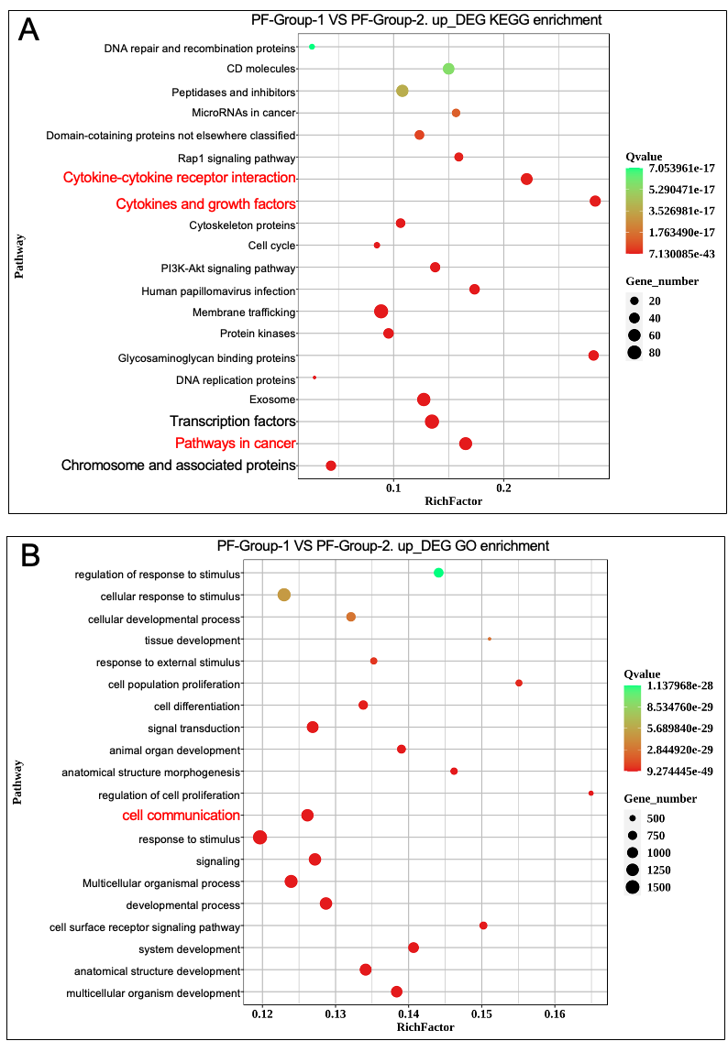
Supplemental Figure 1, Transcriptomic profiling of PF activation by OSCC organoids. A, B, KEGG (A) and GO (B) pathway analysis of upregulated genes in PFs co-cultured with tumor organoid (Group-1) versus that with mucosa organoid (Group-2). n=3 biological replicates; |log2FC|>1, FDR<0.05.

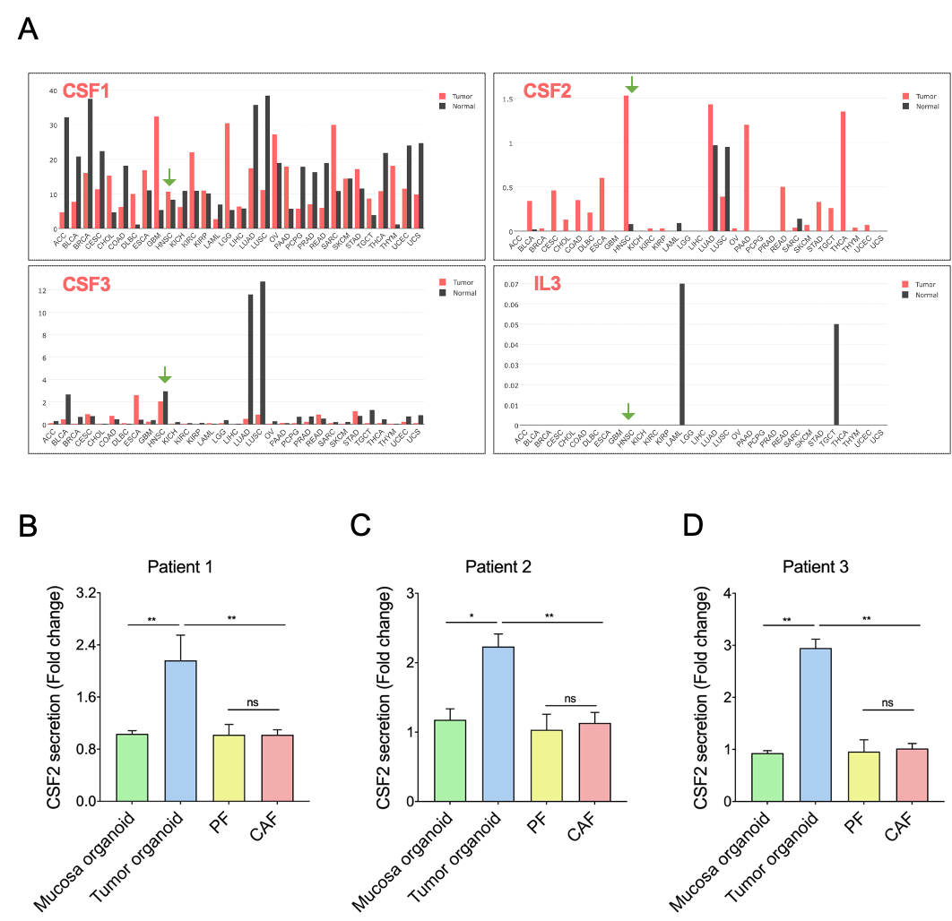
Supplemental Figure 2, CSF2 expression patterns in HNSCC. A, Pan-cancer analysis of CSF2 mRNA expression (TPM values) across 31 tumor types (GEPIA website: http://gepia.cancer-pku.cn). B-D, ELISA quantification of CSF2 secretion in conditioned media from tumor and mucosa organoids, PFs and CAFs (n=3). Data normalized to total protein concentration. Error bars represent mean ± s.d. (*p<0.05, **p<0.01, paired t-test).

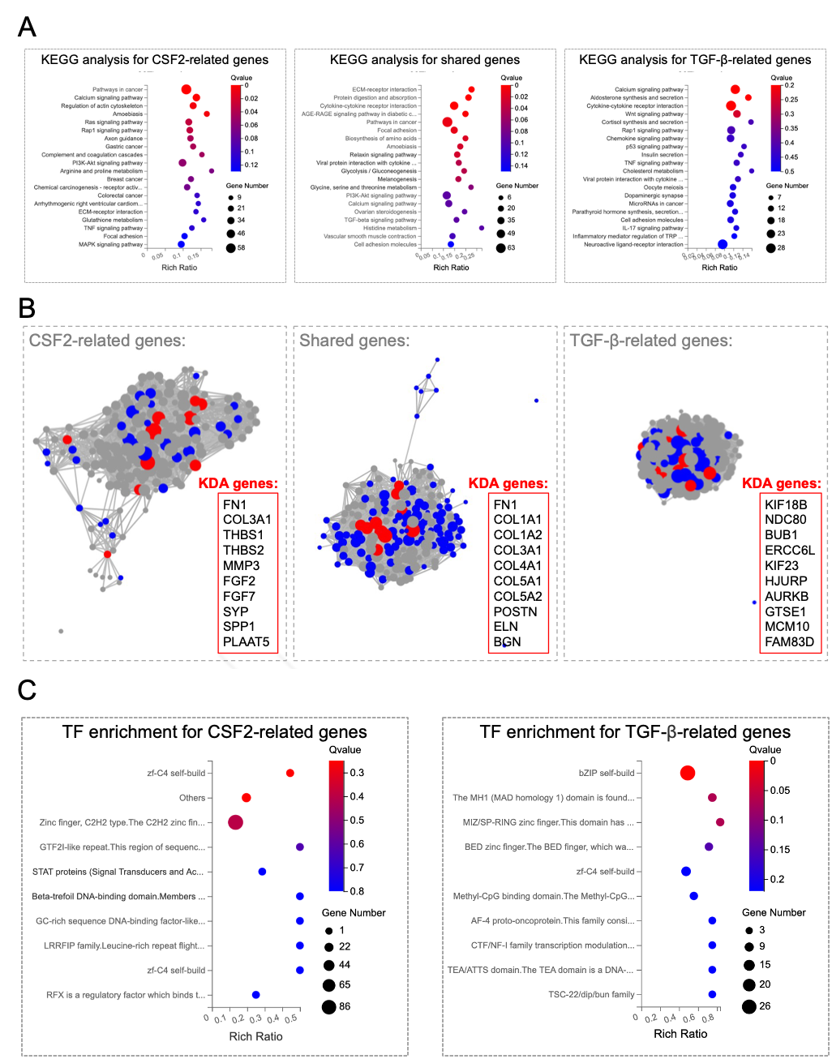
Supplemental Figure 3, Comparison of CSF2- and TGF-β-induced transcription programs. A, KEGG analysis of genes upregulated by CSF2 (left) and TGF-β1 (right), as well as their intersection (middle). B, Key Driver Analysis (KDA) network showing top 10 genes regulated by CSF2 (node size = expression fold change). C, Transcription factor analysis using RNA-seq data from PFs treated with CSF2 or TGF-β1.

Supplemental Table S1. Clinic-pathological information of 10 OSCC PDO samples

No. | Organoid  Establishment | Fibroblast  Establishment | Age | Sex | Site | Pathology | TNM
1 | Tu | CAF+PF | 36 | M | Tongue | OSCC | T2N2bM0
7 | Tu | CAF+PF | 40 | M | Tongue | OSCC | T2N0M0
8 | Tu+Mu | CAF+PF | 44 | M | Cheek | OSCC | T2N0M0
12 | Tu+Mu | CAF+PF | 38 | M | Cheek | OSCC | T3N2aM0
16 | Tu | CAF+PF | 60 | M | Tongue | OSCC | T3N0M0
17 | Tu+Mu | CAF+PF | 54 | M | Cheek, gingiva | OSCC | T2N2aM0
19 | Tu+Mu | CAF+PF | 57 | M | Cheek | OSCC | T4aN2M0
21 | Tu+Mu | CAF+PF | 34 | M | Tongue | OSCC | T2N0M0
25 | Failed | CAF+PF | 67 | F | Gingiva | OSCC | T4aN1M0
27 | Tu+Mu | CAF+PF | 54 | F | Cheek | OSCC | T1N0M0

Abbrivation
OSCC: oral suqmous cell carcinoma, No: number, Tu: Tumor, Mu: Mucosa, CAF: cancer-associated fibroblast, PF: paracanceous fibroblast, M: male, F: female, TNM: tumor node metastasis classification.

Supplemental Table S2. Sequence of qPCR primers.
Gene | Forward Primer (5' to 3') | Reverse Primer (5' to 3')
NNMT | GAGATCGTCGTCACTGACTACT | CACACACATAGGTCACCACTG
FOS | CCGGGGATAGCCTCTCTTACT | CCAGGTCCGTGCAGAAGTC
MAFK | GCACACATGGCAGAGAGAGT | GAGTCCTGCTCACCGTCAAA
NNMT  (For ChIP) | GACACCCGGCAACATTGTTT | TGGTCACAAAACCCACACCA

Supplemental Table S3. Antibodies utilized in this study.
Antibody | Resource | Identifier | Application
CSF2RA | Cell Signaling Technology | Cat# 69817; RRID: AB_3712883 | WB
CSF2RA | Immunoway | Cat# YT5262; RRID: AB_3712886 | IF
CSF2RB | Immunoway | Cat# YT2333; RRID: AB_3712887 | WB
GM-CSF | Immunoway | Cat# YT6007; RRID: AB_3712888 | IF
NNMT | Cell Signaling Technology | Cat# 33361; RRID: AB_3076294 | IF, IHC, WB
NNMT | Abcam | Cat# ab119758; RRID: AB_10902083 | IF
COL1A1 | Cell Signaling Technology | Cat# 72026; RRID: AB_2904565 | IF, WB
pan-Keratin | Cell Signaling Technology | Cat# 4545; RRID: AB_490860 | IF
FN1 | Cell Signaling Technology | Cat# 26836; RRID: AB_2924220 | WB
MYLK | Proteintech | Cat# 21642-1-AP; RRID: AB_10734590 | WB
α-SMA | Cell Signaling Technology | Cat# 19245; RRID: AB_2734735 | WB
FAP | Cell Signaling Technology | Cat# 66562; RRID: AB_2904193 | WB
GFP | Proteintech | Cat# 50430-2-AP; RRID: AB_11042881 | IF
mCherry | Cell Signaling Technology | Cat# 43590; RRID: AB_2799246 | IF
c-FOS | Cell Signaling Technology | Cat# 31254; RRID: AB_3712884 | WB
Phospho-c-FOS (Ser32) | Cell Signaling Technology | Cat# 5348; RRID: AB_10557109 | WB, IF, ChIP
Lamin B1 | Affbiotech | Cat# AF5161; RRID: AB_2837647 | WB
JAK2 | Cell Signaling Technology | Cat# 3230; RRID: AB_2128522 | WB
Phospho-JAK2 | Cell Signaling Technology | Cat# 3771; RRID: AB_330403 | WB
TGF-βR | Cell Signaling Technology | Cat# 49728; RRID: AB_3712889 | WB
WB: western blot, IF: immunofluorescence, IHC: immunohistochemistry, ChIP: Chromatin immunoprecipitation.

