Supplementary information
Decoupling the Impact of Electronic Structure and Electrode Wettability of Functionalized Iron Phthalocyanine Catalysts for Electrochemical Nitrate Reduction to Ammonia
Navid Noor,ª Clara Argentino,ª Ashkan Irannezhad,ª, Amy Wuttke,^{b} Mahtab Masouminia,ª Anja Schouten,ª Katrina Pegrum,ª Madeline LeBreton,ª Reza Eslami,ª Shayan Angizi,ª Mohsen Shakouri,^{c} Alexander Bagger,^{b*} Drew Higgins,^{a *}
ª Department of Chemical Engineering, McMaster University, Hamilton, ON, Canada.
^{b} Department of Physics, Technical University of Denmark, Copenhagen, Denmark.
^{c} Canadian Light Source Inc., University of Saskatchewan, Saskatoon, SK, Canada.

Overview
Supplementary Note 1: Experimental procedure 3
Chemicals 3
CNT purification 3
Characterization and Quantification Methods 4
Wettability test 4
Ammonia quantification 4
¹⁵N isotope-labeling experiment 5
Faradaic Efficiency Calculation for NH₃ 5
Supplementary Note 2: Computational Details 7
Fe-Phthalocyanine with functional groups 7
Free energy corrections of adsorbates 7
Free energy corrections of molecular references 8
Supplementary Note 3: Calculation of free energies of adsorption 10
pH-dependent correction between HNO₃ and NO₃⁻ 10
Calculation of adsorption energies 11
Reference states 13
Supplementary Note 4. Multiphysics Finite Element Method (FEM) mass-transport model 16
Supplementary Note 5: Mass transport and reaction modelling 18
Supplementary Note 6: Experimental results 19
ICP-OES 19
STEM image and the corresponding EDX elemental mapping: 20
Electrochemical performance results: 24
15N Isotope labelling: 31
In situ XAS of FePc-tBu/CNT: 32
Supplementary Note 7: HOMO/LUMO Levels 37
Supplementary Note 8: Electron Density Differences 39
Supplementary Note 9: Calculation of Formation Energies 40
References: 41

Supplementary Note 1: Experimental procedure

Chemicals
Potassium nitrate ($≥99$%, Sigma-Aldrich), potassium nitrate-15N (98 atom % ¹⁵N), Sigma Aldrich) sodium hydroxide (reagent > 98%, pellets (anhydrous) Sigma Aldrich, Nafion 117 containing solution (5%, Sigma-Aldrich), ethanol (anhydrous, Commercial Alcohols), sulfuric acid (95.0-98.0%, Sigma-Aldrich), iron (II) 2,9,16,23-tetra(amino)phthalocyanine (PorphyChem) iron (II) 2,9,16,23-tetra(carboxy)phthalocyanine (PorphyChem), iron (II) 2,9,16,23-tetra(t-butyl)phthalocyanine (PorphyChem), iron (II) 2,3,9,10,16,17,23,24-octa(cyano)phthalocyanine (PorphyChem) multi-walled carbon nanotubes (8 nm, Cheap Tubes), N,N-dimethylformamide (99.8%, Fisher Scientific), maleic acid (NMR standard, Sigma-Aldrich), deuterated dimethyl sulfoxide (99.5%, Sigma-Aldrich), ammonium chloride ($≥99.5$%, Sigma-Aldrich) ammonium sulfate ($≥99\%,$Sigma-Aldrich).

CNT purification
Commercial CNTs (≈500 mg) were dispersed in 100 mL of 10% HCl (prepared by mixing 27 mL concentrated HCl with 73 mL Milli-Q water) and bath-sonicated for 5 min. The suspension was then stirred at 300 rpm for 24 h at room temperature. The powder was collected by centrifugation and washed repeatedly with Milli-Q water (≈5 cycles) until the supernatant reached ~neutral pH. The purified CNTs were dried overnight at 60 °C.
To oxygen functionalized CNTs, a 3:1 (v/v) H₂SO₄/HNO₃ mixture was prepared by combining 60 mL concentrated H₂SO₄ and 20 mL concentrated HNO₃. The dried CNTs from the previous step were added, and the solution was bath-sonicated at ≤40 °C for 2.5 h (temperature kept ≤40 °C to avoid excessive viscosity). The reaction was quenched by dilution into ~800 mL water, then the powder was collected by vacuum filtration and rinsed with Milli-Q water until the filtrate was ~neutral pH. The functionalized CNTs were dried overnight at 60 °C.

Characterization and Quantification Methods
Scanning transmission electron microscopy (STEM) and energy-dispersive X-ray spectroscopy (EDS) were carried out on a Thermo Scientific Spectra Ultra, a double aberration-corrected HRTEM/STEM operated at 300 kV and housed at the Canadian Centre for Electron Microscopy. HAADF-STEM images were acquired with a 50 pA probe current and a 28 mrad convergence angle, and EDS maps were collected using a Thermo Fisher Ultra X system equipped with six Super-X silicon drift detectors. In situ X-ray absorption spectroscopy (XAS) was conducted at the Canadian Light Source (SXRMB beamline) at ambient temperature using a custom electrochemical cell, and spectra were processed with the Demeter software suite.

Wettability test
Wettability was evaluated by static contact-angle measurements using the sessile-drop method (Milli-Q water, ~7 µL). Droplet profiles were imaged with a scientific camera (Kiralux, Thorlabs) fitted with a 12 mm fine-focus zoom lens (MVL12X12Z, Thorlabs). The stage was backlit by a 470 nm LED (M470L4, Thorlabs), collimated with a lens (SM2F32-A) to provide uniform illumination and high edge contrast. Contact angles were extracted by Axisymmetric Drop Shape Analysis (ADSA).
ICP-OES sample preparation
Catalyst powders were digested in aqua regia (HCl:HNO₃ = 3:1, v/v) at 50 °C for 72 h to ensure complete dissolution of Fe. The digests were filtered to remove residual CNTs, and the clear filtrates were diluted 1:1 with Milli-Q water before analysis. Matrix blanks were prepared identically by diluting the 3:1 HCl/HNO₃ mixture 1:1 with Milli-Q water.

Ammonia quantification
Ammonia in the catholyte and acid-trap (AT) solutions was quantified by the indophenol blue colorimetric assay with UV–vis detection. For each measurement, a chromogenic reagent was prepared by dissolving 5 wt% salicylic acid and 5 wt% citric acid in 20 mL of 1 M NaOH. An aliquot (2 mL) of this reagent was mixed with 2 mL of sample, followed by addition of 1 mL of 0.05 M NaClO and 0.2 mL of 1 wt% sodium nitroprusside (Na₂[Fe(CN)₅NO]) as catalyst. Mixtures were incubated for 40 min in the dark, then analyzed on a Cary 5000 UV–Vis–NIR spectrophotometer scanning 550–750 nm; absorbance at 650 nm was used to determine concentration. Concentrations were obtained from a calibration curve constructed with (NH₄)₂SO₄ standards (0.000, 0.005, 0.010, 0.020, 0.040, 0.060, 0.080, 0.100 mM). Samples were diluted as needed to fall within the calibration range.
Ammonia was also quantified by ¹H NMR (600 MHz) using DMSO-d₆ as solvent and maleic acid (C₄H₄O₄) as an internal standard. The internal-standard stock was prepared by dissolving 20 mg maleic acid in 50 g DMSO-d₆ (0.04 wt%). Electrolyte samples were first acidified to pH ≈ 2 with 2 M H₂SO₄. For each measurement, 500 µL of the acidified sample was mixed with 50 µL of 0.5 M H₂SO₄, followed by 25 µL of the internal-standard stock. Sample preparation is illustrated in Figure S2. The NH₄⁺ resonance was integrated against the maleic-acid signal, and the NH₃ concentration was calculated from the integral ratio using the equation provided below.
$\frac{I_{A}}{I_{B}}=\frac{H_{A}C_{A}}{H_{B}C_{B}}$ (1)
Where, I_{A} and I_{B} are the integral of maleic acid and NH₄⁺, H_{A} and H_{B} are the number of protons in maleic acid and NH₄⁺, and C_{A} and C_{B} are the concentrations of maleic acid and NH₄⁺.

¹⁵N isotope-labeling experiment
¹⁵N isotope-labeling experiment was used to ensure that quantified ammonia is a product of electrochemical nitrate reduction to ammonia. In this experiment, chronoamperometry was performed using 0.1 M K¹⁵NO₃ + 0.1 M NaOH at -0.6 V_{RHE} for 30 minutes. Then, ¹⁵NH₄⁺ was quantified using ¹H NMR (600 MHz) using the same method as ¹⁴NH₄⁺ quantification.

Faradaic Efficiency Calculation for NH₃
The NH₃ Faradaic efficiency (FE) was calculated using the following formula (2):
${FE}_{{NH}_{3}}=\frac{8×F×C_{{NH}_{3}}×V}{Q}$ (2)
Where F is the Faraday constant (96485 C/mol), C is NH₃ concentration (M), V is the volume of electrolyte (10 mL), and Q is the charge (C), t is time (s).

Supplementary Note 2: Computational Details
The Density Functional Theory (DFT) calculations, were obtained using the GPAW calculator¹ in plane-wave mode with 600 eV cutoff energy, using the RPBE exchange-correlation functional, Fermi smearing with width 0.05 eV, and 10⁻⁴ eV energy convergence threshold. Data from the electronic structure calculations were processed using the Atomic Simulation Environment (ASE).²

Fe-Phthalocyanine with functional groups
The baseline structure is Fe-Phthalocyanine (FePc) with hydrogen termination of the benzene rings in a computational supercell with 10 Å vacuum padding in each direction, which is relaxed with a maximum force criterion of 0.05 eV/Å and a 1x1x1 k-point grid. The same parameters are used when adsorbed species are present. When introducing functional groups, one hydrogen is substituted per benzene ring by the respective functional group (-COOH, -NH₂ and -tBu), while two hydrogens per benzene ring are each substituted by -CN.
To find the correct spin state, the metal center was initialized with 0, 1, 2, 3, and 4 $μ_{B}$, where it was found that the most stable configuration, i.e. lowest energy, was obtained when initializing the Fe center with 2 $μ_{B}$ regardless of the functional group. This initial magnetic moment for the Fe atom was therefore used throughout all calculations with adsorbates. For some adsorbates the magnetic moment vanished after electronic convergence.

Free energy corrections of adsorbates
Free energy corrections for adsorbates were calculated using a harmonic approximation as implemented in ASEs Harmonic Thermo class.
The vibrations of the adsorbate were calculated in ASE with 0.05 eV/Å force convergence threshold, while the atoms of the FePc were fixed. Remaining imaginary frequencies were replaced by 10 meV to obtain a harmonic approximation for the zero-point energy (ZPE), other contributions to the internal energy (heat capacitance), and entropic contributions. Then, the difference in Gibbs free energy between the bare catalyst, $G_{*}$, and the adsorbate, $G_{\text{*}\text{X}}$, can be approximated using the Helmholtz free energy from an harmonic approximation, under the assumption that the change in pV is negligible (i.e. pV is constant under adsorption and cancels) and room temperature (T = 298.15 K):
$G_{\text{*}\text{X}}-G_{*}=F_{\text{*}\text{X}}+pV-{(F}_{*}+pV)=F_{\text{*}\text{X}}-F_{*}=F_{\text{*}\text{X}}-E_{*}$,
Where,
$$F_{\text{*}\text{X}}=E_{\text{*}\text{X}}+ZPE_{\text{*}\text{X}}+\int_{0}^{T=298.15K}{C_{v, harm} dT}-TS_{\text{*}\text{X}}=E_{\text{*}\text{X}}+G_{\text{*}\text{X,}\text{corr}}$$
and $E_{*}$ is the potential energy of the bare catalyst since that one is fixed, and thus, unchanged in the approximation, not leading to vibrational contributions.
This expression, i.e. $G_{\text{*}\text{X}}-G_{*}=E_{\text{*}\text{X}}+G_{\text{*}\text{X,}\text{corr}}-E_{*}$ is applied in all the equations for adsorption energies presented in Supplementary Note 2.

Free energy corrections of molecular references
The free energy corrections for molecular references were calculated using the free energy corrections with an ideal gas approximation using ASEs IdealGasThermo class [4], such that
$$G_{\text{gas}}=E_{gas}+ZPE_{\text{gas}}+\int_{0}^{T=298.15K}{C_{p} dT}-TS_{\text{gas}},$$
where $E_{gas}$ is the potential energy from DFT, and all other contributions use vibrations calculated after relaxation up to at least 0.01 eV/Å, using a a 1x1x1 k-point grid in a computational cell with 10 Å vacuum padding along each direction. We used standard conditions (T = 298.15 K, p = 101325 Pa) and the parameters (keywords geometry, symmetry number, spin) in table S1 for the different reference molecules.
Table S2 Parameters used for the corresponding keywords in the Ideal gas approximation.
Molecule | Geometry | Symmetry number | Spin
H₂ | linear | 2 | 0
H₂O | nonlinear | 2 | 0
HNO₂ | nonlinear | 1 | 0
HNO₃ | nonlinear | 1 | 0
NH₃ | nonlinear | 3 | 0
NO | linear | 1 | 0.5

Supplementary Note 3: Calculation of free energies of adsorption
In order to calculate free energies of adsorption, we used tabulated free energies to determine the free energy differences of (r1), (r3), and (r4), in which $HNO_{3}\left(g\right)$ reacts respectively to $NH_{3}\left(g\right)$, $HNO_{2}\left(g\right)$, and $NO\left(g\right)$. Each of these species is used to reference the DFT calculated adsorption energies. We start with addressing the importance of including pH-dependence in $NO_{3}^{-}$ (nitrate) reduction, while referencing to $HNO_{3}\left(g\right)$.

pH-dependent correction between HNO₃ and NO₃⁻
The considered reaction is
$HNO_{3}\left(g\right)+4H_{2}\left(g\right)→NH_{3}\left(g\right)+3H_{2}O\left(l\right)$ (r1)
with a Gibbs’ free reaction energy of ^{3,4}
$ΔG_{\text{(r1)}}^{0}=Δ_{f}G_{}^{0}(NH_{3}(g))+3Δ_{f}G_{}^{0}(H_{2}O(l)){-Δ}_{f}G_{}^{0}(HNO_{3}(g))=-6.388 eV$. (3.1)
Since the actual reaction of interest is starting from NO₃⁻, we consider the change from HNO₃(g) to NO₃⁻(aq) with a free energy change ${ΔG}_{HNO_{3}\left(g\right)→NO_{3}^{-}+H^{+}}^{0}$ ³
$HNO_{3}\left(g\right)→{NO}_{3}^{-}\left(aq\right)+H^{+}$,
${ΔG}_{HNO_{3}\left(g\right)→NO_{3}^{-}+H^{+}}^{0}=Δ_{f}G_{}^{0}({NO}_{3}^{-}\left(aq\right)){-Δ}_{f}G_{}^{0}(HNO_{3}(g))=-0.392 eV$.
When considering non-standard conditions, the chemical potential of the anion shows a dependency on pK_{a} and pH according to⁵
$$μ_{NO_{3}^{-}}=μ_{NO_{3}^{-}}^{0}+k_{B}T\ln\left(\left[NO_{3}^{-}\right]\right)$$
$\left[NO_{3}^{-}\right]=\frac{\left[HNO_{3}\right]}{1+{10}^{pK_{a}-pH}}$.
When using the assumptions [NO₃⁻] = 0.1 M at pH=13 and pK_{a}(HNO₃) = -1.4, we obtain [HNO₃] = 0.1 M. Thus for T=298 K,
${ΔG}_{HNO_{3}→NO_{3}^{-}+H^{+}}^{}=-0.392 eV+k_{B}T\ln\left(\frac{\left[HNO_{3}\right]}{1+{10}^{pK_{a}-pH}}\right)=-0.451 eV$, (3.2)
which is plotted for the reduction as ${ΔG}_{NO_{3}^{-}+H^{+}→HNO_{3}}^{}={-ΔG}_{HNO_{3}→NO_{3}^{-}+H^{+}}^{}$ against pH on the SHE scale in Figure SI 1b, which shows for pH>pK_{a}, a constant value for ${-ΔG}_{HNO_{3}→NO_{3}^{-}+H^{+}}^{}$with respect to SHE, corresponding to a pH-dependence on RHE scale (Figure SI 1a, red line):
${ΔG}_{\left(NO_{3}^{-}+H^{+}→HNO_{3}\right),RHE}^{}=0.451 eV+0.059 eV×pH$. (3.3)
Figure SI 1. Free energy differences ${ΔG}_{\left(NO_{3/2}^{-}+H^{+}→HNO_{3/2}\right),RHE}^{}$ for different concentrations of HNO_{3/2} and adsorption energies of correspondingly *NO_{3/2} on FePc-FePc on (a) RHE scale and (b) SHE scale to illustrate the pH-dependence for pH>pK_{a} on the RHE scale.
Therefore, the free energy change for nitrate reduction $ΔG_{\text{r,RHE }}$ is pH-dependent on an RHE scale, using $ΔG_{\text{(r1)}}^{0}$ from (3.1) and ${ΔG}_{HNO_{3}→NO_{3}^{-}+H^{+}}^{}$ from (3.2) applied to reaction
$NO_{3}^{-}\left(aq\right)+9H^{+}+8e^{-}→NH_{3}\left(g\right)+3H_{2}O\left(l\right)$ (r2)
$ΔG_{\text{r,RHE }}=ΔG_{\text{(r1)}}^{0}+{ΔG}_{\left(NO_{3}^{-}+H^{+}→HNO_{3}\right),RHE}^{}=-6.388 eV+0.451 eV+0.059 eV×pH$. (3.4)

Calculation of adsorption energies
In the following, it is described how we determined all free energies of adsorption referenced to $HNO_{3}$ via tabulated formation energies, and further include the offset ${-ΔG}_{(HNO_{3}→NO_{3}^{-}+H^{+}),RHE}^{}={ΔG}_{\left(NO_{3}^{-}+H^{+}→HNO_{3}\right),RHE}^{}$ from (3.3) to use $NO_{3}^{-}$ as the formal “zero” in the free energy diagrams
$G_{\text{HN}{\text{O}}_{\text{3}},corr}={ΔG}_{\left(NO_{3}^{-}+H^{+}→HNO_{3}\right),RHE}^{}$ (3.5)
which is the reference for the adsorption energies
$ΔG_{\text{*N}{\text{O}}_{\text{3}}}=G_{\text{*N}{\text{O}}_{\text{3}}}+\frac{1}{2}G_{{\text{H}}_{\text{2}}}-G_{*}-G_{\text{HN}{\text{O}}_{\text{3}}}+G_{\text{HN}{\text{O}}_{\text{3}},corr}-eV_{RHE}$, and
$ΔG_{\text{*HN}{\text{O}}_{\text{3}}}=G_{\text{*HN}{\text{O}}_{\text{3}}}-G_{*}-G_{\text{HN}{\text{O}}_{\text{3}}}+G_{\text{HN}{\text{O}}_{\text{3}},corr}$.
Furthermore, based on the reaction
$HNO_{3}\left(g\right)+H_{2}\left(g\right)→{HNO}_{2}\left(g\right)+H_{2}O\left(l\right)$ (r3)
with a standard change in free energy of $-2.172 eV$,³ we define with respect to NO₃⁻ again using the offset ${ΔG}_{\left(NO_{3}^{-}+H^{+}→HNO_{3}\right),RHE}^{}$
$G_{\text{HN}{\text{O}}_{\text{2}},corr}=-2.172 eV+{ΔG}_{\left(NO_{3}^{-}+H^{+}→HNO_{3}\right),RHE}^{}-(-2eV_{RHE})$ (3.6)
yielding an expression for the following adsorption energies
$$ΔG_{\text{*N}{\text{O}}_{\text{2}}}=G_{\text{*N}{\text{O}}_{\text{2}}}+\frac{1}{2}G_{{\text{H}}_{\text{2}}}-G_{*}-G_{\text{HN}{\text{O}}_{\text{2}}}+G_{\text{HN}{\text{O}}_{\text{2}},corr}-eV_{RHE}$$
$$ΔG_{\text{*HN}{\text{O}}_{\text{2}}}=G_{\text{*HN}{\text{O}}_{\text{2}}}-G_{*}-G_{\text{HN}{\text{O}}_{\text{2}}}+G_{\text{HN}{\text{O}}_{\text{2}},corr}.$$
Similarly, we obtain for the reaction
$HNO_{3}\left(g\right)+\frac{3}{2}H_{2}\left(g\right)→NO\left(g\right)+{2H}_{2}O\left(l\right)$ (r4)
a standard change in free energy of $-3.245 eV$,³ resulting in
$G_{\text{NO,corr}}=-3.245 eV+{ΔG}_{\left(NO_{3}^{-}+H^{+}→HNO_{3}\right),RHE}^{}-(-3eV_{RHE})$ (3.7)
$$ΔG_{\text{*NO}}=G_{\text{*NO}}-G_{*}-G_{\text{NO}}+G_{\text{NO,corr}}$$
$$ΔG_{\text{*NOH}}=G_{\text{*NOH}}-G_{*}-\frac{1}{2}G_{{\text{H}}_{\text{2}}}-G_{\text{NO}}+G_{\text{NO,corr}}-(-eV_{RHE})$$
$$ΔG_{\text{*NHO}}=G_{\text{*NHO}}-G_{*}-\frac{1}{2}G_{{\text{H}}_{\text{2}}}-G_{\text{NO}}+G_{\text{NO,corr}}-(-eV_{RHE})$$
For the remaining adsorption energies, we reference with respect to the reaction energy $ΔG_{\text{r,RHE }}$from (4)
$$ΔG_{\text{*N}{\text{H}}_{\text{2}}O}=G_{\text{*N}{\text{H}}_{\text{2}}O}-G_{*}-G_{{\text{H}}_{\text{2}}O}+ΔG_{\text{r,RHE}}-G_{\text{N}{\text{H}}_{\text{3}}}+\frac{3}{2}G_{{\text{H}}_{\text{2}}}-(-5eV_{RHE})$$
$$ΔG_{\text{*N}{\text{H}}_{\text{2}}OH}=G_{\text{*N}{\text{H}}_{\text{2}}OH}-G_{*}-G_{{\text{H}}_{\text{2}}O}+ΔG_{\text{r,RHE}}-G_{\text{N}{\text{H}}_{\text{3}}}+G_{{\text{H}}_{\text{2}}}-(-6eV_{RHE})$$
$$ΔG_{\text{*N}{\text{H}}_{\text{2}}}=G_{\text{*N}{\text{H}}_{\text{2}}}-G_{*}+ΔG_{\text{r,RHE}}-G_{\text{N}{\text{H}}_{\text{3}}}+\frac{1}{2}G_{{\text{H}}_{\text{2}}}-(-7eV_{RHE})$$
$$ΔG_{\text{*N}{\text{H}}_{\text{3}}}=G_{\text{*N}{\text{H}}_{\text{3}}}-G_{*}+ΔG_{\text{r,RHE}}-G_{\text{N}{\text{H}}_{\text{3}}}-(-8eV_{RHE})$$
In the expressions above, we have furthermore used the Computational Hydrogen Electrode (CHE),⁶ such that on the RHE scale, the chemical potential of a proton-electron pair yields with applied potential $V_{RHE}$, expressed against RHE:
$$μ_{H^{+}+e^{-}}=\frac{1}{2}G_{H_{2}}-eV_{RHE}$$
This applies for each proton-electron step in the reduction shown in Figure 4a in the main text, i.e. in each step starting from reaction coordinate 3 to 4, the energy is lowered by 0.5 eV under an applied voltage of - 0.5 V vs. RHE. However, the reaction step from reaction coordinate 0 to 1 is an oxidation and therefore the free energy for reaction coordinate 1 increases by 0.5 eV.

Reference states
In the free energy diagrams, the references HNO₃, HNO₂, NO₂⁻, NO and NH₃ are included. To summarize from above, these states are purely determined from thermodynamical tables and corrections for potential and pH, i.e. from Eqs. (3.4)-(3.7)
$$G_{\text{HN}{\text{O}}_{\text{3}}}^{plot}={ΔG}_{\left(NO_{3}^{-}+H^{+}→HNO_{3}\right),RHE}^{}=0.451 eV+0.059 eV×pH$$
$$G_{\text{HN}{\text{O}}_{\text{2}}}^{plot}=-2.172 eV+0.451 eV+0.059 eV×pH+2eV_{RHE})$$
$$G_{\text{NO}}^{plot}=-3.245 eV+0.451 eV+0.059 eV×pH+3eV_{RHE})$$
$G_{\text{N}{\text{H}}_{\text{3}}}^{plot}=-6.388 eV+0.451 eV+0.059 eV×pH+8eV_{RHE})$.
For nitrite (NO₂⁻), the derivation is equivalent to the case of nitrate above [5]:
$${ΔG}_{HNO_{2}\left(g\right)→NO_{2}^{-}+H^{+}}^{0}=Δ_{f}G_{}^{0}({NO}_{2}^{-}\left(aq\right)){-Δ}_{f}G_{}^{0}(HNO_{2}(g))=+0.142 eV$$
Assuming non-standard conditions [NO₂⁻] = 0.1 M at pH=13 and using pK_{a}(HNO₂)=3.25 [5], we obtain [HNO₂] = 0.1 M. Thus for T=298 K,
${ΔG}_{HNO_{2}→NO_{2}^{-}+H^{+}}^{}=0.142 eV+k_{B}T\ln\left(\frac{\left[HNO_{2}\right]}{1+{10}^{pK_{a}-pH}}\right)=0.083 eV$.
This is plotted as a reduction as ${ΔG}_{NO_{2}^{-}+H^{+}→HNO_{2}}^{}={-ΔG}_{HNO_{2}→NO_{2}^{-}+H^{+}}^{}$ against pH on the SHE scale in Figure SI 1b as a brown line, which shows a constant value for pH>pK_{a}(HNO₂), corresponding to a pH-dependence on RHE scale (like it was also shown for nitrate):
${ΔG}_{\left(NO_{2}^{-}+H^{+}→HNO_{2}\right),RHE}^{}=-0.083 eV+0.059 eV×pH$. (3.8)
Thus,
$G_{\text{N}O_{2}^{-}}^{plot}=G_{\text{HN}{\text{O}}_{\text{2}}}^{plot}+{ΔG}_{\left(NO_{2}^{-}+H^{+}→HNO_{2}\right),RHE}^{}=-2.172 eV+0.451 eV+2eV_{RHE}-0.083 eV$,
which means that both on RHE and SHE scale, there is no pH dependence between $NO_{2}^{-}$ and $NO_{3}^{-}$ since the contributions cancel for the pH>pK_{a}(HNO₂) as expected from Figure SI 1 for the region pH>pK_{a}(HNO₂).
How the positions of the references are defined with respect to each other is also illustrated in Figure SI 2.
Figure SI 2. Overview of how the reference states are related to each other. Given that NO₃⁻ is defined to be at 0 eV, the free energy of HNO₃ is fixed through equation (3.3). The levels of HNO₂, NO and NH₃ are set according to tabulated free energies or rather their changes following the reactions (r1), (r3), and (r4). Knowing the level of HNO₂, defines the position of NO₂⁻. All free energy levels are plotted for pH=0 and 0 V vs. SHE. The indicated values for ${ΔG}_{\left(NO_{2}^{-}+H^{+}→HNO_{2}\right),RHE}^{}$ and ${ΔG}_{\left(NO_{3}^{-}+H^{+}→HNO_{3}\right),RHE}^{}$ include pH dependence and the value for pH=0 uses the assumptions of 0.1M concentration for both ions, as explained in Supplementary Note 3.

Supplementary Note 4. Multiphysics Finite Element Method (FEM) mass-transport model
We resolve steady-state transport and interfacial kinetics in a one-dimensional catholyte diffusion layer adjacent to a planar cathode, with $x=0$ at the catalyst–electrolyte interface and $x=δ$ at the edge of the diffusion layer. The goal is to capture concentration changes, migration in the electric field, and their feedback on competing cathodic reactions. The electrolyte is isothermal, and incompressible with constant physical properties; and all potentials are reported $vs$ $RHE$. The dissolved species are $H^{+}(aq)$, $OH^{-}(aq)$, and $NO3^{-}​(aq)$. Their molar fluxes $N_{i}​$ follow the Nernst–Planck form:
$$N_{i}=-D_{i}∇c_{i}-z_{i}\frac{D_{i}F}{RT}c_{i}∇ϕ_{l}+c_{i}u$$ | (4.1)

with concentration $c_{i}​$, diffusion coefficient $D_{i}$, charge $z_{i}​$, Faraday’s constant $F=96485 C mol^{-1}$, gas constant $R=8.314 J mol^{-1}K^{-1}$, temperature $T$, and electrolyte potential $ϕ_{l}​ (V)$. Steady species conservation is:
$$∇.N_{i}=R_{i}$$ | (4.2)

where $R_{i}$is volumetric reaction rate. Charge transport in the electrolyte is $i_{l}=F \sum_{i}{z_{i}N_{i}}$ and satisfies $∇.i_{l}=0$. In the solid, $i_{s}=-σ_{s}∇ϕ_{s}$ (Ohm’s law), and current continuity holds at the interface: $i_{s}.n=-i_{l}.n$. We assume a locally electroneutral electrolyte, $\sum_{i}{z_{i}c_{i}}=0$, and enforce water self-ionization algebraically, $c_{H}.c_{OH}=K_{w}(T)$.
Electrochemistry occurs at $x=0$, where two cathodic reactions compete. In alkaline media we use the balanced overall forms:
$$2{ H}_{2}O+2e^{-}→H_{2}+2 OH^{-} (HER, n=2)$$ | (4.3)
$$NO_{3}^{-}+6 H_{2}O+8e^{-}→NH_{3}+9 OH^{-} (NO_{3}R, n=8)$$ | (4.4)

The cathodic partial current density for reaction is modeled with a concentration-dependent Butler–Volmer form
$$i_{k}=-i_{0,k}{\left(\frac{c_{l,k}}{c^{0}}\right)}^{m_{k}} exp\left(-α_{c,k}\frac{F η_{k}}{RT}\right)$$ | (4.5)

where $i_{0,k}$ is the exchange current density, $c_{l,k}$ ​the interfacial concentration, $m_{k}$ an effective order, and $α_{c,k}$ the cathodic transfer coefficient. The overpotential is
$$η_{k}=ϕ_{s}-ϕ_{l}-U_{k}^{eq}(pH)$$ | (4.6)
With $U_{HER}^{eq}=0 V$ $vs$ $RHE$ and $U_{k}^{eq}(pH)$ found from Nernst equation. Interfacial currents map to species fluxes through Faraday’s law and stoichiometry:
$${\left.-n.N_{i}\right|}_{x=0}=\sum_{k}{v_{i,k}\frac{\left|i_{k}\right|}{n_{k}F}}$$ | (4.7)

Where $v_{i,k}$ is the signed stoichiometric coefficient of species $i$ in reaction $k$ and $n_{k}$​ the electrons per mole in the corresponding overall reaction. The total interfacial current is $i=\sum_{k}{i_{k}}$​, and Faradaic efficiencies are $FE_{k}={\left|i_{k}\right|}/{\left|i\right|}$.
Boundary conditions are chosen to reflect a boundary-layer experiment. At the bulk side ($x=δ$) we impose Dirichlet concentrations $c_{NO_{3}^{-}}\left(δ\right)=C_{NO_{3}^{-}}^{∞}$​ and $c_{H^{+}}\left(δ\right)$​, $c_{{OH}^{-}}\left(δ\right)$ consistent with the specified bulk $pH$ and set $ϕ_{l}\left(L\right)=0$ as the reference. At the electrode ($x=0$), species fluxes follow the interfacial stoichiometry above; the solid potential is fixed by the applied value, $ϕ_{s}=E_{app}$​ $(vs$ $RHE)$.

Supplementary Note 5: Mass transport and reaction modelling
The mechanism by which surface wettability (via contact angle, θ) and bubble formation control the diffusion‐layer thickness has been documented in the gas-evolution literature.⁷⁻⁹ In our model, wettability enters in two places: the bubble departure diameter d_{b}(θ) and the time-averaged bubble coverage Θ(θ). For d_{b}(θ), we use a Fritz force balance between buoyancy and capillary pinning that retains the exact contact-angle dependence of a spherical cap:
$$db\left(θ\right)=ψ\sqrt{\frac{24σ\sin{θ}}{g \left(ρ_{l}- ρ_{g}\right)(2+3\cos{θ-\cos^{3} θ})}}$$
where σ is the surface tension, g gravity, and ρ_{l}, ρ_{g}​ are the liquid and gas densities. The factor ψ is a single calibration constant.¹⁰ The time-averaged bubble coverage, $Θ(θ)$, was expressed as the product of two factors: the areal density of active nucleation sites ($N_{\text{act}}$), and the bubble footprint area ($A_{\text{foot}}$), following the conceptual form described by Vogt et al⁹. With d_{b}(θ) and Θ(θ) specified, the bubble-induced mass transfer coefficient is found from Sherwood correlations: ⁷
$$Sh_{1}= \sqrt{\frac{12}{π} R_{G}^{1/2} Sc^{1/2} Θ^{1/2}}$$
$$Sh_{2}= \frac{2}{\sqrt{5}} Re_{G}^{1/2} Sc^{0.34}\sqrt{1- \frac{\sqrt{8}}{3} \frac{R_{G}}{R}} (1+Θ)$$
$$Sh= \sqrt{Sh_{1}^{2}+ Sh_{2}^{2}}$$
$$k_{bubble}= \frac{Sh D}{d_{b}\left(θ\right)}$$
In these equations, Sc is Schmidt number defined as $ν/D$, R_{G} is Reynolds number defined as $\frac{\left(\dot{V}/A\right)d_{b}}{ν}$ in which $\dot{V}/A$ is volumetric gas flux (m S⁻¹) obtained from Faraday’s law of electrolysis:
$$\frac{\dot{V}}{A}= \frac{jRT}{n_{e}FP}$$
Here, j is the current density, R the gas constant, T the temperature, P the pressure, ne number of electrons, and F Faraday’s constant. Finally, the diffusion-layer thickness is calculated as: ⁷
$$δ \left(θ\right)= \frac{D}{k_{bubble}}$$

Supplementary Note 6: Experimental results

ICP-OES
Table S1: FePc-NH₂/CNT, FePc-tBu/CNT, FePc-COOH/CNT, and FePc-CN/CNT wt.% in different catalysts measured by ICP-OES.
Sample | MPc/ MTPP  (wt.%)
FePc-NH₂/CNT | 6.7
FePc-tBu/CNT | 9.2
FePc-COOH/CNT | 9.7
FePc-CN/CNT | 8.7

STEM image and the corresponding EDX elemental mapping:
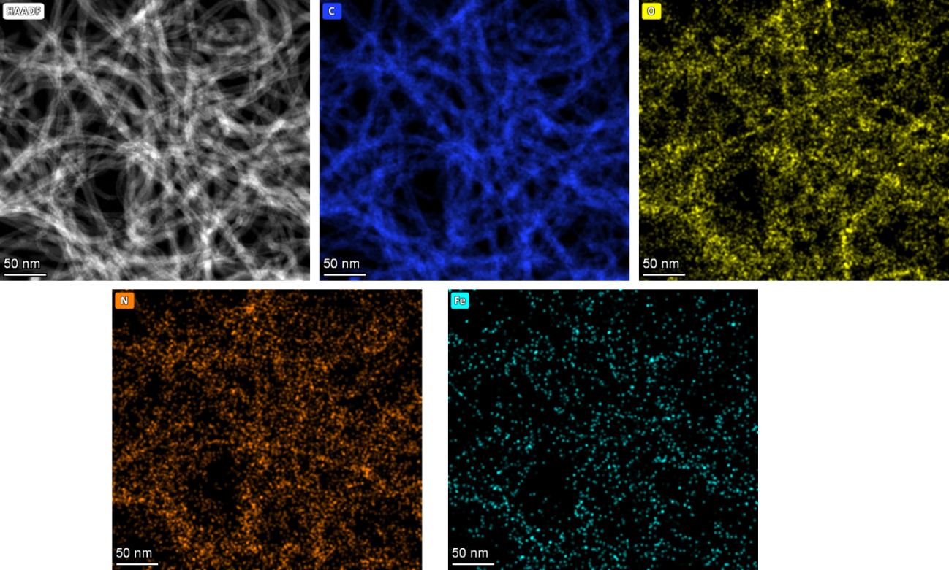
Figure S1. STEM image and the corresponding EDX elemental mapping of FePc-NH₂/CNT [C(blue), O(yellow), N(orange), and Fe(cyan)].

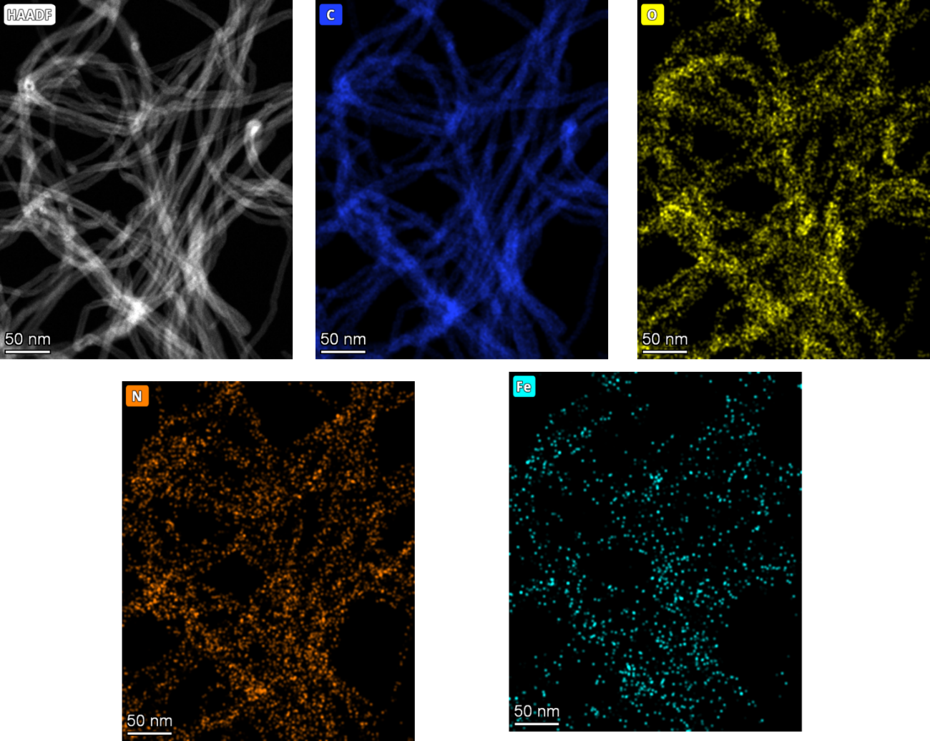
Figure S2. STEM image and the corresponding EDX elemental mapping of FePc-tBu/CNT [C(blue), O(yellow), N(orange), and Fe(cyan)].

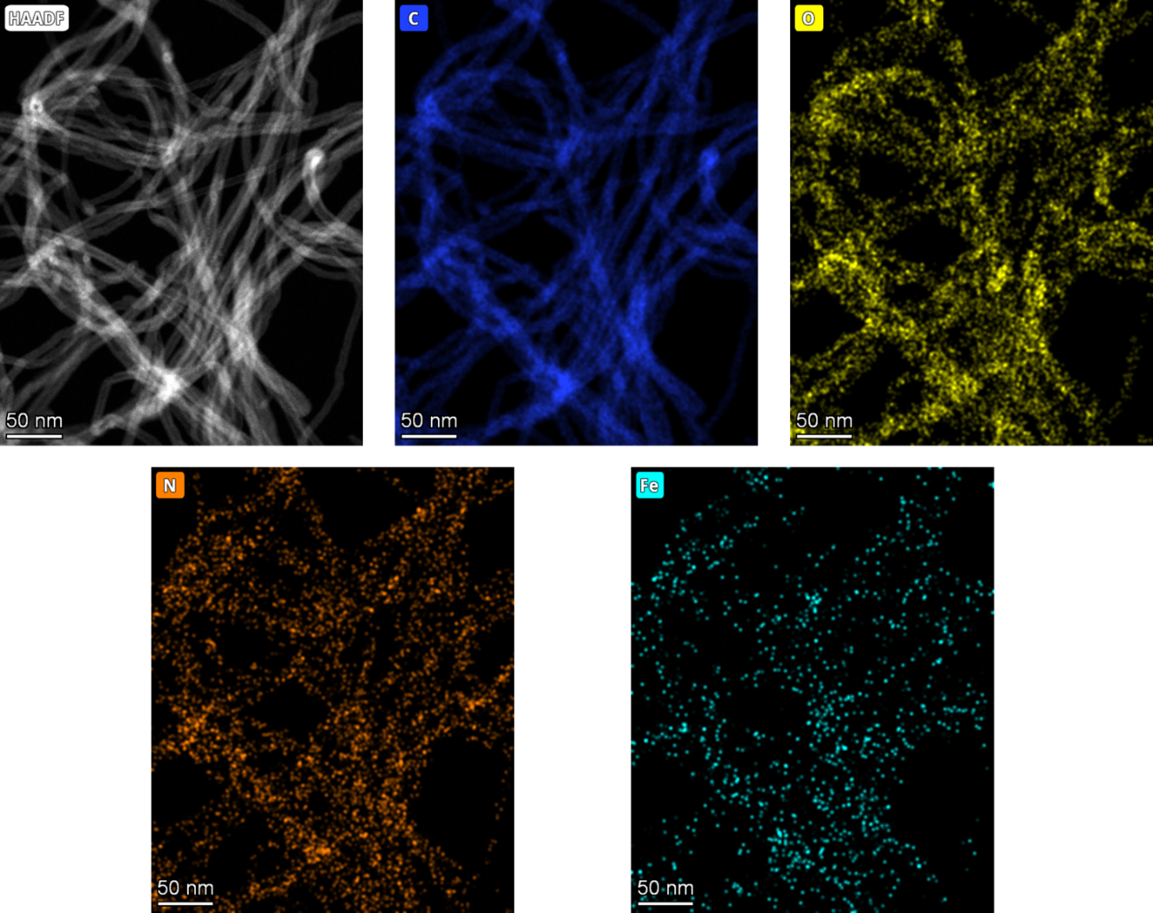
Figure S3. STEM image and the corresponding EDX elemental mapping of FePc-COOH/CNT [C(blue), O(yellow), N(orange), and Fe(cyan)].
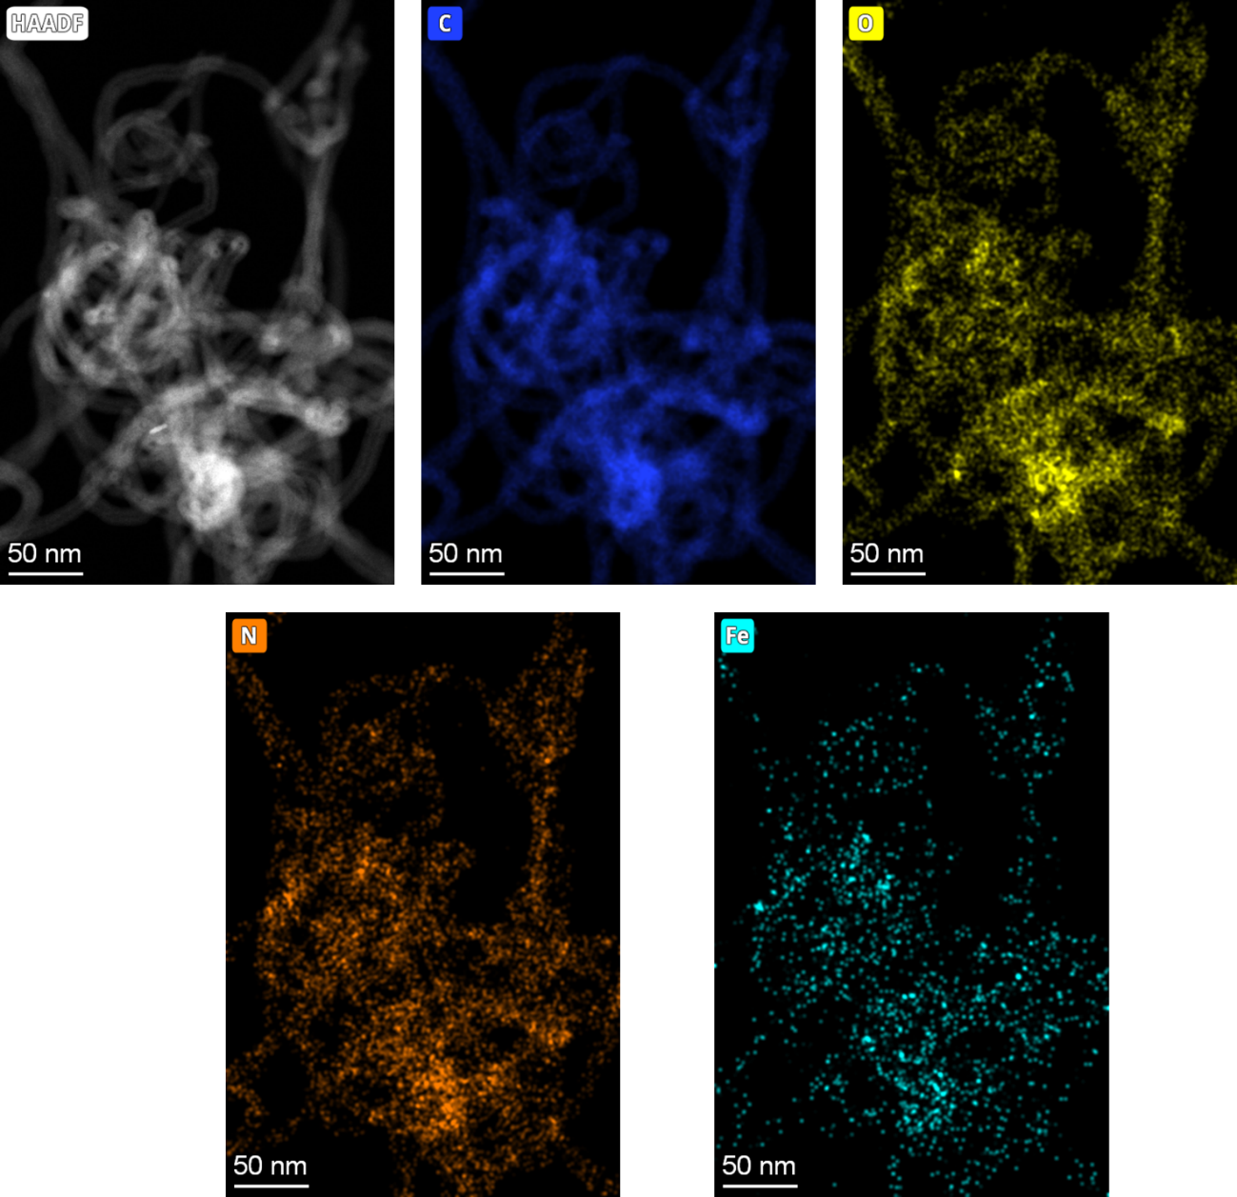
Figure S4. STEM image and the corresponding EDX elemental mapping of FePc-CN/CNT [C(blue), O(yellow), N(orange), and Fe(cyan)].

Electrochemical performance results:
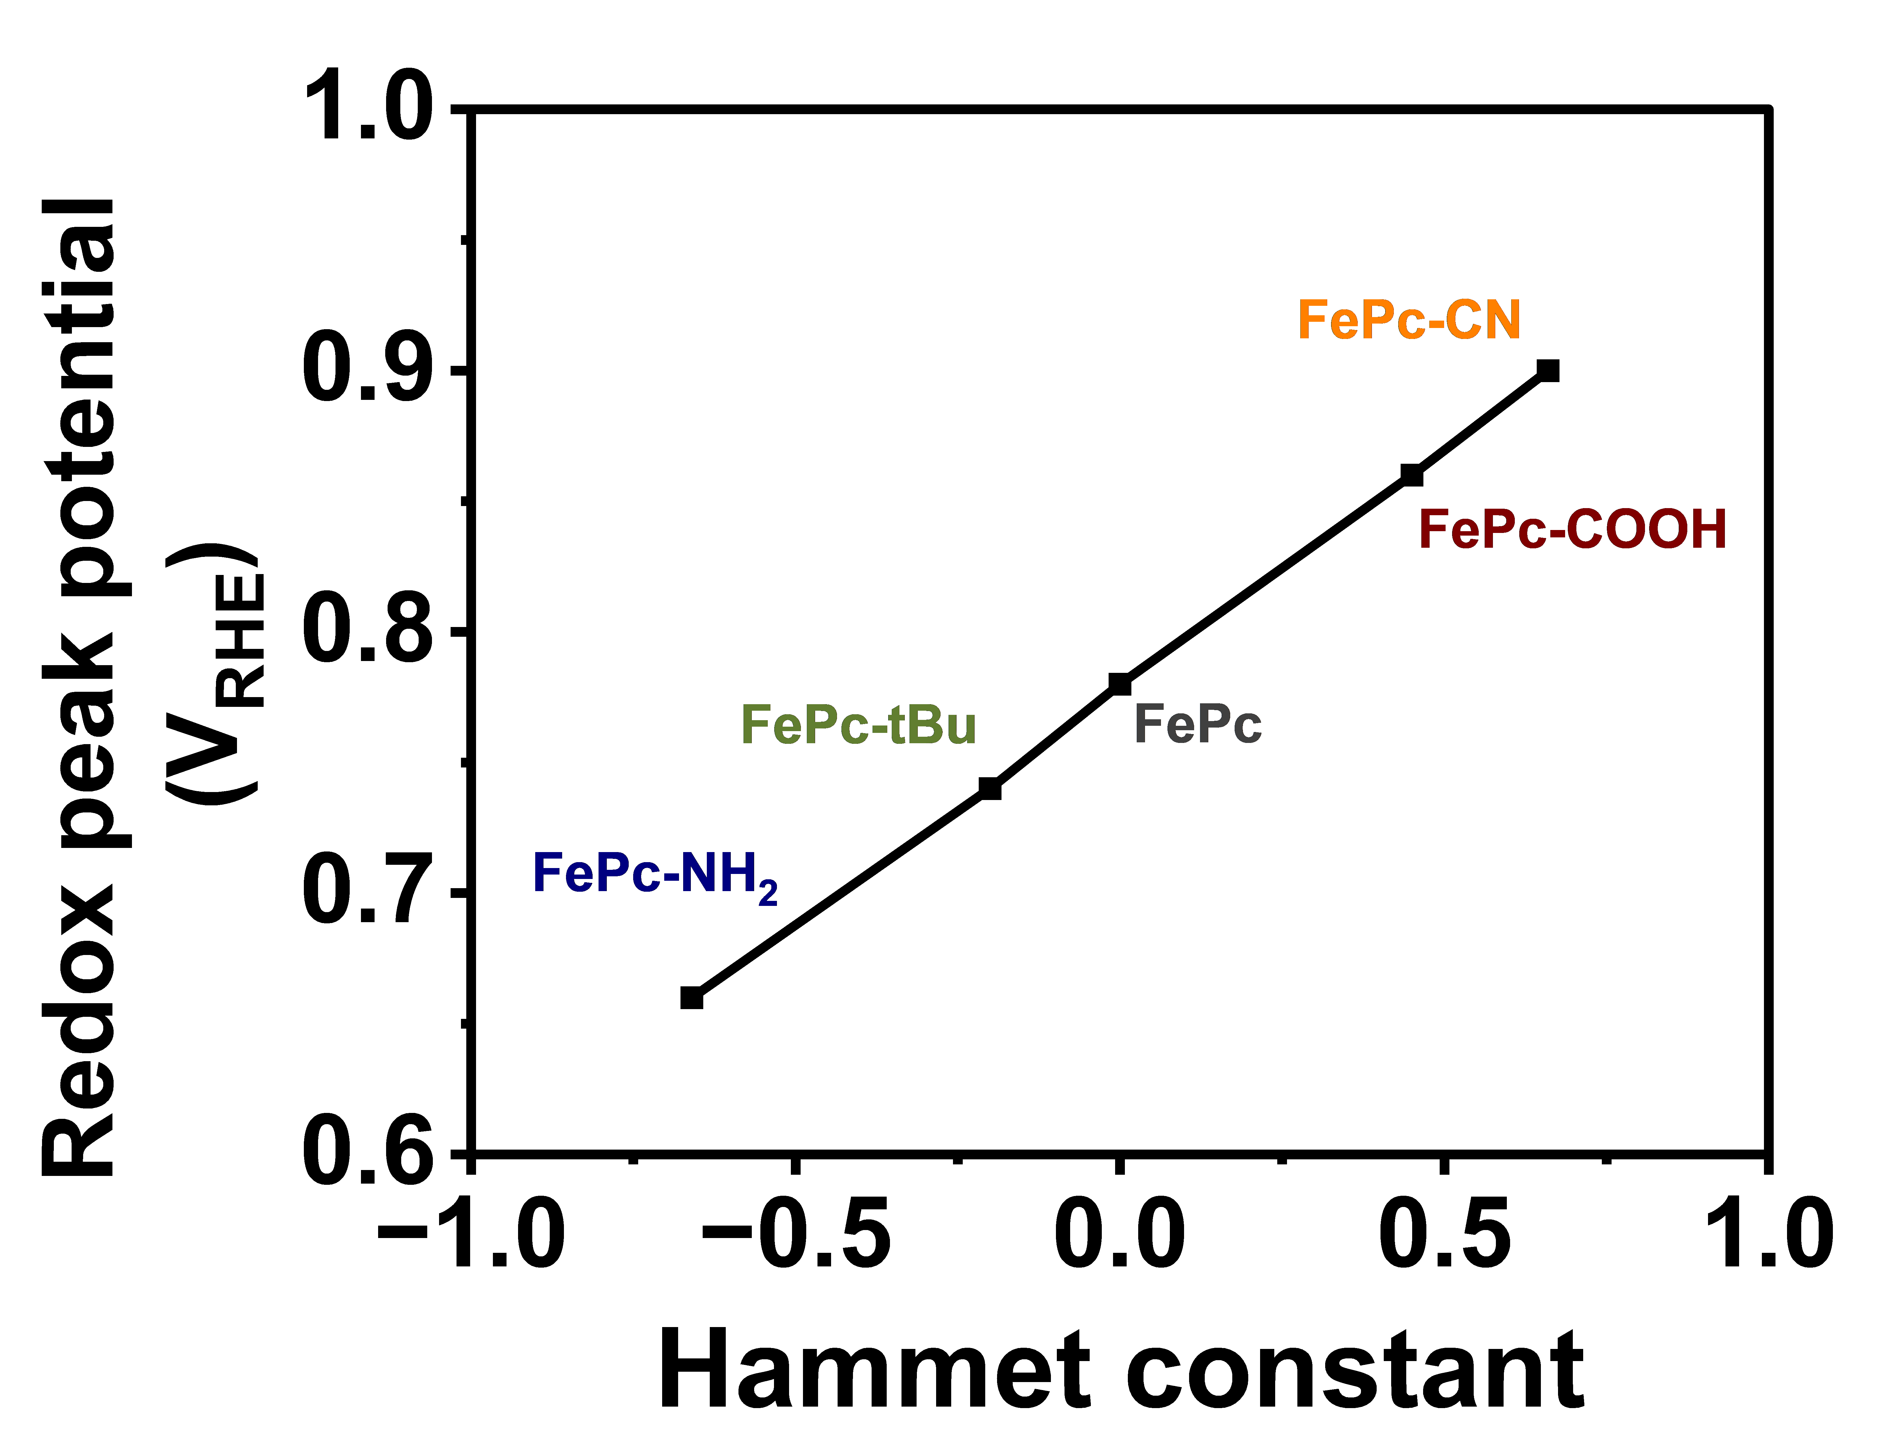
Figure S5. Redox potential Fe³⁺/Fe²⁺ in FePc-R/CNT determined from CVs as a function of the Hammett constant of functional groups.

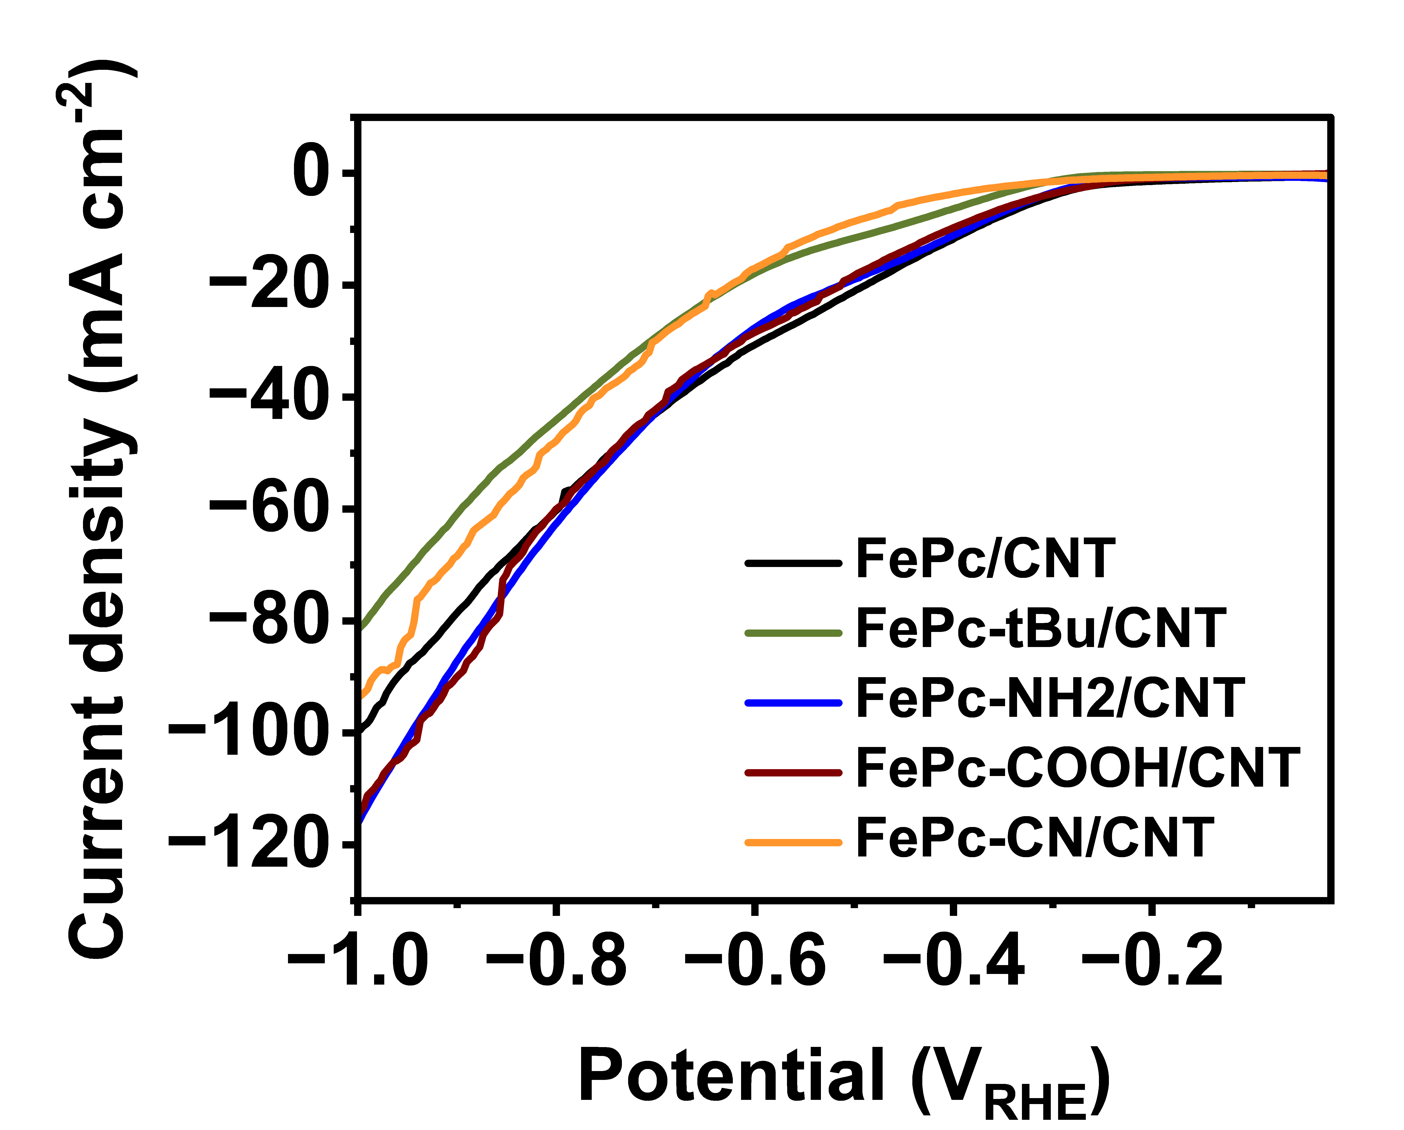
Figure S6. Linear sweep voltammetry of different FePc-R/CNT samples at 10 mV s⁻¹ in 0.1 M KNO₃ + 0.1 M NaOH.

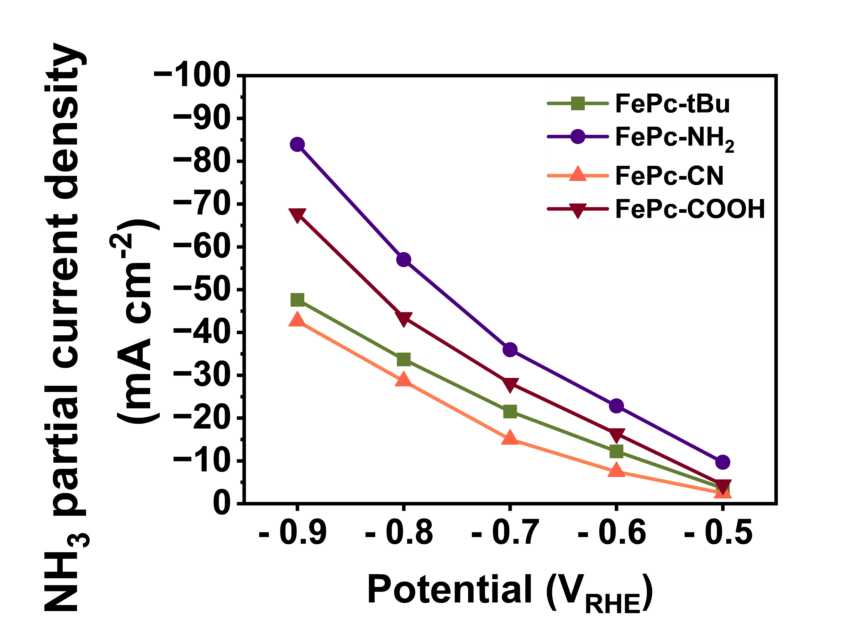
Figure S7. NH₃ partial current density of FePc-NH₂/CNT, FePc-tBu/CNT, FePc-COOH/CNT, and FePc-CN/CNT in electrochemical NO₃⁻ conversion to NH₃ in 0.1M KNO₃ + 0.1M NaOH, 30 minutes chronoamperometry in an H-type cell.

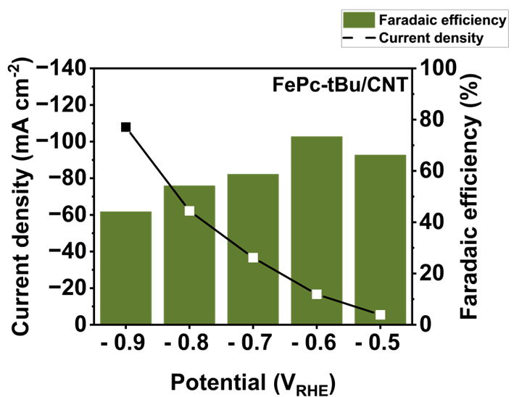
S8. Faradaic efficiency and total current density of FePc-tBu/CNT for electrochemical NO₃⁻ conversion to NH₃ in 0.1 M KNO₃ + 0.1 M NaOH via 30 minutes chronoamperometry measurements in an H-type cell.

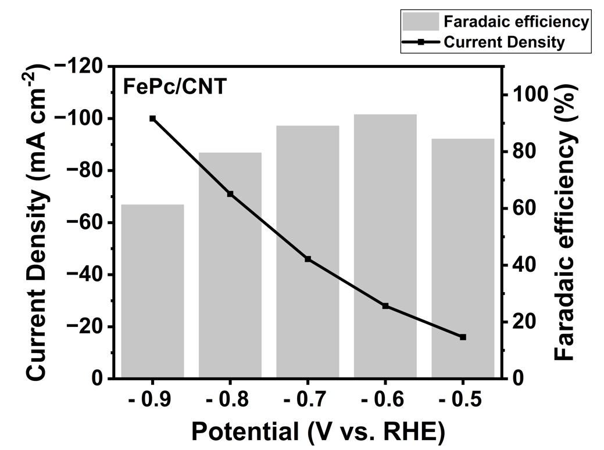
Figure S9. Faradaic efficiency and total current density of FePc in electrochemical NO₃⁻ conversion to NH₃ in 0.1M KNO₃ + 0.1M NaOH, 30 minutes chronoamperometry in an H-type cell.

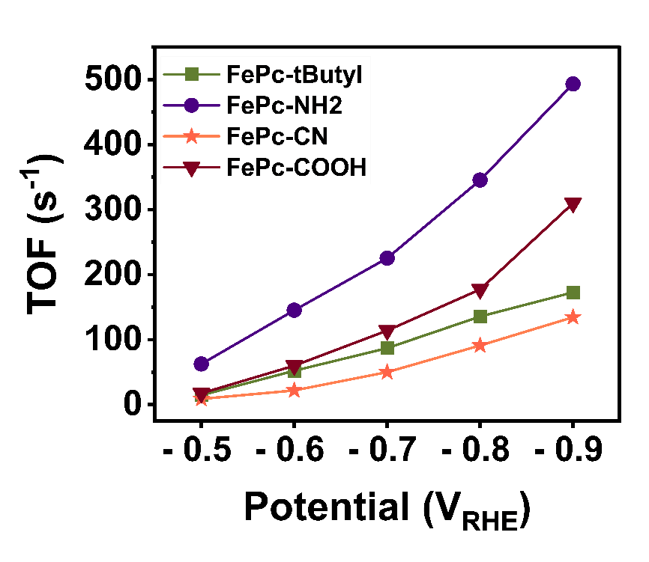
Figure S10. Turnover frequency of FePc-NH₂/CNT, FePc-tBu/CNT, FePc-COOH/CNT, and FePc-CN/CNT in electrochemical NO₃⁻ conversion to NH₃ in 0.1M KNO₃ + 0.1M NaOH, 30 minutes chronoamperometry in an H-type cell.

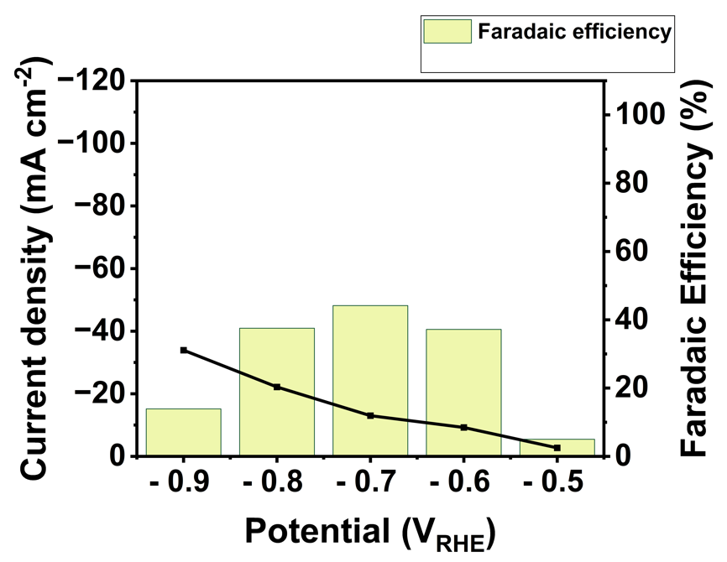
Figure S11. Faradaic efficiency and total current density of acid-washed CNTs in electrochemical NO₃⁻ conversion to NH₃ in 0.1M KNO₃ + 0.1M NaOH, 30 minutes chronoamperometry in an H-type cell.

15N Isotope labelling:
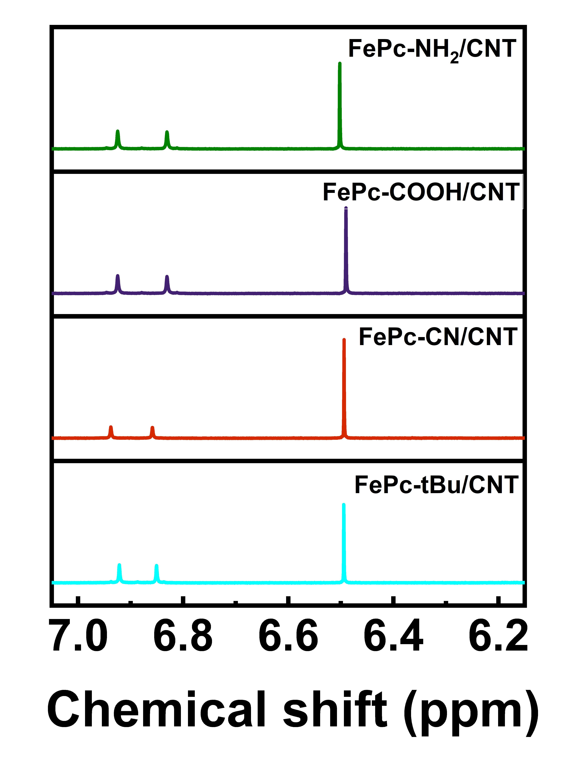
Figure S12. ¹HNMR spectra of FePc-NH₂/CNT, FePc-COOH/CNT, FePC-CN/CNT and FePc-tBu/CNT for ¹⁵N isotope labelling test performed in 0.1M K¹⁵NO₃ and 0.1M NaOH after 30 minutes chronoamperometry at -0.8 V_{RHE}.

In situ XAS of FePc-tBu/CNT:
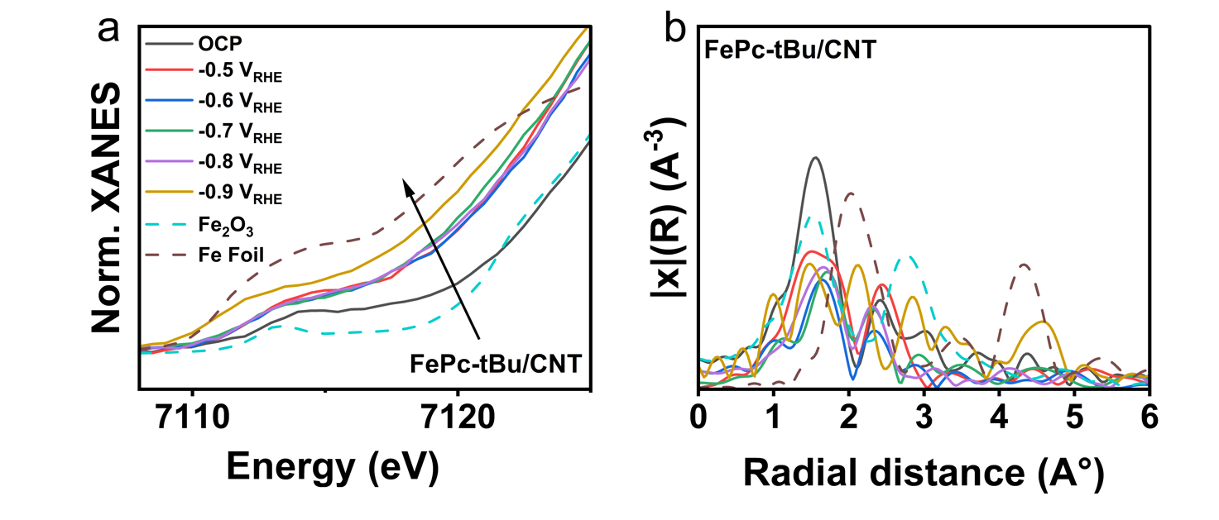
Figure S13. in situ XANES spectra of Fe K edge of a) FePc-tBu/CNT at electrode potentials ranging from OCP to -0.9 VRHE. In situ EXAFS spectra of b) FePc-tBu/CNT under reaction conditions (in 0.1 M KNO3 and 0.1 M NaOH, 30 minutes chronoamperometry in a custom designed H-type cell).

Table S2: Electronic and surface properties of different catalysts.
Catalysts | Functional group | Hammet constant | Wettability | Contact angle | Cluster formation potential (V_{RHE})
FePc-NH₂/CNT | Electron donating | -0.61 | Strongly hydrophilic | 24.4° | No cluster formation
FePc-COOH/CNT | Electron withdrawing | 0.45 | Strongly hydrophilic | 17.5° | -0.8 V_{RHE}
FePc-CN/CNT | Electron withdrawing | 0.66 | Weakly hydrophilic | 43.8° | -0.7 V_{RHE}
FePc-tBu/CNT | Electron donating | -0.2 | Weakly hydrophilic | 50.1° | -0.9 V_{RHE}

Table S3: Diffusion thickness layer and contact angle of FePc-R/CNT catalysts.
Catalyst (variant) | Contact angle | Diffusion thickness (μm)
FePc-NH2/CNT | 24.4° | 125
FePc-COOH/CNT | 17.5° | 110
FePc-CN/CNT | 43.8° | 170
FePc-tBu/CNT | 50.1° | 210

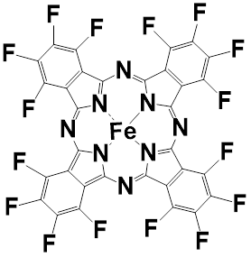
Figure S14. Chemical structure of -F group functionalized FePc.

Figure S15. a) Faradaic efficiency and total current density of FePc-F/CNT, b) NH₃ partial current density of FePc-F/CNT and FePc-CN/CNT in electrochemical NO₃⁻ conversion to NH₃ in 0.1M KNO₃ + 0.1M NaOH, 30 minutes chronoamperometry in an H-type cell.

Supplementary Note 7: HOMO/LUMO Levels
The HOMO/LUMO levels were identified as belonging to the spin down channel, while the highest single occupied molecular orbital in the spin up channel was lower in energy than the HOMO, and equivalently, the lowest unoccupied molecular orbital in the spin up channel lies higher than the overall LUMO; for all systems regardless of the functional group. The HOMO/LUMO energies in the main text are reported with respect to the vacuum level, that was determined for each system as the average electrostatic potential in the vacuum region of the computational cell with a distance of at least 5Å away from any atom and where the electron density is smaller than 10⁻⁷ eÅ⁻³. This vacuum energy level (in eV for the electron energy in vacuum) is subtracted from the “raw” HOMO/LUMO energies to obtain the values in Figure 4c. The DOS for each system is plotted in Figure SI 16, while the wave functions in Figure SI 17 show that those are qualitatively very similar for the HOMO and LUMO of each system with the biggest differences in the vicinity of the functional groups.
(a)
(b)
(d)
(c)
Figure S 16. Density of states for spin up electrons in blue and spin down electrons in red for a) FePc-CN, b) FePc-COOH, c) FePc-NH₂, and d) FePc-tBu.
(c)
(a)
(d)
(b)
(g)
(e)
(h)
(f)
(i)
(j)
Figure SI 17. Pseudowavefunctions belonging to the LUMO and HOMO of a,b) FePc, c,d) FePc-CN, e,f) FePc-COOH g,h) FePc-NH₂, I,j) FePc-tBu.

Supplementary Note 8: Electron Density Differences
We defined the electron density difference associated with introducing a functional group as the difference between the electron density of the catalyst $ρ_{FePc-group}$ vs. the electron density of the same structure with removed functional groups $ρ_{FePc-removed group}$ (i.e. without termination), and the phthalocyanine removed with only the functional groups $ρ_{group}$, such that the visualized difference is:
$$Δρ_{FePc-group}=ρ_{FePc-group}-\left(ρ_{FePc -removed group}+ρ_{group}\right).$$
The electron densities $ρ_{FePc-removedgroup}$ and $ρ_{group}$ are obtained as single point calculations after removing the affected atoms from the relaxed structure $ρ_{FePc-group}$.
The electron density difference $Δρ_{FePc-group}$ as seen in Figure SI 18 was visualized using VESTA ¹¹.
Figure SI 18. Electron density differences with respect to FePc as described in Supplementary Note 4 for a) FePc-CN, b) FePc-COOH, c) FePc-NH₂, and d) FePc-tBu.
(a)
(b)
(d)
(c)

Supplementary Note 9: Calculation of Formation Energies
The formation energy of FePc with a functional group, $E_{f,FePc-group}$, to assess the stability of the Fe atom can be evaluated as
$E_{f,FePc-group}=E_{FePc-group}-E_{Fe}-E_{H_{2}Pc-group}+E_{H_{2}(g)}$,
where the reference energies are $E_{Fe}$ for solid iron Fe; $E_{H_{2}Pc-group}$ for the phthalocyanine with functional groups, but with two terminating hydrogens instead of a metal center; and $E_{H_{2}(g)}$ for the hydrogen atoms after replacement by iron.
To mitigate the choice of reference e.g. Fe(bcc) or the fact if the $E_{H_{2}Pc-group}$ is stable or not it is better to look at the differences in formation energy between FePc-group and FePc:
$$ΔE_{f,FePc-group}=E_{f,FePc-group}-E_{f, FePc}$$
$$=E_{FePc-group}-E_{Fe}-E_{H_{2}Pc-group}+E_{H_{2}(g)}-{(E}_{FePc}-E_{Fe}-E_{H_{2}Pc}+E_{H_{2}(g)}) \\ =E_{FePc-group}-E_{FePc}-{(E}_{H_{2}Pc-group}-E_{H_{2}Pc})$$

References:
1 Hjorth Larsen, A. et al. The atomic simulation environment—a Python library for working with atoms. Journal of Physics: Condensed Matter 29, 273002 (2017). https://doi.org/10.1088/1361-648X/aa680e
2 Larsen, A. H. et al. The atomic simulation environment—a Python library for working with atoms. Journal of Physics: Condensed Matter 29, 273002 (2017).
3 Haynes, W. M. CRC handbook of chemistry and physics. (CRC press, 2016).
4 Calle-Vallejo, F., Huang, M., Henry, J. B., Koper, M. T. & Bandarenka, A. S. Theoretical design and experimental implementation of Ag/Au electrodes for the electrochemical reduction of nitrate. Physical chemistry chemical physics 15, 3196-3202 (2013).
5 Riyaz, M. & Bagger, A. NOX reduction mechanism: Thermal vs electrochemical step. Electrochimica Acta 513, 145429 (2025).
6 Nørskov, J. K. et al. Origin of the overpotential for oxygen reduction at a fuel-cell cathode. The Journal of Physical Chemistry B 108, 17886-17892 (2004).
7 Burdyny, T. et al. Nanomorphology-enhanced gas-evolution intensifies CO2 reduction electrochemistry. ACS Sustainable Chemistry & Engineering 5, 4031-4040 (2017).
8 Zhao, X., Ren, H. & Luo, L. Gas bubbles in electrochemical gas evolution reactions. Langmuir 35, 5392-5408 (2019).
9 Vogt, H. & Stephan, K. Local microprocesses at gas-evolving electrodes and their influence on mass transfer. Electrochimica Acta 155, 348-356 (2015).
10 Demirkır, Ç., Wood, J. A., Lohse, D. & Krug, D. Life beyond fritz: on the detachment of electrolytic bubbles. Langmuir 40, 20474-20484 (2024).
11 Momma, K. & Izumi, F. VESTA: a three-dimensional visualization system for electronic and structural analysis. Journal of Applied Crystallography 41, 653-658 (2008). https://doi.org/doi:10.1107/S0021889808012016

