Supplementary Figures
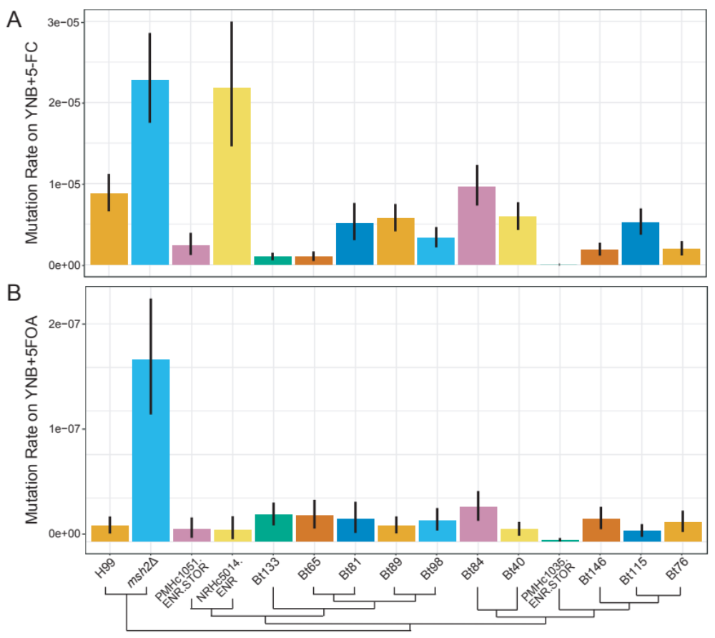Supplementary Figure S1. Bt65 and Bt81 do not display a hypermutator phenotype on 5-FC or 5-FOA. Mutation rates of closely related VNBII strains and controls on (A) YNB + 5-FC and (B) YNB + 5-FOA media. Bars represent the mutation rate and error bars represent 95% confidence intervals; mutation rates represent the number of mutations per cell per generation. Schematic depicts the phylogenetic relationships of all strains included in fluctuation analyses based on Desjardins et al. 2017¹⁸.

Supplementary Figure S2. Growth at elevated temperature does not result in increased mutation rates in C. neoformans strains. Fluctuation assays were used to quantify the mutation rates of strains grown overnight at 30°C or 37°C and plated on YPD + rapamycin + FK506 medium. Bars indicate mean mutation rate and error bars indicate 95% confidence intervals. Mutation rates represent the number of mutations per cell per generation.

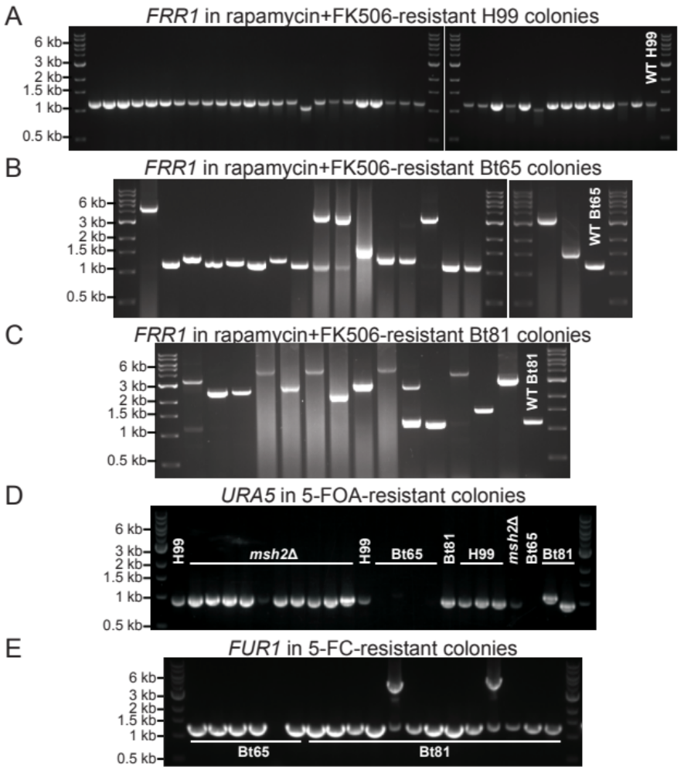
Supplementary Figure S3. Gel electrophoresis FRR1, URA5, and FUR1 PCR products from resistant colonies. Gel electrophoresis of FRR1 PCR products from (A) all H99 rapamycin + FK506-resistant colonies and a subset of (B) Bt65 and (C) Bt81 rapamycin + FK506-resistant colonies sequenced in Figure 1D. PCR amplification of wild-type FRR1 in C. neoformans produces a 1,165 bp electrophoretic species (primers ZC7/8). Gel electrophoresis of a subset of (D) URA5 PCR products from H99, Bt65, and Bt81 5-FOA-resistant colonies and (E) FUR1 PCR products from 5-FC-resistanct colonies of Bt65 and Bt81.

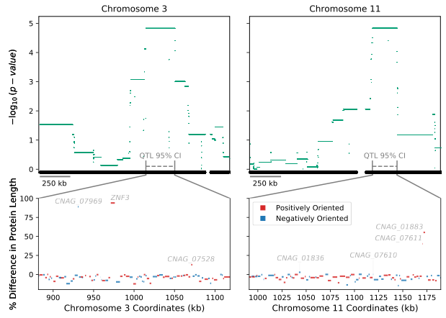
Supplementary Figure S4. Protein length differences of genes within QTL. In the upper panels, points mark the strength of association (y-axis) between bi-allelic SNP sites and hypermutation for Chromosome 3 and Chromosome 11 (top left and right, respectively). Grey dashed lines depict the 95% confidence intervals (CI) of the two QTL. Lower panels show the predicted differences in lengths of proteins (y-axis) encoded by annotated genes in Bt65 compared to H99 within each 95% CI of the QTL (x-axis) on Chromosome 3 and Chromosome 11 (bottom left and right, respectively). The name of each gene with a predicted nonsense mutation is annotated. Blue and red colors denote the gene orientation.

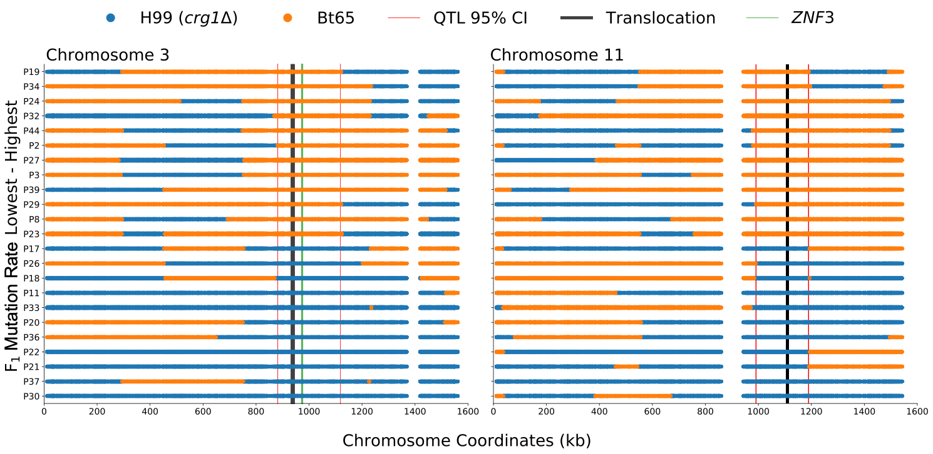
Supplementary Figure S5. Haplotype maps of Bt65 x H99 F₁ progeny utilized for QTL mapping. For the QTLs on Chromosome 3 and Chromosome 11 (left and right, respectively) the haplotypes (x-axis) are inferred by SNP data per segregant (y-axis) and colored blue or orange if inherited from H99 crg1Δ or Bt65, respectively. Segregants are sorted along the y-axis by the quantification of their mutation rate; largest to smallest, top to bottom. Vertical red lines display the boundaries of the QTL(s). Vertical black lines depict the approximate location of the translocation between H99 and Bt65. The boundaries of the QTG, ZNF3, are depicted by vertical green lines. Vertical white spaces indicate the approximate locations of the centromeres.

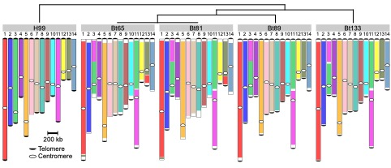
Supplementary Figure S6. Large-scale genomic rearrangements between the H99, Bt65, Bt81, Bt89, and Bt133 genomes. Nanopore whole-genome sequencing followed by synteny analysis was used to identify all indicated genomic rearrangements with respect to the reference strain H99. There is a chromosomal translocation between Chromosomes 3 and 11 that is unique to H99, and a translocation between H99 Chromosomes 1 and 13 that is unique to Bt65 and Bt81. The phylogenetic relationships of these strains are depicted in the top schematic, telomeric repeat sequences accurately identified in the genomic assemblies are indicated by black half circles, and centromeres are indicated by white circles.

Supplementary Figure S7. CNAG_01836 gene model. A grey horizontal bar depicts the entire gene body in the upper panel, and larger grey rectangles show locations of exons. The gene is depicted 5’ to 3’, left to right, and is 1896 nt in length. The locations of SNPs differing between Bt65 and H99 are shown by vertical black rungs along the gene model. Amino acids specified by mRNA codons in the indicated region of CNAG_01836 Exon 7 (nucleotide 1831 to 1848) are shown to illustrate the G to A mutation (nucleotide 1842) predicted to cause an early nonsense mutation in Bt65. The bottom panel depicts the predicted outcome of the nonsense mutation on the protein encoded by CNAG_01836 in Bt65.

Supplementary Figure S8. Mutation rates of Bt81 x H99 F₁ progeny. Fluctuation analysis was used to quantify the mutation rates of the indicated strains on YPD + rapamycin + FK506 medium (y-axis) – sorted smallest to largest, left to right – for F₁ progeny and the parental strains, H99α crg1Δ and Bt81 (x-axis). Bars indicate the mean mutation rate and error bars represent 95% confidence intervals. Mutation rates represent the number of mutations per cell per generation. Inheritance of the Bt81 znf3 allele or H99 crg1Δ ZNF3 allele in the F₁ progeny is indicated above mutation rates.

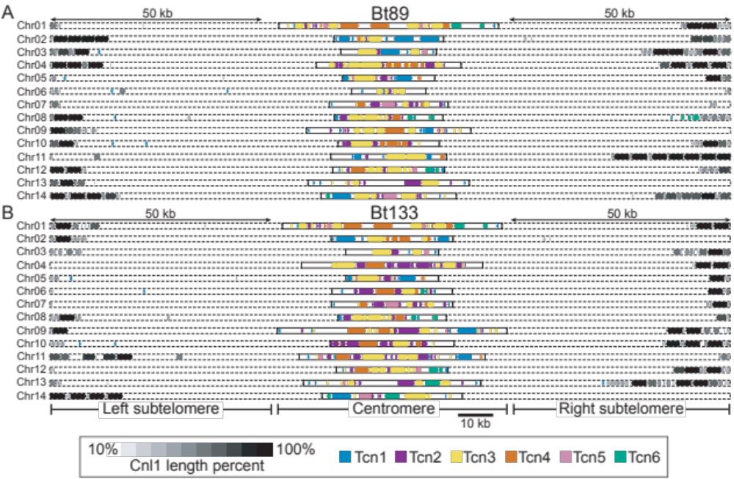
Supplementary Figure S9. Subtelomeric and centromeric retrotransposons in Bt89 and Bt133. Distributions of the Tcn1-Tcn6 LTR-retrotransposons and the Cnl1 non-LTR retrotransposon in the genomes of (A) Bt89 and (B) Bt133. 50 kb of subtelomeric regions as well as centromeric regions are displayed for both strains. Shading corresponds to the lengths of the Cnl1 elements, and gene arrowheads indicate the direction of transcription for all retrotransposons.

Supplementary Figure S10. Centromere lengths do not significantly differ among H99, Bt65, Bt81, Bt89, and Bt133. The length of each centromere (y-axis) is plotted for each strain (x-axis). The thin horizontal black line indicates average centromere length and the thicker black error bars indicate the standard error of the mean. No significant difference was found between the average centromere length of each strain (ANOVA, p-value = 0.153).

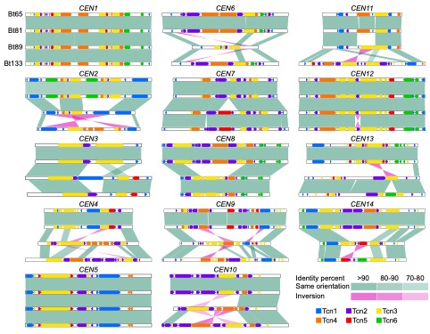
Supplementary Figure S11. Centromeric rearrangements among hypermutators and two closely related strains. Shared homology, genomic rearrangements, inversions, insertions and deletions among the centromeres of each of the 14 chromosomes are depicted for Bt65, Bt81, Bt89, and Bt133. The organization of LTR-retrotransposons Tcn1 through Tcn6 are also indicated for each centromere of each strain.

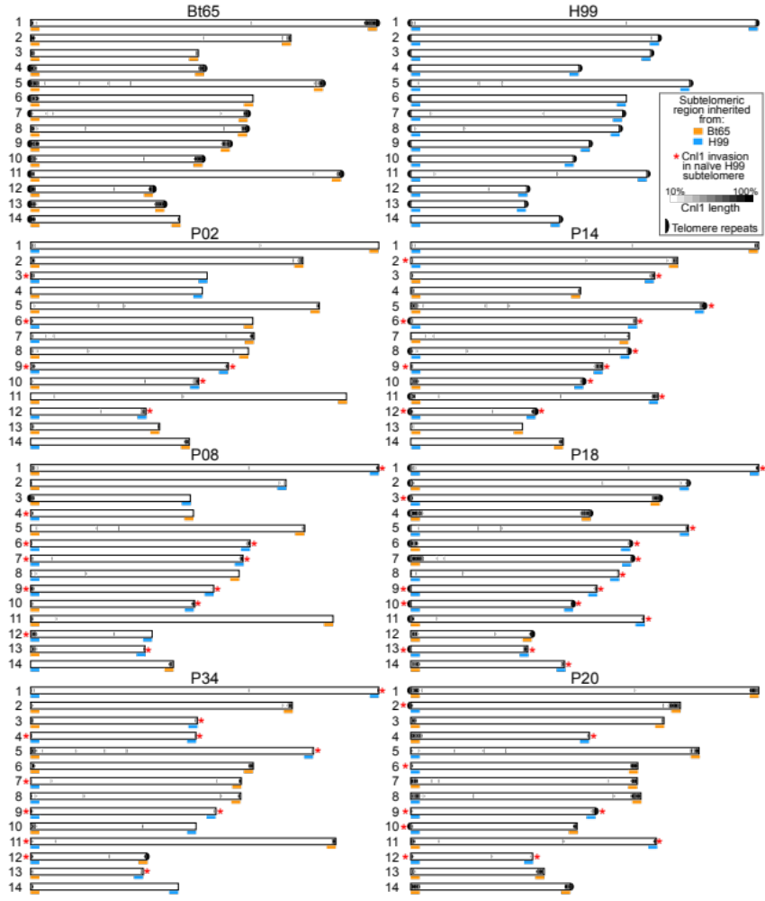
Supplementary Figure S12. Distribution of Cnl1 among Bt65 x H99 F₁ progeny and parental strains. The Cnl1 non-LTR elements identified in the nanopore-based whole-genome assemblies are depicted for H99, Bt65, three hypermutator F₁ progeny (P02, P08, and P34, all on the left), and three non-hypermutator F₁ progeny (P14, P18, and P20, all on the right). Blue and orange bars under the subtelomeric region of each chromosome indicate which parental strain the region was inherited from (orange for Bt65, blue for H99). Red asterisks indicate invasion of Cnl1 into an H99 subtelomeric region that previously had zero Cnl1 copies/fragments. Accurate assembly of telomeric repeat sequences at the end of each chromosome is indicated by a black half circle. Cnl1 length is also indicated by the shade of black for each element.

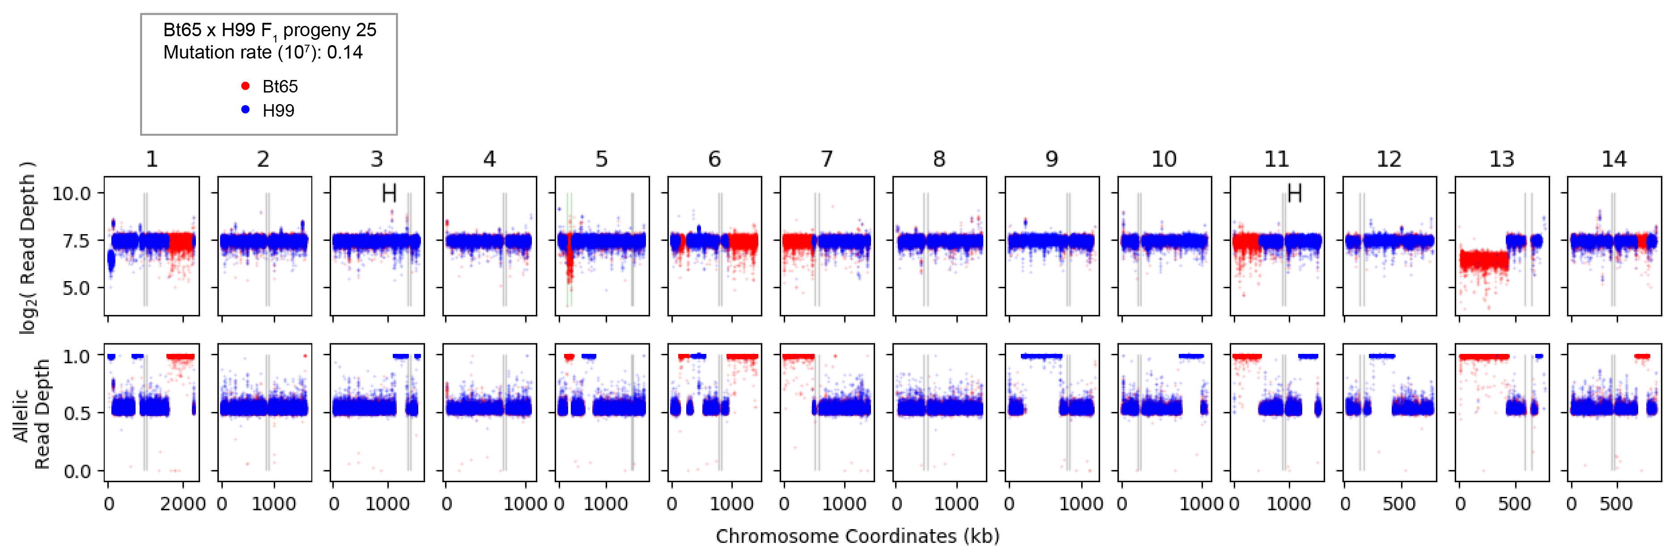
Supplementary Figure S13. Genomic diagnostic plot of Bt65 x H99 F₁ progeny 25. For the 14 chromosomes (columns), the log₂ (read depth) (top row) and allelic read depth ratio (bottom row) per genetic variant are shown for the progeny 25. Red and blue colors indicate the prediction of the allele inherited (Bt65 vs. H99, respectively) at each genetic variant. Allelic read depth ratios nearing 0.5 suggest both alleles are present for a given genetic variant. Marked ranges on Chromosomes 3 and 11 log₂ (read depth) plots indicate the significant hypermutator QTL. Black vertical lines depict the boundaries of the centromeres. The boundaries of the MAT locus on Chromosome 5 are shown by vertical green lines.

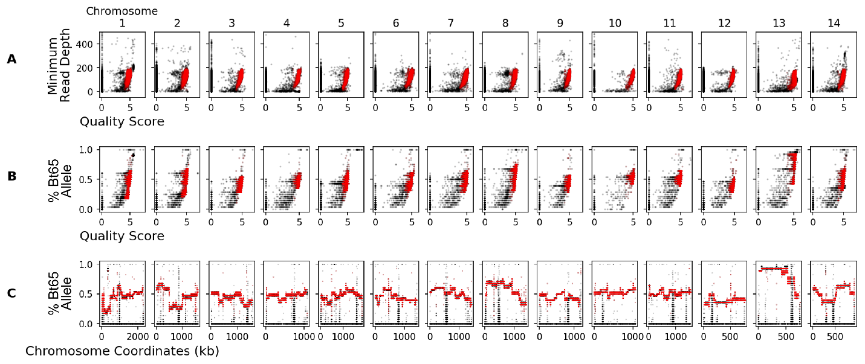
Supplementary Figure S14. Visualization of genetic variant filtering criteria. (A) For the 14 chromosomes (columns), the quality scores of the genetic variants (x-axis) vs. the minimum read depth across the 28 Bt65 x H99 F₁ segregants (y-axis). (B) the quality scores of genetic variants (x-axis) vs. the portion of progeny with the Bt65 allele per genetic variant (y-axis) per chromosome (columns). (C) The portion of progeny with the Bt65 allele per genetic variant (y-axis) across each chromosome (x-axis). The raw genetic variants are shown in black and the filtered SNPs, used in analysis, are shown in red.

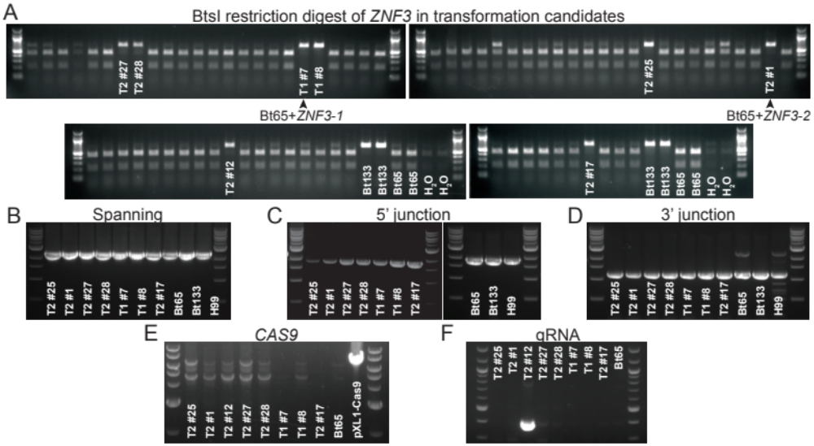
Supplementary Figure S15. Identification and confirmation of correct Bt65+ZNF3 transformants. (A) BtsI restriction enzyme digestion of ZNF3 PCR products from nourseothricin-resistant transformants and controls (primers SJP186/187). (B) PCR amplification of the ZNF3 allele using primers outside of the Bt133 ZNF3 allele used for homologous recombination (primers SJP208/209). PCR amplification to ensure correct integration of the (C) 5’ and (D) 3’ ends of the Bt133 ZNF3 allele at the endogenous ZNF3 locus (primers SJP208/187, and SJP186/209, respectively). PCR to ensure neither (E) CAS9 nor (F) the gRNA constructs were integrated into the transformants (primers JOHE41657/45812 and JOHE50451/50452, respectively).

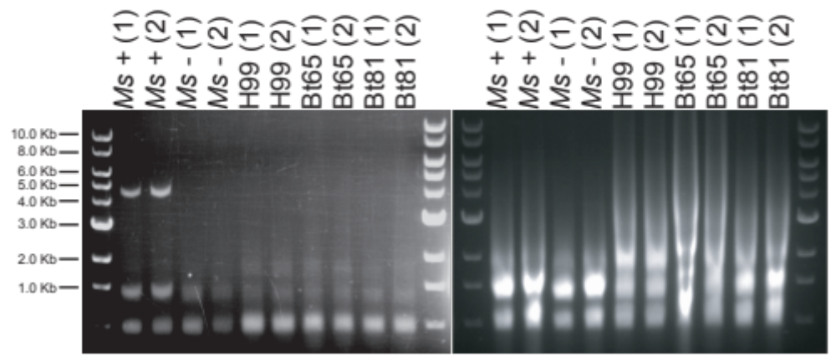
Supplementary Figure S16. Enrichment for dsRNA does not identify any fragments likely to be dsRNA mycoviruses. Pictured on the left are RNA samples following LiCl enrichment for dsRNA run on a 1% agarose gel. Total RNA prior to dsRNA enrichment is pictured on the right on a 1% agarose gel. Ms+ is a Malassezia sympodialis strain that harbors a dsRNA virus, and Ms- is a congenic virus-cleared strain⁵⁵. Two biological replicates for all samples are shown and labeled (1) and (2). The TriDye 1 kb DNA ladder (NEB) was used to estimate RNA fragment sizes.

Supplementary Table Legends
Supplementary Table S1. Strains included in preliminary screen of SDC isolates for hypermutation phenotype.

Supplementary Table S2. Genetic variants and predicted changes in genes within QTL between H99 and Bt65.

Supplementary Table S3. (A) Centromere lengths in H99, Bt65, Bt81, Bt89, and Bt133, and (B) one-way ANOVA and Tukey’s HSD post hoc statistical tests for differences in mean centromere length.

Supplementary Table S4. sRNA analysis

Supplementary Table S5. Strains used in this study.

Supplementary Table S6. Mutation rates and 95% confidence intervals for all fluctuation assays.

Supplementary Table S7. Oligonucleotides used in this study.

Supplementary Table S8. Cnl1 insertion sequences in PCR products.

Supplementary Table S9. Aneuploid, diploid, and clonal Bt65 x H99 F₁ progeny.

