Supplementary Information

High-Throughput Label-free Single-Cell Proteomics Enabled by 5-min Multicolumn NanoLC-MS Platform
Chao Wang ^{a#}, Hsien-Jung L. Lin ^{a#}, Siqi Huang ª, Garrett D. Haynie ª, Kenneth S. Triggs ª, YenJou Chang ª, David V. Hansen ª, Thy Truong ^{b}, Xiaofeng Xie ^{b} and Ryan T. Kelly ^{a*}

a Department of Chemistry and Biochemistry, Brigham Young University, Provo, Utah 84602, United States;
b MicrOmics Technologies, LLC, Spanish Fork, Utah 84660, United States

# These authors contribute equally for this manuscript
*Email: ryan.kelly@byu.edu

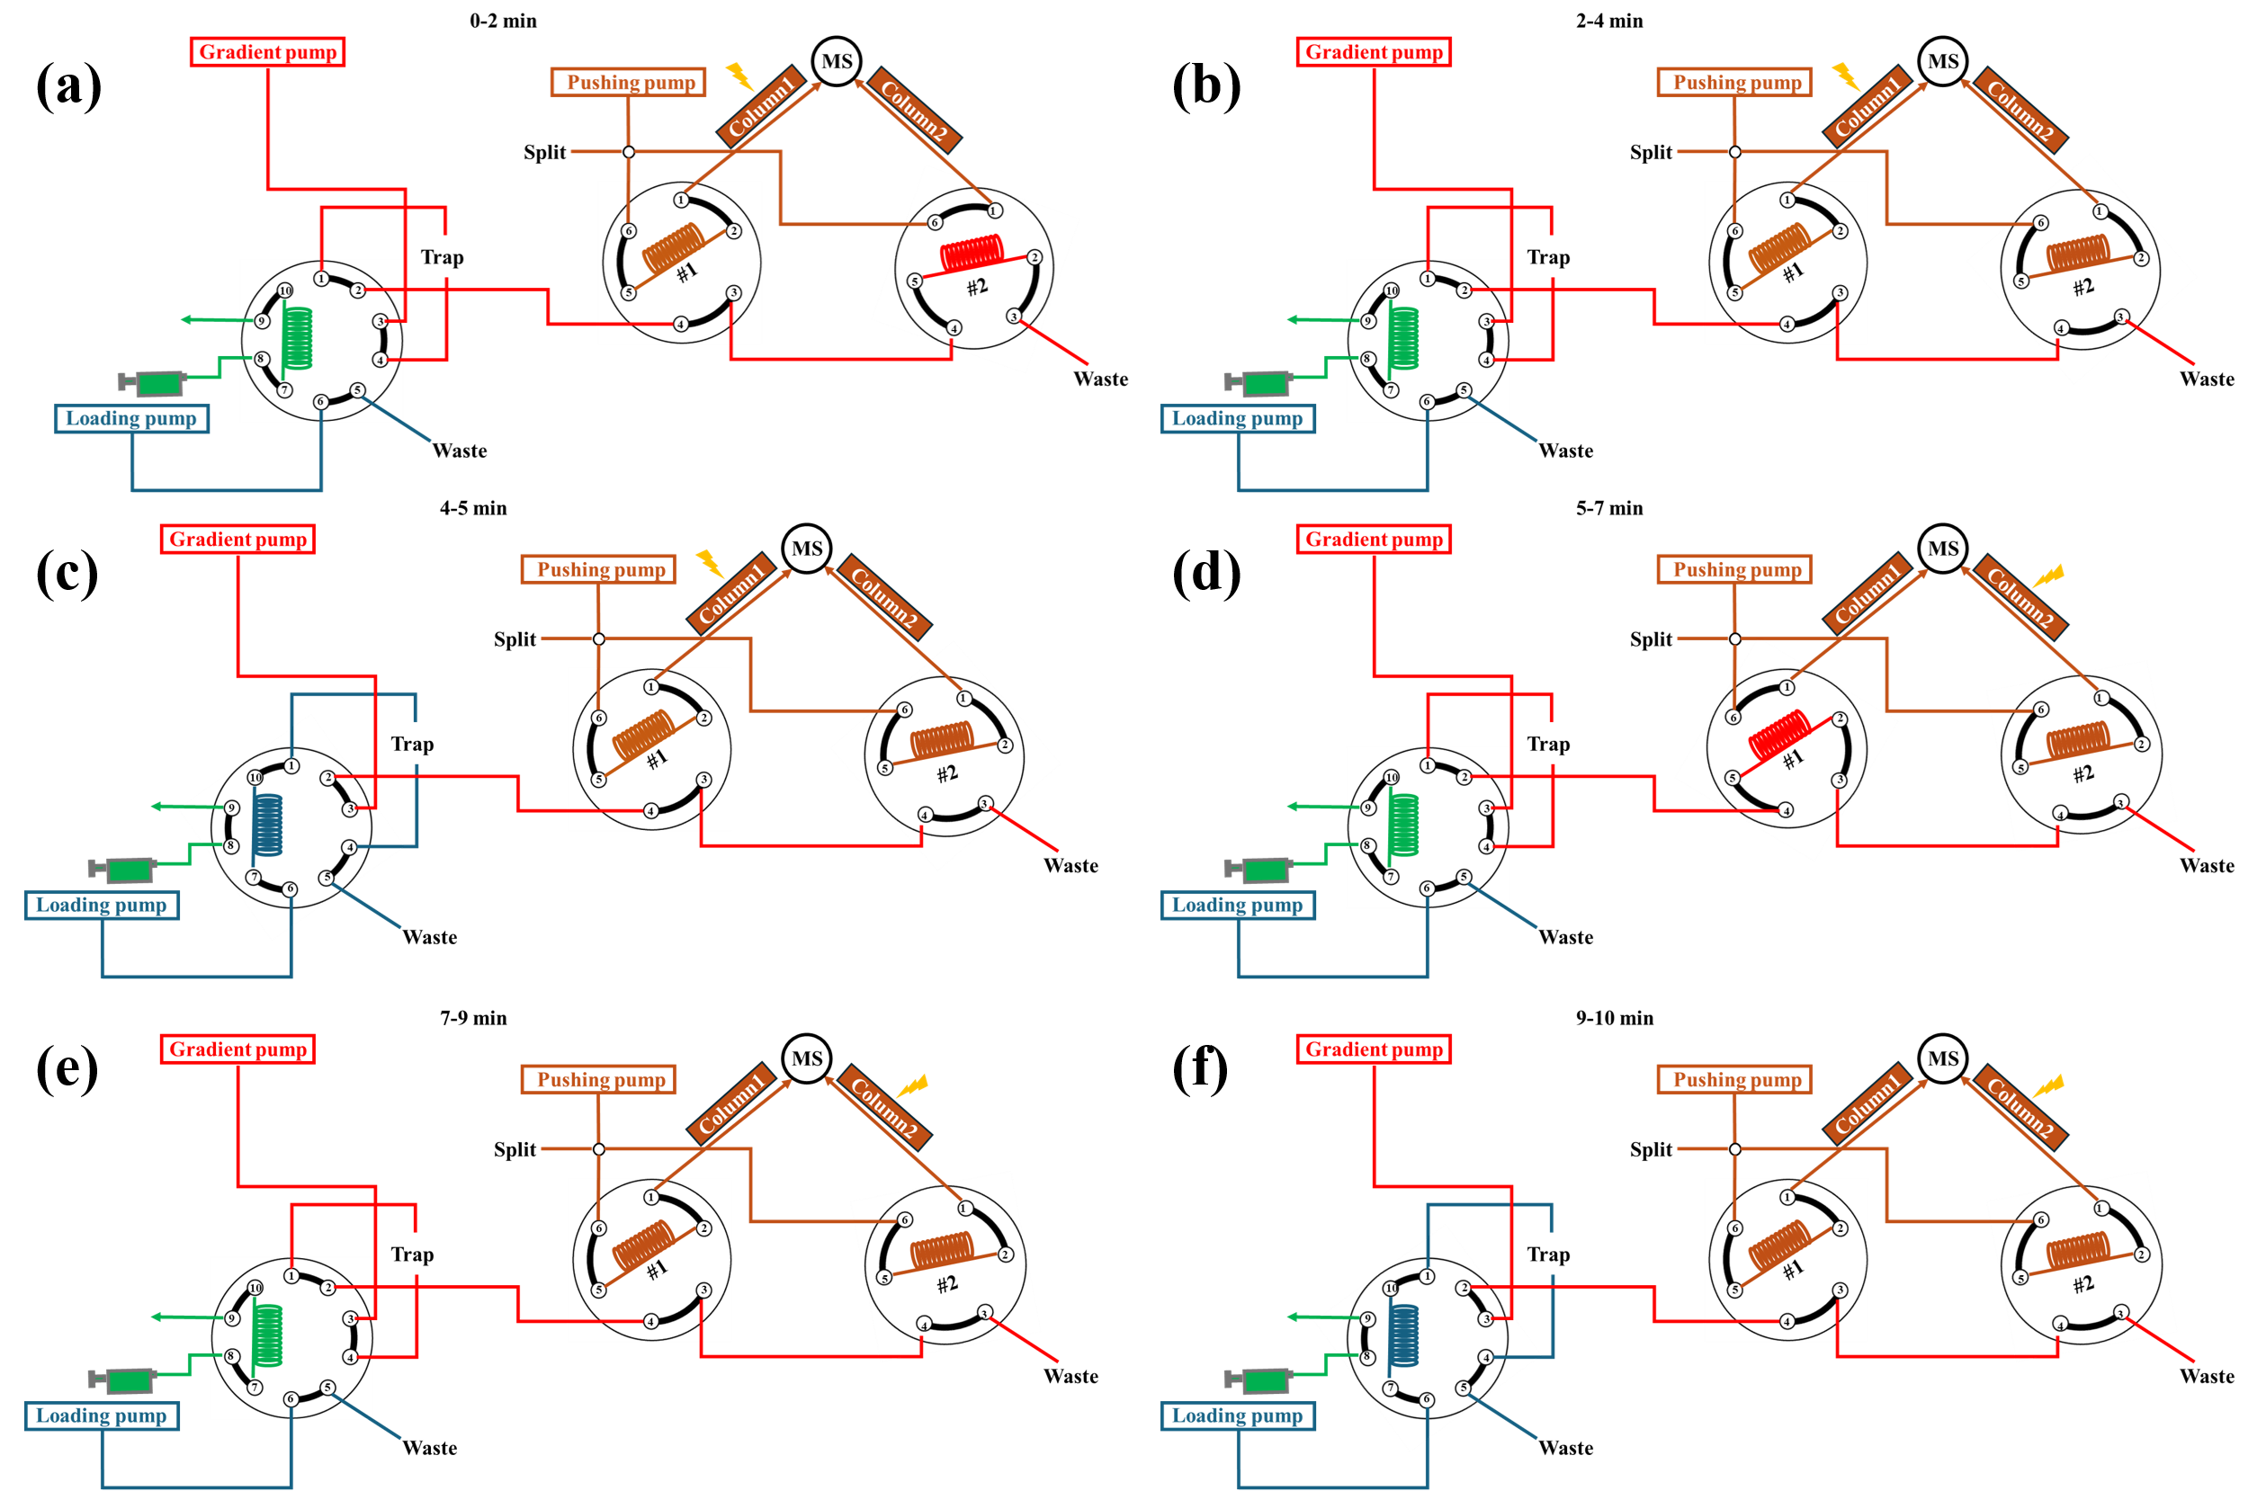
Fig. S1 Minute-by-minute schematic diagrams of the multicolumn LC system.

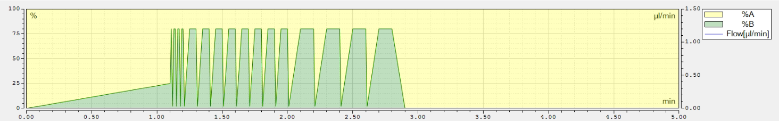
Figure S2 Illustration of the gradient curve used for trap column cleanup.
m/z | sample | blank1 | blank2 | blank3
444.74 | 100% | 0.38% | 0.67% | 0.22%
425.77 | 100% | 0.28% | 0.86% | 0.21%
495.30 | 100% | 0.40% | 0.58% | 0.43%
Table S1 Relative Intensity for three peptides extracted from 2 ng HeLa digests runs and three blank runs

