A chikungunya virus-like particle vaccine reduces chikungunya disease in cynomolgus macaques and protection is mediated by antibody transferred from vaccinated humans

SUPPLEMENTAL INFORMATION
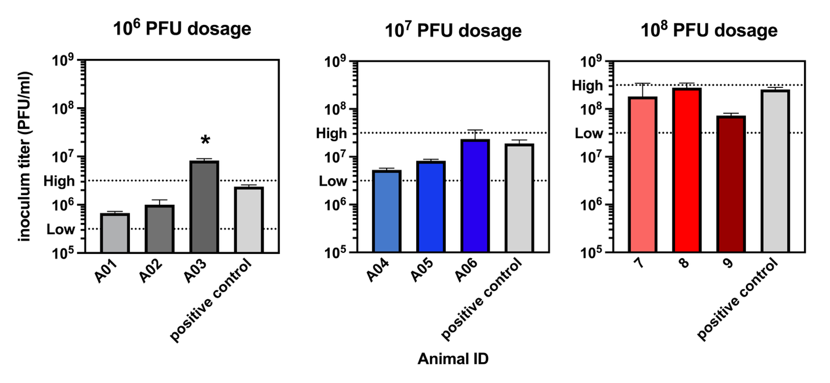
Supplemental Figure 1: Back-titration of CHIKV LR-OPY1 inocula for Study A. On days of virus challenge, the remainder of virus stock in the vial administered to animals was refrozen at -80°C and then processed as a batch by thawing and titrating on Vero cells. Animals were inoculated with 0.42, 0.52 or 0.39 ml of the 10⁶, 10⁷ or 10⁸ PFU vials, to reach the desired inoculum dose, which was verified for each animal (A01-A09). Dotted lines indicate the 10-fold range around the titer of the positive control, which was thawed and re-frozen to reproduce the same treatment as the virus used in inocula. The asterisk above A03 shows the titer was above the 10-fold range around the target dose. PFU is plaque forming units.

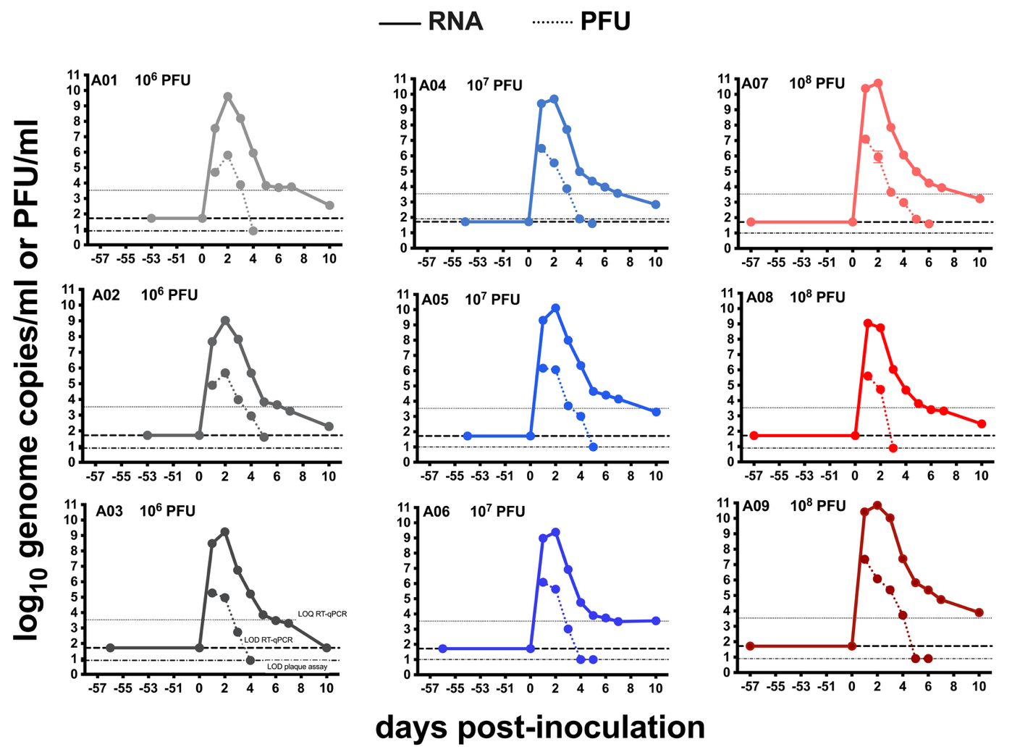
Supplemental Figure 2: CHIKV plasma viremia kinetics in cynomolgus macaques inoculated with 10⁶, 10⁷, or 10⁸ PFU on a per animal level. The solid lines show CHIKV RNA levels and the dotted lines show CHIKV PFU levels. Each dot represents the mean of triplicate technical RT-qPCR replicates and duplicate titrations. The LOD and LOQ are indicated by horizontal lines. Samples that were undetectable were given a value of the LOD for graphing purposes. PFU is plaque forming units.

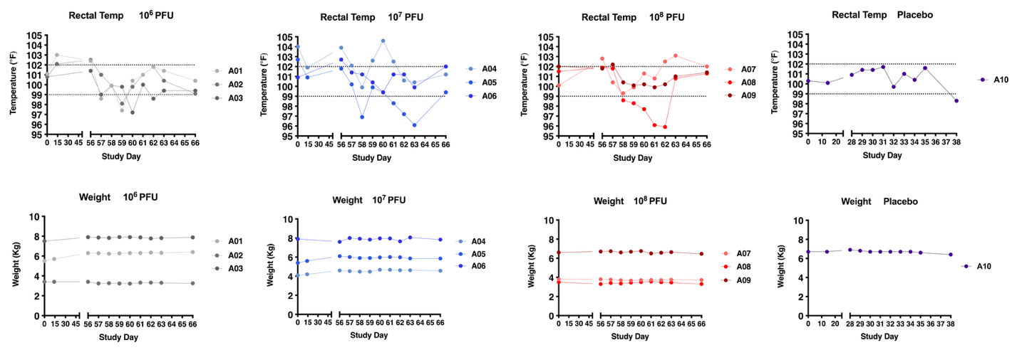
Supplemental Figure 3: Time course of rectal temperatures and body weights in CHIKV-or placebo-inoculated cynomolgus macaques. The 3 CHIKV-infected animal groups were inoculated on study day 56 and monitored until day 66. The placebo-treated animal was mock-inoculated on study day 28 and monitored until day 38. Dotted lines indicate the normal temperature range (99-102 °F).

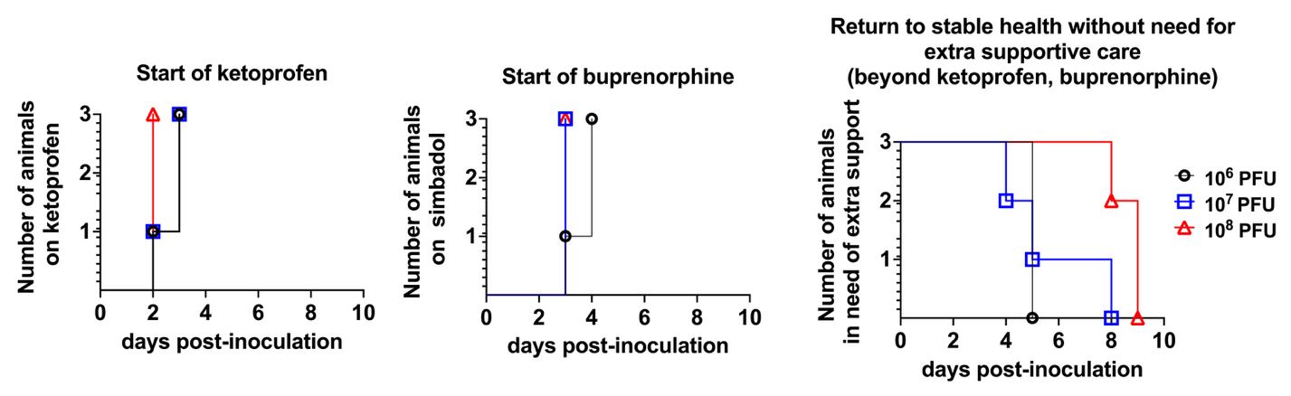 Supplemental Figure 4: Initiation and duration of supportive care in CHIKV-inoculated cynomolgus macaques. Days of treatment initiation of the analgesics ketoprofen and long-acting buprenorphine for pain management and time when animals returned to normal clinical status with normal appetite and no longer required other supportive care beyond ketoprofen or buprenorphine including subcutaneous fluids or orogastric intubation for nutritional supplementation. Differences across groups were not statistically significant (p>0.05, Logrank test).

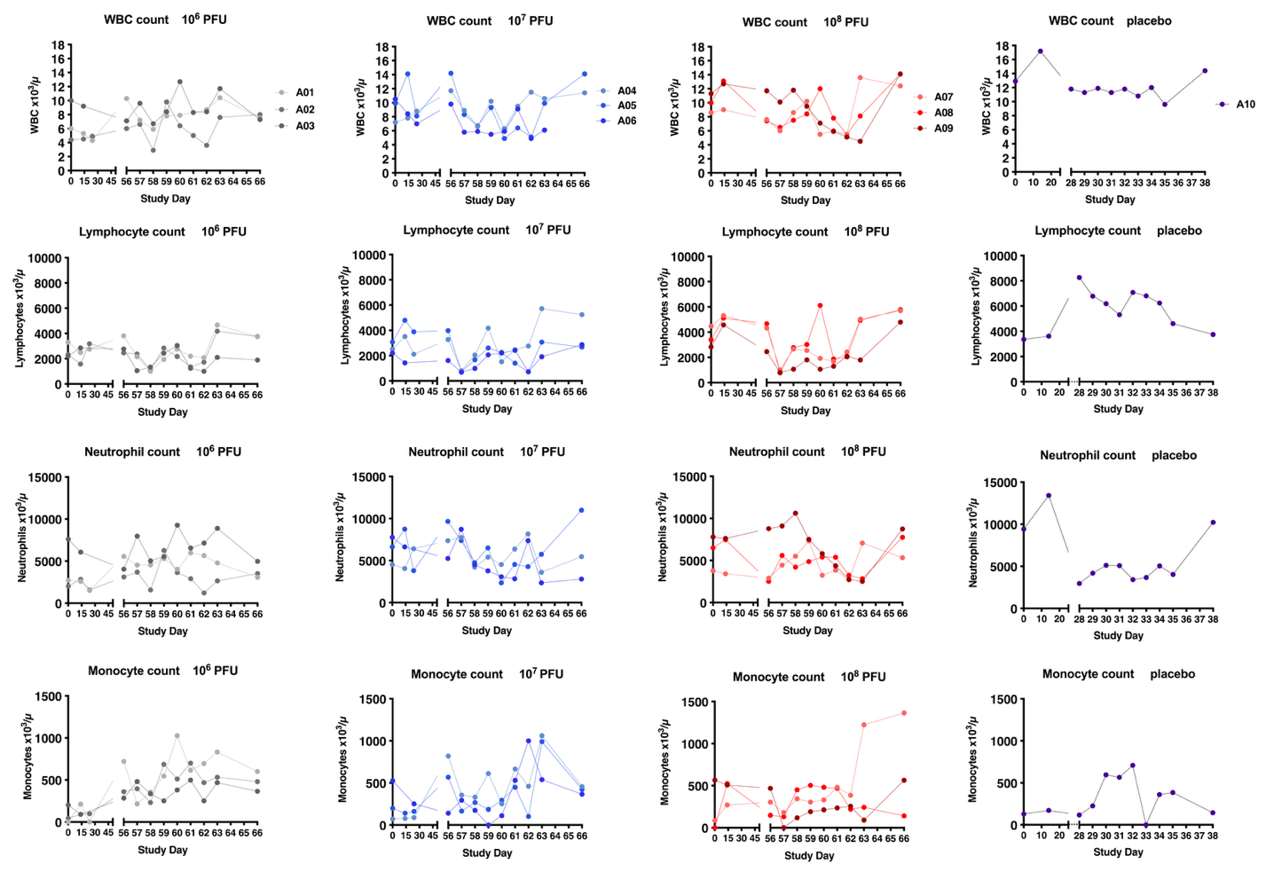
Supplemental Figure 5: Time course of white blood cells (WBC), lymphocytes, neutrophils, and monocytes in CHIKV-inoculated or placebo-treated cynomolgus macaques.

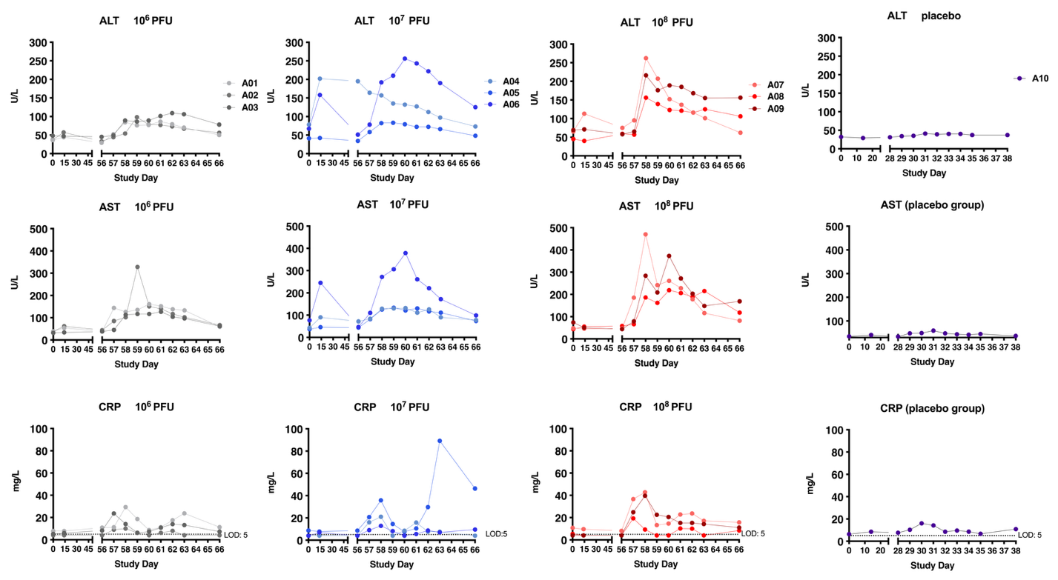 Supplemental Figure 6: Time course of alanine transaminase (ALT), aspartate transanminase (AST) and C-reactive protein (CRP) in serum of CHIKV-inoculated or placebo-treated cynomolgus macaques.

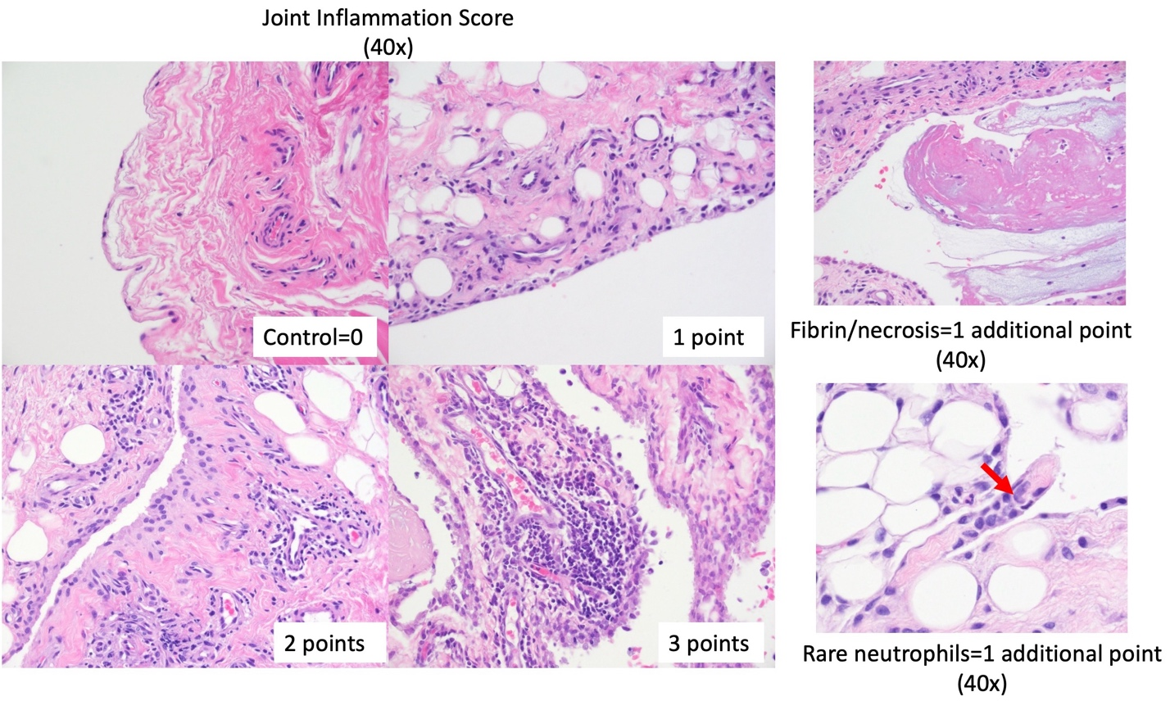 Supplemental Figure 7: Representative histopathology images encompassing the range of severity of joint inflammation across the 4 point scoring scale. Tissues are stained with hematoxylin and eosin.

Supplemental Figure 8: Histopathology scores in joints of CHIKV-inoculated or placebo-treated cynomolgus macaques. The stifle, ankle, and wrist were scored for combined histological findings in joint capsule/synovium, and adjacent tendon and muscle using a scoring metric (Table 2). The sum of all three joint scores for each animal is the combined score for three joints. The combined scores of joint capsule and synovium only exclude scores for tendon and muscle. The total pathology score of all tissues includes the lymphoid tissues and major organs. Horizontal lines indicate the mean. Analyses used Kruskal-Wallis tests.

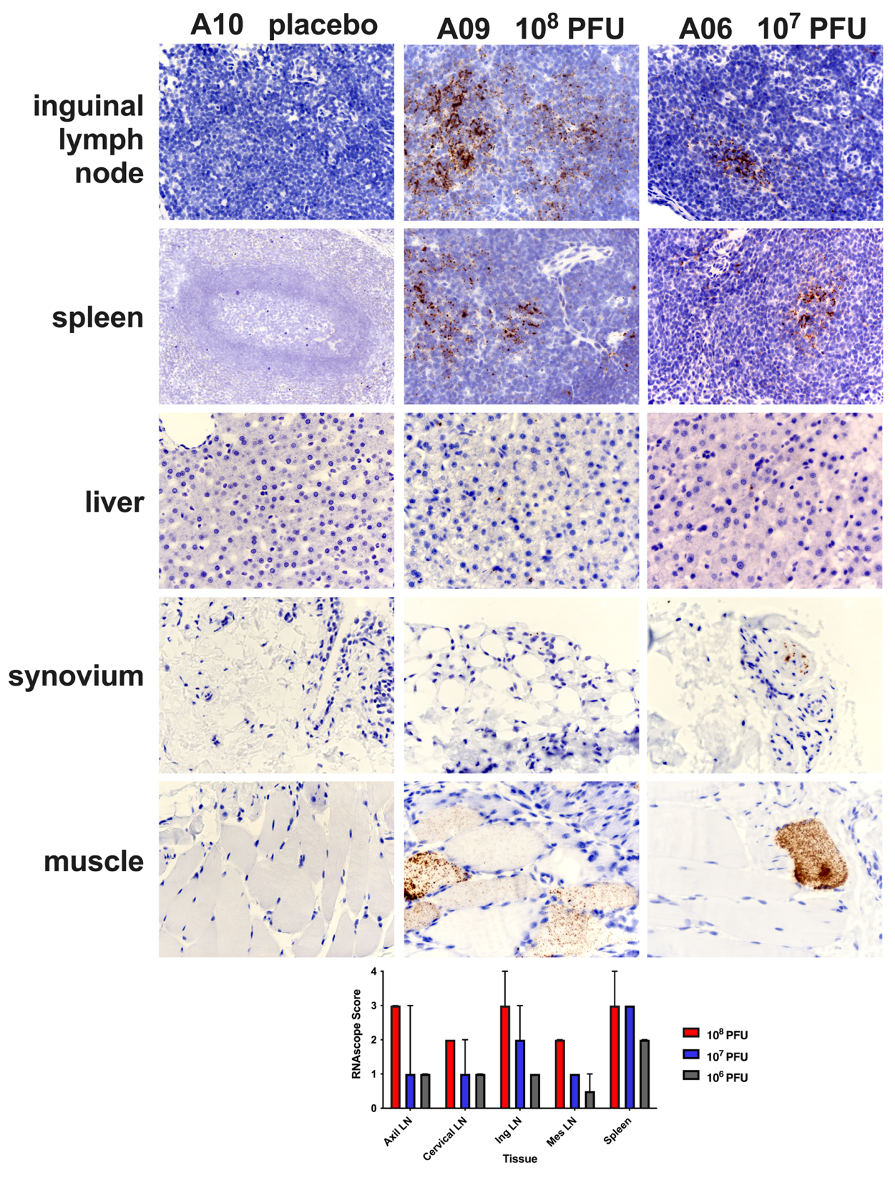 Supplemental Figure 9: CHIKV RNA in tissues of CHIKV- or placebo-inoculated cynomolgus macaques detected using in situ hybridization (ISH). Brown color indicates CHIKV RNA and cell nuclei are blue. RNAscope ISH scoring criteria for lymphoid tissues are presented in Table 2. The graph shows mean values. Kruskal-Wallis tests. Axil is axillary, Ing is inguinal, Mes is mesenteric. LN is lymph node. PFU is plaque forming units.

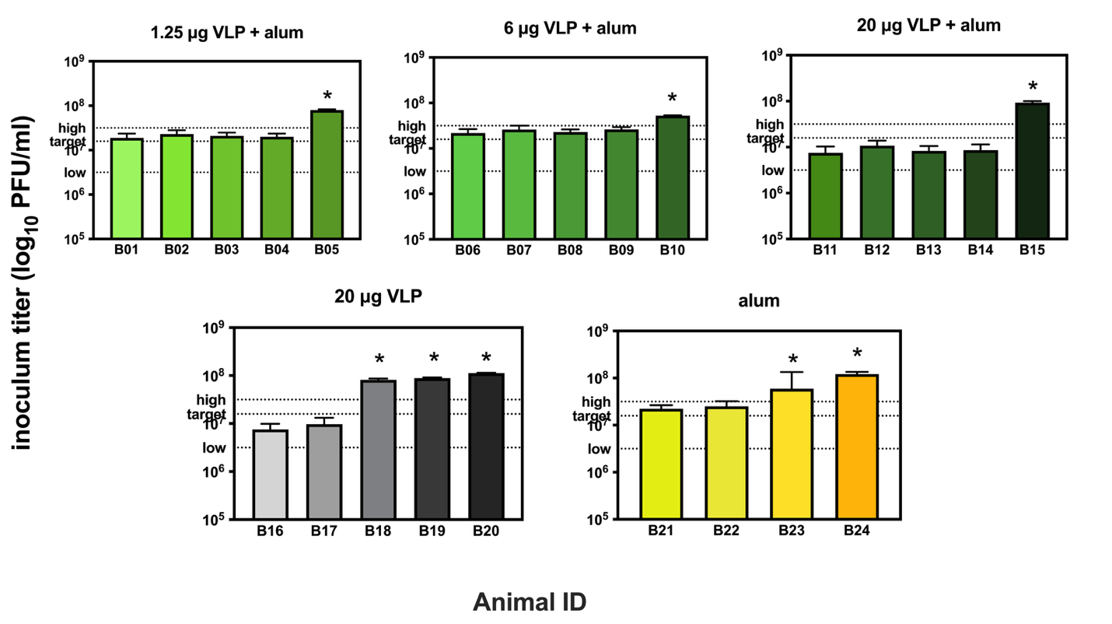
Supplemental Figure 10: Back-titration of CHIKV LR-OPY1 inocula for vaccine and challenge in Study B. The measured titer of the administered stock was 7.2 log₁₀ PFU/ml and is shown as the ‘target’ line. Dotted low and high lines indicate the 10-fold range around the 10⁷ target. The asterisks show values above the 10-fold range. PFU is plaque forming units.

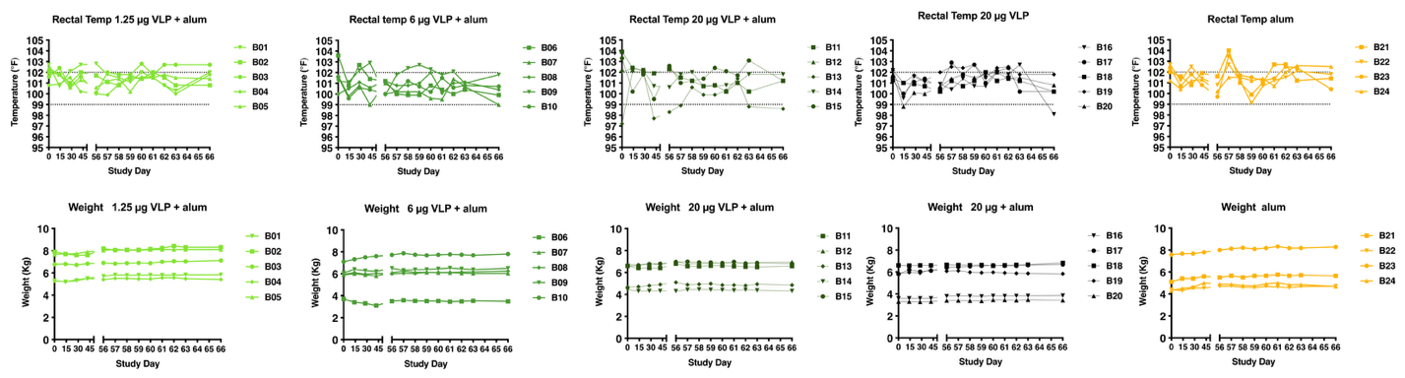
Supplemental Figure 11: Time course of rectal temperatures and body weights in CHIKV VLP + alum vaccinated or alum-only treated CHIKV-challenged cynomolgus macaques. Dotted lines indicate the normal temperature range (99-102 °F).

Supplemental Figure 12: Treatment with analgesics after vaccination and CHIKV challenge in cynomolgus macaques. Each animal is represented by a circle on each day post-challenge. The left side shows animals that did not receive any analgesic treatment. The right side shows animals that received ketoprofen (gray) or both ketoprofen and long-acting buprenorphine (red).

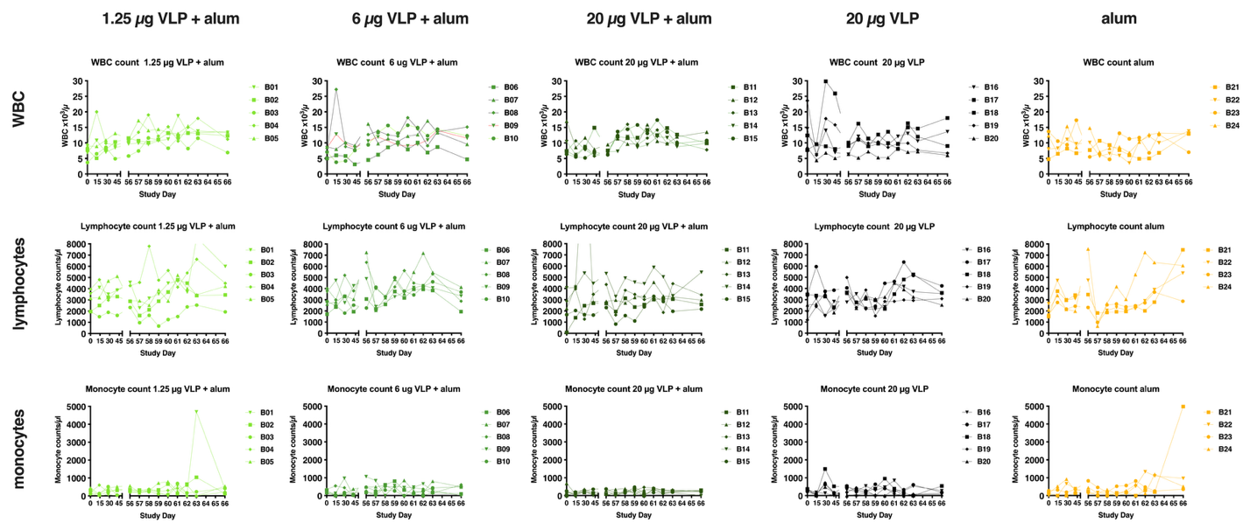
Supplemental Figure 13: Time course of white blood cells (WBC), lymphocytes, and monocyte counts in vaccinated and CHIKV challenged cynomolgus macaques.

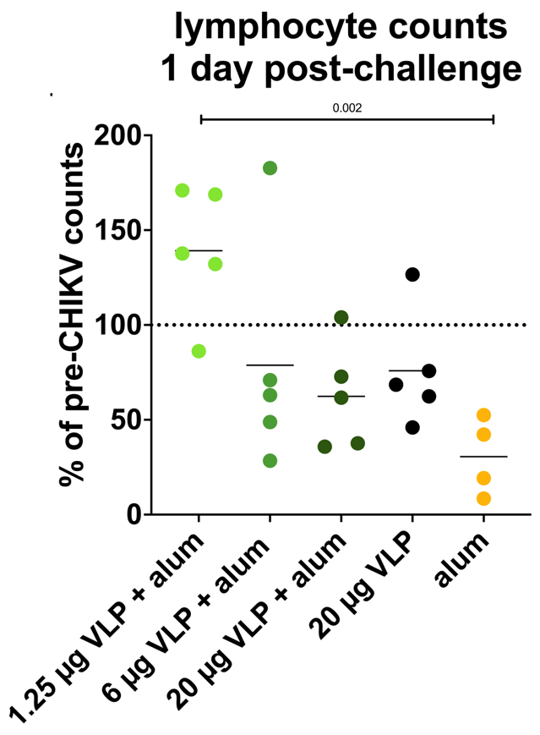
Supplemental Figure 14: Lymphocyte counts on study day 57, 1 day after virus inoculation in vaccinated or alum treated and CHIKV challenged cynomolgus macaques. Counts are expressed as percentage of the lymphocyte numbers on study day 56, just prior to CHIKV inoculation. Lines represent means. Groups were significantly different (p=0.006, ANOVA) and this was driven by a differences between alum versus 1.25 μg VLP + alum groups (p=0.002, Holmes-Sidak’s multiple comparison’s test).
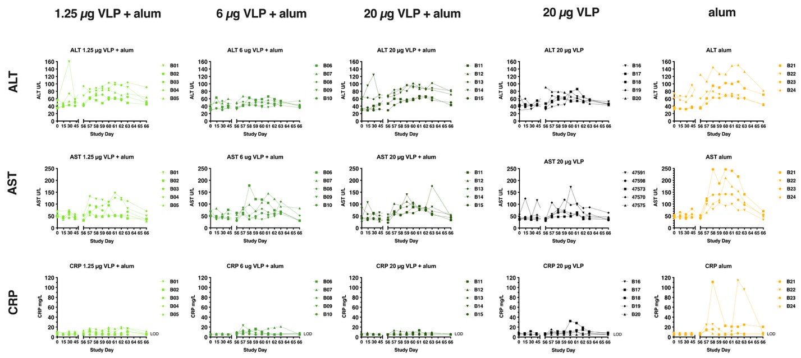

Supplemental Figure 15: Time course of ALT, AST and C-reactive protein (CRP) in serum of vaccinated or alum treated and CHIKV challenged cynomolgus macaques.
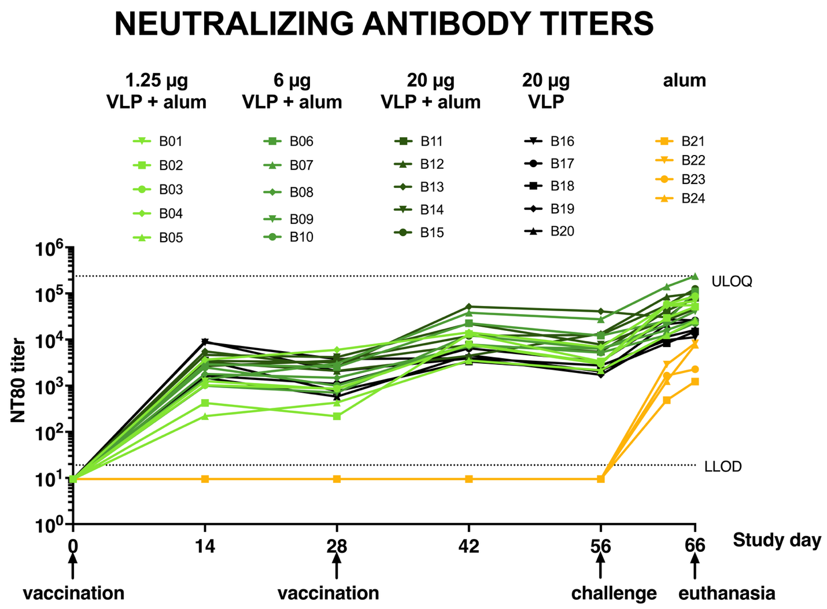
Supplemental Figure 16: Temporal kinetics of CHIKV neutralizing antibody titers after vaccination or alum treatment and CHIKV challenge in individual cynomolgus. Each line represents one animal. Neutralization titers for each sample were generated from duplicate NT₈₀ assays and are reported as the average. LLOD is the lower limit of detection.
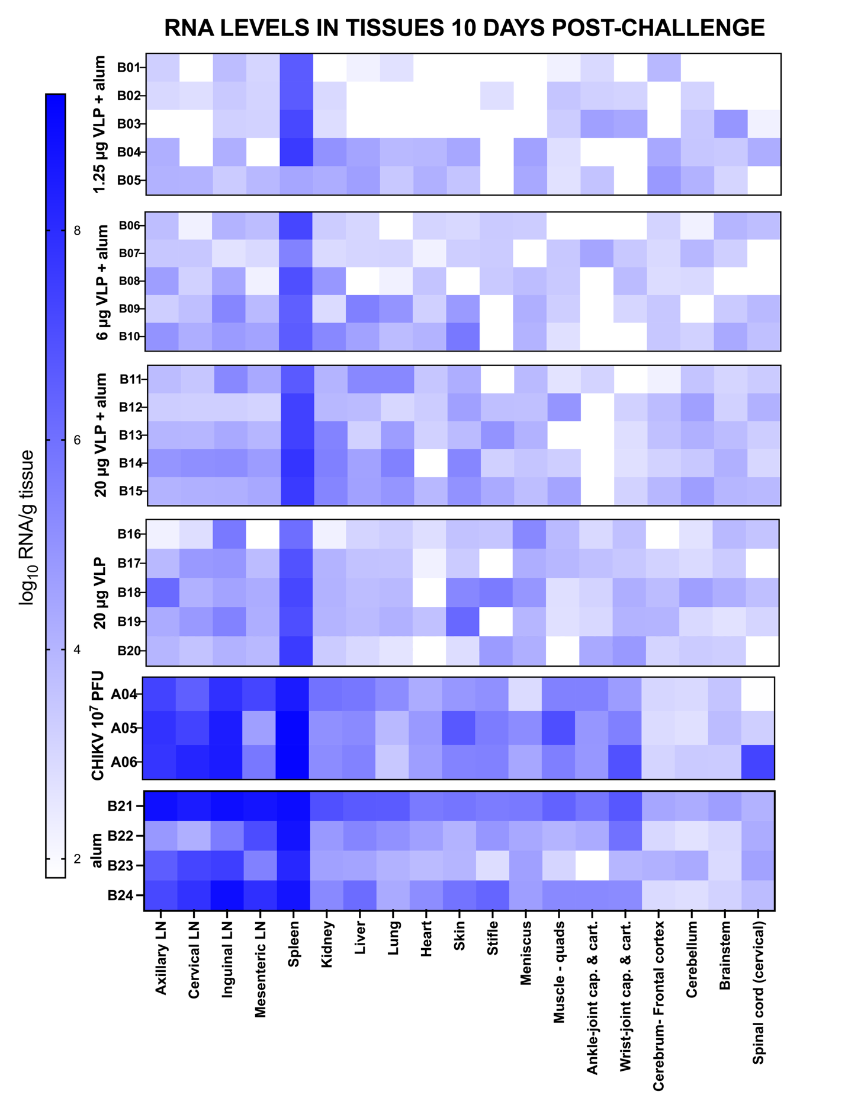 Supplemental Figure 17: CHIKV RNA levels in all sampled tissues after vaccination or alum treatment and CHIKV challenge in cynomolgus macaques. CHIKV RNA levels were measured in homogenized tissues sampled at necropsy, 10 days post-challenge. Darker colors show increasing CHIKV RNA levels. Each CHIKV RNA measurement was generated from triplicate RT-qPCR assays and is reported as the average. LN is lymph node. Quads is quadricep. Cap. Is capsule. Cart. Is cartilage.

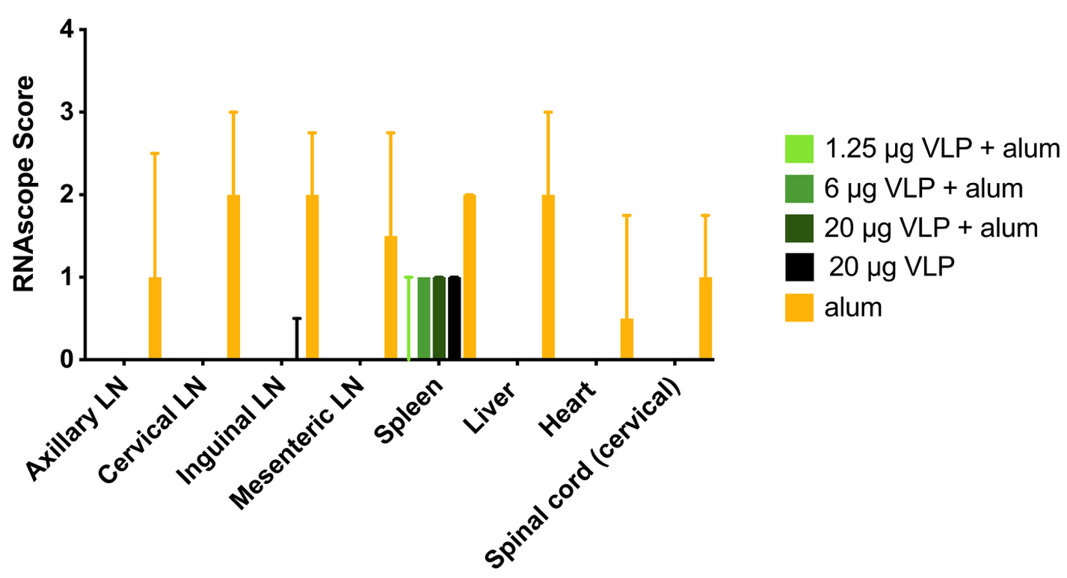 Supplemental Figure 18: CHIKV RNA in tissues of CHIKV VLP vaccinated or alum treated CHIKV-inoculated cynomolgus macaques detected using in situ hybridization (ISH). RNAscope ISH scoring criteria for lymphoid tissues are presented in Table 3. The graph shows mean values with error bars showing ranges. Kruskal-Wallis tests.

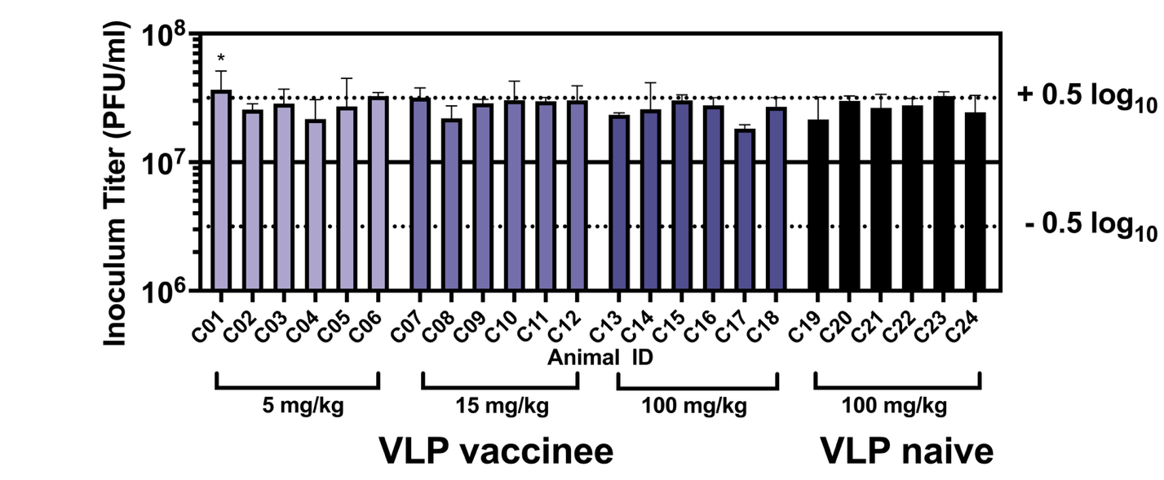

Supplemental Figure 19: Back-titration of CHIKV LR-OPY1 inocula for passive IgG transfer (Study C). Dotted lines indicate the 0.5 log₁₀ range around the goal dose of 10⁷ PFU. The asterisk above animal C01 shows the one inoculum whose value was above the 0.5 log₁₀ range. PFU is plaque forming units.

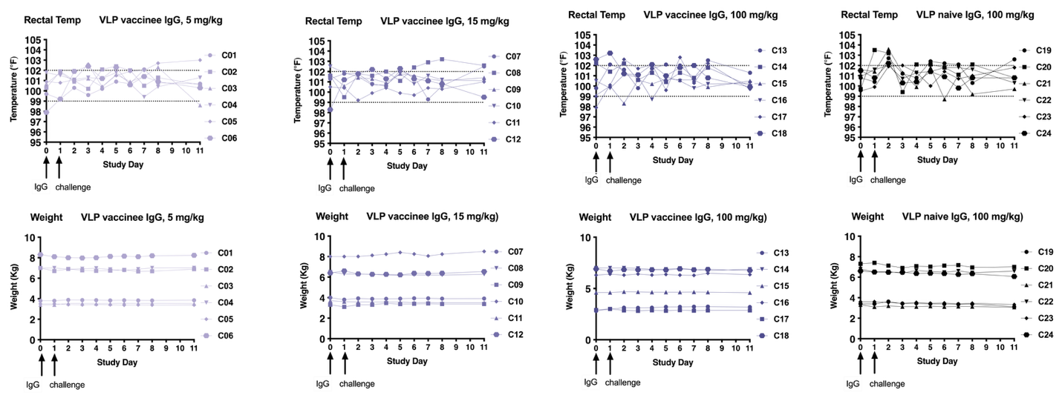
Supplemental Figure 20: Time course of rectal temperatures and body weights in cynomolgus macaques administered antibody from CHIKV VLP vaccinees or VLP naïve people. Dotted lines indicate the normal temperature range (99-102 °F).

Supplemental Figure 21: Treatment with analgesics after IgG administration from CHIKV VLP vaccinated or naïve people and CHIKV challenge in cynomolgus macaques. Each animal is represented by a circle on each day post-challenge. The left side shows animals that did not receive any analgesic treatment. The right side shows animals that received ketoprofen (gray), long-acting buprenorphine (purple), or both ketoprofen and buprenorphine (red).
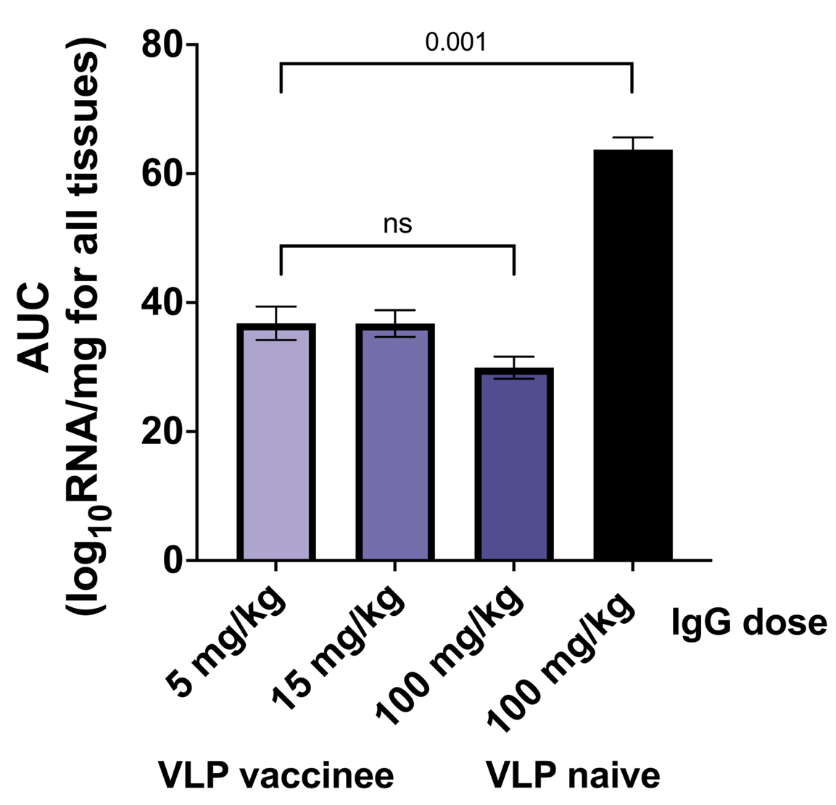

Supplemental Figure 22: Area under the curve (AUC) for CHIKV RNA levels in all sampled tissues after IgG administration from CHIKV VLP vaccinated or naïve people and CHIKV challenge in cynomolgus macaques. Analysis was performed on the combined log transformed viral RNA levels for all tissues and animals per study group. Bars represent mean + SEM. Tukey’s multiple comparison test.

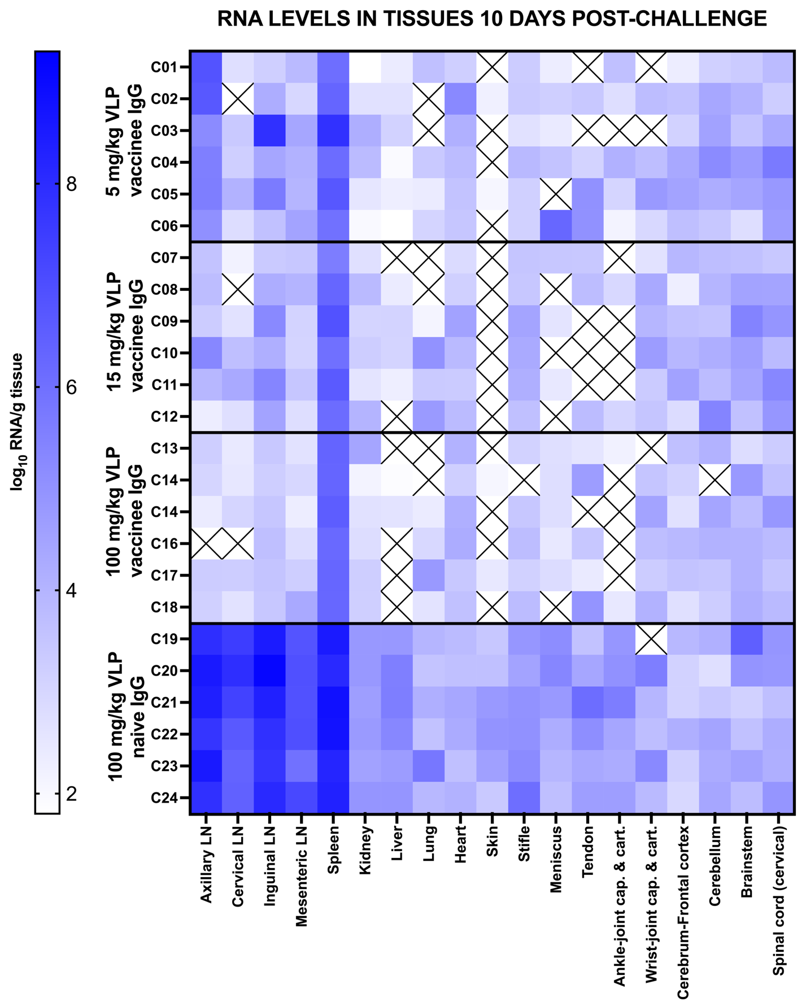

Supplemental Figure 23: CHIKV RNA levels in all sampled tissues after IgG administration from CHIKV VLP vaccinated or naïve people and CHIKV challenge in cynomolgus macaques. CHIKV RNA levels were measured in homogenized tissues sampled at necropsy, 10 days post-challenge. An X symbol indicates tissue was not collected. LN is lymph node. Quads is quadricep. Cap. Is capsule. Cart. Is cartilage.

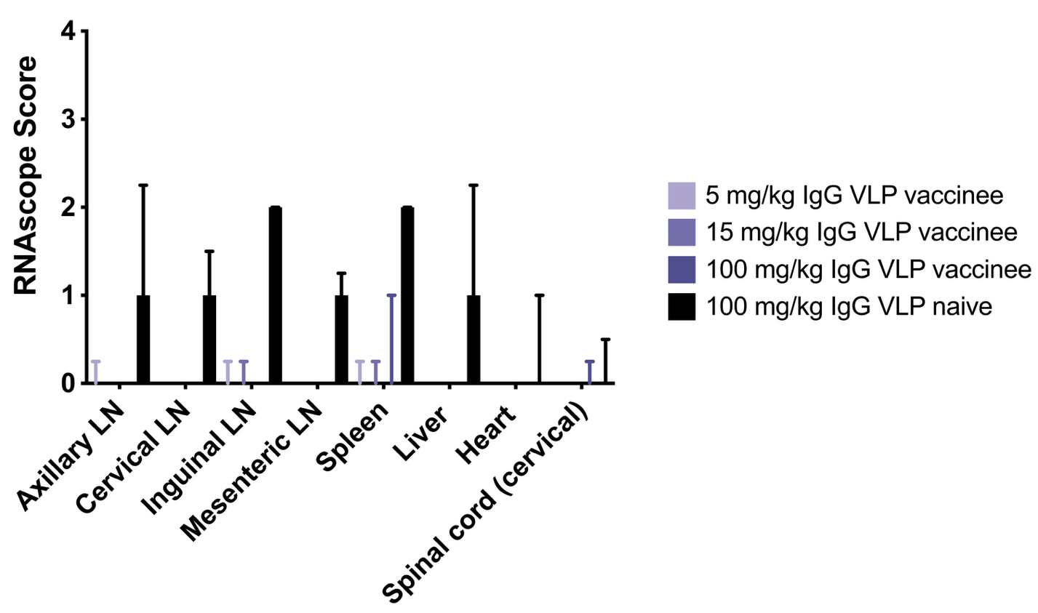 Supplemental Figure 24: CHIKV RNA in tissues after IgG administration from CHIKV VLP vaccinated or naïve people and CHIKV challenge in cynomolgus macaques detected using in situ hybridization (ISH). RNAscope ISH scoring criteria for lymphoid tissues are presented in Table 3. The graph shows mean values with error bars showing ranges. There were no differences between VLP vaccinee IgG dose groups (p>0.05). All scores for VLP vaccinee IgG treated groups were significantly lower than the control IgG group from VLP naïve persons (p=0.002) Kruskal-Wallis test.

