Supplementary Information
A XLS listing of publications in the Journal of Global History is available in GitHub. The data presents multiple author publications as single listings, and editorials and book reviews have been filtered out.

Supplementary Figure 1: Heatmap of Temporal Markers: Ideologies, Sports, Objects, 1900-2025, Ordered by Jensen-Shannon Divergence
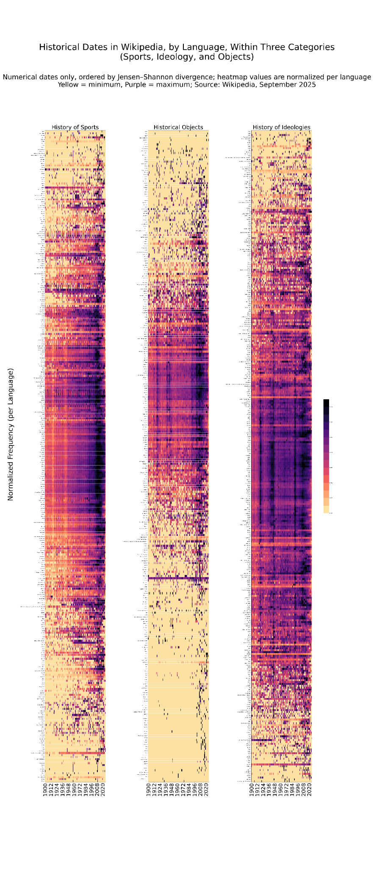

Supplementary Table 2: Peak dates by category (selected by hand)
Categories | Peak Dates | Mentions during interval | Proportion of all dates 1700-2025 represented | Proportion of all dates 1800-2025 | Proportion of all dates 1900-2025
History of Sports | 1718-1723 | 888 | 0.005% | 0.005% | 0.005%
 | 1737 | 323 | 0.002% | 0.002% | 0.002%
 | 1740-1745 | 1588 | 0.009% | 0.009% | 0.009%
 | 1763 | 461 | 0.002% | 0.002% | 0.003%
 | 1769-1781 | 4497 | 0.024% | 0.024% | 0.025%
 | 1787-1790 | 2346 | 0.013% | 0.013% | 0.013%
 | 1814-1821 | 5314 | 0.029% | 0.029% | 0.030%
 | 1845-1852 | 13605 | 0.074% | 0.074% | 0.076%
 | 1860-1863 | 19271 | 0.104% | 0.104% | 0.107%
 | 1870-1914 | 887806 | 4.801% | 4.808% | 4.929%
 | 1919-1936 | 946737 | 5.120% | 5.127% | 5.256%
 | 1948-1964 | 1540657 | 8.331% | 8.343% | 8.553%
 | 1966-2022 | 13676992 | 73.960% | 74.064% | 75.930%
Historical Objects | 1774-1776 | 2770 | 0.467% | 0.510% | 0.615%
 | 1780-1784 | 4148 | 0.699% | 0.764% | 0.921%
 | 1789-1795 | 6444 | 0.000% | 4.715% | 5.684%
 | 1810-1815 | 5975 | 1.007% | 1.101% | 1.327%
 | 1837-1840 | 3864 | 0.651% | 0.712% | 0.858%
 | 1844-1850 | 6669 | 1.124% | 1.229% | 1.481%
 | 1859-1871 | 14033 | 2.365% | 2.585% | 3.117%
 | 1897 | 2196 | 0.370% | 0.405% | 0.488%
 | 1911-1914 | 8352 | 1.407% | 1.539% | 1.855%
 | 1917-1920 | 16439 | 2.770% | 3.028% | 3.651%
 | 1939-1945 | 33623 | 5.666% | 6.194% | 7.468%
 | 1989-2022 | 216970 | 36.563% | 39.969% | 48.188%
History of Ideologies | 1713-1715 | 4731 | 0.056% | 0.058% | 0.066%
 | 1763 | 4158 | 0.049% | 0.051% | 0.058%
 | 1774-1778 | 30244 | 0.359% | 0.371% | 0.420%
 | 1789-1795 | 70845 | 0.841% | 0.869% | 0.983%
 | 1812-1815 | 43466 | 0.516% | 0.533% | 0.603%
 | 1848-1850 | 61509 | 0.730% | 0.754% | 0.854%
 | 1905-1906 | 57588 | 0.683% | 0.706% | 0.799%
 | 1914-1945 | 1915651 | 22.730% | 23.498% | 26.587%
 | 1989-1994 | 489574 | 5.809% | 6.005% | 6.795%
 | 2005-2012 | 744522 | 8.834% | 9.133% | 10.333%

