Supplementary Information:

Additional file 3: Margins plots of cross-level interactions
Interaction plots:
STATA COMMANDS:
mixed PCTAdObesitycounty22 GROCg16 FFRg16 CONVSg16 SUPERCg16 PCT_LACCESS_LOWIg15 PCT_Hg23 HGxGROC HGxFFR HGxCONVS HGxSUPERC HGxACCESS RECFACg16 PCTFoodInsecure21gCounty PCTUnemployed22gcounty MEDHHINCg15 POVRATEg15 || state_id:,variance
gen hgcat = .
replace hgcat = 1 if PCT_Hg23 < 10
replace hgcat = 2 if PCT_Hg23 >=10 & PCT_Hg23 < 20
replace hgcat = 3 if PCT_Hg23 >=20 & PCT_Hg23 < 30
replace hgcat = 4 if PCT_Hg23 >=30 & PCT_Hg23 < 40
replace hgcat = 5 if PCT_Hg23 >=40
label define hgcatlbl 1 "10%" 2 "20%" 3 "30%" 4 "40%" 5 "50%+"
label values hgcat hgcatlbl
mixed PCTAdObesitycounty22 hgcat##c.FFRg16 GROCg16 CONVSg16 SUPERCg16 PCT_LACCESS_LOWIg15 RECFACg16 PCTFoodInsecure2
> 1gCounty PCTUnemployed22gcounty MEDHHINCg15 POVRATEg15 || state_id:, variance
margins hgcat, at(FFRg16 = (5 10 15 20)) atmeans
marginsplot, xdimension(FFRg16) by(hgcat) ylabel(, angle(horizontal) labsize(small)) xlabel(, labsize(small)) title("Interaction: Fast Food Density × Hispanic", size(medsmall)) legend(order(1 "10%" 2 "20%" 3 "30%" 4 "40%" 5 "50%+") size(small))

Interaction plots for all significant effects:
Figures: Marginsplots of Cross-Level Interactions
The following marginsplots display adjusted predictions of adult obesity based on cross-level interactions between racial/ethnic population categories (e.g., % Hispanic, % NH Black) and food environment variables (e.g., fast food density, grocery access). Each plot is stratified into five categories of county-level racial/ethnic population concentration: 10%, 20%, 30%, 40%, and 50% or higher. The linear predictions reflect the fixed portion of the multilevel model, and 95% confidence intervals are provided to convey uncertainty in the estimates.

Figure S8. Interaction between grocery store access and percent Non-Hispanic Black population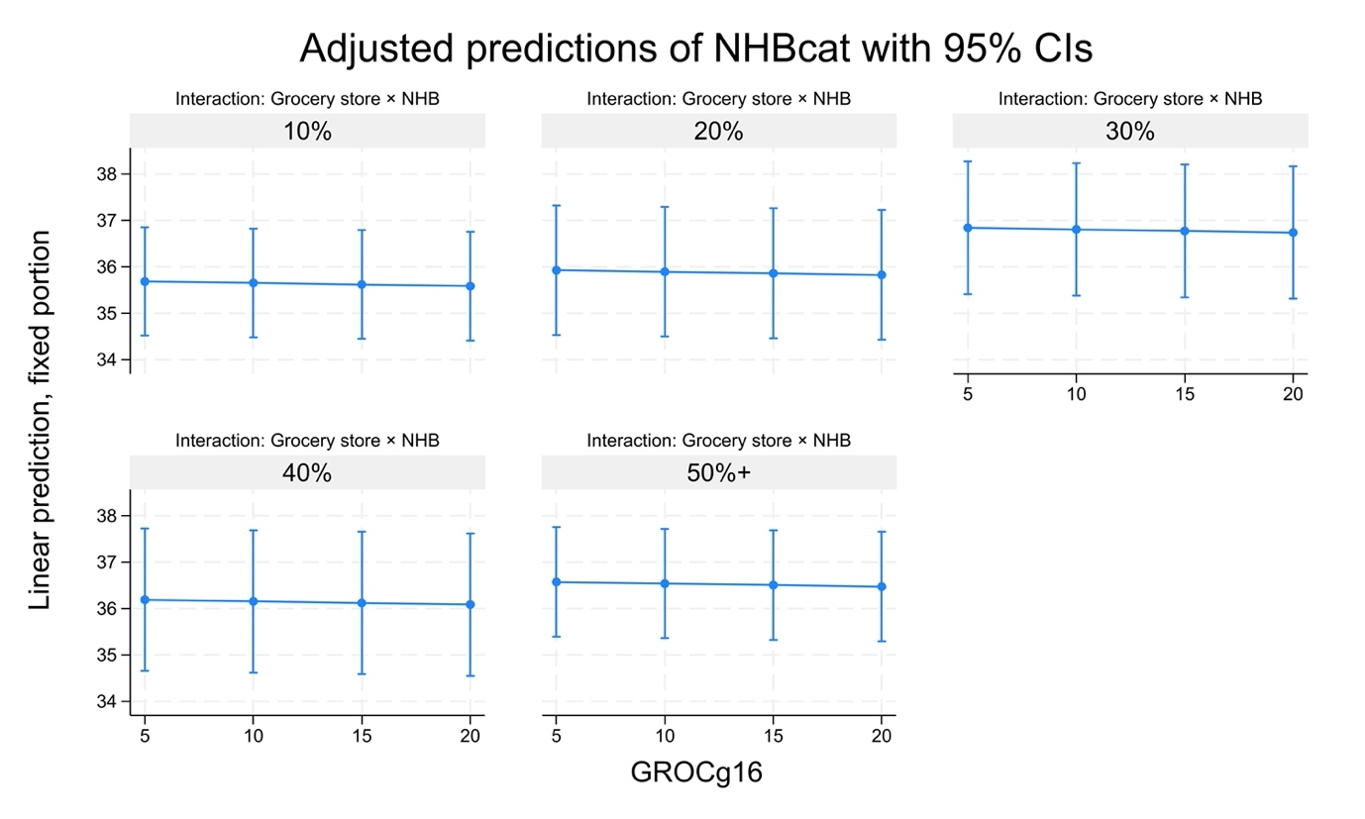

The plot suggests limited variation in predicted obesity rates across NHB density strata. While the direction of association remains mostly flat, the wide confidence intervals reflect substantial uncertainty, particularly in counties with higher NHB composition. This supports the need for more granular or disaggregated data to better isolate environment–demographic interactions.

Figure S9. Interaction between convenience store density and percent Non-Hispanic Black population (NHBcat)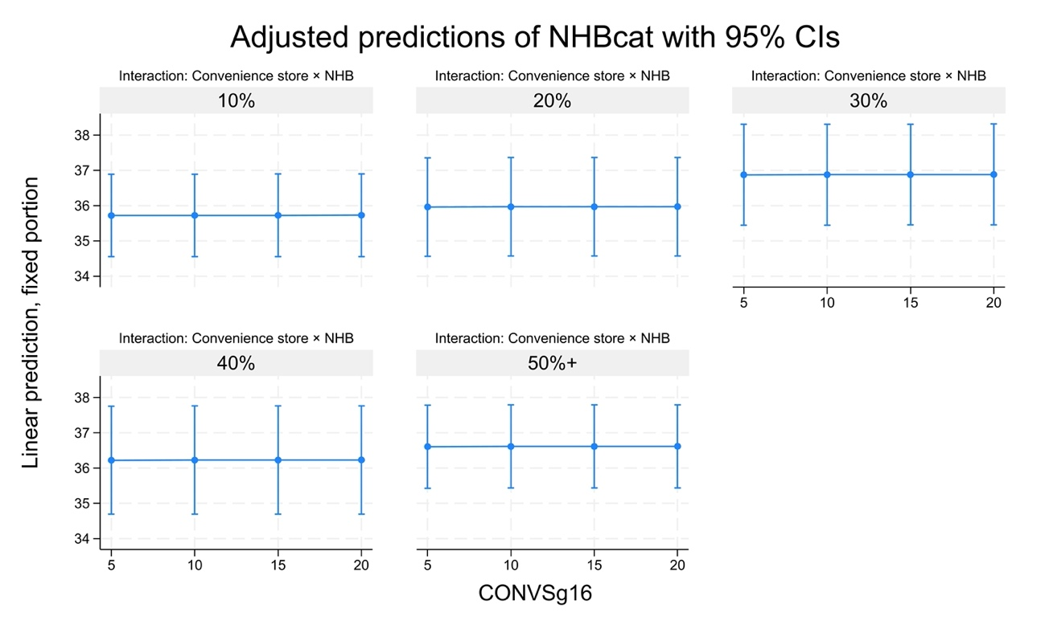
This marginsplot shows predicted adult obesity rates across varying levels of convenience store density (CONVSg16), stratified by five categories of county-level NH Black population percentages (10% to 50%+). While obesity risk remains generally stable, the confidence intervals widen in higher NHB concentrations, suggesting greater variability in counties with high NHB populations.

Figure S10. Interaction between supercenter density and percent Non-Hispanic Black population
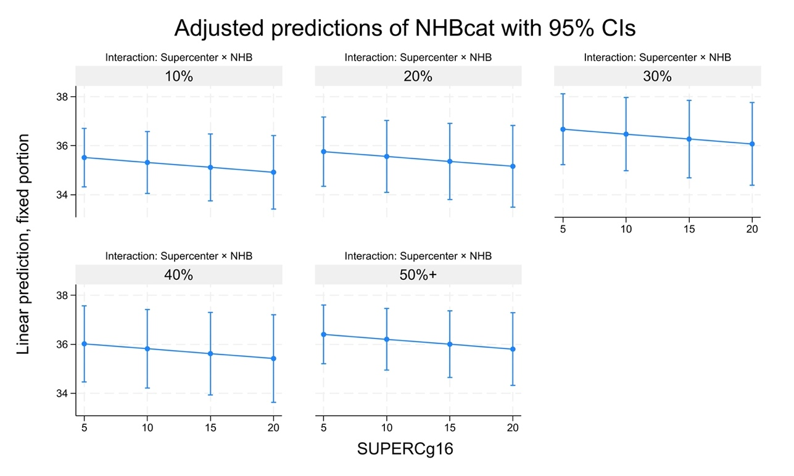

This margins plot illustrates adjusted obesity predictions across increasing supercenter density (SUPERCg16), by NH Black population categories. A clear downward trend is observed, with higher supercenter density associated with lower predicted obesity rates—especially in counties with ≥30% NHB populations. This suggests a potential protective association of supercenter availability in predominantly Black communities.

Figure S11. Interaction between supercenter density and percent Native Hawaiian or Pacific Islander population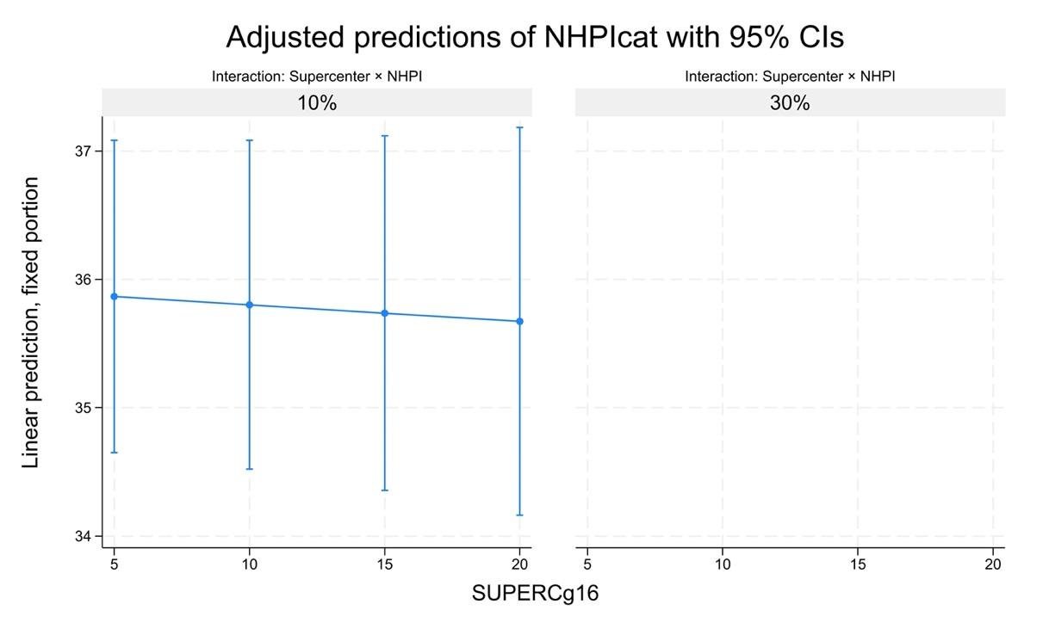
This marginsplot displays adjusted obesity predictions by supercenter density (SUPERCg16) for counties with 10% and 30% NHPI populations. Only sparse data were available for counties with ≥30% NHPI residents, limiting visualization. In counties with 10% NHPI populations, a slight decline in predicted obesity was observed as supercenter density increased, but wide confidence intervals reflect substantial uncertainty due to small sample sizes.

Figure S12. Interaction between low-access, low-income prevalence and percent NHPI population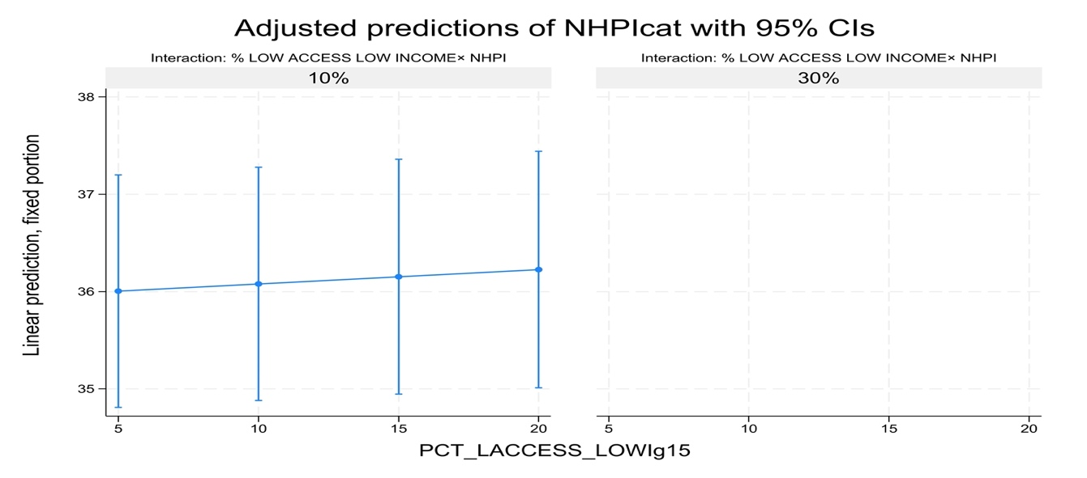
This plot illustrates predicted adult obesity rates across varying levels of low-access, low-income household prevalence (PCT_LACCESS_LOWIg15), stratified by NHPI population categories. For counties with 10% NHPI residents, obesity rates show a slight increasing trend as food access barriers rise, but wide confidence intervals and sparse representation at higher NHPI levels (e.g., 30%) indicate limited generalizability.

Figure S13. Interaction between convenience store density and percent Non-Hispanic White population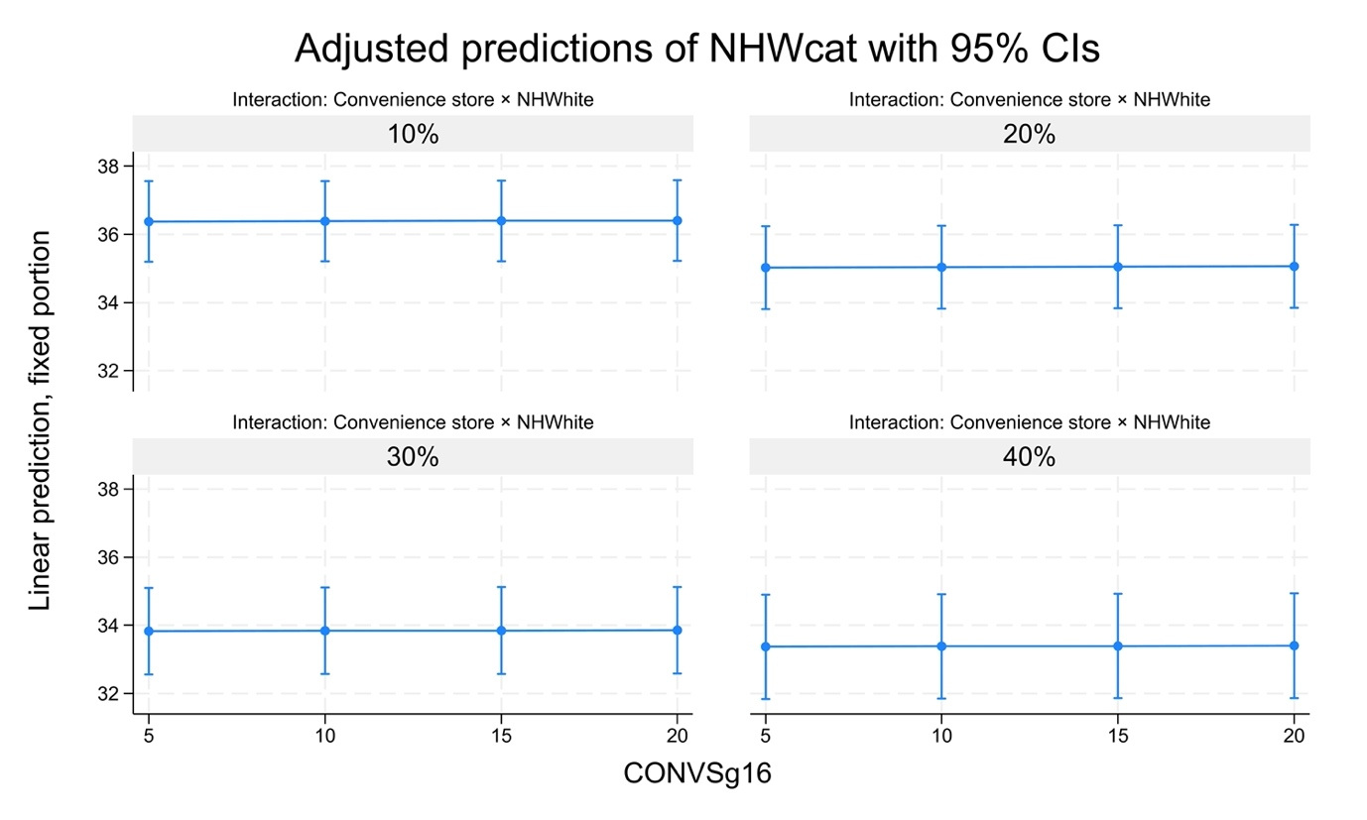
This figure displays adjusted predictions of adult obesity across levels of convenience store density (CONVSg16), stratified by the percentage of non-Hispanic White (NHW) residents. While obesity rates remain relatively stable across store density levels, counties with lower NHW proportions (e.g., 10%) exhibit slightly higher predicted obesity overall. Confidence intervals overlap across categories, indicating modest but non-significant variation.

