The circumpolar distribution of Antarctic seafloor biodiversity hotspots

Jan Jansen^{1,2,*}, Fabio Boeira-Dias^{1,3}, Charley Gros², Craig R. Johnson², Nicole A. Hill^{1,2}

¹Australian Centre for Excellence in Antarctic Science, Institute for Marine and Antarctic Studies, University of Tasmania, Hobart, Australia
²Institute for Marine and Antarctic Studies, University of Tasmania, Hobart, Australia
³Centre for Marine Science and Innovation, University of New South Wales, Sydney, Australia

Supplementary information

Supplementary file 1: Supplementary maps and model diagnostics

Regional biodiversity patterns – detailed comparisons
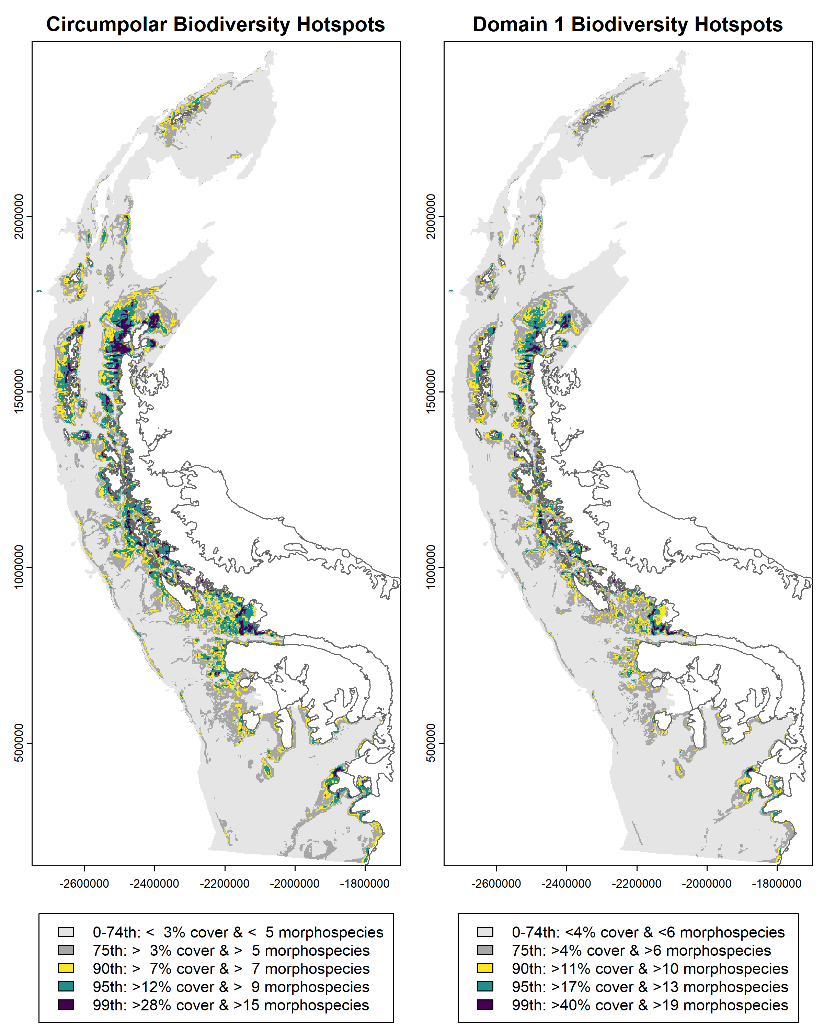

Suppl. Fig. 1: Predicted hotspots of seafloor biodiversity in CCAMLR Planning Domain 1. Biodiversity hotspots in Domain 1 (right panel) contain higher cover and richness compared to the circumpolar average (left panel), which is why the right panel shows fewer cells in the top percentiles compared to the left panel.

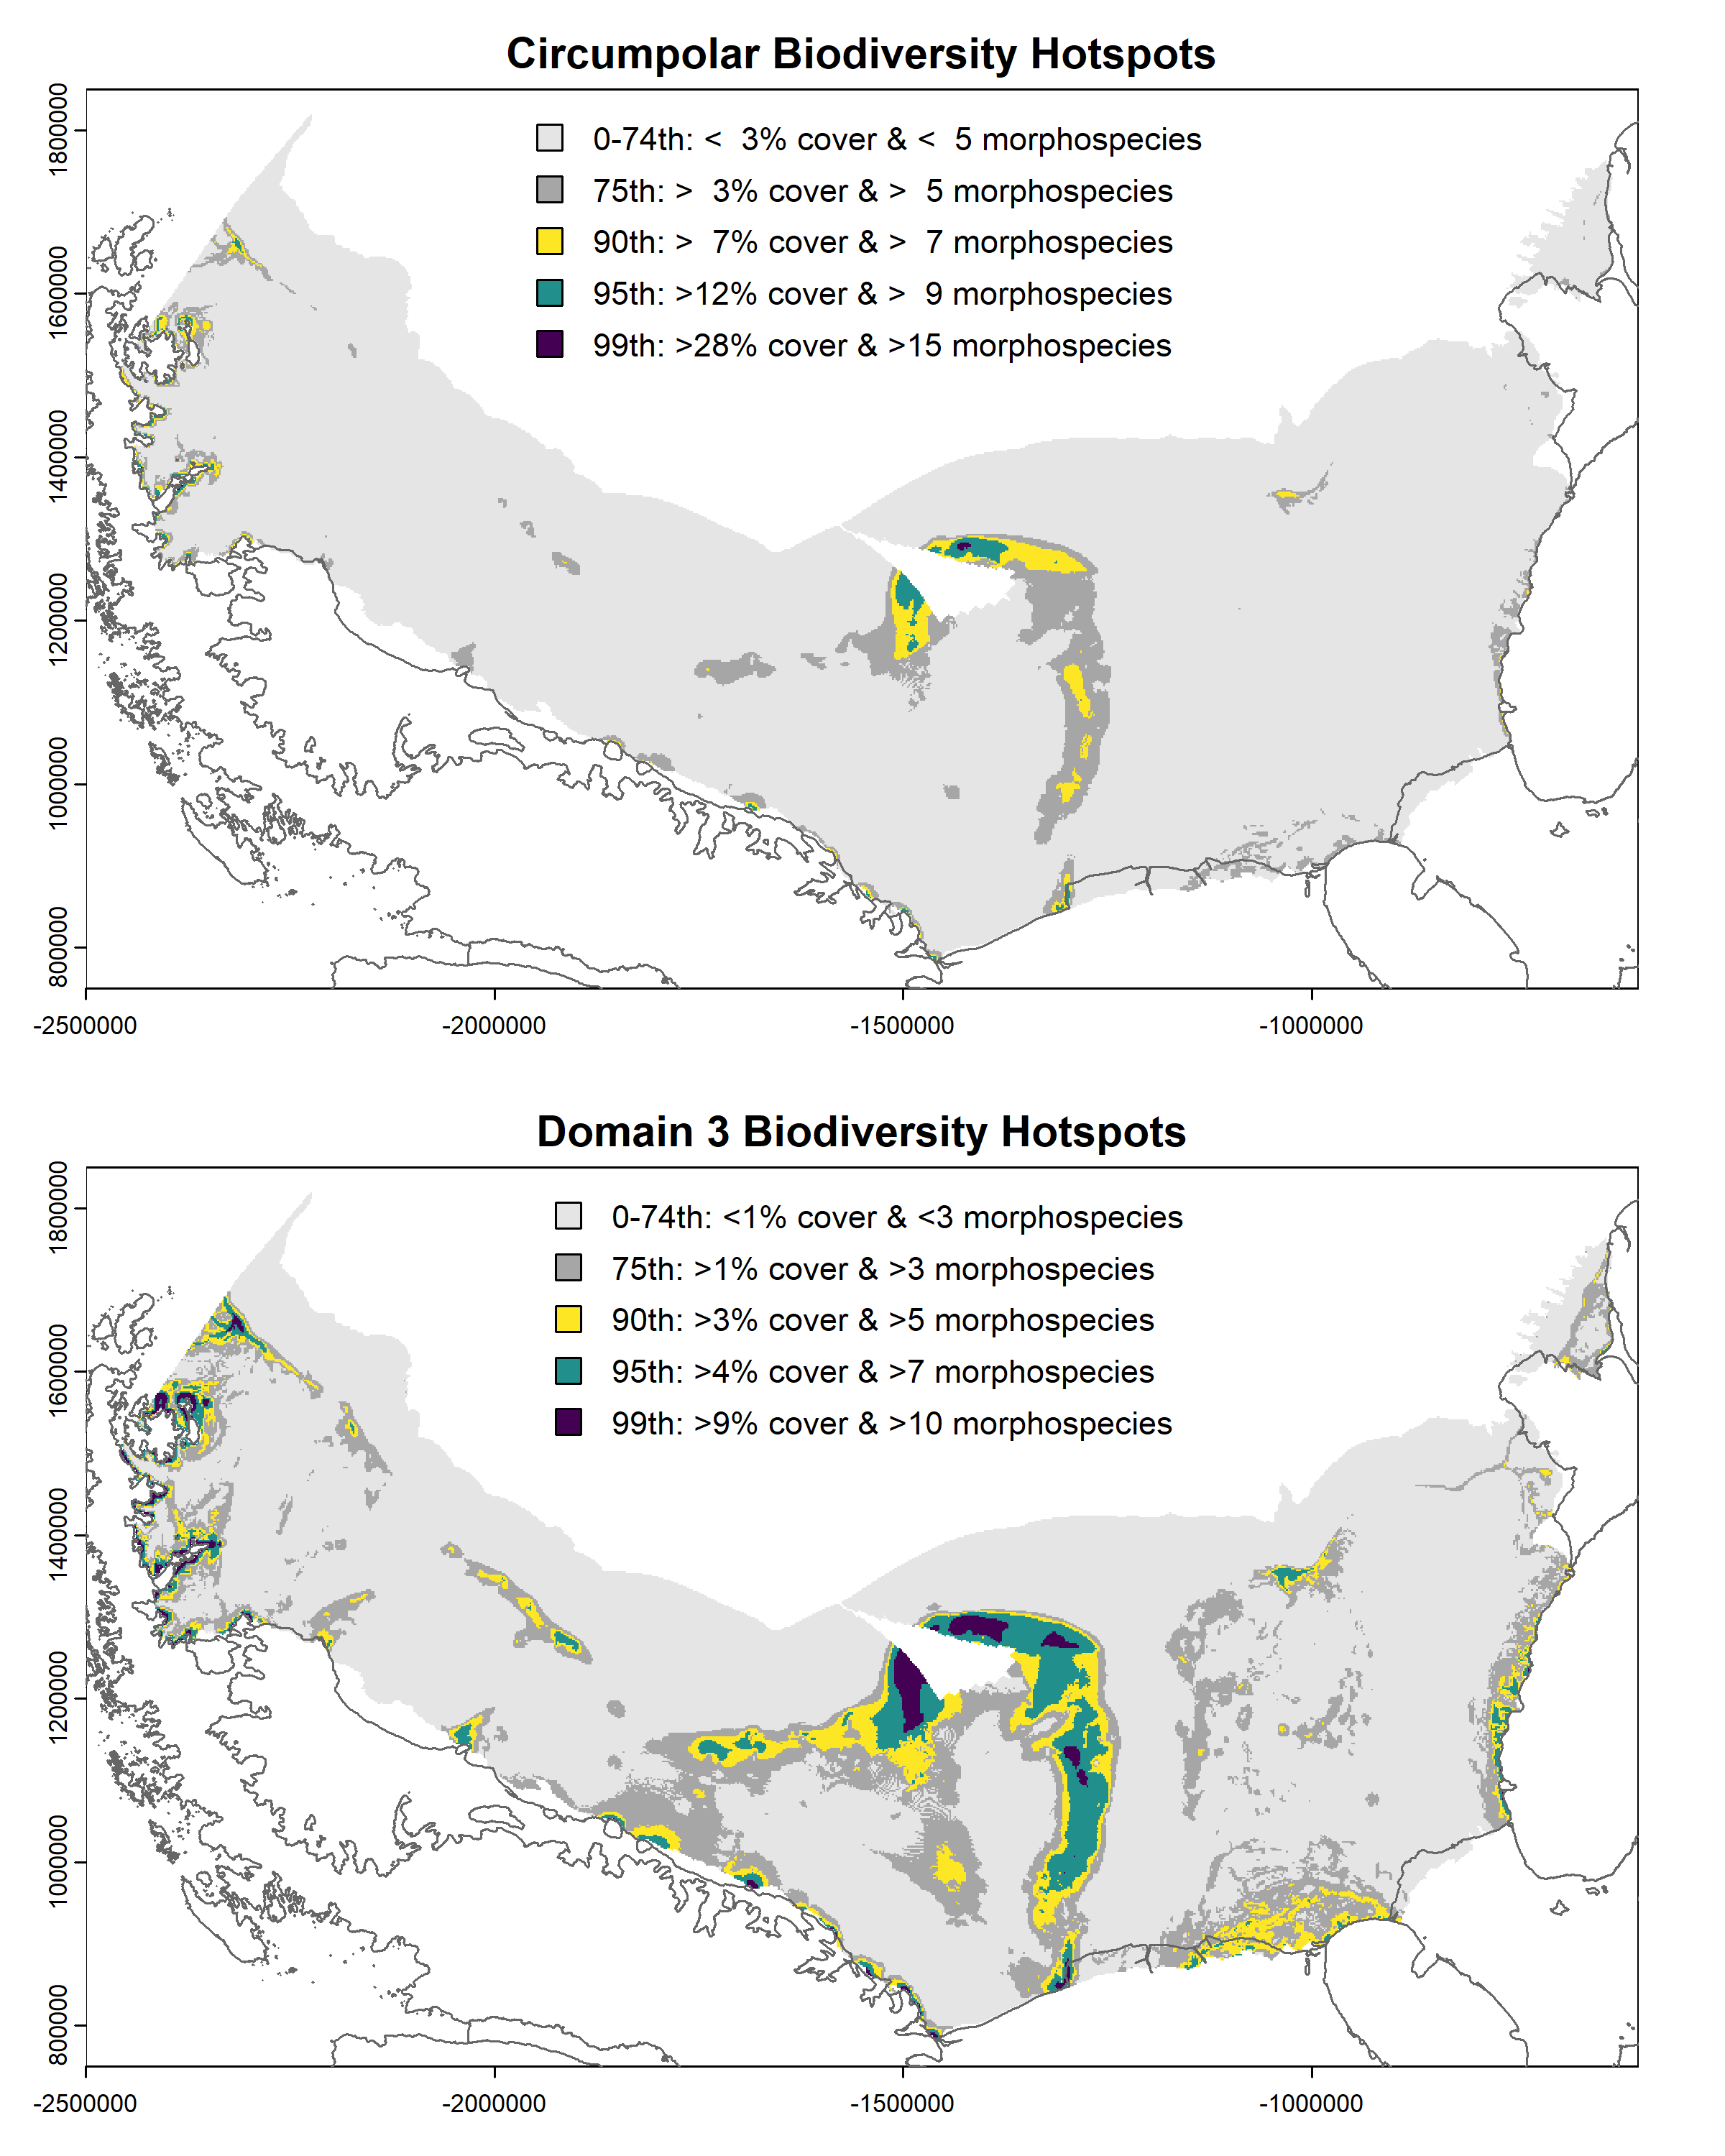
Suppl. Fig. 2: Predicted hotspots of seafloor biodiversity in CCAMLR Planning Domain 3. Biodiversity hotspots in Domain 3 (bottom panel) contain lower cover and richness compared to the circumpolar average (top panel), which is why the bottom panel shows more cells in the top percentiles compared to the top panel. Note that there is very high uncertainty associated with the predicted hotspots in the central Weddell Sea because the environmental conditions in this area are outside of those sampled by seafloor images in this analysis (see also Extended Data Fig. 4).

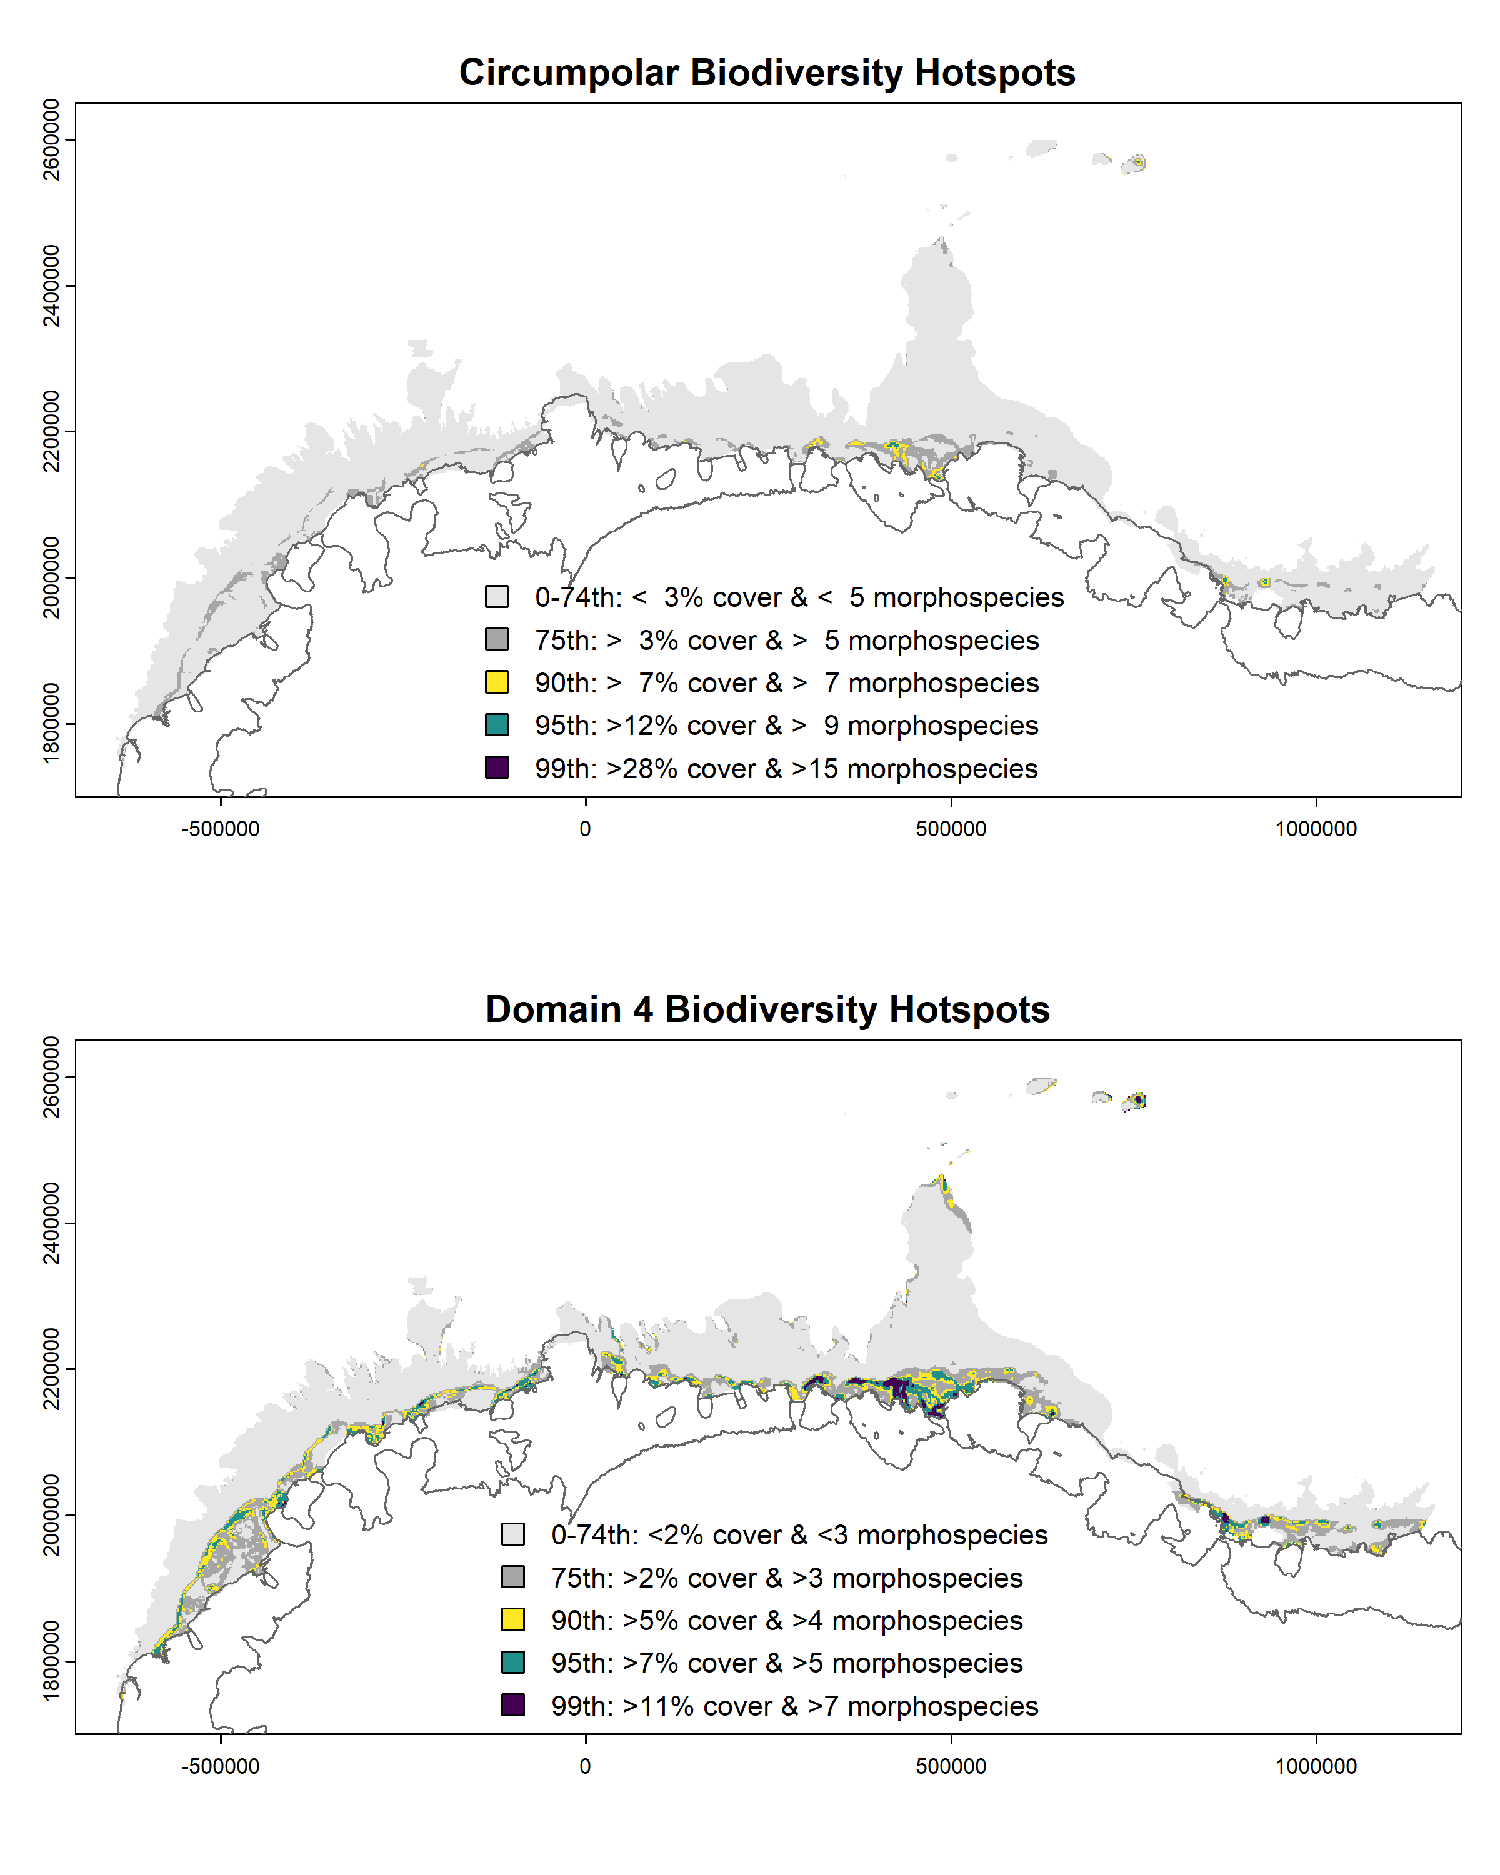
Suppl. Fig. 3: Predicted hotspots of seafloor biodiversity in CCAMLR Planning Domain 4. Biodiversity hotspots in Domain 4 (bottom panel) contain lower cover and richness compared to the circumpolar average (top panel), which is why the bottom panel shows more cells in the top percentiles compared to the top panel.

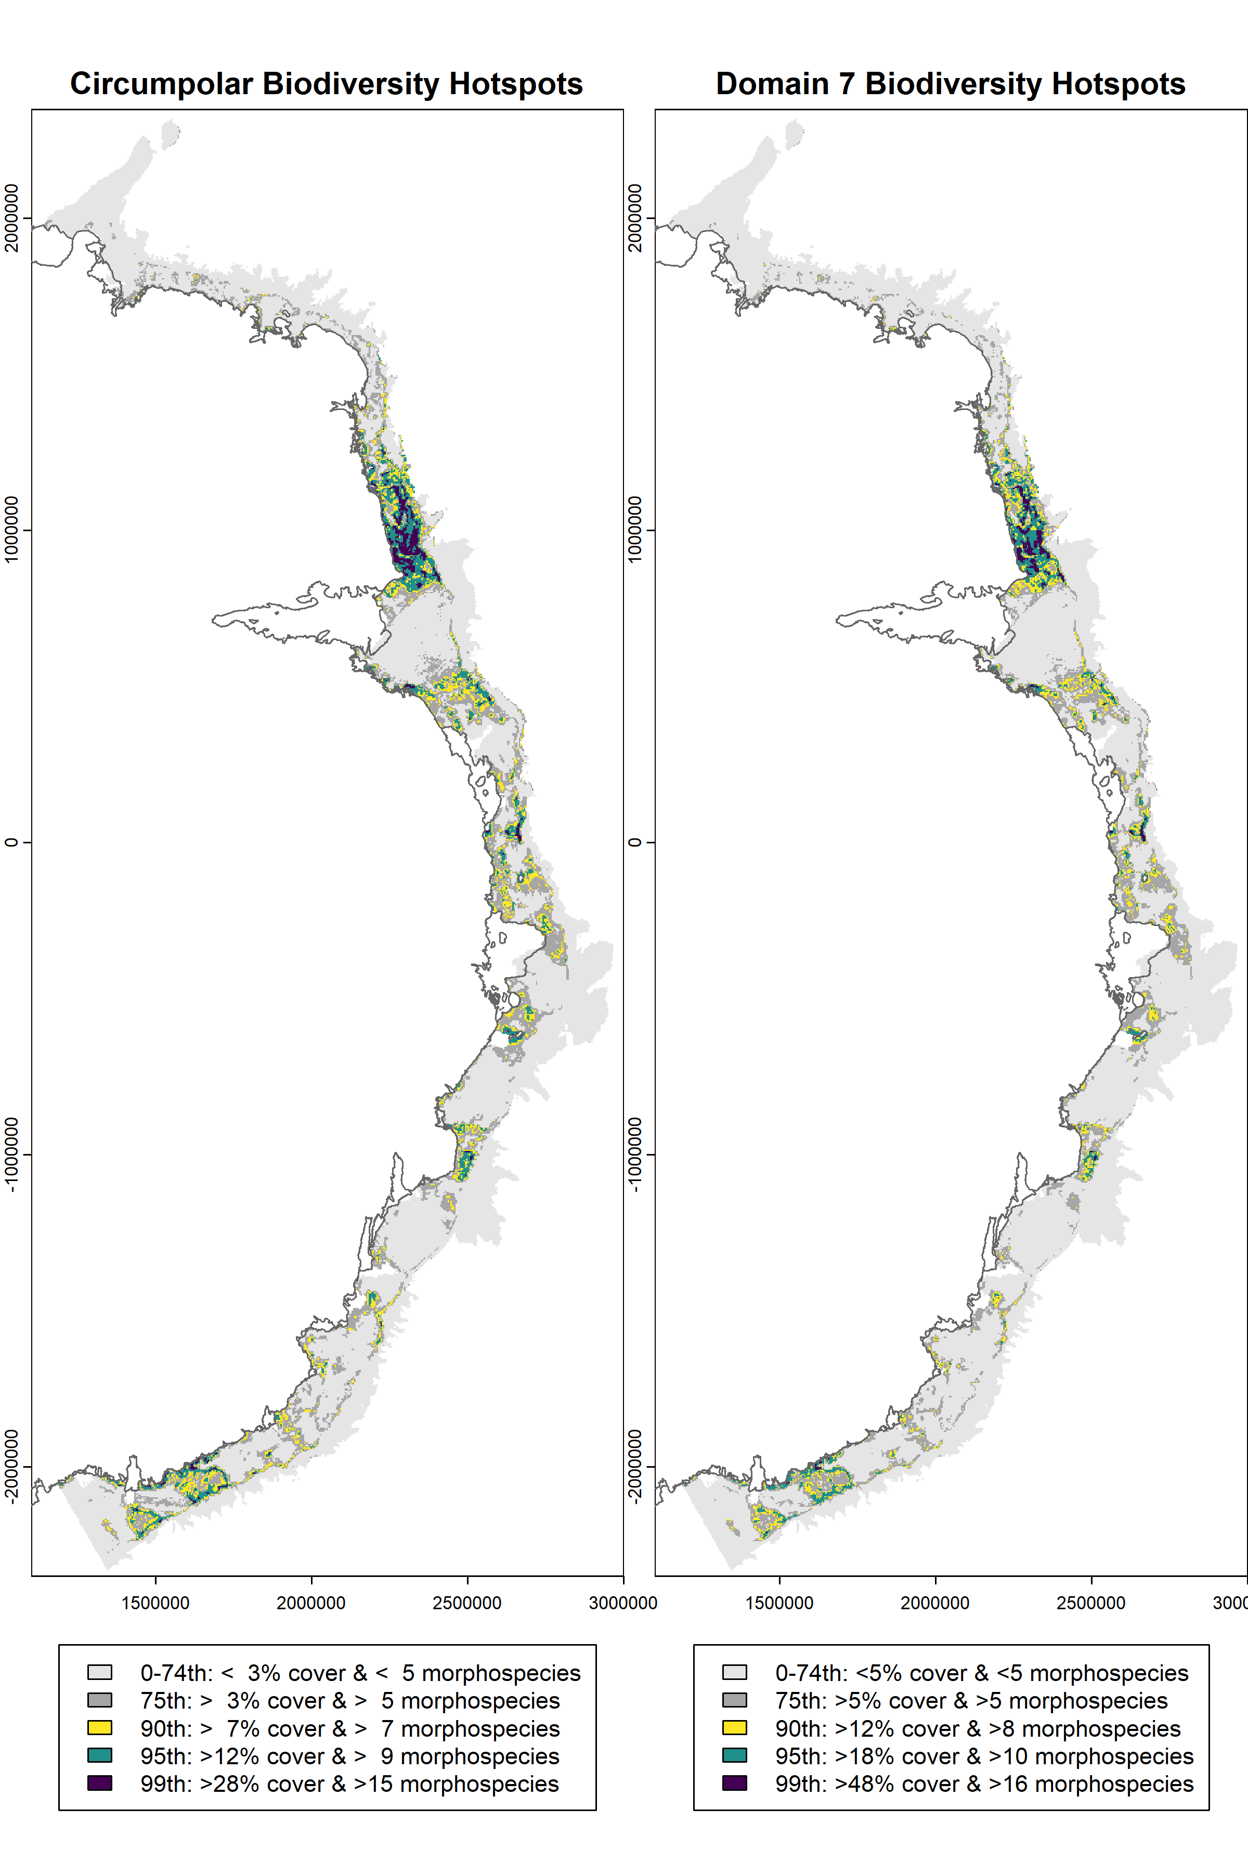
Suppl. Fig. 4: Predicted hotspots of seafloor biodiversity in CCAMLR Planning Domain 7. Biodiversity hotspots in Domain 7 (right panel) contain higher cover and richness compared to the circumpolar average (left panel), which is why the right panel shows fewer cells in the top percentiles compared to the left panel.
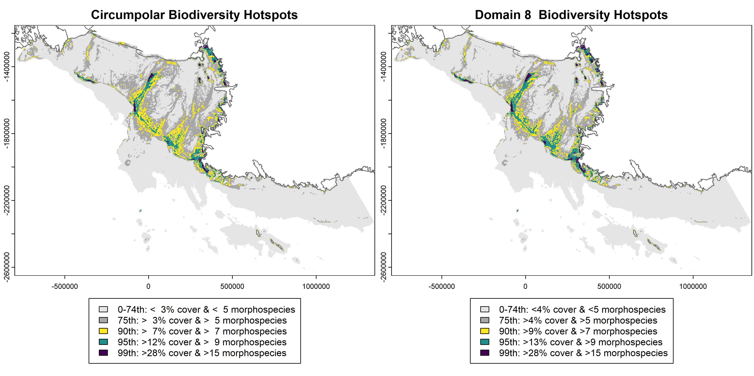
Suppl. Fig. 5: Predicted hotspots of seafloor biodiversity in CCAMLR Planning Domain 8. Biodiversity hotspots in Domain 8 (bottom panel) contain similar cover and richness to the circumpolar average (top panel), which is why both panel shows similar spatial patterns.
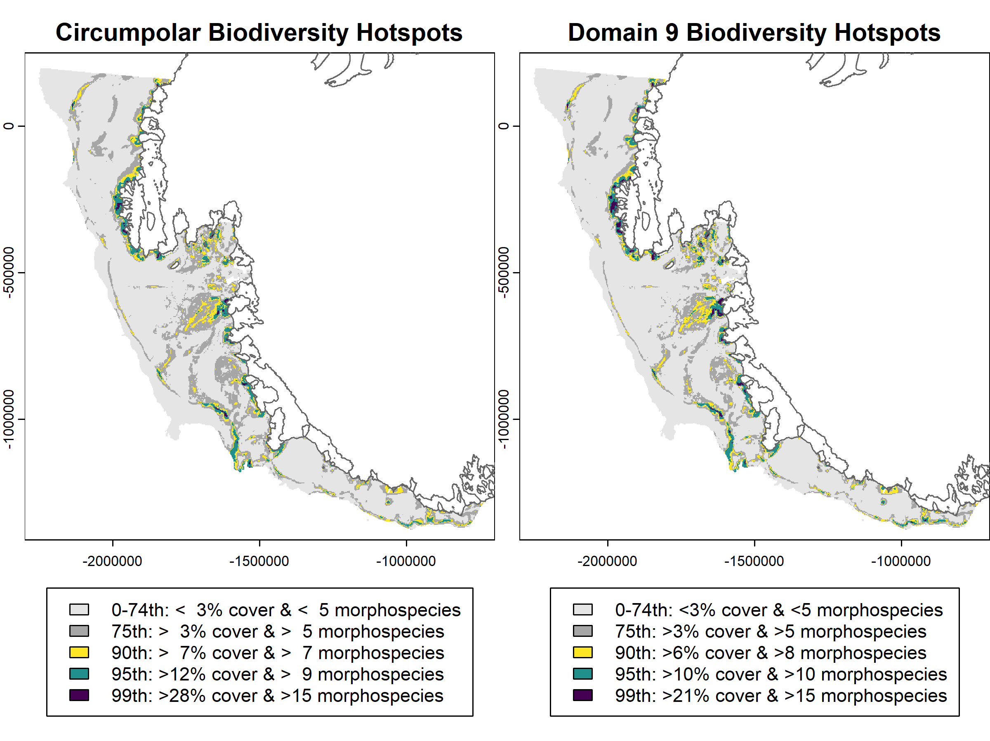
Suppl. Fig. 6: Predicted hotspots of seafloor biodiversity in CCAMLR Planning Domain 9. Biodiversity hotspots in Domain 9 (right panel) contain slightly lower cover and richness compared to the circumpolar average (left panel), which is why the right panel shows more cells in the top percentiles compared to the left panel.

Hotspot environmental conditions
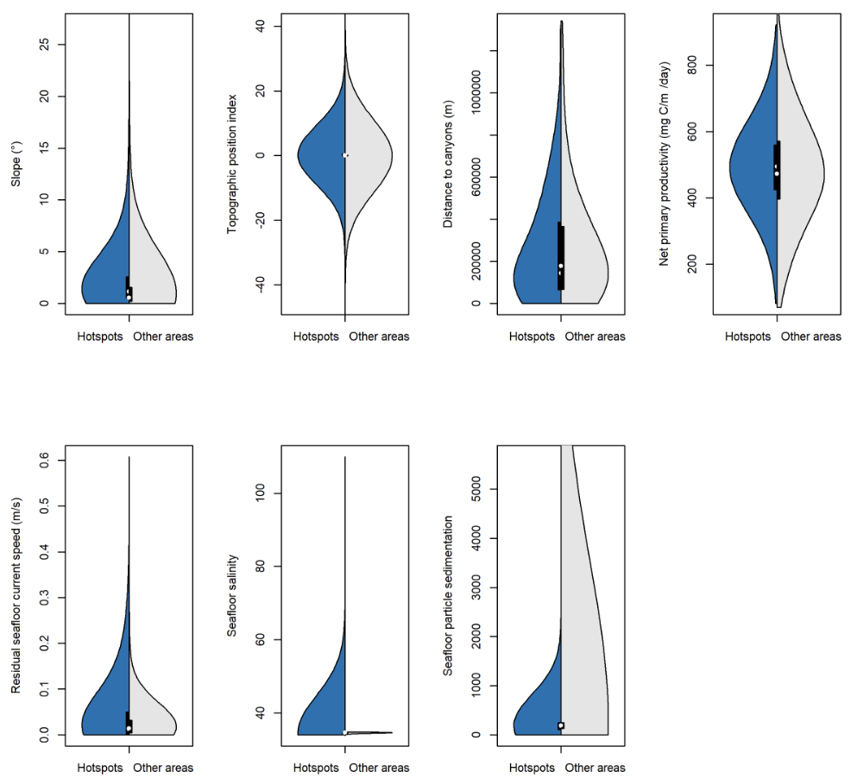
Suppl. Fig. 7: Comparison in frequency distributions between environmental conditions in hotspots areas (90th percentile) versus all other regions for the seven environmental drivers of Antarctic seafloor biodiversity hotspots not displayed in Fig. 2. Note that the distribution showing seafloor salinity values inside hotspots is strongly skewed, and not representative, due to a few outliers of high values.

Model diagnostics
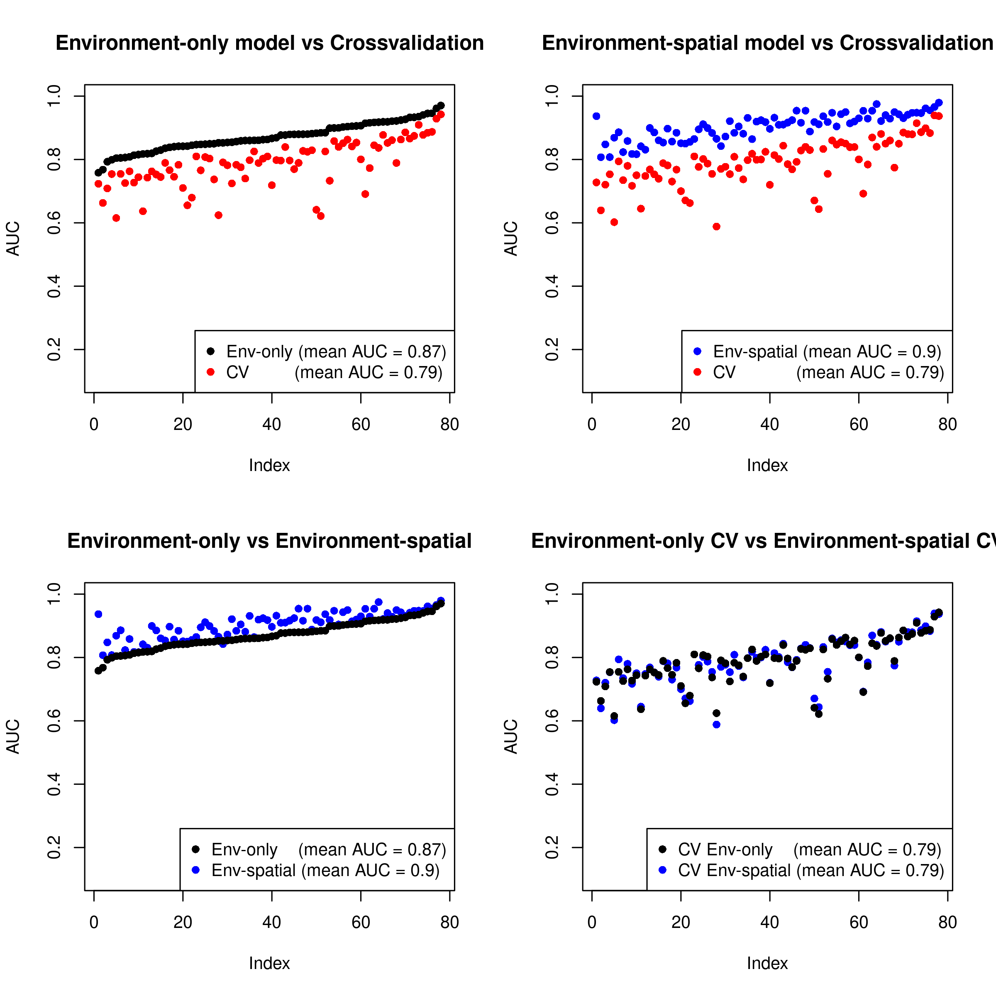
Suppl. Fig. 8: Comparisons of area under the curve (AUC) for our chosen model (“Environment-only”) against 5-fold cross-validation (top-left). We also fitted a model that included both environmental predictors as well as a spatial random variable on the sampling locations to address spatial correlation structure in the data (top-right). While the spatial model performs better explaining the data (direct comparison in bottom-left panel), both models predictions are indistinguishable when cross-validated (bottom-right panel). Given the similarity in predictive performance we chose the simpler model for our analysis.

Environmental predictor variables
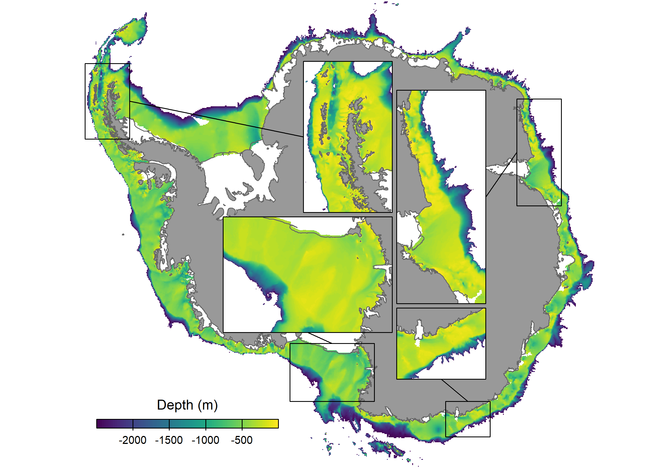
Suppl. Fig. 9: Depth of the Antarctic continental shelf, based on the International Chart of the Southern Ocean (IBCSO)¹.

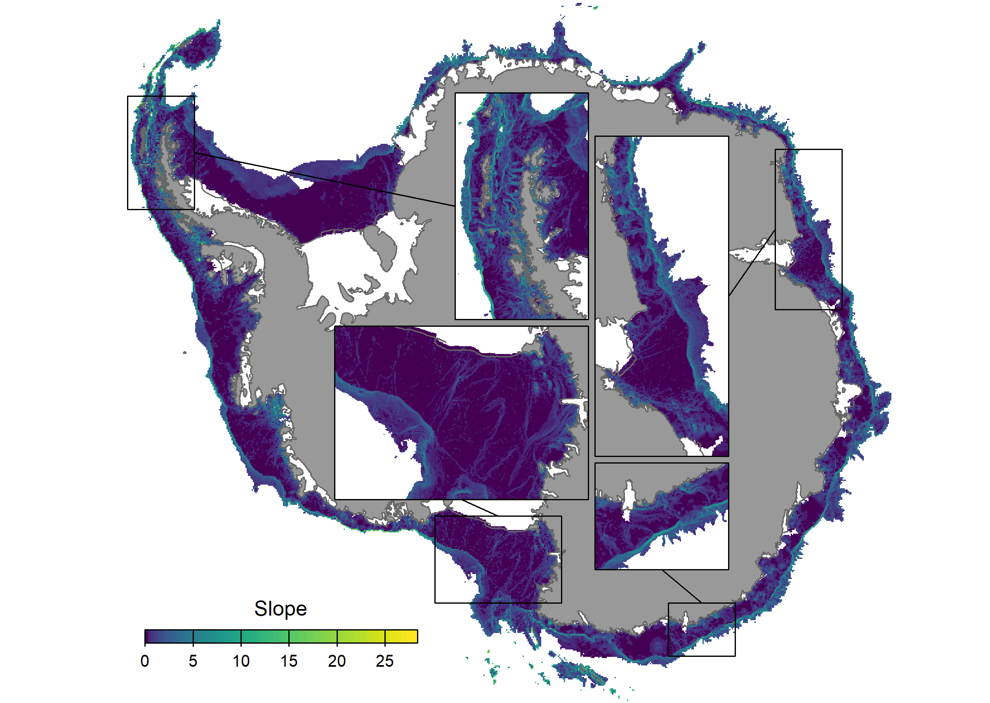
Suppl. Fig. 10: Slope of the Antarctic seafloor, calculated for each raster cell based on eight neighbouring cells.

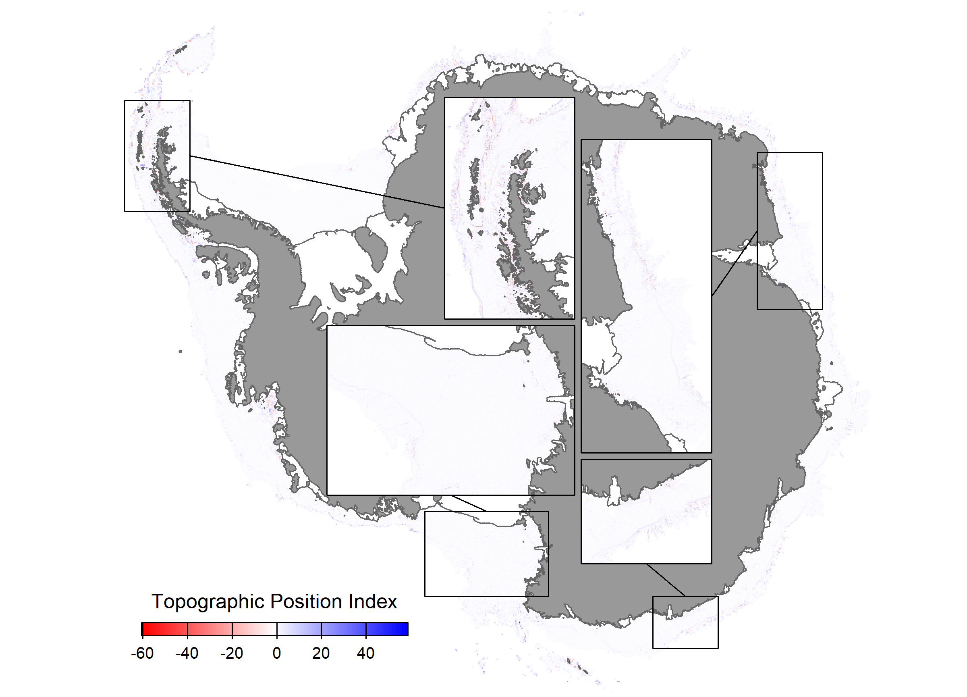
Suppl. Fig. 11: Topographic position index, calculated for each raster cell based on eight neighbouring cells.

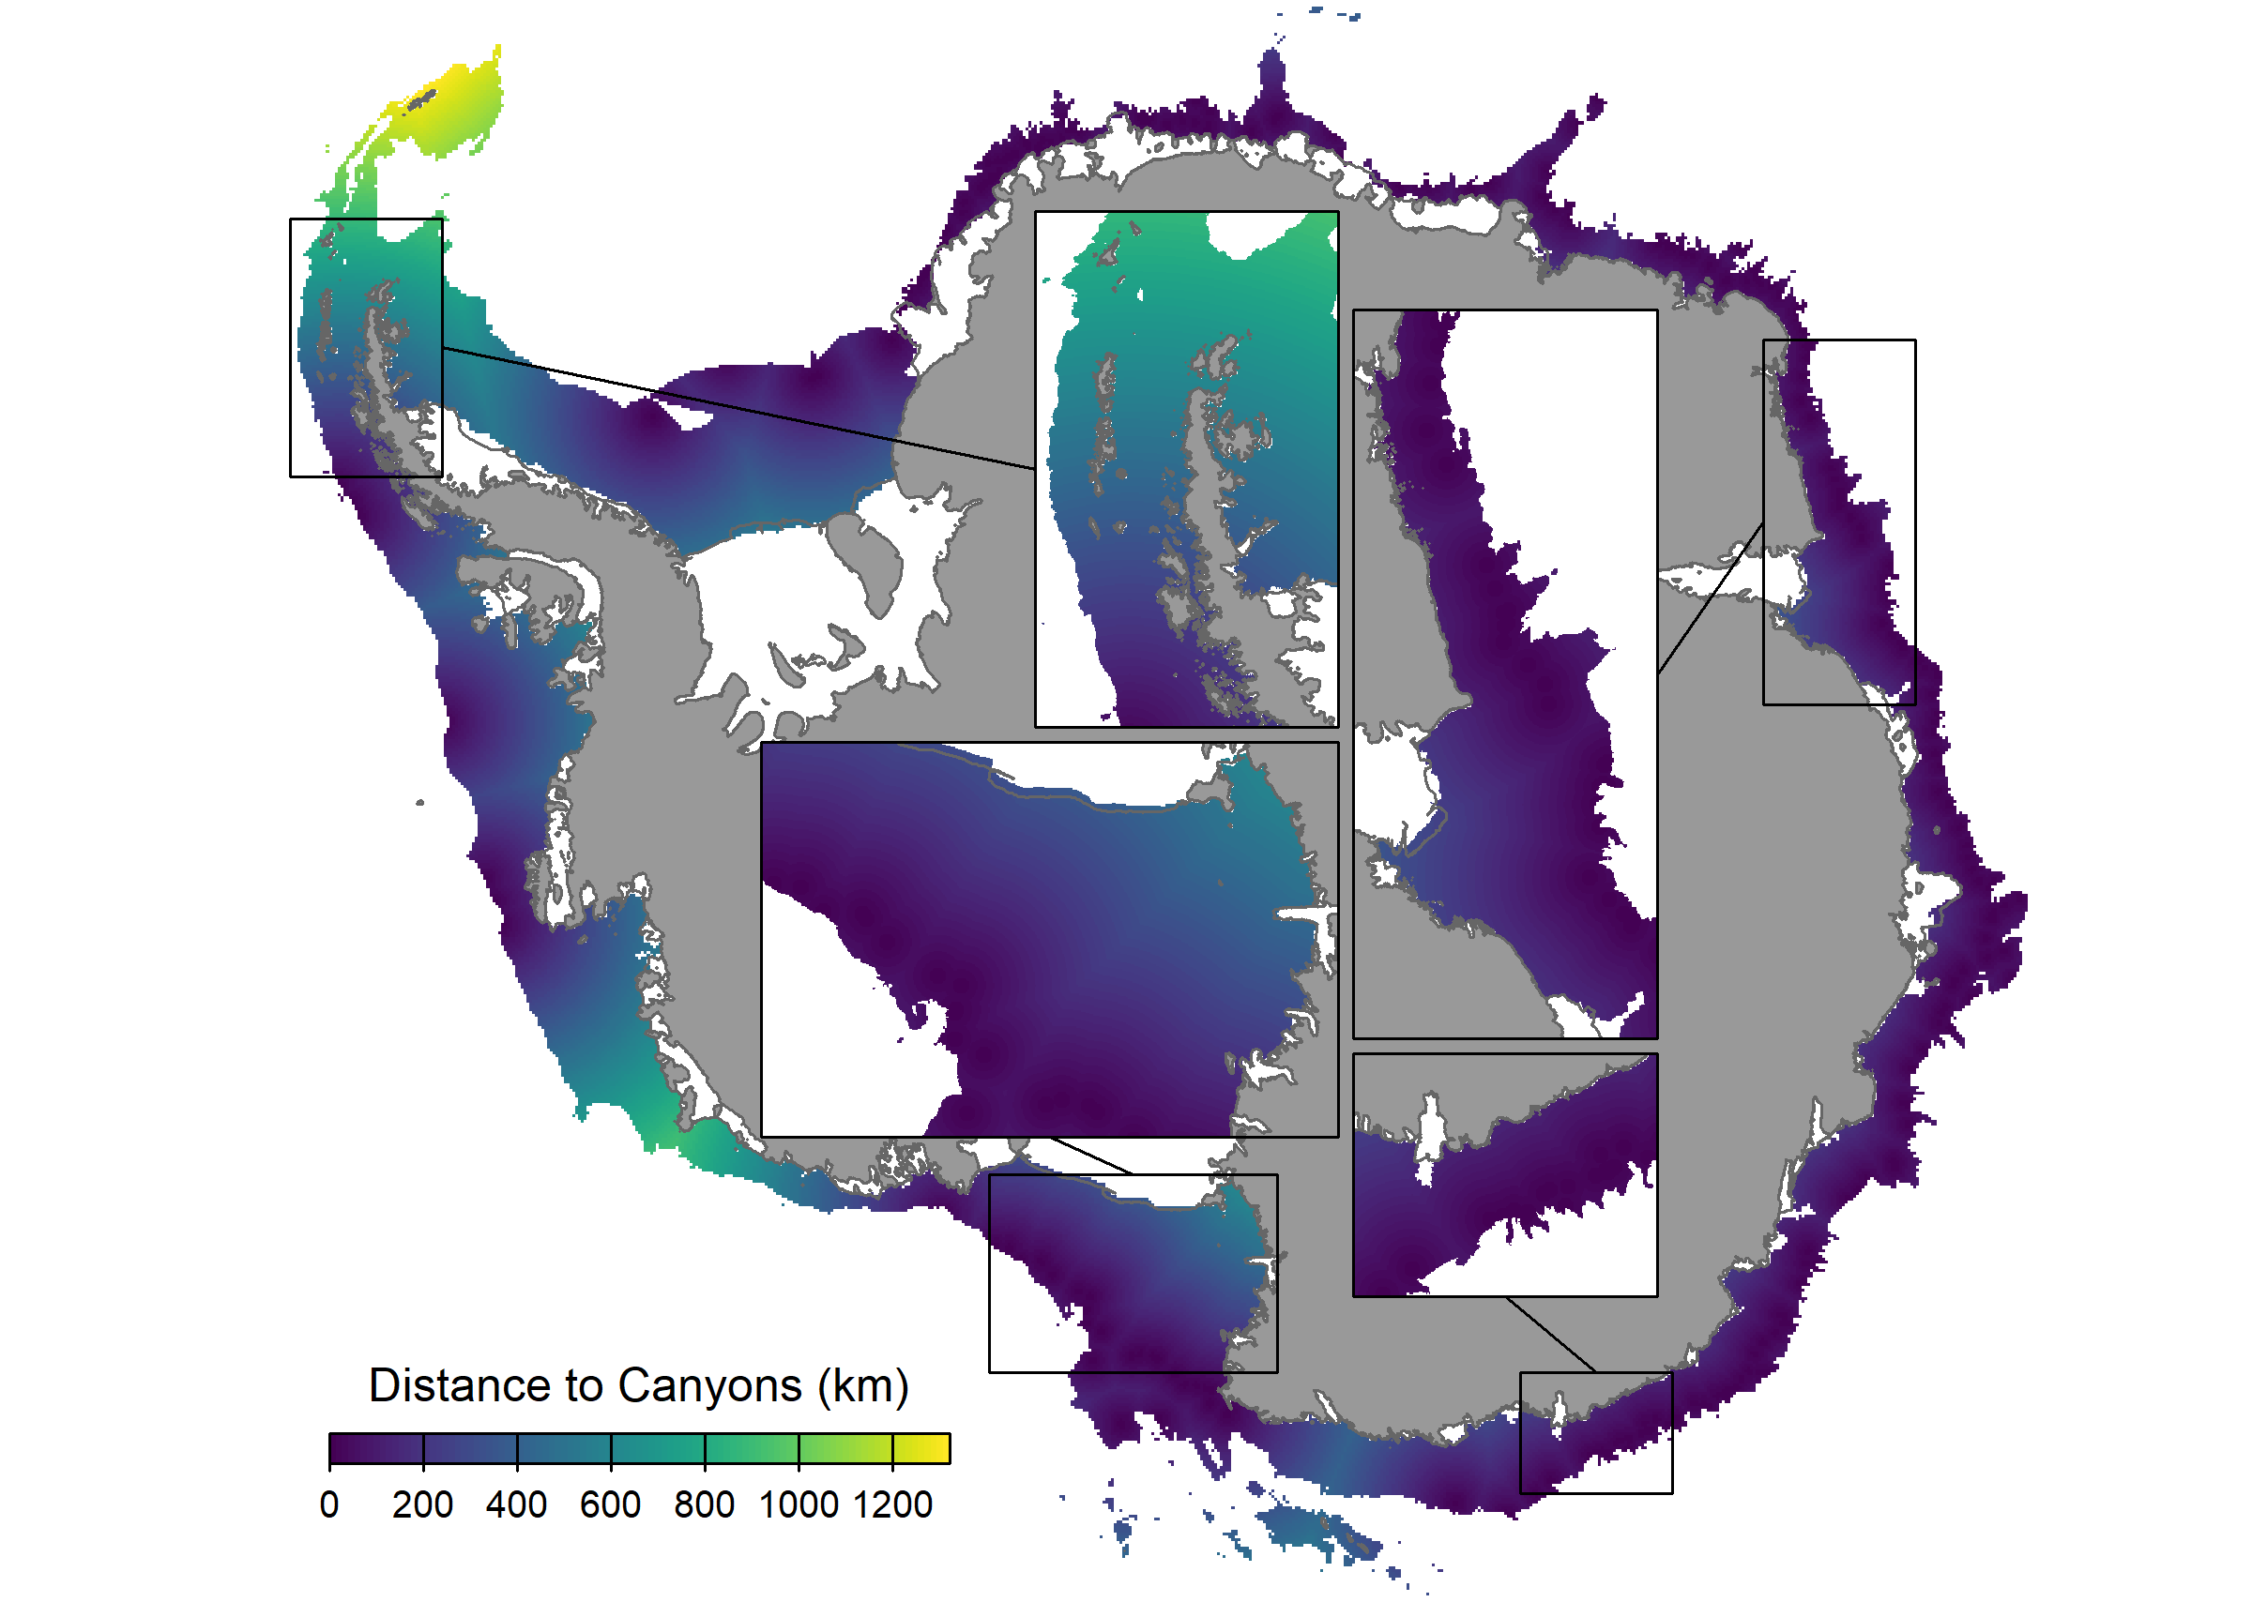
Suppl. Fig. 12: Distance to the heads of underwater canyons.

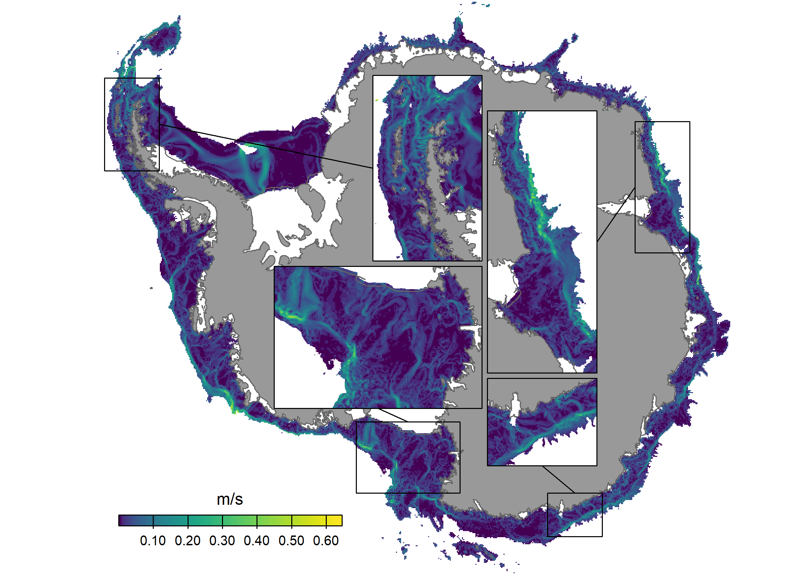
Suppl. Fig. 13: Temporal mean seafloor current speed for a typical summer month, based on WAOM².

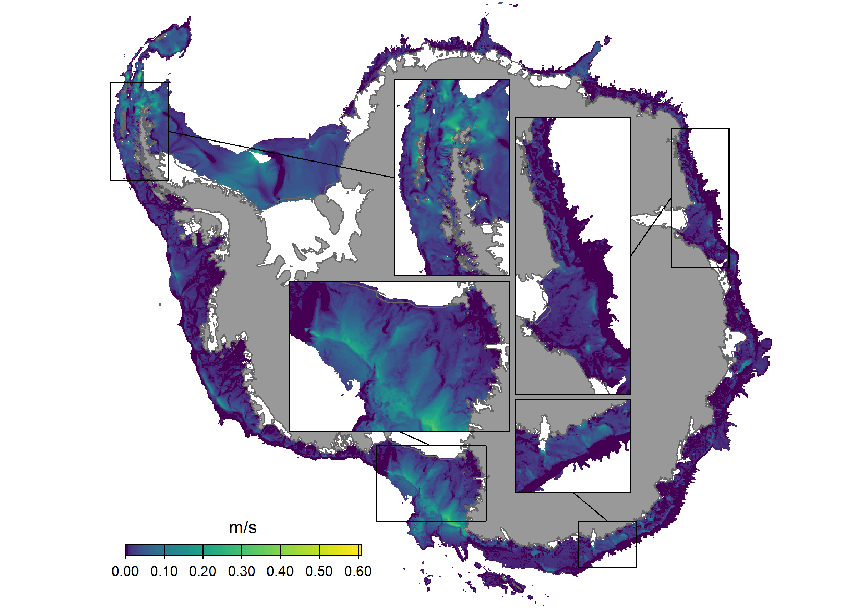
Suppl. Fig. 14: Residual (tidal) seafloor current speed during a typical summer month, based on WAOM².

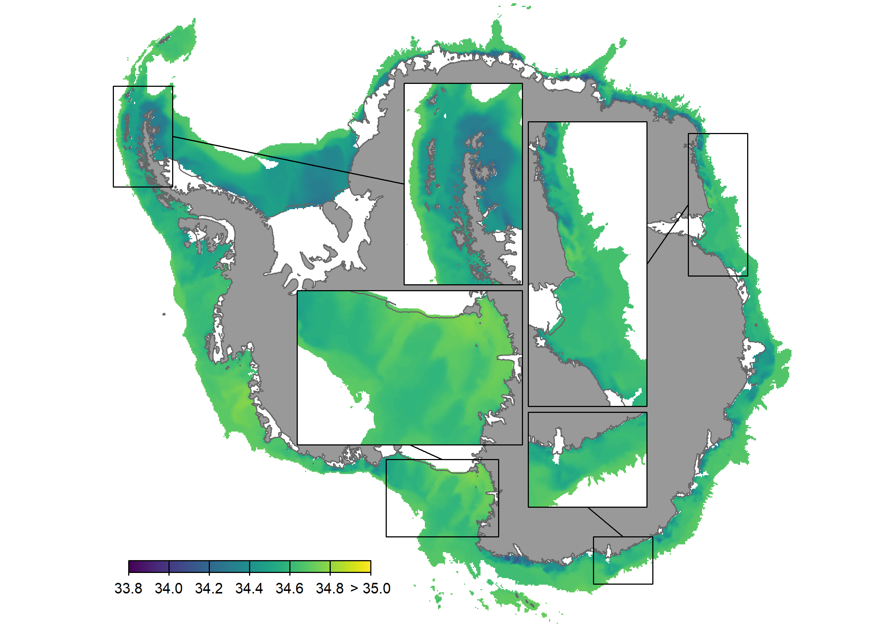
Suppl. Fig. 15: Average seafloor salinity for a 12-month period, based on WAOM².

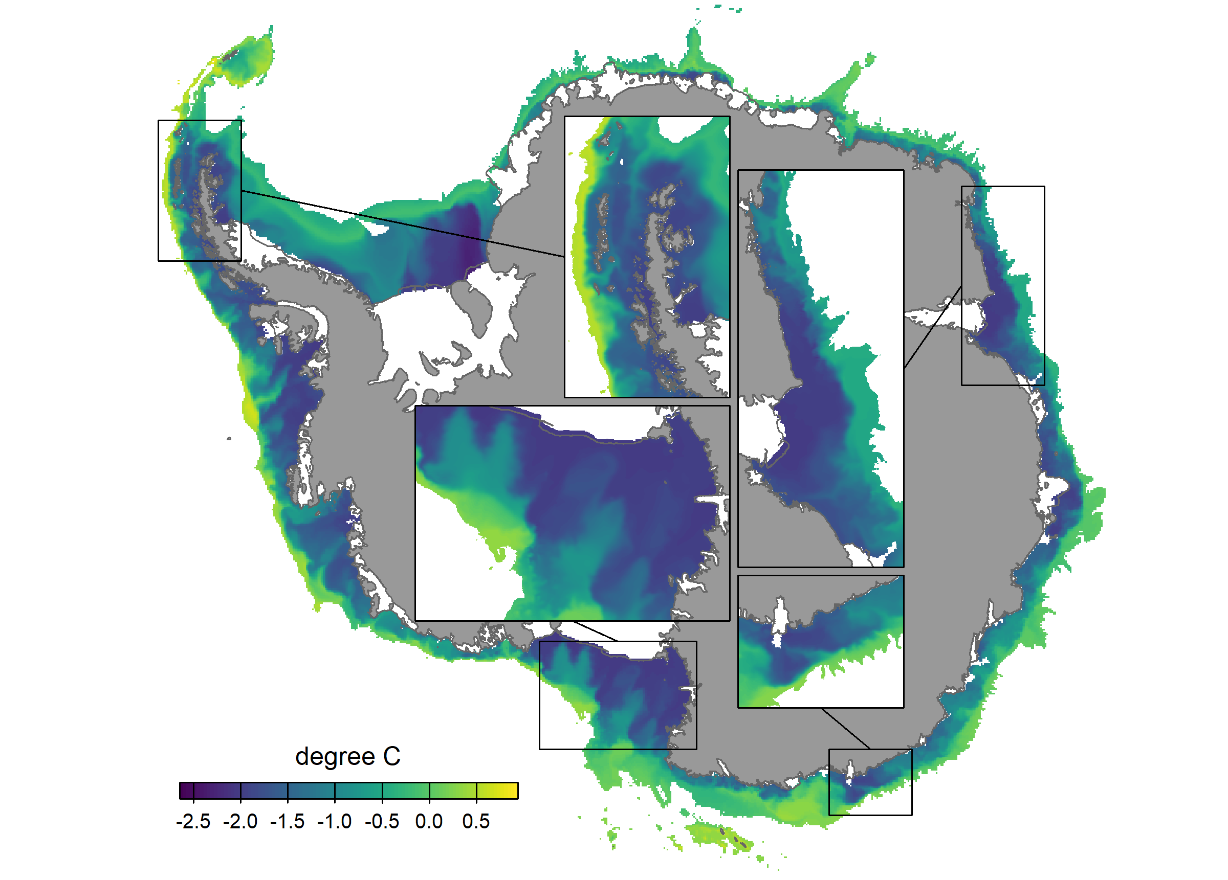
Suppl. Fig. 16: Average seafloor temperature for a 12-month period, based on WAOM².

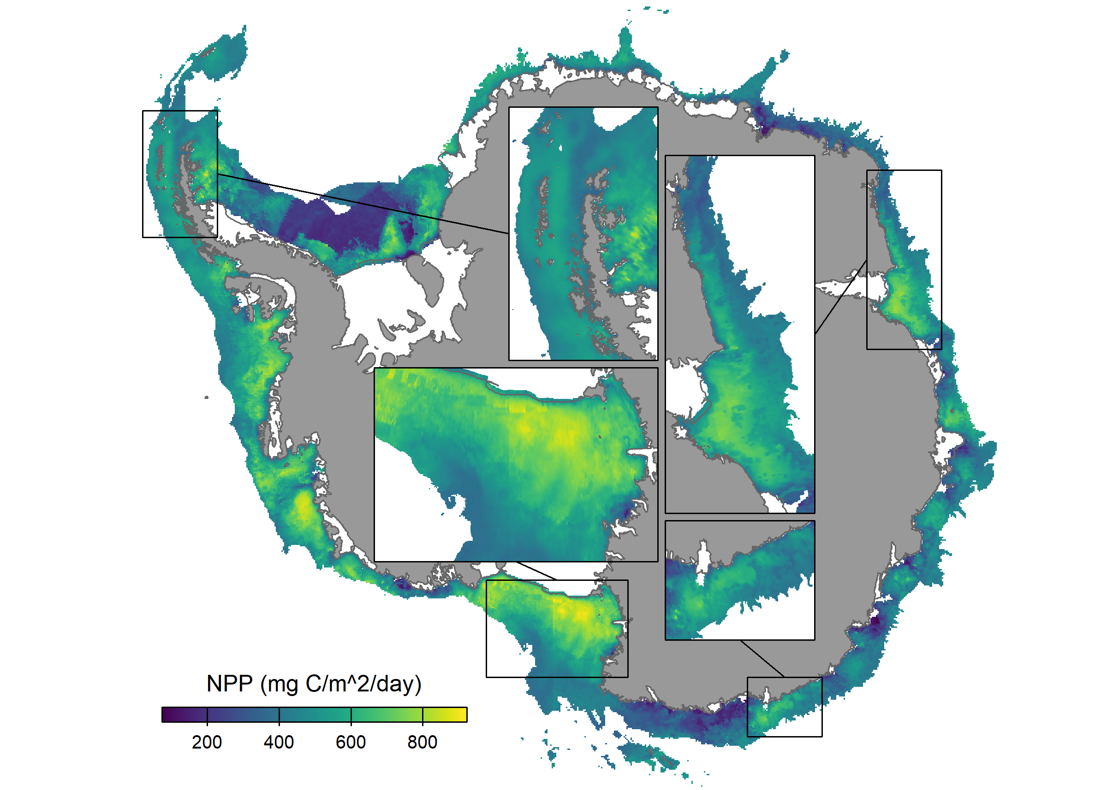
Suppl. Fig. 17: Average exported Net Primary Productivity (NPP) between 2002-2020, based on the CAFÉ model³.

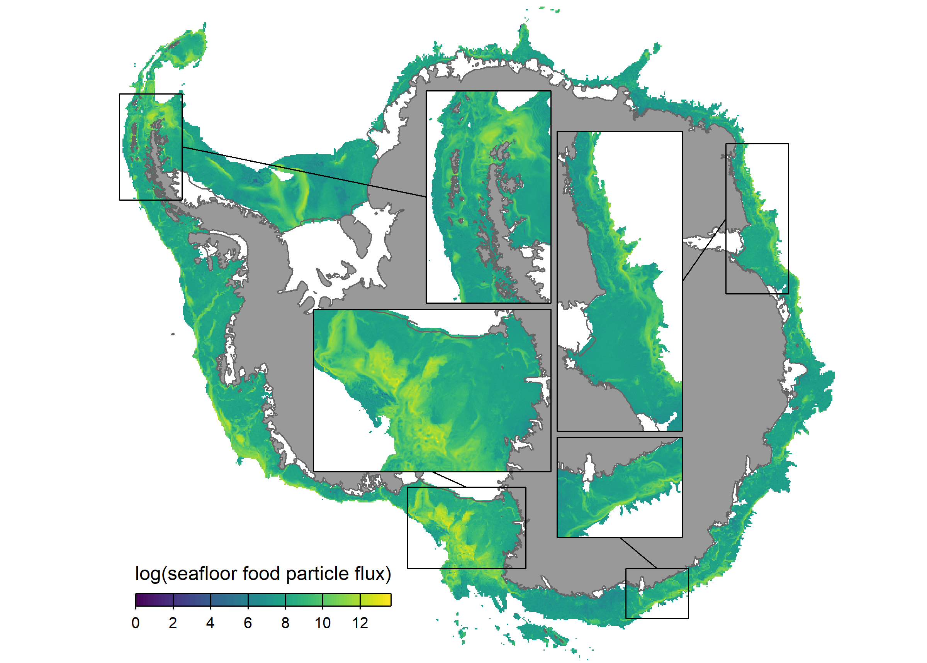
Suppl. Fig. 18: Intensity of the flux of ocean-surface-derived particles along the Antarctic seafloor, simulated using a food-availability model⁴.

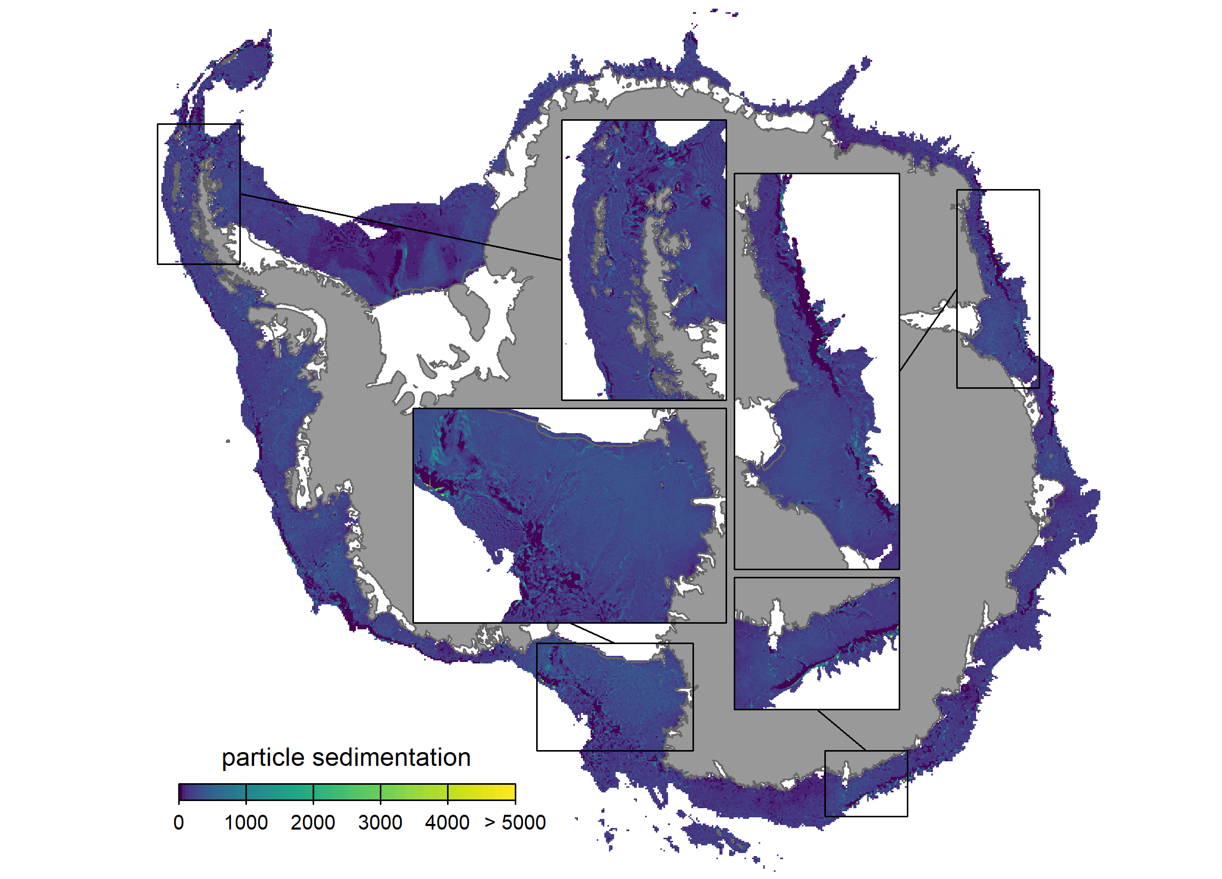
Suppl. Fig. 19: Sedimentation pattern of ocean-surface-derived particles on the Antarctic seafloor, simulated using a food-availability model⁴.

Supplementary Information References
1 Dorschel, B. et al. The International Bathymetric Chart of the Southern Ocean Version 2. Scientific Data 9, 275 (2022). https://doi.org:10.1038/s41597-022-01366-7
2 Boeira Dias, F. et al. Sensitivity of simulated water mass transformation on the Antarctic shelf to tides, topography and model resolution. Frontiers in Marine Science 10 (2023). https://doi.org:10.3389/fmars.2023.1027704
3 Silsbe, G. M., Behrenfeld, M. J., Halsey, K. H., Milligan, A. J. & Westberry, T. K. The CAFE model: A net production model for global ocean phytoplankton. Global Biogeochemical Cycles 30, 1756-1777 (2016). https://doi.org:10.1002/2016gb005521
4 Jansen, J. et al. Abundance and richness of key Antarctic seafloor fauna correlates with modelled food availability. Nature Ecology and Evolution 2, 71-80 (2018). https://doi.org:10.1038/s41559-017-0392-3

