The impact of virtual care on antibiotic prescribing practices for Urinary Tract Infections (UTIs): propensity-score matched cohort study [Supplemental Material]

Table S1 - UTI diagnostic codes from the MSP dataset
ICD-9 Codes | Definition
595.0 | Acute cystitis
599.0 | Urinary tract infection, site not specified
788 | Symptoms involving urinary system
788.1 | Dysuria
788.4 | Frequency of urination and polyuria
788.6 | Other abnormality of urination

Table S2 - Fee-item codes corresponding a virtual care visit from the MSP dataset
Virtual Visit Type | Fee-Item Codes
 | 13036, 13236, 13436, 13536, 13636, 13736, 13836, 13016
  Consultation
 | 13037, 13237, 13437, 13537, 13637, 13737, 13837, 13017
  Visit
 | 13038, 13238, 13438, 13538, 13638, 13738, 13838, 13018
  Counseling
 | 14076, 14078, 13706, 13707
  Telephone management fee
 | 14023
  Telephone follow-up

Table S3 - Fee-item codes corresponding to an in-person visit from the MSP dataset
In-Person Visit Type | Fee-Item Codes
 | 12100, 00100, 15300, 16100, 17100, 18100
  In-office visit
 | 12110, 00110, 15310, 16110, 17110, 18110
  In-office consultation
 | 12101, 00100, 15301, 16101, 17101, 18101
  In-office complete visit
 | 12120, 00120, 15320, 16120, 17120, 18120
  In-office counseling
 | 12200, 13200, 15200, 16200, 17200, 18200
  Out-of-office visit
 | 12210, 13210, 15210, 16210, 17210, 18210
  Out-of-office consultation
 | 12201, 13201, 15201, 16201, 17201, 18201
  Out-of-office complete examination
 | 12220, 13220, 15220, 16220, 17220, 18220
  Out-of-office counseling

Figure S2 - Probability density plot of estimated propensity scores by treatment group in the propensity score matched cohort of all individuals treated for a UTI in BC in 2022
Figure S1 - Probability density plot of estimated propensity scores by treatment group in the full unmatched cohort of all individuals treated for a UTI in BC in 2022

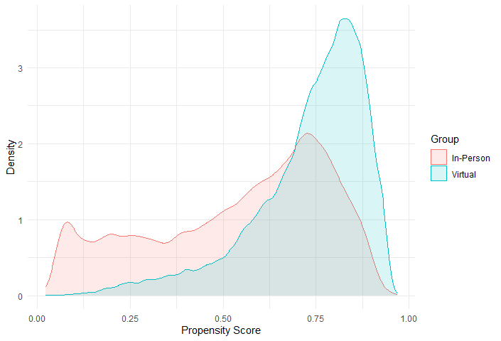
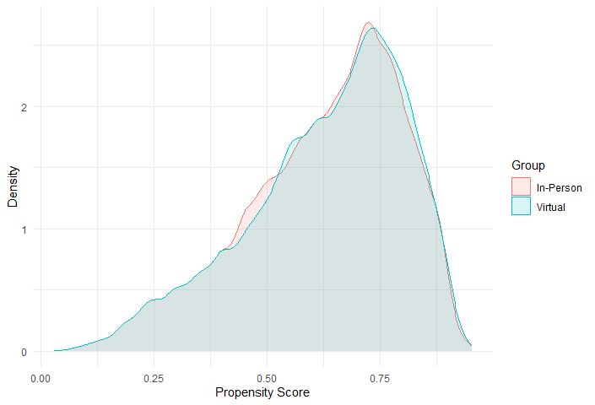

Figure S3 - Probability density plot of estimated inverse propensity scores by treatment group in the IPTW-weighted cohort of all individuals treated for a UTI in British Columbia in 2022

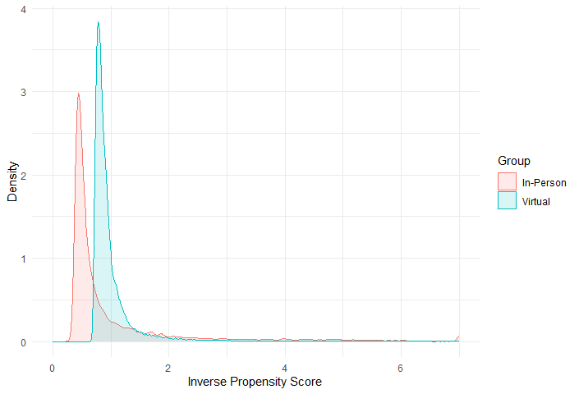
Figure S4 - Probability density plot of estimated propensity scores by treatment group in the full unmatched cohort of all individuals dispensed an antibiotic UTI in BC in 2022
Figure S5 - Probability density plot of estimated propensity scores by treatment group in the propensity score matched cohort of all individuals dispensed an antibiotic UTI in BC in 2022

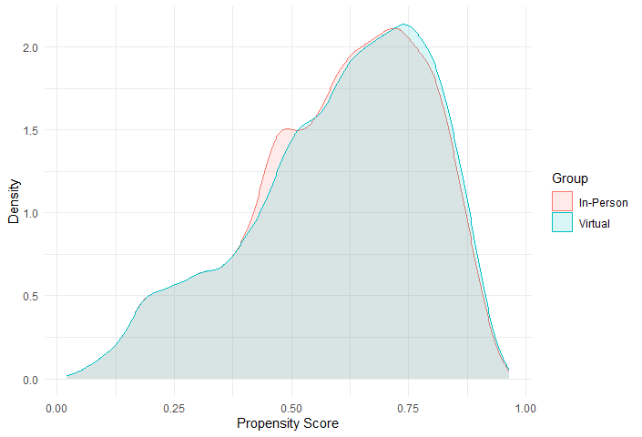
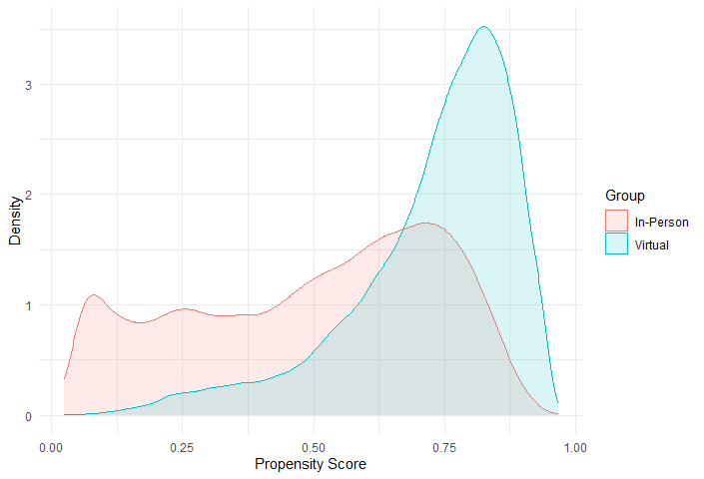

Figure S6 - Probability density plot of estimated inverse propensity scores by treatment group in the IPTW-weighted cohort of all individuals dispensed an antibiotic UTI in BC in 2022

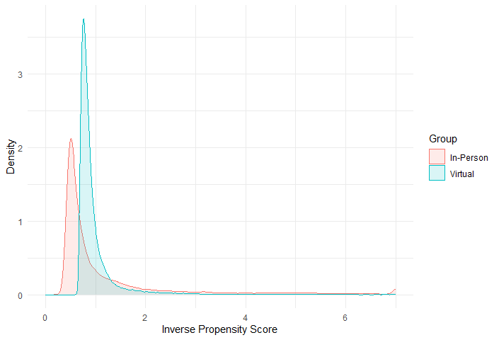

Figure S7 - Probability density plot of estimated propensity scores by treatment group in the full unmatched cohort of all individuals dispensed nitrofurantoin UTI in BC in 2022
Figure S8 - Probability density plot of estimated propensity scores by treatment group in the propensity score matched cohort of all individuals dispensed nitrofurantoin UTI in BC in 2022

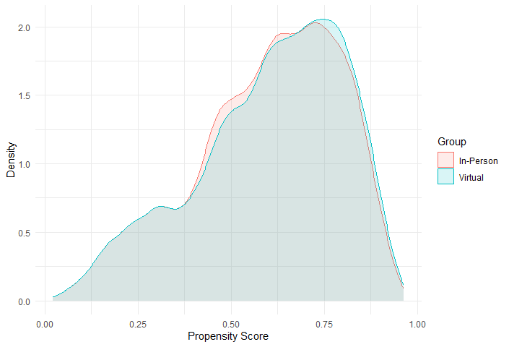
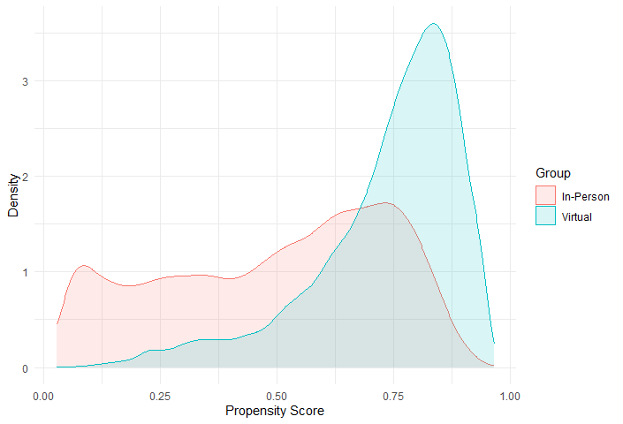

Figure S9 - Probability density plot of estimated inverse propensity scores by treatment group in the IPTW-weighted cohort of all individuals dispensed nitrofurantoin UTI in BC in 2022

