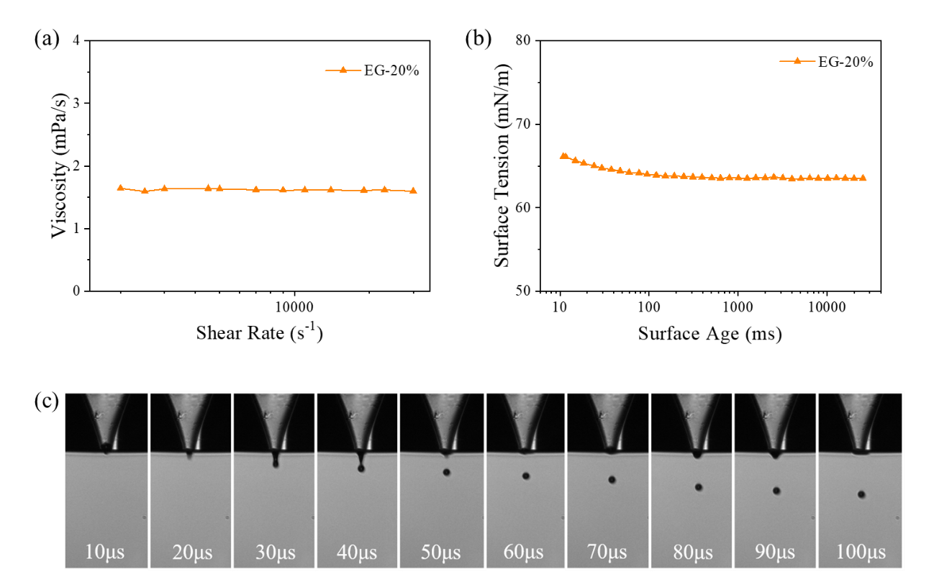
Fig. S1 (a) Viscosity, (b) surface tension and (c) droplet morphology of Reactive Orange 13 ink.


Fig. S2 schematic diagram of ink droplet penetration on fabrics, penetration process of droplets on fabrics.

