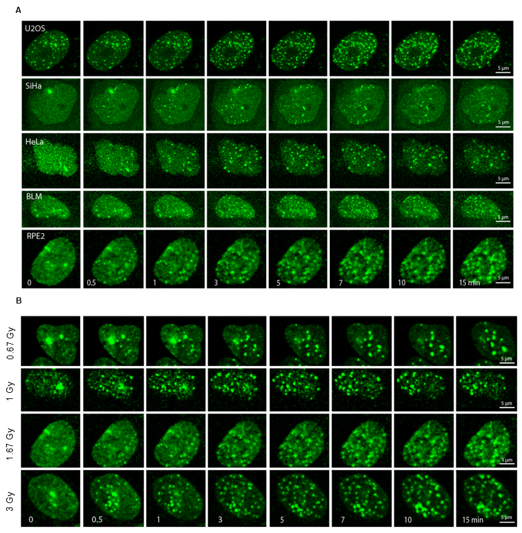
Supplementary Figure 1. Foci formation kinetics is heterogeneous, cell line and dose dependent. Representative images of different cell lines exposed to 1.67 Gy of ultra-soft X-rays (A) or ARPE-19 cells irradiated at different doses (B). Green - RNF168-Clover. Scale bar - 5 μm.

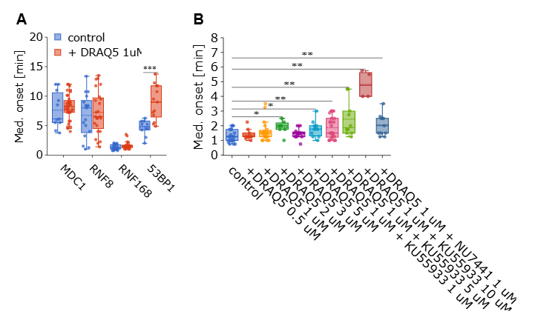
Supplementary Figure 2. Impact of DNA-binding dye DRAQ5 of foci onset. (A) Median foci onset for MDC1-, RNF8-, RNF168- and 53BP1-Clover expressing cells preincubated in normal medium or in the presence of 1 μm DRAQ5. (B) Medium foci onset of RNF168-Clover incubated in the presence of DRAQ5 and DNA repair inhibitors NU7441 and different concentrations of KU55933. More than 4 cells were analyzed per condition. (N cell ≥4).

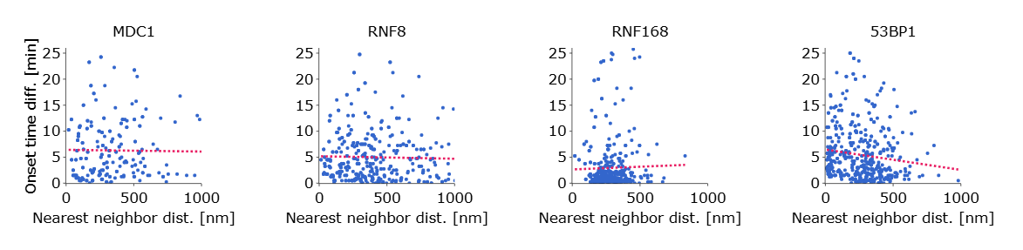
Supplementary figure 3. The onset of foci is not correlated with the distance between them. The plots show the relationship between the distance between nearest-neighbor foci pairs and the difference in the onset time of these foci. Lack of correlation indicates that even closely-spaced foci can be characterised by very different onset times, suggesting that foci onset is not entirely determined by large-scale chromatin structure or arrangement. Over 200 foci were analysed for each combination

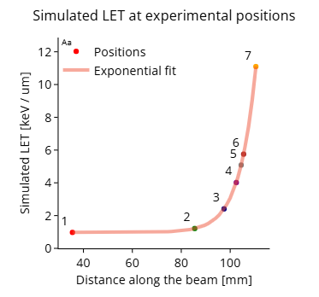
Supplementary Figure 4. Proton irradiation position and corresponding simulated linear LET profile with exponential fit.

