Supplement
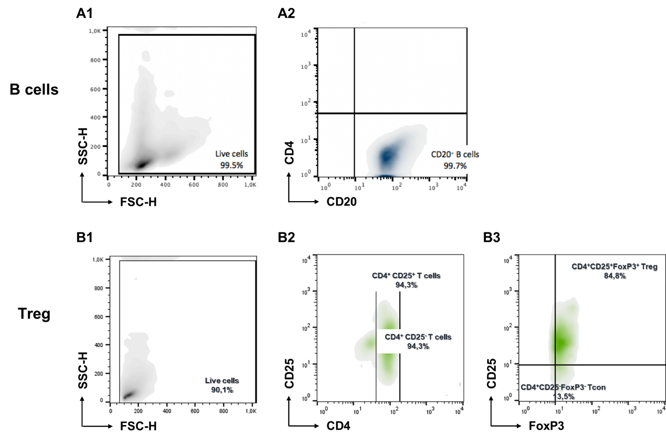
Supplementary Fig. 1 Flow cytometry of B cell and T cell populations, immunomagnetically isolated from PBMCs. (A) To assess the purities of isolated CD20⁺ total B cells, isolated cells were stained with a PerCP-conjugated mAb against CD20 and a FITC-conjugated mAb CD4 to rule out T cell contamination of samples. (A1) Live cells were gated based on size using forward scatter (FSC-H) and side scatter (SSC-H). (A2) B cells were identified in the live cell gate based on their CD20 expression. (B) To assess the purity of isolated Tregs, isolated cells were stained with a PerCP-conjugated mAb against CD4, a PE-conjugated mAb against CD25 and an APC-conjugated mAb against FoxP3. (B1) Live cells were gated based on size using forward scatter (FSC-H) and side scatter (SSC-H). (B2) Live cells were gated based on CD4 and CD25 expression. (B3) Tregs and Tcons were identified in the CD4⁺ T cell gate based on their CD25/FoxP3 expression. Samples were acquired on a FACSCanto II flow cytometer, using CellQuestTM software (BD Biosciences), and analyzed using FlowJoTM (Version 10.7, Ashland, OR, USA).

Supplementary Tab. 1 Purities of total B cells, Tregs and Tons immunomagnetic isolated from peripheral blood samples of healthy donors (HD) and MS patients. Purities of total B cells, Tregs and Tcons, freshly isolated from PBMCs by immunomagnetic separation, were randomly checked by flow cytometry, revealing highly enriched cell populations for both HD and MS. Differences between purities of HD- and MS-cells were not statistically significant as determined by one-way ANOVA and Kruskal‒Wallis tests with Dunn’s post-hoc correction.

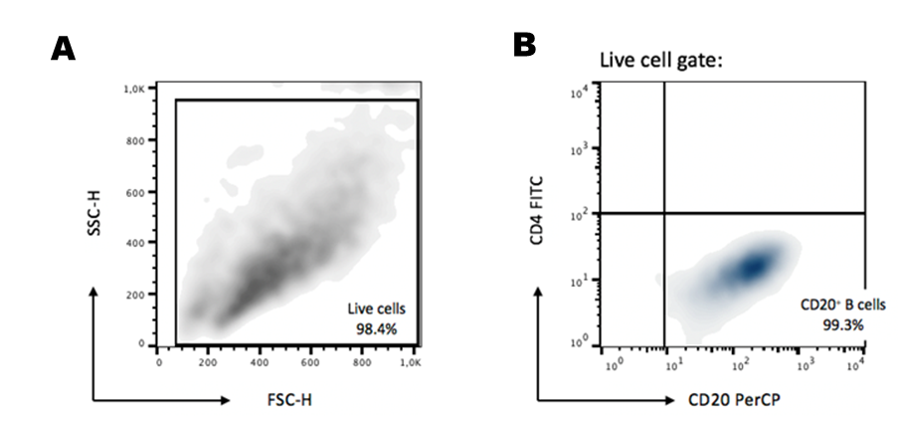
Supplementary Fig. 2 Purity check by flow cytometry of B cell populations, isolated from cell culture. To isolate B cells following monoculture or coculture with Tregs, CD4⁺ cells were first depleted using CD4 MicroBeads, and B cells were subsequently further purified by positive isolation using CD19 MicroBeads. To assess their purity, isolated B cells were stained with a PerCP-conjugated mAb against the B cell surface marker CD20, and a FITC-conjugated mAb against the T cell surface marker CD4, to rule out T cell contamination of samples. One representative sample is shown for the gating strategy. (A) Live cells were gated based on size using forward scatter (FSC-H) and side scatter (SS-HC). (B) B cells were identified in the live gate as CD4⁻CD20⁺ cells. Samples were acquired on a FACSCanto II flow cytometer, using CellQuestTM software (BD Biosciences), and analyzed using FlowJoTM (Version 10.7, Ashland, OR, USA).

Supplementary Tab. 2 Purities of B cells isolated from cell cultures. Purities of total B cells, harvested after cell culture and immunomagnetically purified, were randomly checked by flow cytometry, revealing highly enriched cell populations for both HD (n=6) and MS (n=6). Differences between purities of HD- and MS-cells were not statistically significant as determined by one-way ANOVA and Kruskal‒Wallis tests with Dunn’s posthoc correction.

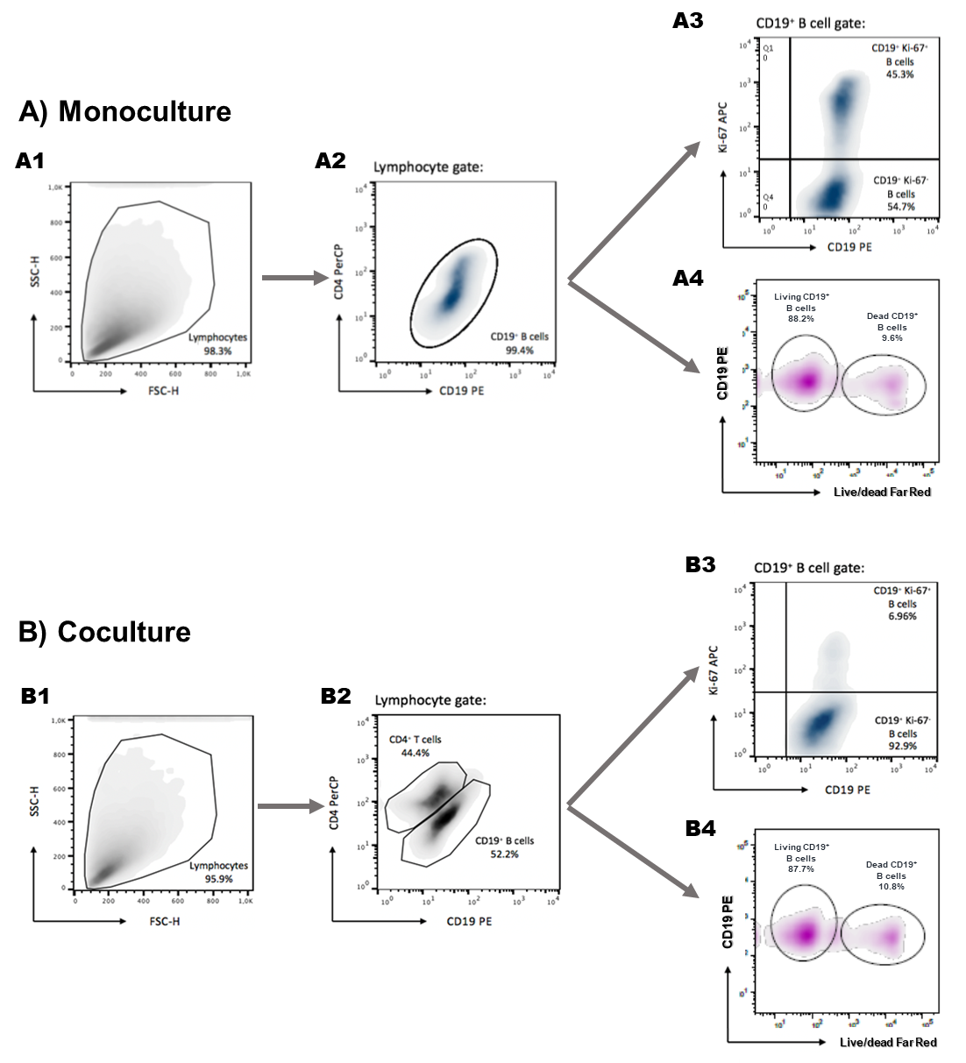
Supplementary Fig. 3 Gating strategy for assessing the percentage of Ki-67⁺ proliferating B cells and of dead B cells in vitro. To determine the percentage of Ki-67⁺ B cells and of dead B cells following BCR stimulation alone (A) or coculture with Tregs (B), cultured cells were harvested and then stained with a PE-conjugated mAb against the B cell surface marker CD19 and a PerCP-conjugated mAb against the T cell surface marker CD4 to clearly distinguish between B cells and T cells. To identify proliferation or dead B cells, cells were intracellularly stained with an APC-conjugated mAb against the nuclear proliferation marker Ki-67. For quantification of dead or dying cells, cells were intracellularly stained with the LIVE/DEAD Fixable Far Red Dead Cell APC-Stain Kit (Fisher Scientific) according to the providers’ protocol. One representative sample is shown for the gating strategies used for (A1) monocultured and (B1) cocultured B cells. Harvested cells were gated based on size using forward scatter (FSC-H) and side scatter (SSC-H). (A2, B2) B cells were identified in the lymphocyte gate based on CD19 expression. (A3, B3) Proliferating B cells were identified in the B cell gate based on intracellular expression of Ki-67. (A4, B4) Dead B cells were identified in the B cell gate based on intracellular expression of intracellular Far Red. Percentages indicate frequencies relative to the parent gate. Samples were acquired on a FACSCanto II flow cytometer, using CellQuestTM software (BD Biosciences), and analyzed using FlowJoTM (Version 10.7, Ashland, OR, USA).
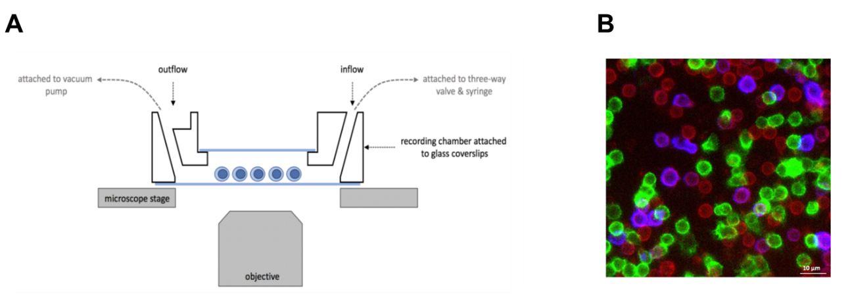

Supplementary Fig. 4 Live-cell calcium imaging experiments were performed using a custom-made recording chamber (A). Fura-2-loaded cells on a glass coverslip were attached to the bottom of the recording chamber, and a second coverslip was attached on top using silicone gel, forming a tightly sealed chamber. The bathing solution in the recording chamber could be exchanged during the experiment with the help of an inflow tube attached to a three-way valve and syringe, and an outflow tube attached to a vacuum pump (35). (B) Following live-cell imaging experiments, cells were fixed and stained with mAbs against CD20, CD27 and CD4. B cells were identified based on their CD20⁺ expression. CD20⁺CD27⁺ B cells were identified as memory B cells (blue), and CD20⁺CD27⁻ cells as naïve B cells (red). Highly enriched Tregs were identified based on their CD4 expression (green).

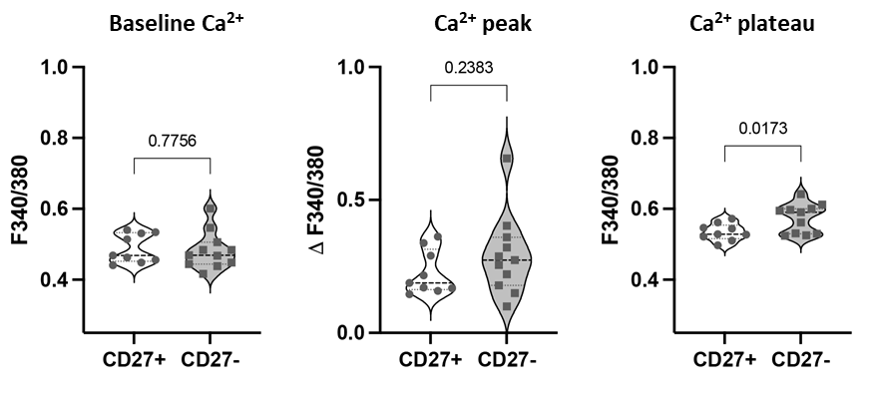
Supplementary Fig. 5 Preliminary analysis of Ca²⁺ responses in CD27⁺ memory BC and CD27⁻ naïve B cells. In the B cell monoculture, there was a trend towards higher peak and plateau Fura-2 values in CD27⁻ naïve B cells compared to CD27⁺ memory B cells in response to stimulation with anti-IgM/anti-CD40. Violin plots represent the distribution of individual data points, as well as medians and 25th and 75th percentiles. P-values are based on Kruskal-Wallis tests with Dunn’s multiple comparisons.
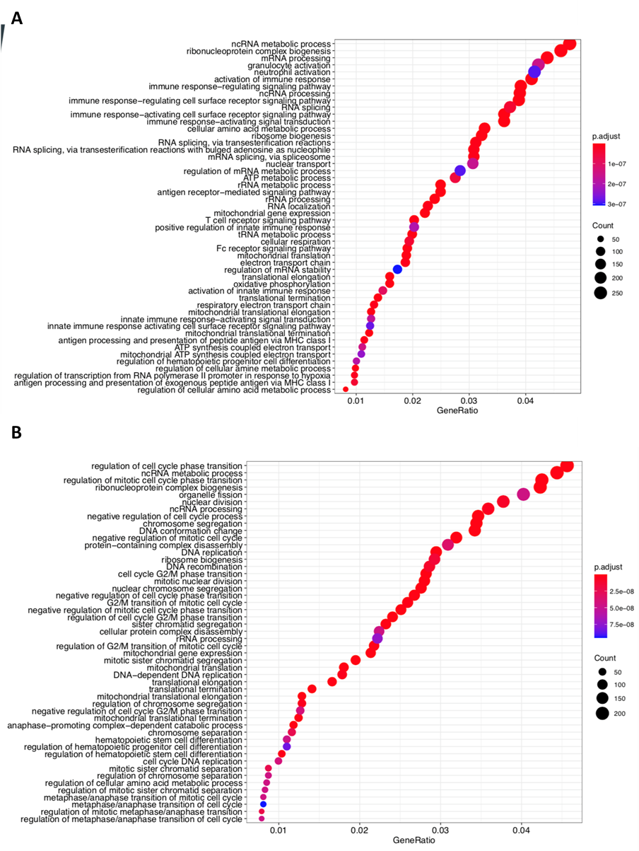
Supplementary Fig. 6 BCR stimulation resulted in an enrichment in pathways associated with immune system activation and cell proliferation. Top 50 enriched pathways identified by gene ontology (GO) analysis for B cells stimulated for 24 hours and 72 hours compared to unstimulated B cells. (A) Compared to unstimulated B cells, GO analysis revealed an enrichment in pathways associated with cellular metabolic processes and immune system activation in B cells stimulated with anti-IgM/anti-CD40 for 24 hours. (B) B cells stimulated for 72 hours showed an enrichment in pathways associated with mitosis. Y-axis labels show GO pathway names, the x-axis represents the percentage of genes that are differentially expressed in the associated pathway (gene ratio). Bubble size represents the number of genes enriched in the respective pathway, bubble color represents the p-value associated with the enrichment. GO dot plots were generated using R studio Version 1.4.

