Supplementary data
The RNA seq raw data produced in this study are available in the NCBI Sequence Read Archive (SRA) at: https://www.ncbi.nlm.nih.gov/sra/PRJNA1367557

Table 1S: Diet specifications. Percentages are of total energy content except for cholesterol (weight %). Approximate analysis.
 | Chow¹ | MC-HFD²
Gross energy kcal/kg | 3298 | 4598
Carbohydrates (%) | 74.6 | 41
Protein (%) | 18.6 | 11
Fat³ (%) | 6.8 | 48
Fructose (%) | 4.1⁴ | 20.5
Cholesterol (weight %) | 0 | 0.5
¹SDS Minipig (Special Diets Services, Scanbur, DK)
² Custom made high fat diet, Foulum, Aarhus University, Aarhus, Denmark
³ Fat in the chow diet is primarily from sunflower and soybean oil, and in the MC-HFD it is primarily from lard with a smaller contribution from soybean oil.
⁴ % associated with sugar, not necessarily just fructose.
Figure 1S: Weight curves for each individual pig, with distinct symbols used only for pig 1 and 30.

Table 2S: Repeated measures two-way ANOVA results for the week, diet and interaction effect of week and diet on morphometric parameters and blood biomarkers of MetS and hepatocellular injury. LDL, low-density lipoprotein. BW, body weight. ABC, abdominal circumference. BMI, body mass index. BSA, body surface area. HDL, high-density lipoprotein. CRP, C-reactive protein. ALT, alanine transaminase. AST, aspartate transaminase. GLDH, glutamate dehydrogenase.
 | Week | P | Diet | P | Week x Diet | P
BW | < 0.0001 | **** | 0.004 | ** | < 0.0001 | ****
ABC | 0.0008 | *** | 0.33 |  | 0.01 | *
BMI | 0.0002 | *** | 0.01 | * | 0.0002 | ***
BSA | < 0.0001 | **** | 0.01 | * | < 0.0001 | ****
Triglyceride | 0.32 |  | 0.57 |  | 0.83
Cholesterol | 0.10 |  | 0.06 |  | 0.02 | *
HDL | 0.009 | ** | 0.002 | ** | 0.01 | *
LDL | 0.54 |  | 0.40 |  | 0.03 | *
Fructosamine | 0.01 | * | 0.70 |  | 0.37
Glucose | 0.002 | ** | 0.24 |  | 0.07
Insulin | 0.08 |  | 0.35 |  | 0.36
CRP | 0.14 |  | 0.21 |  | 0.74
ALT | 0.67 |  | 0.008 | ** | 0.003 | **
AST | 0.62 |  | 0.06 |  | 0.59
GLDH | 0.52 |  | 0.76 |  | 0.01 | *

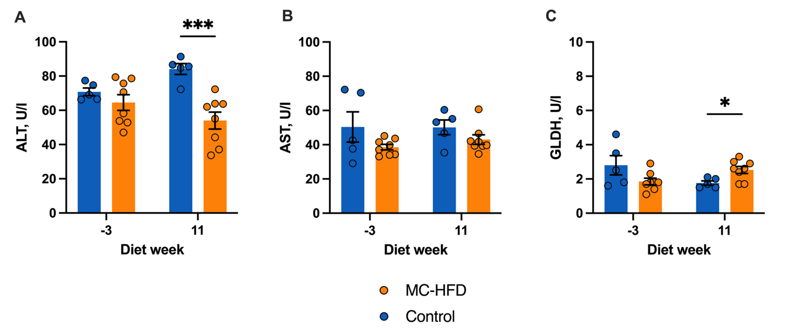
Figure 2S: Blood biomarkers of hepatocellular injury measured in fasting serum samples from the start and end of the study. Statistical significance between control and MC-HFD group at individual time points was evaluated with unpaired Welch’s t-test, for normally distributed data, and Holm-Šídák corrections. For not normally distributed data a non-parametric alternative (Mann-Whitney test) was used (*P < 0.05, ***P < 0.001). Error bars depict SEM. ALT, alanine transaminase. AST, aspartate transaminase. GLDH, glutamate dehydrogenase.
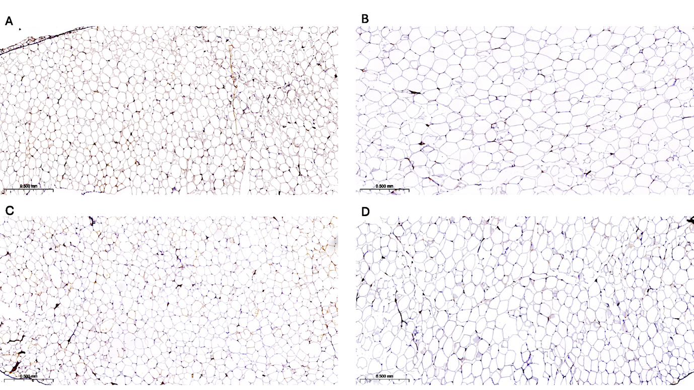
Figure 3S: Histological images of adipocytes from subcutaneous and visceral depots. Representative example of the difference in adipocyte size in MC-HFD pigs compared to control pigs. A: SAT, control. B: SAT, MC-HFD. C: VAT, control. D: VAT, MC-HFD. Bar = 500 µm.
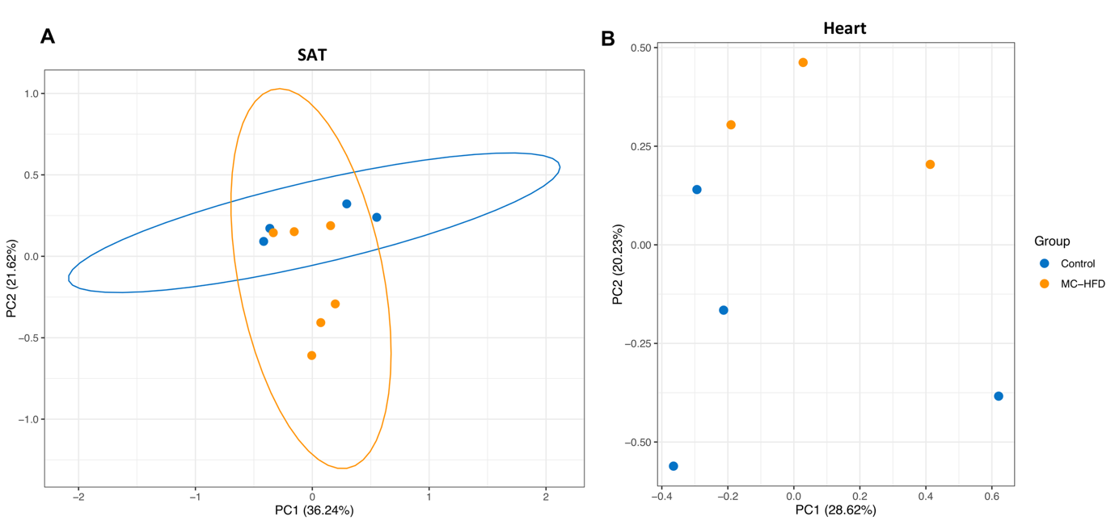
Figure 4S: PCA of RNA-seq data for (A) SAT, and (B) heart datasets. Each data point indicates a pig sample. Colour: diet group. Axes depict PC1-2, including the % of variance explained. The RNA-seq data was pre-processed by filterByExpr using the default settings, followed by CPM for normalization and log2 transformation. PCA was performed using the prcomp function with default settings. No ellipse was computed for heart due to lack of samples.
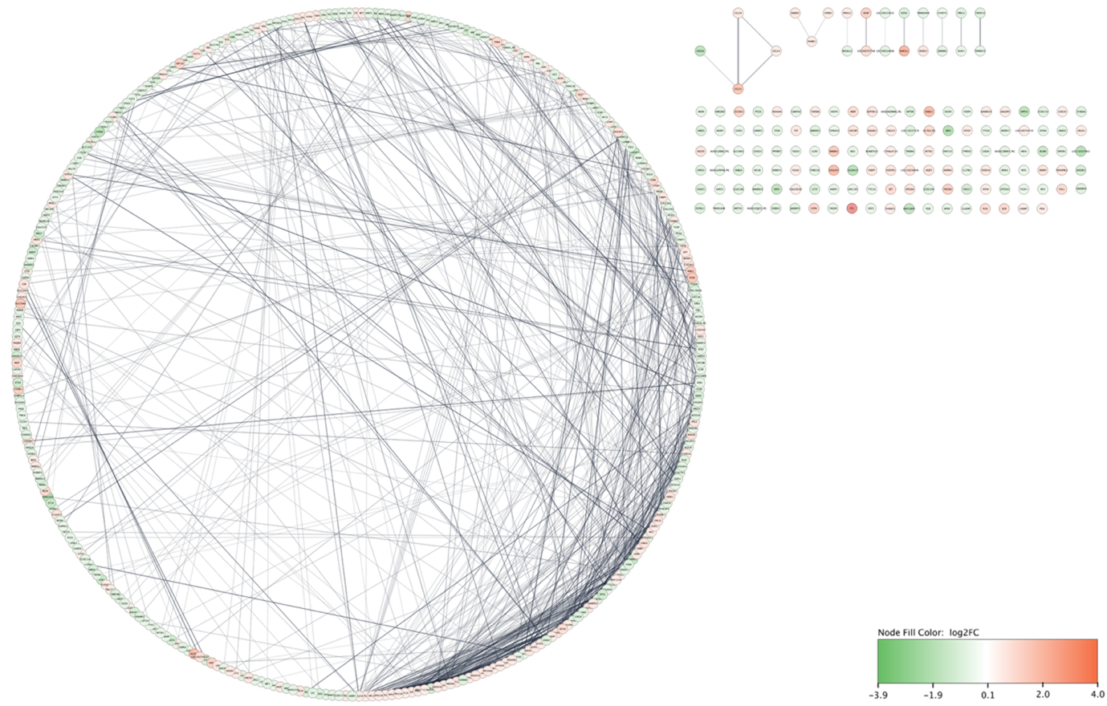
Figure 5S: PPI network of VAT DETs summarized at the gene level. Network was constructed using STRING database and visualized through Cytoscape software. Nodes represent proteins and edges indicate functional or physical protein interactions. A threshold of 0.4 was chosen for the edge confidence. Thickness of each edge indicates the strength of data supporting the interaction. Node colors represent log2FC expression changes (MC-HFD vs. control). The networks were displayed using a degree-sorted circular layout, where the node with the highest degree (number of interactions) is positioned at 6 o’clock, and the remaining nodes are arranged counterclockwise in descending order of degree. The network includes 472 nodes and 815 edges, with a significant number of interactions observed (P = 1.15×10⁻⁰⁸).
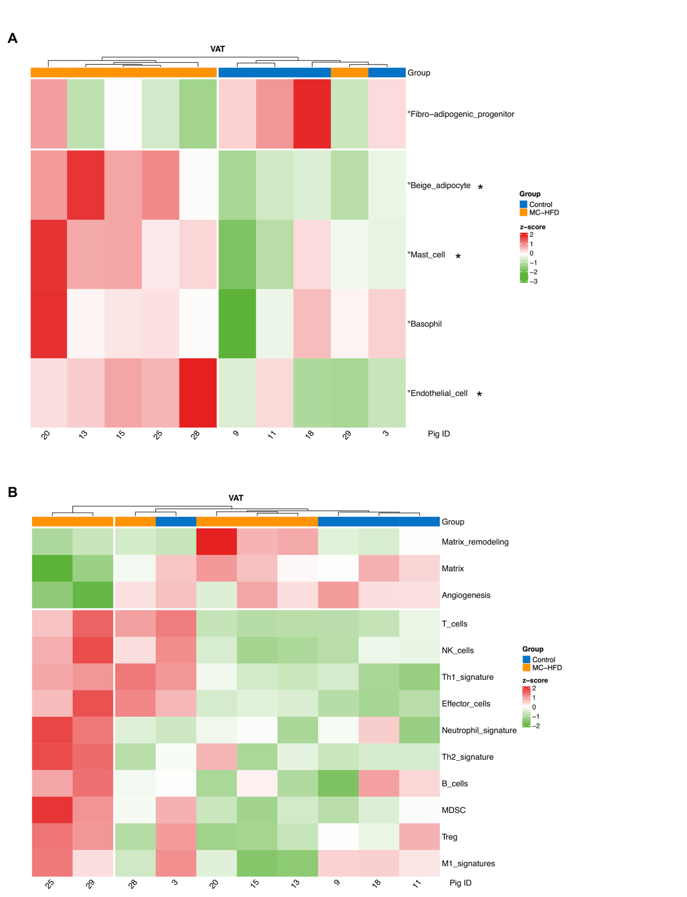
Figure 6S: Heatmap of gene signature scores for VAT dataset. Scores were calculated using single-sample gene set enrichment analysis (GSEA). This analysis used gene-level transcript per million (TPM) counts, which were summarized from salmon output using tximport. Z-scores reflect the scaled signature scores across all samples. (A) Cell type signatures built using the top 20 markers (based on highest expression) from pig single cell atlas database (https://dreamapp.biomed.au.dk/pigatlas/). Given that the signatures appeared to distinguish the two diet groups, a Mann-Whitney test was performed to assess whether the differences were significant. Significance is marked with *. A limitation of these signatures is their potentially low specificity (see supplementary file 9). (B) Gene signatures representing immune cell populations and others, obtained from https://doi.org/10.1016/j.ccell.2021.04.014. These signatures were derived from literature analysis and manual curation, with additional validation using purified cell populations. The signatures were based on human gene names, as such pig orthologs were used when available, otherwise the gene was excluded from the signature. The markers used for each signature are available in supplementary file 9.
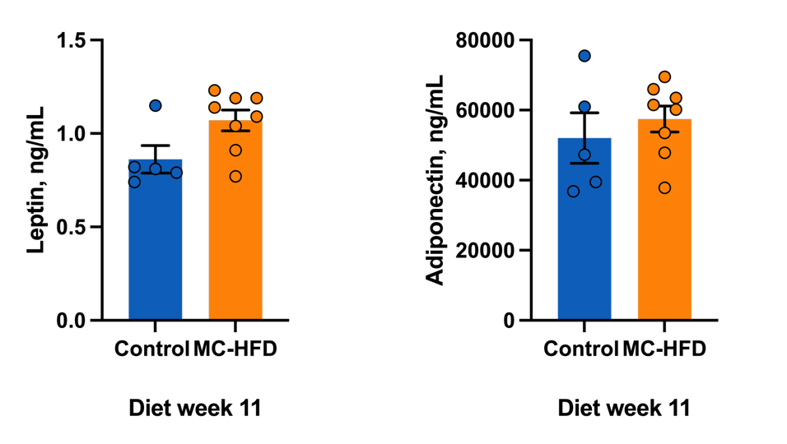
Figure 7S: Preliminary results on adipokines concentrations measured in fasting serum samples from the end of the study. ELISA measurements were performed as single determinations. Statistical significance was evaluated with unpaired Welch´s t-test, for normally distributed data. For not normally distributed data a non-parametric alternative (Mann-Whitney test) was used. Error bars depict SEM.
Supplementary file 1: RNA sample information
Supplementary file 2: Sequencing QC
Supplementary file 3: Salmon stats
Supplementary file 4: DETs in VAT and liver
Supplementary file 5: Enrichment results in VAT and liver
Supplementary file 6: Enrichment of network clusters
Supplementary file 7: Obesity-related-genes and overlapping analysis
Supplementary file 8: Correlation analysis
Supplementary file 9: Signature analysis

