SUPPORTING INFORMATION FOR:

Ravisandiran, S., Navarre, N., Mogollón, J.M. & Cucurachi, S. Quantification of Plastic Recovery by the Informal Waste Sector through a Probabilistic Approach. Journal of Industrial Ecology.
This supporting information (S-1) provides predicted probability distribution functions of model outcomes, and details of assumptions and data issues in their estimations in S-1.1. S-1.2 provides details of estimation of input variables including the data used and steps followed to arrive at the input data ranges. S-1.3 provides the results of the sensitivity analysis, including plots of the model outcomes against the input flow variables.

Table of Contents
S-1.1 Model Outcomes 2
S-1.1.1 Predicted PDFs for model outcomes 2
S-1.1.2 Plastic Waste Generation 2
S-1.1.3 Recovery of recyclable and non-recyclable plastic (RP and NRP) 2
S-1.1.4 PET Recovery Rate 3
S-1.2 Model Inputs 3
S-1.2.1 Exclusions in the model 3
S-1.2.2 Estimation of input flow variables using parameterized formulae 4
S-1.2.3 Estimation of input TCs 8
S-1.3 Sensitivity Analysis of Model outcomes 9
References 12

S-1.1 Model Outcomes
In this section we first show the predicted probability density functions (PDFs) of the model outcomes in Figure S-1.1. In the later subsections, we discuss the nuances of the estimations of the model outcomes – the assumptions made and consequent limitations in the estimations.

S-1.1.1 Predicted PDFs of model outcomes

Figure S-1.1: Predicted Probability Density Functions of the model outcomes

S-1.1.2 Plastic Waste Generation
The last Census of India was conducted in 2011 and the population of Chennai in 2023, 6.4 million, is obtained from the projections of this census (Census of India, 2011). Conversely, GCC reports the population as 7.1 million (GCC, n.d.). This would affect the result of the estimation of plastic waste generated per capita to 93 grams/day from 103 grams/day.

S-1.1.3 Recovery of recyclable and non-recyclable plastic (RP and NRP)
The composition of recyclable plastic in household plastic waste only considers the products which have labels about polymer types, while the fraction of potentially recyclable plastic could higher. This is because the data for fraction of recyclable plastic is obtained from Narayanan & Kapilavai (2021), who classify all products which do not have labels, in the category ‘other’. Thus, the high recovery rates for recyclable plastic could be because a significant portion of recyclable plastic that ends up in mixed waste streams is accounted for as non-recyclable plastic due to absence of labelling. While some of this could have been recovered by the IWS, it still suggests that proper labelling of plastic products in India can improve data quality and help improve segregation and collection.

S-1.1.4 PET Recovery Rate
The recovery rate for PET is found to be 75.5%, based on the sampling of plastic waste generated by households (Narayanan & Kapilavai, 2021) which reports that the composition of PET is 5.5%. But other reports state that the composition of PET in household plastic could vary from 7.4% (CSE, 2020) to 9% (Rafey & Siddiqui, 2021). We use the value from Narayanan & Kapilavai (2021) for out estimation since they perform a survey of household plastic waste in Chennai while others report national estimate for India.

However, when the other values are used, it is found that the recovery rate for PET varies from 46% - 56%. Thus, there is a high sensitivity of the PET recovery rate to the composition values for PET in household plastic waste. Regardless, the recovery rate for PET is still quite high. Other studies report up to 90% recovery rate for PET for India (Choudhary et al., 2019) which is close to our estimations.

It was not possible to calculate the recovery rate for other plastic types (HDPE, PE, PP, etc.) due to lack of data on composition of household plastic waste, and composition of plastic waste managed by the IWS. For the latter, the values are available in the local terms used by the informal waste sector (‘Bommai’, ‘Odappu’, etc.) in Hande (2019a) which is not easily convertible to the distinct polymer types. For the former, most plastic waste composition studies are done on MSW that enters landfills (CPCB, 2015), which does not account for plastic scrap removed by the IWS in landfills, corporation bins, or directly from households. Moreover, non-recyclable multi-layered plastic (MLPs) are included in the values reported for HDPE and LDPE (CPCB, 2015), thus making it difficult to distinguish between the recyclable and non-recyclable fractions.

S-1.2 Model Inputs

S-1.2.1 Exclusions in the model
Several assumptions were made during quantification, which leads to exclusions of some flows and processes while identifying the system boundaries.

It is assumed that there is no leakage during the transportation of plastic scrap between different stages of the recycling values chain. Among collection flows, collections by private service providers and tricycles were not modelled in this system. Moreover, the drop-off of recyclable plastics by households directly to scrap shops is not estimated separately due to a lack of data. Due to the difficulty in estimating waste-picking from streets, the collection of plastic scrap from litter on streets by both street sweepers and waste pickers was also left out of the model.

At the aggregation stage, there is a small amount of plastic that is reused in scrap shops for packaging purposes, which is not included in the quantitative model. Experts who were interviewed also suggested that all unsegregated waste, and sometimes even source-segregated waste, is directly dumped in landfills, but only the former is shown in the model. Moreover, some material is discarded from the MRFs to the landfills, which is not modelled in the system due to lack of data.

Finally, through the interviews, it is known that plastic scrap is sometimes sent outside Chennai for processing. However, the quantities and destinations of the scrap from Chennai are unknown and beyond the scope of this study. Among EOL applications of non-recyclable plastic, a small quantity is used in the construction of roads, but it is not included in the model as it is a negligible quantity, according to an interviewee.

S-1.2.2 Estimation of input flow variables using parameterized formulae
In this section, we explain the steps taken to estimate each input flow, and the resulting data range obtained. We also provide our assessment of the limitation in this estimation.

F2: Plastic scrap collected by IWBs from households

$$F2=N_{IB}×p_{IB}$$
Equation 1
Estimation:
Agarwal et al. (2005) report the average quantity of waste collected by waste pickers on pushcarts in a day. Assuming that waste pickers on pushcarts refer to IWBs, the average quantity of plastic waste collected by an IWB in a day is estimated by multiplying this quantity with the plastic composition of all waste collected by the IWS. Hande (2019a) directly report the average quantity of plastic waste collected by an IWB in a day. These two estimates from literature are used to obtain a data range of 10.8 - 30.8 kg/day for the quantity $p_{IB}$.

There is no official data on the number of IWBs ($N_{IB}$) in the city. Thus, interview data was used to fill in this data gap. Interviewees provided estimates of the number of IWBs operating in their region/ward, which was extrapolated to the entire city of Chennai by scaling according to the populations of the regions.

Applying Equation 1, a range of 662 - 3284 tons/month was obtained.

Limitation:
One of the major causes of uncertainties in this approach for estimating quantities managed by IWBs is the ambiguity in literature regarding the naming conventions for informal workers. For instance, Hande (2019a) refers to waste pickers and IWBs as L0 aggregators and does not distinguish between them. While Agarwal et al. (2005) refer to waste pickers on foot, cycles, and pushcarts, they do not use the term itinerant waste buyers. Since IWBs own vehicles for waste collection, unlike waste pickers who are on foot, it was assumed that the collection quantities corresponding to vehicle ownership refer to IWBs.

Another cause of uncertainty is the unavailability of data on the number of informal workers operating in the city. Enumeration of informal workers in the city could improve this data quality.

F4: Plastic waste collected as unsegregated waste in corporation bins

$$F4=\left(W_{FS}×HH×μ_{FS}\right)-F3$$
Equation 2
Estimation:
First, the total plastic waste collected by the formal sector from households was calculated by using the reported quantity of MSW collected by the municipality ($W_{FS}$), contribution of households to MSW $(HH$), and plastic composition of MSW ($μ_{FS}$). In 2023, $W_{FS}$ was reported to be 5400 tons/day (GCC, n.d.). 68% of MSW in Chennai comes from households ($HH$) (ENVIS Centre, 2016), while the plastic content in MSW ($μ_{FS}$) was found to be 7.48% (CMDA, n.d.).

However, the GCC does not specify the relative contributions of different waste generators to the reported quantity of MSW, and it is unclear if the collected quantity refers to collection from all waste generators or only residential sources. To account for this ambiguity, an additional estimate was calculated assuming that $HH$ is 100%. Using the formula $W_{FS}×HH×μ_{FS}$ with both household contribution scenarios (68% and 100%), two estimates for the total plastic waste collected by the formal sector were obtained: 8240 and 12118 tons/month respectively.

Then, total plastic waste collected by the formal sector with the unsegregated MSW is estimated by subtracting the estimated quantity for total plastic waste collected by the formal sector with the quantity of plastic waste collected in BOVs ($F3$). The minimum and maximum values of the estimated data range for $F3$ were used to obtain the possible values of $F4$ as, 3843, 5602, 7721, and 9480 tons/month.

To obtain the maximum possible collection in corporation bins, it was assumed that the operating efficiency of the bins was 100%. Using the reported number of bins in Chennai, 11511 (GCC, n.d.) each with a capacity of 0.49 tons/day (Hande, 2021), and the plastic content of MSW (7.48%) yields maximum estimate of 12704 tons/month for $F4$.

Limitation:
The large input data range for $F4$ introduces significant uncertainty into the model. A key contributor to this uncertainty is the lack of transparency in official statistics. There is ambiguity regarding the source of MSW collected by the formal sector. Additionally, interview data suggests that official statistics could be under-reporting the actual quantity of MSW collected by the formal sector in Chennai, implying that the operational capacity of corporation bins could be much higher than reported.

Furthermore, studies estimating the plastic composition of unsegregated MSW often fail to account for the plastic already removed by the informal sector (CSE, 2020). Waste pickers typically remove recyclable plastics from corporation bins and landfills, before MSW is sampled for the studies, which means the plastic content in MSW at the generation and collection stages may be underestimated.

F6: Plastic scrap recovered by waste pickers from corporation bins

$$F6=\left(N_{WP}-N_{l,WP}\right)×p_{WP}$$
Equation 3
Estimation:
The number of waste pickers in the city ($N_{WP}$) is estimated by combining data from multiple different sources. Hande (2021) enumerates the number of waste pickers in Ward 100, Chennai, and this figure is extrapolated to the entire city by scaling according to the respective population sizes. Lau et al. (2020) provides an estimate of the number of waste pickers as a percentage of the urban populations of this region. This data is combined with the population of Chennai to obtain another estimate for $N_{WP}$. Following these calculations, a data range of 22780 - 29110 waste pickers is obtained for the city of Chennai. Then, this figure is subtracted by the number of waste pickers in landfills ($N_{l,WP}$) to get the number of workers operating within the city.

Estimates for the average amount of plastic waste collected by waste pickers on foot ($p_{WP}$) were calculated by using two approaches: In the first approach, estimates from literature for the average amount of waste collected per waste picker (Agarwal et al., 2005; Chandramohan et al., 2010; Sharholy et al., 2008) were multiplied by the plastic composition waste collected by IWS, 15.38% (Hande, 2019a, 2021) to get a range of 1.38 - 2.61 kg/day. The second approach directly used estimates of quantities of plastic waste collected waste picker from literature (Chandramohan et al., 2010; Hande, 2019b; Lau et al., 2020), giving a range of 6.23 - 10.7 kg/day.

Finally, using Equation 3, the range of total plastic collected by waste pickers from corporation bins was estimated to be 904 - 9039 tons/month.

Limitation:
The data range obtained for this estimate is very large, with the maximum and minimum values differing by an entire order of magnitude. The uncertainties in this estimate arise due to various reasons.

$p_{WP}$ has a large data range with an order of magnitude of difference between the maximum and minimum values, which contributes heavily to the uncertainties in $F6$. The estimations for $p_{WP}$ by the first approach do not correlate with the second approach. Outcomes of the MCS can be used to inform where the true value of this range lies.

$N_{WP}$ is hard to estimate. The density of waste pickers with respect to the population size is not the same in all wards. Various factors like proximity to landfills, waste collection system in the specific wards, and socio-economic level of the ward influence the number of waste pickers in each ward. Data from the interview suggests that more waste pickers can be found in the outskirts of the city and in less developed parts of the city. Consequently, using national statistics to estimate $N_{WP}$ or assuming a homogeneous distribution of waste pickers in the city reduces accuracy of the estimation. Moreover, the population of waste pickers is dynamic, with different factors influencing the movement of the people in and out of the profession (Sudhir et al., 1997), which makes it hard to estimate the number of waste pickers working at any instant.

F7: Plastic scrap recovered by waste pickers from landfills

$$F7=N_{l,WP}×p_{WP}$$
Equation 4
Estimation:
The total number of waste pickers in landfills ($N_{l,WP}$) is 950, which was the number of registrations received by Ravi & Kumar (2015), in their drive conducted to provide ID cards for waste pickers in landfills and enumerate them. The average amount of plastic scrap collected per waste picker ($p_{WP}$) is between 1.38 to 10.7 kg/day as explained above in Flow 6.

Using Equation 4, a range of 39 to 305 tons/month was obtained for F7.

Limitation:
The number of waste pickers in the landfills could be more, in the case of less than 100% registration of the workers. However, most of the uncertainty arises due to the large data range obtained for $p_{WP}$, as explained above.

F9: Recyclable Plastic scrap collected by formal workers in BOV

$$F9=N_{BV}×p_{rp,BV}$$
Equation 5
Estimation:
From the interview data, it was found that formal workers can collect about 5-10 kg $p_{rp,BV}$ of recyclable plastic in a day in BOVs, that they resell to scrap shops. Applying Equation 5 with the obtained range for $p_{rp,BV}$ and the official reported number of BOVs ($N_{BV}$), 5863, leads to a range of 879 - 1759 tons/month of recyclable plastic recovered in BOVs.

Limitation:
The values obtained from the interviews are only indicative and may contain additional uncertainties.

F12: Non-recyclable plastic collected by formal workers in BOVs

$$F12=N_{BV}×p_{nrp,BV}$$
Equation 6
Estimation:
Similar to Flow 9, interview data provided a range of 10-15 kg/day for average non-recyclable plastic collected by formal workers in BOVs ($p_{nrp,BV}$). Using Equation 6, this leads to a range of 1759 - 2638 tons/month of recovered non-recyclable plastic.

F14: Recyclable plastic scrap aggregated by small scrap shops

$$F14=N_{SS}×p_{SS}$$
Equation 7
Estimation:
Data for average plastic scrap handled by small scrap shops ($p_{SS}$) was obtained from both interviews and other studies (Hande, 2019a; Kabadiwalla Connect, 2021) to get a range of 0.8 - 1.517 tons/month. The total number of scrap shops in the city ($N_{SS}$) was also estimated as a range (1970 - 2524) from Hande (2021) by extrapolating data on Ward 100, to the entire city by scaling according to population, and from (Hande, 2019a) directly. Equation 7 can then be applied to get a range of 1576 - 3829 tons/month for $F14$.

Limitation:
It was not possible to differentiate between waste from households or from other sources (like industry and retail) some of which also dispose their recyclables through the IWS. Thus, it was assumed that households contribute the most to plastic waste collected in small scrap shops. Further research is required to improve this estimate.

S-1.2.3 Estimation of input TCs

TC₅: % of uncollected waste
Data for this parameter (30%) is obtained from Kabadiwalla Connect (2023). The value was determined from a sample of 66 wards that exist downstream around rivers in Chennai where plastic litter ends up. The estimate is then applied as an average for all wards of Chennai. The uncertainty associated with this value is not discussed in the source, so we assume a margin of error of 10%.

TC₁₁: Leakage % from scrap shops
Interview data suggests that 10-20% of plastic scrap aggregated in scrap shops is non-recyclable and is discarded in the unsegregated waste flow.

While we use this estimate, it does not agree with the leakage data from Kabadiwalla Connect (2023) which indicates that there is less than 0.1% leakage from sorting in the informal value chain.

TC₁₇: % of recyclable plastic from L2 aggregator that is sent to recyclers
Interview data is used to estimate a data range of 5-10%.

TC₁₉: % of non-recyclable plastic from L2 aggregator that is sent to pyrolysis plants
Interview data is used to obtain an estimate of 10% for this transfer coefficient. Since the uncertainty in this value was not known, a margin of error of 10% was introduced.

TC₂₃: % of uncollected waste that is openly burned
The value of this parameter (7%) is obtained from Kabadiwalla Connect (2023). Since the uncertainty associated with this data is not given in the source, a 10% margin of error is assumed.

S-1.3 Sensitivity Analysis of Model outcomes
The following figures are plots of each model outcomes against the input variables. They show that post selection of valid parameter spaces for the input variables, $F4$ shows the most correlation for all model outcomes and is thus the variable with the most influence on the model outcomes. This model is most sensitive to the input variable $F4$ because the model definition requires the total plastic waste generated in the city ($F1$) to be dependent on the collection quantities of the different actors, and $F4$ has the largest collection quantity.

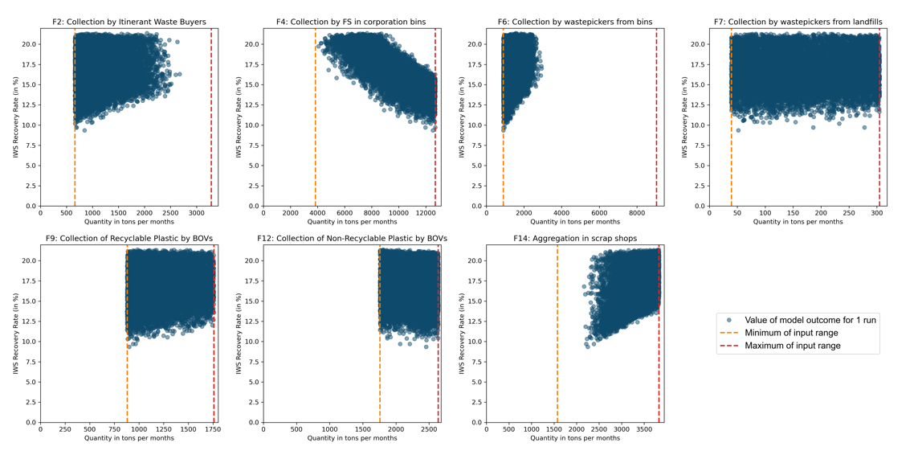
Figure S-1.2: Plots of Informal Waste Sector (IWS) Recovery Rate vs input flow variables
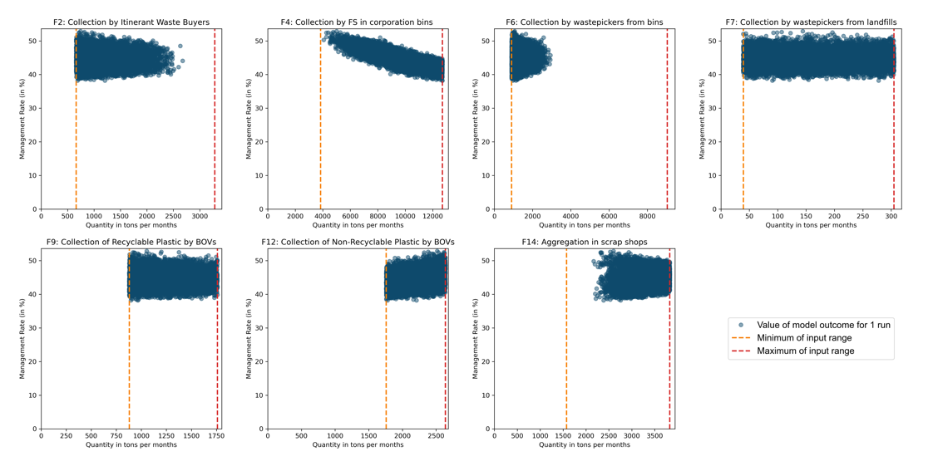
Figure S-1.3: Plots of Management Rate vs input flow variables

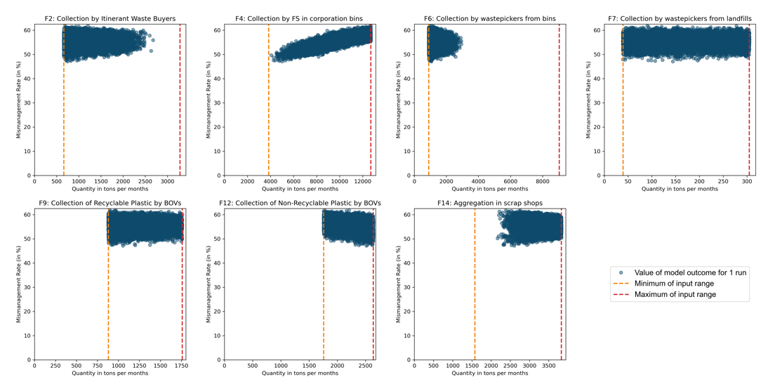
Figure S-1.4: Plots of Mismanagement Rate vs input flow variables
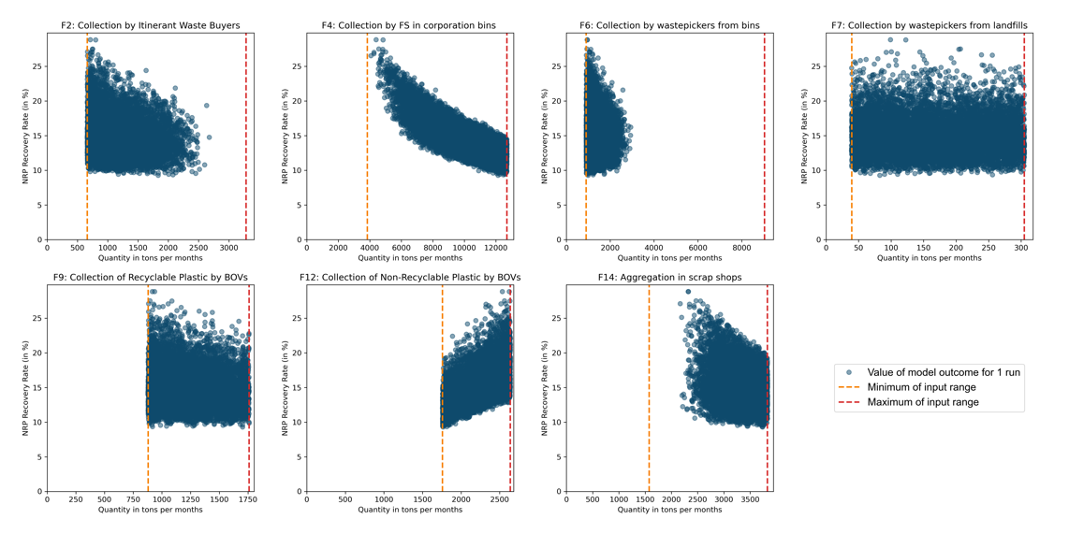
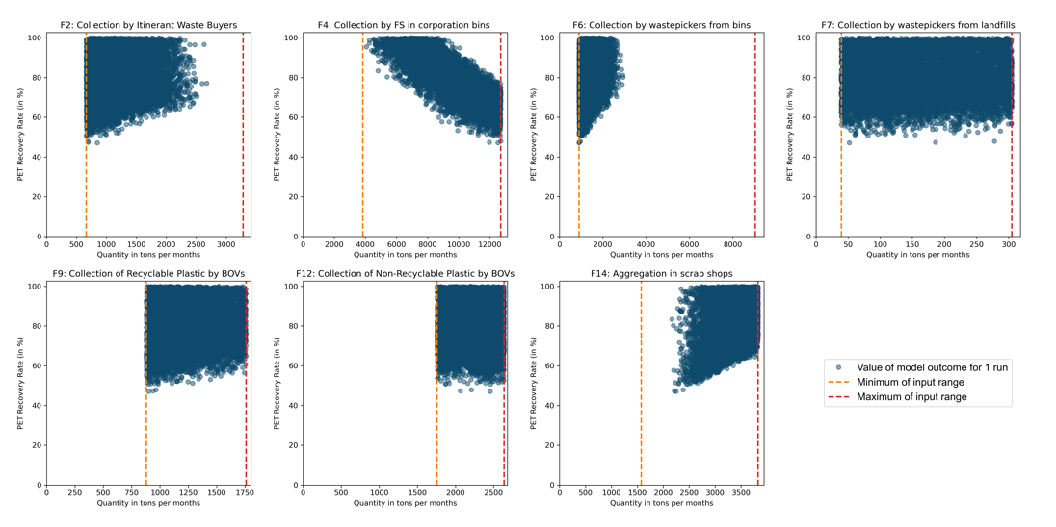
Figure S-1.5: Plots of NRP (Non-recyclable plastic) Recovery Rate vs input flow variables
Figure S-1.6: Plots of PET Recovery Rate vs input flow variables

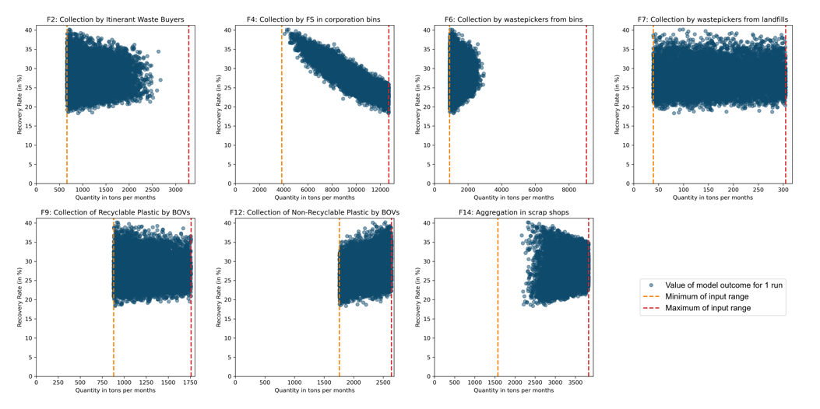
Figure S-1.7: Plots of Recovery Rate vs input flow variables
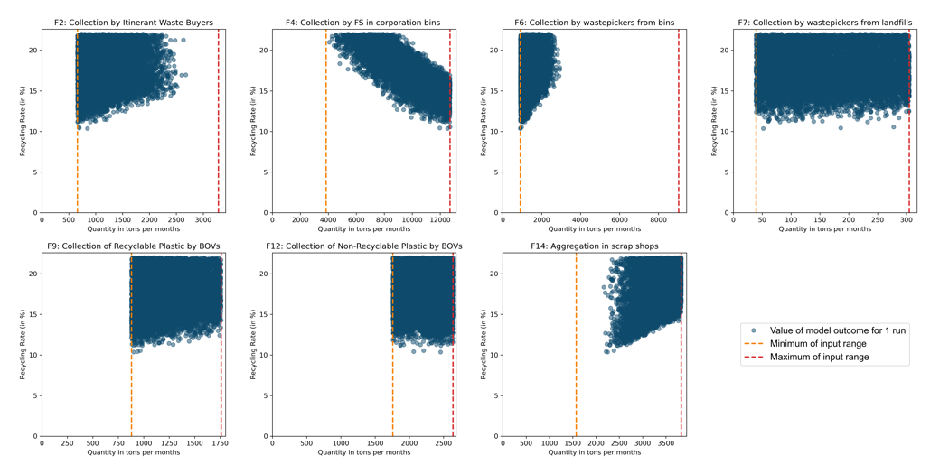
Figure S-1.8: Plots of Recycling Rate vs input flow variables
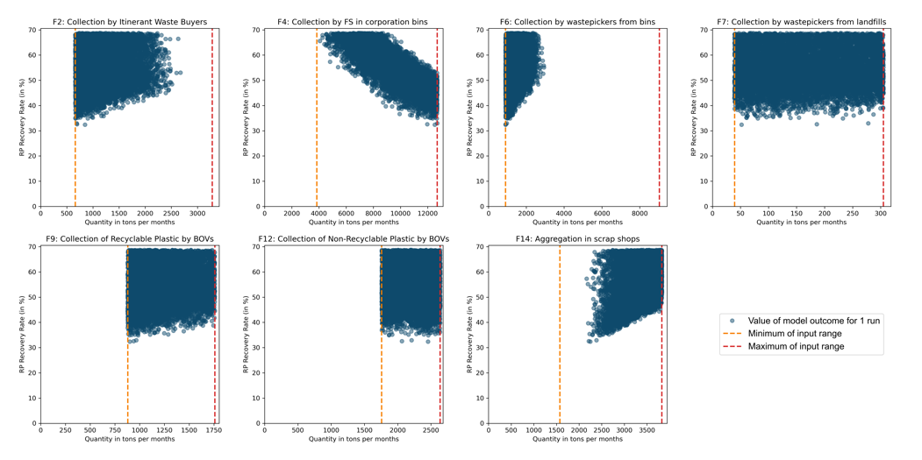
Figure S-1.9: Plots of RP (Recyclable plastic) Recovery Rate vs input flow variables

References

Agarwal, A., Singhmar, A., Kulshrestha, M., & Mittal, A. K. (2005). Municipal solid waste recycling and associated markets in Delhi, India. Resources, Conservation and Recycling, 44(1), 73–90. https://doi.org/10.1016/j.resconrec.2004.09.007
Census of India. (2011). Chennai City Population 2023 | Literacy and Hindu Muslim Population. https://www.census2011.co.in/census/city/463-chennai.html
Chandramohan, A., Ravichandran, C., & Sivashanker, V. (2010). Solid waste, its health impairments and role of rag pickers in Tiruchirappalli city, Tamil Nadu, Southern India. https://doi.org/10.1177/0734242X09352705
Choudhary, K., Sangwan, K. S., & Goyal, D. (2019). Environment and economic impacts assessment of PET waste recycling with conventional and renewable sources of energy. Procedia CIRP, 80, 422–427. https://doi.org/10.1016/j.procir.2019.01.096
CMDA. (n.d.). Solid Waste Management. Retrieved April 14, 2023, from http://www.cmdachennai.gov.in/Volume3_English_PDF/Vol3_Chapter09_Soild%20Waste%20Management.pdf
CPCB. (2015). Assessment and quantification of plastic waste generation in major cities. CENTRAL POLLUTION CONTROL BOARD (CPCB).
CSE. (2020). Managing Plastic Waste in India: Challenges and Agenda. Centre for Science and Environment (CSE). http://www.cseindia.org/content/downloadreports/10352
ENVIS Centre. (2016). Database on Solid waste management in Tamil Nadu. ENVIS Centre, Department of Environment, Government of Tamil Nadu. http://www.tnenvis.nic.in/WriteReadData/UserFiles/file/swm.pdf
GCC. (n.d.). Welcome to Greater Chennai Corporation. Retrieved May 26, 2023, from https://chennaicorporation.gov.in/gcc/department/solid-waste-management/#
Hande, S. (2019a). Leveraging the informal waste ecosystem for better management of post-consumer recyclable waste in Urban India—A case study in Chennai.
Hande, S. (2019b). The informal waste sector: A solution to the recycling problem in developing countries.
Hande, S. (2021). Increasing Waste Recycling Through Better Informal Sector Data.
Kabadiwalla Connect (Director). (2021, January 27). PoS and QR Code based material traceability pilot at Sri Kailash Waste Paper Mart (Chennai) [Video recording]. https://www.youtube.com/watch?v=jUWe6l1NDUM
Kabadiwalla Connect. (2023). Down The Stream: A baseline study report to identify hotspots of plastic waste and open drains along the Adyar and Cooum Rivers in Chennai. Deutsche Gesellschaft für Internationale Zusammenarbeit (GIZ) GmbH.
Lau, W. W. Y., Shiran, Y., Bailey, R. M., Cook, E., Stuchtey, M. R., Koskella, J., Velis, C. A., Godfrey, L., Boucher, J., Murphy, M. B., Thompson, R. C., Jankowska, E., Castillo Castillo, A., Pilditch, T. D., Dixon, B., Koerselman, L., Kosior, E., Favoino, E., Gutberlet, J., … Palardy, J. E. (2020). Evaluating scenarios toward zero plastic pollution. Science, 369(6510), 1455–1461. https://doi.org/10.1126/science.aba9475
Narayanan, S., & Kapilavai, V. S. (2021). The Plasticene Epoch and the brands behind it. CAG. https://www.cag.org.in/sites/default/files/database/The%20Plasticene%20Epoch%20and%20the%20brands%20behind%20it.pdf
Rafey, A., & Siddiqui, F. Z. (2021). A review of plastic waste management in India – challenges and opportunities. International Journal of Environmental Analytical Chemistry, 1–17. https://doi.org/10.1080/03067319.2021.1917560
Ravi, P., & Kumar, V. S. (2015). Report on ID card camps for Waste Pickers. CAG. https://www.cag.org.in/sites/default/files/database/id%20camp%20report_final.pdf
Sharholy, M., Ahmad, K., Mahmood, G., & Trivedi, R. C. (2008). Municipal solid waste management in Indian cities – A review. Waste Management, 28(2), 459–467. https://doi.org/10.1016/j.wasman.2007.02.008
Sudhir, V., Srinivasan, G., & Muraleedharan, V. R. (1997). Planning for sustainable solid waste management in urban India. System Dynamics Review, 13(3), 223–246. https://doi.org/10.1002/(SICI)1099-1727(199723)13:3<223::AID-SDR127>3.0.CO;2-Q

