Supporting Information
Phosphorene Dominated Integrative Dual-Electric Field Guiding Charge Flow and Active Centers for for Vapor-fed Photocatalytic Hydrogen Evolution

Xi Wu^{1,2}, Jingang Song¹, Jinying Zhang³, Haiyan Su¹, Tianyi Ma⁴, Minghua Zeng^{5,}*, Bin Zhang^{2,5,}*, Fuxiang Zhang^{6,}* and Xin Wang^{1,7,}*

¹School of Chemical Engineering and Energy Technology, Guangdong Provincial Key Laboratory of Distributed Energy Systems, Dongguan University of Technology, Dongguan, 523808, China.
²Shenzhen Institute of Translational Medicine, Shenzhen Second People’s Hospital, The First Affiliated Hospital of Shenzhen University, Guangdong Key Laboratory for Biomedical Measurements and Ultrasound Imaging, National-Regional Key Technology Engineering Laboratory for Medical Ultrasound, School of Biomedical Engineering, Shenzhen University Medical School, Shenzhen 518035, China
³State Key Laboratory of Electrical Insulation and Power Equipment, Center of Nanomaterials for Renewable Energy, School of Electrical Engineering, Xi’an Jiaotong University, Xi’an, Shaanxi 710049 China
⁴Centre for Atomaterials and Nanomanufacturing (CAN), School of Science, STEM College, RMIT University, Melbourne, Australia
⁵Key Laboratory for Chemistry and Molecular Engineering of Medicinal Resources (Ministry of Education of China), Guangxi Key Laboratory of Chemistry and Molecular Engineering of Medicinal Resources, School of Chemistry and Pharmaceutical Sciences, Guangxi Normal University, Guilin 541004, P. R. China
⁶State Key Laboratory of Catalysis, Dalian Institute of Chemical Physics, Chinese Academy of Sciences, Dalian National Laboratory for Clean Energy, Dalian 116023, China
⁷Shenzhen Institute of Advanced Technology, Chinese Academy of Sciences, Shenzhen, 518055 China
Email: wangxin@dgut.edu.cn (X. Wang); fxzhang@dicp.ac.cn (F. Zhang); binzhang@email.szu.edu.cn (B. Zhang); zmh@mailbox.gxnu.edu.cn (M. Zeng)

Supplementary Figures and Tables.
Supplementary Fig. S1. (a) Side view (left), top view (middle) and main view (right) of the different binding positions of Rh atoms and VP surface. (b) Side view (left), top view (middle) and main view (right) of the different binding positions of Rh atoms and VP edge. The P and Rh atoms are represented by violet and green spheres, respectively.

Supplementary Fig. S2. (a) Side view (left), top view (middle) and main view (right) of the different binding positions of Rh atoms and BP surface. (b) Side view (left), top view (middle) and main view (right) of the different binding positions of Rh atoms and BP edge. The P and Rh atoms are represented by black and green spheres, respectively.

Supplementary Fig. S3. Electron (left) and hole (right) effective masses along the a, b, and c axes for BP and BP with edge-decorated Rh NPs, respectively.

Supplementary Fig. S4. Schematic diagram of synthesis process over VP/BP-Rh composite.

Supplementary Fig. S5. Schematic diagram of synthesis process over VP/BP composite.

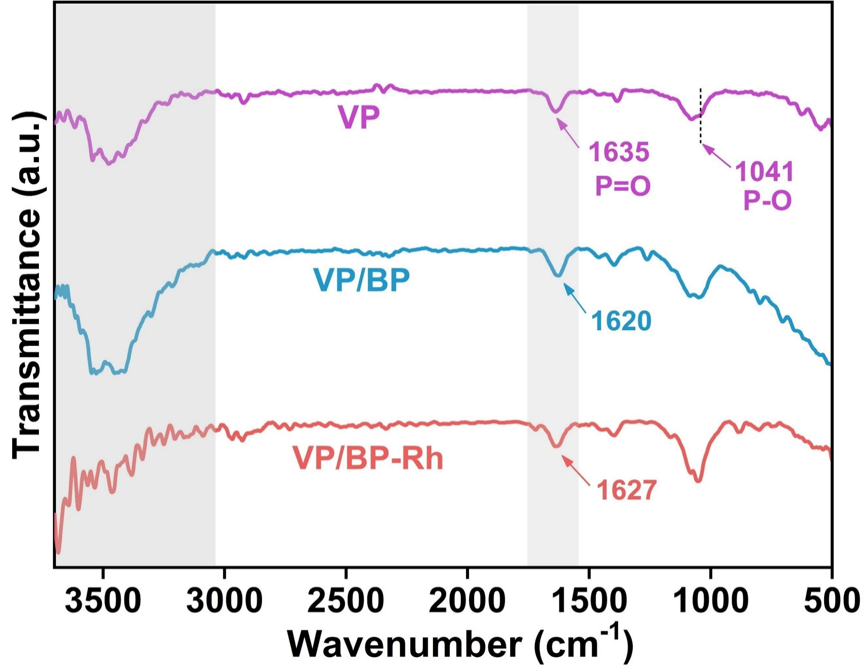
Supplementary Fig. S6. FTIR spectra of the VP, VP/BP and VP/BP-Rh samples.

Supplementary Fig. S7. XPS survey of (a) VP and (b) VP/BP-Rh.

Supplementary Fig. S8. AFM image of (a-b) VP, (c-d) VP/BP and (e-f) VP/BP-Rh in the dark and light.

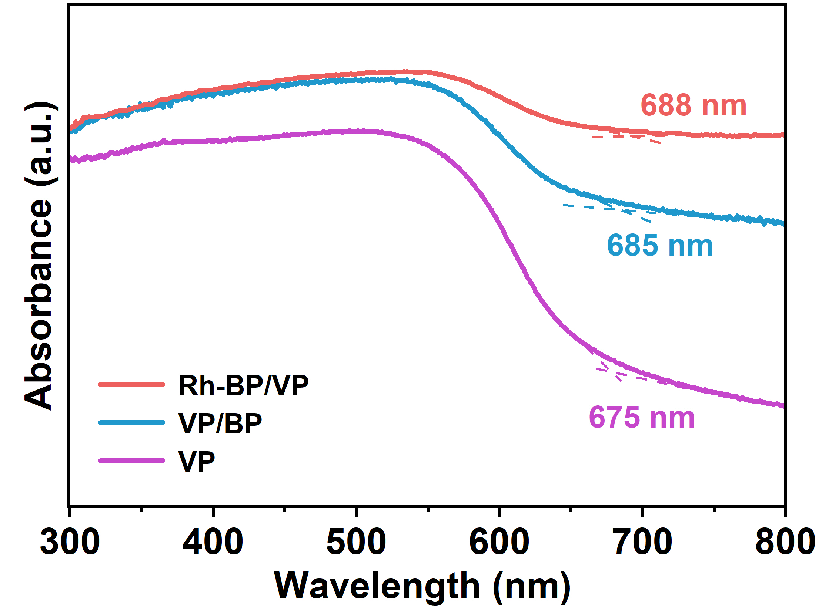
Supplementary Fig. S9. UV-Vis DRS measurements of VP, VP/BP and VP/BP-Rh.

Supplementary Fig. S10. (a) UV/Vis DRS spectra; (b) Plots of (αhν)^{1/2} vs. photon energy (hν) of all samples; (c) electrochemical Mott-Schottky plots and (d) band structures of all samples.

Supplementary Fig. S11. (a) PL spectral profile and (b) TRPL decay kinetics of VP/BP and VP/BP-Rh.

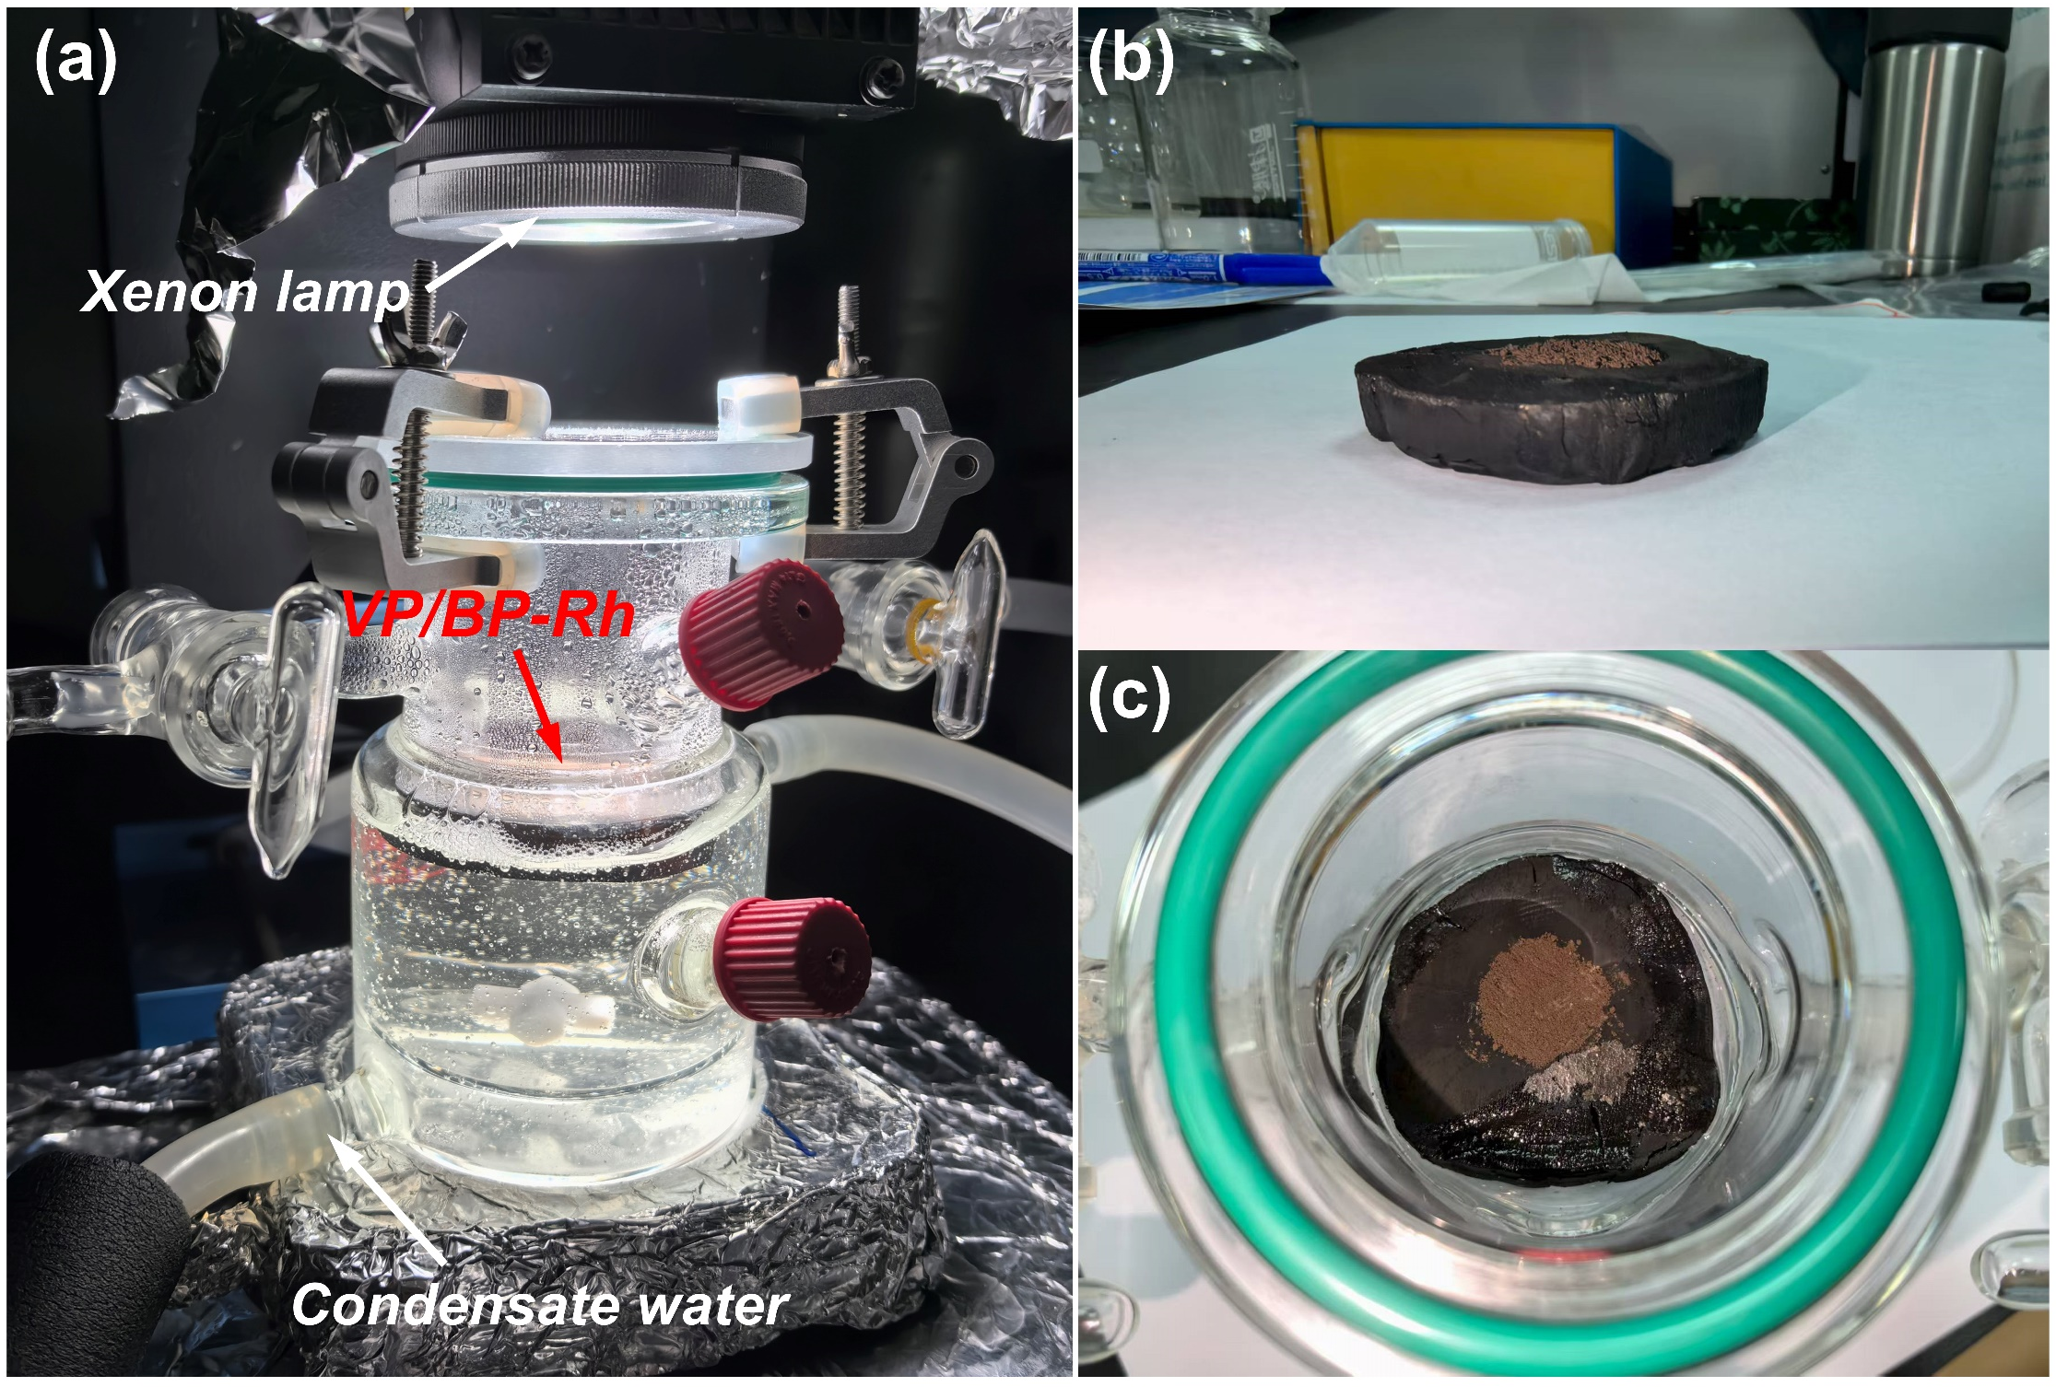
Supplementary Fig. S12. (a) Front view of photocatalytic water vapor splitting reactor. (b) The photo of the VP/BP-Rh supported on C-wood. (c) Top view of the VP/BP-Rh/C-wood system floating on water.

Supplementary Fig. S13. The temperature variation of the VP/BP-Rh surface with respect to illumination time: (a) 1 min; (b) 60 min; (c) 90 min; (d) 120 min.

Supplementary Fig. S14. Photograph of the water vapor generation of the VP/BP-Rh supported on C-wood under the simulated solar irradiation.

Supplementary Fig. S15. Photos of H₂ bubbles on the VP/BP-Rh surface after 120 min photorecation.

In the photocatalytic water vapor splitting system, the water desorption is one of the main factors affecting HER efficiency. And surface hydrophilicity of catalysts was revealed by contact-angle measurement of H₂O. Particularly, pristine VP showed hydrophobic surface with a contact angle of 65.2°. In contrast, VP/BP was surface hydrophilic with the water contact angle of 15.4°, particularly, VP/BP-Rh showed more significant hydrophilicity as water is completely spread out on it, as it can be attributed to the hydrophilicity of Rh nanoparticles that are contacted with water.

Supplementary Fig. S16. Water contact angle measurement for (a) VP, (b) VP/BP and (c) VP/BP-Rh samples.

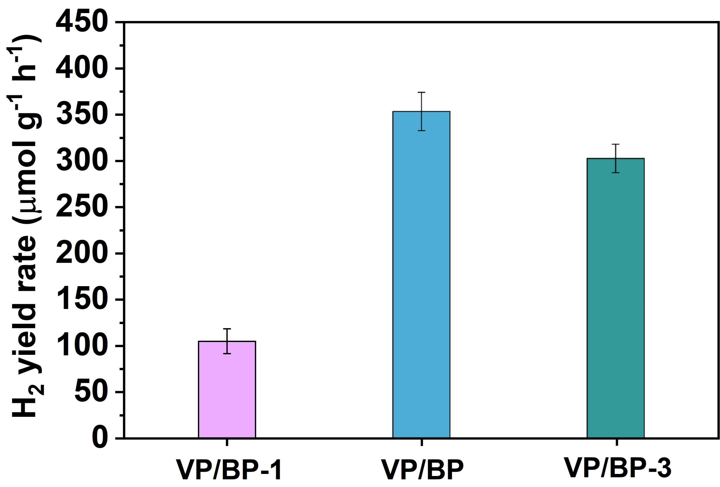
Supplementary Fig. S17. Comparison of the HER performance for different amounts of BP of VP/BP-X (X=1, 3).

Supplementary Fig. S18. Comparison of the HER performance for (a) different loading amount of Rh of VP/BP-Rh and (b) Rh-decorated samples.

Supplementary Fig. S19. TEM images for Rh-VP/BP with surface-loaded Rh NPs.

Supplementary Fig. S20. TEM images for (a) VP/BP-Pt, (b) VP/BP-Ag and (c) VP/BP-Au with edge-loaded noble metal NPs

Supplementary Fig. S21. (a) The action spectra and AQY spectra with the catalysts of VP/BP-Rh in liquid-solid system. (b) Comparison of the AQY for 420 nm in liquid-solid and gas–solid-dominated reaction system.

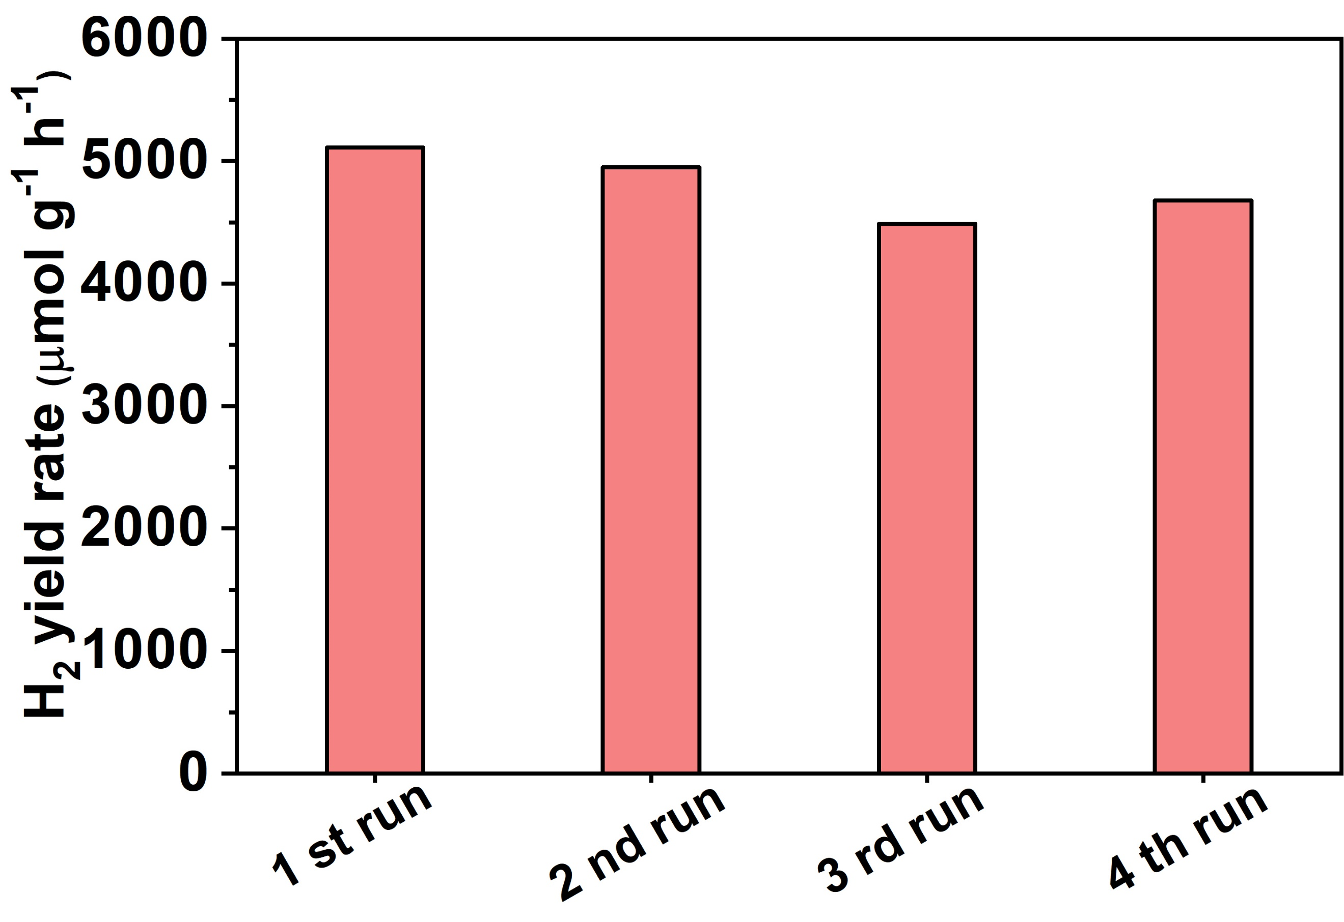
Supplementary Fig. S22. Photocatalytic water vapor-to-H₂ stability for recycles over VP/BP-Rh.
.

Supplementary Fig. S23. Possible structures of H₂O on the (a) surface (b) and edge of VP/BP-Rh.

The photocatalytic HER pathways of liquid and gas-phase H₂O molecules on the surface active sites of VP/BP-Rh photocatalyst are investigated by density functional calculation (Fig. S24). In our calculation, the conversion of liquid *H₂O into *H is the rate-determining step in both gas-solid and liquid-solid systems during HER process, but the Gibbs free energy is lower in the gas-solid system (0.82 eV) than in the liquid-solid system (0.93 eV), which further indicates that accelerated HER process in the gas-solid interfaces over VP/BP-Rh.
Supplementary Fig. S24. Possible spossible adsorption configuration of of *H₂O and *H on VP/BP-Rh surface.

Supplementary Fig. S25. Raw liquid ¹H nuclear magnetic resonance (¹H-NMR) data of (a) benzyl alcohol (BA) and (b) benzaldehyde (BAD) standard solution with a 2 s recycle delay and 16 scans. (c) Raw liquid ¹H-NMR data of the BAD products from VP/BP-Rh under 1 h irradiation with a 2 s recycle delay and 16 scans.

Supplementary Fig. S26. (a) Raw liquid ¹H-NMR data of DMSO solutions at varying concentrations with a 2 s recycle delay and 16 scans; (b) the work curve for determination of liquid ¹H-NMR (mmol/L) concentration.

Supplementary Fig. S27. (a) Time dependence of the raw liquid ¹H-NMR data of BA solution after reaction with the VP/BP-Rh during photocatalytic water vapor splitting; (b) Photocatalytic H₂ and BAD production of VP/BP-Rh under light (AM 1.5 G, 100 mW cm⁻²) illumination for 4 hours.

Supplementary Fig. S28. (a) Control experiments with different scavengers in the H₂ and BAD photosynthesis process over VP/BP-Rh under light (AM 1.5 G, 100 mW cm⁻²). (b) EPR spectra of DMPO-•OH over VP/BP-Rh under light irradiation.

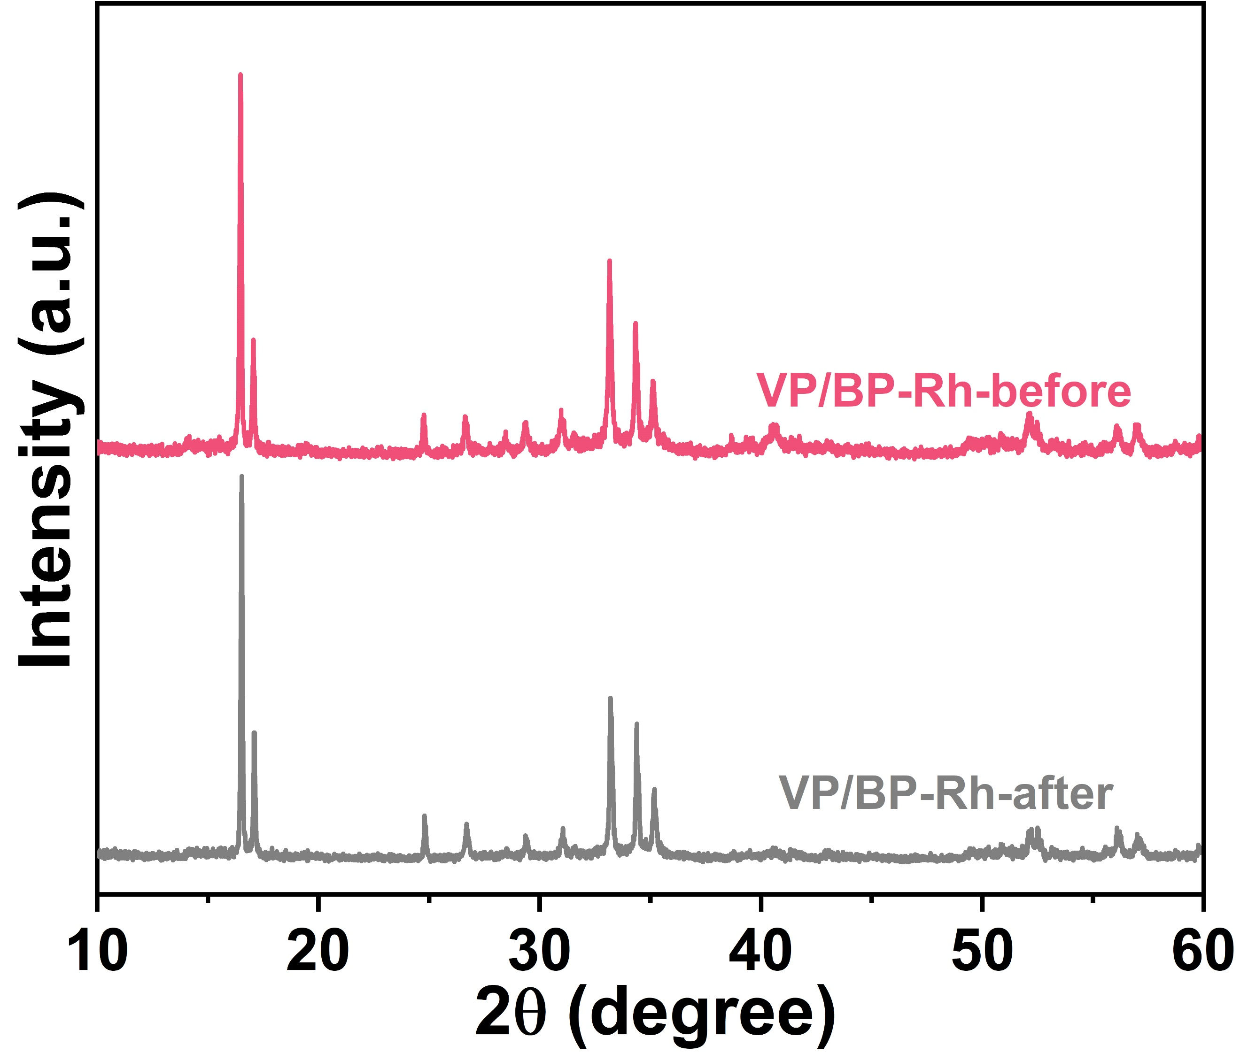
Supplementary Fig. S29. XRD patterns analysis of VP/BP-Rh before and after four-run cycling photoreaction.

Supplementary Fig. S30. (a) P 2p and (b) Rh 3d XPS analysis of VP/BP-Rh before and after four-run cycling photoreaction.

Supplementary Fig. S31. The calculated interlayer electrostatic potentials and optimized local structures (inset) for (a) BP and (b) Rh NPs.

Supplementary Fig. S32. The calculated differential charge density distribution for VP/BP-Rh; Thereinto, charge accumulation is shown in yellow and depletion in blue, respectively.

Table S1. Calculated adsorption energies of Rh atoms on the surface and edge of BP and VP at different sites.
Samples | Site 1  (surface) | Site 2  (surface) | Site 3  (surface) | Site 4  (edge) | Site 5  (edge) | Site 6  (edge)
VP | -5.61 eV | -5.34 eV | -6.31 eV | -6.14 eV | -7.46 eV | -7.69 eV
BP | -5.80 eV | -5.79 eV | -5.79 eV | -8.21 eV | -7.89 eV | -7.85 eV

Table S2. The intensity ratio of P 2p_{1/2} to P 2p_{3/2} as well as P_{x}O_{y}, O-P=O to O-P-O in the XPS spectra of the VP and VP/BP-Rh samples.
Samples | P₂O₅ | O-P=O | O-P-O | P 2P_{1/2} | P 2P_{3/2} | P_{x}O_{y}/P=P
VP | 19793.65 | 40670.57 | 7355.49 | 16960.71 | 43450.54 | 1.12
VP/BP-Rh | 20194.65 | 39537.42 | 17281.26 | 13056.66 | 34687.46 | 1.61

Table S3. Fractions of Rh species obtained from the XPS Rh 3d deconvolution regions for the Rh NPs and VP/BP-Rh.
Samples | Rh 3d_{2/3} |  | Rh 3d_{2/5} |  | Rh 3d_{2/3}/Rh 3d_{2/5}
Samples | Rh³⁺3d_{2/3} | Rh⁰3d_{2/3} | Rh³⁺3d_{2/5} | Rh⁰3d_{2/5} | Rh 3d_{2/3}/Rh 3d_{2/5}
Rh | 112100.60 | 209373.74 | 144401.49 | 366435.85 | 0.45
Rh-VP/BP | 9760.48 | 3812.02 | 14899.04 | 9366.51 | 1.87

The calculated average lifetimes (τ_{aνe.}) based on the information of τ₁ (A₁), τ₂ (A₂) and τ₃ (A₃) according to Equations S1-2:
$I(t)=I_{0}+A_{1}e^{-t/τ_{1}}+A_{2}e^{-t/τ_{2}}+A_{3}e^{-t/τ_{3}}$ (S1)
$τ_{ave.}=\frac{τ_{1}^{2}*A_{1}+τ_{2}^{2}*A_{2}+τ_{3}^{2}*A_{3}}{τ_{1}*A_{1}+τ_{2}*A_{2}+τ_{3}*A_{3}}$ (S2)
I₀, A_{i} and τ_{i} represent the baseline correction, preexponential factors and excited-state luminescence decay time associated with the i th component, respectively.

Table S4. The calculated τ_{aνe.} based on values of τ₁ (A₁), τ₂ (A₂) and τ₃ (A₃) for samples.
Samples | τ₁ (ns) (Rel.%) | τ₂ (ns) (Rel.%) | τ₃ (ns) (Rel.%) | τ_{ave.} (ns) | c²
VP/BP | 0.98 (30.02%) | 4.58 (26.16%) | 42.78 (43.82%) | 20.24 | 1.06
VP/BP-Rh | 1.09 (15.01%) | 5.25 (32.80%) | 49.57 (52.19%) | 27.76 | 1.12
τ_{aνe.} represents the average lifetime of photogenerated carriers; τ₁, τ₂ and τ₃ represent the radiative and nonradiative energy decay processes, respectively; c² represents the goodness of fit parameter.

Table S5. Comparison of photocatalytic HER performance and STH for VP/BP-Rh with the reported photocatalysts in gas–solid and liquid–solid photoreaction systems.
Photocatalysts | Condition | Light source | Sacrificial  agent | H₂ yield  (μmol g ⁻¹ h ⁻¹) | Reference
VP/BP-Rh | gas–solid | 300 W Xe lamp  (λ= 320-780 nm) | —— | 5110.62 | Our work
GO-CTFs | gas–solid | Sunlight | —— | 1961.25 | [1]
TiO₂/Ag gel | gas–solid | 300 W Xe lamp  (λ> 420 nm) | —— | 3.2 | [2]
K-STO/TiN | gas–solid | 300 W Xe lamp  (λ> 420 nm) | —— | 1106.04 | [3]
SrTiO₃:Al-RhCrO_{x}-CoO_{y} | gas–solid | 300 W Xe lamp | —— | 15 | [4]
Pt@DHTA-TAPyT-COF | gas–solid | 300 W Xe lamp  (λ> 420 nm) | —— | 51.2 | [5]
Rh_{2−y}CryO₃/GaN:ZnO | gas–solid | 300 W Xe lamp  (λ> 400 nm) | —— | 37 | [6]
phosphorene/g-C₃N₄ | liquid–solid | 300 W Xe lamp  (λ> 400 nm) | lactic acid | 571 | [7]
Pt/micro-fibrous P/SiO₂ | liquid–solid | 300 W Xe lamp  (λ> 420 nm) | methanol | 633 | [8]
Pt/graphene/SiC | liquid–solid | 300W Xe lamp  (AM-1.5 G) | Na₂S/Na₂SO ₃ | 472 | [9]
BP/BiVO₄ | liquid–solid | 300W Xe lamp  (420 nm) | EDTA | 140 | [10]
Ni/HBP | liquid–solid | 300 W Xe lamp  (λ> 420 nm) | —— | 87.25 | [11]
Co/BP | liquid–solid | 300 W Xe lamp  (λ> 420 nm) | —— | 735 | [12]
amorphous RP/g-C₃N₄ | liquid–solid | 300 W Xe lamp  (λ> 420 nm) | TEOA | 2565 | [13]
RP/g-C₃N₄ | liquid–solid | 300 W Xe lamp  (λ> 420 nm) | TEOA | 1691 | [14]
BPQDs/g-C₃N₄ | liquid–solid | 300 W Xe lamp  (λ> 405 nm) | methanol | 1900 | [15]
dendritic RP | liquid–solid | 300 W Xe lamp  (λ> 420 nm) | methanol | 1280 | [16]
Pt/BP-nanosheets | liquid–solid | 300 W Xe lamp  (λ> 420 nm) | TEOA | 3580 | [17]
red P/g-C₃N₄ | liquid–solid | 300 W Xe lamp  (λ> 405 nm) | L-ascorbic  acid | 1000 | [18]

Table S6. The data of AQY under incident light with different wavelengths over VP/BP-Rh in liquid–solid and gas–solid photoreaction systems.
Wavelength (nm) | Yield of H₂  (μmol g ⁻¹ h ⁻¹) | light intensity (mW/cm²) | AQY (%)
380 (liquid–solid) | 3.31 | 26.7 | 2.17
400 (liquid–solid) | 2.53 | 27.8 | 1.52
420 (liquid–solid) | 2.46 | 51.4 | 0.76
420 (gas–solid) | 11.71 | 55.9 | 3.31
475 (liquid–solid) | 0.91 | 66.3 | 0.19
550 (liquid–solid) | 0.51 | 84.9 | 0.07

References
[1] D. Fan, C. Zhao, Y. Lu, G. Zhang, Z. Li, X. Wang, X. Yang, Immobilization of Covalent Triazine Framework into Hydrogels for Photothermal-Promoted Gas-Solid Photocatalytic Hydrogen Production, Adv. Mater., (2025) 2505932.
[2] M. Gao, C.K. Peh, L. Zhu, G. Yilmaz, G.W. Ho, Photothermal Catalytic Gel Featuring Spectral and Thermal Management for Parallel Freshwater and Hydrogen Production, Adv. Energy Mater., 10 (2020) 2000925.
[3] J. Li, L. Ding, Z. Su, K. Li, F. Fang, R. Sun, Y. Qin, K. Chang, Non-Lignin Constructing the Gas–Solid Interface for Enhancing the Photothermal Catalytic Water Vapor Splitting, Adv. Mater., 35 (2023) 2305535.
[4] T. Suguro, F. Kishimoto, N. Kariya, T. Fukui, M. Nakabayashi, N. Shibata, T. Takata, K. Domen, K. Takanabe, A hygroscopic nano-membrane coating achieves efficient vapor-fed photocatalytic water splitting, Nat. Commun., 13 (2022) 5698.
[5] J.-D. Qu, Y. Wang, T.-T. Sun, X.-Y. Chu, Y.-X. Jiang, N.-N. Zhang, Z.-H. Zhao, H. Dong, Y.-Q. Lan, F.-M. Zhang, Engineering Covalent Organic Frameworks for Photocatalytic Overall Water Vapor Splitting, Angew. Chem. Int. Ed., (2025) e202502821.
[6] F. Dionigi, P.C.K. Vesborg, T. Pedersen, O. Hansen, S. Dahl, A. Xiong, K. Maeda, K. Domen, I. Chorkendorff, Gas phase photocatalytic water splitting with Rh_{2−y}CryO₃/GaN:ZnO in μ-reactors, Energy & Environmental Science, 4 (2011) 2937-2942.
[7] J. Ran, W. Guo, H. Wang, B. Zhu, J. Yu, S.-Z. Qiao, Metal-Free 2D/2D Phosphorene/g-C3N4 Van der Waals Heterojunction for Highly Enhanced Visible-Light Photocatalytic H₂ Production, Adv. Mater., 30 (2018) 1800128.
[8] Z. Hu, L. Yuan, Z. Liu, Z. Shen, J.C. Yu, An Elemental Phosphorus Photocatalyst with a Record High Hydrogen Evolution Efficiency, Angew. Chem. Int. Ed., 55 (2016) 9580-9585.
[9] W. Lu, D. Wang, L. Guo, Y. Jia, M. Ye, J. Huang, Z. Li, Y. Peng, W. Yuan, X. Chen, Bipolar Carrier Transfer Channels in Epitaxial Graphene/SiC Core–Shell Heterojunction for Efficient Photocatalytic Hydrogen Evolution, Adv. Mater., 27 (2015) 7986-7991.
[10] M. Zhu, Z. Sun, M. Fujitsuka, T. Majima, Z-Scheme Photocatalytic Water Splitting on a 2D Heterostructure of Black Phosphorus/Bismuth Vanadate Using Visible Light, Angew. Chem. Int. Ed., 57 (2018) 2160-2164.
[11] M. Wang, S. Xu, Z. Zhou, C.-L. Dong, X. Guo, J.-L. Chen, Y.-C. Huang, S. Shen, Y. Chen, L. Guo, C. Burda, Atomically Dispersed Janus Nickel Sites on Red Phosphorus for Photocatalytic Overall Water Splitting, Angew. Chem. Int. Ed., 61 (2022) e202204711.
[12] B. Tian, B. Tian, B. Smith, M.C. Scott, R. Hua, Q. Lei, Y. Tian, Supported black phosphorus nanosheets as hydrogen-evolving photocatalyst achieving 5.4% energy conversion efficiency at 353 K, Nat. Commun., 9 (2018) 1397.
[13] L. Jing, R. Zhu, D.L. Phillips, J.C. Yu, Effective Prevention of Charge Trapping in Graphitic Carbon Nitride with Nanosized Red Phosphorus Modification for Superior Photo(electro)catalysis, Adv. Funct. Mater., 27 (2017) 1703484.
[14] W. Wang, G. Li, T. An, D.K.L. Chan, J.C. Yu, P.K. Wong, Photocatalytic hydrogen evolution and bacterial inactivation utilizing sonochemical-synthesized g-C₃N₄/red phosphorus hybrid nanosheets as a wide-spectral-responsive photocatalyst: The role of type I band alignment, Appl. Catal., B, 238 (2018) 126-135.
[15] L. Kong, Y. Ji, Z. Dang, J. Yan, P. Li, Y. Li, S. Liu, g-C₃N₄ Loading Black Phosphorus Quantum Dot for Efficient and Stable Photocatalytic H₂ Generation under Visible Light, Adv. Funct. Mater., 28 (2018) 1800668.
[16] C. Wu, R. Zhu, W.Y. Teoh, Y. Liu, J. Deng, H. Dai, L. Jing, Y.H. Ng, J.C. Yu, Hetero-phase dendritic elemental phosphorus for visible light photocatalytic hydrogen generation, Appl. Catal., B, 312 (2022) 121428.
[17] M.Z. Rahman, M. Batmunkh, M. Bat-Erdene, J.G. Shapter, C.B. Mullins, p-Type BP nanosheet photocatalyst with AQE of 3.9% in the absence of a noble metal cocatalyst: investigation and elucidation of photophysical properties, J. Mater. Chem. A, 6 (2018) 18403-18408.
[18] Y.-P. Yuan, S.-W. Cao, Y.-S. Liao, L.-S. Yin, C. Xue, Red phosphor/g-C₃N₄ heterojunction with enhanced photocatalytic activities for solar fuels production, Appl. Catal., B, 140-141 (2013) 164-168.

