Fig. S1. Growth curves of strains xbl1, OpNbldA, ST1, ST2, and ST3 in YEME medium.
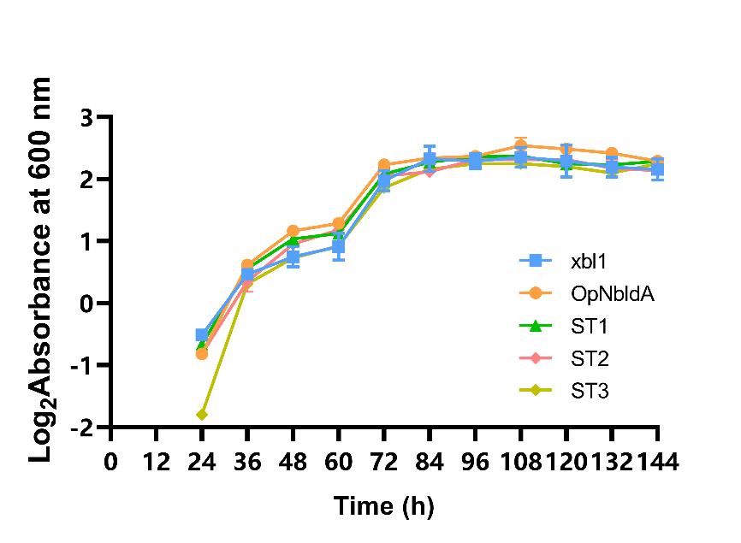

Fig. S2. Amino acid sequence alignment of MiaA homologues.
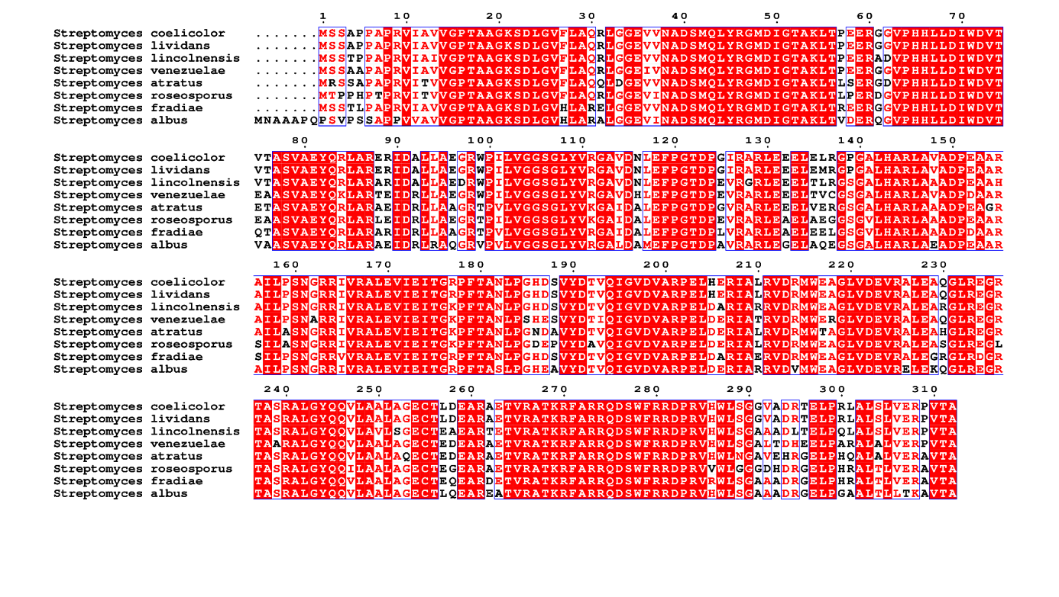
Table S1. Primers used in this study
Primers | Sequence (5’ to 3’)ª
Construction of overexpression strain OpNbldA
HbldA-F | CTTCGCTATTACGCCAGCGCTGTCATACCTGGGG
HbldA-R | GGCCGATTCATTAATGCAGCTTGCTTTCAGACATGAGTCTC
Construction of overexpression strain ST1
ter-R2 | TGCAGGTCGACTCTAGCTAGGGATCCGACGAACAATAAGGCCTCCCAAATCGGGGGGCCTTTTTTATTGATAACAAAACCTTTGGTCG
perm-R | ACAAAACCTTTGGTCGAAAAAAAAAGCCCGCACTGTCAGGTGCGGGCTTTTTTCTGTGTTTCCGCGTGAATTCATTAATGCAGCTGGCA
perm-F | TCGGGCCCTGGCCAGCTAGATTACGCCAGCTGGCGAA
miaA-EF | CGGTTGGTAGGATCCACATAGTGAGCAGCACACCCC
miaA-ER | TCTGTGTTTCCGCGTGAATTTCAGGCTGTAACCGGTC
Construction of overexpression strain ST2
miaB-EF | CGGTTGGTAGGATCCACATAATGACCAGCAGCAGCG
miaB-ER | TCTGTGTTTCCGCGTGAATTTCAGGCCGGCGAGCAG
Construction of overexpression strain ST3
miaE-EF | CGGTTGGTAGGATCCACATAATGGGTATCAGGGCTGTG
miaE-ER | TCTGTGTTTCCGCGTGAATTTTACCCGAAGGTGGACGG
Construction of overexpression strain ST4, ST5, ST6
Emia-F | GGCCAGCTAGATTACGCCAGTCTAGTATGCATGCGAGT
Emia-R | GCACATCCCCCTTTCGCCAGGACGAACAATAAGGCCTCCC
Construction of overexpression strain ST7
EmiaB-ABF | CTAGCTAGAGTCGACCTGCATCTAGTATGCATGCGAGT
XylTE reporter assays
xykasO-F | CCTCTTCGCTATTACGCCAGTGTTCACATTCGAACGG
xykasO-R | CCTCGTAGCCGGCACTGTTCATAACTCCCCCAGTCCTG
xyl-F | ATGAACAGTGCCGGCTACGAGG
xyl-R | CGCGTTGGCCGATTCATTAATGCAGTCAGGTCAGCACGGTCATGAATC
xyermE-F | CCTCTTCGCTATTACGCCAGTCTAGTATGCATGCGAGT
xyermE-R | TCGTAGCCGGCACTGTTCATTGGATCCTACCAACCGGC
xythlM4-F | CCTCTTCGCTATTACGCCAGCCTCGCTCTGCCCGGAC
xythlM4-R | TCGTAGCCGGCACTGTTCATATGGGTGCGTCTGGGGG
xystnY-F | CCTCTTCGCTATTACGCCAGGCATCCGGTCCGCGAAGG
xystnY-R | TCGTAGCCGGCACTGTTCATAATTCCGTTGACGATCCC
xylmbU-F | CCTCTTCGCTATTACGCCAGAAGGAGGGCGTCTTGCGT
xylmbU-R | TCGTAGCCGGCACTGTTCATGCGGCTGCCATCCCTTTC
152F | GCGTAAGGAGAAAATACCGCATCAG
152R | TTCTGTGGATAACCGTATTACCGCC
Construction of overexpression strain STY
miaA-F | GTGAGCAGCACACCCCCC
miaA-R | TGCAGGTCGACTCTAGCTAGTCAGGCTGTAACCGGTCGTTCG
stnY-F | CGGGCCCTGGCCAGCTAGGCATCCGGTCCGCGAAGG
stnY-R | GGGGTGTGCTGCTCACAATTCCGTTGACGATCCCCCGAGTG
Construction of overexpression strain STK
kasO-F | TCGGGCCCTGGCCAGCTAGCTGTTCACATTCGAACGGTCTC
kasO-R | GGGGGGTGTGCTGCTCACCATATGAACTCCCCCAGTC
Construction of overexpression strain STM
thlM4-F | TCGGGCCCTGGCCAGCTAGCCCTCGCTCTGCCCGGAC
thlM4-R | GGGGGGTGTGCTGCTCACCATATGGGTGCGTCTGGGGG
Construction of overexpression strain STU
plmbUmiaA-F | TCGGGCCCTGGCCAGCTAGCAAGGAGGGCGTCTTGCGT
plmbUmiaA-R | GGGGGGTGTGCTGCTCACCATAGCGGCTGCCATCCCTTTC
Construction of plasmid pBTflag-lmbU
BTFU-F | ACGACGGCCAGTGCCAAGCTAAGGAGGGCGTCTTGCGT
BTFU-R | TCTAGAGGATCCCCAACATATTAGGCGCCCCCGACGG
Construction of plasmid pBTflag-adpA
adpAF-R | TCGCCGTCGTGGTCCTTGTAGTCACTACCGCCACCGCCAGAGCCACCTCCGCCTGAACCGCCTCCACCCATCCCGCTGCGCTGCCC
adpAF-F | ACGACGGCCAGTGCCAAGCTAGCGCGGTGCGGCACGGCTACTGGC
flag-R2 | TCTAGAGGATCCCCAACATATTACTTGTCGTCATCGTCCTTGTAGTCGATGTCGTGGTCCTTGTAGTCGCCGTCGTGGTCCTTGT
qRT-PCR
hrdB-RTF | GGGCCTTCGAAGCTGACC
hrdB-RTR | TGGCCGGACTCTTCGCT
qadpAflag-R | GTCGTCATCGTCCTTGTAGTCGA
qadpAflag-F | GAGTCCTGTCGGGTCGT
qflaglmbU-F | TCGACTACAAGGACGATGACGAC
qflaglmbU-R | CCGACGCGAGTGACAAGTAC

