article title: Is ovule packaging strategy in animal-pollinated plants correlated to the level of specialization of their pollination systems?

journal name: Plant-Arthropod Interaction

Marcin ZYCH^{1,3}, Katarzyna ROGUZ^{1,2}, Justyna RYNIEWICZ¹, Anna SZACIŁŁO¹, Robert R. JUNKER^{2,3}

¹ Botanic Garden, Faculty of Biology, University of Warsaw, Aleje Ujazdowskie 4, 00-478 Warszawa, Poland;
² Evolutionary Ecology of Plants, Department of Biology, Philipps-University Marburg, 35043 Marburg, Germany

³Correspondence: M. Zych, e-mail marcin.zych@uw.edu.pl, R.R. Junker e-mail robert.junker@uni-marburg.de

Appendix S1
Results:
The number of ovules per flower was negatively correlated with flower-visitor richness (Pearson’s r = −0.26, p < 0.001). The correlation strengthened when Asteraceae were excluded (r = −0.31, p < 0.01; Fig. 1), weakened when Asclepiadaceae and Orchidaceae were excluded (r = −0.20, p = 0.01; Fig. 2), and remained negative and significant when all three families were excluded together (r = −0.28, p < 0.01; Fig. 3). Using visitor richness aggregated at the insect order level gave the same qualitative pattern (all species: r = −0.40, p < 0.001; minus Asclepiadaceae+Orchidaceae: r = −0.35, p < 0.001; minus Asteraceae: r = −0.39, p < 0.001; minus all three: r = −0.38, p < 0.001).
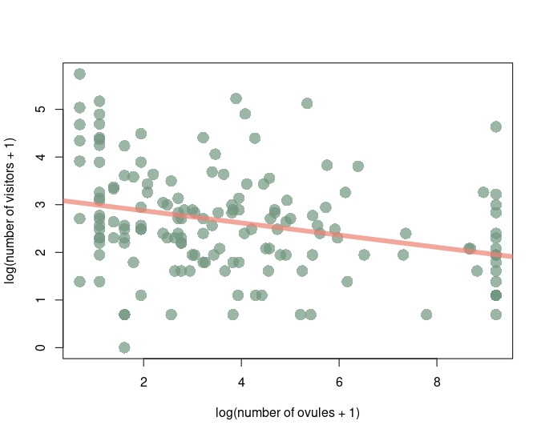
Fig. 1. Ovule number vs pollination system in studied plant species with Asteraceae family excluded from the analysis (p < 0.001, r = -0.36).
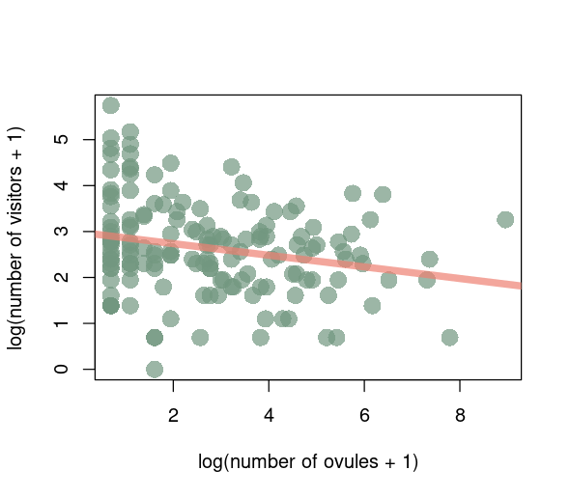

Fig. 2. Ovule number vs pollination system in studied plant species with Asclepiadaceae and Orchidaceae families excluded from the analysis (p < 0.001, r = -0.20)
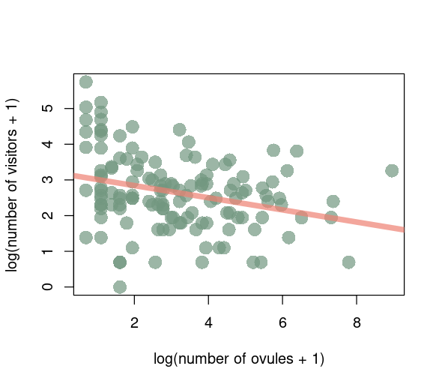

Fig. 3. Ovule number vs pollination system in studied plant species, with Asteraceae, Asclepiadaceae and Orchidaceae families excluded from the analysis, the negative correlation remained strong and significant (p< 0.01, r = -0.28).

