Supplementary Information
Contents
Supplementary Information 1 1
Supplementary Information 2 4
Supplementary Information 3 4
Supplementary Information 4 5
Supplementary Information 5 7
Supplementary Information 6 8
Bibliography 9

Supplementary Information 1
SI1.1: Mass and carapace length descriptives for species-temperature treatments
Treatment | Sex ratio (Male/Female) | Mean ± SE | Range (min-max) (mm)
Mass (g)
P. leptodactylus (9℃) (n=36) | 18/18 | 72.99 ± 7.08 | 174.6 (22.6 – 197.2)
P. leptodactylus (12℃) (n=26) | 14/12 | 48.37 ± 5.09 | 101.6 (13.0-114.6)
P. leptodactylus (17℃) (n=62) | 31/31 | 60.18 ± 3.95 | 185 (17.5 – 203.2)
P. leptodactylus (22℃) (n=24) | 10/14 | 60.6 ± 4.81 | 98 (31.4-129.4)
P. leniusculus (9℃) (n=36) | 20/16 | 38 ± 4.02 | 72.8 (16.3 – 89.1)
P. leniusculus (12℃) (n=24) | 12/12 | 48.37 ± 3.86 | 67.5 (18.0 – 85.5)
P. leniusculus (17℃) (n=36) | 15/21 | 31.61 ± 2.66 | 70.2 (15.1 – 85.3)
P. leniusculus (22℃) (n=24) | 10/14 | 32.9 ± 3.6 | 69.1 (15.1 – 84.2)
Carapace Length (mm)
P. leptodactylus (9℃) (n=36) | 18/18 | 65.61 ± 2.03 | 46.4 (46.5 – 92.9)
P. leptodactylus (12℃) (n=26) | 14/12 | 54.47 ± 2.36 | 40.4 (36.2 – 76.6)
P. leptodactylus (17℃) (n=62) | 31/31 | 61.41 ± 1.41 | 52.2 (41.3 – 93.5)
P. leptodactylus (22℃) (n=24) | 10/14 | 65.1 ± 1.62 | 38.57 (52.6 – 91.3)
P. leniusculus (9℃) (n=36) | 20/16 | 47.38 ± 1.56 | 38.5 (36 – 74.5)
P. leniusculus (12℃) (n=24) | 12/12 | 45.48 ± 1.27 | 25.8 (34.0 – 59.8)
P. leniusculus (17℃) (n=36) | 15/21 | 44.89 ± 1.05 | 27.6 (34.2 – 61.8)
P. leniusculus (22℃) (n=24) | 10/14 | 46.85 ± 1.23 | 21.8 (38.4 – 60.2)

Table SI1.2: Kendall’s correlation between proportion of prey consumed and mass split by temperature and crayfish species. Kendall’s Tau is provided to 3 s.f. p-values provided by p-value approximation due to ties in the ranking.
Species | Temperature | Kendall’s T | p-value
Pontastacus leptodactylus | 9℃ | -0.0960 | 0.419
Pontastacus leptodactylus | 12℃ | 0.0254 | 0.859
Pontastacus leptodactylus | 17℃ | -0.169 | 0.058
Pontastacus leptodactylus | 22℃ | -0.126 | 0.404
Pacifastacus leniusculus | 9℃ | -0.140 | 0.239
Pacifastacus leniusculus | 12℃ | -0.0321 | 0.835
Pacifastacus leniusculus | 17℃ | -0.0524 | 0.666
Pacifastacus leniusculus | 22℃ | -0.0804 | 0.604

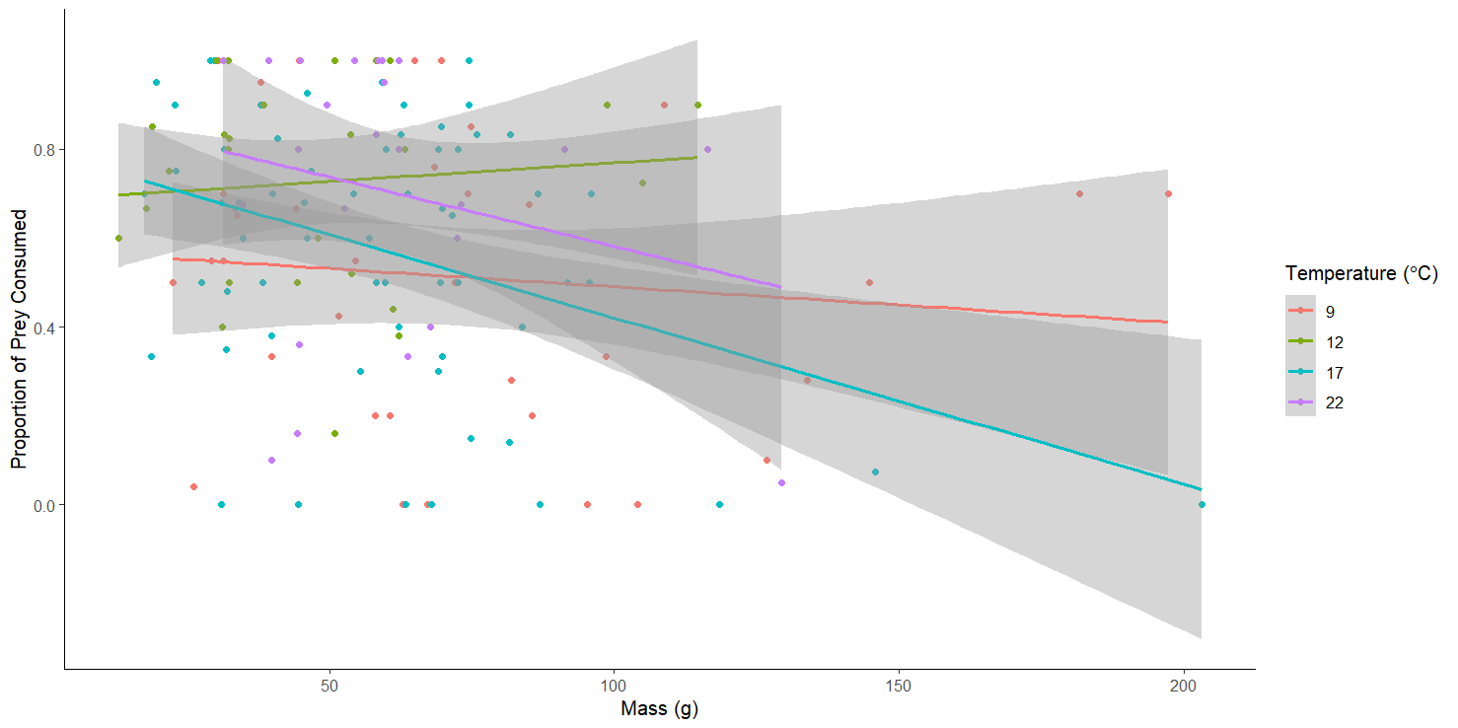
Figure SI1.1: Interaction between mass and temperature on the proportion of prey consumed for Pontastacus leptodactylus.
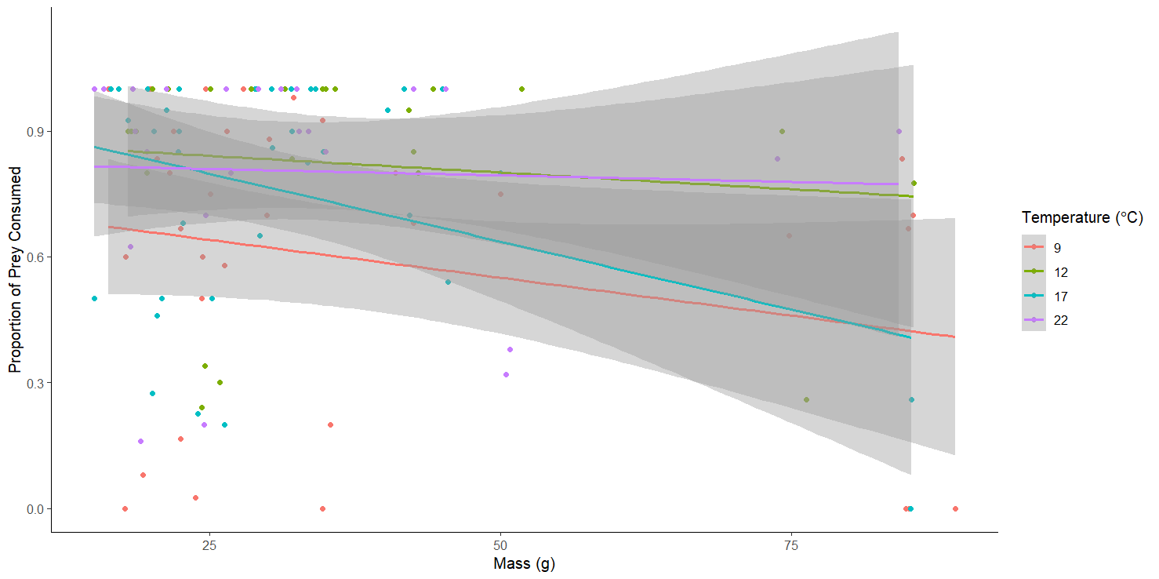
Figure SI 1.2: Interaction between mass and temperature on the proportion of prey consumed for Pacifastacus leniusculus.

Supplementary Information 2
See “Supplementary Material 2 – Crayfish CPUEs.xlsx” for temperature matched crayfish CPUEs.

Supplementary Information 3
SI3: Average numbers of eggs per ovigerous females used for RIPq calculations taken from Table 1 of Hynes (1955) matched to temperature conditions
RIPq temperature condition | Temperatures in Hynes (1955) | Number of Eggs
9°C | 8.2 and 9.8°C (average of egg numbers at these temperatures) | 18.8
12°C | 11.5°C | 17.4
17°C | 15.3°C | 13.6
22°C | 15.3°C | 13.6

Supplementary Information 4

Functional response curves within species. Functional response curves had broadly overlapped confidence intervals for P. leptodactylus compared between temperature (Figure SI4). For P. leniusculus 12, 17 and 22℃ curves confidence intervals overlapped, as did 9 and 17℃. However, at 9℃ P. leniusculus functional response curves diverge from 12 and 22℃ curves, possessing a significantly different curve at low densities (ca. 0 - 18) (Figure SI4 - Left). For P. leniusculus at 9℃ the FR curve doesn’t plateau because a high enough density was not used, thus saturation didn’t occur, producing an unreliable and non-significant handling time.
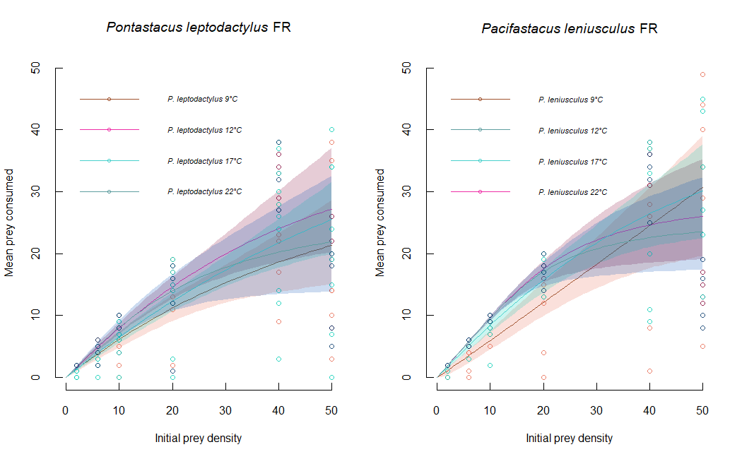
A)
B)

Figure SI4: Functional responses curves, with raw mean prey consumed data points, of Pontastacus leptodactylus and Pacifastacus leniusculus towards Gammarus pulex at temperature treatments: 9, 12, 17 and 22 ℃. Shaded areas are 95% bootstrapped CIs, and darker areas represent overlap.

Supplementary Information 5
Mechanistic comparisons of attack rate and handling times within and between species using z-tests in Frair compare (Juliano 1998).
Table SI 5: z-test comparisons to determine significant differences in attack rate or handling time between species at different temperature conditions: 9, 12, 17 and 22℃. 9℃ was not compared for Pacifastacus leniusculus.
Species Comparison | Temperature | Estimate | z | p-value
Attack rate
P. leniusculus - P. leptodactylus | 12℃ | 2.95 | 3.69 | <0.001
P. leniusculus - P. leptodactylus | 17℃ | 1.065 | 3.72 | <0.001
P. leniusculus - P. leptodactylus | 22℃ | 3.00 | 3.06 | <0.01
Handling time
P. leniusculus - P. leptodactylus | 12℃ | 0.01 | 2.73 | <0.01
P. leniusculus - P. leptodactylus | 17℃ | 0.0041 | 1.020 | 0.30
P. leniusculus - P. leptodactylus | 22℃ | 0.0030 | 0.67 | 0.49

Table SI 5.2: z-test comparisons to determine significant differences in attack rate or handling time within species between temperature conditions: 9, 12, 17 and 22℃. 9℃ was not compared for Pacifastacus leniusculus.
Species | Comparison | Estimate | z | p-value
Attack rate
P. leptodactylus | 9℃ - 12℃ | -0.81 | -2.80 | <0.01
P. leptodactylus | 9℃ - 17℃ | -0.063 | -0.35 | 0.72
P. leptodactylus | 9℃ - 22℃ | -1.17 | -3.06 | <0.01
P. leptodactylus | 12℃ - 17℃ | 0.75 | 2.74 | <0.01
P. leptodactylus | 12℃ - 22℃ | -0.35 | -0.81 | 0.41
P. leptodactylus | 17℃ - 22℃ | -1.10 | -2.99 | <0.01
P. leniusculus | 12℃ - 17℃ | 2.63 | -3.28 | <0.01
P. leniusculus | 17℃ - 22℃ | -3.04 | -3.19 | <0.01
P. leniusculus | 12℃ - 22℃ | -0.40 | 0.34 | 0.73
Handling time
P. leptodactylus | 9℃ - 12℃ | 0.00171 | 0.30 | 0.76
P. leptodactylus | 9℃ - 17℃ | 0.0081 | 1.43 | 0.15
P. leptodactylus | 9℃ - 22℃ | -0.010 | -1.74 | 0.08
P. leptodactylus | 12℃ - 17℃ | 0.0063 | 1.42 | 0.15
P. leptodactylus | 12℃ - 22℃ | -0.012 | -2.46 | <0.05
P. leptodactylus | 17℃ - 22℃ | -0.018 | -3.76 | <0.001
P. leniusculus | 12℃ - 17℃ | 0.013 | 3.75 | <0.001
P. leniusculus | 17℃ - 22℃ | -0.017 | -4.78 | <0.0001
P. leniusculus | 12℃ - 22℃ | -0.0047 | -1.32 | 0.18

Supplementary Information 6
Tables SI 6: Mean RIP values from interspecies across the same temperature, and intraspecies comparisons across different temperatures. Species are Pontastacus leptodactylus and Pacifastacus leniusculus. RIP values to 3 s.f., values above 1 indicate greater relative impact.
Species | Comparison | RIP value
P. leptodactylus | 12℃ - 9℃ | 1.593
P. leptodactylus | 17℃ - 9℃ | 4.50
P. leptodactylus | 22℃ - 9℃ | 0.515
P. leptodactylus | 17℃ - 12℃ | 2.63
P. leptodactylus | 22℃ - 12℃ | 0.321
P. leptodactylus | 22℃ - 17℃ | 0.136
P. leniusculus | 17℃ - 12℃ | 0.174
P. leniusculus | 22℃ - 17℃ | 0.156
P. leniusculus | 22℃ - 12℃ | 0.996
Temperature | Comparison | RIP Value
12℃ | P. leptodactylus – P. leniusculus | 1.72
17℃ | P. leptodactylus – P. leniusculus | 1.82
22℃ | P. leptodactylus – P. leniusculus | 1.77

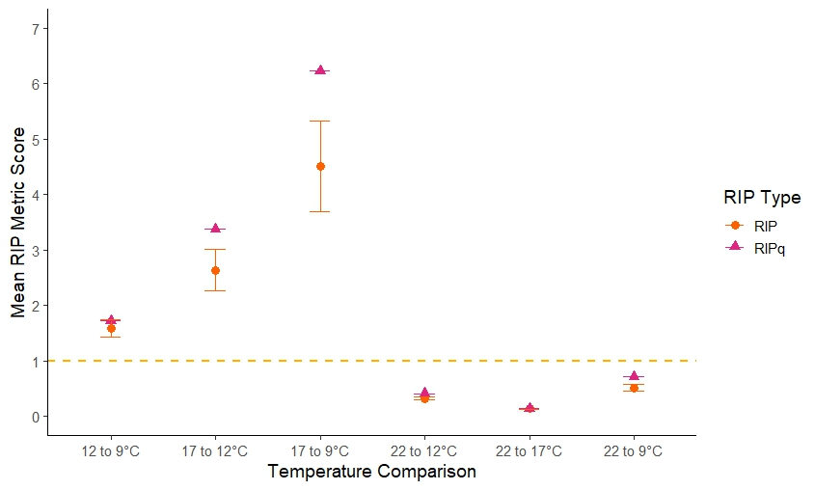
Figure SI 6: Relative Impact Scores (RIP; based on Functional Response Ratio) and RIPq scores which incorporate the ‘resource reproductive qualifier’ for between-temperature comparisons for Pontastacus leptodactylus. The resource reproductive qualifier was based on average egg number per ovigerous female Gammarus pulex at different temperatures. Points above the dashed yellow line indicate greater Relative Impact Potential from the first temperature stated compared to the second e.g. at 12 compared to 9℃.

Bibliography
Juliano SA (1998) Nonlinear Curve Fitting: Predation and Functional Response Curves. In: Design and Analysis of Ecological Experiments. Chapman and Hall/CRC

