Supplementary file

Soil type and Wastewater Contaminants drive Antibiotic Resistance Genes, Mobile Genetic Elements, and Bacterial Communities in Soil, Cilantro Rhizosphere, and Phyllosphere

Sara Gallego¹, Leila Soufi², Ioannis Kampouris¹, Rehana Abdulvakkeil³, Dipen Pulami³, Kathia Lüneberg⁴, Benjamin J. Heyde^{3,5}, Doreen Babin¹, Christina Siebe⁴, Jan Siemens³, Stefanie P. Glaeser³, Kornelia Smalla¹ and Elisabeth Grohmann²
¹Julius Kühn Institute (JKI) - Federal Research Centre for Cultivated Plants, Institute for Epidemiology and Pathogen Diagnostics, Messeweg 11-12, 38104 Braunschweig, Germany
²Berlin University of Applied Sciences, Faculty of Life Sciences and Technology, Department of Microbiology, Berlin, Germany
³Justus Liebig University Giessen, iFZ Research Center for BioSystems, Land Use and Nutrition, Institute of Soil Science and Soil Conservation, Giessen, Germany.
⁴Instituto de Geología, Universidad Nacional Autónoma de México, Ciudad Universitaria, México
⁵Ruhr University Bochum, Institute of Geography, Unit Soil Sciences and Soil Resources, Bochum, Germany

*Corresponding authors: Sara Gallego (sara.gallego@julius-kuehn.de) and Elisabeth Grohmann (e-mail: egrohmann@bht-berlin.de),

Correspondence for cultivation studies: Stefanie P. Glaeser (e-mail: Stefanie.Glaeser@umwelt.uni-giessen.de)

Table S1. qPCR primer and probe sets used in this study.
Target gene/plasmid group | Primers/Probes | Sequence [5´-3] | Annealing temp | Reference
Bacterial 16S  rRNA gene | Bact1369F  Prok1492R  TM1389F_P | CGGTGAATACGTTCYCGG  GGWTACCTTGTTACGACTT  CTTGTACACACCGCCCGTC | 56°C | (Suzuki et al., 2000)
ermA | ermA-F  ermA-R  ermA-P | TCTTATCGTTGAGAAGGGAT  CTACACTTGGCTTAGGATGA  TGCAAAATCTGCAACGAGCTTTGGG | 55°C | (Werner et al., 2022)
ermB | ermBF  ermBR  ermBP | GGATTCTACAAGCGTACCTTGGA  GCTGGCAGCTTAAGCAATTGCT  CACTAGGGTTGCTCTTGCACACTCAAGTC | 60°C | (Böckelmann et al., 2009)
inc18 | Inc18-F  Inc18-R  Inc18-P | AACTATCAAGGGGCTAATAGGG  CCACCCTTGACGGACAAATA  TTGCAAAGCTTGGGTATCAA | 58°C | (Soufi et al., 2025)
intI1 | intI1-LC1  intI1-LC5  intI1-P | GCCTTGATGTTACCCGAGAG  GATCGGTCGAATGCGTGT  ATTCCTGGCCGTGGTTCTGGGTTTT | 60°C | (Barraud et al., 2010)
korB (IncP-1) | korB-F  korB-Fz  korB-R  korB-Rge  korB-Rd  tp_korBgz  tp_korB | TCATCGACAACGACTACAACG  TCGTGGATAACGACTACAACG  TTCTTCTTGCCCTTCGCCAG  TTYTTCYTGCCCTTGGCCAG  TTCTTGACTCCCTTCGCCAG  TSAGGTCGTTGCGTTGCAGGTTYTCAAT  TCAGYTCRTTGCGYTGCAGGTTCTCGAT | 54°C | (Jechalke et al., 2013b, 2013a)
qnrA | qnrA-F  qnrA-F | ATTTCTCACGCCAGGATTTG  GCAGATCGGCATAGCTGAAG | 62°C | (Marti and Balcázar, 2013)
qnrS | qnrS F  qnrS R | GACGTGCTAACTTGCGTGAT  TGGCATTGTTGGAAACTTG | 62°C | (Marti and Balcázar, 2013)
repA_N | RepA_N-F  RepA_N-R  RepA_N-P | TCTACACAGTTGCTGAATTAATG  GGTTTTCCGAGATATAGCAG  CTGCTAAATTGCAGAGAAGG | 55°C | (Soufi et al., 2025)
rep_{pI258} | pI258-F  pI258-R  pI258-P | GTGCGAGTACTTAGGTTATGGAGA  TTCCTTGGTAAGACTTGCTTCA  TAACTCAAGAGCGTGTTGGC | 55°C | (Soufi et al., 2025)
rep_{pSK1} | pSK1-F  pSK1-R  pSK1-P | CAGGCGCTTGAAGAATTACC  CACTTACAAGTTCAAATTCGACG  CTTATCAAGGGAAAAGTCA | 56°C | (Soufi et al., 2025)
sul1 | q-sul_1 653f  q-sul_1 719r  tp_sul1 | CCGTTGGCCTTCCTGTAAAG  TTGCCGATCGCGTGAAGT  CAGCGAGCCTTGCGGCGG | 60°C | (Heuer and Smalla, 2007)
sul2 | q_sul2 595f  q_sul2 654f  tp_sul2 614 | CGGCTGCGCTTCGATT  CGCGCGCAGAAAGGATT  CGGTGCTTCTGTCTGTTTCGCGC | 60°C | (Heuer and Smalla, 2007)
tetA | tetA_qfw  tetA_qrv  tetA_tp | CCGCGCTTTGGGTCATT  TGGTCGCGTCCCAGTGA  TCGGCGAGGATCG | 60°C | (Guarddon et al., 2011)
tetM | tetM_qfw  tetM_qrv  tetM_tp | GGTTTCTCTTGGATACTTAAATCAATCR  CCAACCATAYAATCCTTGTTCRC  ATGCAGTTATGGARGGGATACGCTATGGY | 60°C | (Peak et al., 2007)

Table S2. Primer systems and final primer concentrations used for characterization of cultivated bacterial strains.
Target genes | Primers | Sequence (5´- … - 3´) | Concen-trations in PCRs [µM] | Primer system specific cycling conditionsª | Fragment size | Reference
gadAB | gadA_F  gadA_R | GATGAAATGGCGTTGGCGCAAG  GGCGGAAGTCCCAGACGATATCC | 0.4  0.4 | 95°C, 30 s, 65°C, 30 s, 72°C, 1 min 30 s (30 x) | 373 bp | (Doumith et al., 2012)
uidA | uidA_F  uidA_R | CCAAAAGCCAGACAGAGT  GCACAGCACATCCCCAAAGAG | 0.3  0.3 | 95°C, 30 s, 58°C, 30 s. and 72°C, 1 min 30 s (30 x) | 623 bp | (McDaniels et al., 1996)
BOX elements | BOXA1R | CTACGGCAAGGCGACGCTGACG | 1.0 | 94°C, 30 s, 53°C, 1 min, 70°C, 8 min (30 x) | 150 to > 3,000 bp | (Versalovic et al., 1994)
bla_{CTX-M} | CTX-M-U1  CTX-M-U2 | ATGTGCAGYACCAGTAARGTKATGGC  TGGGTRAARTARGTSACCAGAAYCAGCGG | 0.4  0.4 |  | 593 bp | (Monstein et al., 2007)
bla_{TEM} | TEM-164.SE  TEM-165.AS | TCGCCGCATACACTATTCTCAGAATGA  ACGCTCACCGGCTCCAGATTTAT | 0.4  0.4 | 95°C, 30 s, 60°C, 30 s, 72°C, 2 min (30 x) | 445 bp | (Monstein et al., 2007)
bla_{SHV} | bla-SHV.SE  bla-SHV.AS | ATGCGTTATATTCGCCTGTG  TGCTTTGTTATTCGGGCCAA | 0.4  0.4 |  | 747 bp | (Monstein et al., 2007)
16S rRNA gene | EUB9F  EUB1492r | GAGTTTGATCMTGGCTCAG  CGGTTACCTTGTTACGACTT | 0.2  0.2 | 95°C, 30 s, 54°C, 30 s, 72°C, 1 min 30 s (34 x) | ~1470 bp | (Lane, 1991)
ª PCRs start with an initial denaturation at 95°C for 3 min and end with a final extension at 72°C for 10 min.

Table S3. Linear regression with bootstrap values of 16S rRNA gene copy numbers, antibiotic resistance gene (ARG) and mobile genetic element (MGE) relative abundances between samples from unstained soil and preferential water flow path soil (stained soil), irrigated with untreated (UWW) or treated (TWW) wastewater, both unspiked and spiked with antibiotics and disinfectants. Only significant values are reported (see attached Excel file “linear_model_regression_bootstrap_soils”).
Table S4. Linear regression with bootstrap values of 16S rRNA gene copy numbers, antibiotic resistance gene (ARG) and mobile genetic element (MGE) relative abundances in samples from unstained soil and preferential water flow path soil (stained soil), rhizosphere, and phyllosphere irrigated with untreated (UWW) or treated (TWW) wastewater, both unspiked and spiked with antibiotics and disinfectants. Only significant values are reported (see attached Excel file “linear_model _regression_bootstrap”).

Table S5. Differentially abundant amplicon sequence variants (ASVs) in soil from preferential flow path soil, rhizosphere and phyllosphere irrigated with untreated and treated wastewater, both unspiked and spiked with antibiotics and disinfectants (see attached Excel file “all_diff_abundant_ASVs_all”).

Table S6. Overview of cultivated and characterized third-generation-cephalosporin-resistant (3GCR) enterobacteria and Pseudomonadaceae strains (see attached Excel file “Characterized bacterial 3GCR strains”).
Extended-spectrum beta-lactamase (ESBL) genes: 0: not detected; 1: detected. Phylotypes according to Figure S14; genotypes according to Fig. S15.

Table S7. Overview of amplicon sequence variants (ASVs) representing genera of cultivated third-generation-cephalosporin-resistant (3GCR) enterobacteria and Pseudomonas spp. strains (see attached Excel file “ASVs representing cultivated genera”). ASV read numbers are given. ASVs marked in bold share identical 16S rRNA gene sequences with the corresponding cultivated bacterial strain(s), whereas those marked with an asterisk differ by one nucleotide.

Soil type | Coordinates | Years of UWW irrigation | Village
Leptosol | 20°4'44.90"N 99°12'20.10"W | 92 | Tlaxcoapan
Vertisol | 20°8'30.89"N 99°10'25.26"W | 111 | Ulapa de Melchor Ocampo

Fig. S1. Geographical map of the Mezquital Valley indicating the soil sampling sites, coordinates, closest villages, and years of untreated wastewater irrigation (UWW) of the soils.
Fig. S2. Vertical section of Leptosol soil column.
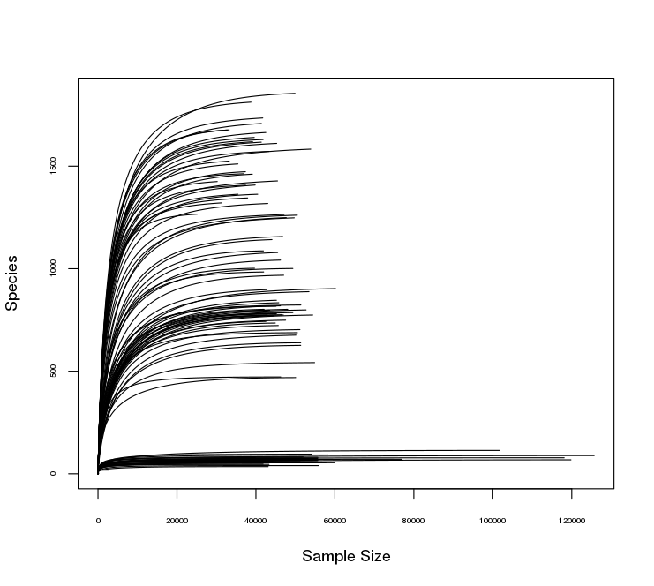
Fig. S3. Rarefaction curves of 16S rRNA gene sequences retrieved from the sequencing analysis (n=115).
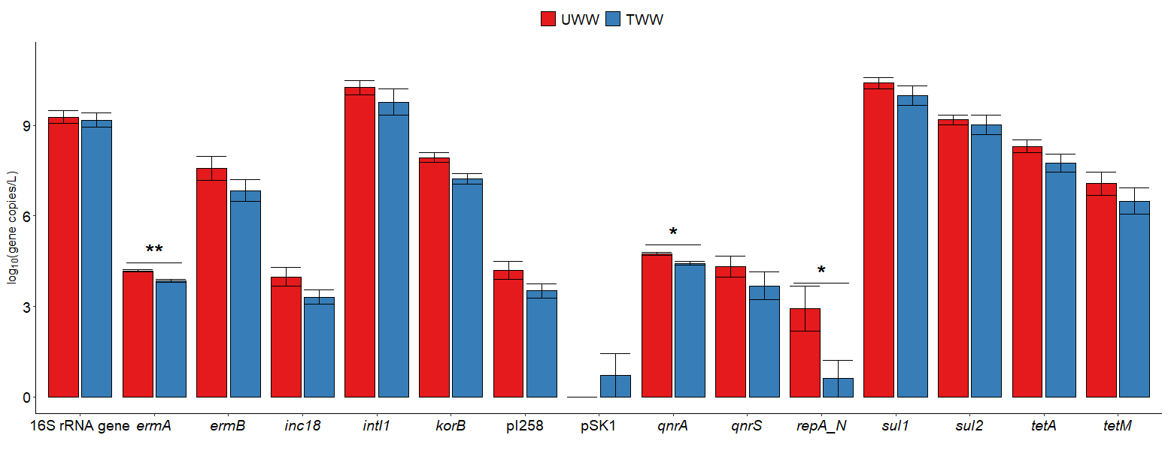
Fig. S4. Antibiotic resistance gene (ARG) and mobile genetic element (MGE) absolute abundances (log₁₀ gene copies per L) in untreated (UWW) and treated (TWW) wastewater samples. Statistical significance was assessed using Wilcoxon test. The significance levels are indicated by the following asterisks: p<0.05 (*), p<0.01 (**), and p<0.001 (***).
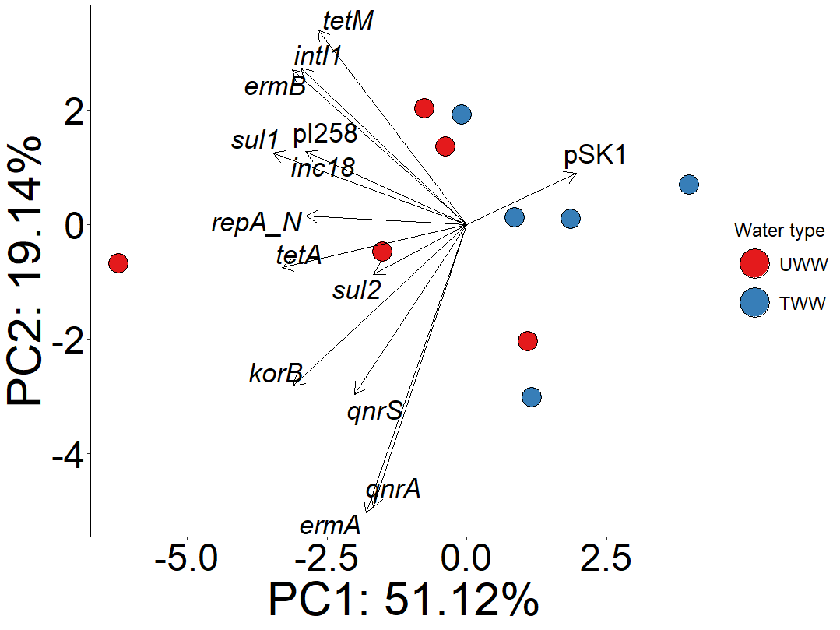
Fig. S5. Principal component analysis using antibiotic resistance gene (ARG) and mobile genetic element (MGE) relative abundances from untreated (UWW) and treated (TWW) wastewater. Significance of separation was assessed with PERMANOVA test (water type: R²=0.20, p=0.1053).

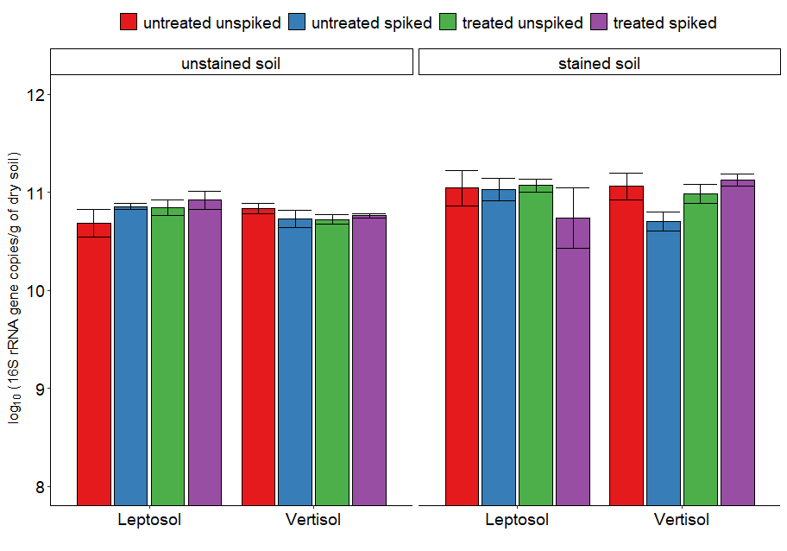
Fig. S6. 16S rRNA gene log₁₀ copies per gram of dry soil in samples from unstained soil and preferential water flow path soil (stained soil) irrigated with untreated (UWW) or treated (TWW) wastewater, both unspiked and spiked with antibiotics and disinfectants. No significant differences were observed (p>0.05; linear regression with bootstrap values).

A
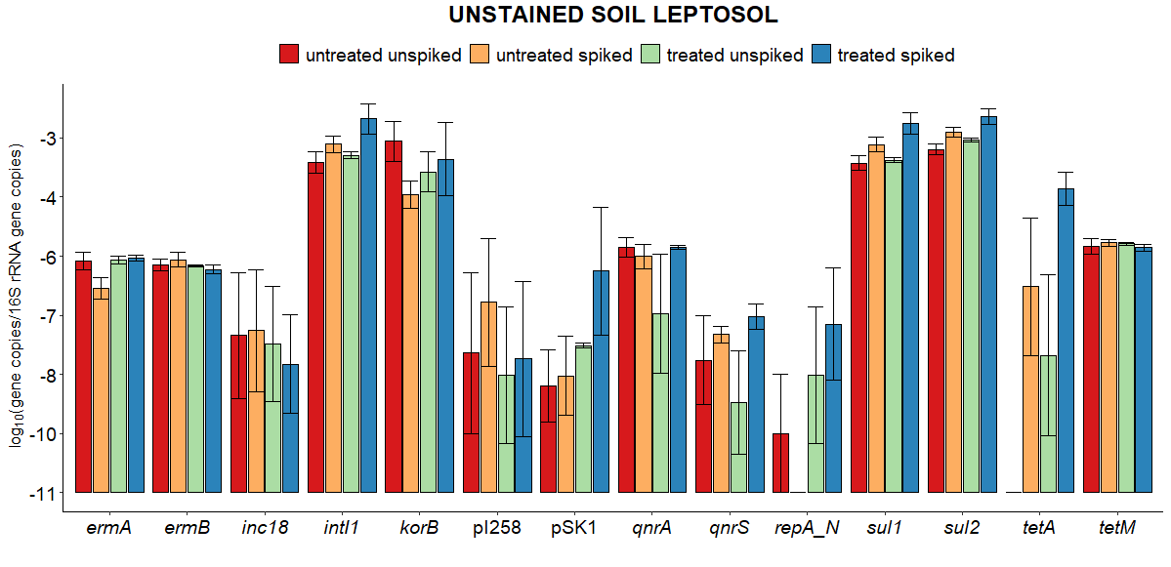
B
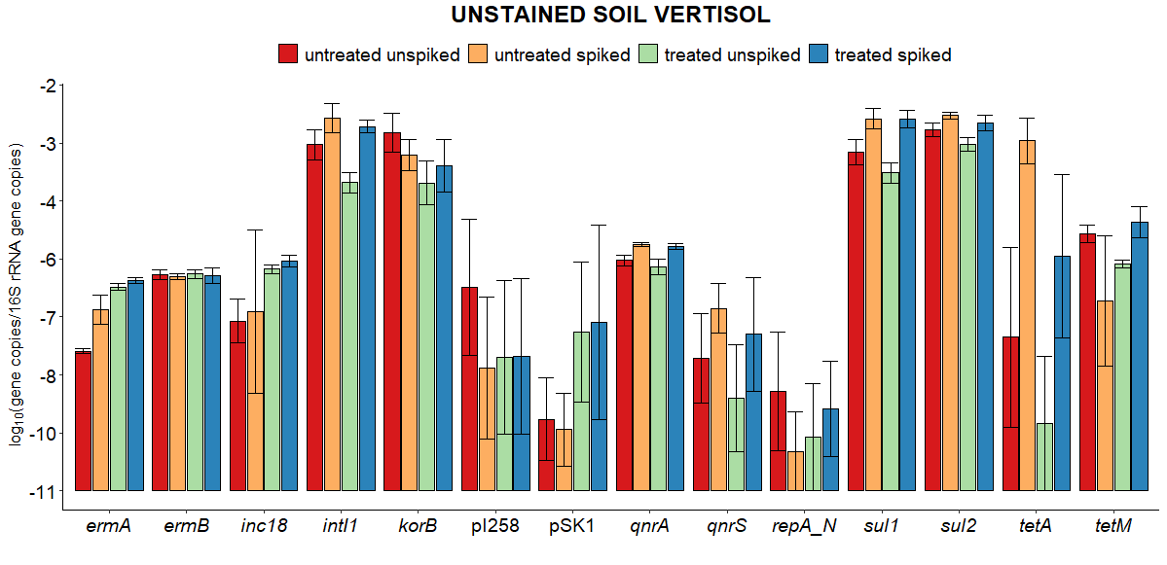

C
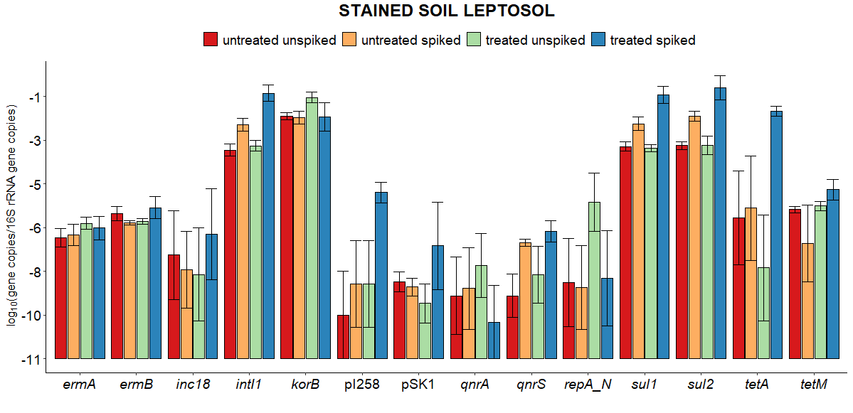
D
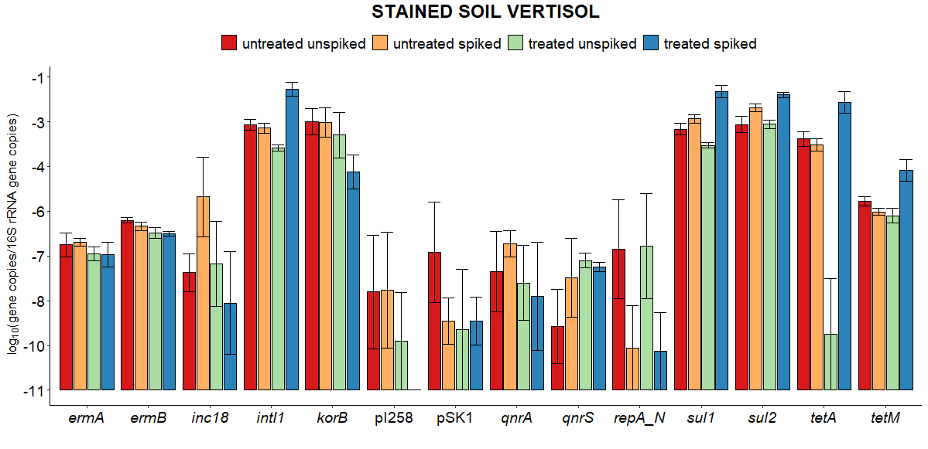

E
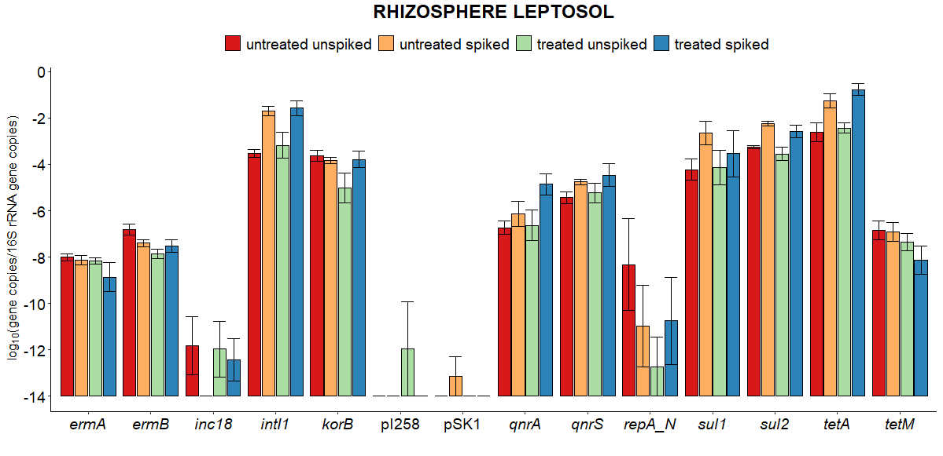
F
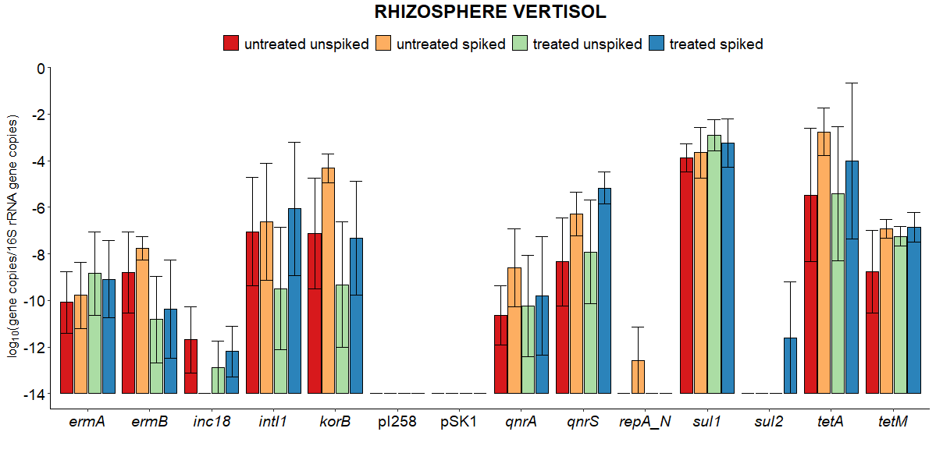

G
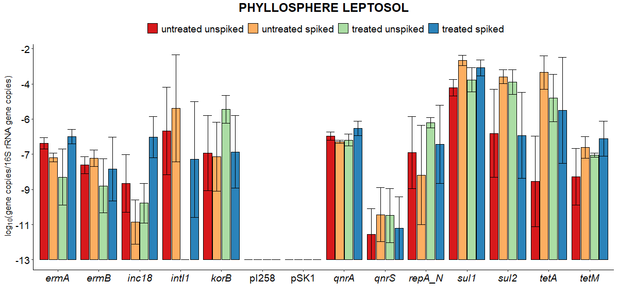
H
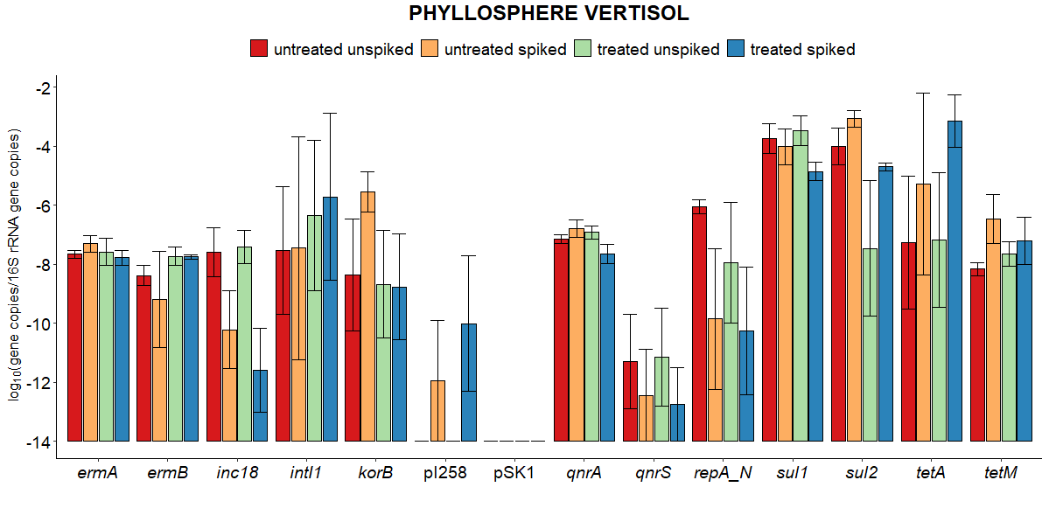
Fig. S7. Antibiotic resistance gene (ARG) and mobile genetic element (MGE) relative abundances (log₁₀ copies/16S rRNA gene copies) in A) Leptosol soil samples from unstained soil, B) Vertisol soil samples from unstained soil, C) Leptosol soil samples from preferential water flow path soil (stained soil), D) Vertisol soil samples from preferential water flow path soil (stained soil), E) cilantro rhizosphere from Leptosol columns, F) cilantro rhizosphere from Vertisol columns, G) cilantro phyllosphere from Leptosol columns, H) cilantro phyllosphere from Vertisol columns irrigated with untreated (UWW) or treated (TWW) wastewater, both unspiked and spiked with antibiotics and disinfectants.

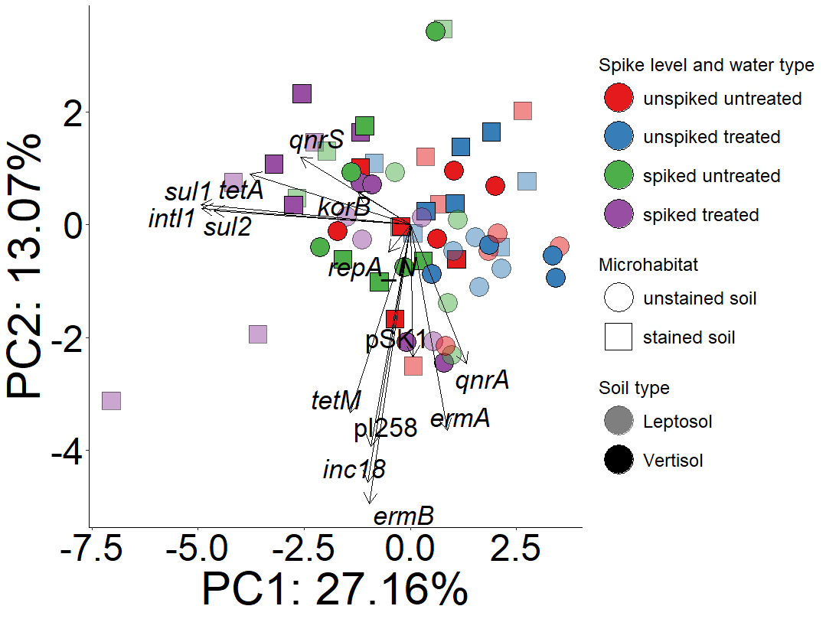

Fig. S8. Principal Component Analysis of antibiotic resistance gene (ARG) and mobile genetic element (MGE) distributions in Leptosol and Vertisol soils from unstained soil and preferential water flow path soil (stained soil) irrigated with untreated (UWW) or treated (TWW) wastewater, both unspiked and spiked with antibiotics and disinfectants. Significance of separation was assessed with PERMANOVA test (microhabitat: R²=0.06, p=0.003; soil type: R²=0.02, p=0.2872; spike level: R²=0.09, p=0.0001; water type: R²=0.013, p=0.4776).

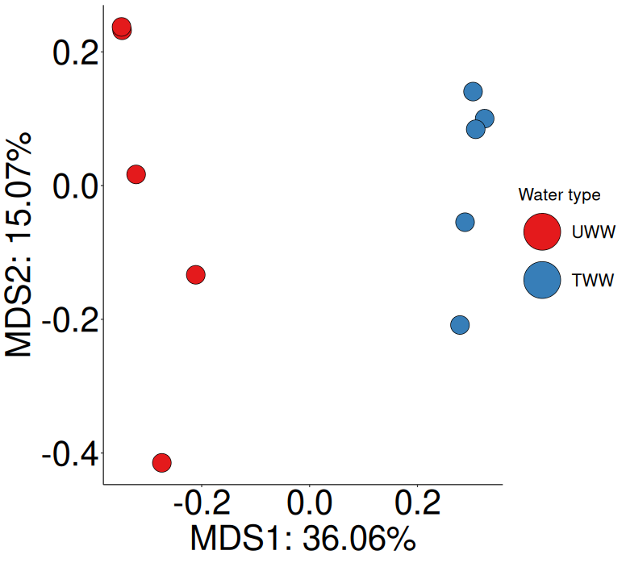
Fig. S9. Multidimensional scaling analysis performed on Bray-Curtis distance matrices from 16S rRNA gene amplicon sequencing data from untreated (UWW) and treated (TWW) wastewater. Significance of separation was assessed with PERMANOVA test (water type: R²=0.36, p=0.0081).

A
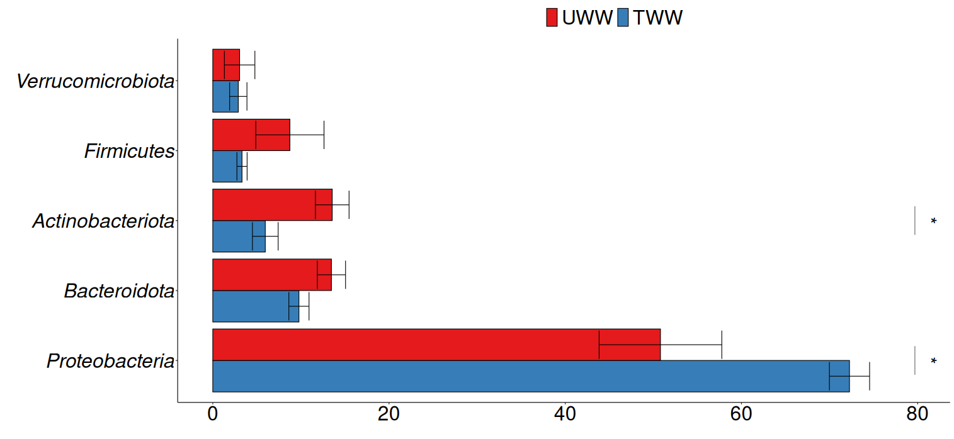
B
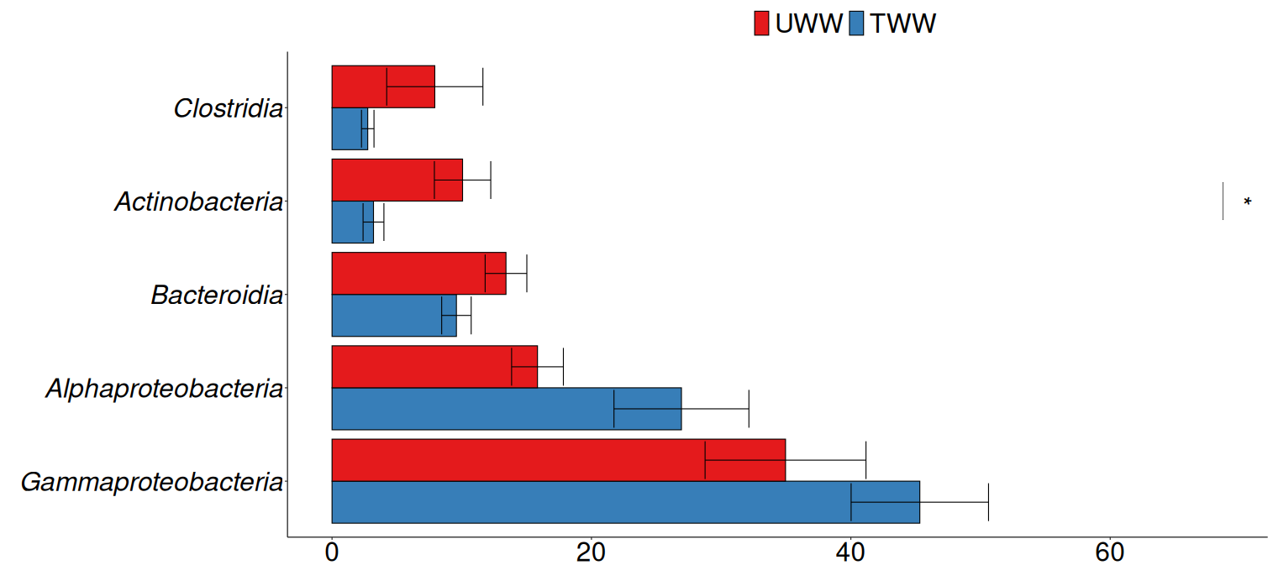
Fig. S10. Relative abundance of the five most abundant bacterial phyla (A) and classes (B) in untreated (UWW) and treated (TWW) wastewater. Statistical significance was assessed using Wilcoxon test. The significance levels are indicated by the following asterisks: p<0.05 (*), p<0.01 (**), and p<0.001 (***).
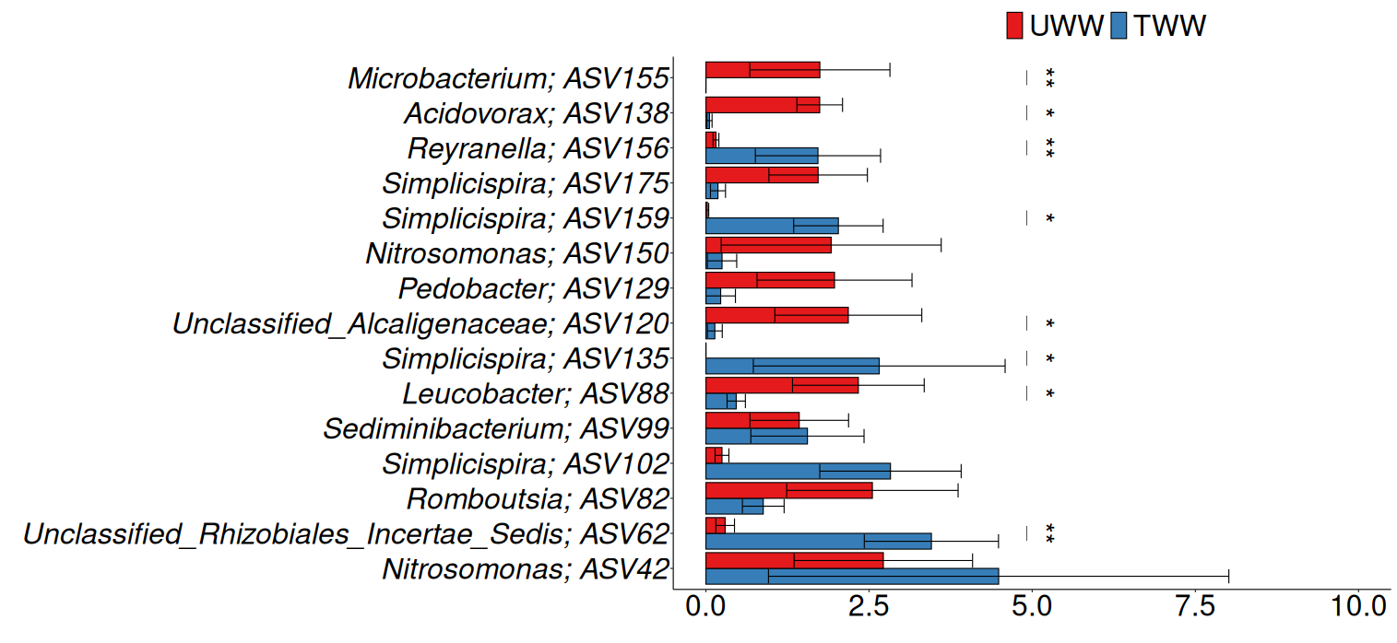
Fig. S11. Relative abundance of the 15 most abundant amplicon sequence variants (ASVs) in untreated (UWW) and treated (TWW) wastewater. Statistical significance was assessed using Wilcoxon test. The significance levels are indicated by the following asterisks: p<0.05 (*), p<0.01 (**), and p< 0.001 (***).

A
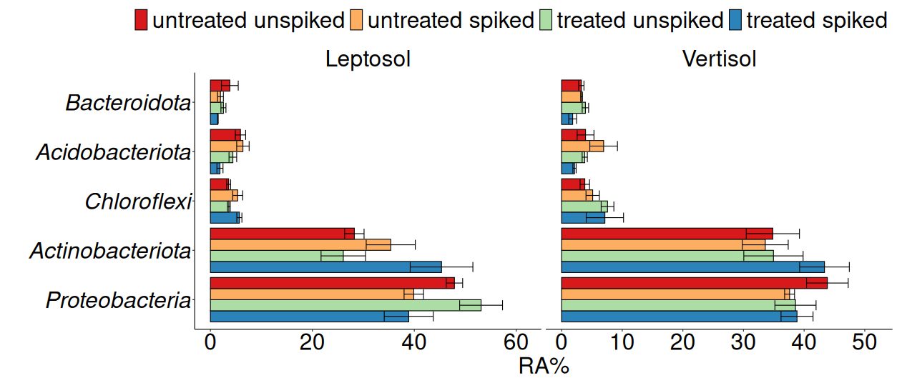
B
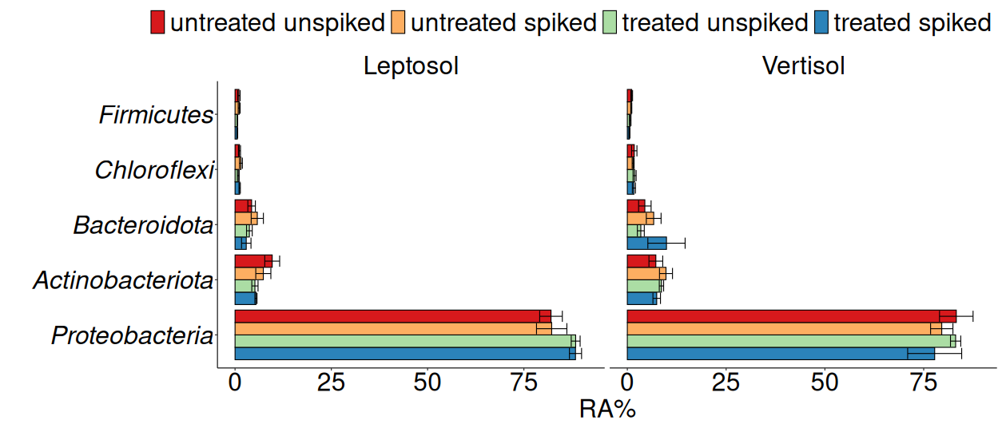
C
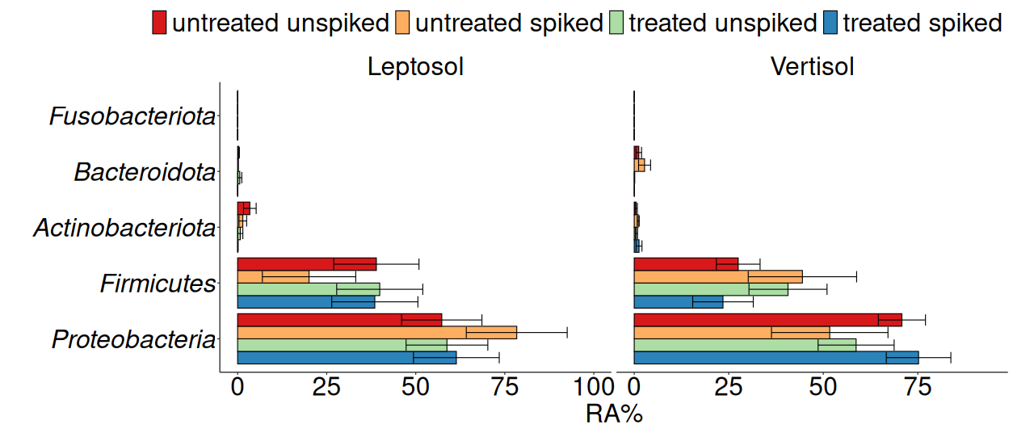
Fig. S12. Relative abundance (RA) (% reads) of the five most abundant phyla in soil from preferential water flow path soil (A), rhizosphere (B), and phyllosphere (C) irrigated with untreated (UWW) and treated (TWW) wastewater, both unspiked and spiked with antibiotics and disinfectants. No significant differences were observed (p>0.05; Dunn´s test with Benjamini Hochberg adjustment).

A
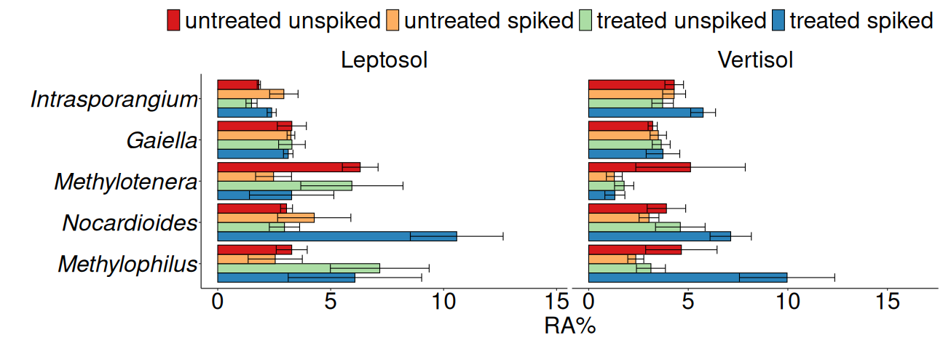
B
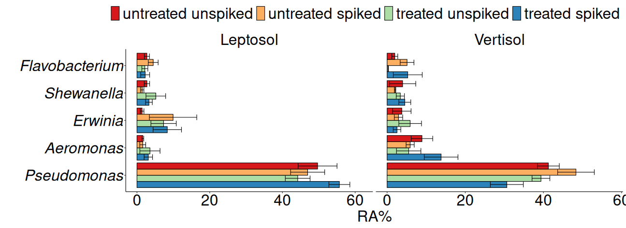

C
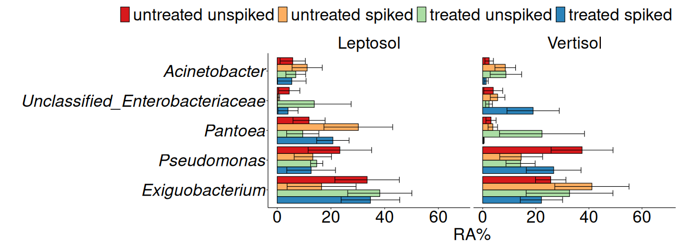
Fig. S13. Relative abundance (RA) (% reads) of the 5 most abundant genera in soil from preferential water flow path soil (A), rhizosphere (B), and phyllosphere (C) irrigated with untreated (UWW) and treated (TWW) wastewater, both unspiked and spiked with antibiotics and disinfectants. No significant differences were observed (p>0.05; Dunn´s test with Benjamini Hochberg adjustment).

Fig. S14. Phylogenetic affiliation of cultivated third-generation-cephalosporin-resistant 3GCR enterobacteria and Pseudomonas spp. strains based on partial 16S rRNA gene sequences spanning approx. 830 nt of the 16S rRNA gene sequences among gene positions 104 to 934 according to the numbering of the 16S rRNA gene by Brosius et al. (1978). The phylogenetic tree was calculated in ARB (Ludwig et al., 2004) in the All-Species Living Tree project (LTP) database (Yarza et al., 2010) using the Neighbor joining method and the Jukes Cantor evolutionary DNA model implemented in ARB. Numbers at nodes represent bootstrap values in % based on 100 replications. Only values of 70 % and above are depicted. Enterococcus spp. type strain sequences were used as outgroup. Bar: 0.1 base substitutions per nucleotide position. Strains cultivated in this study are given in bold. GenBank accession numbers of respective 16S rRNA gene sequences are given. Based on sequence similarities and clustering in the trees phylotypes were defined.

A

B
C

Fig. S15. Cluster analyses of cultivated bacterial strains based on genomic fingerprint patterns generated by BOX-PCR and analyzed in BioNumerics (Applied Math). BOX-PCR patterns were separated by 1.4% agarose gel electrophoresis and DNA fragments were visualized by ethidium bromide staining. Similarity matrixes based on the Pearson correlation index were calculated, and cluster analysis was performed with the unweighted pair group method with arithmetic mean (UPGMA) method. Only a few representative (shown in bold and highlighted in grey) were chosen from groups of strains sharing identical DNA fingerprints and subjected to 16S rRNA gene Sanger sequencing. A, third-generation-cephalosporin-resistant (3GCR) Citrobacter, B, other 3GCR enterobacteria, C, Pseudomonas (Pseudomonadaceae).
References
Barraud, O., Baclet, M.C., Denis, F., Ploy, M.C., 2010. Quantitative multiplex real-time PCR for detecting class 1, 2 and 3 integrons. J. Antimicrob. Chemother. 65, 1642–1645. https://doi.org/10.1093/jac/dkq167
Böckelmann, U., Dörries, H.H., Ayuso-Gabella, M.N., De Marçay, M.S., Tandoi, V., Levantesi, C., Masciopinto, C., Houtte, E. Van, Szewzyk, U., Wintgens, T., Grohmann, E., 2009. Quantitative PCR monitoring of antibiotic resistance genes and bacterial pathogens in three European artificial groundwater recharge systems. Appl. Environ. Microbiol. 75, 154–163. https://doi.org/10.1128/AEM.01649-08
Brosius, J., Palmer, M.L., Kennedy, P.J., Noller, H.F. 1978. Complete nucleotide sequence of a 16S ribosomal RNA gene from Escherichia coli. Proc. Natl. Acad. Sci. U S A. 75(10), 4801-4805. doi: 10.1073/pnas.75.10.4801
Doumith, M., Day, M.J., Hope, R. et al. 2012. Improved multiplex PCR strategy for rapid assignment of the four major Escherichia coli phylogenetic groups. J. Clin. Microbiol. 50(9), 3108-3110. https://doi.org/10.1128/JCM.01468-12
Guarddon, M., Miranda, J.M., Rodríguez, J.A., Vázquez, B.I., Cepeda, A., Franco, C.M., 2011. Real-time polymerase chain reaction for the quantitative detection of tetA and tetB bacterial tetracycline resistance genes in food. Int. J. Food Microbiol. 146, 284–289. https://doi.org/10.1016/j.ijfoodmicro.2011.02.026
Heuer, H., Smalla, K., 2007. Manure and sulfadiazine synergistically increased bacterial antibiotic resistance in soil over at least two months. Environ. Microbiol. 9, 657–666. https://doi.org/10.1111/J.1462-2920.2006.01185.X
Jechalke, S., Dealtry, S., Smalla, K., Heuer, H., 2013a. Quantification of IncP-1 Plasmid Prevalence in Environmental Samples. Appl. Environ. Microbiol. 79, 1410–1413. https://doi.org/10.1128/AEM.03728-12
Jechalke, S., Kopmann, C., Rosendahl, I., Groeneweg, J., Weichelt, V., Krögerrecklenfort, E., Brandes, N., Nordwig, M., Ding, G.C., Siemens, J., Heuer, H., Smalla, K., 2013b. Increased abundance and transferability of resistance genes after field application of manure from sulfadiazine-treated pigs. Appl. Environ. Microbiol. 79, 1704–1711. https://doi.org/https://doi.org/10.1128/AEM.03172-12
Lane, D.J. 1991. 16S/ 23S rRNA sequencing. In: Eds: Stackebrandt, E., Goodfellow, M. Nucleic acid techniques in bacterial systematics. John Wiley and Sons, Chichester, UK. pp. 115-175
Ludwig, W., Strunk, O., Westram, R., Richter, L., Meier, H., Yadhukumar Buchner,A., Lai, T., Steppi, S., Jobb, G., et al. 2004 ARB: a software environment for sequence data. Nucl. Acids. Res. 32, 1363–1371. doi: 10.1093/nar/gkh293. Print 2004.
Marti, E., Balcázar, J.L., 2013. Real-time PCR assays for quantification of qnr genes in environmental water samples and chicken feces. Appl. Environ. Microbiol. 79, 1743–1745. https://doi.org/10.1128/AEM.03409-12
McDaniels, A.E., Rice, E.W., Reyes, A.L. et al. 1996. Confirmational identification of Escherichia coli, a comparison of genotypic and phenotypic assays for glutamate decarboxylase and β-D- glucuronidase. Appl. Environ. Microbiol. 62(9), 3350-3354. https://doi.org/10.1128/aem.62.9.3350-3354.1996
Monstein, H.J., Östholm-Balkhed, Å, Nilsson, M. v. et al. 2007. Multiplex PCR amplification assay for the detection of blaSHV, blaTEM and blaCTX-M genes in Enterobacteriaceae. APMIS 115(12), 1400-1408. https://doi.org/10.1111/j.1600-0463.2007.00722.x
Peak, N., Knapp, C.W., Yang, R.K., Hanfelt, M.M., Smith, M.S., Aga, D.S., Graham, D.W., 2007. Abundance of six tetracycline resistance genes in wastewater lagoons at cattle feedlots with different antibiotic use strategies. Environ. Microbiol. 9, 143–151. https://doi.org/10.1111/j.1462-2920.2006.01123.x
Soufi, L., Kampouris, I.D., Lüneberg, K., Heyde, B.J., Pulami, D., Glaeser, S.P., Siebe, C., Siemens, J., Smalla, K., Grohmann, E., Gallego, S., 2025. Wastewater-borne pollutants influenced antibiotic resistance genes and mobile genetic elements in the soil without affecting the bacterial community composition in a changing wastewater irrigation system. J. Hazard. Mater. 494, 138680. https://doi.org/10.1016/j.jhazmat.2025.138680
Suzuki, M.T., Taylor, L.T., DeLong, E.F., 2000. Quantitative analysis of small-subunit rRNA genes in mixed microbial populations via 5’-nuclease assays. Appl. Environ. Microbiol. 66, 4605–4614. https://doi.org/10.1128/AEM.66.11.4605-4614.2000
Versalovic, J., Schneider, M., Bruijn, F.J. de et al. 1994. Genomic fingerprinting of bacteria using repetitive sequence-based polymerase chain reaction. Methods Mol. Cell Biol. 5, 25-40.
Werner, K.A., Schneider, D., Poehlein, A., Diederich, N., Feyen, L., Axtmann, K., Hübner, T., Brüggemann, N., Prost, K., Daniel, R., Grohmann, E., 2022. Metagenomic Insights Into the Changes of Antibiotic Resistance and Pathogenicity Factor Pools Upon Thermophilic Composting of Human Excreta. Front. Microbiol. 13. https://doi.org/10.3389/fmicb.2022.826071
Yarza, P., Ludwig, W., Euzéby, J., Amann, R., Schleifer, K.-H., Glöckner, F.O., Rosselló-Móra, R. 2010. Update of the All-Species Living Tree Project based on 16S and 23S rRNA sequence analyses. Syst Appl Microbiol. 33(6), 291-299. doi: 10.1016/j.syapm.2010.08.001.

