Supplementary file

Sara Gallego¹, Leila Soufi², Ioannis Kampouris¹, Kathia Lüneberg³, Benjamin J. Heyde^{4,5}, Doreen Babin¹, Christina Siebe³, Jan Siemens⁴, Kornelia Smalla¹ and Elisabeth Grohmann²
¹Julius Kühn Institute (JKI), Federal Research Centre for Cultivated Plants, Institute for Epidemiology and Pathogen Diagnostics, Messeweg 11-12, 38104 Braunschweig, Germany
²Berlin University of Applied Sciences, Faculty of Life Sciences and Technology, Department of Microbiology, Berlin, Germany
³Instituto de Geología, Universidad Nacional Autónoma de México, Ciudad Universitaria, México
⁴Justus Liebig University Giessen, iFZ Research Center for BioSystems, Land Use and Nutrition, Institute of Soil Science and Soil Conservation, Giessen, Germany.
⁵Ruhr University Bochum, Institute of Geography, Unit Soil Sciences and Soil Resources, Bochum, Germany

*Corresponding authors: Sara Gallego (sara.gallego@julius-kuehn.de) and Elisabeth Grohmann (e-mail: egrohmann@bht-berlin.de)

Table S1. qPCR primer and probe sets used in this study.
Target gene/plasmid group | Primers/Probes | Sequence [5´-3] | Annealing temp | Reference
Bacterial 16S  rRNA gene | Bact1369F  Prok1492R  TM1389F_P | CGGTGAATACGTTCYCGG  GGWTACCTTGTTACGACTT  CTTGTACACACCGCCCGTC | 56°C | (Suzuki et al., 2000)
ermA | ermA-F  ermA-R  ermA-P | TCTTATCGTTGAGAAGGGAT  CTACACTTGGCTTAGGATGA  TGCAAAATCTGCAACGAGCTTTGGG | 55°C | (Werner et al., 2022)
ermB | ermBF  ermBR  ermBP | GGATTCTACAAGCGTACCTTGGA  GCTGGCAGCTTAAGCAATTGCT  CACTAGGGTTGCTCTTGCACACTCAAGTC | 60°C | (Böckelmann et al., 2009)
inc18 | Inc18-F  Inc18-R  Inc18-P | AACTATCAAGGGGCTAATAGGG  CCACCCTTGACGGACAAATA  TTGCAAAGCTTGGGTATCAA | 58°C | (Soufi et al., 2025)
intI1 | intI1-LC1  intI1-LC5  intI1-P | GCCTTGATGTTACCCGAGAG  GATCGGTCGAATGCGTGT  ATTCCTGGCCGTGGTTCTGGGTTTT | 60°C | (Barraud et al., 2010)
korB (IncP-1) | korB-F  korB-Fz  korB-R  korB-Rge  korB-Rd  tp_korBgz  tp_korB | TCATCGACAACGACTACAACG  TCGTGGATAACGACTACAACG  TTCTTCTTGCCCTTCGCCAG  TTYTTCYTGCCCTTGGCCAG  TTCTTGACTCCCTTCGCCAG  TSAGGTCGTTGCGTTGCAGGTTYTCAAT  TCAGYTCRTTGCGYTGCAGGTTCTCGAT | 54°C | (Jechalke et al., 2013b, 2013a)
qnrA | qnrA-F  qnrA-F | ATTTCTCACGCCAGGATTTG  GCAGATCGGCATAGCTGAAG | 62°C | (Marti and Balcázar, 2013)
qnrS | qnrS F  qnrS R | GACGTGCTAACTTGCGTGAT  TGGCATTGTTGGAAACTTG | 62°C | (Marti and Balcázar, 2013)
repA_N | RepA_N-F  RepA_N-R  RepA_N-P | TCTACACAGTTGCTGAATTAATG  GGTTTTCCGAGATATAGCAG  CTGCTAAATTGCAGAGAAGG | 55°C | (Soufi et al., 2025)
rep_{pI258} | pI258-F  pI258-R  pI258-P | GTGCGAGTACTTAGGTTATGGAGA  TTCCTTGGTAAGACTTGCTTCA  TAACTCAAGAGCGTGTTGGC | 55°C | (Soufi et al., 2025)
rep_{pSK1} | pSK1-F  pSK1-R  pSK1-P | CAGGCGCTTGAAGAATTACC  CACTTACAAGTTCAAATTCGACG  CTTATCAAGGGAAAAGTCA | 56°C | (Soufi et al., 2025)
sul1 | q-sul_1 653f  q-sul_1 719r  tp_sul1 | CCGTTGGCCTTCCTGTAAAG  TTGCCGATCGCGTGAAGT  CAGCGAGCCTTGCGGCGG | 60°C | (Heuer and Smalla, 2007)
sul2 | q_sul2 595f  q_sul2 654f  tp_sul2 614 | CGGCTGCGCTTCGATT  CGCGCGCAGAAAGGATT  CGGTGCTTCTGTCTGTTTCGCGC | 60°C | (Heuer and Smalla, 2007)
tetA | tetA_qfw  tetA_qrv  tetA_tp | CCGCGCTTTGGGTCATT  TGGTCGCGTCCCAGTGA  TCGGCGAGGATCG | 60°C | (Guarddon et al., 2011)
tetM | tetM_qfw  tetM_qrv  tetM_tp | GGTTTCTCTTGGATACTTAAATCAATCR  CCAACCATAYAATCCTTGTTCRC  ATGCAGTTATGGARGGGATACGCTATGGY | 60°C | (Peak et al., 2007)

Table S2. Differentially abundant amplicon sequence variants (ASVs) in soil from preferential flow paths, rhizosphere and phyllosphere irrigated with untreated and treated wastewater, both unspiked and spiked with antibiotics and disinfectants (see attached Excel file).
Soil type | Coordinates | Years of UWW irrigation | Village
Leptosol | 20°4'44.90"N 99°12'20.10"W | 92 | Tlaxcoapan
Vertisol | 20°8'30.89"N 99°10'25.26"W | 111 | Ulapa de Melchor Ocampo

Fig. S1. Geographical map of the Mezquital Valley indicating the soil sampling sites, coordinates, closest villages, and years of untreated wastewater irrigation (UWW) of the soils.
Fig. S2. Vertical section of Leptosol soil column.
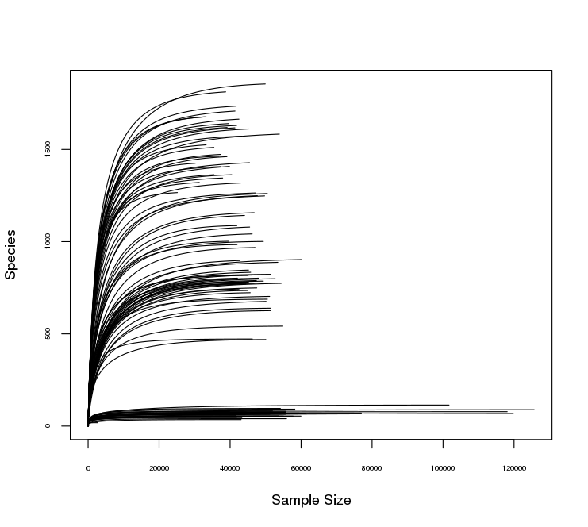
Fig. S3. Rarefaction curves of 16S rRNA gene sequences retrieved from the sequencing analysis (n=115).
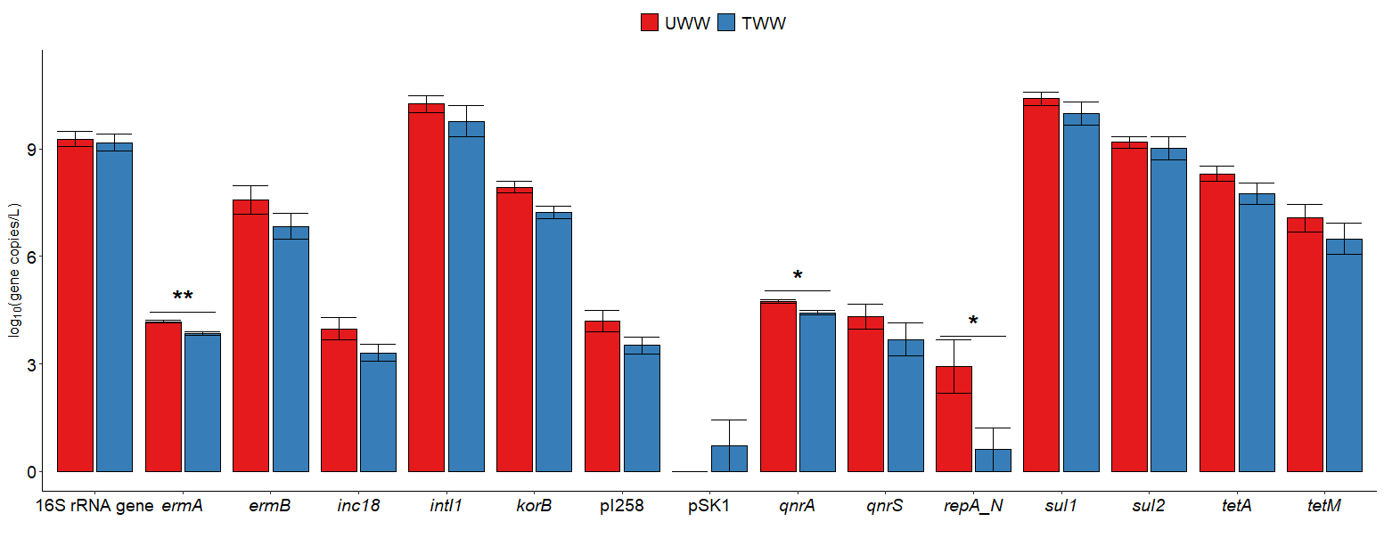
Fig. S4. Antibiotic resistance gene (ARG) and mobile genetic element (MGE) absolute abundances (log₁₀ gene copies per L) in untreated (UWW) and treated (TWW) wastewater samples. Statistical significance was assessed using Wilcoxon test. The significance levels are indicated by the following asterisks: p<0.05 (*), p<0.01 (**), and p<0.001 (***).
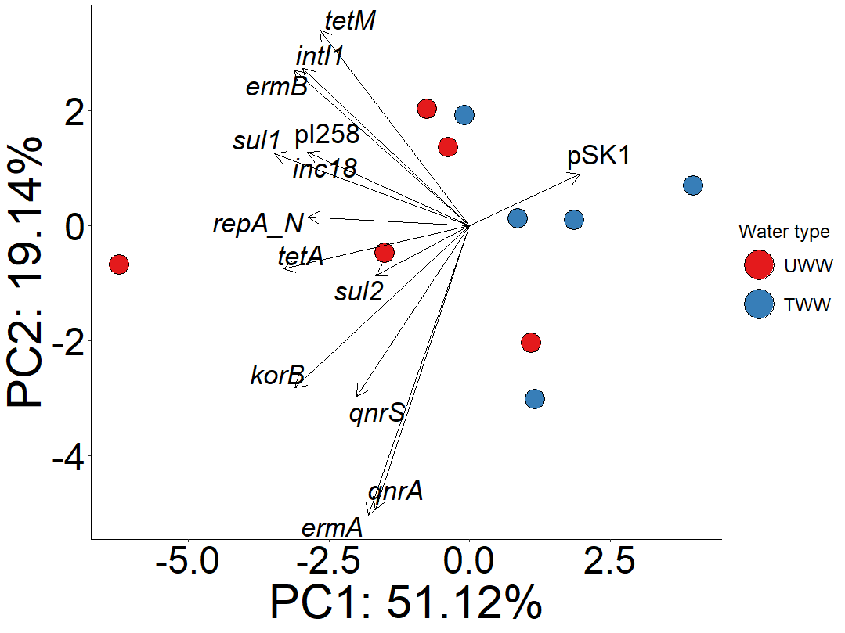
Fig. S5. Principal component analysis using antibiotic resistance gene (ARG) and mobile genetic element (MGE) relative abundances from untreated (UWW) and treated (TWW) wastewater. Significance of separation was assessed with PERMANOVA test (water type: R²=0.20, p=0.1053).

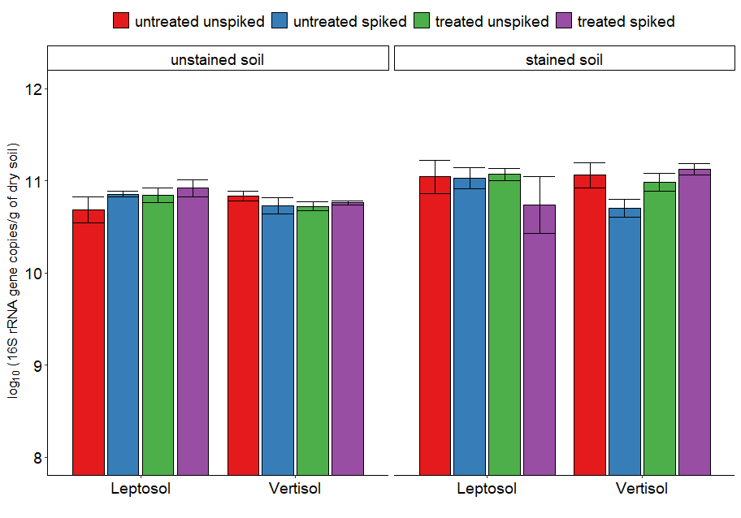
Fig. S6. 16S rRNA gene log₁₀ copies per gram of dry soil in samples from unstained soil and preferential water flow paths (stained soil) irrigated with untreated (UWW) or treated (TWW) wastewater, both unspiked and spiked with antibiotics and disinfectants. No significant differences were observed (p>0.05; linear regression with bootstrap values).

A
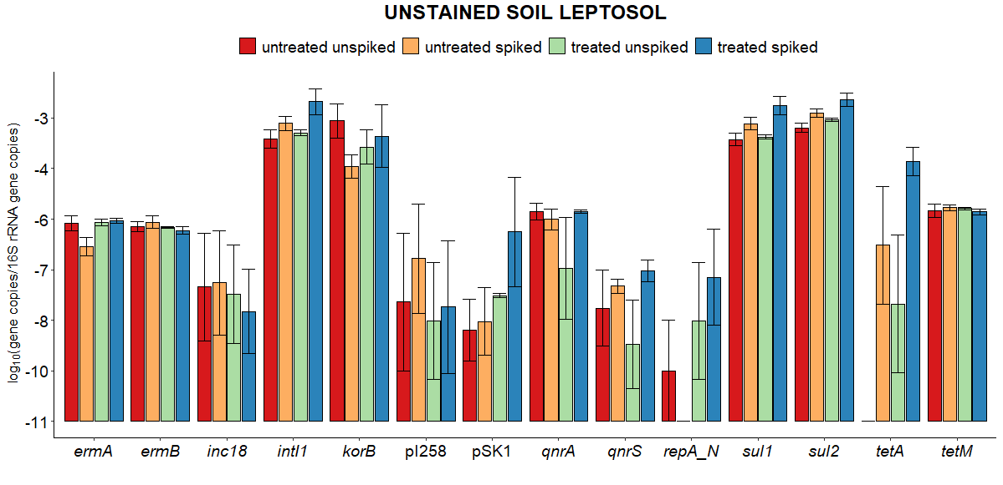
B
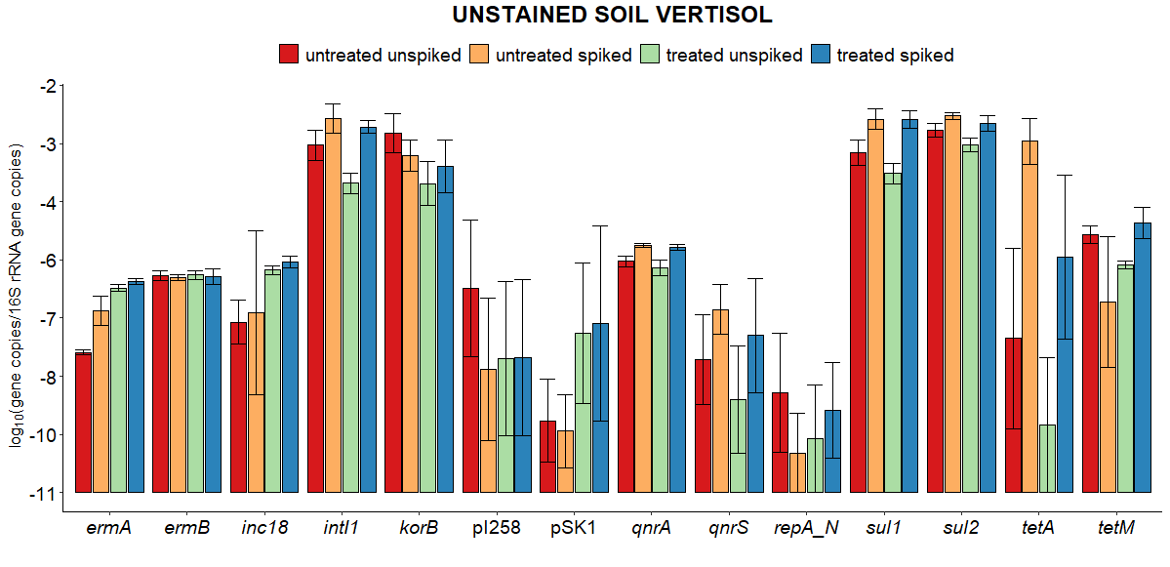

C
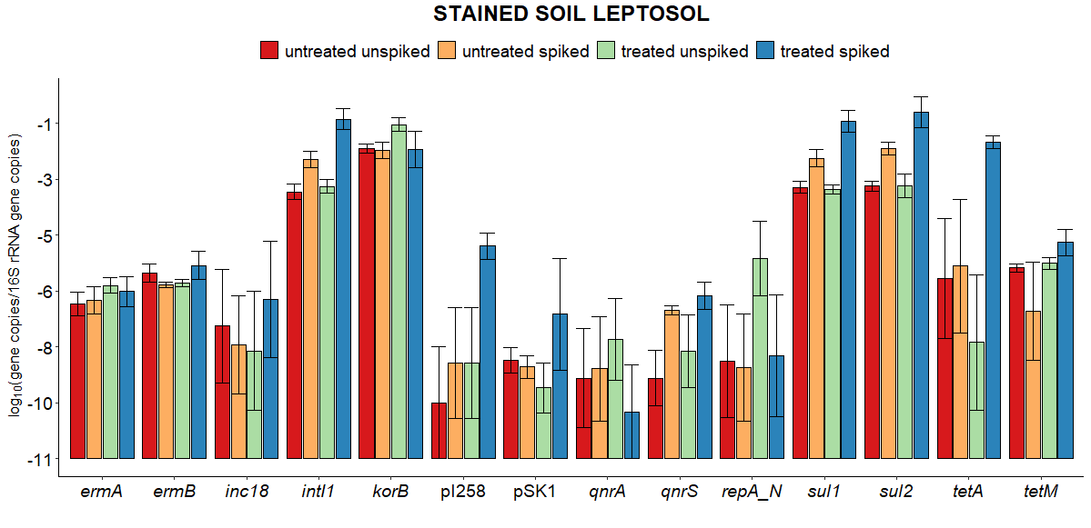
D
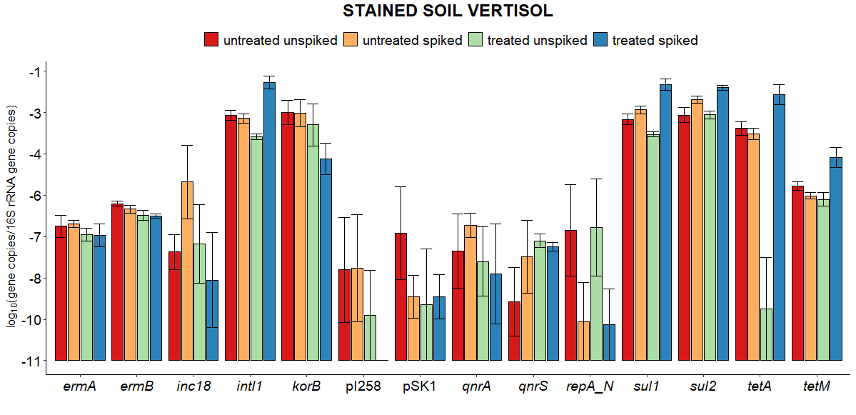

E
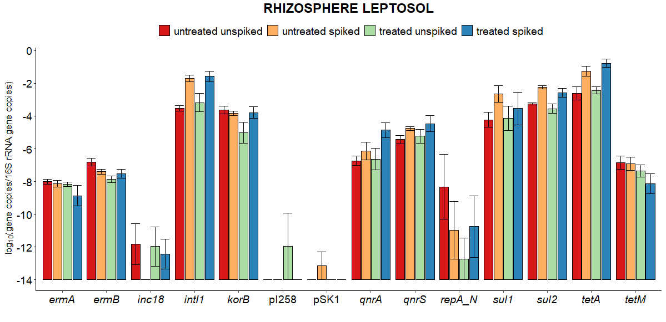
F
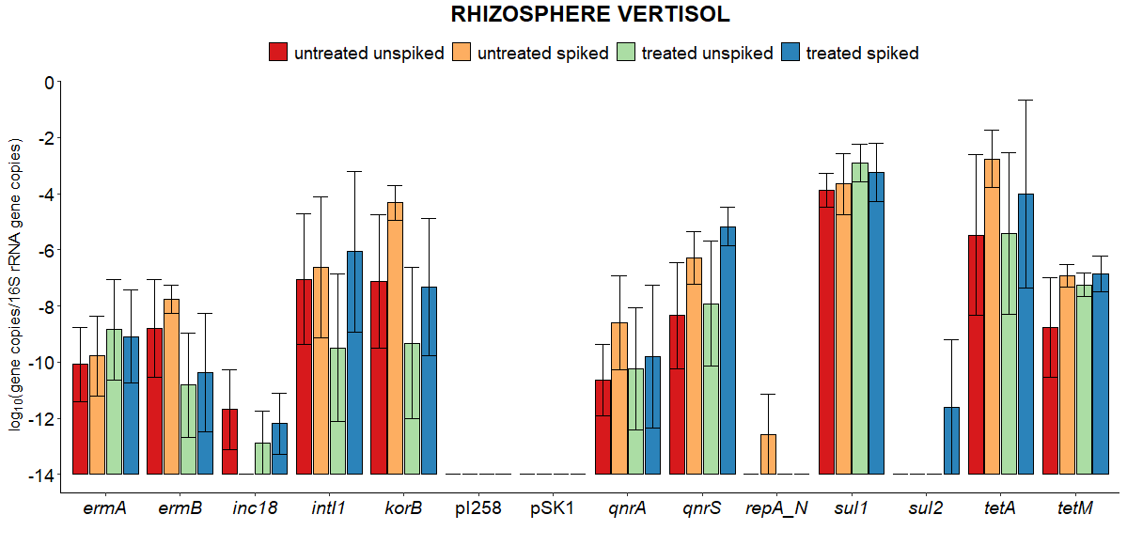

G
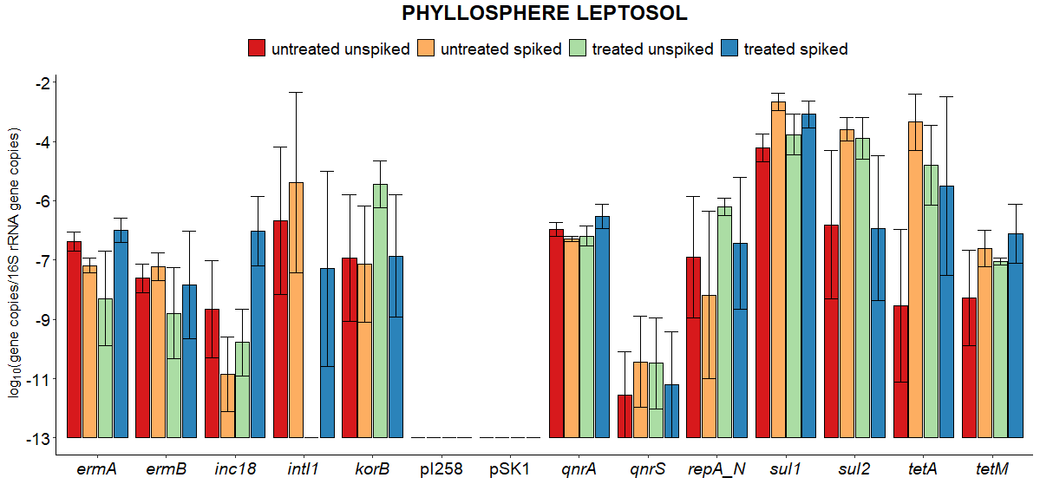
H
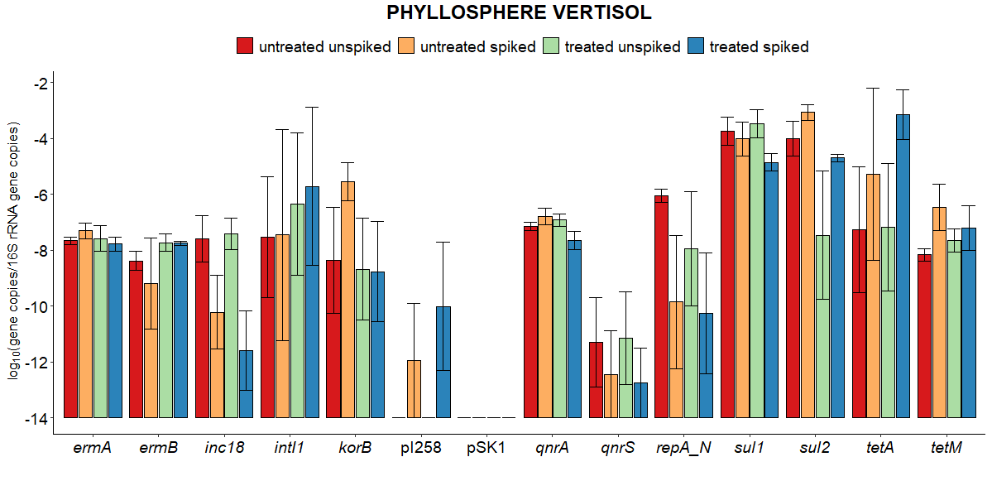
Fig. S7. Antibiotic resistance gene (ARG) and mobile genetic element (MGE) relative abundances (log₁₀ copies/16S rRNA gene copies) in A) Leptosol soil samples from unstained soil, B) Vertisol soil samples from unstained soil, C) Leptosol soil samples from preferential water flow paths (stained soil), D) Vertisol soil samples from preferential water flow paths (stained soil), E) cilantro rhizosphere from Leptosol columns, F) cilantro rhizosphere from Vertisol columns, G) cilantro phyllosphere from Leptosol columns, H) cilantro phyllosphere from Vertisol columns irrigated with untreated (UWW) or treated (TWW) wastewater, both unspiked and spiked with antibiotics and disinfectants.

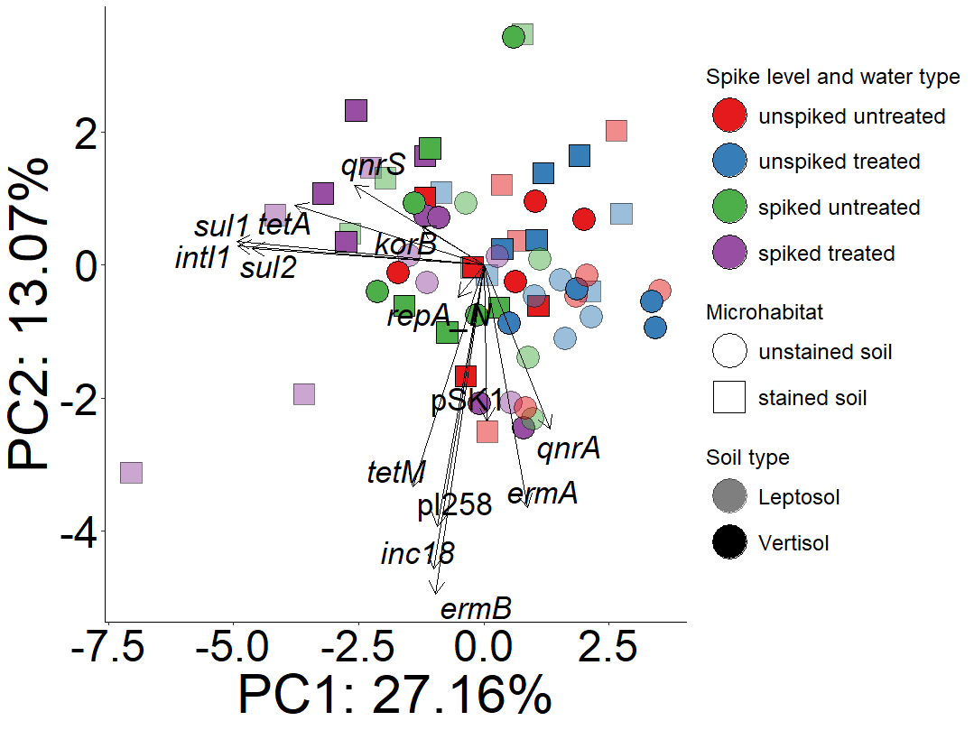

Fig. S8. Principal Component Analysis of antibiotic resistance gene (ARG) and mobile genetic element (MGE) distributions in Leptosol and Vertisol soils from unstained soil and preferential water flow paths (stained soil) irrigated with untreated (UWW) or treated (TWW) wastewater, both unspiked and spiked with antibiotics and disinfectants. Significance of separation was assessed with PERMANOVA test (microhabitat: R²=0.06, p=0.003; soil type: R²=0.02, p=0.2872; spike level: R²=0.09, p=0.0001; water type: R²=0.013, p=0.4776).

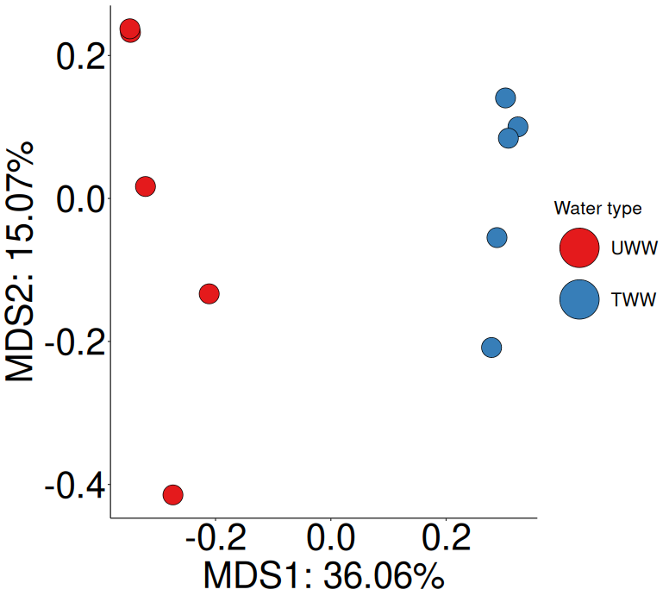
Fig. S9. Multidimensional scaling analysis performed on Bray-Curtis distance matrices from 16S rRNA gene amplicon sequencing data from untreated (UWW) and treated (TWW) wastewater. Significance of separation was assessed with PERMANOVA test (water type: R²=0.36, p=0.0081).

A
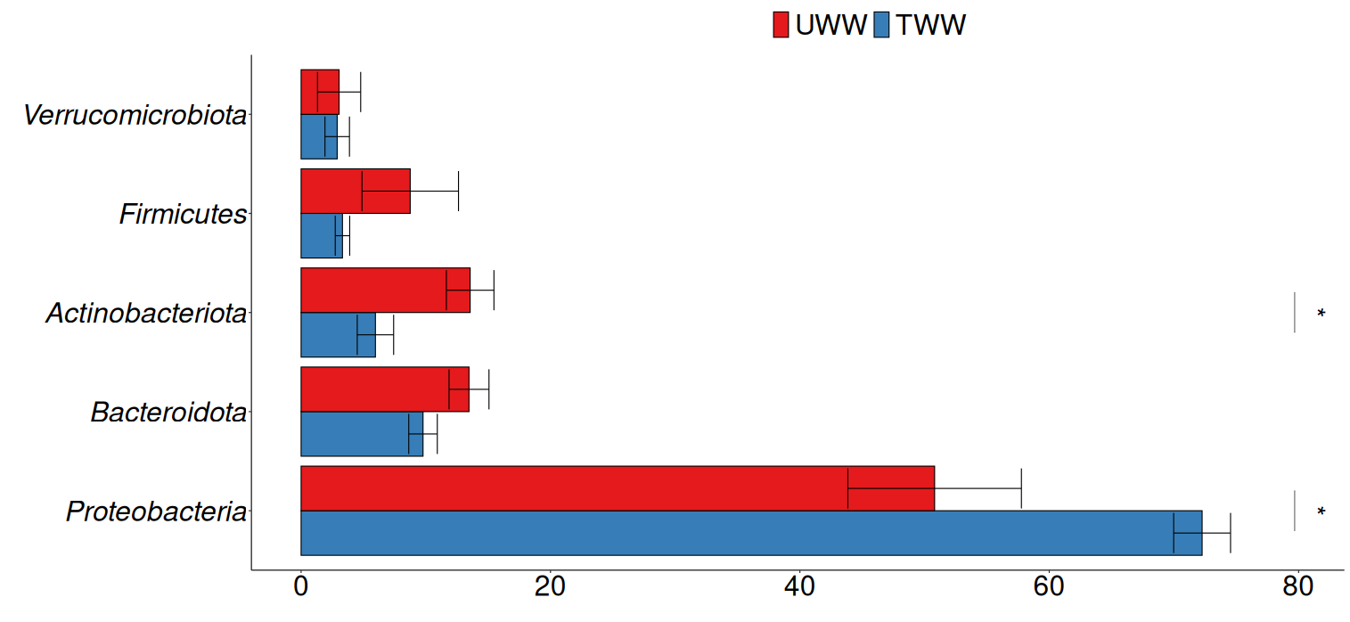
B
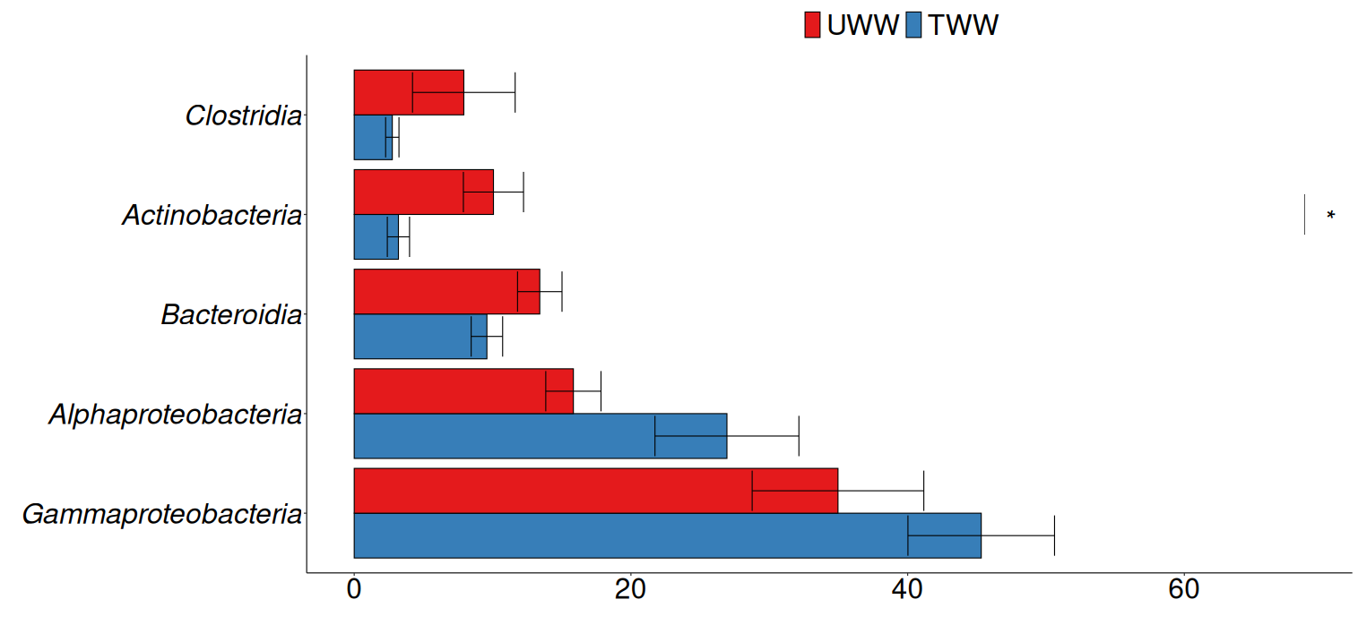
Fig. S10. Relative abundance of the five most abundant bacterial phyla (A) and classes (B) in untreated (UWW) and treated (TWW) wastewater. Statistical significance was assessed using Wilcoxon test. The significance levels are indicated by the following asterisks: p<0.05 (*), p<0.01 (**), and p<0.001 (***).
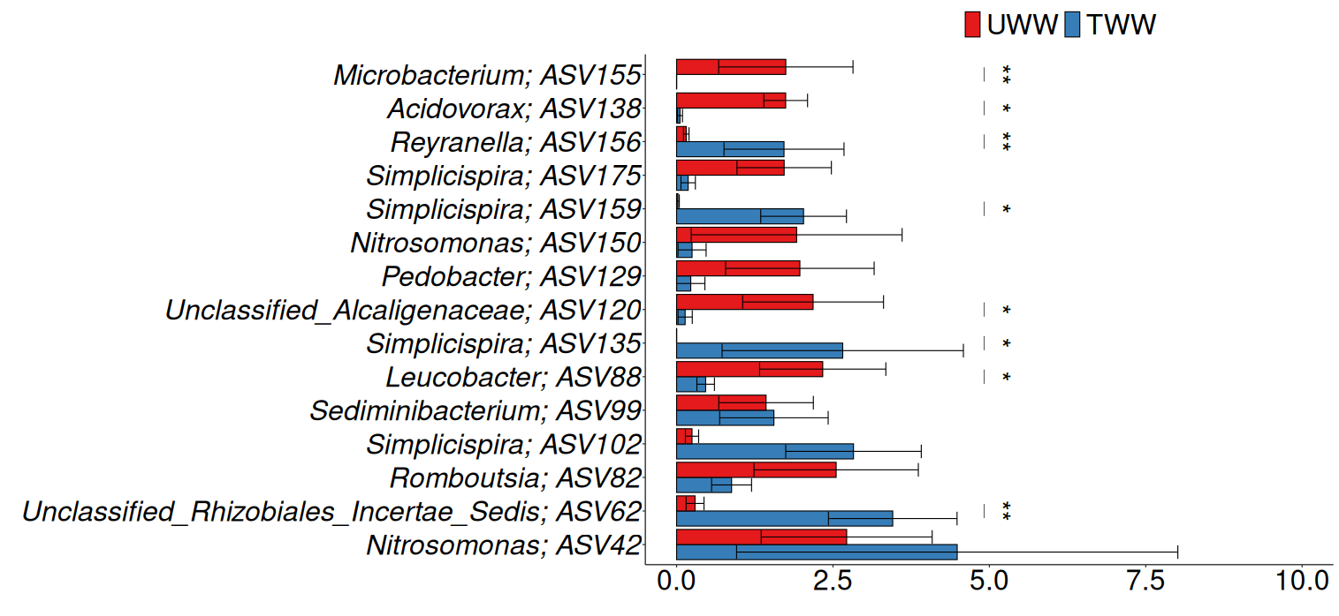
Fig. S11. Relative abundance of the 15 most abundant amplicon sequence variants (ASVs) in untreated (UWW) and treated (TWW) wastewater. Statistical significance was assessed using Wilcoxon test. The significance levels are indicated by the following asterisks: p<0.05 (*), p<0.01 (**), and p< 0.001 (***).

A
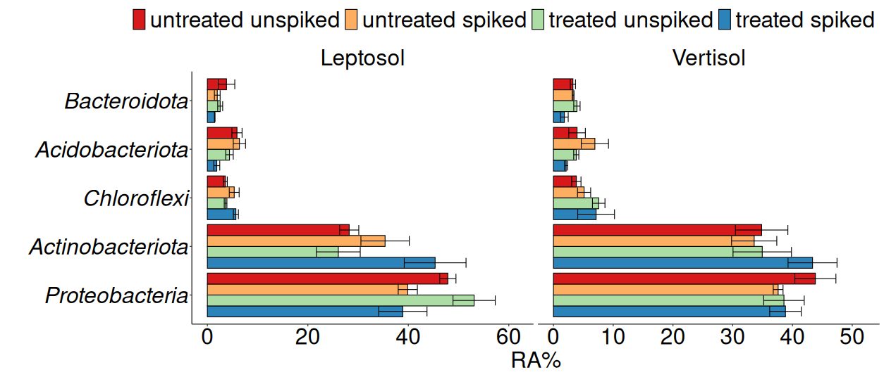
B
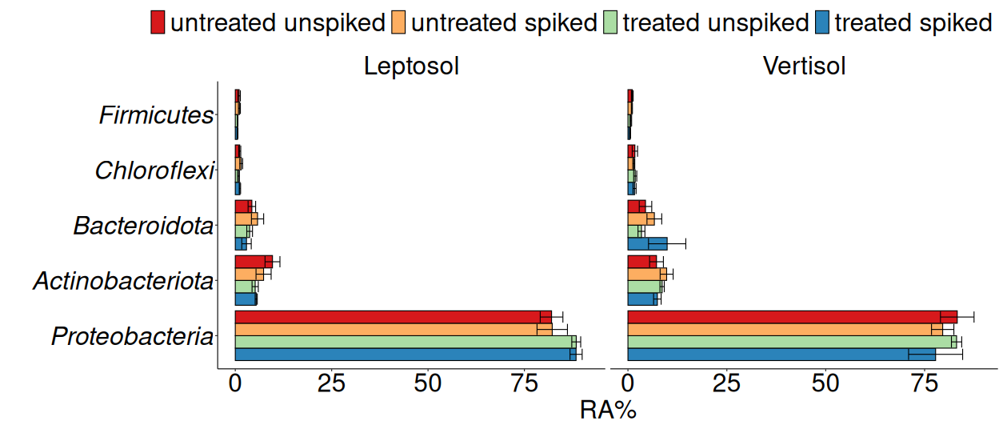
C
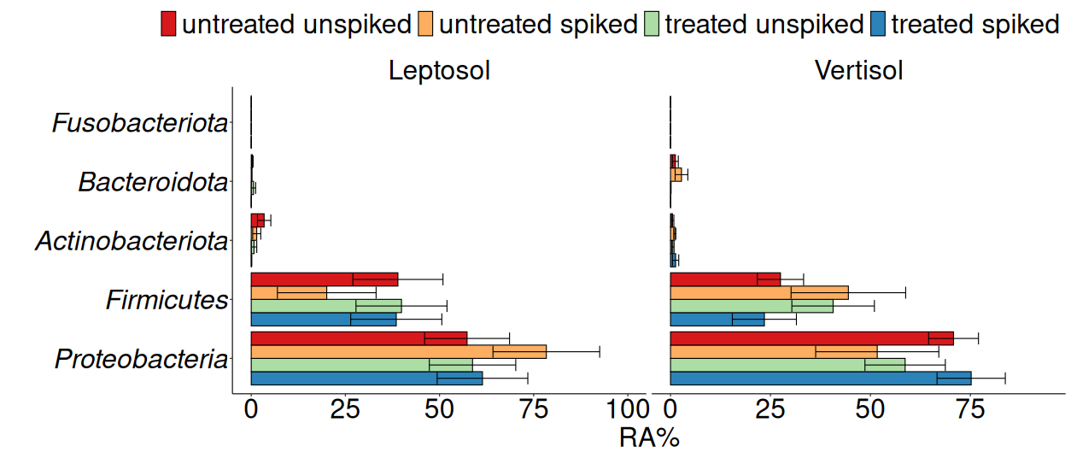
Fig. S12. Relative abundance (RA) (% reads) of the five most abundant phyla in soil from preferential water flow paths (A), rhizosphere (B), and phyllosphere (C) irrigated with untreated (UWW) and treated (TWW) wastewater, both unspiked and spiked with antibiotics and disinfectants. No significant differences were observed (p>0.05; Dunn´s test with Benjamini Hochberg adjustment).

A
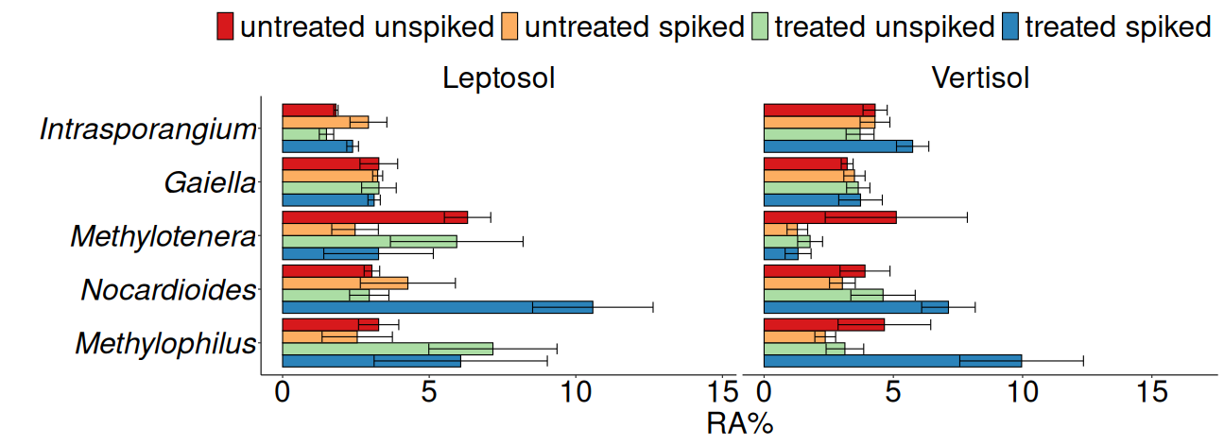
B
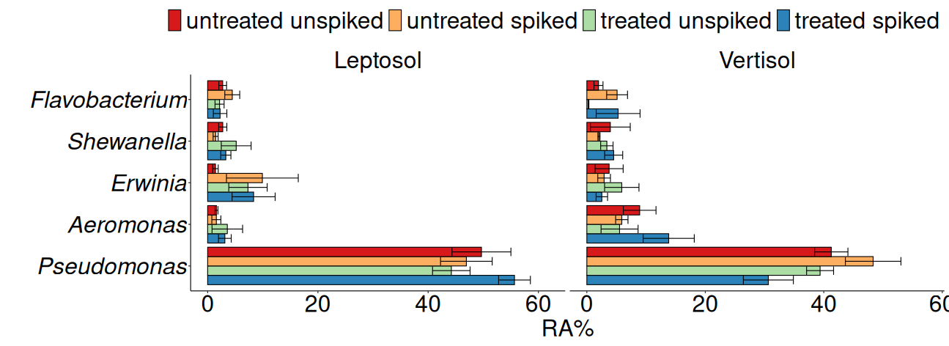

C
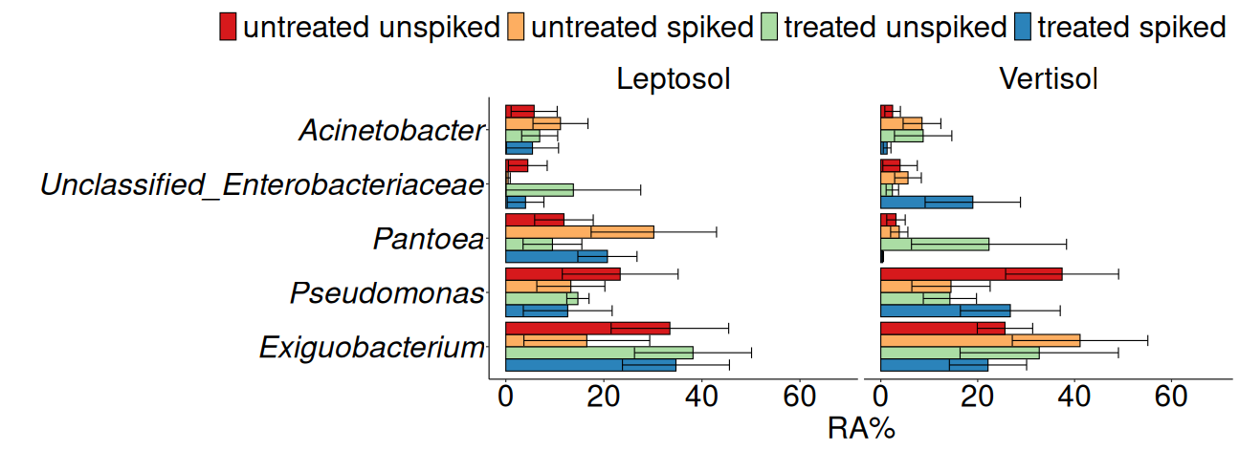
Fig. S13. Relative abundance (RA) (% reads) of the 5 most abundant genera in soil from preferential water flow paths (A), rhizosphere (B), and phyllosphere (C) irrigated with untreated (UWW) and treated (TWW) wastewater, both unspiked and spiked with antibiotics and disinfectants. No significant differences were observed (p>0.05; Dunn´s test with Benjamini Hochberg adjustment).

References
Barraud, O., Baclet, M.C., Denis, F., Ploy, M.C., 2010. Quantitative multiplex real-time PCR for detecting class 1, 2 and 3 integrons. J. Antimicrob. Chemother. 65, 1642–1645. https://doi.org/10.1093/jac/dkq167
Böckelmann, U., Dörries, H.H., Ayuso-Gabella, M.N., De Marçay, M.S., Tandoi, V., Levantesi, C., Masciopinto, C., Houtte, E. Van, Szewzyk, U., Wintgens, T., Grohmann, E., 2009. Quantitative PCR monitoring of antibiotic resistance genes and bacterial pathogens in three European artificial groundwater recharge systems. Appl. Environ. Microbiol. 75, 154–163. https://doi.org/10.1128/AEM.01649-08
Guarddon, M., Miranda, J.M., Rodríguez, J.A., Vázquez, B.I., Cepeda, A., Franco, C.M., 2011. Real-time polymerase chain reaction for the quantitative detection of tetA and tetB bacterial tetracycline resistance genes in food. Int. J. Food Microbiol. 146, 284–289. https://doi.org/10.1016/j.ijfoodmicro.2011.02.026
Heuer, H., Smalla, K., 2007. Manure and sulfadiazine synergistically increased bacterial antibiotic resistance in soil over at least two months. Environ. Microbiol. 9, 657–666. https://doi.org/10.1111/J.1462-2920.2006.01185.X
Jechalke, S., Dealtry, S., Smalla, K., Heuer, H., 2013a. Quantification of IncP-1 Plasmid Prevalence in Environmental Samples. Appl. Environ. Microbiol. 79, 1410–1413. https://doi.org/10.1128/AEM.03728-12
Jechalke, S., Kopmann, C., Rosendahl, I., Groeneweg, J., Weichelt, V., Krögerrecklenfort, E., Brandes, N., Nordwig, M., Ding, G.C., Siemens, J., Heuer, H., Smalla, K., 2013b. Increased abundance and transferability of resistance genes after field application of manure from sulfadiazine-treated pigs. Appl. Environ. Microbiol. 79, 1704–1711. https://doi.org/https://doi.org/10.1128/AEM.03172-12
Marti, E., Balcázar, J.L., 2013. Real-time PCR assays for quantification of qnr genes in environmental water samples and chicken feces. Appl. Environ. Microbiol. 79, 1743–1745. https://doi.org/10.1128/AEM.03409-12
Peak, N., Knapp, C.W., Yang, R.K., Hanfelt, M.M., Smith, M.S., Aga, D.S., Graham, D.W., 2007. Abundance of six tetracycline resistance genes in wastewater lagoons at cattle feedlots with different antibiotic use strategies. Environ. Microbiol. 9, 143–151. https://doi.org/10.1111/j.1462-2920.2006.01123.x
Soufi, L., Kampouris, I.D., Lüneberg, K., Heyde, B.J., Pulami, D., Glaeser, S.P., Siebe, C., Siemens, J., Smalla, K., Grohmann, E., Gallego, S., 2025. Wastewater-borne pollutants influenced antibiotic resistance genes and mobile genetic elements in the soil without affecting the bacterial community composition in a changing wastewater irrigation system. J. Hazard. Mater. 494, 138680. https://doi.org/10.1016/j.jhazmat.2025.138680
Suzuki, M.T., Taylor, L.T., DeLong, E.F., 2000. Quantitative analysis of small-subunit rRNA genes in mixed microbial populations via 5’-nuclease assays. Appl. Environ. Microbiol. 66, 4605–4614. https://doi.org/10.1128/AEM.66.11.4605-4614.2000
Werner, K.A., Schneider, D., Poehlein, A., Diederich, N., Feyen, L., Axtmann, K., Hübner, T., Brüggemann, N., Prost, K., Daniel, R., Grohmann, E., 2022. Metagenomic Insights Into the Changes of Antibiotic Resistance and Pathogenicity Factor Pools Upon Thermophilic Composting of Human Excreta. Front. Microbiol. 13. https://doi.org/10.3389/fmicb.2022.826071

