Temporal Trends and Prognostic Factors in Critically Ill Adult Patients with Acute Leukemia: An Individual Participant Data Meta-Analysis – Supplementary material
Dara Chean^{1,2}, Thibault Dupont¹, Joseph L Nates³, Nirmala K Manjappachar³, Marijana Medic⁴, Gulbin Aygencel⁵, Corentin Orvain⁶, Achille Kouatchet⁷, Ajay Sheshadri⁸, Tasmea K Haque⁸, Lene Russell⁹, Thomas Pabst¹⁰, Melda Turkoglu⁵, Marlies Ostermann¹¹, Marcio Soares¹², Tugba Cetintepe¹³, Rena Buckstein¹⁴, Nahema Issa¹⁵, Djamel Mokart¹⁶, Pedro Caruso¹⁷, Patricia Cornejo-Juarez¹⁸, David Schnell¹⁹, Tobias Lahmer²⁰, Sofiane Fodil²¹, Etienne Lengliné²¹, David Luque-Paz²², Virginie Lemiale¹, Daniele Poole^{2,22}, Michael Darmon^{1,2}, Elie Azoulay¹

¹Medical Intensive Care Unit, Saint-Louis Teaching Hospital, Paris, France
²European Society of Intensive Care Medicine (ESICM) Methodology Group, Brussels, Belgium
³Division of Anesthesiology, Critical Care, and Pain Medicine, Department of Critical Care Medicine, The University of Texas MD Anderson Cancer Center, Houston, TX
⁴Intensive Care Unit, Department of Internal Medicine, University Hospital Centre Zagreb, Zagreb, Croatia
⁵Department of Internal Medicine, Division of Intensive Care Medicine, Gazi University School of Medicine, Ankara, Turkey
⁶Maladies du Sang, CHU d'Angers, Angers, France
⁷Medical Intensive Care Unit, CHU d'Angers, Angers, France
⁸Division of Internal Medicine, Department of Pulmonary Medicine, The University of Texas MD Anderson Cancer Center, Houston, TX
⁹Copenhagen University Hospital Gentofte, Hellerup, and Department of Clinical Medicine, University of Copenhagen, Copenhagen, Denmark
¹⁰Department of Medical Oncology, Inselspital, University Hospital Bern, University of Bern, Berne, Switzerland
¹¹King's College London, Guy's & St Thomas' NHS Foundation Trust, Department of Critical Care, Westminster Bridge Road, London, UK
¹²Department of Critical Care and Postgraduate Program, D'Or Institute for Research and Education, Rio de Janeiro, Brazil
¹³Department of Hematology, Izmir Katip Celebi University, Ataturk Training and Research Hospital, Izmir, Turkey
¹⁴Odette Cancer Centre, Sunnybrook Health Sciences Centre, Toronto, ON, Canada
¹⁵Internal Medicine and Infectious Disease Unit, Groupe Saint-André, University Hospital, Bordeaux, France
¹⁶Department of Anesthesiology and Critical Care, Paoli-Calmettes Institute, Marseille, France
¹⁷Intensive Care Unit, AC Camargo Cancer Center, São Paulo, Brazil
¹⁸Department of Infectious Diseases, Instituto Nacional de Cancerología, Mexico, Mexico
¹⁹Medical-Surgical Intensive Care Unit, Angoulême Hospital, Angoulême, France
²⁰Technical University Munich (TUM) School of Medicine and Health, Department of Clinical Medicine - Clinical Department for Internal Medicine II, University Medical Center, TUM, Munich, Germany
²¹Hematology Department, Saint-Louis Teaching Hospital, Paris, France
²²Infectious Diseases and Intensive Care Unit, Pontchaillou University Hospital, Rennes, France
²³Operative Unit of Anesthesia and Intensive Care, S. Martino Hospital, Belluno, Italy

Correspondence to:
Professor Elie Azoulay,
Medical Intensive Care Unit, AP-HP, Saint-Louis Hospital, Paris-Cité University
INSERM UMR1342 Institut de Recherche Saint-Louis
1 avenue Claude Vellefaux, 75010 Paris, FRANCE
Phone: +33 142 499 421 Fax: +33 142 499 426
E-mail: elie.azoulay@aphp.fr

Summary - Tables
Table S1. Preferred Reporting Items for Systematic Review and Meta- Analysis of Individual Participant Data (PRISMA-IPD) checklist. 7
Table S2. Full systematic search string. 11
Table S3. Summary of the 29 included studies. 12
Table S4. Quality assessment of the 29 studies that included patients in the individual participant data meta-analysis using the Newcastle-Ottawa Scale (NOS) for cohort studies.(31) The thresholds provided by the NIH (National Institutes of Health, https://www.ncbi.nlm.nih.gov/books/NBK115843/bin/appe-fm3.pdf) were used to convert the Newcastle-Ottawa scale to AHRQ (Agency for Healthcare Research and Quality). Of the 29 included studies, 11 studies were graded as “good quality” as they had 3 or 4 stars in selection domain AND 1 or 2 stars in comparability domain AND 2 or 3 stars in outcome domain. Other 18 studies were graded as “fair quality” as they had 2 stars in selection domain AND 1 or 2 stars in comparability domain AND 2 or 3 stars in outcome domain. 19
Table S5. Demographic characteristics of acute leukemia patients who required invasive mechanical ventilation. 23
Table S6. Results of the mixed-effects logistic regression model in the overall population of critically ill acute leukemia patients. Each predictor is detailed with its different categories for categorical variables. ICU denotes for intensive care unit. 24
Table S7. Results of the mixed-effects logistic regression model in patients who required invasive mechanical ventilation. Each predictor is detailed with its different categories for categorical variables. ICU denotes for intensive care unit. 24
Table S8. Measurement of goodness of fit across the different models. In a sensitivity analysis we treated year of ICU admission and patient age as continuous variables. For overall population and intubated patients, both Akaike information criterion (AIC), and bayesian information criterion (BIC) were lower in the main model. 25
Table 9. Table summarizing the calculation of variance inflation factor (VIF) across the different models. VIF values greater than 5 indicate potential multicollinearity among predictors. Variables in our models showed low collinearity. 25

Summary - Figures
Figure S1. Patient age repartition stratified on year of intensive care unit (ICU) admission, in the overall population. Proportions of elderly patients (aged > 65 years) were significantly higher after 2010. P-value was calculated using Fisher’s exact test. 27
Figure S2. Boxplot representing the patient age distribution stratified on year of intensive care unit (ICU) admission, in the overall population. Patient age was significantly higher after (median 59 years (interquartile range 49-68)) than before 2010 (51 years (38-62)). P-value was calculated using Wilcoxon rank sum test. 27
Figure S3. Patient age repartition stratified on year of intensive care unit (ICU) admission, in patients who required invasive mechanical ventilation. Proportions of elderly patients (aged > 65 years) were significantly higher after 2010. P-value was calculated using Fisher’s exact test. 28
Figure S4. Boxplot representing the patient age distribution stratified on year of intensive care unit (ICU) admission, in patients who required invasive mechanical ventilation. Patient age was significantly higher after (median 58 years (interquartile range 47-67)) than before 2010 (51 years (38-62)). P-value was calculated using Wilcoxon rank sum test. 28
Figure S5. Repartition of palliative patients stratified on year of intensive care unit (ICU) admission. Palliative were defined as patients who died in the ICU without being intubated. Other patients are referred as “full code ICU” patients. The proportion of palliative patients was significantly higher after than before 2010. P-value was calculated using Fisher’s exact test. 29
Figure S6. Repartition of patients who required invasive mechanical ventilation stratified according to year of intensive care unit (ICU) admission. There was no significant difference between patients admitted before versus after 2010. P-value was calculated using Fisher’s exact test. 29
Figure S7. Crude intensive care unit (ICU) mortality in high-income and upper-middle countries. ICU mortality was lower in high-income countries. P-value was calculated using Fisher’s exact test. 30
Figure S8. Crude intensive care unit (ICU) mortality of intubated patients in high-income and upper-middle countries. ICU mortality was lower in high-income countries. P-value was calculated using Fisher’s exact test. 30
Figure S9. Visual representation of the association between intensive care unit (ICU) mortality, age, and year of admission, in the overall population. This representation was modeled using a spline regression model. Patients admitted before 2010 and patients admitted after 2010 are modeled in blue and orange with confidence intervals, respectively. 31
Figure S10. Visual representation of intensive care unit (ICU) mortality across the years in patients who required invasive mechanical ventilation. This representation was modeled using a spline regression model. Confidence intervals are represented. 31
Figure S11. Forest plots of results from mixed-effects logistic regression models. In these sensitivity analyses, age and year of Intensive care unit (ICU) were modeled as continuous variables. ICU of origin was modeled as a random variable with random intercept. Results are represented as log odds ratios (OR) with their 95% confidence intervals (95% CI) in the forest plot. OR with their 95% CI are presented in the right part of each panel. Panel A presents the results for all included patients. Panel B presents the results for patients who required invasive mechanical ventilation. P-value < 0.05 indicates that the explanatory variable is associated with ICU mortality. 32
Figure S12. Receiver operating characteristic (ROC) curves for each mixed-effects logistic regression model. ROC curve of model for the overall population and for intubated patients are represented in blue and red, respectively. Areas under the curve (AUC) are presented on the top of each ROC curve. P-value were calculated using the Homer-Lemeshow test (H-L test). P-values < 0.05 indicates a poor goodness of fit. Panel A and Panel B represent ROC curves for models using age and year of intensive care unit (ICU) admission as categorical variables. Panel C and Panel D represent ROC curves for models using age and year of ICU admission as continuous variables. 33

Table S1. Preferred Reporting Items for Systematic Review and Meta- Analysis of Individual Participant Data (PRISMA-IPD) checklist.
PRISMA-IPD  Section/topic | Item No | Checklist item | Reported on page
Title
Title | 1 | Identify the report as a systematic review and meta-analysis of individual participant data. | 1
Abstract
Structured summary | 2 | Provide a structured summary including as applicable: | 4
Structured summary | 2 | Background: state research question and main objectives, with information on participants, interventions, comparators and outcomes. | 4
Structured summary | 2 | Methods: report eligibility criteria; data sources including dates of last bibliographic search or elicitation, noting that IPD were sought; methods of assessing risk of bias. | 4
Structured summary | 2 | Results: provide number and type of studies and participants identified and number (%) obtained; summary effect estimates for main outcomes (benefits and harms) with confidence intervals and measures of statistical heterogeneity. Describe the direction and size of summary effects in terms meaningful to those who would put findings into practice. | 4
Structured summary | 2 | Discussion: state main strengths and limitations of the evidence, general interpretation of the results and any important implications. | 4
Structured summary | 2 | Other: report primary funding source, registration number and registry name for the systematic review and IPD meta-analysis. | 4
Introduction
Rationale | 3 | Describe the rationale for the review in the context of what is already known. | 6
Objectives | 4 | Provide an explicit statement of the questions being addressed with reference, as applicable, to participants, interventions, comparisons, outcomes and study design (PICOS). Include any hypotheses that relate to particular types of participant-level subgroups. | 7
Methods
Protocol and registration | 5 | Indicate if a protocol exists and where it can be accessed. If available, provide registration information including registration number and registry name. Provide publication details, if applicable. | 8
Eligibility criteria | 6 | Specify inclusion and exclusion criteria including those relating to participants, interventions, comparisons, outcomes, study design and characteristics (e.g. years when conducted, required minimum follow-up). Note whether these were applied at the study or individual level i.e. whether eligible participants were included (and ineligible participants excluded) from a study that included a wider population than specified by the review inclusion criteria. The rationale for criteria should be stated. | 8
Identifying studies - information sources | 7 | Describe all methods of identifying published and unpublished studies including, as applicable: which bibliographic databases were searched with dates of coverage; details of any hand searching including of conference proceedings; use of study registers and agency or company databases; contact with the original research team and experts in the field; open adverts and surveys. Give the date of last search or elicitation. | 8
Identifying studies - search | 8 | Present the full electronic search strategy for at least one database, including any limits used, such that it could be repeated. | Table S2
Study selection processes | 9 | State the process for determining which studies were eligible for inclusion. | 8
Data collection processes | 10 | Describe how IPD were requested, collected and managed, including any processes for querying and confirming data with investigators. If IPD were not sought from any eligible study, the reason for this should be stated (for each such study). | 9
Data collection processes | 10 | If applicable, describe how any studies for which IPD were not available were dealt with. This should include whether, how and what aggregate data were sought or extracted from study reports and publications (such as extracting data independently in duplicate) and any processes for obtaining and confirming these data with investigators. | 9
Data items | 11 | Describe how the information and variables to be collected were chosen. List and define all study level and participant level data that were sought, including baseline and follow-up information. If applicable, describe methods of standardising or translating variables within the IPD datasets to ensure common scales or measurements across studies. | 9
IPD integrity | A1 | Describe what aspects of IPD were subject to data checking (such as sequence generation, data consistency and completeness, baseline imbalance) and how this was done. | 9
Risk of bias assessment in individual studies. | 12 | Describe methods used to assess risk of bias in the individual studies and whether this was applied separately for each outcome. If applicable, describe how findings of IPD checking were used to inform the assessment. Report if and how risk of bias assessment was used in any data synthesis. | 8
Specification of outcomes and effect measures | 13 | State all treatment comparisons of interests. State all outcomes addressed and define them in detail. State whether they were pre-specified for the review and, if applicable, whether they were primary/main or secondary/additional outcomes. Give the principal measures of effect (such as risk ratio, hazard ratio, difference in means) used for each outcome. | 9
Synthesis methods | 14 | Describe the meta-analysis methods used to synthesise IPD. Specify any statistical methods and models used. Issues should include (but are not restricted to):  - Use of a one-stage or two-stage approach.  - How effect estimates were generated separately within each study and combined across studies (where applicable).  - Specification of one-stage models (where applicable) including how clustering of patients within studies was accounted for.  - Use of fixed or random effects models and any other model assumptions, such as proportional hazards.  - How (summary) survival curves were generated (where applicable).  - Methods for quantifying statistical heterogeneity (such as I² and τ²).  - How studies providing IPD and not providing IPD were analysed together (where applicable).  - How missing data within the IPD were dealt with (where applicable). | 10
Exploration of variation in effects | A2 | If applicable, describe any methods used to explore variation in effects by study or participant level characteristics (such as estimation of interactions between effect and covariates). State all participant-level characteristics that were analysed as potential effect modifiers, and whether these were pre-specified. | 10
Risk of bias across studies | 15 | Specify any assessment of risk of bias relating to the accumulated body of evidence, including any pertaining to not obtaining IPD for particular studies, outcomes or other variables. | 10
Additional analyses | 16 | Describe methods of any additional analyses, including sensitivity analyses. State which of these were pre-specified. | 10
Results
Study selection and IPD obtained | 17 | Give numbers of studies screened, assessed for eligibility, and included in the systematic review with reasons for exclusions at each stage. Indicate the number of studies and participants for which IPD were sought and for which IPD were obtained. For those studies where IPD were not available, give the numbers of studies and participants for which aggregate data were available. Report reasons for non-availability of IPD. Include a flow diagram. | 12
Study characteristics | 18 | For each study, present information on key study and participant characteristics (such as description of interventions, numbers of participants, demographic data, unavailability of outcomes, funding source, and if applicable duration of follow-up). Provide (main) citations for each study. Where applicable, also report similar study characteristics for any studies not providing IPD. | Table S3
IPD integrity | A3 | Report any important issues identified in checking IPD or state that there were none. | 12
Risk of bias within studies | 19 | Present data on risk of bias assessments. If applicable, describe whether data checking led to the up-weighting or down-weighting of these assessments. Consider how any potential bias impacts on the robustness of meta-analysis conclusions. | Table S4
Results of individual studies | 20 | For each comparison and for each main outcome (benefit or harm), for each individual study report the number of eligible participants for which data were obtained and show simple summary data for each intervention group (including, where applicable, the number of events), effect estimates and confidence intervals. These may be tabulated or included on a forest plot. | Table S3
Results of syntheses | 21 | Present summary effects for each meta-analysis undertaken, including confidence intervals and measures of statistical heterogeneity. State whether the analysis was pre-specified, and report the numbers of studies and participants and, where applicable, the number of events on which it is based. | Chean et al.(1)
Results of syntheses | 21 | When exploring variation in effects due to patient or study characteristics, present summary interaction estimates for each characteristic examined, including confidence intervals and measures of statistical heterogeneity. State whether the analysis was pre-specified. State whether any interaction is consistent across trials. | Chean et al.(1)
Results of syntheses | 21 | Provide a description of the direction and size of effect in terms meaningful to those who would put findings into practice. | Chean et al.(1)
Risk of bias across studies | 22 | Present results of any assessment of risk of bias relating to the accumulated body of evidence, including any pertaining to the availability and representativeness of available studies, outcomes or other variables. | Table S4
Additional analyses | 23 | Give results of any additional analyses (e.g. sensitivity analyses). If applicable, this should also include any analyses that incorporate aggregate data for studies that do not have IPD. If applicable, summarise the main meta-analysis results following the inclusion or exclusion of studies for which IPD were not available. | 15
Discussion
Summary of evidence | 24 | Summarise the main findings, including the strength of evidence for each main outcome. | 16
Strengths and limitations | 25 | Discuss any important strengths and limitations of the evidence including the benefits of access to IPD and any limitations arising from IPD that were not available. | 16
Conclusions | 26 | Provide a general interpretation of the findings in the context of other evidence. | 17
Implications | A4 | Consider relevance to key groups (such as policy makers, service providers and service users). Consider implications for future research. | 17
Funding
Funding | 27 | Describe sources of funding and other support (such as supply of IPD), and the role in the systematic review of those providing such support. | 27

Table S2. Full systematic search string.
 | Search string
PubMed | ((((((((((("leukemia"[MeSH Terms]) AND ("intensive care units"[MeSH Terms])) OR (("leukemia"[MeSH Terms]) AND ("critical care"[MeSH Terms]))) OR (("hematologic neoplasms"[MeSH Terms]) AND ("intensive care units"[MeSH Terms]))) OR (("hematologic neoplasms"[MeSH Terms]) AND ("critical care"[MeSH Terms]))) OR (("hematologic diseases"[MeSH Terms]) AND ("intensive care units"[MeSH Terms]))) OR (("hematologic diseases"[MeSH Terms]) AND ("critical care"[MeSH Terms])) AND ((fha[Filter]) AND (2000:2022[pdat]))) NOT ("child"[MeSH Terms]) AND ((fha[Filter]) AND (english[Filter]))) NOT ("review"[Filter]) AND ((fha[Filter]) AND (english[Filter]))) NOT ("meta-analysis"[Filter]) AND ((fha[Filter]) AND (english[Filter]))) NOT ("blood transfusion"[MeSH Major Topic]) AND ((fha[Filter]) AND (english[Filter]))) NOT ("blood coagulation"[MeSH Major Topic])

Table S3. Summary of the 29 included studies.
Title | First author | Publication year | N centers | Participating centers | First admission | Last admission | Patients with acute leukemia | Non alloHSCT | ICU deaths
Predictors of noninvasive ventilation failure in patients with hematologic malignancy and acute respiratory failure(2) | M. Adda | 2008 | 1 | SaintLouis | 1995 | 2005 | 38 | 0 | 16
Deterioration of previous acute lung injury during neutropenia recovery(3) | E. Azoulay | 2002 | 1 | SaintLouis | 1991 | 2000 | 43 | 0 | 23
The Prognosis of Acute Respiratory Failure in Critically Ill Cancer Patients(4) | E. Azoulay | 2004 | 1 | SaintLouis | 1993 | 2002 | 62 | 52 | 29
Dexamethasone in patients with acute lung injury from acute monocytic leukaemia(5) | E. Azoulay | 2012 | 1 | SaintLouis | 1993 | 2008 | 40 | 40 | 14
Outcomes of Critically Ill Patients With Hematologic Malignancies: Prospective Multicenter Data From France and Belgium—A Groupe de Recherche Respiratoire en Réanimation Onco-Hématologique Study(6) | E. Azoulay | 2013 | 17 | SaintLouis, HotelDieu, Versailles, Avicennes, LaRocheSurYon, Cochin, Nancy, Marseille, Angers, PitieSalpetriere, Brest, Grenoble, SaintEtienne, Roubaix, Lille, Bruxelles, Gand | 2009 | 2011 | 356 | 286 | 105
Determinants of 1-year survival in critically ill acute leukemia patients: a GRRR-OH study(7) | M. Tavares | 2018 | 41 | SaintLouis, Marseille, Cochin, Bruxelles, Barcelona, Prague, Dublin, Pilsen, MayoClinic, Hershey, Versailles, Roubaix, Palma, Helsinki, Caen, Nimegue, KingsCollege, Copenhague, Odense, Groningue, Tempere, Grenoble, Orleans, PitieSalpetriere, Rouen, Oslo, Toronto, Vienne, Amsterdam, SaoLuis, Rio, SaoPaulo, Rome, Gand, Lyon, Lille, Nantes, Maastricht, Trondheim, Angers, Montpellier | 2015 | 2016 | 260 | 182 | 175
Predictors of intensive care unit admission in patients with hematologic malignancy(8) | A. Vijenthira | 2020 | 1 | Toronto | 2009 | 2015 | 44 | 44 | 13
Hospital-acquired infections at an oncological intensive care cancer unit: differences between solid and hematological cancer patients(9) | P. Cornejo-Juarez | 2016 | 1 | Mexico | 2013 | 2014 | 23 | 22 | 11
Intensive care in patients with newly diagnosed malignancies and a need for cancer chemotherapy(10) | M. Darmon | 2005 | 1 | SaintLouis | 1997 | 2003 | 36 | 36 | 14
Molecular detection of respiratory viruses in immunocopromised ICU patients: Incidence and meaning(11) | D. Schnell | 2012 | 1 | SaintLouis | NA | NA | 21 | 17 | 3
Improved survival rates of AML patients following admission to the intensive care unit(12) | P. Fassbind | 2019 | 1 | Berne | 2006 | 2017 | 76 | 72 | 20
Prognostic factors in critically ill cancer patients admitted to the intensive care unit(13) | G. Aygencel | 2014 | 1 | Ankara | NA | NA | 35 | 22 | 24
Can treating critically-ill haematological malignancy patients in a separate intensive care unit decrease intensive care unit mortality?(14) | G. Aygencel | 2021 | 1 | Ankara | NA | NA | 123 | 76 | 62
Comparison of 1,3-β-D-glucan with galactomannan in serum and bronchoalveolar fluid for the detection of Aspergillus species in immunosuppressed mechanical ventilated critically ill patients(15) | T. Lahmer | 2016 | 1 | Munich | 2014 | 2015 | 2 | 2 | 2
Survival in neutropenic patients with severe sepsis or septic shock(16) | M. Legrand | 2012 | 1 | SaintLouis | 1998 | 2009 | 152 | 126 | 58
Sepsis and Septic Shock in Patients With Malignancies: A Groupe de Recherche Respiratoire en Réanimation Onco-Hématologique Study(17) | V. Lemiale | 2020 | 20 | SaintLouis, Marseille, Avicennes, IGR, Nantes, Cochin, Brest, Grenoble, Rouen, Bruxelles, Versailles, Amiens, Caen, LaRocheSurYon, Orleans, Gand, Lyon, Roubaix, PitieSalpetriere, Angers | 2005 | 2015 | 250 | 190 | 76
Intensive care unit management of patients with newly diagnosed acute myeloid leukemia with no organ failure(18) | E. Lengliné | 2012 | 1 | SaintLouis | 1998 | 2009 | 62 | 62 | 30
Characteristics and outcomes of patients with cancer requiring admission to intensive care units: A prospective multicenter study(19) | M. Soares | 2010 | NA | NA | 2007 | 2007 | 13 | 10 | 8
Outcomes in Critically Ill Patients with Cancer-Related Complications(20) | V. Torres | 2016 | 1 | Rio | 1999 | 2007 | 42 | 41 | 28
Hematologic malignancies in the medical intensive care unit – Outcomes and prognostic factors(21) | M. Grgic Medic | 2015 | 1 | Zagreb | 2011 | 2013 | 165 | 130 | 91
ICU and 6-month outcome of oncology patients in the intensive care unit(22) | S. McGrath | 2010 | 1 | GuysStThomas | 2004 | 2008 | 56 | 44 | 17
Outcomes and Predictors of 28-Day Mortality in Patients With Hematologic Malignancies and Septic Shock Defined by Sepsis-3 Criteria(23) | N. Manjappachar | 2022 | 1 | Bordeaux | 2012 | 2016 | 256 | 190 | 14
Long-term prognosis of septic shock in cancer patients(24) | F. Camou | 2020 | 1 | Houston | 2016 | 2019 | 31 | 22 | 176
Outcome of patients with newly diagnosed AML admitted to the ICU, including preemptive admission – a multi‐center study(25) | C. Desprez | 2023 | 1 | Angers | 2017 | 2020 | 101 | 101 | 18
Impact of Urgent Chemotherapy in Critically Ill Patients(26) | M. de Oliveira | 2020 | 1 | SaoPaulo | 2010 | 2019 | 24 | 15 | 10
Prediction of bleeding and thrombosis by standard biochemical coagulation variables in haematological intensive care patients(27) | L. Russell | 2017 | 1 | Copenhague | 2008 | 2012 | 89 | 58 | 52
Progression of the Radiologic Severity Index is associated with increased mortality and healthcare resource utilisation in acute leukaemia patients with pneumonia(28) | A. Sheshadri | 2019 | 1 | Houston | NA | NA | 97 | 75 | 33
Determination of the relationship between mortality and SOFA, qSOFA, MASCC scores in febrile neutropenic patients monitored in the intensive care unit(29) | T. Cetintepe | 2021 | 1 | Izmir | 2015 | 2018 | 45 | 43 | 45
Acute respiratory distress syndrome in patients with hematological malignancies(30) | M. Turkoglu | 2013 | 1 | Ankara | 2007 | 2011 | 71 | 45 | 51

Table S4. Quality assessment of the 29 studies that included patients in the individual participant data meta-analysis using the Newcastle-Ottawa Scale (NOS) for cohort studies.(31) The thresholds provided by the NIH (National Institutes of Health, https://www.ncbi.nlm.nih.gov/books/NBK115843/bin/appe-fm3.pdf) were used to convert the Newcastle-Ottawa scale to AHRQ (Agency for Healthcare Research and Quality). Of the 29 included studies, 11 studies were graded as “good quality” as they had 3 or 4 stars in selection domain AND 1 or 2 stars in comparability domain AND 2 or 3 stars in outcome domain. Other 18 studies were graded as “fair quality” as they had 2 stars in selection domain AND 1 or 2 stars in comparability domain AND 2 or 3 stars in outcome domain.
 |  |  | Selection |  |  |  | Comparability | Outcome
Title | First author | Publication year | Representativeness | Selection of the non-exposed cohort | Ascertainment | Outcome not present at start |  | Assessment | Follow-up | Adequacy of follow-up
Predictors of noninvasive ventilation failure in patients with hematologic malignancy and acute respiratory failure | M. Adda | 2008 |  | * | * | * | * |  | *
Deterioration of previous acute lung injury during neutropenia recovery | E. Azoulay | 2002 |  | * | * | * | * |  | *
The Prognosis of Acute Respiratory Failure in Critically Ill Cancer Patients | E. Azoulay | 2004 | * | * | * | * | * |  | *
Dexamethasone in patients with acute lung injury from acute monocytic leukaemia | E. Azoulay | 2012 |  | * | * | * | * | * | * | *
Outcomes of Critically Ill Patients With Hematologic Malignancies: Prospective Multicenter Data From France and Belgium—A Groupe de Recherche Respiratoire en Réanimation Onco-Hématologique Study | E. Azoulay | 2013 | * | * | * | * | * | * | * | *
Determinants of 1-year survival in critically ill acute leukemia patients: a GRRR-OH study | M. Tavares | 2018 | * | * | * | * | * | * | * | *
Predictors of intensive care unit admission in patients with hematologic malignancy | A. Vijenthira | 2020 |  | * | * | * | * |  | *
Hospital-acquired infections at an oncological intensive care cancer unit: differences between solid and hematological cancer patients | P. Cornejo-Juarez | 2016 |  | * | * | * | * |  | *
Intensive care in patients with newly diagnosed malignancies and a need for cancer chemotherapy | M. Darmon | 2005 |  | * | * | * | * |  | *
Molecular detection of respiratory viruses in immunocopromised ICU patients: Incidence and meaning | D. Schnell | 2012 |  | * | * | * | * |  | *
Improved survival rates of AML patients following admission to the intensive care unit | P. Fassbind | 2019 | * | * | * | * | * | * | * | *
Prognostic factors in critically ill cancer patients admitted to the intensive care unit | G. Aygencel | 2014 |  | * | * | * | * | * | * | *
Can treating critically-ill haematological malignancy patients in a separate intensive care unit decrease intensive care unit mortality? | G. Aygencel | 2021 | * | * | * | * | * |  | *
Comparison of 1,3-β-D-glucan with galactomannan in serum and bronchoalveolar fluid for the detection of Aspergillus species in immunosuppressed mechanical ventilated critically ill patients | T. Lahmer | 2016 |  | * | * | * | * |  | *
Survival in neutropenic patients with severe sepsis or septic shock | M. Legrand | 2012 | * | * | * | * | * |  | *
Sepsis and Septic Shock in Patients With Malignancies: A Groupe de Recherche Respiratoire en Réanimation Onco-Hématologique Study* | V. Lemiale | 2020 | * | * | * | * | * |  | *
Intensive care unit management of patients with newly diagnosed acute myeloid leukemia with no organ failure | E. Lengliné | 2012 |  | * | * | * | * | * | * | *
Characteristics and outcomes of patients with cancer requiring admission to intensive care units: A prospective multicenter study | M. Soares | 2010 |  | * | * | * | * |  | *
Outcomes in Critically Ill Patients with Cancer-Related Complications | V. Torres | 2016 |  | * | * | * | * |  | *
Hematologic malignancies in the medical intensive care unit – Outcomes and prognostic factors | M. Grgic Medic | 2015 | * | * | * | * | * | * | * | *
ICU and 6-month outcome of oncology patients in the intensive care unit | S. McGrath | 2010 | * | * | * | * | *
Outcomes and Predictors of 28-Day Mortality in Patients With Hematologic Malignancies and Septic Shock Defined by Sepsis-3 Criteria | N. Manjappachar | 2022 | * | * | * | * | * | * | * | *
Long-term prognosis of septic shock in cancer patients | F. Camou | 2020 |  | * | * | * | *
Outcome of patients with newly diagnosed AML admitted to the ICU, including preemptive admission – a multi‐center study | C. Desprez | 2023 | * | * | * | * | * | * | * | *
Impact of Urgent Chemotherapy in Critically Ill Patients | M. de Oliveira | 2020 |  | * | * | * | *
Prediction of bleeding and thrombosis by standard biochemical coagulation variables in haematological intensive care patients | L. Russell | 2017 | * | * | * | * | *
Progression of the Radiologic Severity Index is associated with increased mortality and healthcare resource utilisation in acute leukaemia patients with pneumonia | A. Sheshadri | 2019 | * | * | * | * | *
Determination of the relationship between mortality and SOFA, qSOFA, MASCC scores in febrile neutropenic patients monitored in the intensive care unit | T. Cetintepe | 2021 |  | * | * | * | * | * | * | *
Acute respiratory distress syndrome in patients with hematological malignancies | M. Turkoglu | 2013 | * | * | * | * | * | * | * | *

Table S5. Demographic characteristics of acute leukemia patients who required invasive mechanical ventilation.
 | Missing values¹ | Patients requiring invasive mechanical ventilation  (n = 1090)¹
Age, years | 3 (0.3%) | 57 (43 - 66)
Age > 65 years | 3 (0.3%) | 301 (28%)
Male patients | 4 (0.4%) | 645 (59%)
Acute leukemia type | 0 (0%)
ALL |  | 149 (14%)
AML |  | 801 (73%)
Not specified |  | 140 (13%)
Acute leukemia status | 109 (10%)
Consolidation or Remission |  | 219 (22%)
Diagnosis or Induction |  | 622 (63%)
Relapse or Refractory |  | 140 (14%)
Year of admission | 152 (14%)
Before 2010 |  | 315 (34%)
After 2010 |  | 623 (66%)
Time from diagnosis to ICU admission, days | 526 (48%) | 25 (5 - 114)
SOFA score at ICU admission | 206 (19%) | 10.0 (7.0 - 13.0)
Main reason of ICU admission | 86 (7.9%)
Respiratory |  | 601 (60%)
Shock |  | 287 (29%)
Monitoring |  | 27 (2.7%)
Neurologic |  | 48 (4.8%)
Renal or Metabolic |  | 23 (2.3%)
Other |  | 18 (1.8%)
WBC count at ICU admission | 174 (16%) | 1 (0 - 14)
Neutropenia at ICU admission | 1 (<0.1%) | 480 (44%)
Need for vasopressors | 48 (4.4%) | 815 (78%)
Need for RRT | 30 (2.8%) | 322 (30%)
ICU mortality | 2 (0.2%) | 714 (66%)
¹Median (Q1 - Q3); n (%)
ALL, acute lymphoblastic leukemia; AML, acute myeloid leukemia; ICU, intensive care unit; SOFA, sepsis-related organ failure assessment; RRT, renal replacement therapy; WBC, white blood cell

Table S6. Results of the mixed-effects logistic regression model in the overall population of critically ill acute leukemia patients. Each predictor is detailed with its different categories for categorical variables. ICU denotes for intensive care unit.
Characteristic | OR | 95% CI | p-value
Acute myeloid leukemia | 1.65 | 1.22, 2.23 | < 0.01
Acute leukemia status
Consolidation or Remission | — | —
Diagnosis or Induction | 1.58 | 1.16, 2.13 | < 0.01
Relapse or Refractory | 1.87 | 1.25, 2.79 | < 0.01
Age at ICU admission
≤ 65 years | — | —
> 65 years | 1.71 | 1.31, 2.23 | < 0.01
Year of admission
Before 2010 | — | —
After 2010 | 0.83 | 0.55, 1.24 | 0.36
Need for life-sustaining therapy
0 | — | —
1 | 6.97 | 5.02, 9.69 | < 0.01
Abbreviations: CI = Confidence Interval, OR = Odds Ratio
CI, confidence intervals; ICU, intensive care unit; OR, odds ratio

Table S7. Results of the mixed-effects logistic regression model in patients who required invasive mechanical ventilation. Each predictor is detailed with its different categories for categorical variables. ICU denotes for intensive care unit.
Characteristic | OR | 95% CI | p-value
Acute myeloid leukemia | 1.20 | 0.80, 1.80 | 0.38
Acute leukemia status
Consolidation or Remission | — | —
Diagnosis or Induction | 1.54 | 1.04, 2.27 | 0.031
Relapse or Refractory | 2.93 | 1.60, 5.37 | < 0.01
Age at ICU admission
≤ 65 years | — | —
> 65 years | 1.78 | 1.21, 2.61 | < 0.01
Year of admission
Before 2010 | — | —
After 2010 | 0.60 | 0.37, 0.98 | 0.040
Need for vasopressors or RRT
0 | — | —
1 | 2.87 | 1.87, 4.40 | < 0.01
Abbreviations: CI = Confidence Interval, OR = Odds Ratio
CI, confidence intervals; ICU, intensive care unit; OR, odds ratio

Table S8. Measurement of goodness of fit across the different models. In a sensitivity analysis we treated year of ICU admission and patient age as continuous variables. For overall population and intubated patients, both Akaike information criterion (AIC), and Bayesian information criterion (BIC) were lower in the main model.
 | All patients |  | Intubated patients
 | AIC | BIC | AIC | BIC
Age and Year of admission treated as dichotomous variables (main model) | 1785.559 | 1828.123 | 979.683 | 1017.120
Age and Year of admission treated as continuous variables (sensitivity analysis) | 1797.191 | 1839.755 | 980.073 | 1017.510
AIC, Akaike information criterion; BIC, Bayesian information criterion

Table 9. Table summarizing the calculation of variance inflation factor (VIF) across the different models. VIF values greater than 5 indicate potential multicollinearity among predictors. Variables in our models showed low collinearity.
Term | VIF | VIF_CI_low | VIF_CI_high | SE_factor | Tolerance | Tolerance_CI_low | Tolerance_CI_high
Age and year of ICU admission as categorical variables, overall population
AML | 1,03135 | 1,005736 | 1,171343 | 1,015554 | 0,969603 | 0,853721 | 0,994297
Status | 1,017589 | 1,000922 | 1,33568 | 1,008756 | 0,982715 | 0,748682 | 0,999079
Age | 1,015378 | 1,000535 | 1,442046 | 1,007659 | 0,984855 | 0,693459 | 0,999465
YearAdmission | 1,023681 | 1,002582 | 1,217172 | 1,011771 | 0,976866 | 0,821577 | 0,997424
LifeSustainingTherapy | 1,018652 | 1,00115 | 1,302624 | 1,009283 | 0,98169 | 0,767681 | 0,998852
Age and year of ICU admission as categorial variables, intubated patients
AML | 1,046592 | 1,009308 | 1,233217 | 1,023031 | 0,955483 | 0,810888 | 0,990778
Status | 1,027888 | 1,002074 | 1,37496 | 1,013848 | 0,972869 | 0,727294 | 0,99793
Age | 1,017429 | 1,000296 | 2,026401 | 1,008677 | 0,98287 | 0,493486 | 0,999704
YearAdmission | 1,027599 | 1,002 | 1,380765 | 1,013705 | 0,973142 | 0,724236 | 0,998004
VasopressorsOrRRT | 1,013905 | 1,000087 | 3,221916 | 1,006928 | 0,986286 | 0,310374 | 0,999913
Age and year of ICU admission as continuous variables, overall population
AML | 1,013901 | 1,000342 | 1,564912 | 1,006926 | 0,98629 | 0,639014 | 0,999658
Status | 1,019252 | 1,00129 | 1,287257 | 1,00958 | 0,981111 | 0,776845 | 0,998711
Age | 1,011515 | 1,000134 | 1,987365 | 1,005741 | 0,988616 | 0,503179 | 0,999866
YearAdmission | 1,001769 | 1 | 3,88E+09 | 1,000884 | 0,998234 | 2,58E-10 | 1
LifeSustainingTherapy | 1,012009 | 1,000167 | 1,861152 | 1,005986 | 0,988134 | 0,537302 | 0,999833
Age and year of ICU admission as continuous variables, intubated patients
AML | 1,02939 | 1,002479 | 1,348454 | 1,014588 | 0,97145 | 0,74159 | 0,997527
Status | 1,029679 | 1,002561 | 1,343962 | 1,014731 | 0,971177 | 0,744068 | 0,997446
Age | 1,009239 | 1,000005 | 18,85776 | 1,004609 | 0,990845 | 0,053029 | 0,999995
YearAdmission | 1,000359 | 1 | Inf | 1,000179 | 0,999641 | 0 | 1
VasopressorsOrRRT | 1,009997 | 1,000009 | 12,00298 | 1,004986 | 0,990102 | 0,083313 | 0,999991
AML, acute myeloid leukemia; CI, confidence intervals; ICU, intensive care unit; RRT, renal replacement therapy; VIF, variance inflation factor

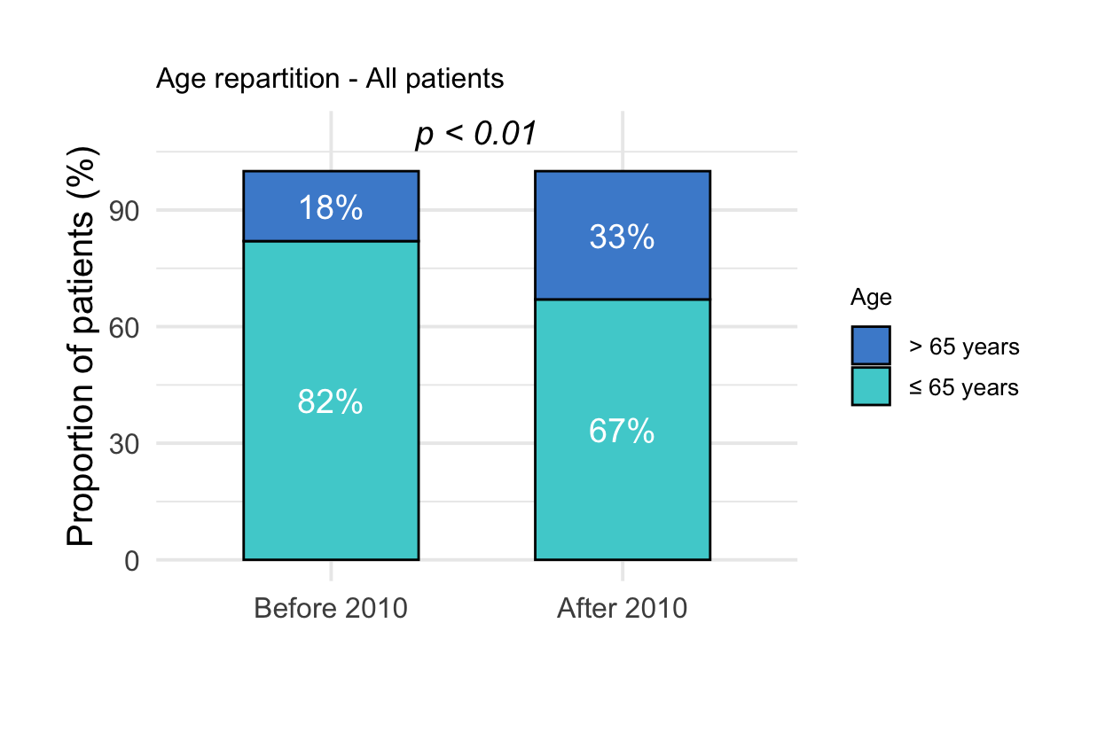
Figure S1. Patient age repartition stratified on year of intensive care unit (ICU) admission, in the overall population. Proportions of elderly patients (aged > 65 years) were significantly higher after 2010. P-value was calculated using Fisher’s exact test.
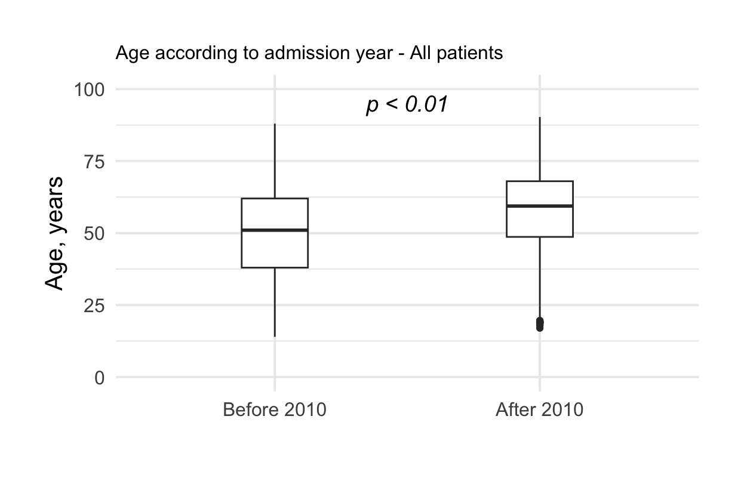
Figure S2. Boxplot representing the patient age distribution stratified on year of intensive care unit (ICU) admission, in the overall population. Patient age was significantly higher after (median 59 years (interquartile range 49-68)) than before 2010 (51 years (38-62)). P-value was calculated using Wilcoxon rank sum test.
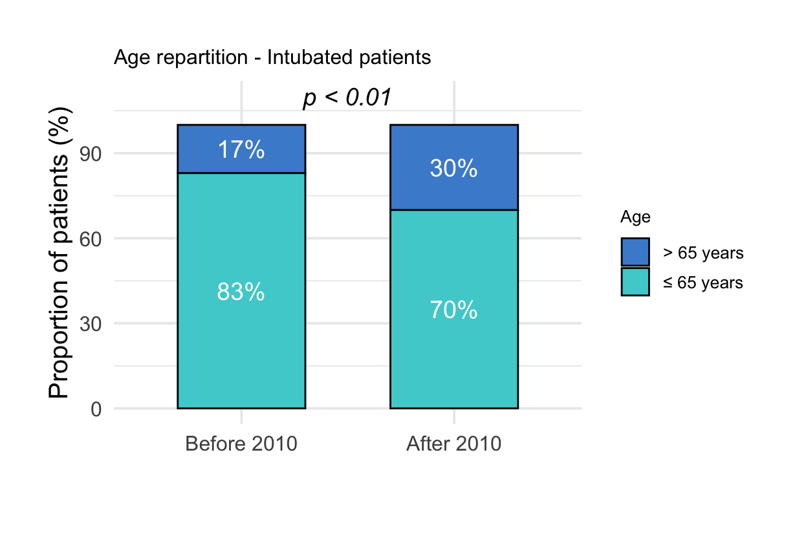
Figure S3. Patient age repartition stratified on year of intensive care unit (ICU) admission, in patients who required invasive mechanical ventilation. Proportions of elderly patients (aged > 65 years) were significantly higher after 2010. P-value was calculated using Fisher’s exact test.

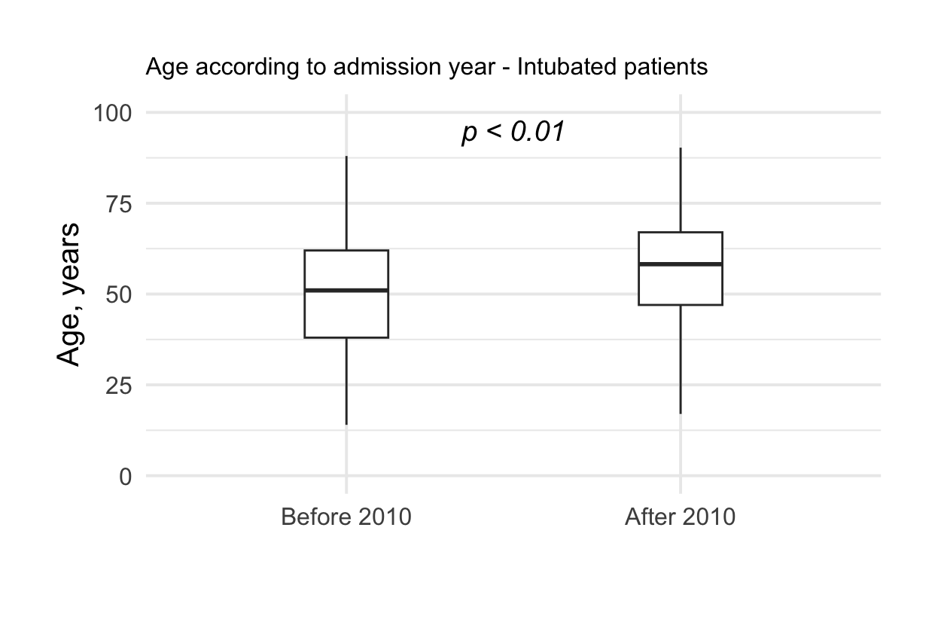
Figure S4. Boxplot representing the patient age distribution stratified on year of intensive care unit (ICU) admission, in patients who required invasive mechanical ventilation. Patient age was significantly higher after (median 58 years (interquartile range 47-67)) than before 2010 (51 years (38-62)). P-value was calculated using Wilcoxon rank sum test.
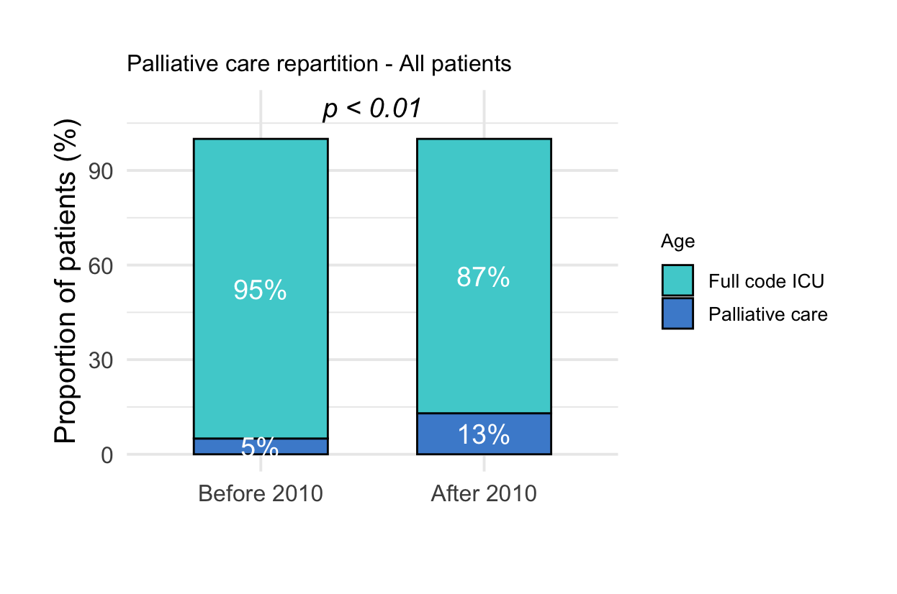
Figure S5. Repartition of palliative patients stratified on year of intensive care unit (ICU) admission. Palliative were defined as patients who died in the ICU without being intubated. Other patients are referred as “full code ICU” patients. The proportion of palliative patients was significantly higher after than before 2010. P-value was calculated using Fisher’s exact test.

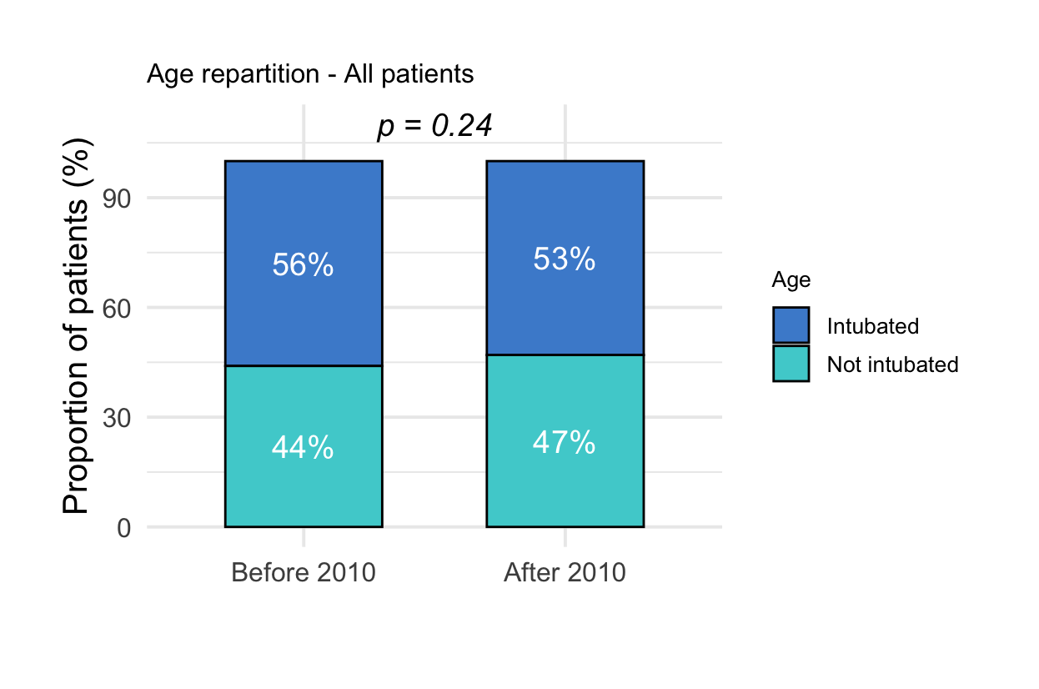
Figure S6. Repartition of patients who required invasive mechanical ventilation stratified according to year of intensive care unit (ICU) admission. There was no significant difference between patients admitted before versus after 2010. P-value was calculated using Fisher’s exact test.
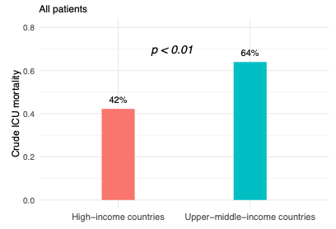
Figure S7. Crude intensive care unit (ICU) mortality in high-income and upper-middle countries. ICU mortality was lower in high-income countries. P-value was calculated using Fisher’s exact test.

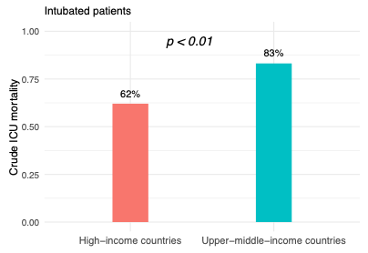
Figure S8. Crude intensive care unit (ICU) mortality of intubated patients in high-income and upper-middle countries. ICU mortality was lower in high-income countries. P-value was calculated using Fisher’s exact test.

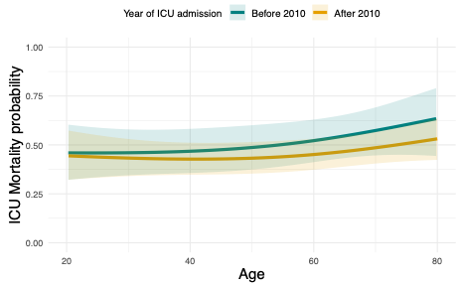
Figure S9. Visual representation of the association between intensive care unit (ICU) mortality, age, and year of admission, in the overall population. This representation was modeled using a spline regression model. Patients admitted before 2010 and patients admitted after 2010 are modeled in blue and orange with confidence intervals, respectively.

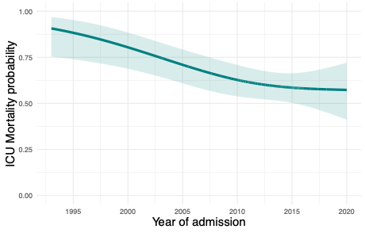
Figure S10. Visual representation of intensive care unit (ICU) mortality across the years in patients who required invasive mechanical ventilation. This representation was modeled using a spline regression model. Confidence intervals are represented.

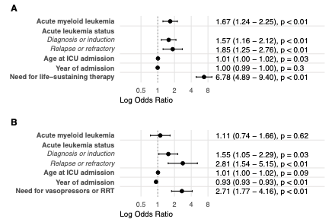
Figure S11. Forest plots of results from mixed-effects logistic regression models. In these sensitivity analyses, age and year of intensive care unit (ICU) were modeled as continuous variables. Center of ICU admission was modeled as a random variable with random intercept. Results are represented as odds ratios (OR) with 95% confidence intervals (95% CI) using a log scale in the forest plot. OR with their 95% CI are presented on the right-side part of each panel. Panel A presents the results for all included patients. Panel B presents the results for patients who required invasive mechanical ventilation. P-value < 0.05 indicates that the explanatory variable is associated with ICU mortality. RRT stands for renal replacement therapy.

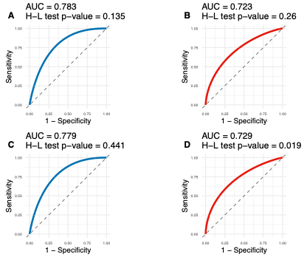
Figure S12. Receiver operating characteristic (ROC) curves for each mixed-effects logistic regression model. ROC curve of model for the overall population and for intubated patients are represented in blue and red, respectively. Areas under the curve (AUC) are presented on the top of each ROC curve. P-value were calculated using the Homer-Lemeshow test (H-L test). P-values < 0.05 indicates a poor goodness of fit. Panel A and Panel B represent ROC curves for models using age and year of intensive care unit (ICU) admission as categorical variables. Panel C and Panel D represent ROC curves for models using age and year of ICU admission as continuous variables.

References
1. Chean D, Luque-Paz D, Poole D, Fodil S, Lengliné E, Dupont T, et al. Critically ill adult patients with acute leukemia: a systematic review and meta-analysis. Ann Intensive Care. 2025 Jan 16;15(1):9.
2. Adda M, Coquet I, Darmon M, Thiery G, Schlemmer B, Azoulay E. Predictors of noninvasive ventilation failure in patients with hematologic malignancy and acute respiratory failure. Crit Care Med. 2008 Oct;36(10):2766–72.
3. Azoulay E, Darmon M, Delclaux C, Fieux F, Bornstain C, Moreau D, et al. Deterioration of previous acute lung injury during neutropenia recovery. Crit Care Med. 2002 Apr;30(4):781–6.
4. Azoulay É, Thiéry G, Chevret S, Moreau D, Darmon M, Bergeron A, et al. The prognosis of acute respiratory failure in critically ill cancer patients. Medicine (Baltimore). 2004 Nov;83(6):360–70.
5. Azoulay É, Canet E, Raffoux E, Lengliné E, Lemiale V, Vincent F, et al. Dexamethasone in patients with acute lung injury from acute monocytic leukaemia. Eur Respir J. 2012 Mar;39(3):648–53.
6. Azoulay E, Mokart D, Pène F, Lambert J, Kouatchet A, Mayaux J, et al. Outcomes of critically ill patients with hematologic malignancies: prospective multicenter data from France and Belgium--a groupe de recherche respiratoire en réanimation onco-hématologique study. J Clin Oncol. 2013 Aug 1;31(22):2810–8.
7. Tavares M, Lemiale V, Mokart D, Pène F, Lengliné E, Kouatchet A, et al. Determinants of 1-year survival in critically ill acute leukemia patients: a GRRR-OH study. Leuk Lymphoma. 2018;59(6):1323–31.
8. Vijenthira A, Chiu N, Jacobson D, Freedman Z, Cheung MC, Goddard S, et al. Predictors of intensive care unit admission in patients with hematologic malignancy. Sci Rep. 2020 Dec 3;10(1):21145.
9. Cornejo-Juárez P, Vilar-Compte D, García-Horton A, López-Velázquez M, Ñamendys-Silva S, Volkow-Fernández P. Hospital-acquired infections at an oncological intensive care cancer unit: differences between solid and hematological cancer patients. BMC Infect Dis. 2016 10;16:274.
10. Darmon M, Thiery G, Ciroldi M, de Miranda S, Galicier L, Raffoux E, et al. Intensive care in patients with newly diagnosed malignancies and a need for cancer chemotherapy. Crit Care Med. 2005 Nov;33(11):2488–93.
11. Schnell D, Legoff J, Mariotte E, Seguin A, Canet E, Lemiale V, et al. Molecular detection of respiratory viruses in immunocopromised ICU patients: Incidence and meaning. Respir Med. 2012 Aug;106(8):1184–91.
12. Fassbind P, Jeker B, Mueller BU, Bacher U, Zimmerli S, Endrich O, et al. Improved survival rates of AML patients following admission to the intensive care unit. Leuk Lymphoma. 2019 Oct;60(10):2423–31.
13. Aygencel G, Turkoglu M, Turkoz Sucak G, Benekli M. Prognostic factors in critically ill cancer patients admitted to the intensive care unit. J Crit Care. 2014 Aug;29(4):618–26.
14. Aygencel G, Boyacı Dündar N, Türkoğlu M, Yegin ZA, Özkurt ZN, Yağcı AM. Can treating critically-ill haematological malignancy patients in a separate intensive care unit decrease intensive care unit mortality? Turk J Med Sci. 2021 Aug 30;51(4):2095–100.
15. Lahmer T, Neuenhahn M, Held J, Rasch S, Schmid RM, Huber W. Comparison of 1,3-β-d-glucan with galactomannan in serum and bronchoalveolar fluid for the detection of Aspergillus species in immunosuppressed mechanical ventilated critically ill patients. J Crit Care. 2016 Dec;36:259–64.
16. Legrand M, Max A, Peigne V, Mariotte E, Canet E, Debrumetz A, et al. Survival in neutropenic patients with severe sepsis or septic shock. Crit Care Med. 2012 Jan;40(1):43–9.
17. Lemiale V, Pons S, Mirouse A, Tudesq JJ, Hourmant Y, Mokart D, et al. Sepsis and Septic Shock in Patients With Malignancies: A Groupe de Recherche Respiratoire en Réanimation Onco-Hématologique Study. Crit Care Med. 2020 Jun;48(6):822–9.
18. Lengliné E, Raffoux E, Lemiale V, Darmon M, Canet E, Boissel N, et al. Intensive care unit management of patients with newly diagnosed acute myeloid leukemia with no organ failure. Leuk Lymphoma. 2012 Jul;53(7):1352–9.
19. Soares M, Caruso P, Silva E, Teles JMM, Lobo SMA, Friedman G, et al. Characteristics and outcomes of patients with cancer requiring admission to intensive care units: a prospective multicenter study. Critical Care Medicine. 2010 Jan;38(1):9–15.
20. Torres VBL, Vassalo J, Silva UVA, Caruso P, Torelly AP, Silva E, et al. Outcomes in Critically Ill Patients with Cancer-Related Complications. PloS One. 2016;11(10):e0164537.
21. Grgić Medić M, Gornik I, Gašparović V. Hematologic malignancies in the medical intensive care unit--Outcomes and prognostic factors. Hematology. 2015 Jun;20(5):247–53.
22. McGrath S, Chatterjee F, Whiteley C, Ostermann M. ICU and 6-month outcome of oncology patients in the intensive care unit. QJM. 2010 Jun;103(6):397–403.
23. Manjappachar NK, Cuenca JA, Ramírez CM, Hernandez M, Martin P, Reyes MP, et al. Outcomes and Predictors of 28-Day Mortality in Patients With Hematologic Malignancies and Septic Shock Defined by Sepsis-3 Criteria. J Natl Compr Canc Netw. 2022 Jan;20(1):45–53.
24. Camou F, Didier M, Leguay T, Milpied N, Daste A, Ravaud A, et al. Long-term prognosis of septic shock in cancer patients. Support Care Cancer. 2020 Mar;28(3):1325–33.
25. Desprez C, Kouatchet A, Marchand T, Mear JB, Tadié JM, Peterlin P, et al. Outcome of patients with newly diagnosed AML admitted to the ICU, including preemptive admission - a multi-center study. Ann Hematol. 2023 Jun;102(6):1383–93.
26. de Oliveira MCF, Ferreira JC, Nassar Junior AP, Dettino ALA, Caruso P. Impact of Urgent Chemotherapy in Critically Ill Patients. J Intensive Care Med. 2020 Apr;35(4):347–53.
27. Russell L, Madsen MB, Dahl M, Kampmann P, Perner A. Prediction of bleeding and thrombosis by standard biochemical coagulation variables in haematological intensive care patients. Acta Anaesthesiol Scand. 2018 Feb;62(2):196–206.
28. Sheshadri A, Godoy M, Erasmus JJ, Gruschkus S, Hasan A, Evans SE, et al. Progression of the Radiologic Severity Index is associated with increased mortality and healthcare resource utilisation in acute leukaemia patients with pneumonia. BMJ Open Respir Res. 2019;6(1):e000471.
29. Cetintepe T, Cetintepe L, Solmaz S, Calık S, Ugur MC, Gediz F, et al. Determination of the relationship between mortality and SOFA, qSOFA, MASCC scores in febrile neutropenic patients monitored in the intensive care unit. Support Care Cancer. 2021 Jul;29(7):4089–94.
30. Türkoğlu M, Erdem GU, Suyanı E, Sancar ME, Yalçın MM, Aygencel G, et al. Acute respiratory distress syndrome in patients with hematological malignancies. Hematology. 2013 May;18(3):123–30.
31. Wells G, Shea B, O’Connell D, Robertson J, Peterson J, Losos M, et al. The Newcastle-Ottawa Scale (NOS) for Assessing the Quality of Nonrandomized Studies in Meta- Analysis.

