Analysis of bidirectional promoter activity and structure of the large intergenic region (LIR) in mulberry crinkle leaf virus
Jing-Jing Yang^{1, +}, Ying Huang^{1, +}, Meng-Si Zhang¹, William Kojo Smith¹, Zi-Jun Wang¹, Ke-Qing Liu¹, Yi-Bo He^{1, 2}, Lei-Lei Shi^{1, 2}, and Quan-You Lu^{1, 2,*}
Supplemental table S1, S2 and S3
Supplemental figure S1 and S2

Table S1 Primers used in this paper
Primer | Primer Sequence (5'→3')
For amplification of full-length sequences of MCLV LIR
PF | CCGAAGCTTTTATAGAAGGGAAGGAGTTG
PR | ATTGGATCCCGGTTCCTTGCTCCGC
rF | CCGAAGCTTCGGTTCCTTGCTCCGCAAG
rR | ATTGGATCCTTATAGAAGGGAAGGAGTTG
For amplification of sequences of rP6 and P6
P4+1F | CAAAAGGAGGCGGCCGACACAAGGAAAAAGCAAAAGCAGATTC
P4+1R | GAATCTGCTTTTGCTTTTTCCTTGTGTCGGCCGCCTCCTTTTG
rP4+1F | GAATCTGCTTTTGCTTTTTCCTTGTGTCGGCCGCCTCCTTTTG
rP4+1R | CAAAAGGAGGCGGCCGACACAAGGAAAAAGCAAAAGCAGATTC
For amplification of rP6- and P6-truncted mutants
rPF1 | AAGCTTTTATTAGTGGGTCCCACTTTT
rPF4 | AAGCTTTTGTGTCGGCCGCCTCCTT
rPF2 | AAGCTTAGCAACCTCTTTAATAATTAT
rPR2 | GGACTTTTGGTGGCAGCGGCAAATGAA
PF2 | AAGCTTTTGGTGGCAGCGGCAAATGAA
PR2 | GGACTTAGCAACCTCTTTAATAATTAT
For construction of MCLV^{mLIR}
MCLV-5'F | cggggatcctctagagtcgacTTATAGAAGGGAAGGAGTTGA
R1 | GGGGGTATTTATAGCTCATCGGTTCCTTGCTCCGCAAG
F1 | CTTGCGGAGCAAGGAACCGATGAGCTATAAATACCCCC
R2 | CCTTTTCAAACTCTTCATCT
F2 | AGATGAAGAGTTTGAAAAGG
R3 | AACTCCTTCCCTTCTATAAATGGCTTCAAATTCTAACT
F3 | AGTTAGAATTTGAAGCCATTTATAGAAGGGAAGGAGTT
MCLV-3'R | agggcatgcctgcaggtcgacCGGTTCCTTGCTCCGCAA
For qPCR assay
qMCLV F1* | GCAAGTGTCATGCGAACCCC
qMCLV R1* | TACCCATTACCACCAGTATG
Note: The sequences with red and black horizontal underline are the Hind III/BamH I cleavage sites,respectively. The sequences with wavy line are the homologous arm sequence for homologous recombination between target gene fragments. * These primers were designed by Han et al.

Table S2 The cis-acting elements in LIR predicted by PLACE
Elements | Signal sequences | Elements | Signal sequences
BOXIINTPATPB | (+) ATAGAA | CAREOSREP1 | (-) CAACTC
DOFCOREZM | (+) AAAG | CURECORECR | (-) GTAC
CURECORECR | (+) GTAC | NODCON2GM | (-) CTCTT
OSE2ROOTNODULE | (-) CTCTT | CACTFTPPCA1 | (-) YACT
BOXIINTPATPB | (-) ATAGAA | ARR1A | (+) NGATT
CAATBOX1 | (-) CAAT | CCAATBOX1 | (-) CCAAT
SORLIP1AT | (-) GCCAC | E2FCONSENSUS | (-) WTTSSCSS
E2FBNTRNR | (+) GCGGCAAA | EBOXBNNAPA | (-) CANNTG
MYCCONSENSUSAT | (-) CANNTG | EBOXBNNAPA | (+) CANNTG
MYCCONSENSUSAT | (+) CANNTG | SORLIP2AT | (+) GGGCC
TATABOX4 | (-) TATATAA | TATABOX4 | (+) TATATAA
ROOTMOTIFTAPOX1 | (-) ATATT | ROOTMOTIFTAPOX1 | (+) ATATT
SORLIP1AT | (-) GCCAC | ACGTROOT1 | (-) GCCACGTGGC
GBOXLERBCS | (-) MCACGTGGC | EMBP1TAEM | (-) CACGTGGC
BOXIIPCCHS | (-) ACGTGGC | ACGTABREMOTIFA2OSEM | (-) ACGTGKC
ABREATCONSENSUS | (-) YACGTGGC | ACGTROOT1 | (+) GCCACGTGGC
SORLIP1AT | (+) GCCAC | ABREZMRAB28 | (-) CCACGTGG
IRO2OS | (-) CACGTGG | ABRERATCAL | (-) MACGYGB
GBOXLERBCS | (+) MCACGTGGC | ABREZMRAB28 | (+) CCACGTGG
CACGTGMOTIF | (-) CACGTG | EBOXBNNAPA | (-) CANNTG
MYCCONSENSUSAT | (-) CANNTG | ABRELATERD1 | (-) ACGTG
CACGTGMOTIF | (+) CACGTG | EMBP1TAEM | (+) CACGTGGC
EBOXBNNAPA | (+) CANNTG | ABREATCONSENSUS | (+) YACGTGGC
MYCCONSENSUSAT | (+) CANNTG | IRO2OS | (+) CACGTGG
ABRERATCAL | (+) MACGYGB | ACGTATERD1 | (-) ACGT
BOXIIPCCHS | (+) ACGTGGC | ACGTABREMOTIFA2OSEM | (+) ACGTGKC
ABRELATERD1 | (+) ACGTG | ACGTATERD1 | (+) ACGT
UPRMOTIFIIAT | (-) CCNNNNNNNNNNNNCCACG | SORLIP1AT | (-) GCCAC
UPRMOTIFIIAT | (-) CCNNNNNNNNNNNNCCACG | SV40COREENHAN | (+) GTGGWWHG
ARR1AT | (+) NGATT | CAATBOX1 | (-) CAAT
CCAATBOX1 | (-) CCAAT | E2FCONSENSUS | (+) WTTSSCSS
SORLIP2AT  SITEIIATCYTC  WUSATAg  GTGANTG10  PYRIMIDINEBOXOSRAMY1A  GCCCORE  CBFHV  DPBFCOREDCDC3  GT1CONSENSUS  DOFCOREZM  GT1CONSENSUS  DOFCOREZM  GT1CONSENSUS  DOFCOREZM  GT1CONSENSUS  DOFCOREZM  GT1CONSENSUS  PYRIMIDINEBOXOSRAMY1A  GT1CONSENSUS  GT1GMSCAM4  DOFCOREZM  E2FCONSENSUS  CBFHV  SEF4MOTIFGM7S  CACTFTPPCA1  CPBCSPOR  POLASIG3  POLASIG3  DOFCOREZM  OSE2ROOTNODULE | (-) GGGCC  (-) TGGGCY  (-) TTAATGG  (+) GTGA  (-) CCTTTT  (-) GCCGCC  CBFHV  (+) ACACNNG  (+) GRWAAW  (+) AAAG  (+) GRWAAW  (+) AAAG  (+) GRWAAW  (+) AAAG  (+) GRWAAW  (+) AAAG  (+) GRWAAW  (-) CCTTTT  (+) GRWAAW  (+) GAAAAA  (+) AAAG  (+) WTTSSCSS  (+) RYCGAC  (+) RTTTTTR  (-) YACT  (-) TATTAG  (+) AATAAT  (-) AATAAT  (+) AAAG  (-) CTCTT | SORLIP2AT  SORLIP2AT  CAATBOX1  LTRECOREATCOR15  DOFCOREZM  DRECRTCOREAT  LTRECOREATCOR15  POLLEN1LELAT52  GT1GMSCAM4  POLLEN1LELAT52  GT1GMSCAM4  POLLEN1LELAT52  GT1GMSCAM4  POLLEN1LELAT52  GT1GMSCAM4  POLLEN1LELAT52  GT1GMSCAM4  DOFCOREZM  GT1CONSENSUS  DOFCOREZM  ARR1AT  DRECRTCOREAT  LTRECOREATCOR15  DOFCOREZM  CACTFTPPCA1  HDZIP2ATATHB2  HDZIP2ATATHB2  TAAAGSTKST1  NODCON2GM | (+) GGGCC  (-) GGGCC  (+) CAAT  (+) CCGAC  (+) AAAG  (+) RCCGAC  (+) CCGAC  (+) AGAAA  (+) GAAAAA  (+) AGAAA  (+) GAAAAA  (+) AGAAA  (+) GAAAAA  (+) AGAAA  (+) GAAAAA  (+) AGAAA  (+) GAAAAA  (+) AAAG  (+) GRWAAW  (+) AAAG  (+) NGATT  (+) RCCGAC  (+) CCGAC  (+) AAAG  (+) YACT  (+) TAATMATTA  (-) TAATMATTA  (+) TAAAG  (-) CTCTT

Table S3 The cis-acting elements in P232 predicted by PLACE
Elements | Signal sequences | Elements | Signal sequences
SORLIP1AT | (-) GCCAC | E2FCONSENSUS | (-) WTTSSCSS
E2FBNTRNR | (+) GCGGCAAA | EBOXBNNAPA | (-) CANNTG
MYCCONSENSUSAT | (-) CANNTG | EBOXBNNAPA | (+) CANNTG
MYCCONSENSUSAT | (+) CANNTG | SORLIP2AT | (+) GGGCC
TATABOX4 | (-) TATATAA | TATABOX4 | (+) TATATAA
ROOTMOTIFTAPOX1 | (-) ATATT | ROOTMOTIFTAPOX1 | (+) ATATT
SORLIP1AT | (-) GCCAC | ACGTROOT1 | (-) GCCACGTGGC
GBOXLERBCS | (-) MCACGTGGC | EMBP1TAEM | (-) CACGTGGC
BOXIIPCCHS | (-) ACGTGGC | ACGTABREMOTIFA2OSEM | (-) ACGTGKC
ABREATCONSENSUS | (-) YACGTGGC | ACGTROOT1 | (+) GCCACGTGGC
SORLIP1AT | (+) GCCAC | ABREZMRAB28 | (-) CCACGTGG
IRO2OS | (-) CACGTGG | ABRERATCAL | (-) MACGYGB
GBOXLERBCS | (+) MCACGTGGC | ABREZMRAB28 | (+) CCACGTGG
CACGTGMOTIF | (-) CACGTG | EBOXBNNAPA | (-) CANNTG
MYCCONSENSUSAT | (-) CANNTG | ABRELATERD1 | (-) ACGTG
CACGTGMOTIF | (+) CACGTG | EMBP1TAEM | (+) CACGTGGC
EBOXBNNAPA | (+) CANNTG | ABREATCONSENSUS | (+) YACGTGGC
MYCCONSENSUSAT | (+) CANNTG | IRO2OS | (+) CACGTGG
ABRERATCAL | (+) MACGYGB | ACGTATERD1 | (-) ACGT
BOXIIPCCHS | (+) ACGTGGC | ACGTABREMOTIFA2OSEM | (+) ACGTGKC
ABRELATERD1 | (+) ACGTG | ACGTATERD1 | (+) ACGT
UPRMOTIFIIAT | (-) CCNNNNNNNNNNNNCCACG | SORLIP1AT | (-) GCCAC
UPRMOTIFIIAT | (-) CCNNNNNNNNNNNNCCACG | SV40COREENHAN | (+) GTGGWWHG
ARR1AT | (+) NGATT | CAATBOX1 | (-) CAAT
CCAATBOX1 | (-) CCAAT | E2FCONSENSUS | (+) WTTSSCSS
SORLIP2AT | (-) GGGCC | SORLIP2AT | (+) GGGCC
SITEIIATCYTC | (-) TGGGCY | SORLIP2AT | (-) GGGCC
WUSATAg | (-) TTAATGG | CAATBOX1 | (+) CAAT
GTGANTG10 | (+) GTGA | LTRECOREATCOR15 | (+) CCGAC
PYRIMIDINEBOXOSRAMY1A | (-) CCTTTT | DOFCOREZM | (+) AAAG
GCCCORE | (-) GCCGCC | DRECRTCOREAT | (+) RCCGAC
CBFHV  DPBFCOREDCDC3  GT1CONSENSUS  DOFCOREZM  ARR1AT | (+) RYCGAC  (+) ACACNNG  (+) GRWAAW  (+) AAAG  (+) NGATT | LTRECOREATCOR15  GT1CONSENSUS  GT1GMSCAM4  DOFCOREZM  E2FCONSENSUS | (+) CCGAC  (+) GRWAAW  (+) GAAAAA  (+) AAAG  (+) WTTSSCSS
DRECRTCOREAT  LTRECOREATCOR15  DOFCOREZM  CACTFTPPCA1  HDZIP2ATATHB2  HDZIP2ATATHB2  TAAAGSTKST1  NODCON2GM | (+) RCCGAC  (+) CCGAC  (+) AAAG  (+) YACT  (+) TAATMATTA  (-) TAATMATTA  (+) TAAAG  (-) CTCTT | CBFHV  SEF4MOTIFGM7S  CACTFTPPCA1  CPBCSPOR  POLASIG3  POLASIG3  DOFCOREZM  OSE2ROOTNODULE | (+) RYCGAC  (+) RTTTTTR  (-) YACT  (-) TATTAG  (+) AATAAT  (-) AATAAT  (+) AAAG  (-) CTCTT

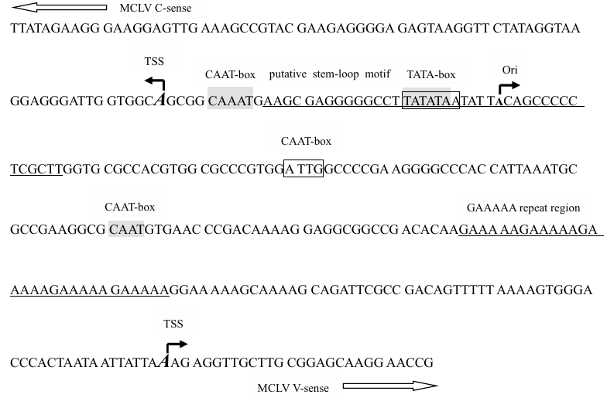 Figure S1 Predicted map of cis-acting elements in MCLV LIR
Note: Nucleotide sequence, putative core elements TATA-box and CAAT-box, and transcription start sites (TSS) in virion- (V-) and complementary- (C-) sense of the directional promoter P232. The predicted TATA-box and CAAT-box in the V- and C-sense are highlighted with shaded backgrounds boxes, respectively. The underlined sequences are GAAAAA repeat region and putative stem-loop motif. The bigger italic letters and the solid arrows on the top of them indicate the predicted TSS in V-, and C-sense direction. The smaller letter and the solid arrow on the top of its indicate the predicted origin of replication (Ori). The two hollow arrows pointing left and right indicate C-sense V-sense of P232, respectively.

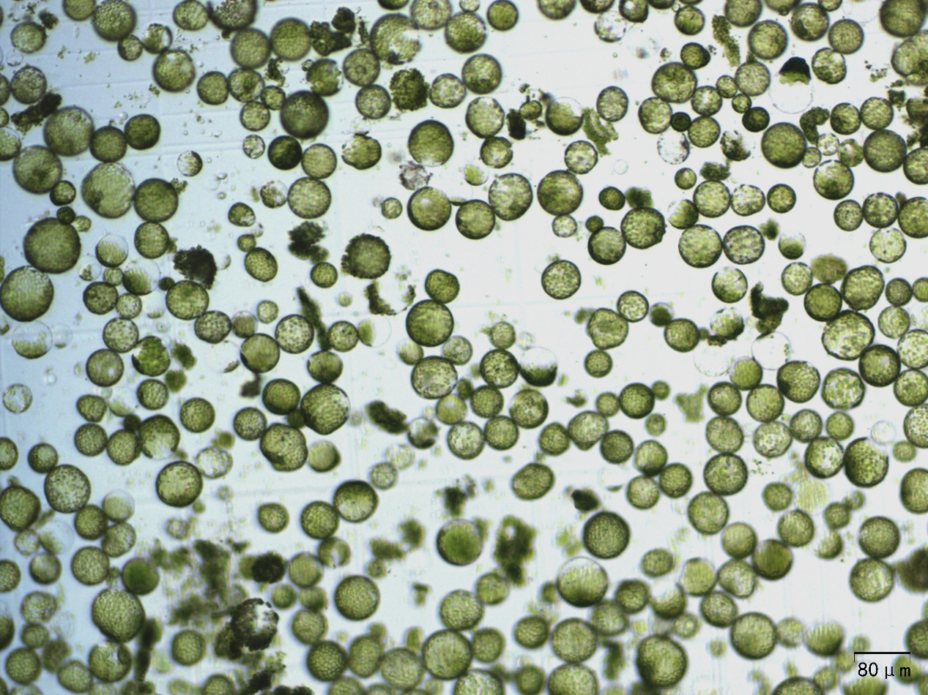
Figure S2 Image of protoplasts isolated from N. benthamiana
Scale bar：80 μm

