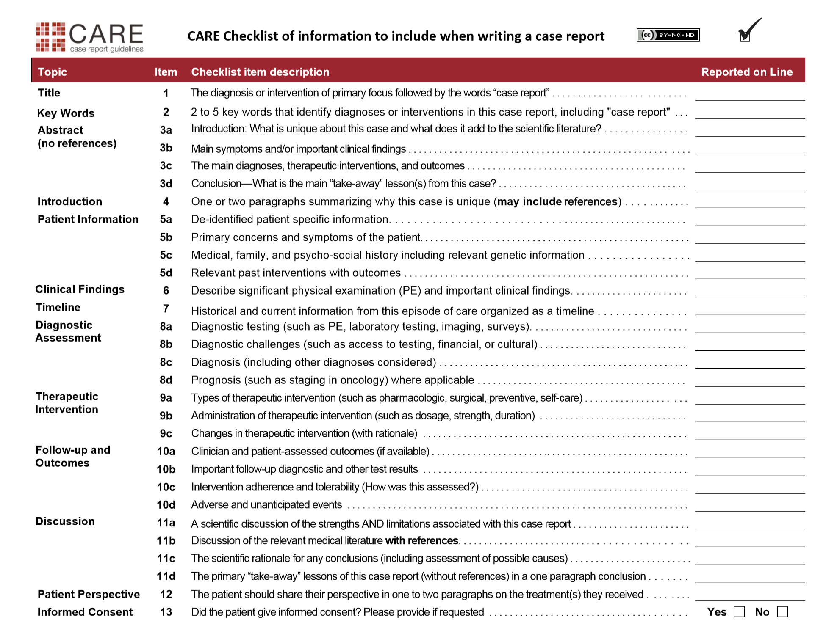
N/A

Page 5-6

Page 5-6

Page 5-6

Page 5-6

N/A

N/A

Page 3-4
N/A

Page3- 4

Page 3-4

Page 3-4

Page 3-4
Page 3-4
Page 3-4
Page 3-4
Page 4
Page 3-4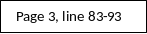
Page 3-4
Page 3-4
Page 3-4
Page 3-4
Page 3
Page 2
Page 2
Page 2
Page 2
Page 2
Page 1

