Supplemental information

Integrated tumor tissue metabolomic and transcriptomic approaches for identifying diagnostic biomarkers in endometrial cancer with diabetes mellitus
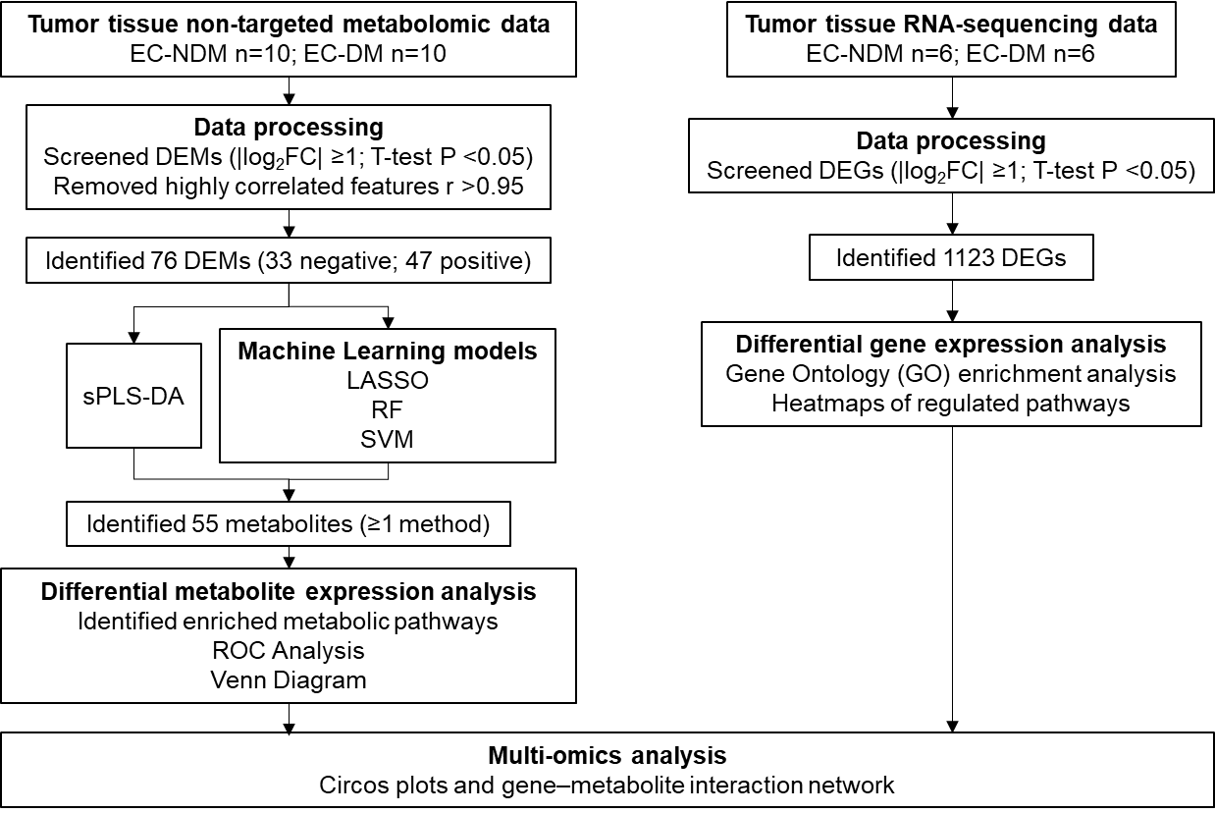

Fig. S1. Study design. Workflow illustrating the sequential steps of metabolomic and transcriptomic analyses. Non-targeted metabolomics profiling was performed on tumor tissue samples from all enrolled patients. RNA sequencing was conducted on a subset of patients with matched metabolomic data. Data integration was performed exclusively on samples with both metabolomic and transcriptomic datasets, enabling the identification of potential biomarkers.

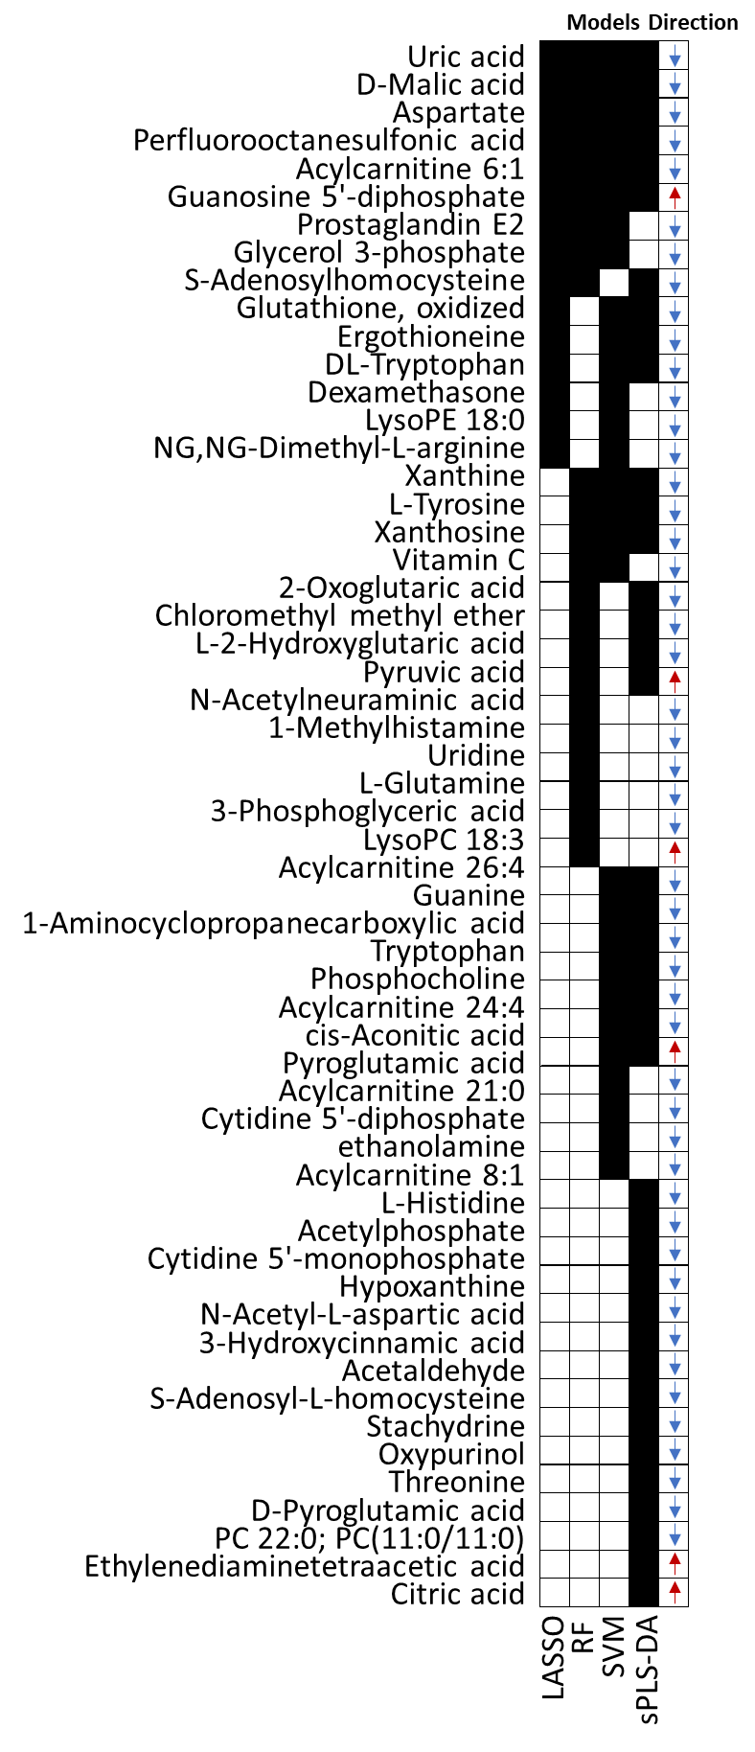

Fig. S2. Differential metabolites identified by ≥1 methods between EC-NDM and EC-DM. Black squares denote metabolites selected by each method. Red upward arrows indicate increased expression levels and blue downward arrows indicate decreased expression levels in the EC-DM group compared with the EC-NDM group.

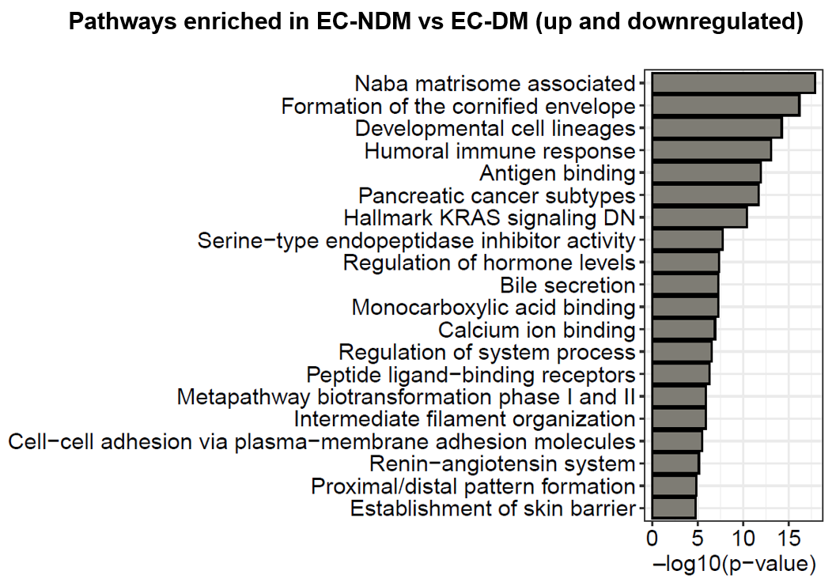

Fig. S3. Differentially expressed genes and enriched pathways between EC–NDM and EC–DM (up and downregulated)
A total of 1,123 differentially expressed genes (DEGs, including both upregulated and downregulated) were analyzed using Metascape, integrating GO Biological Process (GO BP), GO Molecular Function (GO MF), Reactome, KEGG, WikiPathways (WP), BioCarta, and Hallmark databases. The top 20 enriched pathways are shown, ranked by –log10 (p-value).
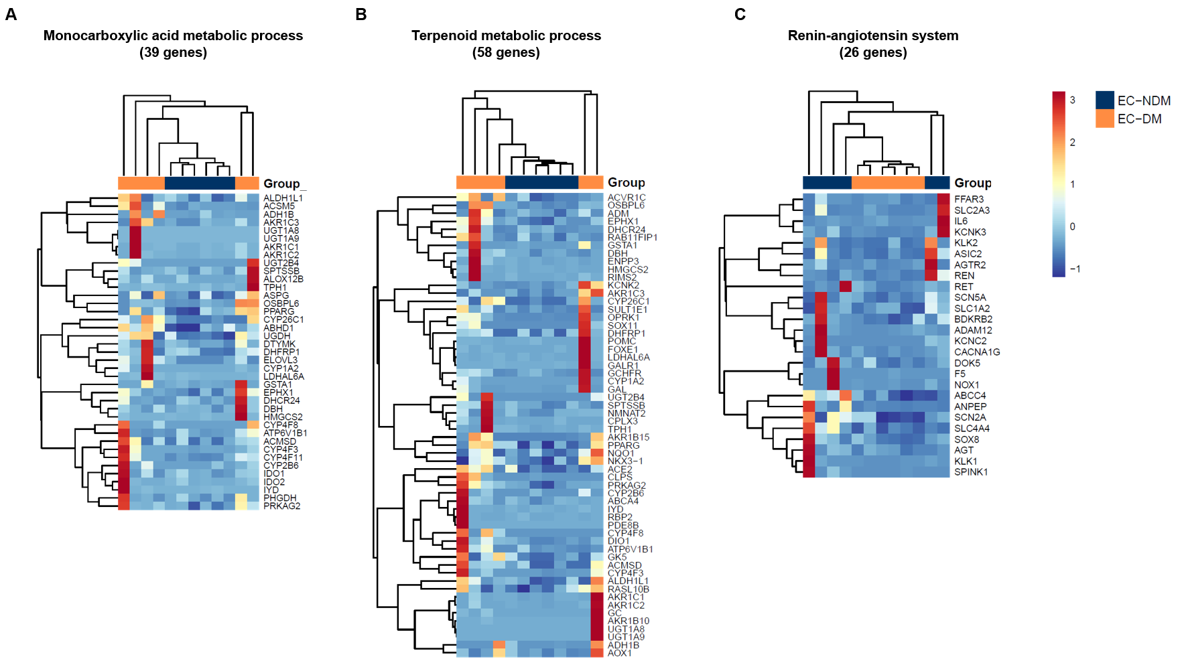
Fig. S4. RNA metabolic pathways associated with EC-NDM and EC-DM.
Related to Fig. 4 and Table S4. Differential expression and pathway enrichment analyses were performed on RNA-seq data from EC-NDM (n = 6) and EC-DM (n = 6) samples. Heatmaps present normalized expression levels of differentially expressed genes (DEGs) in three representative enriched pathways: A. monocarboxylic acid metabolic process, B. terpenoid metabolic process, and C. renin–angiotensin system.

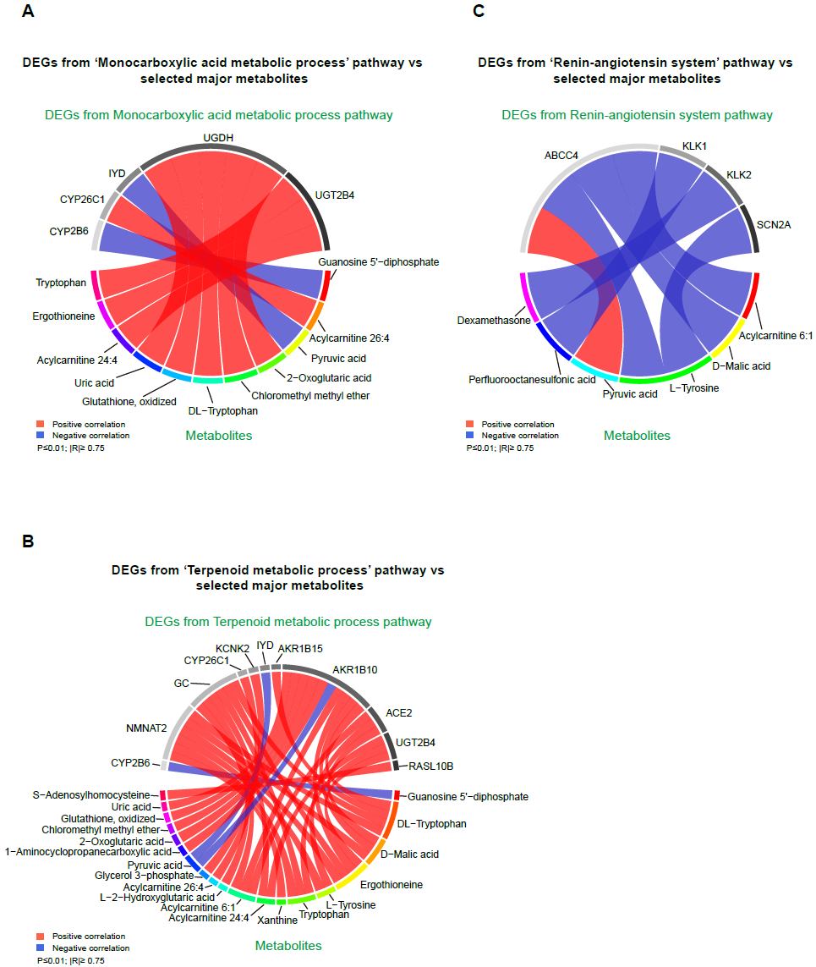

Fig. S5. Correlation between pathway-specific DEGs and metabolites.
Related to Table S4. Chord diagrams illustrate significant correlations between differentially expressed genes (DEGs) assigned to the indicated pathways and metabolites identified in Fig. 2A. Only correlations with Pearson’s r ≥ 0.75 and p ≤ 0.01 are shown. Red lines denote positive correlations; blue lines denote negative correlations.
A. Correlations between DEGs from the monocarboxylic acid metabolic process pathway and metabolites identified in Fig. 2A;
B. correlations between DEGs from the terpenoid metabolic process pathway and metabolites identified in Fig. 2A;
C. correlations between DEGs from the renin–angiotensin system pathway and metabolites identified in Fig. 2A.

