Biophysical modeling of anatomically realistic prenatal cortical folding development
Jixin Hou¹, Zhengwang Wu², Kun Jiang¹, Taotao Wu³, Lu Zhang⁴, Dajiang Zhu⁵, Wei Gao⁶, Mir Jalil Razavi⁷, Tianming Liu⁸, Ellen Kuhl⁹, Gang Li², Xianqiao Wang¹*

¹School of ECAM, College of Engineering, University of Georgia, Athens, GA 30602, USA
²Department of Radiology and Biomedical Research Imaging Center, The University of North Carolina at Chapel Hill, NC 27599, USA
³School of Chemical, Materials, and Biomedical Engineering, College of Engineering, University of Georgia, Athens, GA 30602, USA
⁴Department of Computer Science, Indiana University-Indianapolis, Indianapolis, IN 46202, USA
⁵Department of Computer Science, University of Texas at Arlington, Arlington, TX 76019, USA
⁶Department of Biomedical Sciences and Imaging, Biomedical Imaging Research Institute, Cedars-Sinai Medical Center, Los Angeles, CA 90048, USA
⁷Department of Mechanical Engineering, Binghamton University, Binghamton, NY 13902, USA
⁸School of Computing, University of Georgia, Athens, GA 30602, USA
⁹Department of Mechanical Engineering, Stanford University, Stanford, CA 94305, USA

*Corresponding Author: xqwang@uga.edu
ORCID of Xianqiao Wang: https://orcid.org/0000-0003-2461-3015
ORCID of Jixin Hou: https://orcid.org/0000-0002-5073-0701

Table S1: Malformation case descriptions and corresponding modeling treatments. Case descriptions are provided in Radiopaedia.org. R1: dorsal precentral & posterior cingulate, R4: lateral precentral & postcentral, R6: inferior frontal, R11: caudal middle frontal , R16: dorsal prefrontal.
Malformation | MRI | Age | Gender | Case description | Modeling treatments
Lissencephaly | 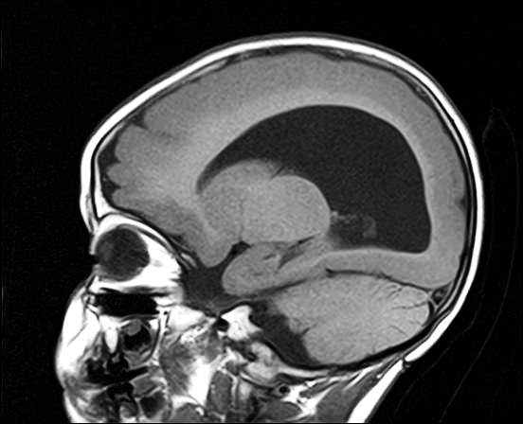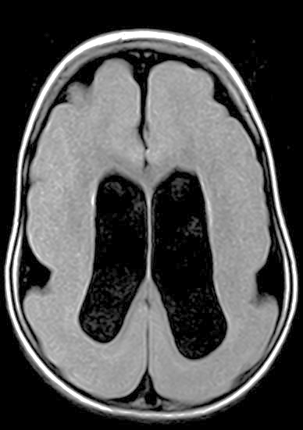 | 3 yr | F | Diffuse thickening of the cerebral cortex bilaterally (mean thickness = 18 mm) with few poorly formed gyri; smooth outer surface of both cerebral hemispheres with shallow Sylvian fissures. | Double cortical thickness and reduce regional growth ratios to 30%.
Pachygyria | 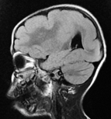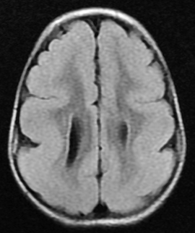 | 5 yr | F | Cortical thickening of the bilateral cerebral hemisphere with few sulci; grey matter heterotopia is in keeping with lissencephaly type I. | Double cortical thickness and maintain normal regional growth models.
Regional pachygyria | 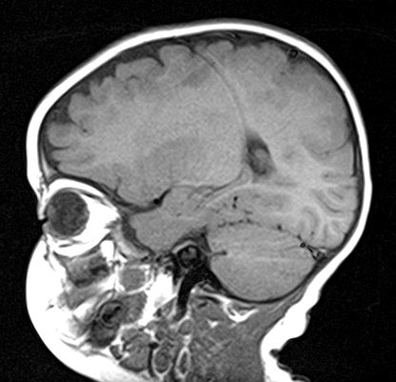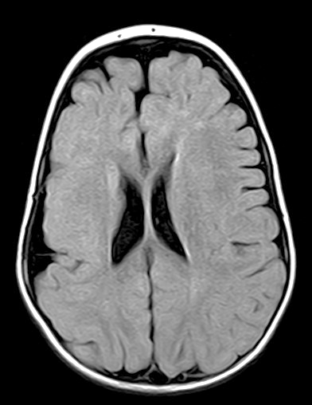 | 1 yr | F | Asymmetric cerebral hemispheres, the right is smaller than the left with reduced white matter and enlarged CSF spaces; thickening of the right hemispheric cortex with poorly formed gyri and a smooth outer surface. | Half tangential growth ratios in the affected regions (R1, R4, and R11).
Regional polymicrogyria | 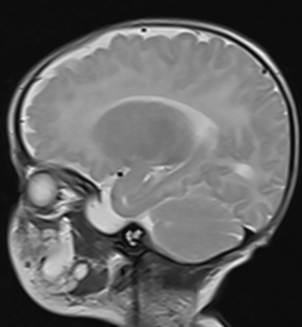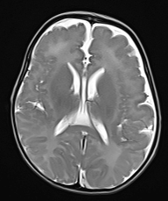 | 1 mo | M | Abnormal cortex with multiple small gyri, bumpy, disorganized, at superolateral frontal lobes, slightly parietal lobes, and perisylvian; more prominent on right side, with relatively abnormal sulcation. | Reduce cortical thickness by 40% in selected frontal regions (R1, R4, R6, R11, R16).
Regional polymicrogyria and hemiatrophy | 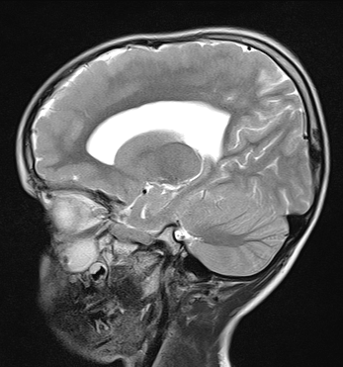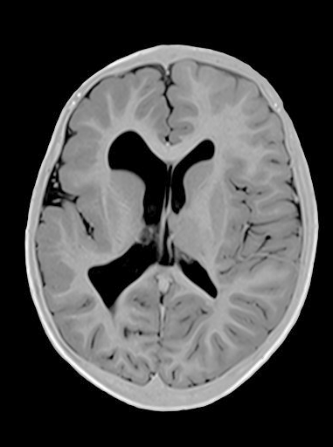 | 6 yr | M | The right cerebral hemisphere is small compared to the left side, showing abnormal sulcation and dysmorphic cortex; there is relative smaller size of the right caudate nucleus with ex-vacuo dilatation of frontal and occipital horns of the right lateral ventricle. | Reduce cortical thickness by 40% in regions R6 and R16, and half the growth ratios and the white matter subregions beneath.

Table S2: Model parameters used in the cortical folding simulations.
Parameter | Gray matter |  |  |  | White matter
Parameter | Density | Shear modulus | Bulk modulus | Poisson’s ratio | Density | Shear modulus | Bulk modulus | Poisson’s ratio
Parameter | $$g/{cm^{3}}$$ | kPa | kPa | -- | $$g/{cm^{3}}$$ | kPa | kPa | --
Values | 1.05 | 0.65 | 5.17 | 0.49 | 1.02 | 0.68 | 7.50 | 0.49

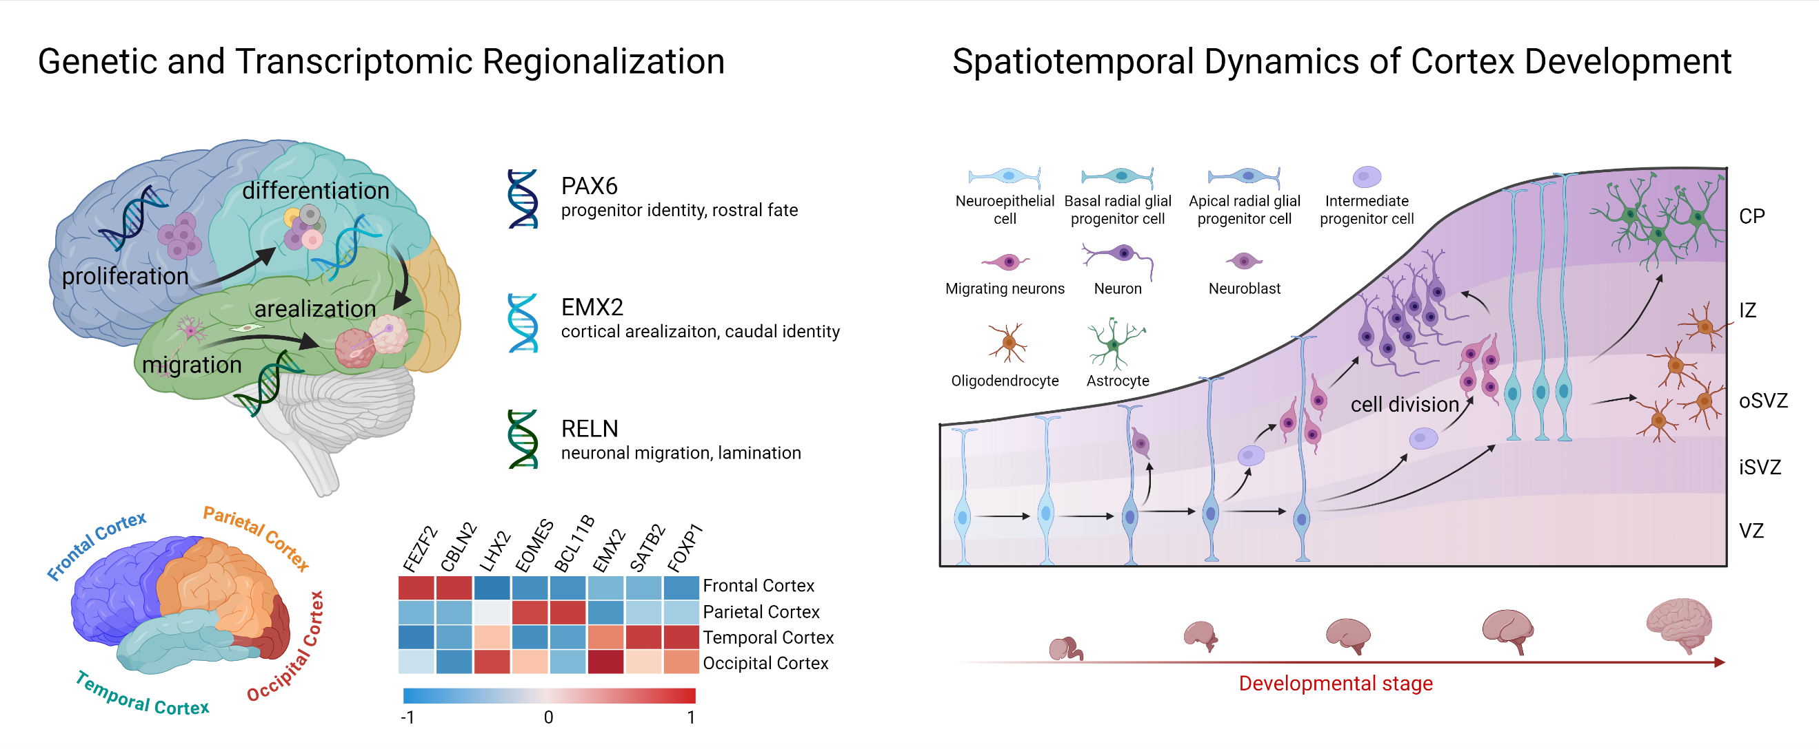
Fig. S1 | Genetic and cellular mechanisms underlying cortical regionalization. Schematic illustration of genetic and transcriptomic factor–driven cortical regionalization (left) and spatiotemporal cellular dynamics during early cortical formation (right).

Fig. S2 | Symbolic regression framework for regional growth model characterization. a: Tree-structured expression of a candidate function (left) and example of crossover and mutation operations (right). b: Data preprocessing for regional surface area and cortical thickness (top left), symbolic regression algorithmic settings (top right), and example of determining an optimized function candidate (bottom).

Fig. S3 | Characterization of region-specific growth models in the right hemisphere using symbolic regression. a: Developmental parcellation maps with corresponding anatomical regions. b-c: Growth models identified in radial and tangential directions. Dots denote MRI data from 22 to 40 GWs; lines indicate fitted growth models, with mathematic formulas shown at the bottom of each subfigure. R² indicates fitting goodness. d: Summary of identified regional growth model in both directions. Insets illustrate schematic representations of radial and tangential growth, with the left inset showing a magnified view of the tangential growth ratio near t = 1. e: Growth ratio values visualized on the brain surface at 22 GWs for two developmental stages. Distinct regional growth trajectories were captured in both radial and tangential directions.

Fig. S4 | Whole-brain modeling framework. a: Initial gray and white matter surfaces with regional parcellation. b: Hexahedral mesh construction, with magnified view showing smoothed mesh near surfaces. c: Mesh quality check confirming good mesh quality. d: Mesh regionalization based on parcellation from panel a for regional material property assignment. e: Double-layer finite element model with distinct growth treatment for gray and white matter (left), and local material orientation extraction for orthotropic growth assignment in gray matter. f: Anatomy-guided growth profile.

Fig. S5 | Examination of hemispheric symmetry in cortical folding patterns. a: Regional growth ratio at 40 GWs in left and right hemispheres (visualized on the brain surface at 22 GWs). Right hemisphere is mirrored for comparison. b: Folding patterns and major sulcal landmarks in both hemispheres at 40 GWs. c: Folding patterns of ten subjects at 40 GWs, with mean curvature (MC) distribution projected onto spheres to visualize major sulci. d: Left: comparison of regional sulcal depth (SD), local GI (LGI), and cortical thickness (CT) between hemispheres. Right: deviations of the three metrics in the right hemisphere relative to the left. e: Global GI and sulcal counts in left versus right hemispheres. Boxes represent interquartile ranges (25–75%); whiskers, 1.5× IQR; individual dots represent subject values, with paired dots connected to show within-subject comparisons (n = 20; 10 subjects per case). Statistical significance was determined using the Wilcoxon signed-rank test (two-tailed). ***P < 0.001; **P < 0.01; *P < 0.05; n.s., not significant.

Fig. S6 | Growth model of white matter. a: Folding pattern on white matter surface, shown from top to bottom views for the left hemisphere and the whole brain. b: Growth model derived for white matter, with plots showing (from left to right) the raw volume data and the normalized growth ratios. Dots denote MRI data from 22 to 40 GWs; lines indicate fitted growth model, with mathematic formula shown below. $R^{2}$ indicates fitting goodness.

