Appendix
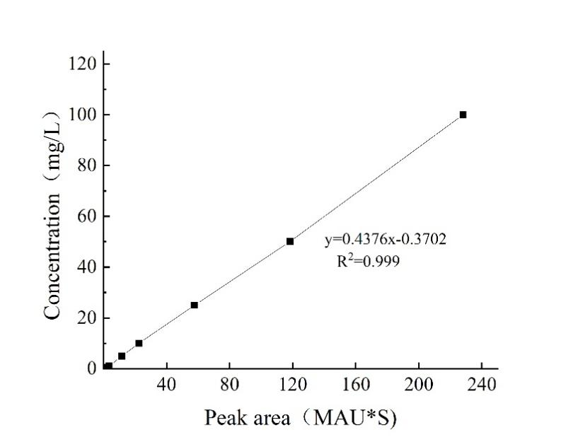
Fig. S1 Standard curve for antidesmone

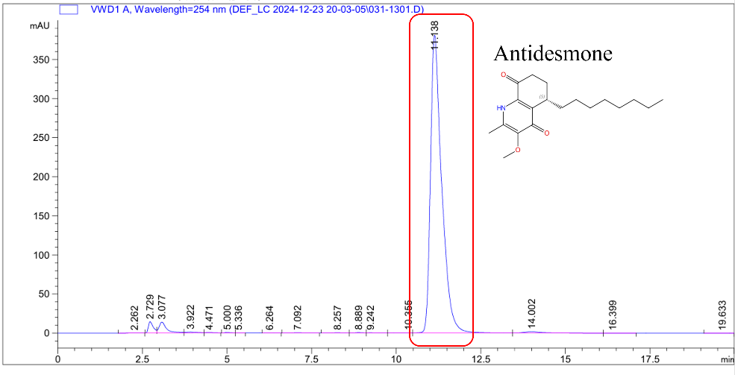
Fig. S2 Liquid chromatogram of antidesmone standard substance

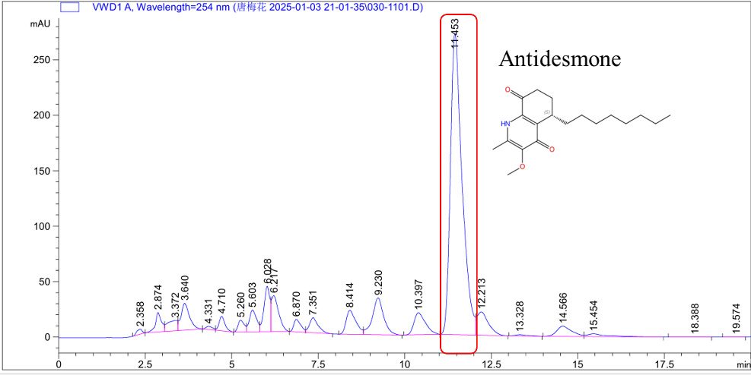
Fig. S3 Liquid chromatography of the antidesmone sample
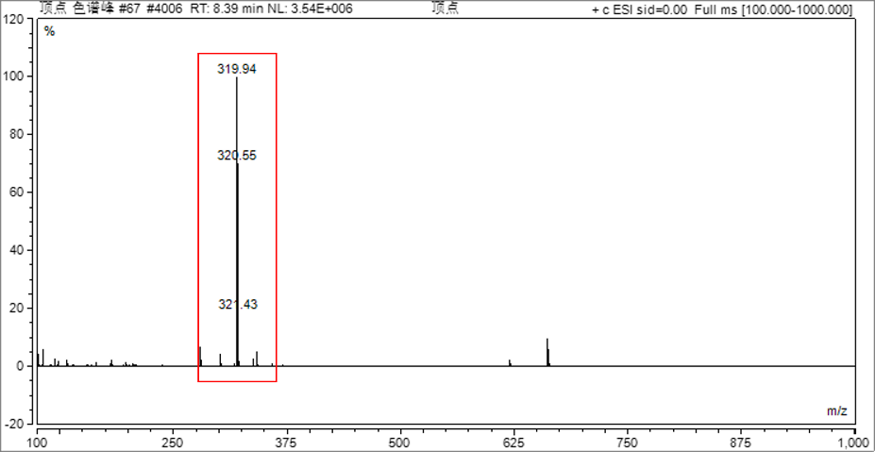
Fig. S4 Liquid chromatography-Mass spectrometry (LC-MS) Spectrum of antidesmone
Note: The molecular mass of antidesmone is 319.44.

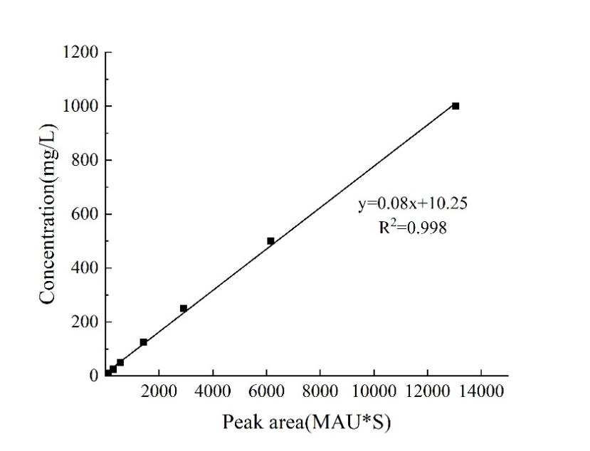
Fig. S5 Standard curve for trans-tiliroside

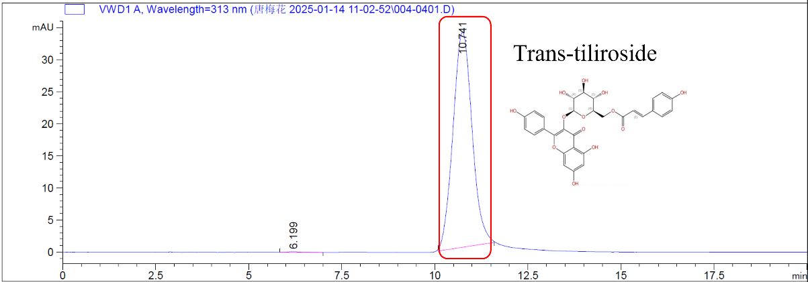
Fig. S6 Liquid chromatogram of trans-tiliroside standard substance

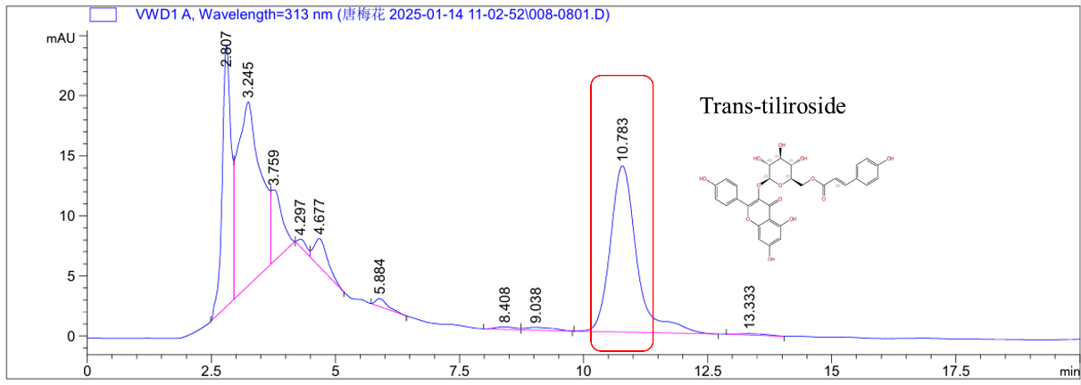
Fig. S7 Liquid chromatography of the trans-tiliroside sample

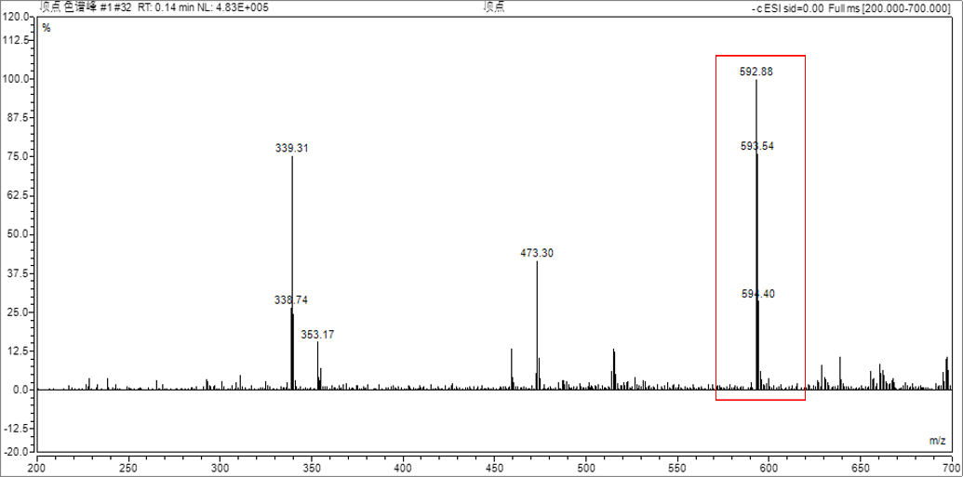
Fig. S8 Liquid chromatography-Mass spectrometry (LC-MS) Spectrum of
trans-tiliroside
Note: The molecular mass of trans-tilirosideis 594.52.

