Catalogue
Supplemental Methods 2
Figure S1. Longitudinal change in macular choroidal thickness (ΔChT) over 12 months. 5
Figure S2. Longitudinal choroidal thickness trajectories by cluster. 6
Figure S3. Two-dimensional UMAP embedding of ΔChT featuresshowing clear separation between clusters. 7
Figure S4. Longitudinal trajectories of axial length and refractive error by choroidal thickness cluster. 8
Figure S5. ANCOVA diagnostics for 12-month axial-length model. 9
Figure S6. Residuals versus fitted values for the longitudinal mixed-effects 10
1.Supplementary Table S1. Mean change in choroidal thickness (ΔChT) from baseline at each ETDRS subfield 11
2. Supplementary Table S2. Between-group differences in ΔChT by ETDRS subfield and time 13
3.Supplementary Table S3. Adjusted cluster differences in axial length: 12-month ANCOVA and annual slope (LMM) 23

Supplemental Methods
Clustering of structural trajectories.
We calculated the change in subfoveal choroidal thickness (ChT) from the baseline, denoted as ΔChT, and utilized the ΔChT values at 3, 6, 9, and 12 months as features. These features were standardized using z-scores and grouped using k-means clustering (k=2; nstart=100)¹. The cluster with more negative mean ΔChT across timepoints was labeled Thinning-dominant, and the other Stable ChT. Cluster separation was visualized using spaghetti plots of ΔChT and 2-D embeddings, utilizing UMAP if available, or PCA otherwise. Stability was assessed by performing repeated clustering with different seeds (n=20) and measuring label agreement².
Primary models.
- ANCOVA: adjusted 12-month axial length (AL) difference
$${\text{AL}}_{\text{12}}\text{=}{\text{β}}_{\text{0}}\text{+}{\text{β}}_{\text{1}}{\text{1}}_{\text{TD}}\text{+}{\text{β}}_{\text{2}}{\text{AL}}_{\text{0}}\text{+}{\text{γ}}^{\text{⊤}}\text{Z}\text{+}\text{ε}\text{,}$$
Where 1_{TD} indicates Thinning-dominant, Z are prespecified covariates available in the dataset.
(2) Longitudinal mixed-effects model (LMM)³: annual slope difference
$${\text{AL}}_{\text{it}}\text{=}{\text{β}}_{\text{0}}\text{+}{\text{β}}_{\text{1}}\text{t}\text{+}{\text{β}}_{\text{2}}{\text{1}}_{\text{TD}}\text{+}{\text{β}}_{\text{3}}\text{(}\text{t}\text{×}{\text{1}}_{\text{TD}}\text{)+}{\text{γ}}^{\text{⊤}}{\text{Z}}_{\text{i}}\text{+}{\text{b}}_{\text{0}\text{i}}\text{+}{\text{b}}_{\text{0(}\text{iye}\text{)}}\text{+}{\text{ϵ}}_{\text{it}}\text{,}$$
with $\text{t}\text{=month/12}$. The parameter of interest is β₃, the Thinning-dominant vs Stable difference in annual AL slope. Random intercepts were fit for subject and eye; sensitivity analyses considered a random slope for time, subject-only random intercepts, and spline-based nonlinear time.
Clinical interpretability.
We prespecified a minimally clinically important difference (MCID) of 0.05 mm/year for the AL slope and interpreted 95% CIs relative to this threshold⁴.
Diagnostics and robustness.
Model adequacy was assessed by residual-vs-fitted and Q–Q plots (ANCOVA), residual plots and random-effects distributions (LMM), and Cook’s distance for influence (ANCOVA). Sensitivity analyses included: (i) random-slope LMM; (ii) nonlinear time via restricted cubic splines; (iii) alternative random-effects structures; (iv) clustering stability across seeds. Retention across visits and the construction of the analytic cohort (≥2 timepoints per eye) were summarized.

Reference
1 Jain, A. K. Data clustering: 50 years beyond K-means. PATTERN RECOGNITION LETTERS 31, 651-666 (2010). https://doi.org/10.1016/j.patrec.2009.09.011
2 Steinley, D. Profiling local optima in K-means clustering: Developing a diagnostic technique. PSYCHOLOGICAL METHODS 11, 178-192 (2006). https://doi.org/10.1037/1082-989X.11.2.178
3 Bates, D., Mächler, M., Bolker, B. M. & Walker, S. C. Fitting Linear Mixed-Effects Models Using lme4. JOURNAL OF STATISTICAL SOFTWARE 67, 1-48 (2015). https://doi.org/10.18637/jss.v067.i01
4 Chen, H. Y. et al. Low-intensity red-light therapy in slowing myopic progression and the rebound effect after its cessation in Chinese children: a randomized controlled trial. GRAEFES ARCHIVE FOR CLINICAL AND EXPERIMENTAL OPHTHALMOLOGY 261, 575-584 (2023). https://doi.org/10.1007/s00417-022-05794-4

Figure S1. Longitudinal change in macular choroidal thickness (ΔChT) over 12 months.
Pooled across atropine and placebo arms, mean ΔChT in the foveal (0–1 mm) and perifoveal rings (1–3, 3–6 mm) declines from baseline to a nadir at 6–9 months, followed by partial rebound at 12 months; points denote ring-specific means and error bars indicate variability.

Figure S2. Longitudinal choroidal thickness trajectories by cluster.
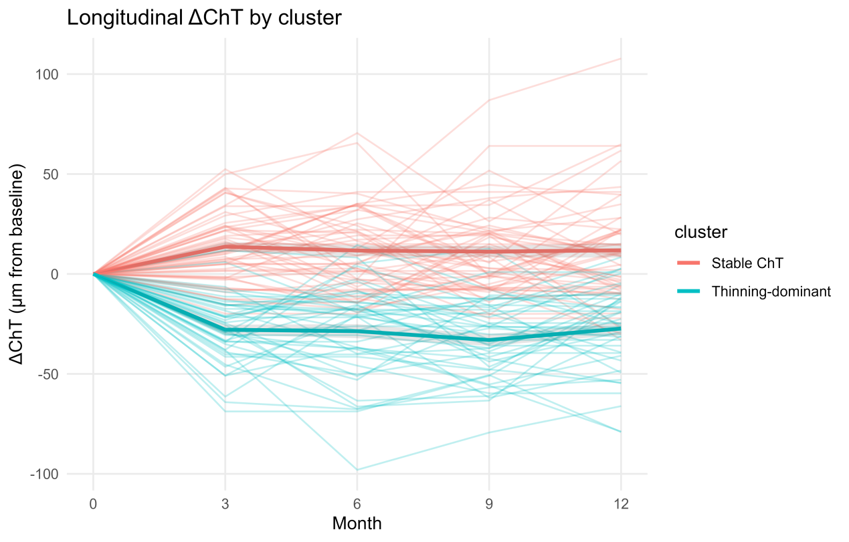
Spaghetti plots illustrating individual and mean (bold line) subfoveal choroidal thickness changes (ΔChT) from baseline to 12 months for each cluster. The Thinning-dominant cluster (cyan) demonstrated consistently greater choroidal thinning compared with the Stable ChT cluster (red) across follow-up visits. Shaded regions represent mean ± 95% CI.

Figure S3. Two-dimensional UMAP embedding of ΔChT featuresshowing clear separation between clusters.
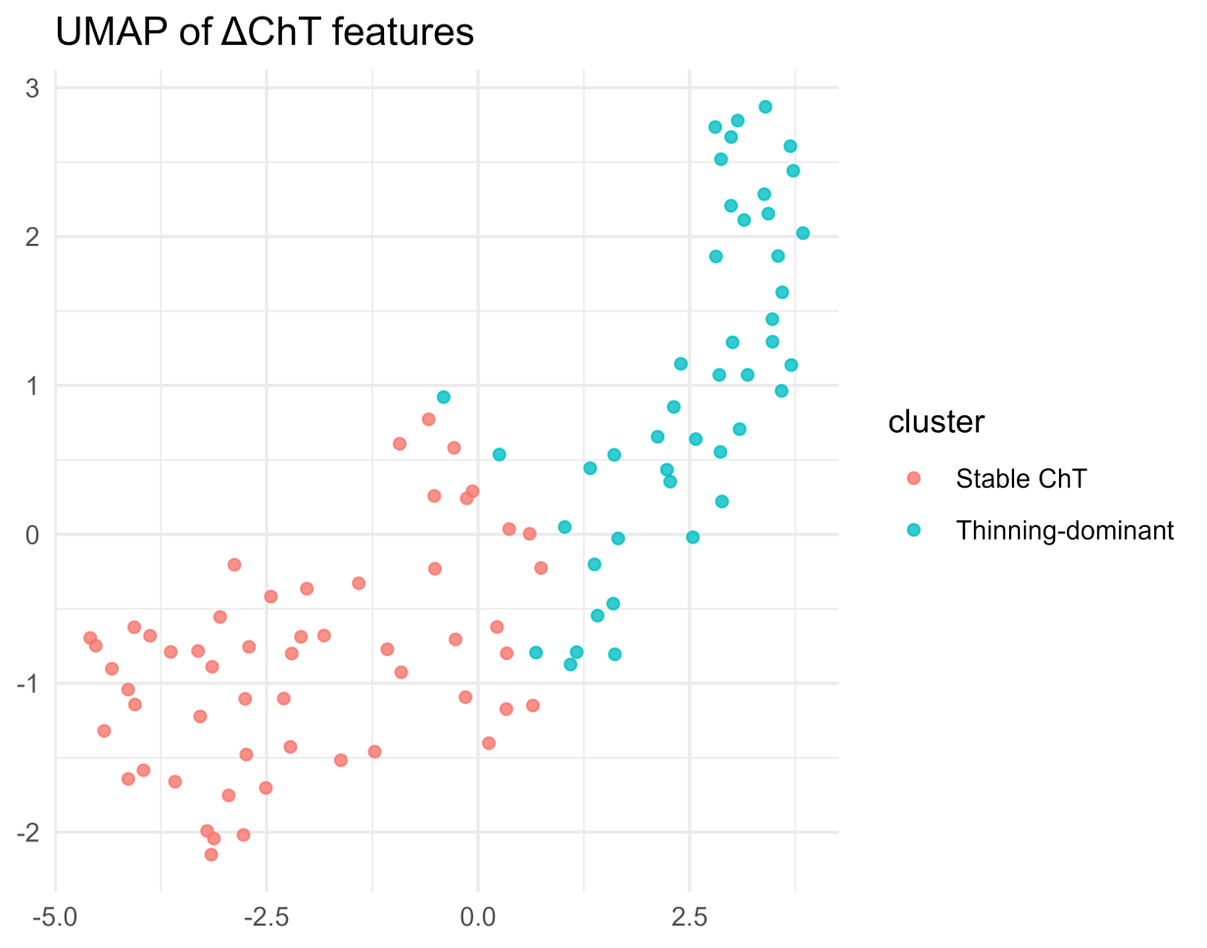
The Uniform Manifold Approximation and Projection (UMAP) of choroidal thickness change (ΔChT) features demonstrates distinct separation between the Stable ChT (red) and Thinning-dominant (cyan) clusters, confirming internal consistency of the clustering solution.

Figure S4. Longitudinal trajectories of axial length and refractive error by choroidal thickness cluster.
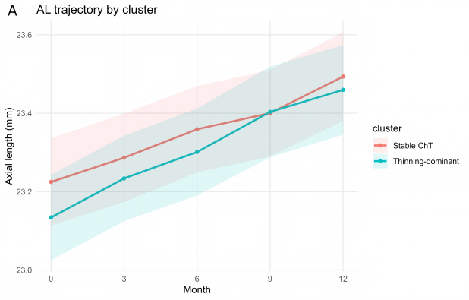 | 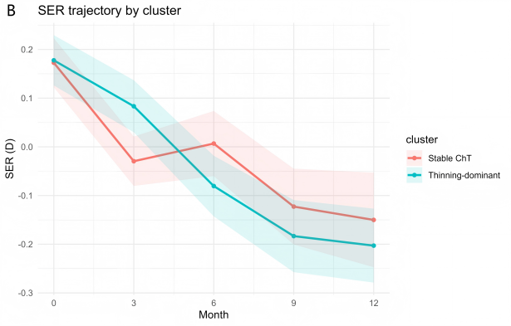
(A) Axial length (AL) trajectories over 12 months for eyes in the Stable ChT and Thinning-dominant clusters. The Thinning-dominant group showed a tendency toward greater elongation, consistent with model-estimated differences in annual growth rate.
(B) Spherical equivalent refraction (SER) trajectories over the same period, showing parallel myopic shifts in both clusters, with a slightly greater negative trend in the Thinning-dominant group.
Shaded areas represent 95% confidence intervals derived from linear mixed-effects estimates.

Figure S5. ANCOVA diagnostics for 12-month axial-length model.
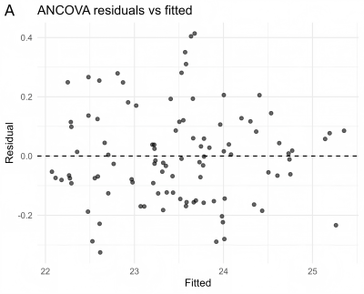 | 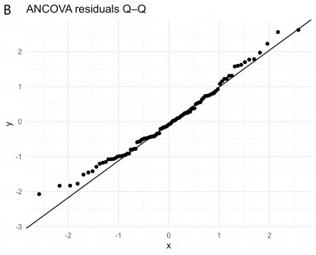 | 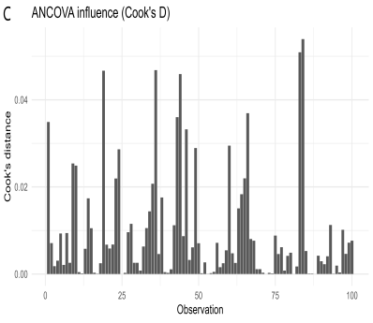
(A) Residuals versus fitted values showing approximately random scatter with only mild heteroscedasticity. (B) Normal Q–Q plot of residuals indicating near-normality with minor tail deviations. (C) Influence diagnostics (Cook’s distance) for individual eyes; no observations exceed conventional concern thresholds.

Figure S6. Residuals versus fitted values for the longitudinal mixed-effects
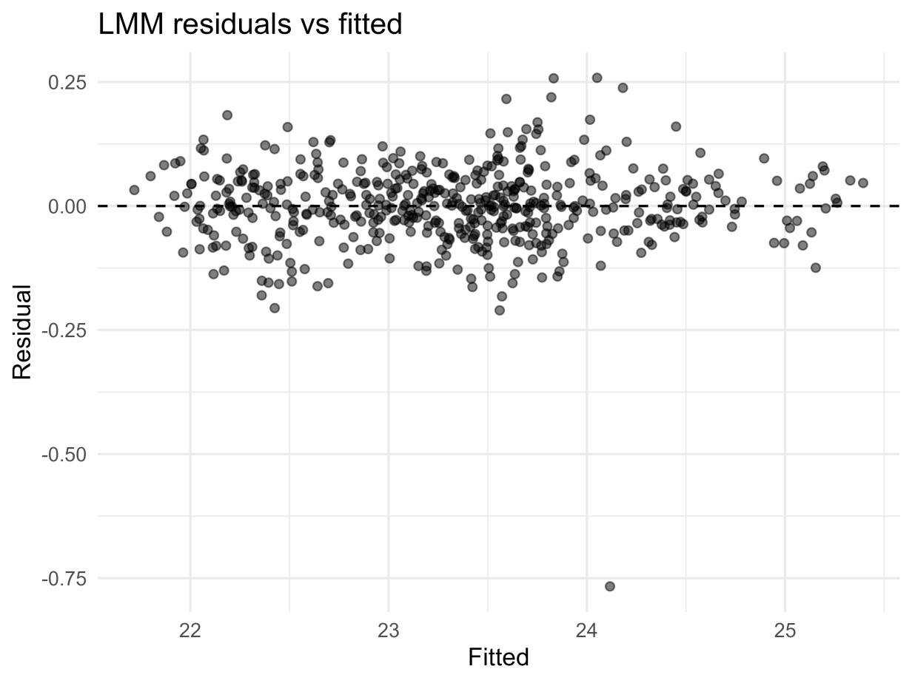
Points show model residuals against fitted values from the longitudinal mixed-effects model of axial length with a time×cluster interaction and random intercepts for eye within subject. Residuals are centered near zero without discernible structure, supporting adequacy of model fit.

1.Supplementary Table S1. Mean change in choroidal thickness (ΔChT) from baseline at each ETDRS subfield
ETDRS subfield | 3 m | 6 m | 9 m | 12 m
0–1 mm (central) | -5.0 ± 24.1 | -6.4 ± 26.9 | -8.7 ± 25.6 | -5.8 ± 27.0
0–3 mm | -5.4 ± 23.7 | -6.2 ± 24.7 | -8.4 ± 22.0 | -5.7 ± 23.4
0–6 mm | -6.1 ± 23.0 | -5.6 ± 23.2 | -7.7 ± 20.3 | -5.7 ± 21.9
1–3 mm S | -4.9 ± 23.3 | -6.5 ± 24.4 | -9.2 ± 20.4 | -6.8 ± 23.0
1–3 mm T | -5.6 ± 22.6 | -6.6 ± 26.6 | -7.9 ± 24.4 | -5.4 ± 25.3
1–3 mm I | -7.2 ± 28.0 | -7.1 ± 26.2 | -7.6 ± 23.6 | -5.3 ± 23.9
1–3 mm N | -4.1 ± 24.0 | -4.8 ± 23.4 | -8.6 ± 20.9 | -5.3 ± 22.6
1–6 mm S | -5.8 ± 23.4 | -5.7 ± 24.7 | -8.4 ± 21.6 | -6.2 ± 23.6
1–6 mm T | -6.2 ± 23.0 | -5.8 ± 24.9 | -7.3 ± 22.8 | -5.6 ± 23.3
1–6 mm I | -7.7 ± 27.9 | -6.5 ± 26.5 | -7.6 ± 22.9 | -7.3 ± 25.3
1–6 mm N | -4.6 ± 21.4 | -4.4 ± 20.9 | -7.6 ± 17.5 | -3.6 ± 19.3
3–6 mm S | -6.0 ± 23.7 | -5.4 ± 25.1 | -8.2 ± 22.3 | -6.0 ± 24.3
3–6 mm T | -6.4 ± 23.3 | -5.5 ± 24.6 | -7.1 ± 22.6 | -5.6 ± 23.0
3–6 mm I | -5.5 ± 24.4 | -6.4 ± 27.0 | -7.5 ± 23.1 | -7.9 ± 26.3
3–6 mm N | -4.8 ± 20.9 | -4.7 ± 20.4 | -7.2 ± 17.0 | -3.1 ± 18.7

Footnotes: Values are mean ± SD (µm) of change in choroidal thickness (ΔChT) from baseline. Participant-level means were computed per ETDRS subfield at each visit (3, 6, 9, 12 months); when both eyes were available, eye-level values were averaged. ETDRS sectors: central 0–1 mm; inner ring 1–3 mm; outer ring 3–6 mm; S = superior, I = inferior, N = nasal, T = temporal. Negative values indicate thinning.

Supplementary Table S2. Between-group differences in ΔChT by ETDRS subfield and time
Subfield | Time | n_Placebo | n_Atropine | Mean ΔChT (Placebo, µm) | Mean ΔChT (Atropine, µm) | Diff (A−P, µm) | p (Wilcoxon, raw) | q (BH, full-table) | EMM diff (A−P, µm) | EMM lcl | EMM ucl | p (LMM)
0–1 mm (central) | Baseline | 52 | 48 | 0.0 ± 0.0 | 0.0 ± 0.0 | 0.00 |  |  | -0.00 | -12.22 | 12.22 | 1.000
0–1 mm (central) | 3 m | 52 | 48 | -6.8 ± 30.4 | -3.2 ± 22.6 | 3.64 | 0.346 | 0.883 | 3.64 | -8.58 | 15.86 | 0.556
0–1 mm (central) | 6 m | 52 | 48 | -8.4 ± 31.5 | -4.4 ± 27.9 | 4.01 | 0.627 | 0.883 | 4.01 | -8.21 | 16.24 | 0.516
0–1 mm (central) | 9 m | 52 | 48 | -12.5 ± 33.4 | -4.6 ± 25.9 | 7.92 | 0.112 | 0.874 | 7.92 | -4.30 | 20.14 | 0.201
0–1 mm (central) | 12 m | 52 | 48 | -9.8 ± 36.2 | -1.5 ± 24.5 | 8.31 | 0.133 | 0.883 | 8.31 | -3.91 | 20.54 | 0.180
0–3 mm | Baseline | 52 | 48 | 0.0 ± 0.0 | 0.0 ± 0.0 | 0.00 |  |  | 0.00 | -11.05 | 11.05 | 1.000
0–3 mm | 3 m | 52 | 48 | -5.6 ± 29.1 | -5.1 ± 22.6 | 0.52 | 0.551 | 0.883 | 0.52 | -10.53 | 11.57 | 0.926
0–3 mm | 6 m | 52 | 48 | -7.0 ± 28.2 | -5.4 ± 26.6 | 1.51 | 0.817 | 0.943 | 1.51 | -9.54 | 12.56 | 0.787
0–3 mm | 9 m | 52 | 48 | -11.0 ± 25.9 | -5.6 ± 22.8 | 5.41 | 0.223 | 0.883 | 5.41 | -5.64 | 16.45 | 0.334
0–3 mm | 12 m | 52 | 48 | -8.4 ± 30.3 | -2.8 ± 21.4 | 5.57 | 0.394 | 0.883 | 5.57 | -5.48 | 16.62 | 0.319
0–6 mm | Baseline | 52 | 48 | 0.0 ± 0.0 | 0.0 ± 0.0 | 0.00 |  |  | -0.00 | -10.39 | 10.39 | 1.000
0–6 mm | 3 m | 52 | 48 | -5.7 ± 27.5 | -6.4 ± 23.9 | -0.74 | 0.622 | 0.883 | -0.74 | -11.13 | 9.66 | 0.888
0–6 mm | 6 m | 52 | 48 | -6.0 ± 24.9 | -5.3 ± 26.8 | 0.67 | 0.583 | 0.883 | 0.67 | -9.72 | 11.07 | 0.898
0–6 mm | 9 m | 52 | 48 | -10.0 ± 21.7 | -5.3 ± 22.1 | 4.63 | 0.210 | 0.883 | 4.63 | -5.76 | 15.03 | 0.379
0–6 mm | 12 m | 52 | 48 | -8.2 ± 26.8 | -2.9 ± 20.1 | 5.35 | 0.368 | 0.883 | 5.35 | -5.04 | 15.74 | 0.309
1–3 mm S | Baseline | 52 | 48 | 0.0 ± 0.0 | 0.0 ± 0.0 | 0.00 |  |  | 0.00 | -10.68 | 10.68 | 1.000
1–3 mm S | 3 m | 52 | 48 | -4.5 ± 28.1 | -5.3 ± 22.1 | -0.80 | 0.607 | 0.883 | -0.80 | -11.48 | 9.88 | 0.883
1–3 mm S | 6 m | 52 | 48 | -6.8 ± 28.2 | -6.2 ± 25.1 | 0.54 | 0.915 | 0.975 | 0.54 | -10.14 | 11.22 | 0.920
1–3 mm S | 9 m | 52 | 48 | -10.1 ± 22.3 | -8.1 ± 22.9 | 1.98 | 0.692 | 0.883 | 1.98 | -8.71 | 12.66 | 0.715
1–3 mm S | 12 m | 52 | 48 | -8.7 ± 29.5 | -4.8 ± 22.0 | 3.85 | 0.467 | 0.883 | 3.85 | -6.84 | 14.53 | 0.477
1–3 mm T | Baseline | 52 | 48 | 0.0 ± 0.0 | 0.0 ± 0.0 | 0.00 |  |  | 0.00 | -11.53 | 11.53 | 1.000
1–3 mm T | 3 m | 52 | 48 | -6.3 ± 28.5 | -4.8 ± 20.5 | 1.53 | 0.537 | 0.883 | 1.53 | -10.00 | 13.07 | 0.792
1–3 mm T | 6 m | 52 | 48 | -8.2 ± 30.4 | -4.8 ± 26.7 | 3.33 | 0.692 | 0.883 | 3.33 | -8.20 | 14.86 | 0.568
1–3 mm T | 9 m | 52 | 48 | -11.2 ± 29.0 | -4.4 ± 24.3 | 6.83 | 0.115 | 0.874 | 6.83 | -4.71 | 18.36 | 0.243
1–3 mm T | 12 m | 52 | 48 | -9.4 ± 32.7 | -1.1 ± 22.3 | 8.34 | 0.117 | 0.874 | 8.34 | -3.19 | 19.87 | 0.154
1–3 mm I | Baseline | 52 | 48 | 0.0 ± 0.0 | 0.0 ± 0.0 | 0.00 |  |  | -0.00 | -12.10 | 12.10 | 1.000
1–3 mm I | 3 m | 52 | 48 | -7.6 ± 32.4 | -6.8 ± 34.0 | 0.78 | 0.442 | 0.883 | 0.78 | -11.32 | 12.88 | 0.898
1–3 mm I | 6 m | 52 | 48 | -7.4 ± 27.8 | -6.7 ± 33.1 | 0.66 | 0.681 | 0.883 | 0.66 | -11.45 | 12.76 | 0.915
1–3 mm I | 9 m | 52 | 48 | -11.9 ± 28.0 | -3.0 ± 23.5 | 8.83 | 0.101 | 0.874 | 8.83 | -3.27 | 20.94 | 0.151
1–3 mm I | 12 m | 52 | 48 | -8.4 ± 30.9 | -1.9 ± 22.1 | 6.53 | 0.315 | 0.883 | 6.53 | -5.58 | 18.63 | 0.288
1–3 mm N | Baseline | 52 | 48 | 0.0 ± 0.0 | 0.0 ± 0.0 | 0.00 |  |  | 0.00 | -10.96 | 10.96 | 1.000
1–3 mm N | 3 m | 52 | 48 | -3.6 ± 30.3 | -4.6 ± 22.7 | -0.98 | 0.964 | 0.986 | -0.98 | -11.94 | 9.99 | 0.860
1–3 mm N | 6 m | 52 | 48 | -5.0 ± 29.2 | -4.5 ± 26.1 | 0.41 | 0.986 | 0.986 | 0.41 | -10.56 | 11.37 | 0.941
1–3 mm N | 9 m | 52 | 48 | -10.0 ± 26.5 | -7.2 ± 24.0 | 2.74 | 0.598 | 0.883 | 2.74 | -8.22 | 13.71 | 0.621
1–3 mm N | 12 m | 52 | 48 | -6.4 ± 30.6 | -4.2 ± 23.0 | 2.20 | 0.812 | 0.943 | 2.20 | -8.77 | 13.16 | 0.692
1–6 mm S | Baseline | 52 | 48 | 0.0 ± 0.0 | 0.0 ± 0.0 | 0.00 |  |  | -0.00 | -10.92 | 10.92 | 1.000
1–6 mm S | 3 m | 52 | 48 | -4.6 ± 27.4 | -7.0 ± 22.9 | -2.38 | 0.915 | 0.975 | -2.38 | -13.30 | 8.54 | 0.666
1–6 mm S | 6 m | 52 | 48 | -6.1 ± 26.1 | -5.2 ± 27.4 | 0.87 | 0.501 | 0.883 | 0.87 | -10.04 | 11.79 | 0.874
1–6 mm S | 9 m | 52 | 48 | -9.9 ± 22.0 | -6.8 ± 24.9 | 3.06 | 0.434 | 0.883 | 3.06 | -7.85 | 13.98 | 0.579
1–6 mm S | 12 m | 52 | 48 | -8.7 ± 27.5 | -3.5 ± 23.6 | 5.13 | 0.332 | 0.883 | 5.13 | -5.79 | 16.05 | 0.353
1–6 mm T | Baseline | 52 | 48 | 0.0 ± 0.0 | 0.0 ± 0.0 | 0.00 |  |  | 0.00 | -10.90 | 10.90 | 1.000
1–6 mm T | 3 m | 52 | 48 | -6.9 ± 28.7 | -5.4 ± 22.3 | 1.49 | 0.343 | 0.883 | 1.49 | -9.40 | 12.39 | 0.787
1–6 mm T | 6 m | 52 | 48 | -7.5 ± 26.7 | -3.9 ± 26.6 | 3.61 | 0.598 | 0.883 | 3.61 | -7.29 | 14.50 | 0.513
1–6 mm T | 9 m | 52 | 48 | -10.5 ± 23.9 | -3.9 ± 24.5 | 6.57 | 0.094 | 0.874 | 6.57 | -4.33 | 17.46 | 0.235
1–6 mm T | 12 m | 52 | 48 | -8.9 ± 28.1 | -2.0 ± 21.4 | 6.90 | 0.329 | 0.883 | 6.90 | -3.99 | 17.80 | 0.212
1–6 mm I | Baseline | 52 | 48 | 0.0 ± 0.0 | 0.0 ± 0.0 | 0.00 |  |  | 0.00 | -12.19 | 12.19 | 1.000
1–6 mm I | 3 m | 52 | 48 | -8.2 ± 30.9 | -7.2 ± 37.4 | 1.05 | 0.299 | 0.883 | 1.05 | -11.14 | 13.23 | 0.865
1–6 mm I | 6 m | 52 | 48 | -6.5 ± 27.2 | -6.6 ± 35.8 | -0.08 | 0.692 | 0.883 | -0.08 | -12.26 | 12.11 | 0.990
1–6 mm I | 9 m | 52 | 48 | -11.7 ± 23.6 | -3.1 ± 25.0 | 8.66 | 0.057 | 0.874 | 8.66 | -3.53 | 20.84 | 0.162
1–6 mm I | 12 m | 52 | 48 | -11.4 ± 31.6 | -2.9 ± 22.8 | 8.48 | 0.296 | 0.883 | 8.48 | -3.70 | 20.67 | 0.171
1–6 mm N | Baseline | 52 | 48 | 0.0 ± 0.0 | 0.0 ± 0.0 | 0.00 |  |  | -0.00 | -9.56 | 9.56 | 1.000
1–6 mm N | 3 m | 52 | 48 | -2.9 ± 26.3 | -6.5 ± 22.1 | -3.57 | 0.636 | 0.883 | -3.57 | -13.13 | 5.98 | 0.460
1–6 mm N | 6 m | 52 | 48 | -3.3 ± 26.2 | -5.6 ± 24.5 | -2.33 | 0.617 | 0.883 | -2.33 | -11.89 | 7.23 | 0.630
1–6 mm N | 9 m | 52 | 48 | -7.5 ± 22.2 | -7.6 ± 20.5 | -0.13 | 0.981 | 0.986 | -0.13 | -9.69 | 9.43 | 0.979
1–6 mm N | 12 m | 52 | 48 | -3.9 ± 26.5 | -3.3 ± 19.4 | 0.55 | 0.860 | 0.956 | 0.55 | -9.01 | 10.10 | 0.910
3–6 mm S | Baseline | 52 | 48 | 0.0 ± 0.0 | 0.0 ± 0.0 | 0.00 |  |  | -0.00 | -11.17 | 11.17 | 1.000
3–6 mm S | 3 m | 52 | 48 | -4.7 ± 27.5 | -7.5 ± 23.6 | -2.85 | 0.926 | 0.975 | -2.85 | -14.02 | 8.32 | 0.613
3–6 mm S | 6 m | 52 | 48 | -5.9 ± 26.1 | -4.9 ± 28.5 | 0.96 | 0.410 | 0.883 | 0.96 | -10.21 | 12.13 | 0.865
3–6 mm S | 9 m | 52 | 48 | -9.8 ± 22.4 | -6.4 ± 25.8 | 3.39 | 0.422 | 0.883 | 3.39 | -7.78 | 14.56 | 0.548
3–6 mm S | 12 m | 52 | 48 | -8.6 ± 27.8 | -3.1 ± 24.5 | 5.49 | 0.290 | 0.883 | 5.49 | -5.68 | 16.65 | 0.332
3–6 mm T | Baseline | 52 | 48 | 0.0 ± 0.0 | 0.0 ± 0.0 | 0.00 |  |  | -0.00 | -10.84 | 10.84 | 1.000
3–6 mm T | 3 m | 52 | 48 | -7.1 ± 29.1 | -5.6 ± 23.2 | 1.48 | 0.332 | 0.883 | 1.48 | -9.35 | 12.32 | 0.787
3–6 mm T | 6 m | 52 | 48 | -7.3 ± 26.0 | -3.6 ± 26.8 | 3.67 | 0.532 | 0.883 | 3.67 | -7.17 | 14.50 | 0.504
3–6 mm T | 9 m | 52 | 48 | -10.2 ± 23.0 | -3.8 ± 25.0 | 6.47 | 0.115 | 0.874 | 6.47 | -4.36 | 17.31 | 0.239
3–6 mm T | 12 m | 52 | 48 | -8.8 ± 27.2 | -2.3 ± 21.6 | 6.47 | 0.430 | 0.883 | 6.47 | -4.37 | 17.31 | 0.239
3–6 mm I | Baseline | 52 | 48 | 0.0 ± 0.0 | 0.0 ± 0.0 | 0.00 |  |  | -0.00 | -11.85 | 11.85 | 1.000
3–6 mm I | 3 m | 52 | 48 | -8.4 ± 30.8 | -2.5 ± 20.7 | 5.87 | 0.175 | 0.883 | 5.87 | -5.97 | 17.72 | 0.328
3–6 mm I | 6 m | 52 | 48 | -6.2 ± 27.7 | -6.5 ± 36.9 | -0.32 | 0.785 | 0.942 | -0.32 | -12.17 | 11.53 | 0.957
3–6 mm I | 9 m | 52 | 48 | -11.6 ± 23.1 | -3.1 ± 25.9 | 8.58 | 0.068 | 0.874 | 8.58 | -3.27 | 20.43 | 0.154
3–6 mm I | 12 m | 52 | 48 | -12.2 ± 33.1 | -3.2 ± 23.4 | 9.04 | 0.319 | 0.883 | 9.04 | -2.81 | 20.88 | 0.133
3–6 mm N | Baseline | 52 | 48 | 0.0 ± 0.0 | 0.0 ± 0.0 | 0.00 |  |  | -0.00 | -9.29 | 9.29 | 1.000
3–6 mm N | 3 m | 52 | 48 | -2.7 ± 25.4 | -7.1 ± 22.3 | -4.36 | 0.528 | 0.883 | -4.36 | -13.65 | 4.93 | 0.355
3–6 mm N | 6 m | 52 | 48 | -3.6 ± 25.5 | -5.9 ± 24.4 | -2.34 | 0.769 | 0.942 | -2.34 | -11.63 | 6.95 | 0.619
3–6 mm N | 9 m | 52 | 48 | -6.8 ± 21.4 | -7.8 ± 19.9 | -1.00 | 0.833 | 0.943 | -1.00 | -10.29 | 8.30 | 0.832
3–6 mm N | 12 m | 52 | 48 | -3.1 ± 25.7 | -3.1 ± 18.9 | 0.04 | 0.769 | 0.942 | 0.04 | -9.25 | 9.34 | 0.992
ΔChT (µm) = change from baseline (negative = thinning). Between-group contrasts are Atropine − Placebo. “p (Wilcoxon)” are unadjusted two-sided rank-sum p values; “q (BH)” applies a single Benjamini–Hochberg FDR across all sector×time tests. “EMM diff” (95% CI) and “p (LMM)” come from a linear mixed-effects model with subject/eye random intercepts and month-specific contrasts via emmeans; these model-based estimates are the primary inference, with Wilcoxon as sensitivity. Values are rounded (means to 1 decimal; contrasts/CI to 2). Abbreviations: EMM, estimated marginal mean; LMM, linear mixed-effects model; BH, Benjamini–Hochberg.

3.Supplementary Table S3. Adjusted cluster differences in axial length: 12-month ANCOVA and annual slope (LMM).
model | contrast | estimate | lcl | ucl | p value | N_eyes | scale
ANCOVA (AL_12 ~ cluster + AL_0 + covars) | TD - Stable | 0.05444700 | -0.009992621 | 0.1188866 | 0.097 | 100 | mm (12m difference)
LMM (AL ~ time×cluster + covars + (1|subject/eye)) | TD - Stable (annual slope) | 0.06765253 | 0.023268181 | 0.1120369 | 0.003 | 100 | mm/year (slope)
Positive values represent the difference between Thinning-dominant and Stable. ANCOVA accounts for baseline AL and other available covariates like age or treatment group; LMM incorporates a time×cluster component with random intercepts for each subject/eye. MCID reference for slope is 0.05 mm/year.

