Fig.S1
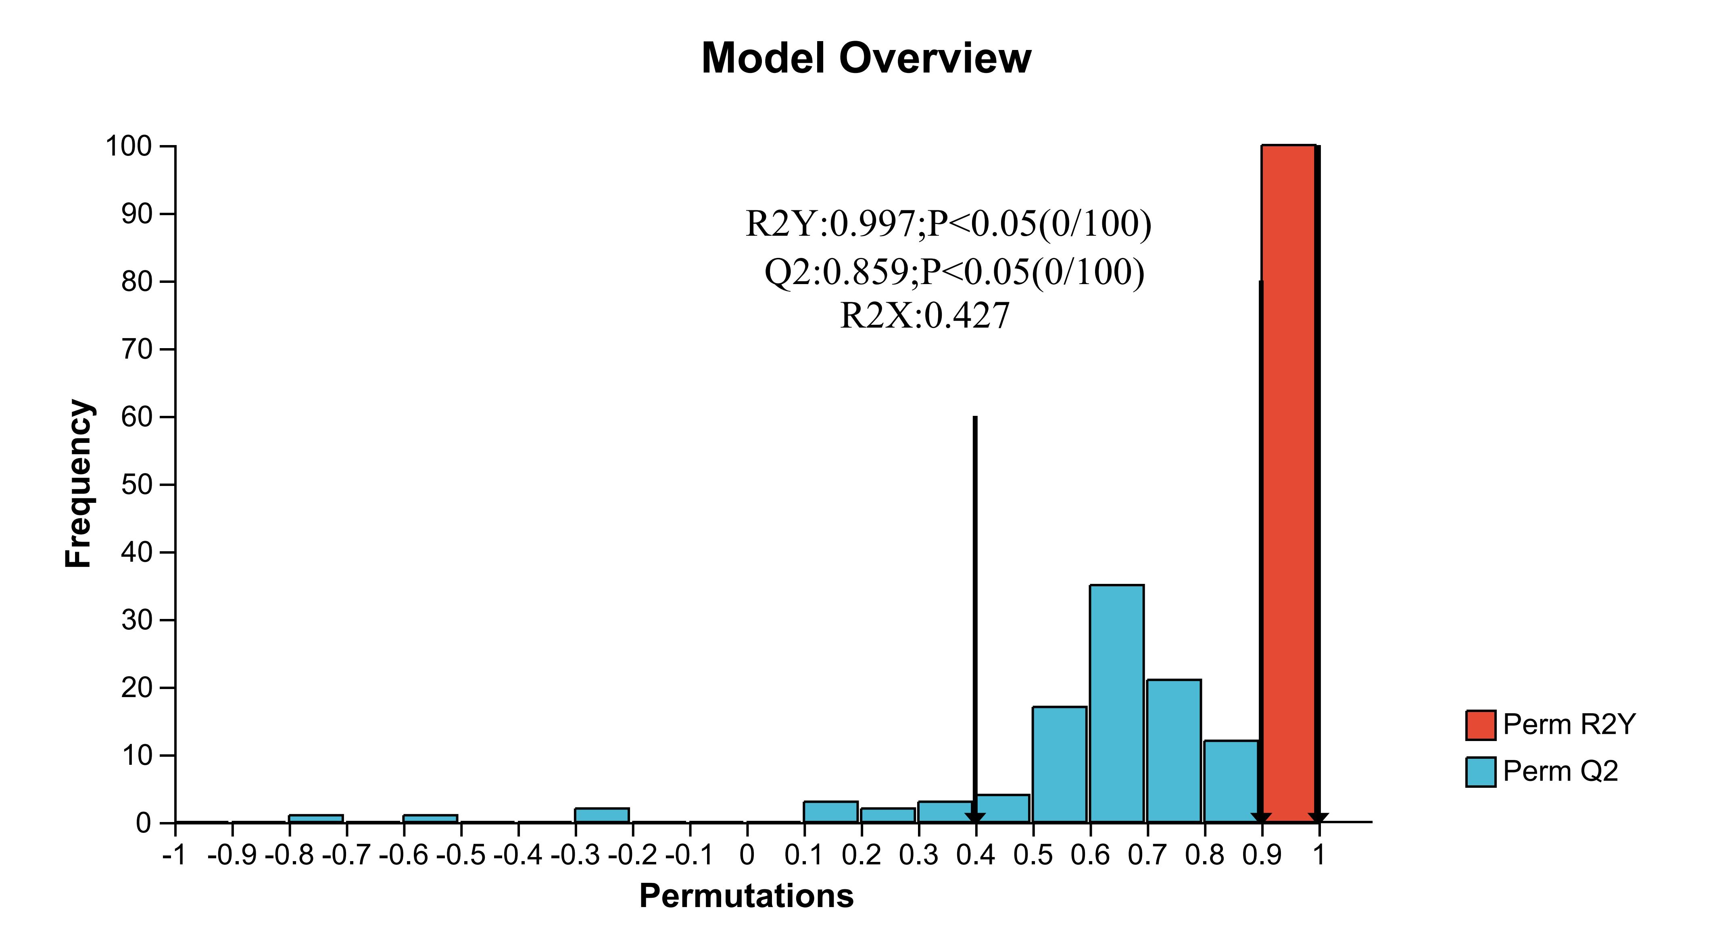
Fig.S2 The x-axis represents the accuracy of the permutation-based random models, and the y-axis represents the number of random models. Red bars indicate the frequency distribution of the Q² values obtained from permutation tests, while blue bars indicate the frequency distribution of the R²Y values. The p-value is calculated as:
p = (number of random models performing better than the original model) / (total number of permutation models).
For example, a Q² p-value of 0.01 indicates that, among 100 permutations, only 1 random model showed better predictive ability than the original model (1/100). Likewise, an R²Y p-value of 0.05 indicates that, among 100 permutations, 5 random models showed better explanatory ability than the original model (5/100). In general, p < 0.05 is taken to indicate that the model has good performance and is unlikely to be obtained by chance.

Fig.S2
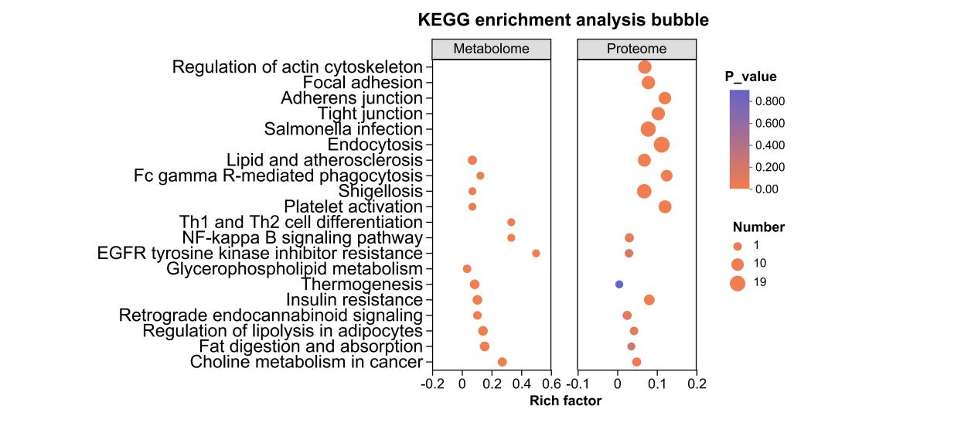
Fig. S2 Integrated KEGG enrichment analysis of lipidomics and proteomics

Fig. S3

Fig.S3 Correlation Sankey plot for Fig. 4C cross-omics analysis.
Sankey diagram showing pairwise correlations between differential metabolites/lipids (left) and differential proteins (right) identified under the high vs. low IL-33 stratification. Each flow represents a statistically significant metabolite–protein correlation (FDR-controlled). Thicker flows indicate either stronger correlation or multiple metabolites converging on the same protein cluster. The plot highlights that multiple membrane-remodelling lipids (PC/PE/CL) simultaneously connect to actin/adhesion/endocytic proteins (e.g. VASP, TLN1, FLNA, ARPC3, TAGLN2), supporting a convergent IL-33-responsive module linking lipid remodelling to vesicle/cytoskeleton processes.

Fig. S4
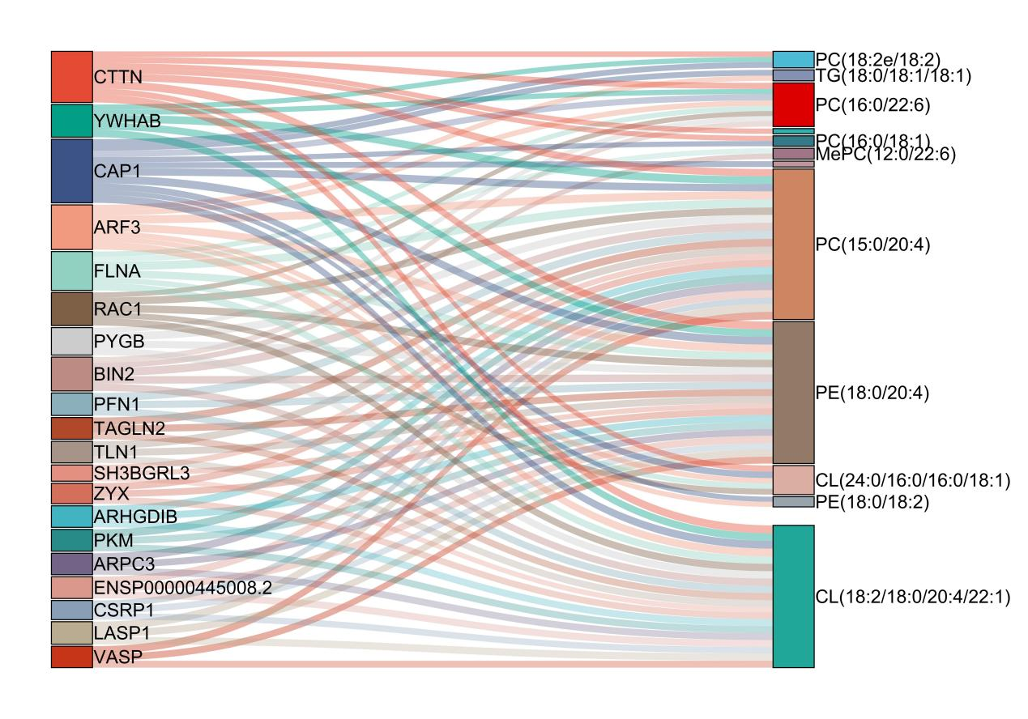
Fig. S4 Protein–metabolite correlation chord diagram for Fig. 4C.
Chord diagram depicting significant correlations between individual lipid/metabolite species (left half of the circle) and cytoskeleton/vesicle-related proteins (right half of the circle). Each chord denotes a metabolite–protein pair with significant correlation; red chords indicate positive correlations, and green chords indicate negative correlations. The figure illustrates a bidirectional pattern within classes: most PC/PE/CL species correlate positively with proteins involved in focal adhesion, actin remodelling and endocytosis (e.g. FLNA, VASP, RAC1, TLN1, ARPC3), whereas selected SM species show opposite associations, consistent with an IL-33-driven shift from SM-rich microdomains toward more flexible PC/PE/CL-enriched membranes.

