Search step
1 | "spinal muscular atrophy type 1" OR "SMA type 1 " OR "SMN1 gene" OR "SMN2 gene" OR "Werdnig-Hoffmann disease" OR "Infantile-onset SMA"
2 | "onasemnogene abeparvovec" OR "Zolgensma" OR "gene therapy"
3 | 1 AND 2

Table 1 Databases search strategy

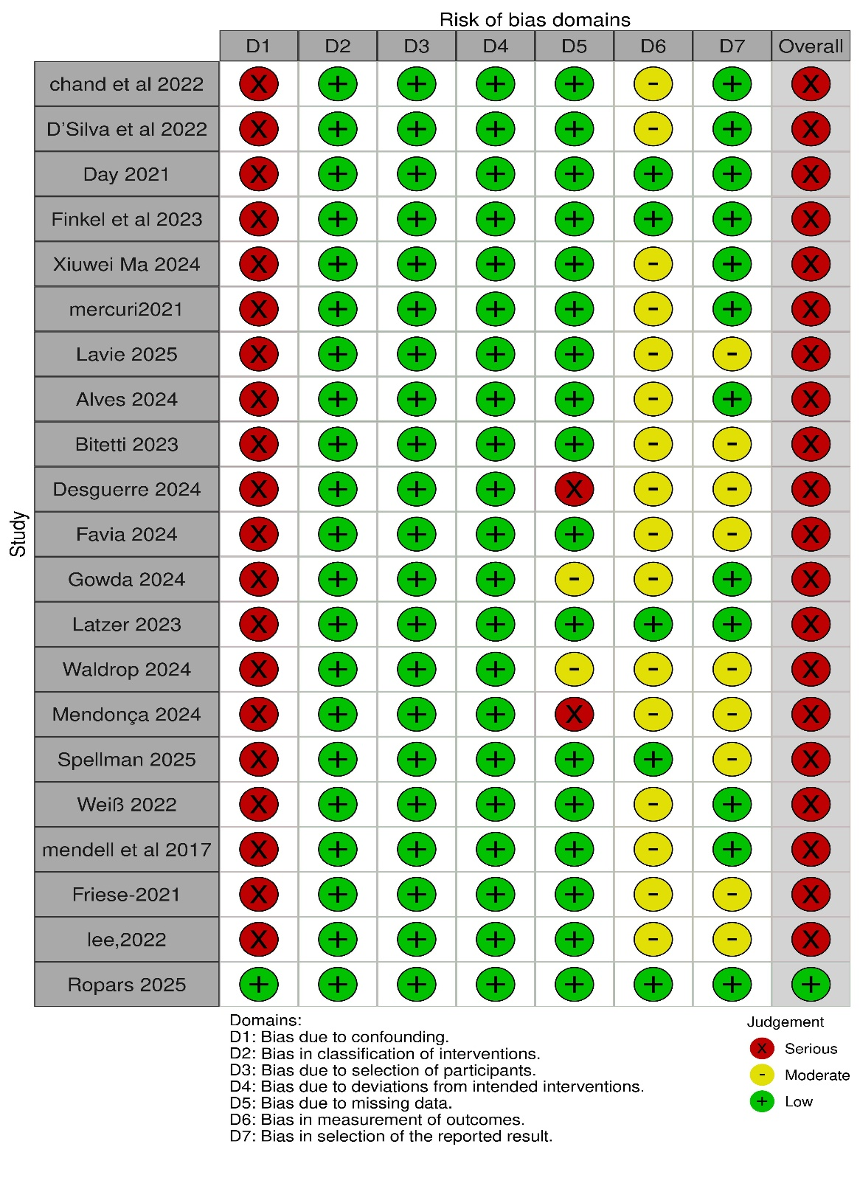
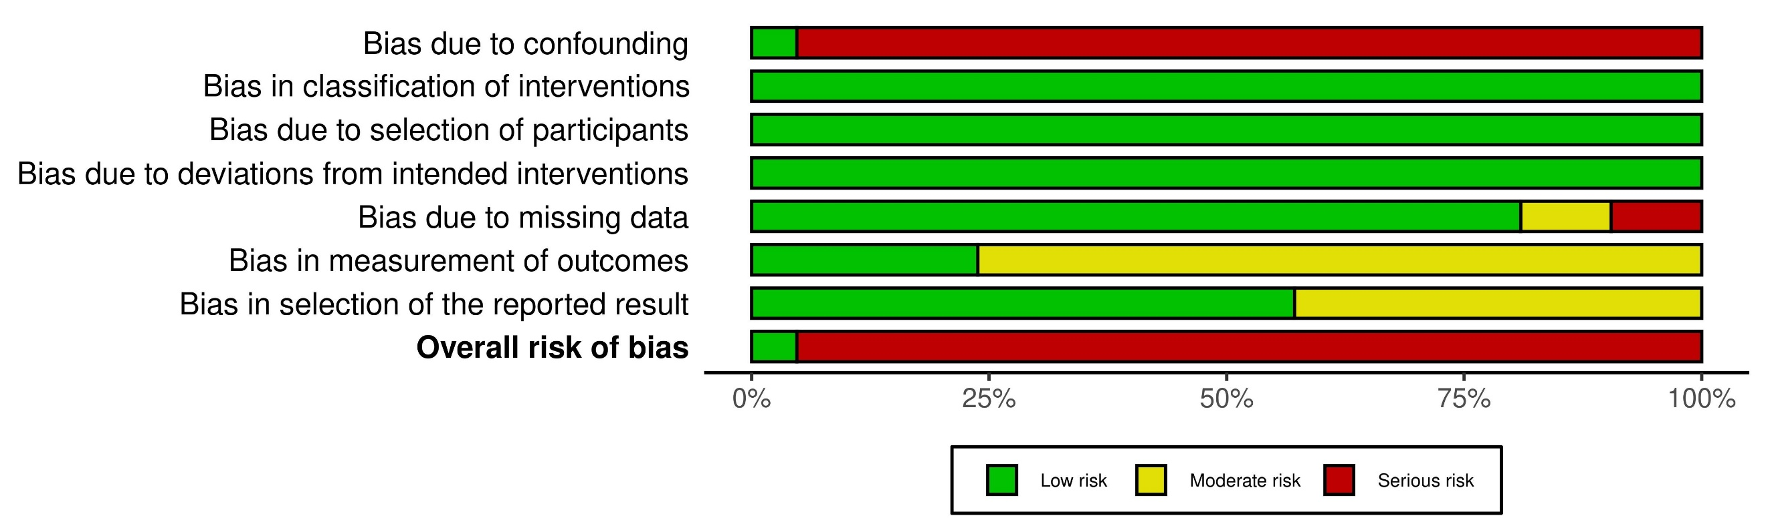
Figure S1 Summary of quality assessment using ROBINS-I V2 tool

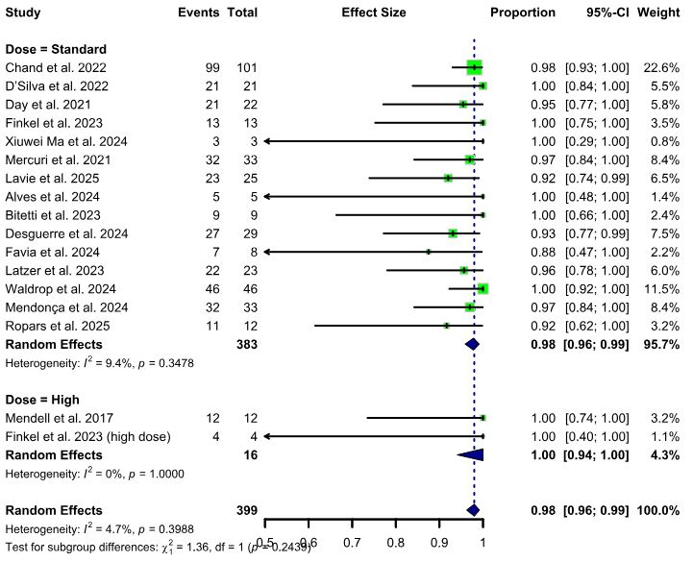
Figure S2 Subgroup analysis by drug dose for pooled overall survival

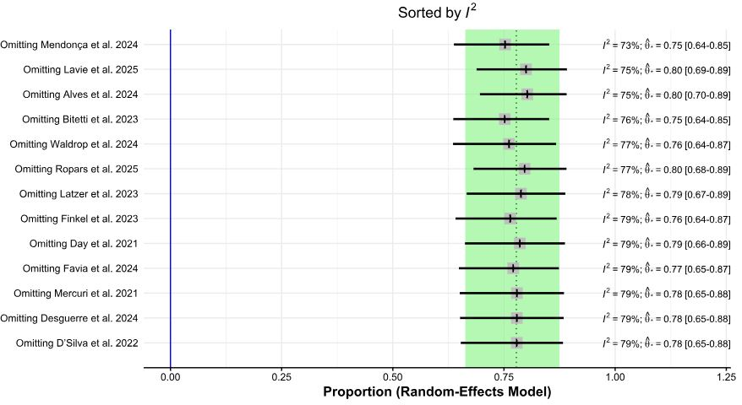
Figure S3 Sensitivity analysis for event-free survival endpoint

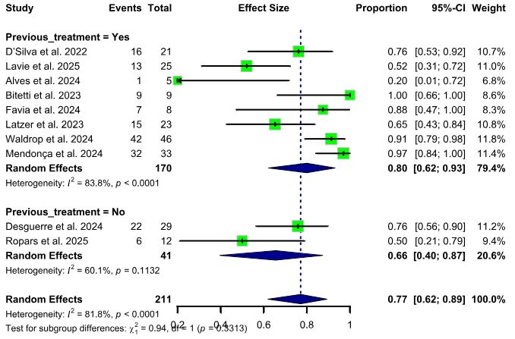
Figure S4 Subgroup analysis by previous treatment status for pooled event-free survival

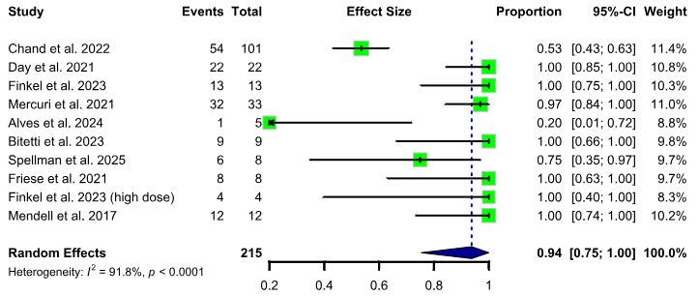
Figure S5 Pooled overall adverse event proportion

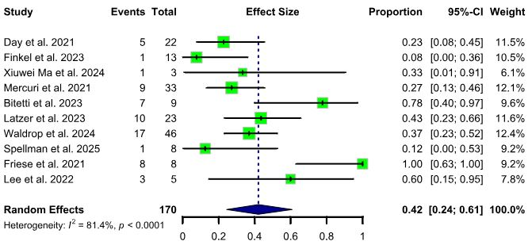
Figure S6 Pooled proportion of ALT elevation

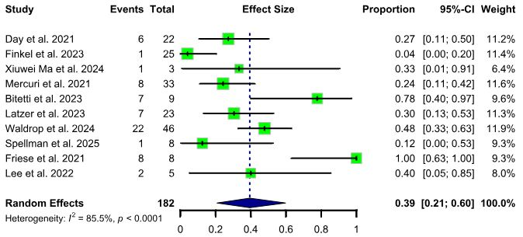
Figure S7 Pooled proportion of AST elevation

Figure S8 Pooled proportion of pneumonia
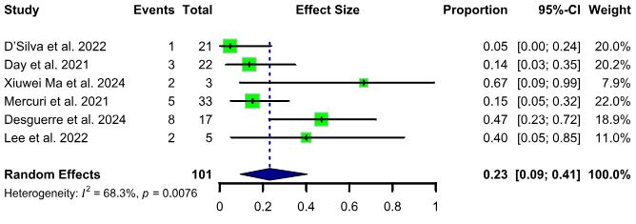

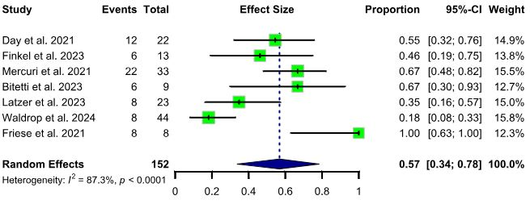
Figure S9 Pooled proportion of pyrexia

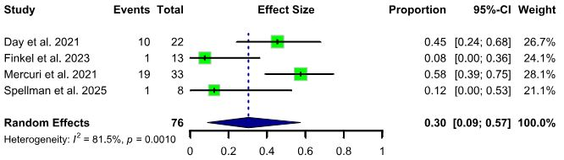
Figure S10 Pooled proportion for Serious adverse events

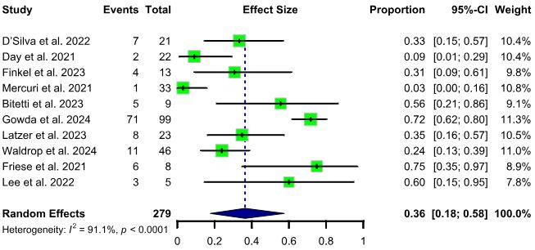

Figure S11 Pooled proportion of thrombocytopenia

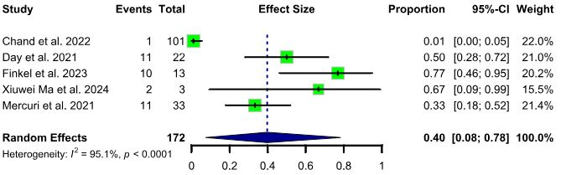

Figure S12 Pooled proportion of Upper respiratory tract infection (URTI)

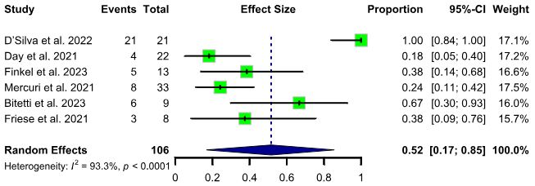
Figure S13 Pooled proportion of vomiting

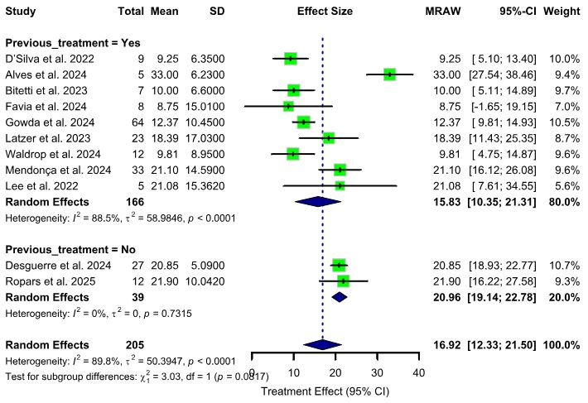
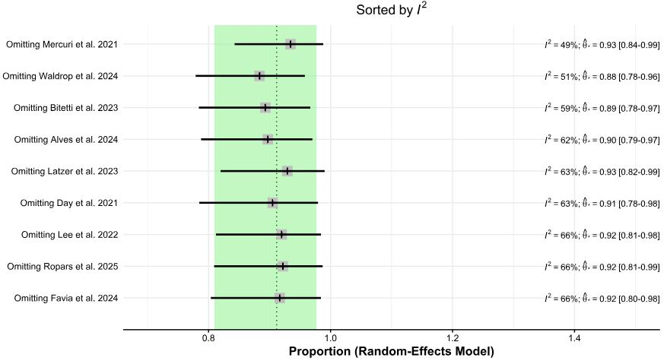
Figure S15 Subgroup analysis by previous treatment status for mean change from baseline in CHOP-INTEND score
Figure S14 leave-one-out sensitivity analysis for proportion of patients achieving a CHOP-INTEND score ≥ 40

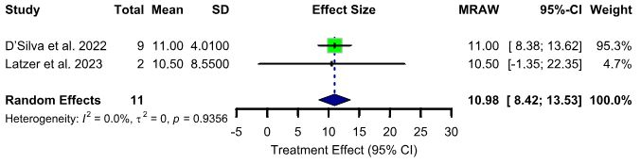
Figure S16 Mean change from baseline in HFMSE score

