Supplementary Material

GliaMimic: a longitudinal, multimodal in vitro platform for assessing Glioblastoma treatment response and relapse in patient-derived organoids and spheroids
Selina Camenisch¹, Luisa Bell², Nadine Stokar-Regenscheit², Natalia Vélez Char³, Wolfram Jochum³, Simon Heinze⁴, Anna Maria Zeitlberger⁵, Thomas Hundsberger⁶, Marian Neidert⁵, Peter Wick^{1*}, Vanesa Ayala-Nunez^{1*}

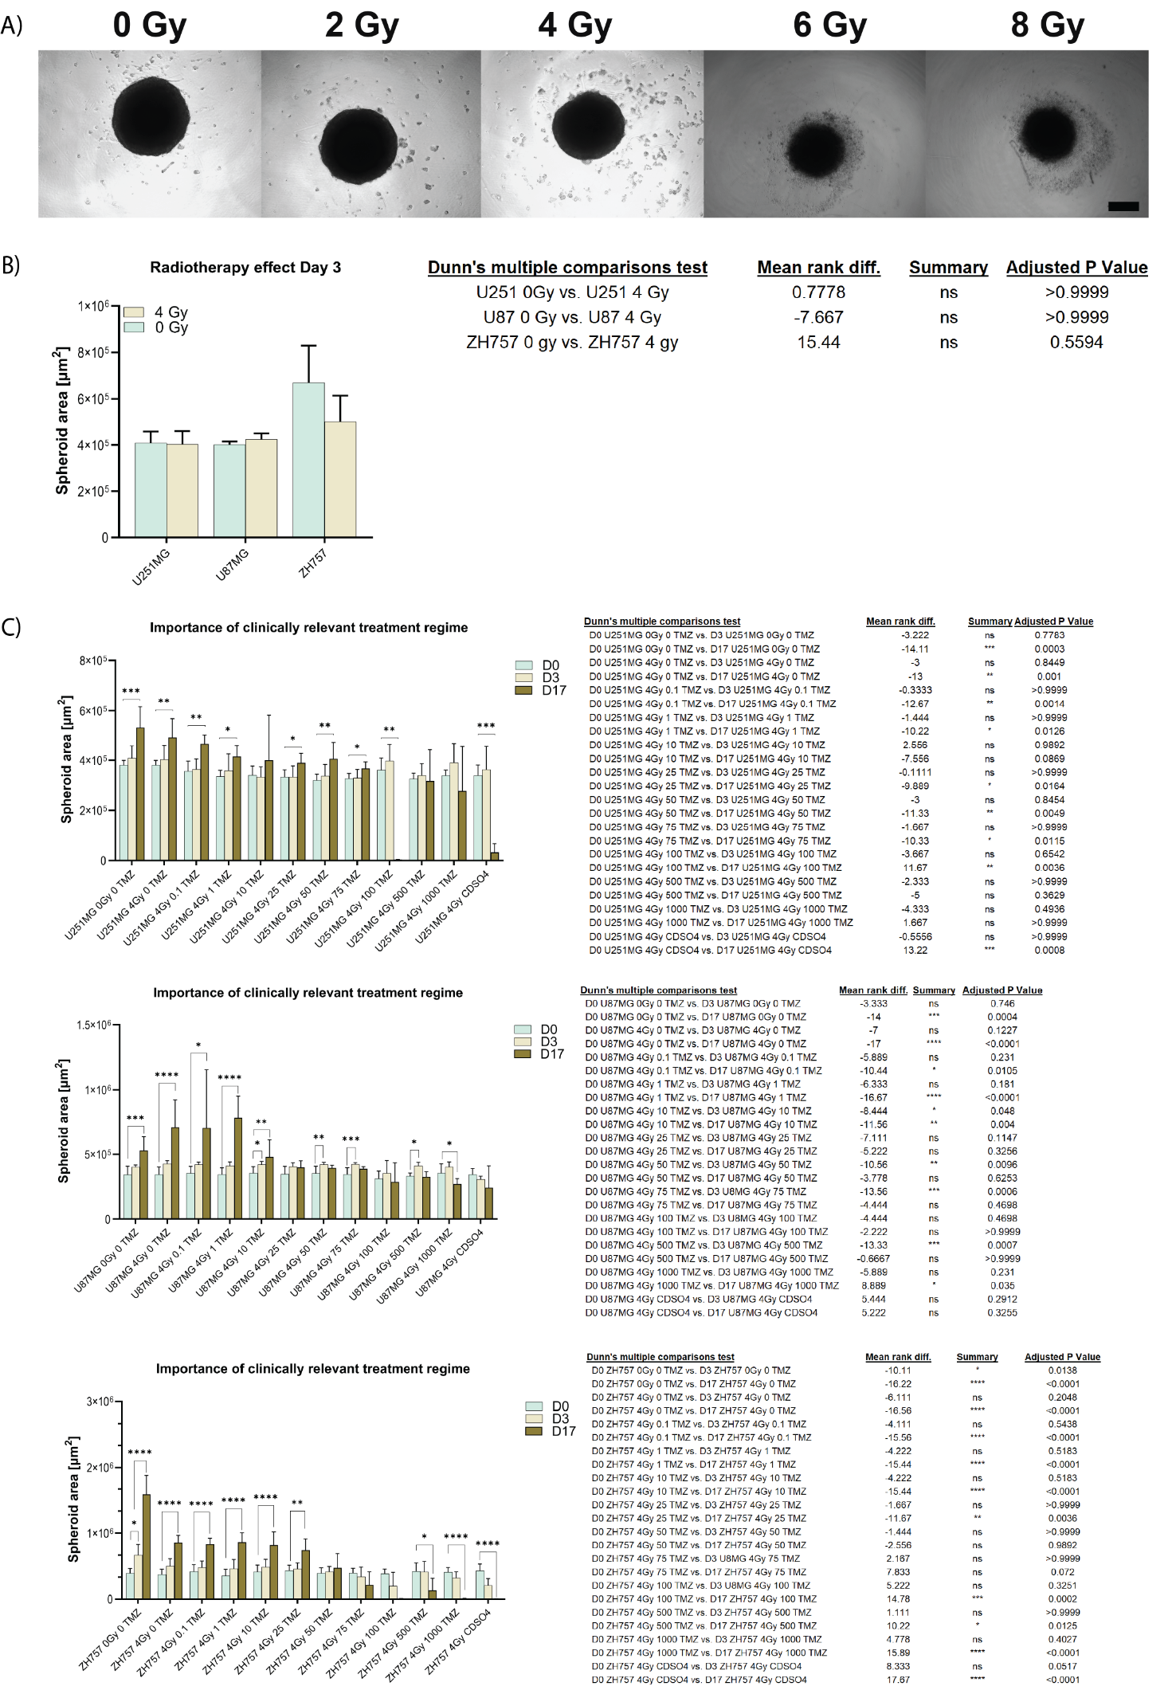
Supplementary Figure S1. Irradiation and long-term treatment efficacy in GBM. A) The structural integrity and spheroid morphology were assessed for irradiated GBM spheroids (U87MG) (2, 4, 6, 8 Gy) after 3 days to determine the maximum tolerable radiation dose. 4 Gy was identified as optimal irradiation dose, as higher doses led to spheroid disintegration and did not ensure sustained experimental utility. Scale bar: 200 µm. B) Depiction of spheroid area obtained from bright field images for ZH757, U87MG, U251MG as bar plot showing mean ± SD, which were calculated from three technical and three biological replicates (n = 3) (N = 9 spheroids / treatment concentration for each cell line). Statistical analysis was performed using Kruskal-Wallis test followed by Dunn's multiple comparisons test in GraphPad Prism (v10, GraphPad Software). For all conditions comparable sizes to controls were maintained (ns). C) The impact of prolonged TMZ treatment on GBM spheroid growth is depicted. Spheroid area was quantified from bright-field images for U251MG, U87MG, and ZH757 under various TMZ doses (0, 0.1, 1, 10, 25, 50, 75, 100, 500, 1000 µM) and CdSO₄ control, comparing baseline (day 0), end of GliaMimic’s continuous treatment (day 3), and GliaMimic’s end of treatment (day 17). Data is represented as bar plots showing mean ± SD with three technical and three biological replicates (n = 3) (N = 9 spheroids / treatment concentration for each cell line). Statistical analysis was performed using Kruskal-Wallis test followed by Dunn's multiple comparisons test in GraphPad Prism (v10, GraphPad Software). Significance was predominantly observed between day 0 and day 17, underscoring the importance of clinically relevant and extended treatment regimes. All statistical results are presented as bar plots with the following significance notation: *p < 0.05, **p < 0.01, ***p < 0.001, and ****p < 0.0001; nonsignificant differences (p ≥ 0.05).
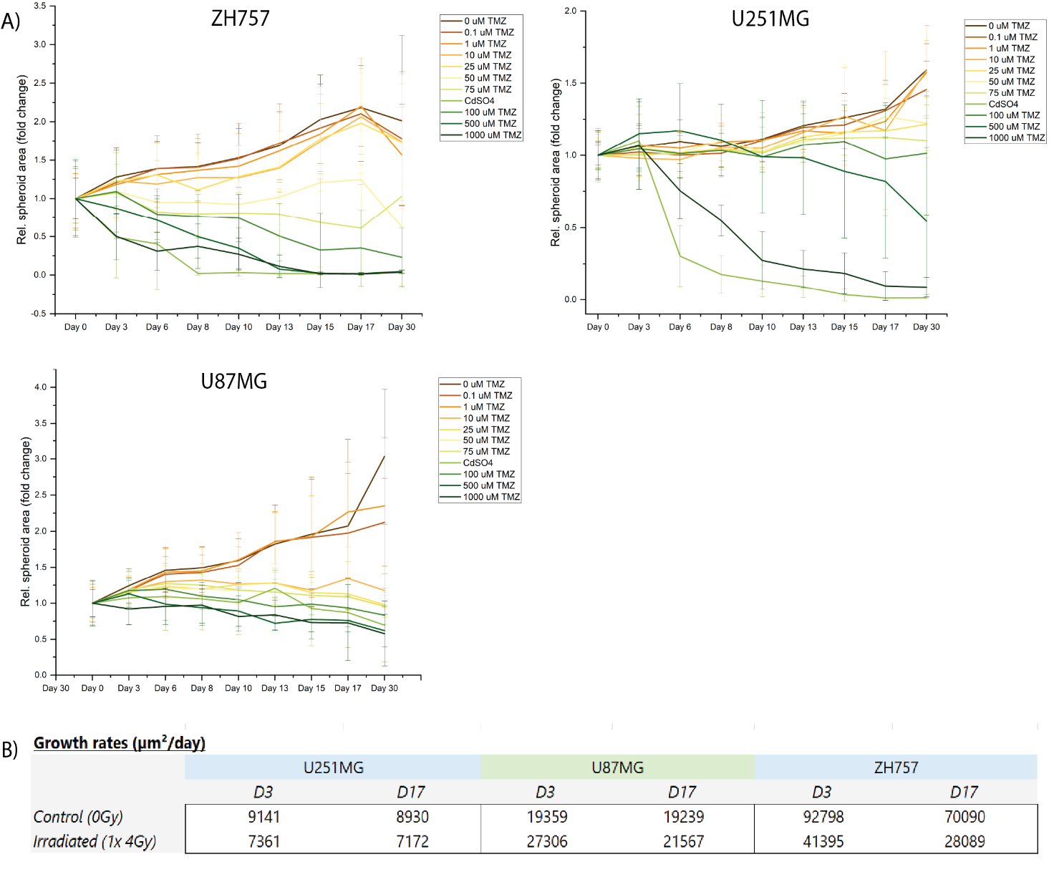
Supplementary Figure S2. Relative spheroid area fold change over 30 days of treatment. A) Bright-field imaging was performed every two to three days to assess spheroid growth in ZH757, U251MG, and U251MG cell lines under increasing concentrations of TMZ (0, 0.1, 1, 10, 25, 50, 75, 100, 500, and 1000 µM), alongside a CdSO₄ control. The fold change in spheroid area was normalized to baseline measurements of each treatment condition (day 0) and data represent mean ± SD calculated from three technical and three biological replicates (n = 3) (N = 9 spheroids / timepoint / treatment concentration for each cell line). D) Tabular depiction of GBM spheroid growth rates for U87MG, U251MG and ZH757 in µm²/day.

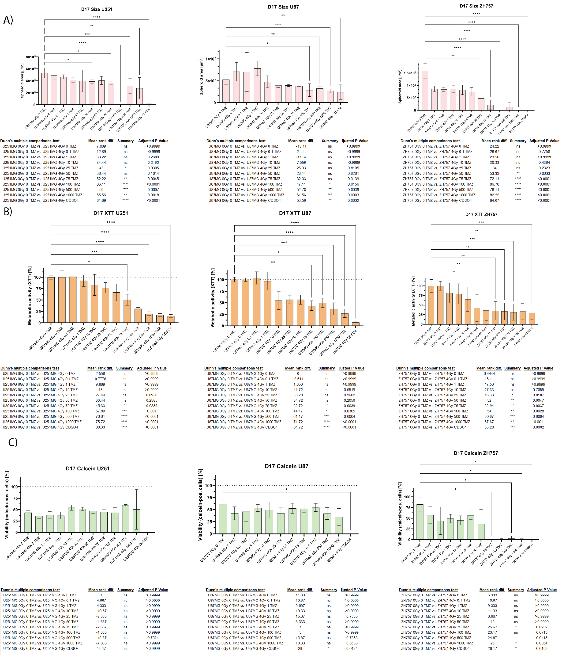
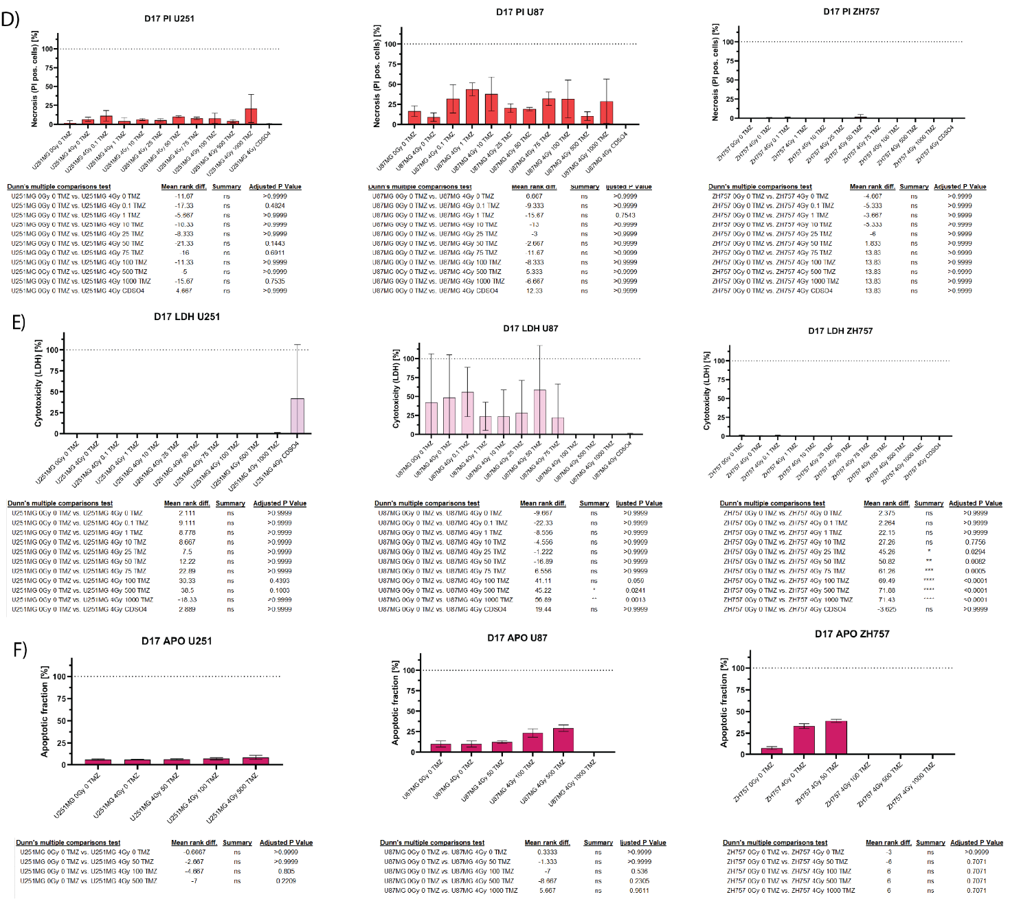

Supplementary Figure S3. Capturing treatment effects at end of GliaMimic treatment in spheroids. Bar plots are capturing treatment progression were calculated from three technical and three biological replicates across A) spheroid area (n = 3) (N = 9 spheroids / timepoint / treatment concentration for each cell line), B) metabolic activity (XTT assay) (N = 9 spheroids / timepoint / treatment concentration for each cell line), C) viable cell fraction (calcein+) (N = 3 spheroids / timepoint / treatment concentration for each cell line), D) necrotic cell fraction (PI+) (N = 3 spheroids / timepoint / treatment concentration for each cell line), E) cytotoxicity (LDH release) (N = 9 spheroids / timepoint / treatment concentration for each cell line), and F) apoptotic fraction (N = 3 spheroids / timepoint / treatment concentration for each cell line) at the end of treatment (day 17) in U251, U87MG, and ZH757 GBM models. Bar plots are representing mean ± SD. Treatment conditions (0, 0.1, 1, 10, 25, 50, 75, 100, 500, 1000 μM TMZ) and a CdSO₄ control were compared to the no treatment (NT) control. Statistical analysis was performed using Kruskal-Wallis test followed by Dunn's multiple comparisons test in GraphPad Prism (v10, GraphPad Software). All results are presented as bar plots with the following significance notation: *p < 0.05, **p < 0.01, ***p < 0.001, and ****p < 0.0001; non-significant differences (p ≥ 0.05).

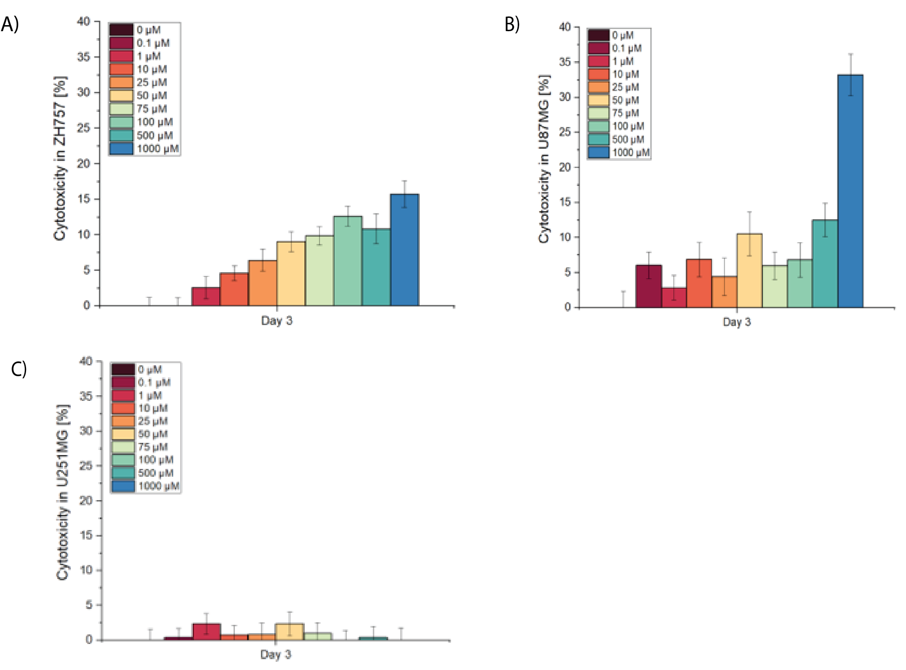
Supplementary Figure S4. Dose-dependent cytotoxicity (LDH release) in GBM cell lines after 3 days of continuous treatment. Bar plots show mean ± SD for A) U251MG, B) U87MG, and C) ZH757 calculated from three technical and three biological replicates (n = 3) (N = 9 spheroids / treatment concentration for each cell line) and demonstrating a clear dose-response relationship in U87MG and ZH757.
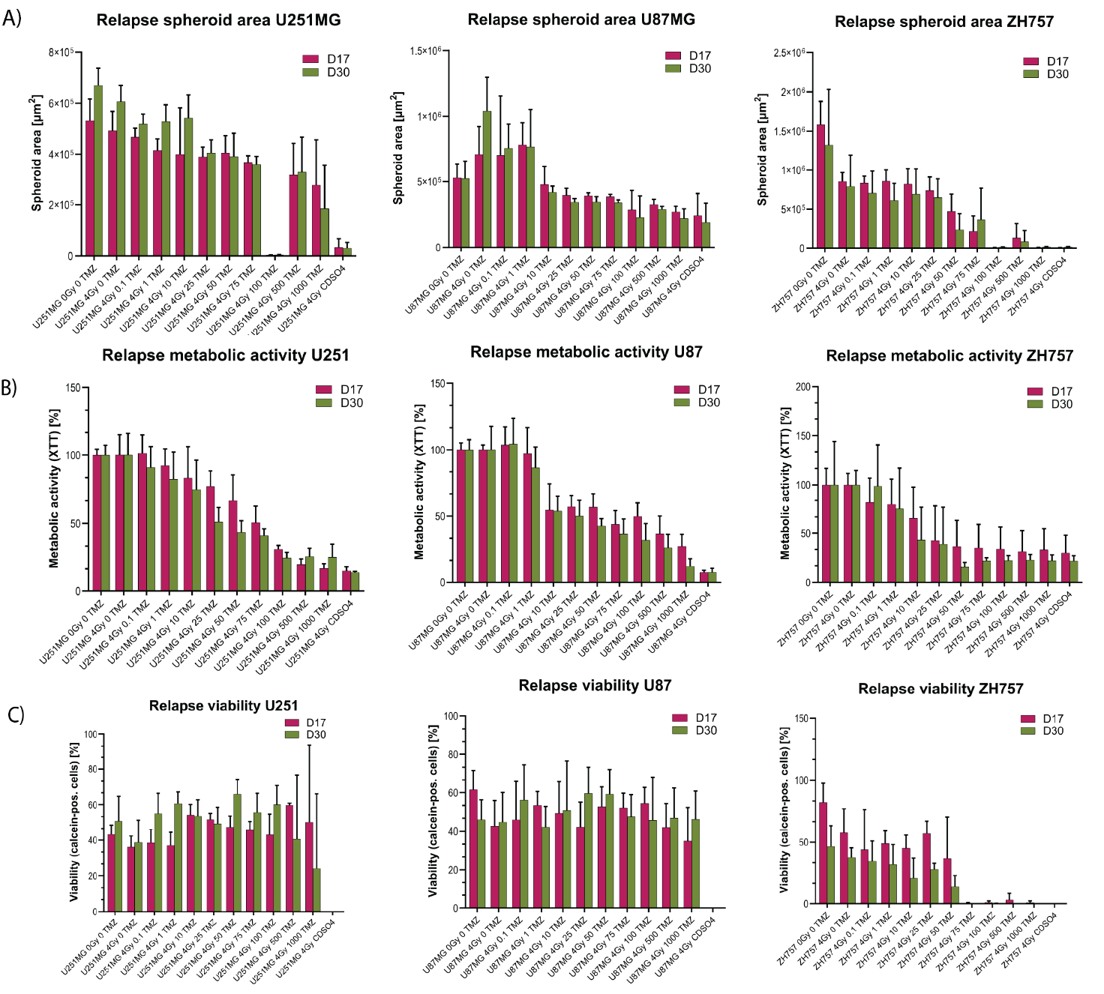
Supplementary Figure S5. Evaluation of GliaMimic treatment discontinuation and relapse in GBM spheroid models. Bar plots were calculated from three technical and three biological replicates (n=3) and depict A) spheroid area (N = 9 spheroids / timepoint / treatment concentration for each cell line), B) metabolic activity (XTT assay) (N = 9 spheroids / timepoint / treatment concentration for each cell line), and C) viable cell fraction (calcein+) (N = 3 spheroids / timepoint / treatment concentration for each cell line) for ZH757, U87MG, and U251MG at the end of treatment (day 17) and after 2 weeks of discontinuation (day 30, relapse timepoint). Data represent mean ± SD.

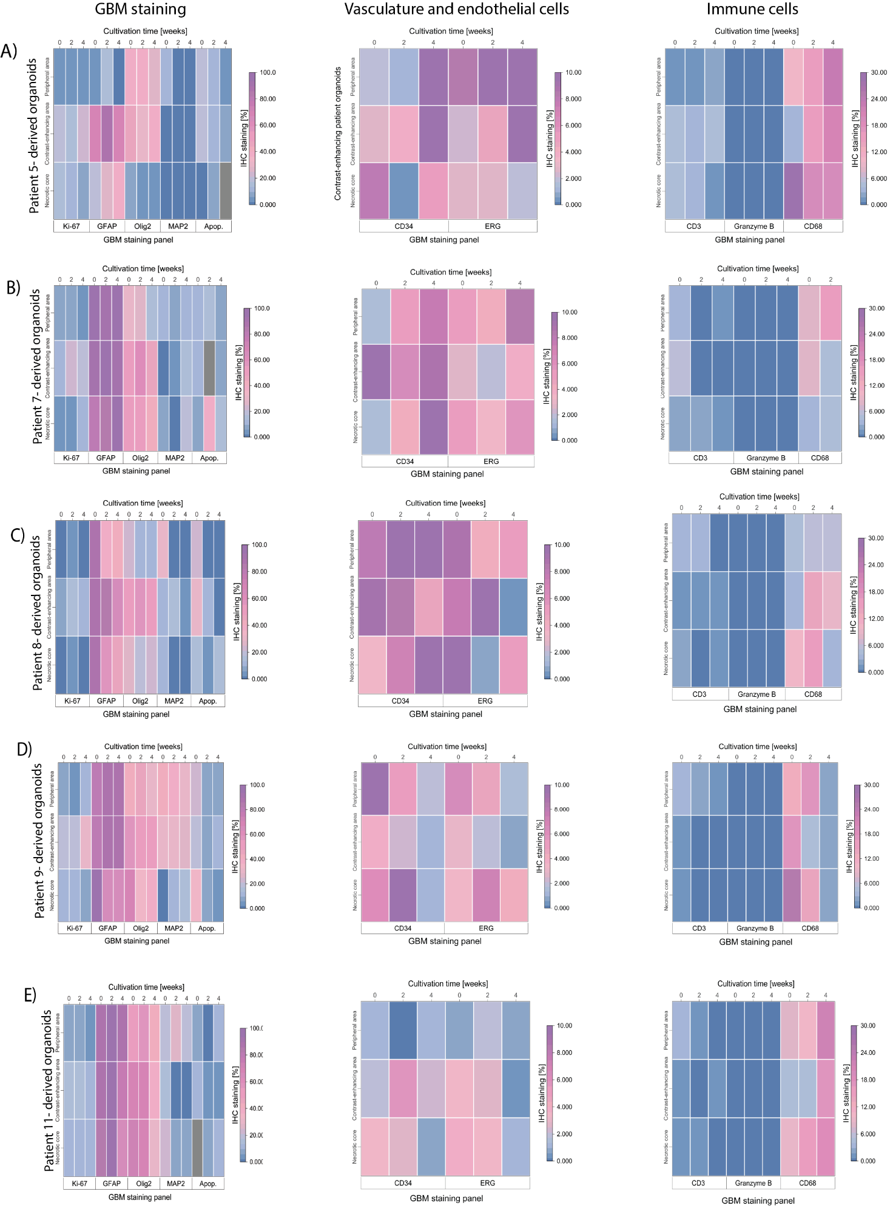
Supplementary Figure S6. Immunohistochemical characterization of patient-derived GBM organoids over 4 weeks of cultivation. Heatmaps A-E) display mean expression levels of endothelial and vascular markers (CD34, ERG), immune cell populations (CD3, Granzyme B, CD68), and a tumor cell panel (Ki-67, GFAP, Olig2, MAP2, apoptotic fraction) across PDOs from 5 GBM patients (N = 3 organoids / staining for each patient). Measurements were taken after 2 and 4 weeks, with additional comparison to the patient’s original tumor tissue (surgery day). PDOs exhibited pronounced inter- and intratumoral heterogeneity, including GBM cells, vasculature, and immune infiltrates. Notably, organoids closely mirrored the patient-matched tissue, supporting their clinical relevance as a tumor model. Statistical comparisons between timepoints were omitted due to the descriptive nature of the analysis.

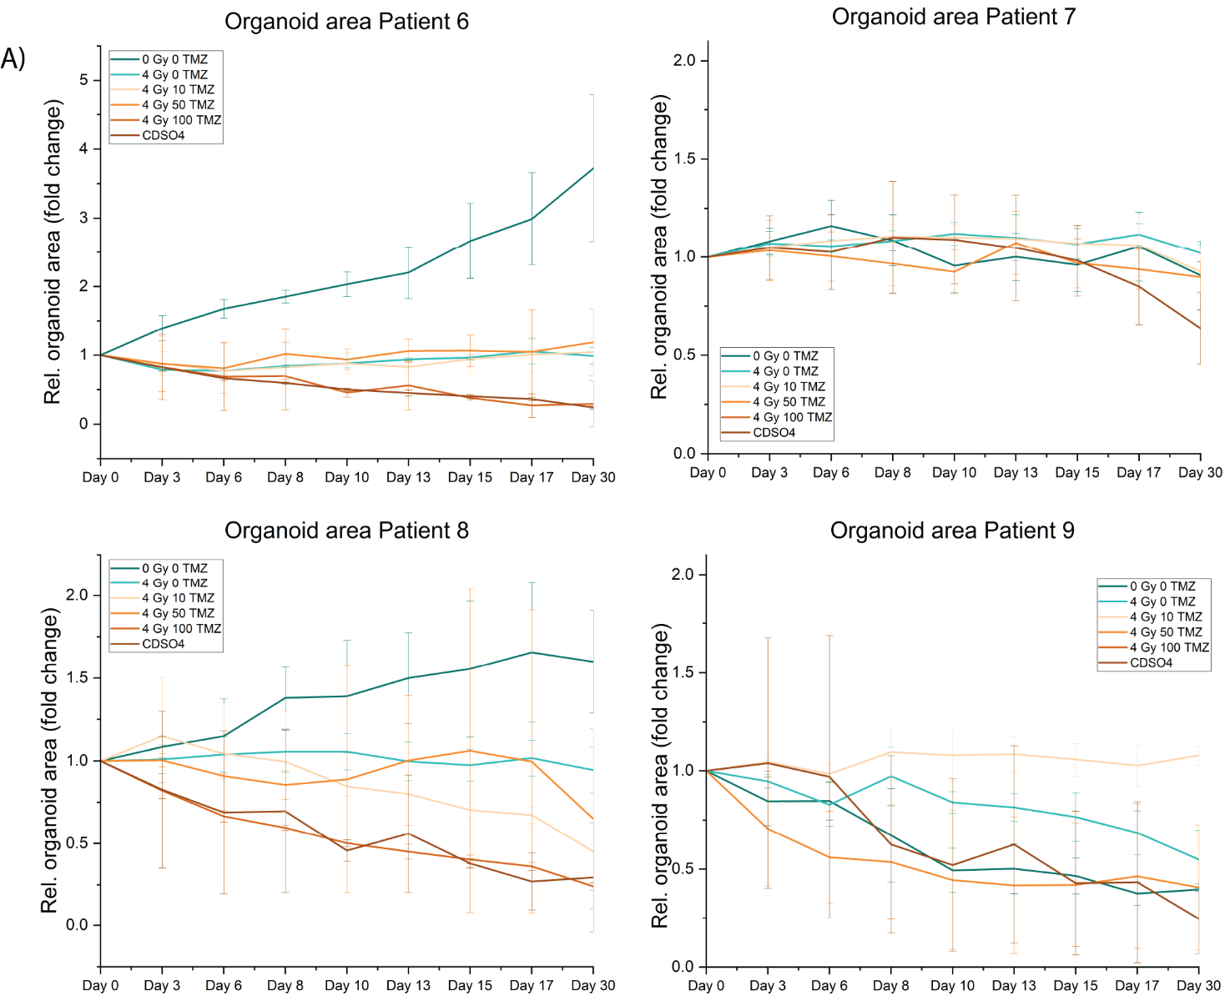
Supplementary Figure S8. Relative spheroid area fold change over 30 days of treatment. Bright-field imaging was performed every two to three days to assess organoid growth in A) patient 6, B) patient 7, C) patient 8 and D) patient 9 under increasing concentrations of TMZ (NT, 0,10, 50, 100 µM). The fold change in spheroid area was normalized to baseline measurements of each treatment condition (day 0) and data represent mean ± SD of three technical replicates (N = 3 organoids / timepoint / treatment concentration for each patient).
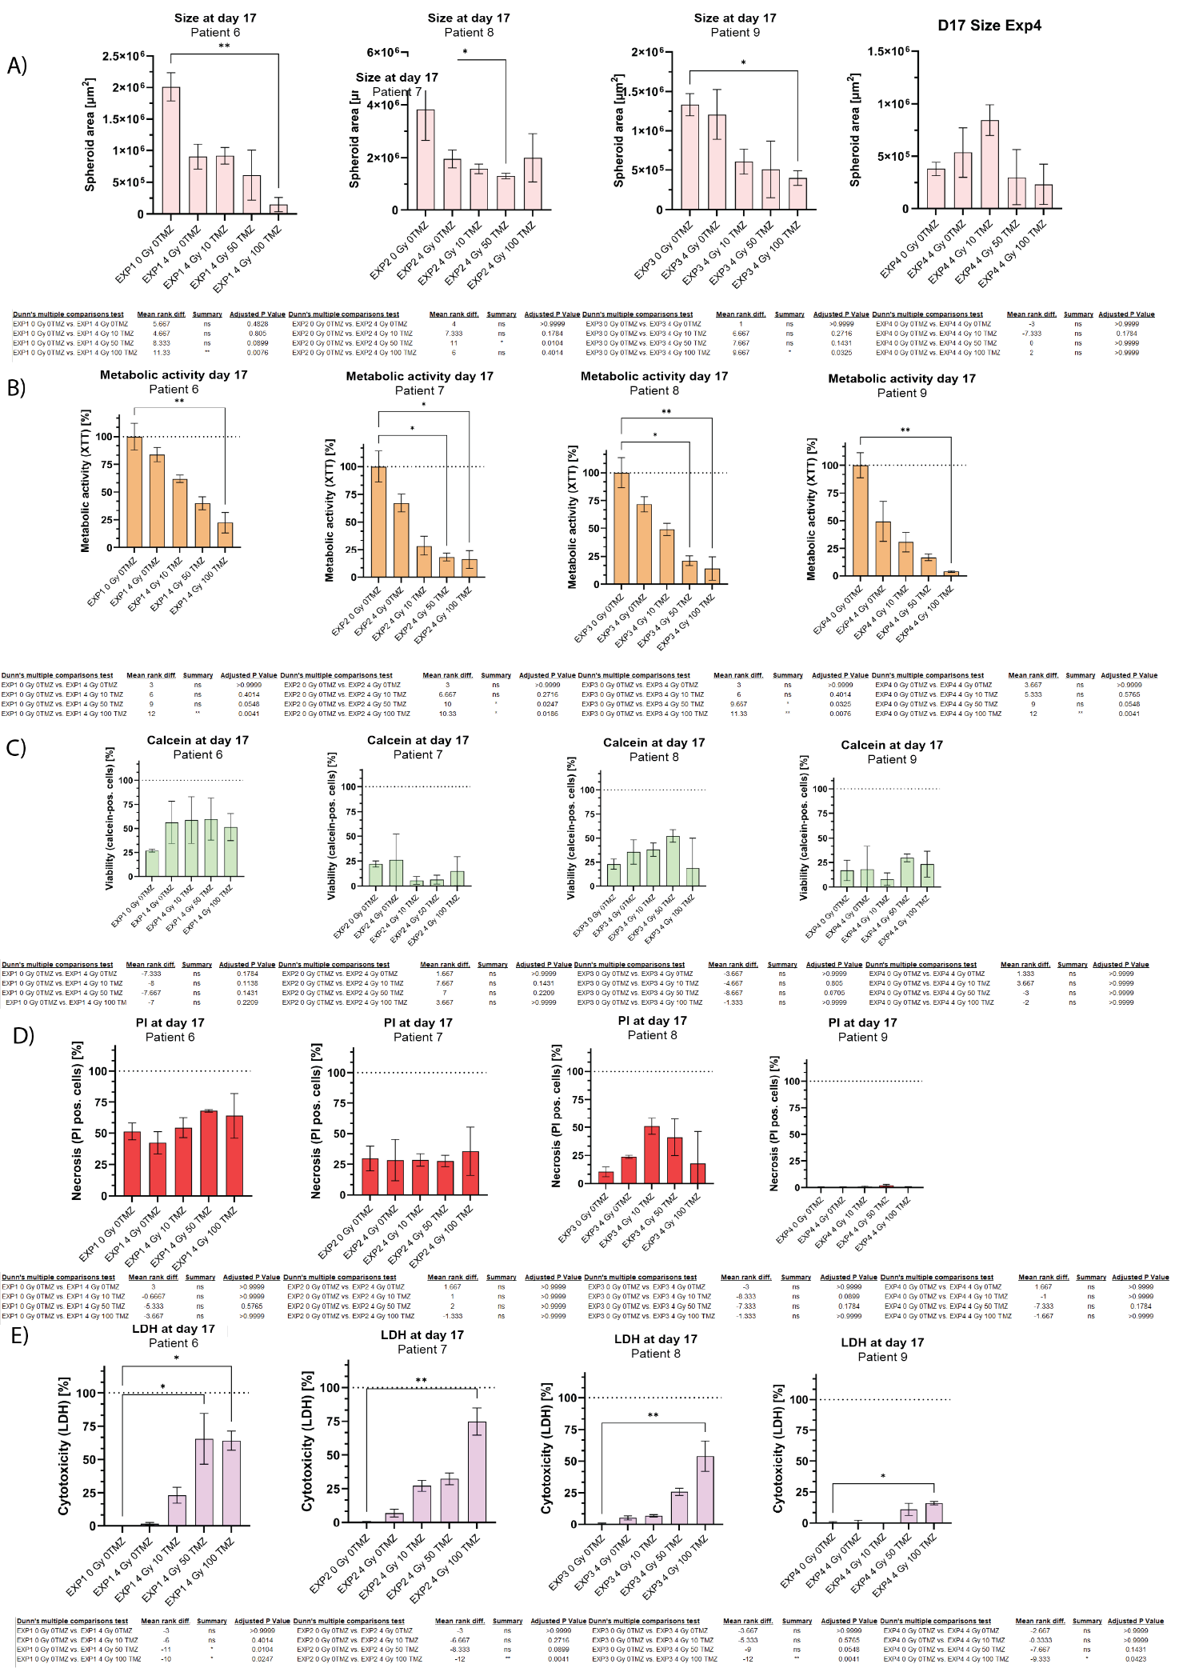
Supplementary Figure S9. Capturing treatment effects at end of GliaMimic treatment in PDOs. Bar plots comparing the effects of GliaMimic treatment across A) GBM organoid size, B) metabolic activity (XTT assay), C) viable cell fraction (calcein+), D) necrotic cell fraction (PI+), E) cytotoxicity (LDH release) at the end of treatment (day 17) in patient-derived organoids from 4 different patients. Bar plots are representing mean ± SD calculated from three technical replicates (N = 3 PDOs / timepoint / treatment concentration for each patient). Treatment conditions (0, 10, 50, 100 μM TMZ) were compared to the no treatment (NT) control. Statistical analysis was performed using Kruskal-Wallis test followed by Dunn's multiple comparisons test in GraphPad Prism (v10, GraphPad Software). All results are presented as bar plots with the following significance notation: *p < 0.05, **p < 0.01, ***p < 0.001, and ****p < 0.0001; non-significant differences (p ≥ 0.05).
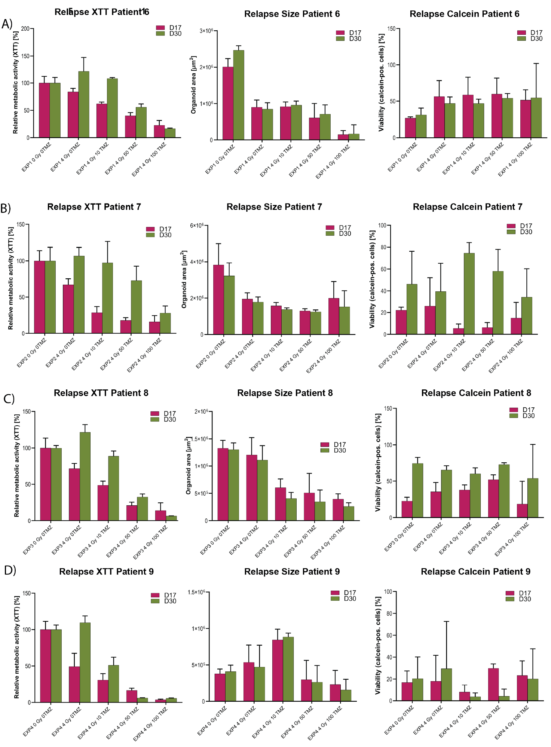
Supplementary Figure S10 Evaluation of GliaMimic treatment discontinuation and relapse in GBM spheroid models. Bar plots depict A) patient-derived organoid area, B) metabolic activity (XTT assay), and C) viable cell fraction (calcein AM+). GBM PDOs derived from four patients at the end of treatment (day 17) and after two weeks of discontinuation (day 30, relapse timepoint). Data represents mean ± SD and were calculated from three technical replicates (N = 3 PDOs / timepoint / treatment concentration for each patient).

Tables
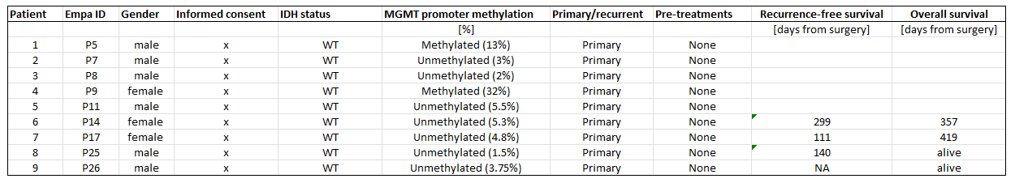
Supplementary Table 1 Patient information. Clinical indications (Patient #, GBO ID, HOCH Patient ID donor age, gender, informed consent, MGMT promoter methylation status, IDH status, pretreatments, primary/recurrent) about GBM patients used for the generation of patient-derived organoids is provided in a tabular form.
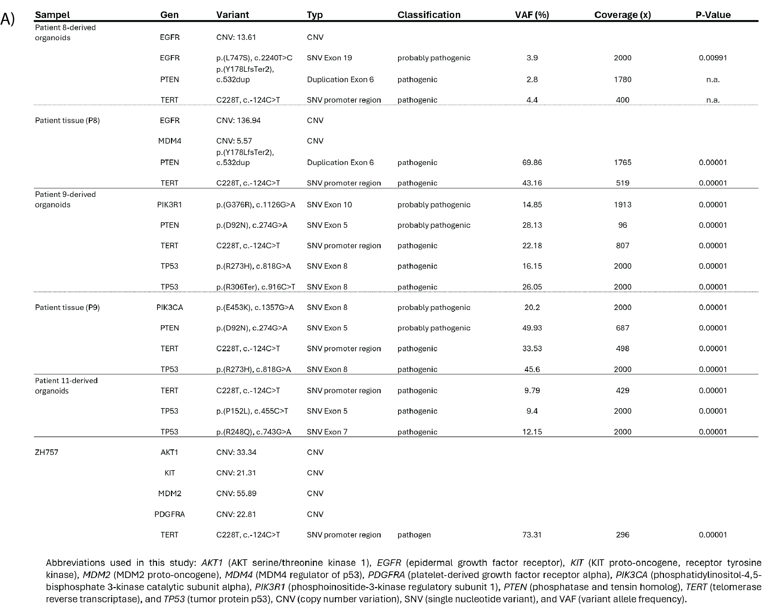

Supplementary Table 2. Mutational profiling (whole genome sequencing) of GBM PDOs derived from patient 8, 9 and 11, with corresponding patient tumor tissue available for comparison in patient 8 and 9. Tumor DNA was profiled using the Oncomine Comprehensive Assay v3 (ThermoFisher) on an Ion Torrent sequencing platform. Abbreviations used: AKT1 (AKT serine/threonine kinase 1), EGFR (epidermal growth factor receptor), KIT (KIT proto-oncogene, receptor tyrosine kinase), MDM2 (MDM2 proto-oncogene), MDM4 (MDM4 regulator of p53), PDGFRA (platelet-derived growth factor receptor alpha), PIK3CA (phosphatidylinositol-4,5-bisphosphate 3-kinase catalytic subunit alpha), PIK3R1 (phosphoinositide-3-kinase regulatory subunit 1), PTEN (phosphatase and tensin homolog), TERT (telomerase reverse transcriptase), TP53 (tumor protein p53), CNV (copy number variation), SNV (single nucleotide variant), and VAF (variant allele frequency).

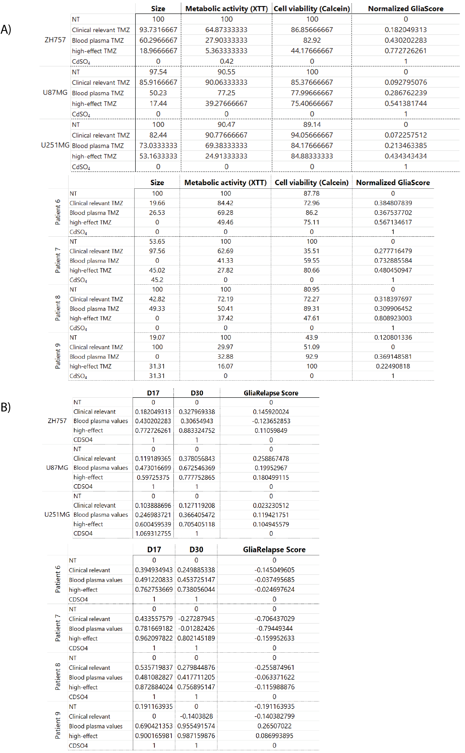
Supplementary Table 3 Calculation of GliaScore. In A) each time-independent GliaScore value for the three spheroid cell lines (ZH757, U87MG and U251MG) as well as for the PDOs (patient 6 - 9) are depicted for the three readouts size, metabolic activity and cell viability (calcein +). The overall normalized GliaScore value is shown in the last column with scores ranging from 0 (showing baseline values in the NT control) to 1 (indicating maximal possible treatment response). In B) RelapseScore values are depicted for end of treatment (day 17) and relapse time point (day 30), summarizing the RelapseScore value of size, metabolic activity and cell viability (calcein +). In the last column, the difference between relapse evaluation and end of treatment depict the RelapseScore with positive values indicating a tumor regrowth and potential relapse, while a negative score shows no increase in tumor size, metabolic activity nor viability in comparison to the end of treatment values.

