Allosteric Ensembles Elucidate Mechanisms of Inhibition in Human Soluble Epoxide Hydrolase

Authors
Qiongju Qiu¹, Oriol Gracia Carmona^{1,2}, Giancarlo Abis¹, Franca Fraternali^{2*} and Maria R Conte^{1*}
Affiliations
¹Randall Centre for Cell and Molecular Biophysics, King’s College London, New Hunt’s House, Guy’s Campus, London SE1 1UL, UK
²Institute of Structural and Molecular Biology, University College London, Darwin Building, Gower Street, London, WC1E 6BT, United Kingdom.
* Corresponding authors. Emails: sasi.conte@kcl.ac.uk; f.fraternali@ucl.ac.uk

This PDF file includes:

Supplementary Figure S1 to S5
Supplementary Tables S1

Other Supplementary Materials for this manuscript include the following:

Supplementary Video S1

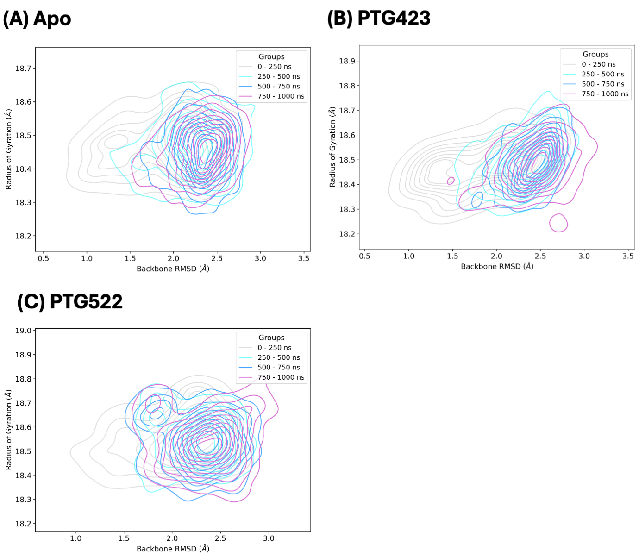

Supplementary Figure S1. REMD simulations reach equilibrium within 1 μs. (A-C) 2D density plots of backbone Root-Mean-Square-Deviation (RMSD) and Radius of gyration (Rg) at increasing cumulative simulation time for system (A) Apo (apoprotein), (B) 15d-PGJ₂ bound to C423 (PTG423) and (C) 15d-PGJ₂ bound to C522 (PTG522). Time intervals (0-250, 250-500, 500-750, and 750-1000 ns) are colored in grey, cyan, blue, and purple, respectively.

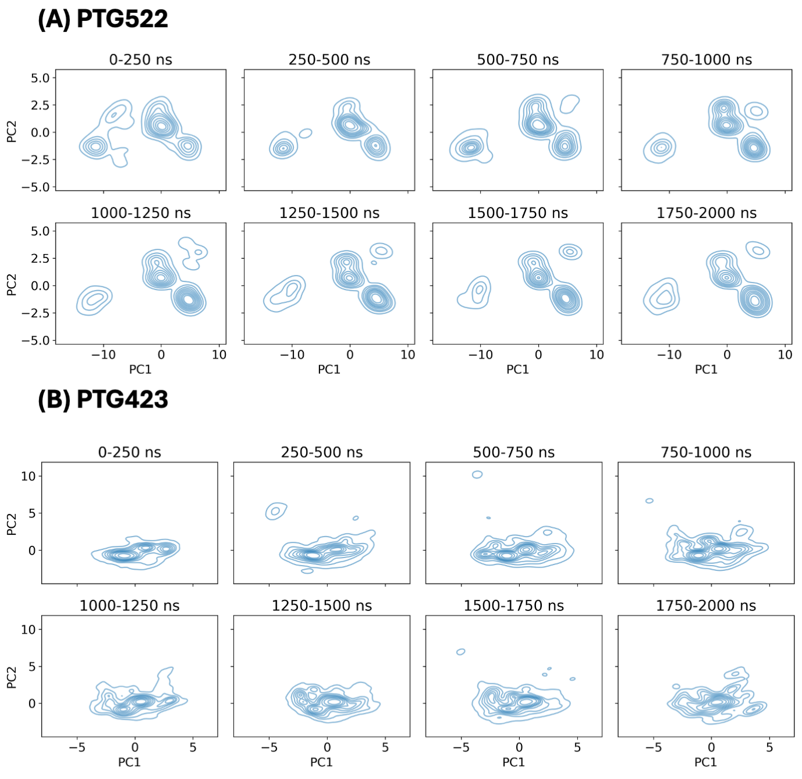
Supplementary Figure S2. Analysis of 2 μs REMD simulations. Extending the REMD simulations to 2 μs confirmed conformational sampling completeness. 2D supervised PCA projections of REMD trajectories based on the center of mass of the 15d-PGJ₂ cyclopentanone ring in different cumulative time (0-2 μs) for simulation system (A) PTG522 and (B) PTG423.

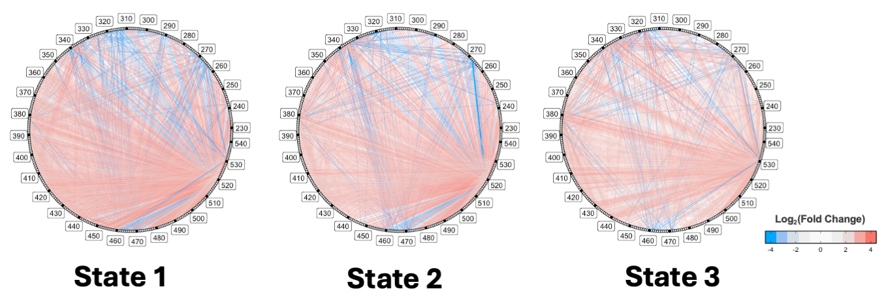
Supplementary Figure S3. The three states of PTG522 showed similar allostery communication with state 3 being the weakest. Log₂ fold-change in signal coupling between each fragment in state 1, 2, and 3 of PTG522 as compared to Apo. Fragments 229–546 are represented as circular dots, labeled every 10 fragments (black dots). An increase or decrease of correlation between two fragments is shown by red or blue lines, respectively.

Supplementary Figure S4. Propagation of allosteric signals from the distal sites (C423 or C522) to sEH CTD catalytic site (residues Y383, Y466, D335, D496, H524) in each simulation system (Apo, PTG423, PTG522). (A–B) Shortest pathway of communication from the allosteric site (A) C522 or (B) C423 to the catalytic center of sEH CTD. The allosteric sites, intermediate fragments, and catalytic sites are colored in blue, green, and red, respectively. Thickness of pathway indicates correlation strength. Key protein regions in each system are labelled and highlighted by dashed lines.

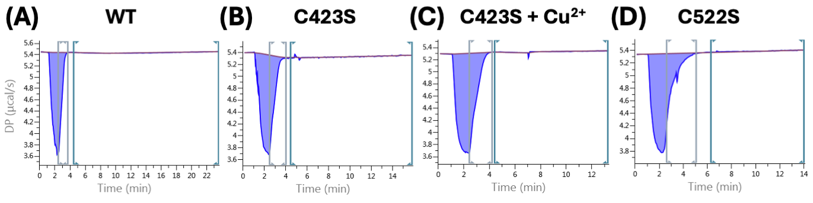
Supplementary Figure S5. Data point selection for Single Injection Method (SIM) Isothermal Titration Calorimetry (ITC) kinetic analysis. (A-D) Representative windows used for fitting of Michaelis–Menten kinetic curves in SIM ITC experiments with 14(15)-EET titration into sEH CTD (A) WT, (B) C423S, (C) C423S (in presence of Cu²⁺), and (D) C522S. Grey window indicates selected data points, start and end of the window are corresponding to saturated enzyme condition and start of kinetics curve, respectively. Initial injection peaks are excluded.

Supplementary Table S1. Forward (F) and Reverse (R) primers for mutagenesis. The mutation sites are highlighted in bold.
Mutation Site | Primer
C423S | (F) CATAAAGTCTCTGAAGCGGGAG
C423S | (R) CATGGATAAAACACTCTCATC
R410A | (F) AAGCCTCTTCGCGGCAAGCGATG
R410A | (R) TTGAAAGTCCGACTCAG
S439A/R440A | (F) CAGCCTCGCGGCGATGGTCACTG
S439A/R440A | (R) TTGAAAGTCCGACTCAG
K495A | (F) CACGGCGGAGGCGGACTTCGTGC
K495A | (R) ACCATCAGGGCCGGA

Supplementary Video S1.
Movies of representative REMD simulation trajectories capturing new protein-ligand conformations in (A) PTG423 and (B) PTG522.

