Supplementary figure S1:
Endplate injury grading: Based on sagittal T1-weighted MRI, endplate injury is classified as follows: Grade 0: The cortex is intact with no angulation. Grade 1: The cortex is discontinuous or angulated, limited to one-third of the endplate (anterior, middle or posterior). Grade 2: The cortex is destroyed involving two-thirds of the endplate. Grade 3: The endplate has a full-thickness fracture with displacement (>2 mm).

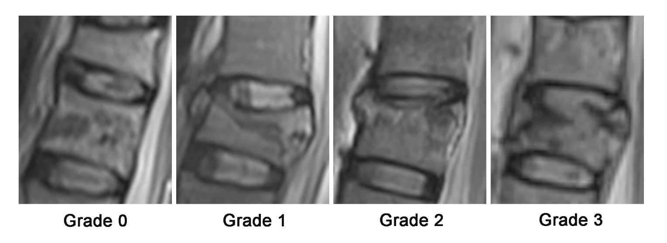
Supplementary figure S2:
Intervertebral disc (IVD) injury grading: Using T2-weighted STIR MRI, intervertebral disc injury is classified as follows: Grade 0: Signal intensity is normal compared to the adjacent uninjured intervertebral disc. Grade 1: Diffuse high signal indicates edema. Grade 2: Focal high signal appears in the periphery (annulus fibrosus). Grade 3: The intervertebral disc tissue herniates into the endplate or vertebral body.

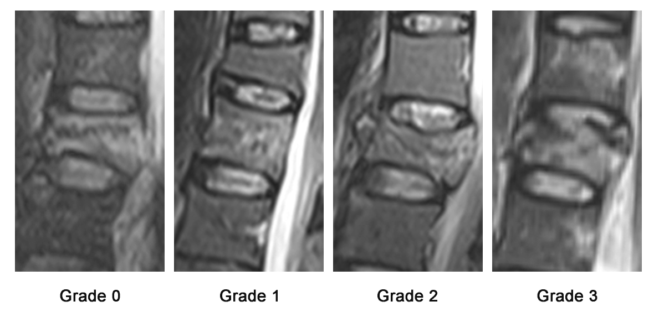

Supplementary figure S3:
Posterior Ligamentous Complex (PLC)injury grading: According to the AO Spine TLICS criteria, grading is performed via MRI as follows: Grade I: Sprain (high signal on T2, no rupture). Grade II: Partial tear (less than 50% of fibers ruptured). Grade III: Complete rupture (≥50% of fibers ruptured or avulsion).

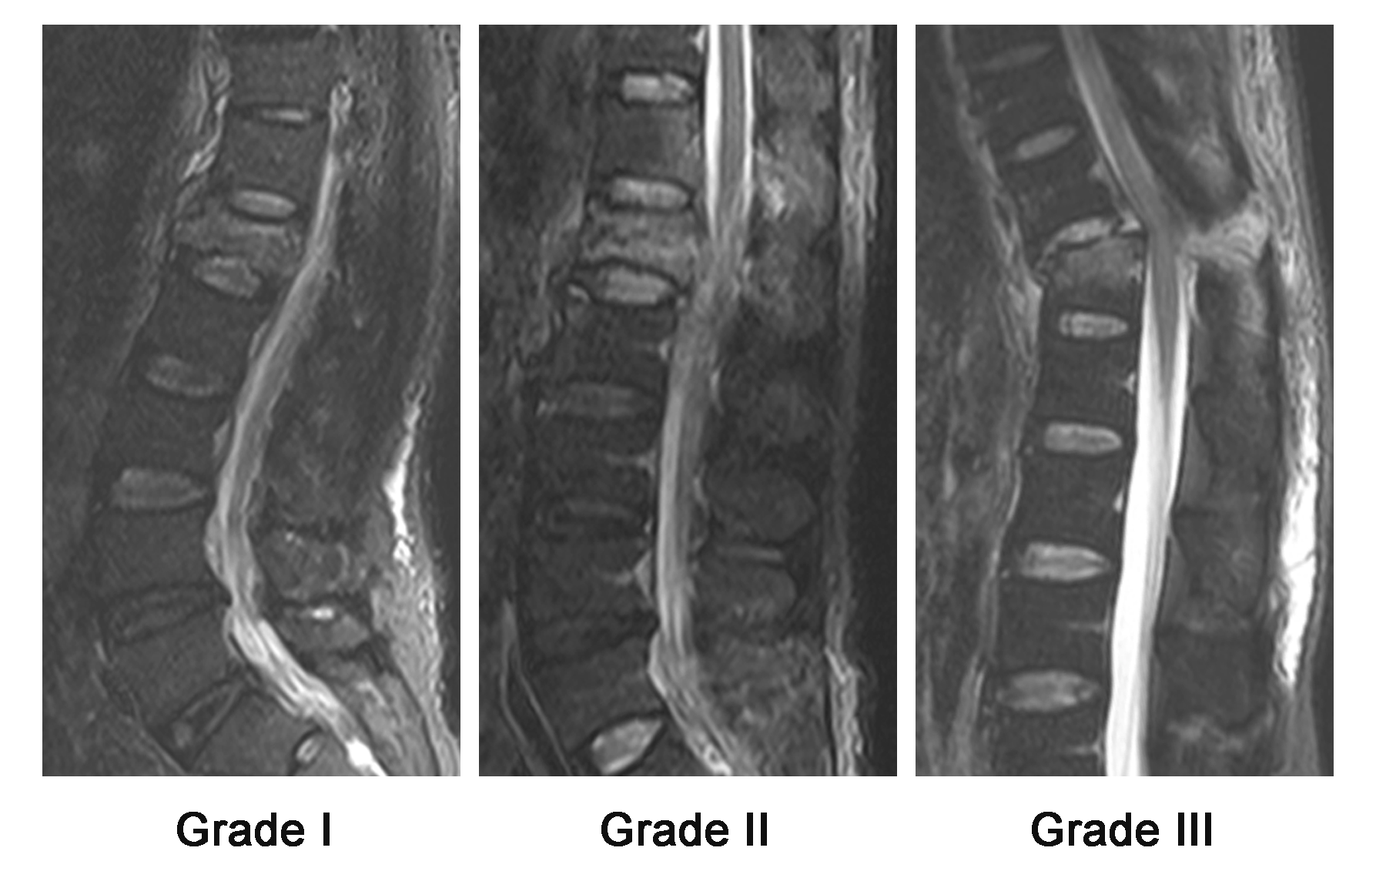

Supplementary figure S4:
Spinal canal compromise: It is calculated on axial CT as [(area of the canal at the level of the fracture) / (area of the canal at the adjacent normal level)] × 100%. a/a’ × 100%.

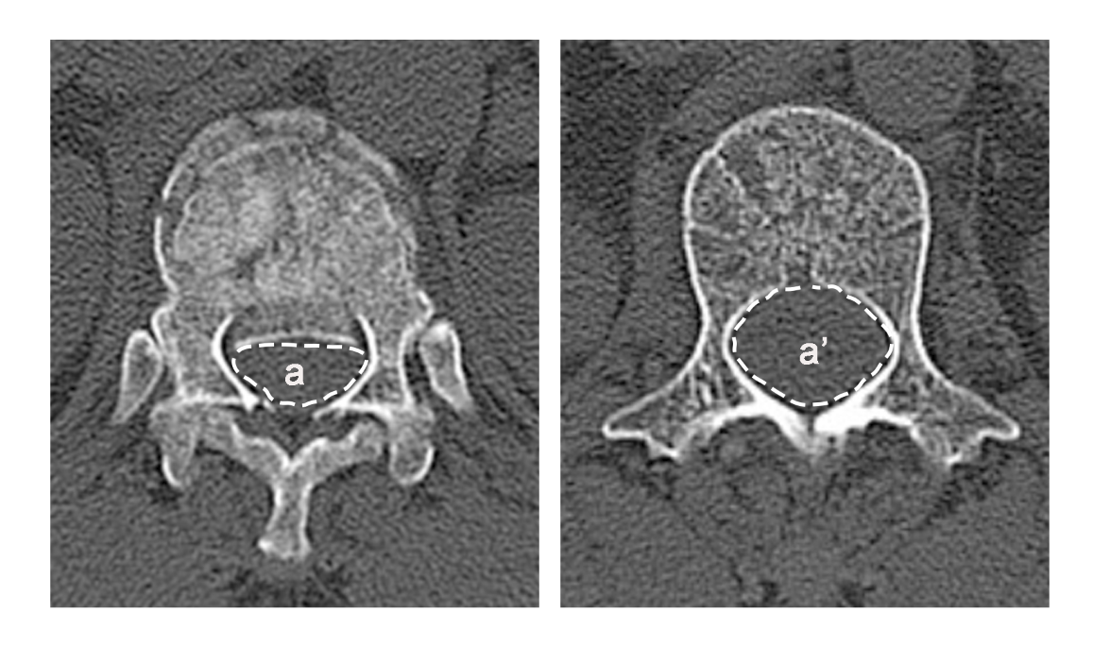

Supplementary figure S5:
Preoperative Vertebral Compression Ratio: The ratio of the anterior height of the fractured vertebral body to the average anterior height of the adjacent vertebral bodies. [AVH – (AVH’+AVH’’)/2] × 100%. AVH: Anterior vertebral height.

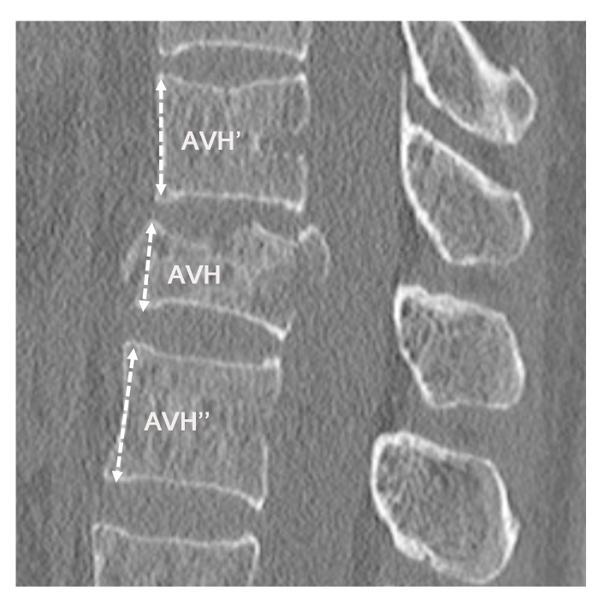

Supplementary figure S6: Interpedicular Distance (IPD) Increase Rate: The ratio of the increased width between the pedicles of the injured vertebra to the average distance between the pedicles of the adjacent vertebrae above and below. IPD = [D - (D’ + D’’)/2] / (D’ + D’’) × 100%.

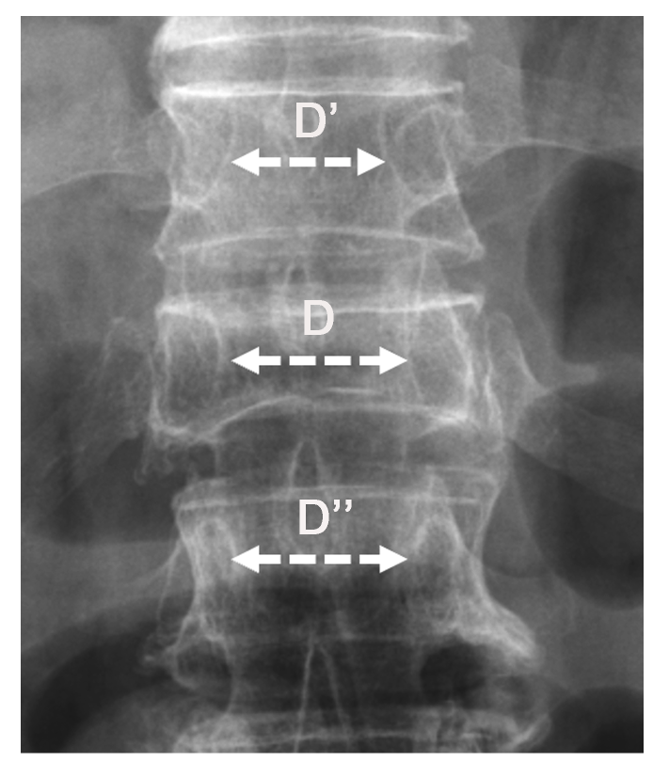

Supplementary figure S7:
Vertebral Body HU Value: Select one normal vertebra above and below the injured vertebra (for example, if there is a fracture at T12, measure T11 and L1), avoiding the fracture area and regions of interference such as bone islands and hemangiomas. ROI selection: On the axial CT slice at the mid-portion of the vertebral body, use an elliptical ROI to cover the cancellous bone (avoiding the cortical bone and the basivertebral veins), and take the average value. In this study, this variable is treated as a continuous variable.

