Supplementary Information for

The evolutionary lifecycle
of ribosome hibernation factors

Authors
Lewis I. Chan^{1,}†, Kimiho Omae^{2,}†, Charlotte Rebecca Brown^{1,}†, Kazuaki Amikura^{2,}†, Chinenye L. Ekemezie¹, Jessica Clark¹, Kenji Nishide², Karla Helena-Bueno¹, Pawel Palmowski¹, Andrew Porter¹, Shino Suzuki², Sergey V. Melnikov¹

Affiliations
¹ School of Medicine, Newcastle University, Newcastle upon Tyne, UK
² Geobiology and Astrobiology Laboratory, RIKEN Pioneering Research Institute, Wako, Saitama, Japan
† Contributed equally.

Correspondence
shino.suzuki@riken.jp and sergey.melnikov@ncl.ac.uk

Supplementary Figures:

Figure S1 | Genome search for homologous hibernation factors.

Figure S2 | Distribution of HPF isoforms differing in protein domain composition across bacterial species.

Figure S3 | Analysis of hibernation factors’ operons.

Figure S4 | RaiA gene has been acquired relatively recently in bacterial evolution.

Figure S5 | Some horizontal gene transfer events appear to reflect phage infections.

Figure S6 | Unlike factors of protein synthesis, ribosome hibernation factors are highly prone to truncations and loss of N- and C-terminal domains.

Figure S7 | Unlike factors of protein synthesis, hibernation factors evolve rapidly and under lower selective pressure.

Supplementary Data:

Data S1 | Homologs of hibernation factors analyzed in this study.

Data S2 | Mass-spectrometry analysis of ribosomes from stationary E. coli.

Data S3 | Bacteria lacking HPF proteins.

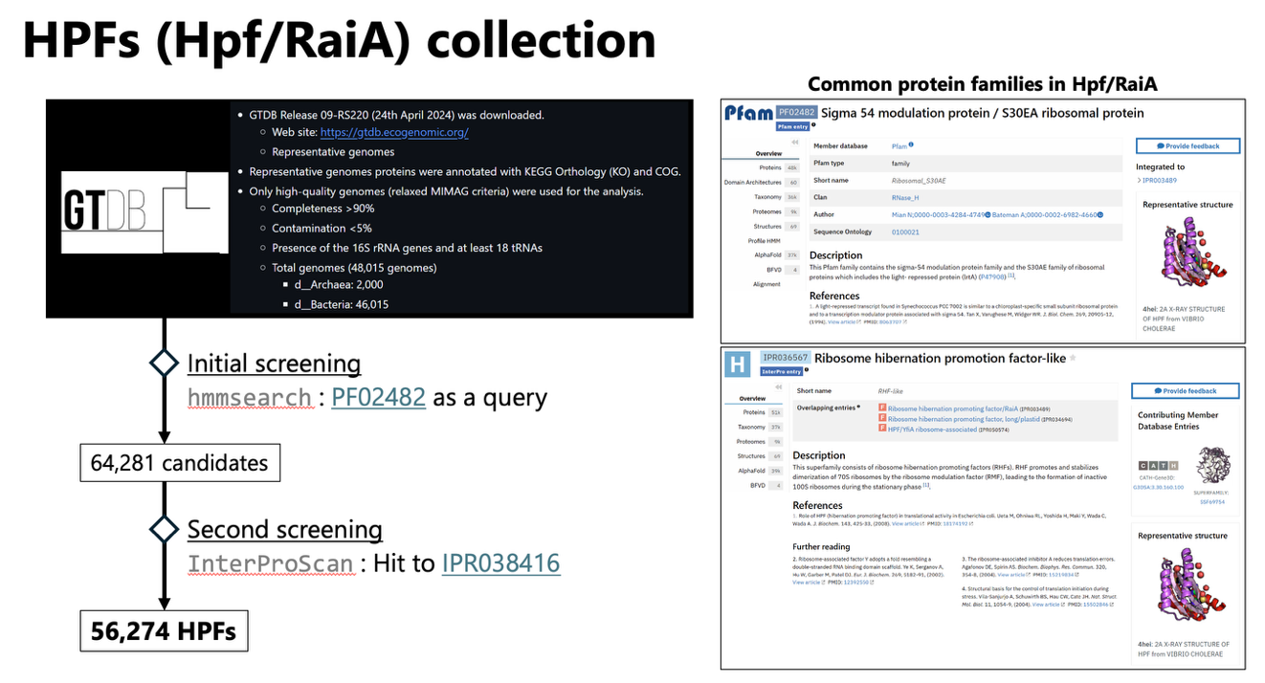

Figure S1 | Genome search for homologous hibernation factors. An outline of the initial search for the homologs of ribosome hibernation factors later refined by the analysis of bacterial operon composition.

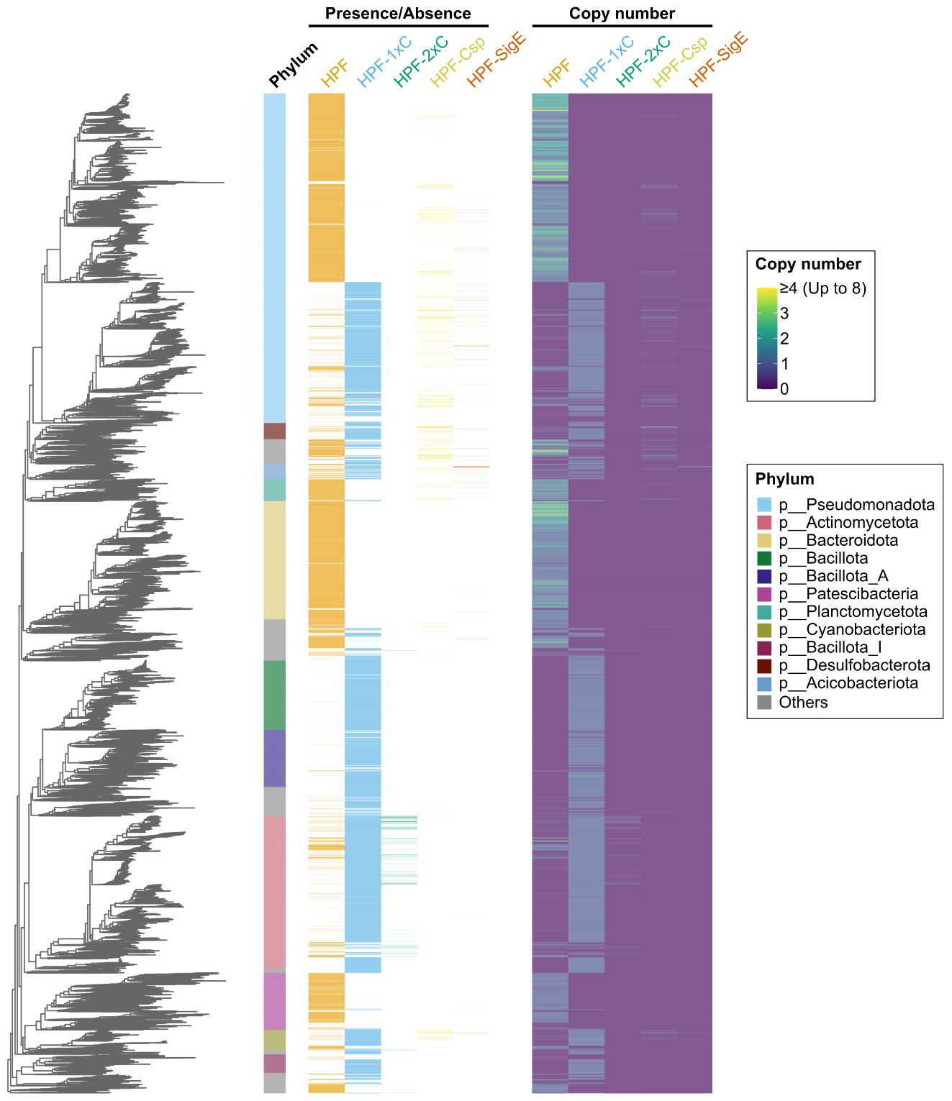

Figure S2 | Distribution of HPF isoforms differing in protein domain composition across bacterial species. The bacterial tree of life illustrating the distribution of HPF isoforms and their gene copy number variation across bacterial clades. Note that this initial analysis merely reflects the domain composition rather than the evolutionary relationships between various HPF isoforms. Therefore, the short (HPF) and long (HPF-1xC) isoforms of HPF are shown as separate proteins, despite some of them being directly related through vertical evolution. Similarly, HPF and RaiA (e.g. in E. coli) are shown as two copies of HPF, despite only one of these proteins (HPF) can be traced as the direct vertically evolving homolog of the ancestral HPF shown in Fig. 1.

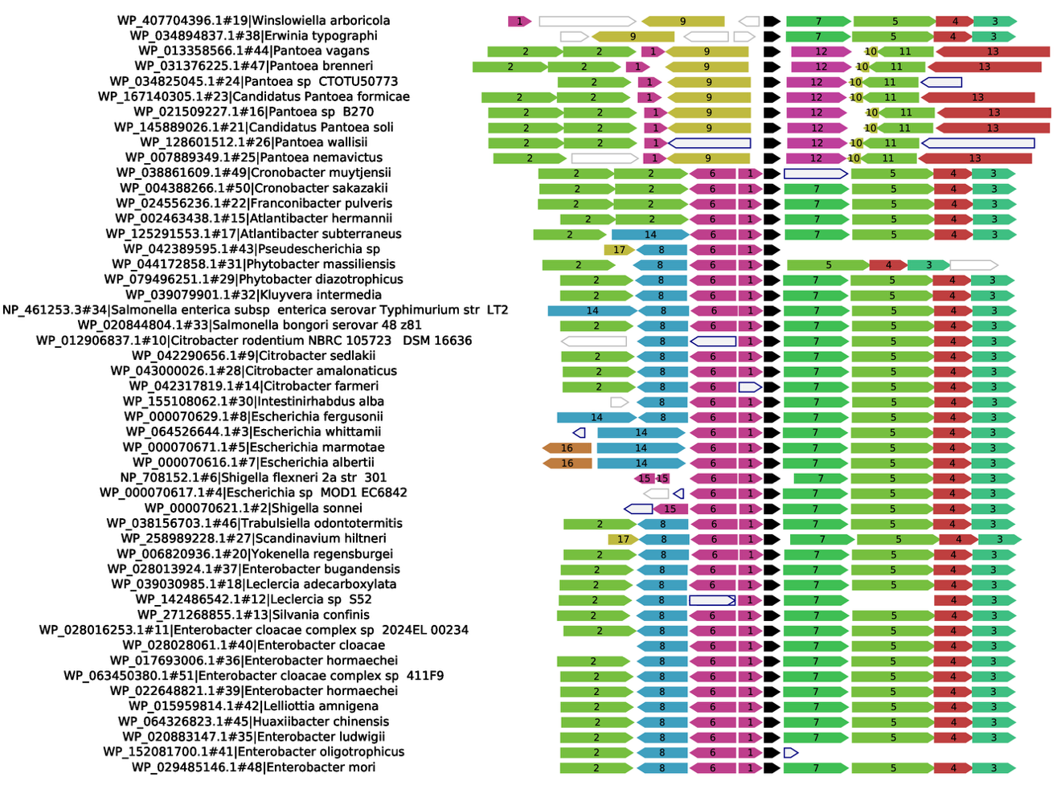

Figure S3 | Analysis of hibernation factors’ operons. An example of tracing the conservation of hibernation factors’ operons in bacterial species shows the evolution of ElaB-coding operon.

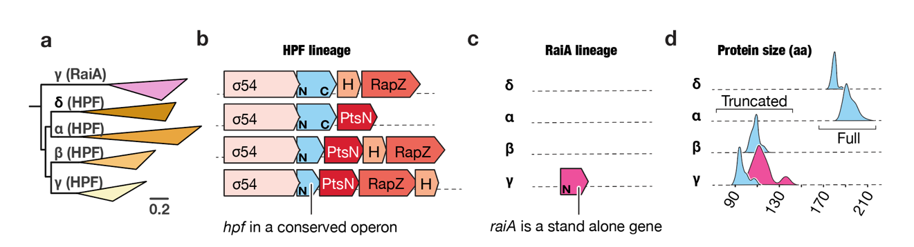

Figure S4 | RaiA gene has been acquired relatively recently in bacterial evolution. (a) A schematic tree calculated for proteins HPF and RaiA from γ-proteobacteria and HPF from other proteobacteria, illustrating that proteins HPF form a monophyletic cluster—while protein RaiA forms a stand-alone cluster. This branching illustrates that RaiA represents a more recently acquired isoform of HPF in proteobacteria and suggests its origin either via ancient horizontal gene transfer or a genome duplication followed by neofunctionalization. (b) Comparison of HPF-coding operons between four major branches of proteobacteria shown in panels (c,d). The panel illustrates a gradual reduction of HPF in size—this protein loses its C-terminal domain without losing its conserved position within the operon. (c) Schematics illustrates the origin of RaiA in γ-proteobacteria as a stand-alone gene. (d) Distribution of HPF (in blue) and RaiA (in magenta) by length.

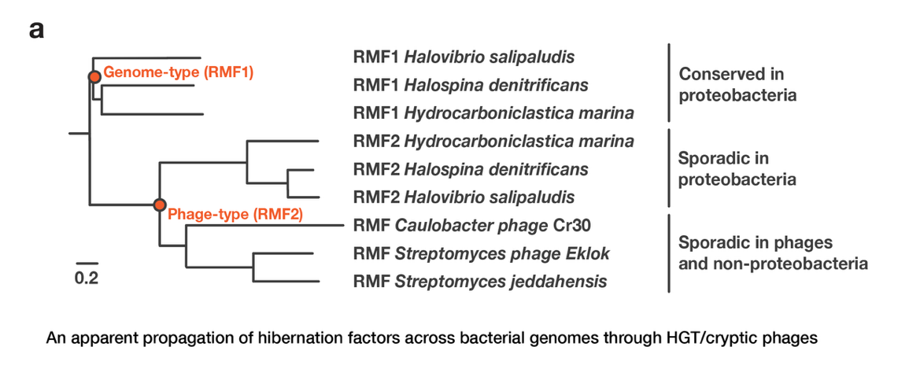

Figure S5 | Some horizontal gene transfer events appear to reflect phage infections. The tree illustrates the propagation of the RMF-coding gene across distant branches of bacterial species. It shows that some bacteria (e.g. Halovibrio or Halospina) have not one, but two RMF-coding genes. In these species, the first copy (RMF1) is traced back to the origin of γ-proteobacteria; however, the second copy (RMF2) clusters with RMF variants found either in distant bacterial lineages outside of the γ-proteobacteria group or in phages. This clustering indicates that the sporadic occurrence of RMF in non-proteobacterial species has a likely cryptic origin and originated via phage infections.

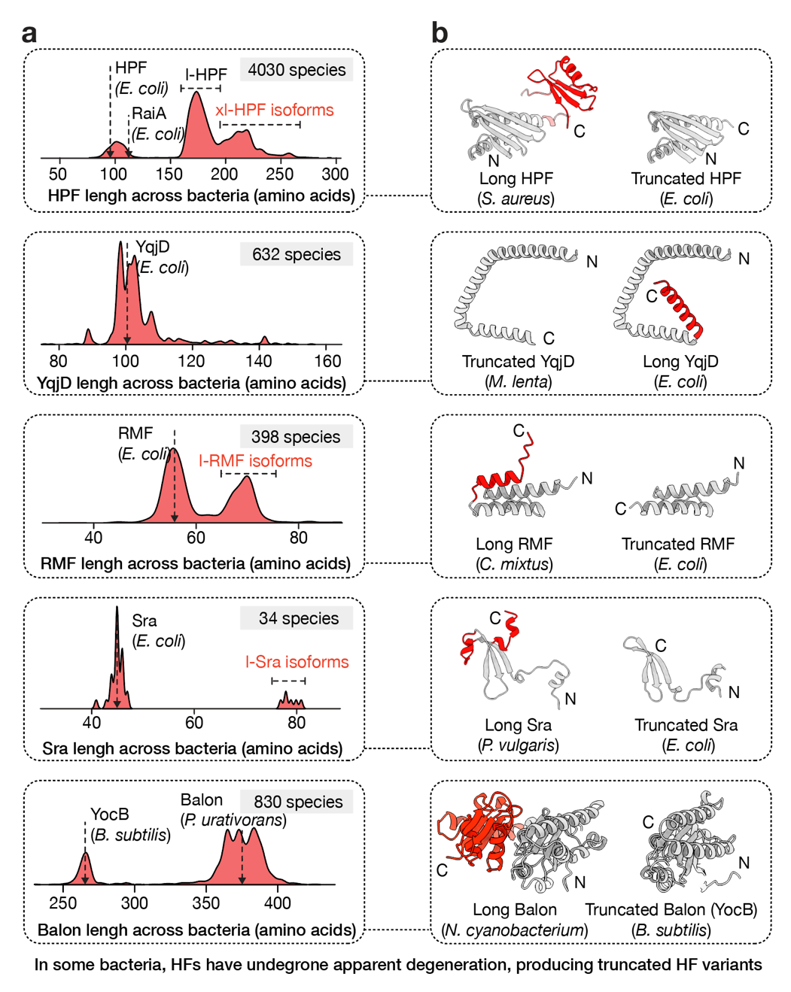

Figure S6 | Unlike factors of protein synthesis, ribosome hibernation factors are highly prone to truncations and loss of N- and C-terminal domains. Structures compare homologous hibernation factors from E. coli and more earlier diverging bacteria with longer isoforms of hibernation factors. Overall, this illustrates that ribosome hibernation factors tend to undergo domain loss (or entire protein loss) in certain lineages of bacteria, which illustrates a qualitatively distinct mode of evolution for the factors of ribosome hibernation compared to the factors of protein synthesis (i.e. EF-Tu, EF-G, EF-P).

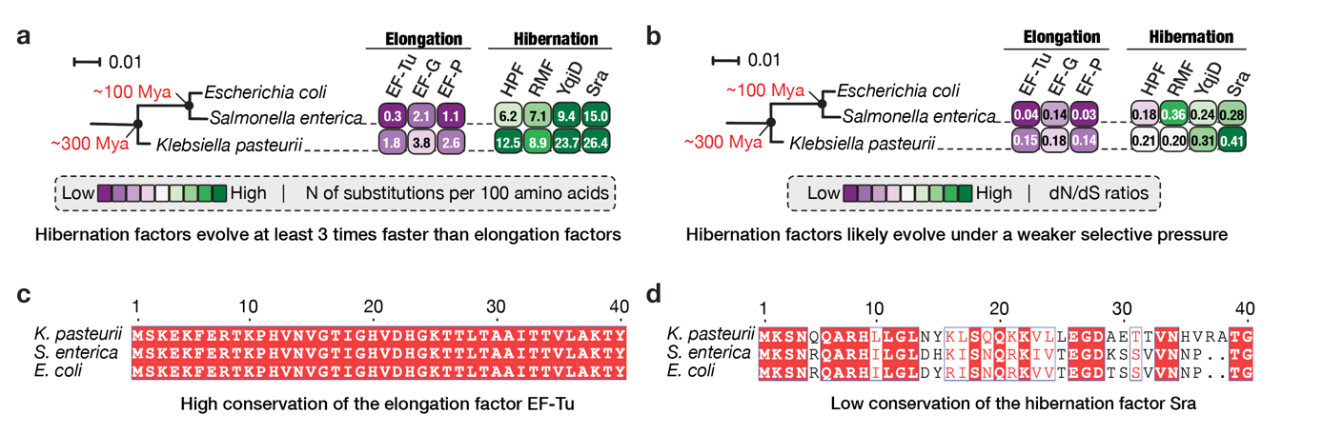

Figure S7 | Unlike factors of protein synthesis, hibernation factors evolve rapidly and under lower selective pressure. (a, b) The tree and diagram compare the rates of amino acid substitutions (a) and the ratios of synonymous to non-synonymous mutations among homologs of elongation factors and hibernation factors from three closely related bacterial species. (c, d) Sequence alignments for these species compare the conservation of the translation factor EF-Tu and the hibernation factor Sra.

