Appendix
Figure 2: Sex differences in all-cause excess ASMR (males-females) for individuals aged 45+ over time by state
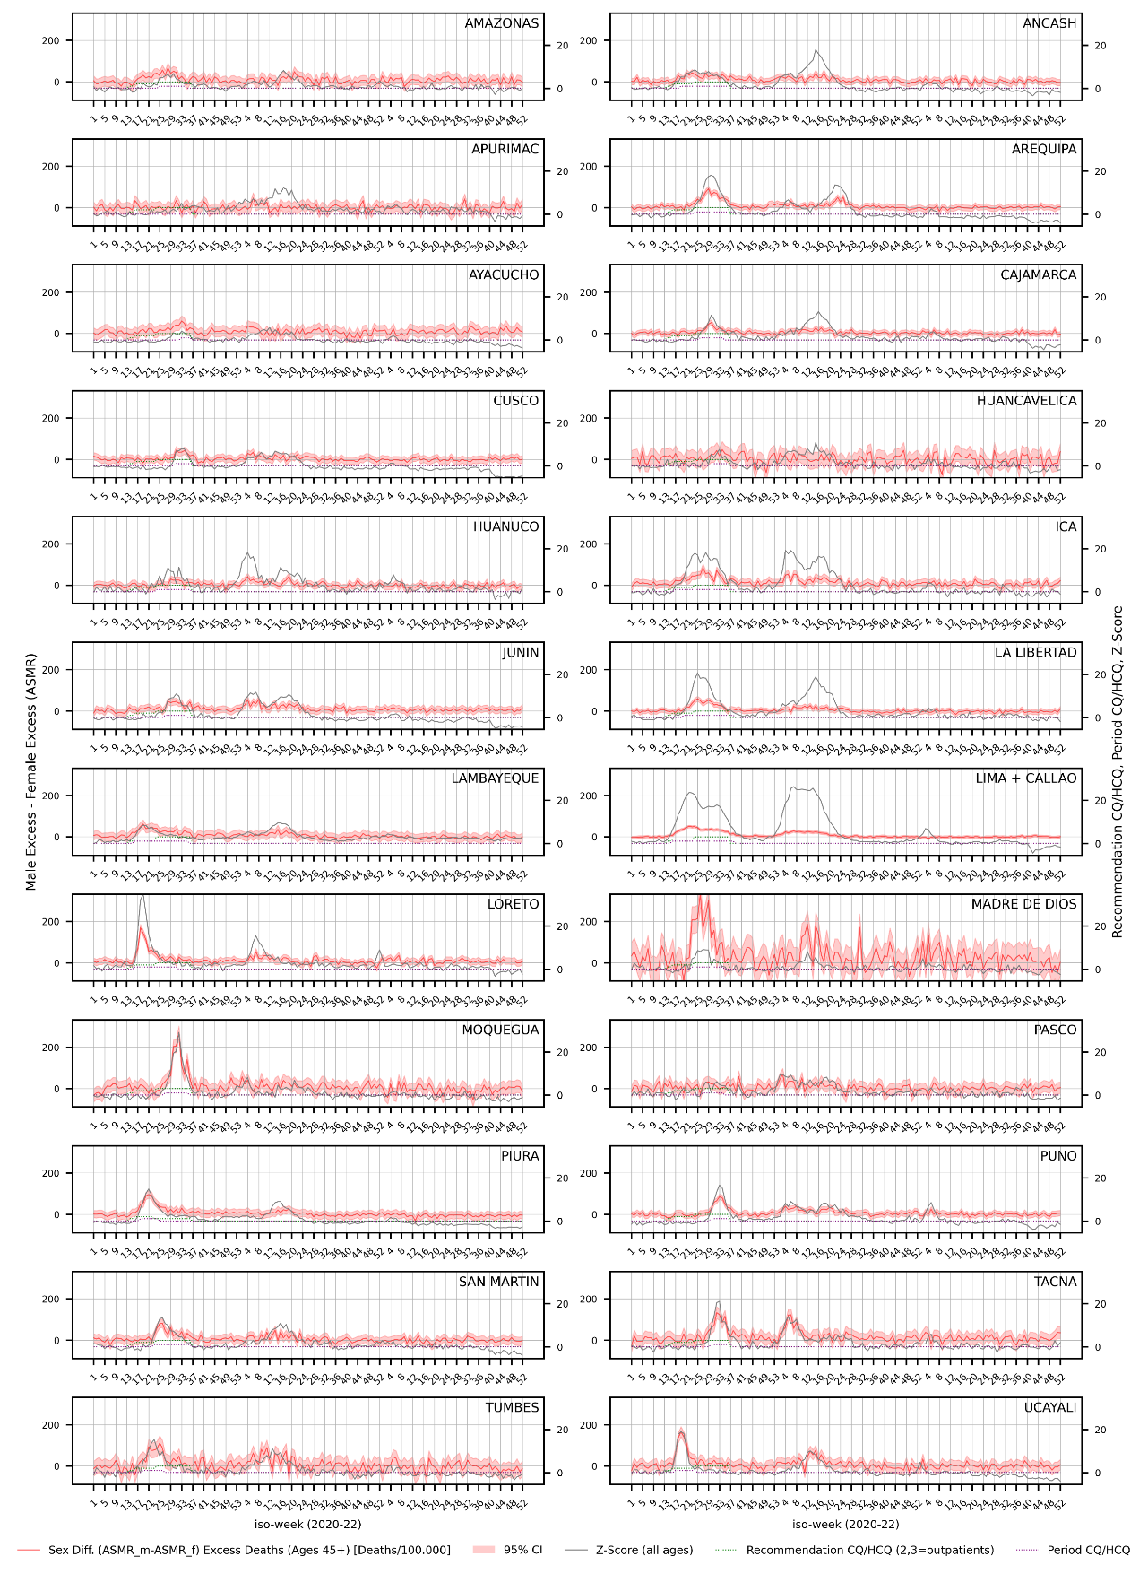
Note: The variance of the sex difference was obtained as the sum of male and female ASMR variances (see the Statistical Analysis section), and the 95% confidence interval (95% CI) was constructed as the point estimate ± 1.96 times the square root of this variance, assuming the independence of errors (Cov(m, f) = 0).
Figure 3: Sex differences in COVID-19 ASMR (males-females) for individuals aged 45+ over time by state
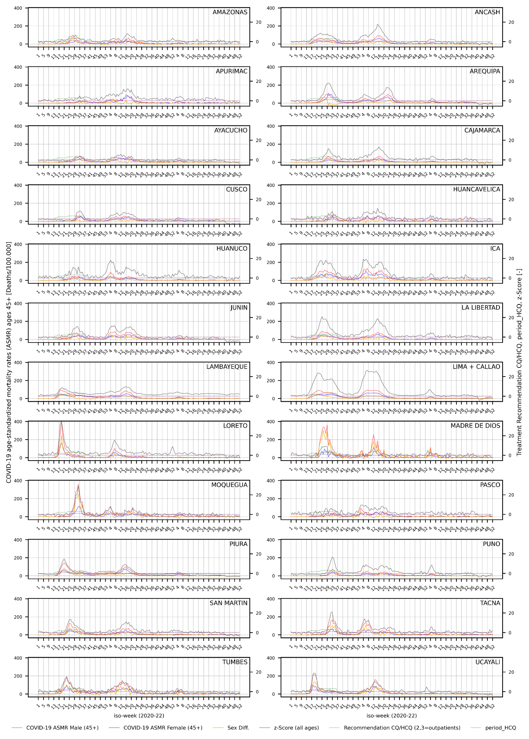
Table 3: Sum of delivered HCQ tablets per state population
State | HCQ_per_pop
State | period_HCQ z-score = 4 |  | period_HCQ z-score = 3.5 |  | period_HCQ z-score = 3 |  | period_HCQ z-score = 2.5
Amazonas | 39.62 | 39.62 |  | 39.62 |  | 39.62
Ancash | 14.74 | 14.74 |  | 14.74 |  | 14.74
Apurimac | - | - |  | 20.86 |  | 20.86
Arequipa | 19.47 | 19.47 |  | 19.47 |  | 19.47
Ayacucho | - | - |  | 27.35 |  | 27.35
Cajamarca | 8.33 | 8.33 |  | 8.33 |  | 8.33
Cusco | 10.30 | 10.30 |  | 10.30 |  | 10.30
Huancavelica | 11.65 | 11.65 |  | 11.65 |  | 11.65
Huánuco | 26.92 | 26.92 |  | 26.92 |  | 26.92
Ica | 36.48 | 36.48 |  | 36.48 |  | 36.48
Junín | 15.32 | 15.32 |  | 15.32 |  | 15.32
La Libertad | 17.16 | 17.16 |  | 17.16 |  | 17.16
Lambayeque | 16.36 | 21.55 |  | 21.55 |  | 21.55
Lima + Callao | 18.69 | 18.69 |  | 18.69 |  | 18.69
Loreto | 18.64 | 18.64 |  | 20.61 |  | 21.81
Madre de Dios | 178.36 | 178.36 |  | 178.36 |  | 178.36
Moquegua | 35.60 | 35.60 |  | 35.60 |  | 35.60
Pasco | 25.17 | 25.17 |  | 25.17 |  | 25.17
Piura | 5.51 | 5.51 |  | 5.51 |  | 5.51
Puno | 7.65 | 7.65 |  | 7.65 |  | 7.65
San Martin | 36.37 | 36.37 |  | 36.37 |  | 36.37
Tacna | 19.75 | 19.75 |  | 19.75 |  | 19.75
Tumbes | 12.29 | 12.29 |  | 12.29 |  | 12.29
Ucayali | 20.57 | 20.57 |  | 20.57 |  | 39.68
Median | 18.66 | 19.08 |  | 20.16 |  | 20.31
Mean | 26.68 | 26.92 |  | 26.82 |  | 27.64
Std. Dev. | 33.68 | 33.62 |  | 32.25 |  | 32.30
Note: The different CQ/HCQ drugs used were 'CLOROQUINA 150 MG TAB', 'CLOROQUINA FOSFATO 250 MG (EQUIV. 155 MG CLOROQUINA BASE) TAB', 'HIDROXICLOROQUINA [SULFATO] 400 MG TAB', 'HIDROXICLOROQUINA SULFATO 200 MG (EQUIV. 155 MG HIDROXICLOROQUINA) TAB' [36]. According to the treatment protocol, 1 CQ is considered equivalent to 1/6 HCQ [9]. All drugs were standardized using 1 tablet '155 MG HIDROXICLOROQUINA' as the base. All of these standardized tablets that were distributed before or during period_HCQ were summed and divided by the state population, with period_HCQ constructed with different definitions (z-score thresholds) as described in the Data Preparation section. Missing values stem from the lack of identification of period_HCQ with the given z-score threshold.

Table 4: Scarcity CQ/HCQ: Doses per positive test
State | CQ/HCQ-Doses per positive tests in age group 45+ |  |  |  | Total tests per population  during Period_HCQ (z-score = 2.5)
State | period_HCQ z-score = 4 | period_HCQ z-score = 3.5 | period_HCQ z-score = 3 | period_HCQ z-score = 2.5
Amazonas | 1.36 | 1.21 | 1.21 | 1.11 | 0.19
Ancash | 0.46 | 0.46 | 0.42 | 0.41 | 0.21
Apurimac | NaN | NaN | 4.48 | 2.12 | 0.13
Arequipa | 0.23 | 0.22 | 0.22 | 0.22 | 0.50
Ayacucho | NaN | NaN | 3.30 | 2.11 | 0.06
Cajamarca | 0.59 | 0.59 | 0.57 | 0.57 | 0.10
Cusco | 0.41 | 0.41 | 0.41 | 0.41 | 0.14
Huancavelica | 1.36 | 1.09 | 1.09 | 1.09 | 0.09
Huánuco | 1.23 | 1.14 | 1.14 | 1.14 | 0.14
Ica | 0.54 | 0.54 | 0.54 | 0.54 | 0.39
Junín | 1.12 | 1.03 | 1.03 | 1.03 | 0.10
La Libertad | 0.51 | 0.51 | 0.48 | 0.48 | 0.19
Lambayeque | 0.94 | 0.80 | 0.70 | 0.59 | 0.17
Lima + Callao | 0.27 | 0.27 | 0.27 | 0.27 | 0.40
Loreto | 1.38 | 1.38 | 1.09 | 0.94 | 0.08
Madre de Dios | 3.66 | 3.35 | 3.35 | 3.05 | 0.26
Moquegua | 0.40 | 0.40 | 0.39 | 0.39 | 0.48
Pasco | 1.80 | 1.68 | 1.68 | 1.68 | 0.14
Piura | 0.64 | 0.64 | 0.64 | 0.64 | 0.04
Puno | 0.56 | 0.56 | 0.56 | 0.56 | 0.08
San Martin | 1.36 | 1.36 | 1.29 | 1.29 | 0.11
Tacna | 0.51 | 0.51 | 0.51 | 0.49 | 0.26
Tumbes | 1.01 | 1.01 | 1.01 | 1.01 | 0.05
Ucayali | 1.80 | 1.80 | 1.80 | 2.17 | 0.07
Median | 0.79 | 0.72 | 0.85 | 0.79 | 0.14
Mean | 1.00 | 0.94 | 1.16 | 1.00 | 0.18
Std. Dev. | 0.73 | 0.67 | 1.04 | 0.70 | 0.13
Note: CQ/HCQ deliveries [36] that occurred before or during period_HCQ were considered, and 1 CQ/HCQ dose corresponds to 18 tablets of HIDROXICLOROQUINA SULFATO 200 MG [41]. All positive COVID-19 tests in the 45+ age group that occurred during period_HCQ were counted, with period_HCQ constructed with different specifications (z-score thresholds) as described in the Data Preparation section.

Table 5: Inference with Wild Cluster Bootstrap [50] for Models 1, 2, 3, and 4 (Table 2, main text)
Model | p-value (Wild Cluster Bootstrap)
Model | 1 (all-cause excess) | 2 (all-cause excess) | 3 (COVID-19) | 4 (COVID-19)
period_HCQ | 0.000 | 0.001 | 0.002 | 0.000
period_HCQ x G6PDd prevalence | - | 0.075 | - | 0.023
period_HCQ x HCQ_per_pop | - | 0.046 | - | 0.003
period_HCQ x z-score | - | 0.000 | - | 0.004
z-score | 0.000 | 0.000 | 0.000 | 0.000
Sex difference test positive rate (lag 4) | 0.028 | 0.029 | 0.003 | 0.003
Sex difference vaccination rate (lag 3) | 0.002 | 0.051 | 0.000 | 0.007

Figure 4: Marginal effect of period_HCQ conditional on G6PDd prevalence. Dependent variable: sex difference in all-cause excess ASMR (males-females) at age 45+
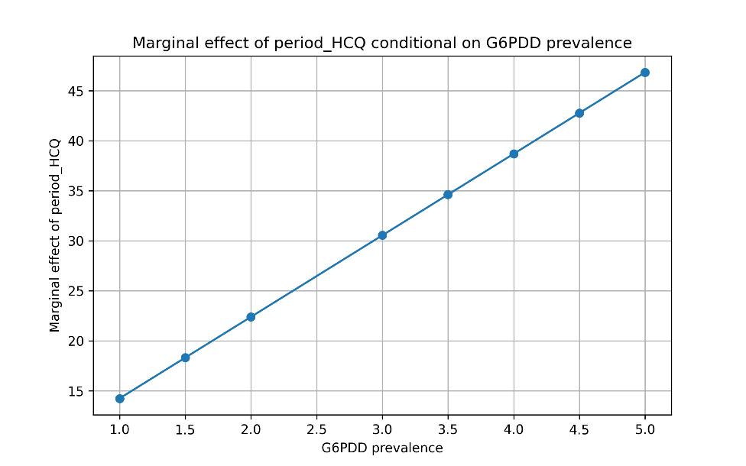
Note: The variable HCQ_per_pop (time-invariant) is held at its mean. The variable z-score is held at its mean during period_HCQ.
Figure 5: Marginal effect of period_HCQ conditional on G6PDd prevalence. Dependent variable: sex difference in Covid-19 ASMR (males-females) ages 45+
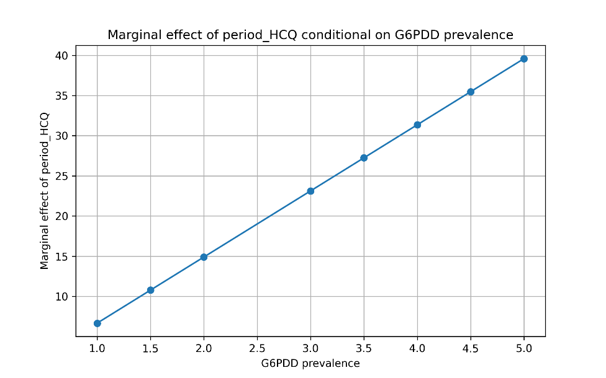
Note: The variable HCQ_per_pop (time-invariant) is held at its mean. The variable z-score is held at its mean during period_HCQ.

Figure 6: States of Peru and modeled G6PDd prevalence [28]
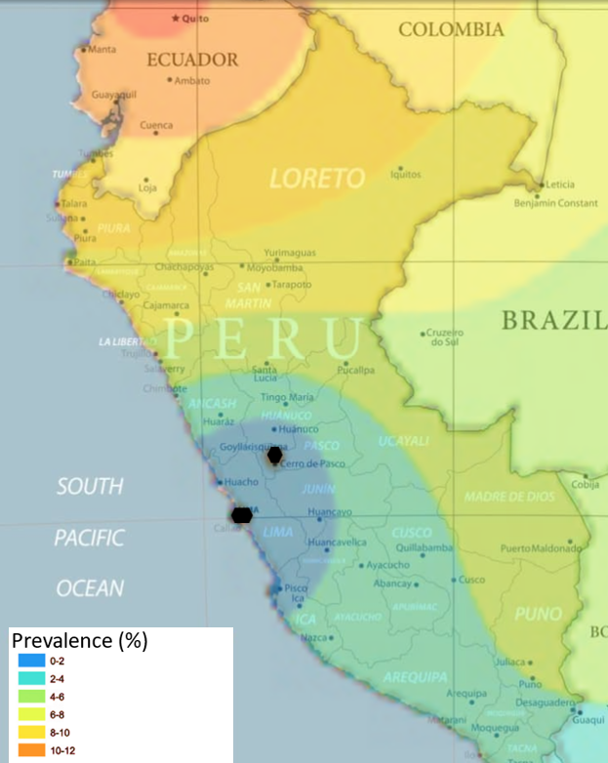

Table 6: G6PDd prevalence by state, derived from [28]
State | G6PDd prevalence [28]
Amazonas | 4.5 (6-10%)
Ancash | 2.0 (2-4%)
Apurimac | 2.0 (2-4%)
Arequipa | 2.0 (2-4%)
Ayacucho | 2.0 (2-4%)
Cajamarca | 4.0 (6-8%)
Cusco | 2.0 (2-4%)
Huancavelica | 1.5 (0-4%)
Huanuco | 2.0 (2-4%)
Ica | 1.5 (0-4%)
Junin | 1.5 (0-4%)
La Libertad | 3.0 (4-6%)
Lambayeque | 4.0 (6-8%)
Lima + Callao | 1.0 (0-2%)
Loreto | 4.5 (6-10%)
Madre de Dios | 3.0 (4-6%)
Moquegua | 2.0 (2-4%)
Pasco | 1.5 (0-4%)
Piura | 5.0 (8-10%)
Puno | 3.0 (4-6%)
San Martin | 3.5 (4-8%)
Tacna | 2.0 (2-4%)
Tumbes | 5.0 (8-10%)
Ucayali | 3.0 (4-6%)
Note: G6PDd prevalence was coded on the basis of Monteiro et al. (2014); values in parentheses indicate the original modeled prevalence [28].

