Supporting Information: Spectra and Figures
This document contains placeholders for numbered spectra and associated captions extracted from the manuscript.
Figure 1. FT-IR absorption spectrum of 10,12-pentacosadiynoic acid (PCDA)
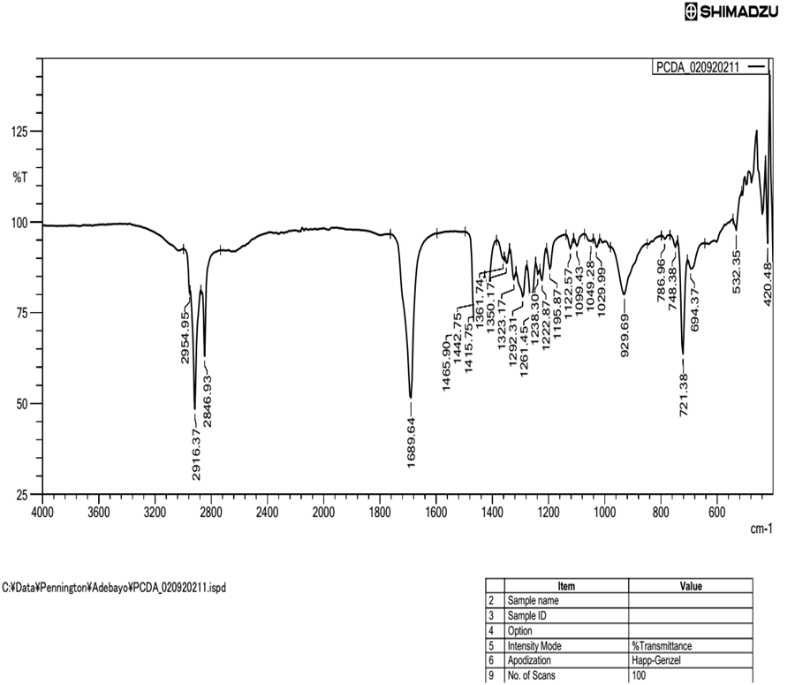

Figure 2. FT-IR absorption spectrum of sodium 10,12-pentacosadiynoate (PCDA-Na)
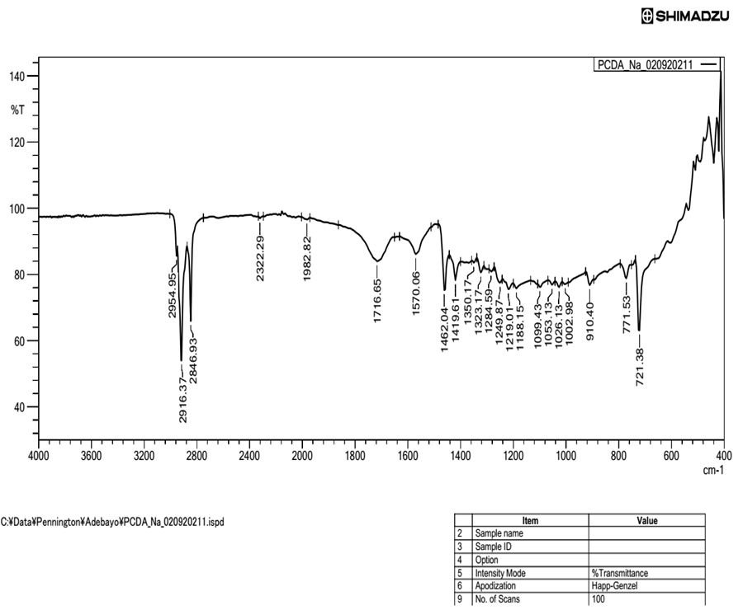

Figure 3. Comparative FT-IR spectra of PCDA and PCDA-Na
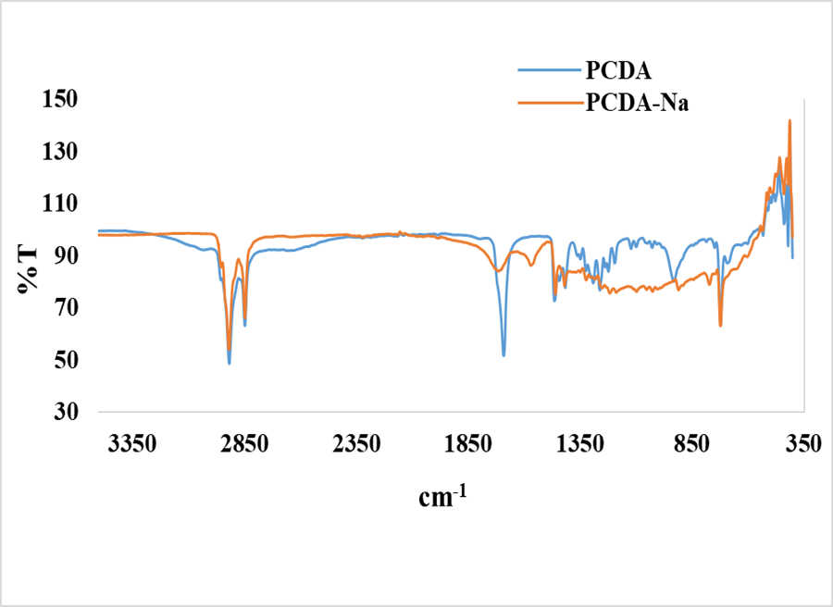

Figure 4. XRD patterns overlay of the PCDA and PCDA-Na
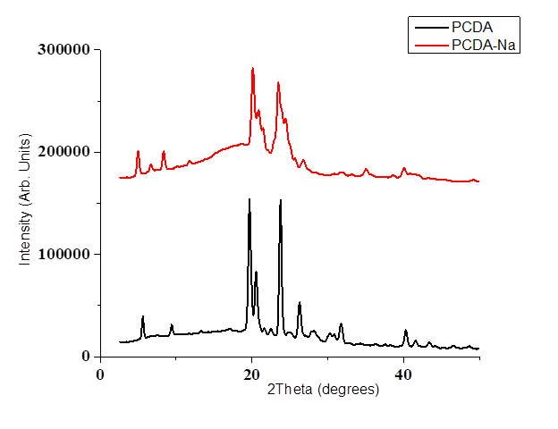

Figure 5. DSC-TGA thermograms for PCDA-Na (Na₂CO₃)
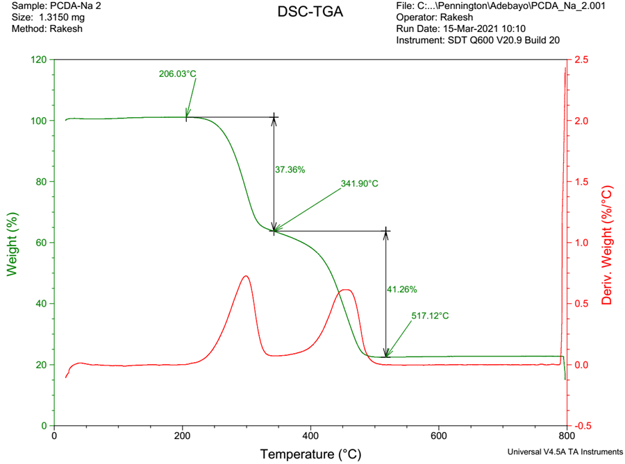

Figure 6. DSC-TGA thermograms for PCDA-Na (NaOH)
